LEVEL 7 ASSESSMENT SPECIFICATION
Student name: Pati Asha
Student ID number:2513192
Programme: MSc Public Health and Social Care in Practice
Module: Health Care System, Organisation and Leadership
Module code: LCHS7002
CASE STUDY ANALYSIS REPORT
Report on Comparative Analysis of COVID-19 Leadership Responses: Spain, South Korea, and Canada

Table of Contents
1. Introduction 5
1.1 Overview of COVID-19 and its Global Impact 5
1.2 Significance and Role of Leadership in Health Care Responses at the time of Pandemic 6
1.3 Outline of the Report Structure 8
2. Health Care System Organisations in the selected jurisdiction 8
2.1 Decentralised Healthcare Structure and Federal Approaches in Spain during COVID-19 8
2.1.1 Background of the Healthcare System in Spain 8
2.1.2 Decentralisation of the Healthcare System in Spain 9
2.1.3 Response Measures Taken during the Pandemic in Spain 10
2.2 Centralised Healthcare Structure and Approaches in South Korea during COVID-19 12
2.2.1 Background of the Healthcare System in South Korea 12
2.2.2 Centralisation and Policy Coordination in South Korea’s Health Administration 13
2.2.3 Response Measures Taken during the Pandemic in South Korea 14
2.3 Hybrid Healthcare Structure and Federalism in Approaches in Canada during COVID-19 15
2.3.1 Evaluation of the Healthcare System in Canada 15
2.3.2 Universal and Hybrid Structure of the Healthcare System in Canada 16
2.3.3 Federal and Provincial Response Initiatives during the COVID-19 Outbreak 17
2.4 Comparative Analysis of Health Care Systems 18
2.4.1 Critical Analysis of Centralisation vs. Decentralisation in Health Systems in Canada, South Korea and Spain 18
2.4.2 Influence of Health System Design on Pandemic Preparedness and Response Outcomes 19
3. Evaluating Leadership Approaches during the COVID-19 Pandemic in Spain, South Korea, and Canada 19
3.1 Democratic Leadership Style in Spain: Minister of Health, Salvador Illa 250 19
3.1.1 Early Government Response and Criticism 19
3.1.2 Advantages and Challenges in Democratic Leadership 20
3.2 Authoritative Leadership Style in South Korea: Prime Minister Chung Sye-kyun 21
3.2.1 Government-Led Response and Successes 21
3.2.2 Advantages and Challenges in Authoritative Leadership 22
3.3 Transformational Leadership Style in Canada: Prime Minister Justin Trudeau 22
3.3.1 Decentralised Response Structure and Challenges 22
3.3.2 Key Features, Benefits, and Drawbacks of Transformational Leadership 23
3.4 Comparative Analysis of Leadership Styles in Canada, South Korea and Spain 24
3.4.1 Critical Analysis of Leadership Styles 24
3.4.2 Effectiveness of the Leadership Styles and Decision-Making Processes 24
3.5 Impact of Leadership on Health Outcomes 25
3.5.1 Analysis of COVID-19 Outcomes across the selected nations 25
3.5.2 Relationship between Leadership Effectiveness and Health System Performance 26
3.5.3 Key insights from Each Country’s Approach 26
4. Discussion 27
4.1 Synthesis of Key Findings from the Health System, Organisational Leadership Analysis 27
4.2 Reflection on the significance of Adaptive Leadership in Health Crisis 28
4.3 Key Recommendations for Improving Health System Resilience 28
5. Conclusion 29
References 29

1. Introduction

1.1 Overview of COVID-19 and its Global Impact
The COVID-19 pandemic, which was announced by the World Health Organisation (WHO) in March 2020, was one of the biggest health crises across the globe in modern history, radically affecting societies, economies, and governments across the world (Chang, 2020). The spread of the SARS-CoV-2 virus exerted pressure on healthcare systems unprecedented in the number of years, revealing severe critical weak points in the preparedness, leadership, and coordination processes. By mid-2021, the cumulative global surveillance data showed that over 200 million cases and about 4 million deaths had been reported, with unequal country performance pointing to gaps in governance institutions, resource distribution, and overall policy of the health of a specific country (Wagner et al., 2022).
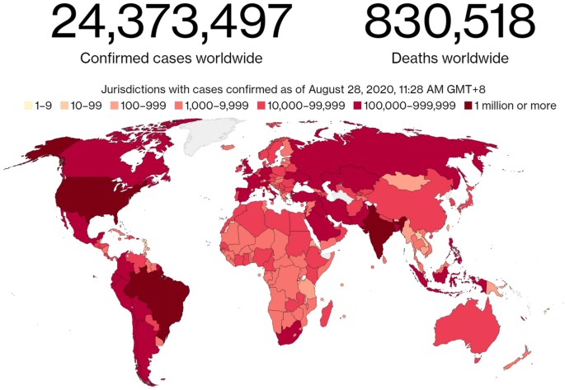
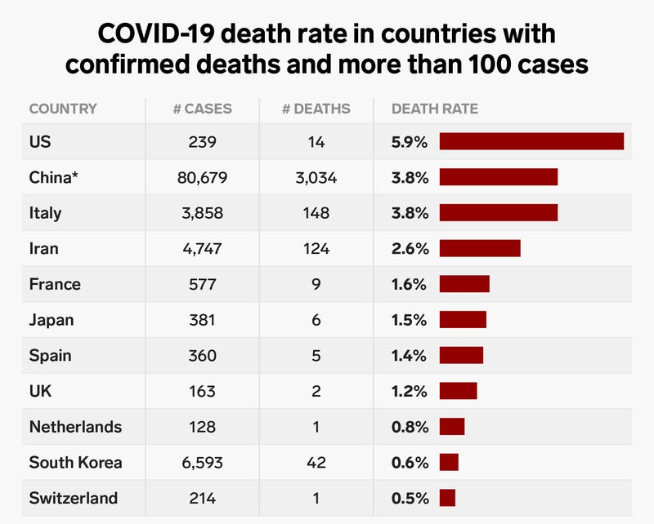
Figure 1: COVID-19 statistics
(Source: WHO, 2025)
The provided picture shows a table that gives information on COVID-19 death rate in eleven countries that has over 100 cases. The table shows that the US has the highest death rate at 5.9% while Switzerland has the lowest death rate at 0.5%. The data was collected at the time of the image. Figure 1 (Map): This world map shows the total confirmed COVID -19 cases all around the globe as of August 28, 2020. Overall, there have been over 24 million total cases and 830,000 deaths worldwide. Jurisdictions with darker reds on the map have experienced higher case totals since the start of the pandemic.
Outside of the direct health consequences, there were far-reaching socioeconomic and political impacts of the pandemic, putting the ability of states to maintain stability and the safety of citizens to the test. Haldane et al. (2021) put it clearly, the ability of the health system to absorb shocks, be able to adapt functionally and to change sustainably during a shock such as the pandemic became a central factor in effective management of the pandemic. As a result, leadership variables took the centre stage in assessing the national responses since it has a direct influence on the determination of communication strategies, decision making and the dynamics of compliance of people.

1.2 Significance and Role of Leadership in Health Care Responses at the time of Pandemic
Healthcare crisis leadership involves leading through complex adaptive systems through uncertainty and balancing the empirical evidence, resource allocation and societal demands at the same time. Flexibility, collaborative responsibility, and responsiveness to changing situations, as highlighted by the adaptive leadership theory, as highlighted by Sott and Bender (2025), are qualities that cannot be ignored in such pandemic environments where solutions seldom follow the linear paradigm. In the times of COVID-19, leaders had to manage not only biomedical and logistical processes but also develop people's trust and morale.
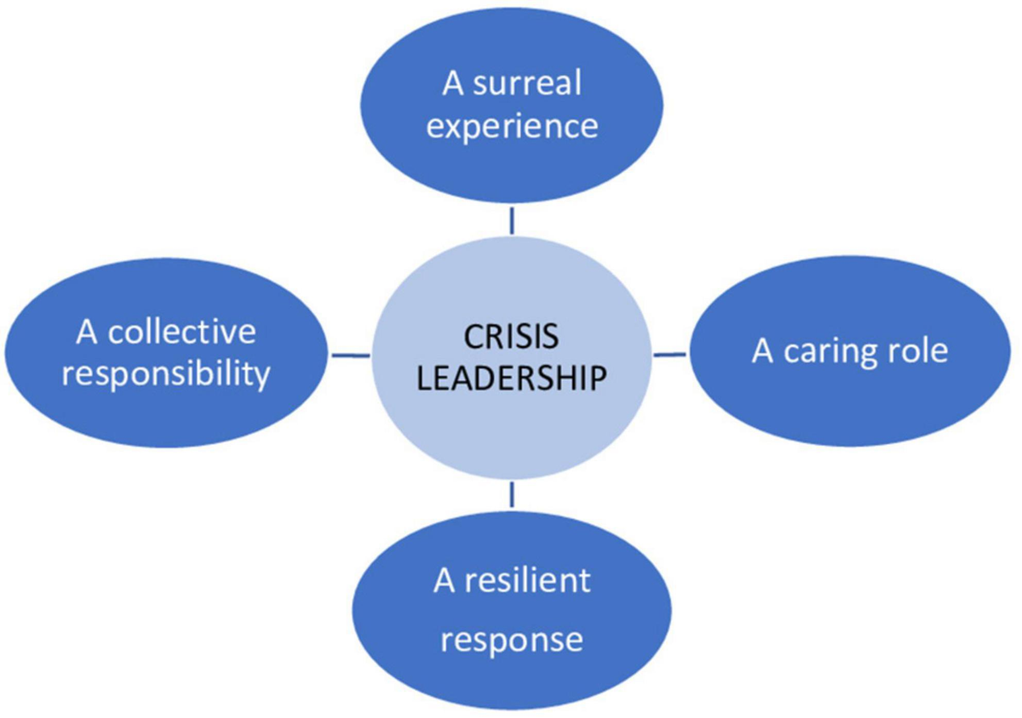
Figure 2: Crisis leadership
(Source: Author)
Empirical research indicates that the different modalities of leadership, transformational, situational, or authoritarian, have different impacts on the outcome of the pandemic. An example is Ma and Yang (2020), who revealed that transformational leadership behaviours in China aroused motivation and team spirit among healthcare professionals, hence increasing their compliance with safety measures. Conversely, inflexible or centrally-authoritarian leadership styles were dangerous to cooperation and openness (Patapan, 2022). This aspect of the crisis intensified the need to make adaptive and evidence-based decisions, where heads quickly absorb new information about the epidemiology and reposition themselves based on it (Rachmad, 2022).
Additionally, the notion of crisis leadership was broadened to include emotional intelligence, empathy, and moral responsibility, which corresponds to the equity-based approach toward the concept of crisis leadership by Virella (2023), who proposes inclusive and ethical leadership in times of emergency. Good leaders were also present and communicated well, balanced national and regional efforts, and mobilised the communities, which are essential in attaining behaviour compliance and system resilience (Kaul et al., 2020).

1.3 Outline of the Report Structure
The present report performs a comparative study of COVID-19 leadership action in three different governance models, which include exposure of a decentralised healthcare system (Spain) and a centralised and technologically developed model (South Korea and Canada). Part 2 will compare the organisational forms of healthcare systems and crisis-management systems in both countries, with special focus on the role of decentralisation versus centralisation in terms of coordination effectiveness and leadership performance. The third section is a critical appraisal of the leadership styles used and incorporates theoretical views of adaptive, transformational and situational leadership styles. Moreover, it will provide a comparative synthesis that will summarise the lessons that were learned in the future of health emergencies, and finally, the policy suggestion regarding the promotion of leadership development toward resilient health systems will be discussed.

2. Health Care System Organisations in the selected jurisdiction

2.1 Decentralised Healthcare Structure and Federal Approaches in Spain during COVID-19

2.1.1 Background of the Healthcare System in Spain
The healthcare system in Spain has a decentralised system where the central government provides regulatory standards and the 17 autonomous communities have the responsibility of implementing and providing the services (López-Casasnovas and Pifarré i Arolas, 2021). This structure is based on the 1978 Constitution, which emphasises regional autonomy and health equity. It is mainly funded by taxes and includes universal coverage via the Sistema Nacional de Salud (SNS), therefore, making services free or affordable to citizens (WHO, 2023).
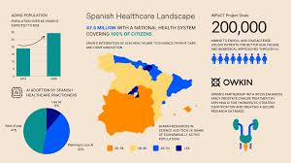
Figure 3: Spanish healthcare
(Source: WHO, 2023)
In spite of its merits of accessibility, decentralisation has traditionally driven health governance fragmentation through regional gaps in infrastructure and human resources (Ribeiro et al., 2018). Before the pandemic, Spain faced challenges in facilitating health data integration between each of the regions, hence making it challenging to conduct monitoring nationally and to organise the response.

2.1.2 Decentralisation of the Healthcare System in Spain
Decentralisation worked as both a strength and a weakness during COVID-19. Legido-Quigley et al. (2020) recorded the report that the regional governments were innovative and flexible; however, the lack of coordinated action slowed down the initial containment efforts. Nationwide guidelines were initially given by the Ministry of Health and allowed regions to apply and interpret the policies independently, which led to unequal lockdowns and testing policies.
The decentralised model allowed some of the regions, including Catalonia and Madrid, to put localised testing and surveillance systems into place in a relatively short period of time, but they could not interoperate with the national data infrastructure (García-Basteiro et al., 2020). Shishkin et al. explain that decentralisation has the potential to enhance local responsiveness and hinder national integration in times of crisis requiring unified and rapid response (Shishkin et al., 2025).

2.1.3 Response Measures Taken during the Pandemic in Spain
The early reaction of Spain in early 2020 was more reactive than proactive because of the absence of a national early warning system. In March 2020, the government declared a state of emergency in the country, temporarily re-centralising some of the powers to simplify coordination (Lopez-Casasnovas and Pifarré i Arolas, 2021). Still, national and regional powers remained in conflict, which weakened integrity.
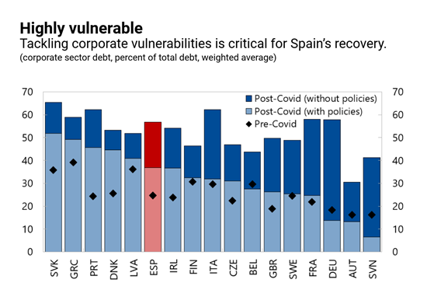
Figure 4: Spanish Covid-19
(Source: WHO, 2023)
The leadership style was indicative of situational and adaptive leadership styles. Regional leaders kept the interventions that fitted their own situation, and national leaders were able to adopt communication and policy based on the changes in data, and this proves the adaptive framework as explained by Sott and Bender (2025). In spite of such adaptations, there was a poor inter-regional communication and a lack of uniform data sharing that undermined the national decision-making (Gao and Yu, 2020).
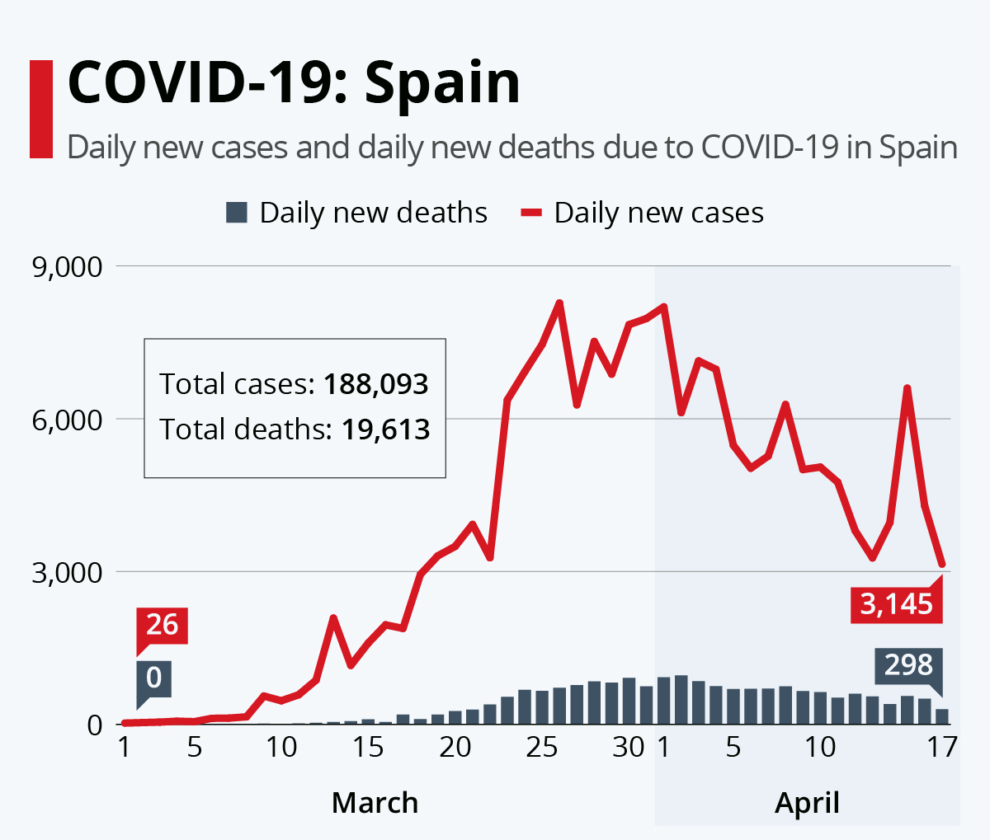
Figure 5: Spanish Covid-19
(Source: WHO, 2023)
More importantly, the Spanish reaction indicated the trade-off between crisis centralisation and decentralised autonomy. Although decentralisation encourages democratic action and ownership by the regions, it may slow down a cohesive way of managing the crisis, where quick coordination is vital. However, the proper vaccine rollout in Spain, organised by the European Union, served as an example of enhanced leadership and cooperation in the country, which highlighted the dynamic nature of leadership practices (Haldane et al., 2021).

2.2 Centralised Healthcare Structure and Approaches in South Korea during COVID-19

2.2.1 Background of the Healthcare System in South Korea
The healthcare system of South Korea operates under a highly centralised model spearheaded by the Ministry of Health and Welfare and assisted by the Korea Disease Control and Prevention Agency (KDCA). The system is a universal health insurance, combining both the public and the private systems and is highly regulated by the government (WBG, 2025). This centralisation made it easy to allocate resources quickly and enforce policy countrywide in the event of health emergencies.
The focus on the digital health infrastructure and data integration offered an opportunity to base the real-time surveillance and contact tracing (Oh et al., 2020). Yoon, Kwon, and Park (2024) point out that the pre-existing epidemic management system in South Korea, reinforced following the outbreak of MERS in 2015, prepared the nation to respond decisively to the outbreak of COVID-19.
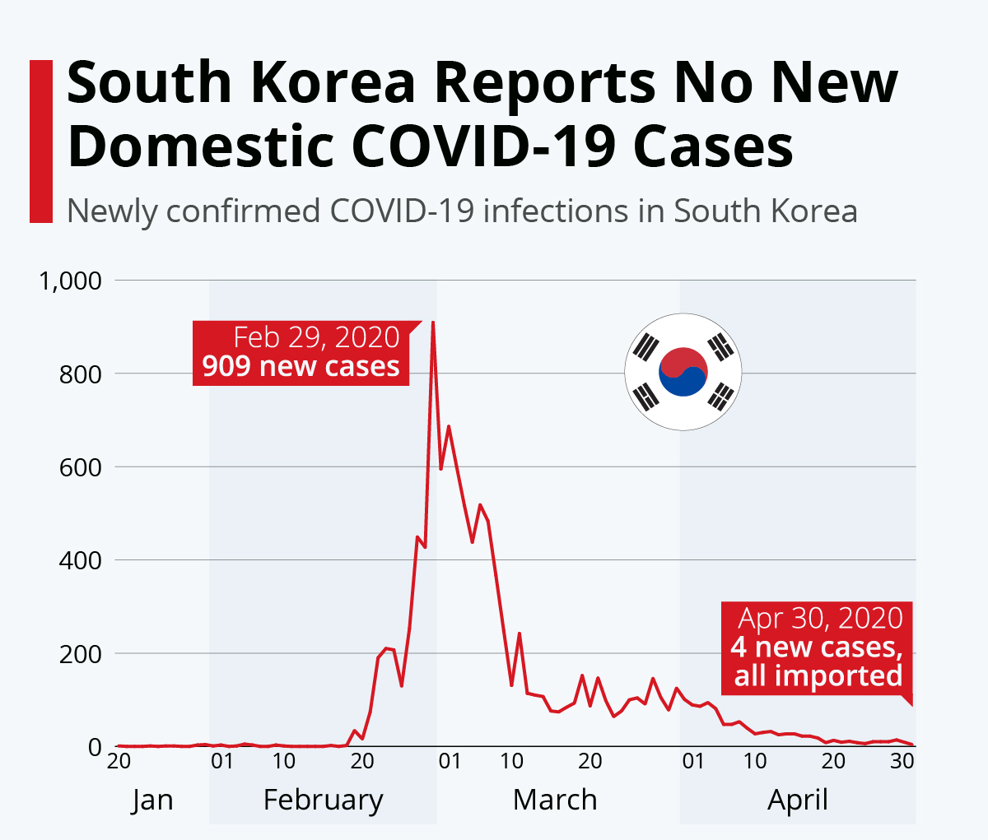
Figure 6: South-Korea Covid-19
(Source: WHO, 2023)
The above figure showcases the implementation of a centralized South Korean healthcare system and coordinated data-driven testing, tracing, and treatment strategy has resulted in an effective containment of COVID-19 as evidenced by the low COVID-19 death rates.

2.2.2 Centralisation and Policy Coordination in South Korea’s Health Administration
The rapid top-down decision-making in South Korea was facilitated by centralisation. The system of a single command organised the government in terms of testing, distribution of resources in hospitals, and information spreading (You, 2020). The KDCA was central in the national uniformity, and the local governments were run by the central guidance.
This model also has elements of authoritarian leadership, with its hierarchy in decision-making and high compliments (Duan et al., 2018). However, it incorporated reactive elements; policy changes were dependent on the feedback on epidemiology, which was also the characteristic of the hybrid leadership in crisis (Bhat and Saba, 2025). To give an example, the policy on testing was constantly adjusted according to the statistics of infections, and the system of digital tracing rapidly expanded (Littlecott et al., 2023).

2.2.3 Response Measures Taken during the Pandemic in South Korea
The reaction of South Korea was defined by active contention and mass testing as well as open communication. In February 2020, the drive-through testing hubs and digital tracking applications became available in the country, preventing mass lockdowns (Oh et al., 2020). There was centralisation of the public communication, which maintained uniformity of the message that increased trust and compliance.
The leadership model was situational, having a balanced approach to strict control and open interactions. Aslam et al. (2022) suggest that situational leadership, which is flexing the style according to circumstances, was instrumental to continuing motivation and compliance of healthcare workers and the population. Transformational leadership was proven through the speed with which the government adjusted and implemented data-driven policies, which provided motivation to act collectively and ensure citizens in the country were confident (Ma and Yang, 2020).

2.3 Hybrid Healthcare Structure and Federalism in Approaches in Canada during COVID-19

2.3.1 Evaluation of the Healthcare System in Canada
The healthcare system of Canada, officially called Medicare, is a publicly funded and universally available system with a decentralised federal system. The system is implemented in the form of a shared responsibility between federal and provincial governments (Martin et al., 2018). Even though financial resources are provided by the federal government through the Canada Health Transfer and the setting of national principles under the Canada Health Act, most health services are left to be planned, financed, and provided by the provinces. This federal-provincial structure gives flexibility in the implementation of policies but also creates interprovincial differences in service delivery (Marchildon et al., 2021).
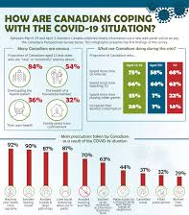
Figure 7: Canadian situation
(Source: Marchildon et al., 2021)
The Canadian health system architecture is often described as a model of a federated universal system, where the universal access to necessary healthcare is to be accompanied by the diversity of jurisdiction. This kind of structure promotes regional independence but may hinder the achievement of national coherence in emergencies across the country, like the COVID-19 pandemic (Gluck and Huberfeld, 2018). As an example, despite the federal government setting a single public health direction and border control, provinces decided in isolation as to when a lockdown, school closure, and vaccination strategies could be implemented. This organisational disintegration manifested itself in initial pandemic processes when the coordination between the provinces was slow, and the health results varied (Detsky and Bogoch, 2020).

2.3.2 Universal and Hybrid Structure of the Healthcare System in Canada
The health system in Canada is a hybrid between the provision of health services and financing. The public plan also provides medically necessary services to everyone; however, a significant portion of healthcare, including dental care, prescriptive medication, and long-term care, is privately funded (Martin et al., 2018). Nevertheless, the availability of non-core services through privatisation created inequality, like in the sphere of elder care and access to mental health services (Cote et al., 2020).
In addition, the hybrid framework also affected pandemic-response coordination. Although Canada has preserved strong acute-care capacity by means of its state-run hospitals, the disjointed configuration of long-term care homes, many of which are privately run, turned out to be a key point of failure. As of the early 2020s, more than 80 per cent of COVID-19 deaths could be linked to long-term care homes (Dosa et al., 2020). Systems thinking scholars believe that this complexity requires integrated governance strategies to bring provincial systems together in a learning network instead of letting them operate as autonomous systems (Khalil and Lakhani, 2022).
Simultaneously, the flexibility of the hybrid system was also interesting. British Columbia and Ontario were the provinces that introduced digital health solutions and increased telemedicine in times of lockdowns, and used the agility of the private technology sector and the state health requirements (Reay et al., 2021).

2.3.3 Federal and Provincial Response Initiatives during the COVID-19 Outbreak
The response to the pandemic in Canada was based on federalism, a national policy with local jurisdiction. International border closures, emergency income supports, and vaccine procurement were coordinated by the federal government, whereas the local containment measures and health care capacity were organised by provinces (GOC, 2025). The PHAC has led the scientific communication and coordination across different governments; however, initial issues in the testing capacity and data integration demonstrated the fragmentation of the system (Decoteau and Garrett, 2022).
With the development of the pandemic, adaptive responses were developed in the provinces. Initially, the most affected provinces, Ontario and Quebec, created regional task forces to organise contact tracing, intensive-capacity, and vaccination efforts (Detsky and Bogoch, 2020). The interdependence that is needed in federal health governance was achieved by means of federal-provincial collaboration, including the Special Advisory Committee on COVID-19 (Marchildon et al., 2021).
Canada has been experiencing a slow introduction of vaccination, but this has since improved as the supply chains stabilised. As of the middle of 2022, over 83 per cent of eligible Canadians have been fully vaccinated, which is a sign of federal procurement capacity and provincial effectiveness in local allocation (Wagner et al., 2022).
Conclusively, the hybrid model of federalism in Canada provided a degree of flexibility and creativity, but revealed coordination problems at the initial stages of the pandemic. Crisis highlighted the need to have a systems-thinking approach that balances autonomy and single crisis management to strengthen national resilience to health (Rusoja et al., 2018).

2.4 Comparative Analysis of Health Care Systems

2.4.1 Critical Analysis of Centralisation vs. Decentralisation in Health Systems in Canada, South Korea and Spain
The degree of centralisation in the national health systems is a primary determinant of crisis responsiveness. The national health system in Spain was very centralised and made mobilisation of resources quick, and at the same time, it limited the flexibility of the region. A single authority with national lockdowns and health directives organised by the Spanish Ministry of Health is an example of a coherent policy (Legido-Quigley et al., 2020). However, the flexibility at the regional level was also restricted by this model, which led to delays in the customisation of interventions to the local outbreaks (Lopez-Casasnovas and Pifarre i Arolas, 2021).
South Korea, on the other hand, has a semi-centralised paradigm of combining a central command and local discretion in operations. The Korea Disease Control and Prevention Agency (KDCA) established standardised testing, tracing, and isolation procedures and allowed the municipalities to customise the implementation to local requirements (Oh et al., 2020). This central coordination with local flexibility was crucial to the success of South Korea in controlling transmission without lockdowns at the national level (You, 2020).
The federal-decentralised system in Canada, which has been mentioned above, focused on provincial sovereignty. Although this agency encouraged innovation and policy diversity, it postponed the implementation of the unified national policies in the initial crisis phases (Detsky and Bogoch, 2020). Pressure on the coordination of transnational processes is often observed in the case of decentralised systems, but these abide by the concept of resilience because of distributed decision-making and localised adaptation (Abimbola et al., 2019). Most importantly, Shishkin et al. (2025) came to the conclusion that centralisation improves structural control in times of crisis but may inhibit system learning and stakeholder involvement, but that decentralisation, in its turn, encourages responsiveness to context but leads to fragmented implementation.

2.4.2 Influence of Health System Design on Pandemic Preparedness and Response Outcomes
The management of main aspects of the pandemic, including surveillance, communication, and equity, was directly related to the organisational structure of each country. The well-developed system of public health and digitalisation of South Korea allowed for the swift tracking of cases and the adherence of the population (Littlecott et al., 2023). The disjointed system in Canada brought about unequal results, with provinces such as Alberta doing better in the effectiveness of the vaccination rollout, and provinces such as Ontario having frequent outbreaks in long-term care institutions (Dosa et al., 2020). The complexity of hybrid systems also requires ongoing learning and horizontal coordination processes, which agrees with the clinical microsystems theory, which focuses on the local units' integration into system-wide improvements (Cote et al., 2020).
Systems-thinking The pandemic has shown that resilience is not only created due to centralisation but also with interconnectedness and feedback between and within governance levels (Witter et al., 2023). The experience of Canada demonstrated the merits of multi-level governance, but the example of South Korea demonstrated the effectiveness of centralised communication that is based on data.

3. Evaluating Leadership Approaches during the COVID-19 Pandemic in Spain, South Korea, and Canada

3.1 Democratic Leadership Style in Spain: Minister of Health, Salvador Illa 250

3.1.1 Early Government Response and Criticism
The democratic values of teamwork and inclusivity defined the leadership of COVID-19 in Spain, and was led by the Minister of Health, Salvador Illa, whose actions coordinated the actions of the other ministers via open communication and consultation. Democratic leadership during crises can encourage the decision-making process together and collective responsibility over the results (Virella, 2023). This is the strategy that Illa followed by involving local health officials, WHO recommendations, and civil society professionals in the planning of the restrictions in public health. This inclusiveness was to promote civil trust and legitimacy, and it fits the equity-oriented crisis leadership model, which is concerned with fairness and responsibility (Virella, 2023).
Nevertheless, the government of Spain received a lot of criticism in the first months due to lockdown delays and mixed messages (Garcia-Basteiro et al., 2020). The Democratic focus on consensus-making slowed down the process of decision-making when decisive action was required. According to the observations of Legido-Quigley et al. (2020), regional independence in Spain made coordination difficult, resulting in disparities in the spread of infection-control results in autonomous communities. The inclusiveness and decisiveness balance proved to be one of the greatest challenges to effective democratic leadership in crises affecting their nation.

3.1.2 Advantages and Challenges in Democratic Leadership
Nevertheless, Illa demonstrated the power of democratic leadership to enhance the resilience of the government and adaptability to change in the long run. Through a wider range of stakeholders, Spain might improve its policies through an iterative process as science develops (WHO, 2023). The model promoted moral accountability and active engagement, and these factors enhanced compliance in subsequent phases. However, in times of high uncertainty, where urgent decision-making and directive actions are needed, democratic leadership may falter (Stewart et al., 2023). The case of Spain had demonstrated how highly consultative decisions can make processes less efficient in emergencies. However, this style was in line with the ones that the WHO gives more attention to the concept of participatory governance to enable Spain to regain institutional credibility during the recovery phase (WHO, 2023).

3.2 Authoritative Leadership Style in South Korea: Prime Minister Chung Sye-kyun

3.2.1 Government-Led Response and Successes
An example of an authoritarian leadership paradigm in the case of the COVID-19 response in South Korea under Prime Minister Chung Sye-kyun is that centralised decision-making was implemented within a strictly hierarchical system. Authoritative leadership, based on harsh control and hierarchical coordination, can bring effective results in the case of a crisis (Patapan, 2022). In that regard, the South Korean government promptly implemented the national emergency measures, enforced the use of technologies in the process of contact tracing, and deployed the real-time testing infrastructure (Oh et al., 2020). These actions depicted a successful top-down government whereby compliance was incorporated by legal penalties and social responsibility models (WBG, 2025).

3.2.2 Advantages and Challenges in Authoritative Leadership
The authoritative model helped quickly mobilise resources and provided uniformity in the nationwide communication. As Duan et al. (2018) argue, authoritarian or dictatorial leadership may help to avoid the so-called decision paralysis in case of an emergency, resulting in transparency and quick implementation. The exploitation of this advantage was demonstrated by the suppression of early outbreaks of infection in South Korea (Yoon et al., 2024).
Furthermore, an authoritative leadership can promote popular exhaustion or opposition in the long term when citizens believe that it oversteps its limits or fails to consult with the citizens (Patapan, 2022). Therefore, it will be effective in containing the crisis in the immediate situation, but it is not as sustainable in a long-term health crisis when society is required to adapt and innovate.

3.3 Transformational Leadership Style in Canada: Prime Minister Justin Trudeau

3.3.1 Decentralised Response Structure and Challenges
The leadership of Canada, led by Prime Minister Justin Trudeau, was transformational in nature, with a focus on empathy, unity and motivation based on values. Transformational leadership is characterised by the ability to motivate shared cause and adjust to the changing and challenging situations (Kwan, 2020). The government of Trudeau supported the cooperation of the federal and provincial governments in the context of hybrid healthcare in Canada (Martin et al., 2018).
However, the decentralisation also resulted in coordination issues since the provinces operated autonomously regarding lockdowns and vaccination programs (Detsky and Bogoch, 2020). Yucel (2021) believes that transformational leaders might not be able to ensure uniformity in distributed authority systems. Nevertheless, the style of Trudeau managed to establish inclusiveness and empathy, which essentially is a psychosocial buffer that needs to be critical in protecting citizens facing isolation and uncertainty (Kaul et al., 2020). His understanding tone was based on the principles of adaptive leadership, where well-being is the central value, as well as the economic balance (Sott and Bender, 2025).

3.3.2 Key Features, Benefits, and Drawbacks of Transformational Leadership
The leadership qualities of Trudeau were classic transformational ones, which included visionary communication, empowerment, and moral stewardship (Ma and Yang, 2020). His emphasis on scientific leadership and open communication with the citizens was in line with international best practices. The fiscal interventions made by the government, including the Canada Emergency Response Benefit (CERB), addressed the needs of citizens and made them believe in the government institutions (GOC, 2025). Nonetheless, the use of consensus and inspiration of transformational leadership can be limited in situations where the epidemiology data changes very quickly. Kwan (2020) warns that excessive focus on vision can become so blurred in terms of operations. The ability to inspire and bring together a multicultural population to the adaptive recovery was central to the success of Trudeau, and the divided provincial execution revealed the boundaries of change without a systemic tie.

3.4 Comparative Analysis of Leadership Styles in Canada, South Korea and Spain

3.4.1 Critical Analysis of Leadership Styles
Leadership responses have been compared, showing that the effectiveness is not as much in the theoretical form of style but rather in the practical nature of the style. The democratic practice in Spain was highly inclusive but poorly executed, and the authoritative model in South Korea was successful at keeping the situation in check due to strict control (You, 2020).
The transformational leadership in Canada fostered the confidence and the emotional strength of people and faced the problem of inconsistency of policies even on provincial levels (Detsky and Bogoch, 2020). According to Aslam et al. (2022), crisis performance is determined by situational adaptability, which is not fixed archetypes. A combination of democratic consultation, decisive authority and transformational empathy was more resilient.
An example is that the strict instructions of South Korea were supplemented by open communication, which is also a characteristic of transformational leaders (Crippen, 2023). Likewise, a later recovery of Spain was advantageous due to the introduction of a stronger central command to support its democratic spirit (Legido-Quigley et al., 2020). This interaction fulfils the hypothesis of Bhat and Saba (2025) that response-recovery leadership is a dynamically changing concept that changes with the progression of a crisis.

3.4.2 Effectiveness of the Leadership Styles and Decision-Making Processes
The three countries were influenced by the fit between leadership style and institutional capacity to achieve effectiveness. Big power leadership worked as bureaucratic and technological structures were strong, such as in South Korea (Oh et al., 2020). The democratic leadership was useful in the long-term legitimacy and equity, such as in the recovery period in Spain (WHO, 2023). An example of transformational leadership is Canada, which developed trust and compliance among citizens in times of uncertainty, reducing the effect of social fragmentation (Kaul et al., 2020). It was the most effective crisis leaders who combined several styles using adaptive learning (Rachmad, 2022). Spain was shifting to a hybrid approach of centralisation and community engagement; South Korea was averting its control by being transparent, and Canada reinforced the coordination between the governments.
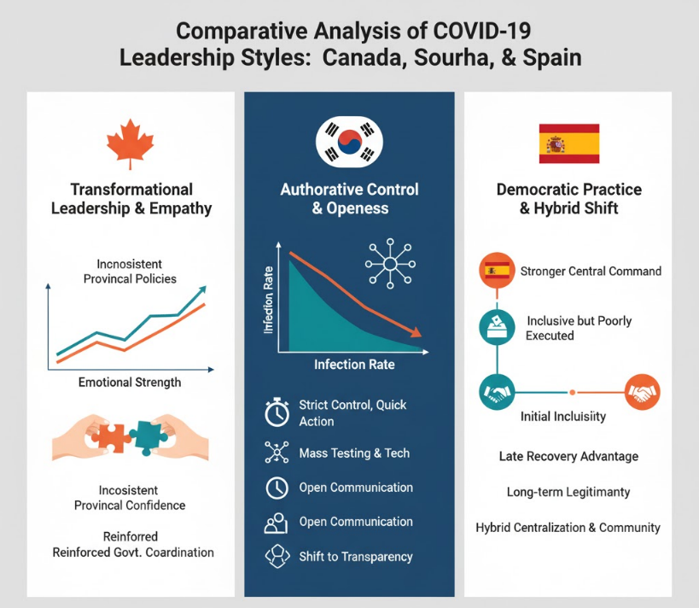
Figure 8: Comparative analysis
(Source: Author)

3.5 Impact of Leadership on Health Outcomes

3.5.1 Analysis of COVID-19 Outcomes across the selected nations
The performance of the country on the COVID-19 pandemic in Spain, South Korea, and Canada depicts how a leadership style determined their health outcomes. In Spain, led by Minister of Health Salvador Illa, there was a democratic leadership style that focused on inclusivity and consultation but was characterised by slow reaction and policy inconsistency (Legido-Quigley and others, 2020). Early in 2020, Spain recorded some of the largest rates of infection and mortality in Europe, which scholars attribute to the lack of coordinated health governance and decentralised decision-making (Lopez-Casasnovas and Pifarre i Arolas, 2021).
The leadership in reaction to Canada, through Prime Minister Justin Trudeau, was characterised by a transformational and federal leadership model. The autonomy of the provinces in health management was provided, which led to different results in different jurisdictions (Martin et al., 2018). Early communication, welfare and vaccination diplomacy helped to build up the trust of the population, but the inability to provide long-term care protection and logistics of vaccinations at the early stages generated initial weaknesses (GOC, 2025).

3.5.2 Relationship between Leadership Effectiveness and Health System Performance
The quality of leadership also had a direct impact on the resilience of health systems and the ability to adapt in every country. The democratic strategy of Spain was the strategy of collaboration, but it did not have the decisive force needed during an emergency. Legido-Quigley et al. (2020) cite the problem of missing the rapid command integration as an undermining factor of the national response. Spanish leadership was characterised by participatory leadership as opposed to crisis agility, restraining the coordination of hospitals and slowing down testing strategies.
In South Korea, the authoritative leadership proved that central control might be effective in establishing crisis governance in the country when combined with transparency and citizen participation (Gao and Yu, 2020). The real-time data analytics, speed of decision-making, and enforcement mechanisms used by the government improved the level of trust and compliance. The World Bank Group (2025) emphasised that the authoritative style may be suitable in cases of such strong ethical and communicative structures as democratic accountability.
Empathy, innovation, and resilience of the communities of Canada were promoted by transformational leadership (Ma et al., 2021). The focus on solidarity and cooperation by the federation, as articulated by Trudeau, served to maintain morale and social life. But, decentralised administration hampered quick national coordination, which reflected the drawbacks of federalism during crises (Abimbola et al., 2019). According to Reay et al. (2021), adaptive intergovernmental collaboration is a determinant of health outcomes in federations, and Canada partially did it by providing transparent and open communication with the public and enhancing the idea of supporting scientific leadership.

3.5.3 Key insights from Each Country’s Approach
The most important lesson brought by Spain is that democratic leaders must have supportive crisis systems in place, i.e., quick decision-making systems and coherent command systems must be in place to respond in time (Garcia-Basteiro et al., 2020). The experience of South Korea can be used to demonstrate that strong coordination with the principles of adaptive leadership, which include flexibility, transparency, and the ability to learn through data, is beneficial (Bhat and Saba, 2025). The situation in Canada proves that transformational leadership leads to trust and resilience, yet needs effective integration of structures among decentralised health networks that will provide a consistent result (Marchildon et al., 2021).
Altogether, the critical aspect of successful leadership in times of crisis is not only the governance structure but also adaptive capacity, which consists of the capacity to combine information, align stakeholders, and convey messages appropriately in the environment of uncertainty Crippen, 2023).

4. Discussion

4.1 Synthesis of Key Findings from the Health System, Organisational Leadership Analysis
Comparative evaluation of Spain, South Korea, and Canada proves that the leadership style has had a significant impact on the governance and subsequent outcomes of the pandemic. In Spain, the leadership style was democratic, but it encouraged inclusivity, which hindered the establishment of any serious coordination because of the decentralised structures (Legido-Quigley et al., 2020). Unlike that, the authoritative governance of South Korea emphasised the excellence of early intervention and centralised command systems, especially through the support of technological surveillance and mass testing (Oh et al., 2020; You et al., 2020). Transformational leadership in Canada provided efficient communication and moral direction but revealed weaknesses in the institutions, which is a disintegrated federal system (Detsky and Bogoch, 2020).
In a variety of situations, leaders who embraced adaptive leadership ideals of striking an equilibrium between control, transparency, and flexibility attained greater resilience and continued popularity (Sott and Bender, 2025). Therefore, crisis leadership requires structural power and emotional intelligence to energise obedience and stimulate creativity.

4.2 Reflection on the significance of Adaptive Leadership in Health Crisis
Adaptive leadership cannot be avoided in complicated, uncertain circumstances like pandemics. It equips leaders to combine changing scientific facts, bring together the parties, and maintain society's trust (Virella, 2023). The case of South Korea is of a merger of an authoritarian framework and flexibility of responsiveness, which produces operational efficiency without loss of transparency. The leadership in Canada was characterised by the values of adaptability, i.e. communication, empathy, and policy learning, but was limited by institutional fragmentation. On the other hand, the dependence of Spain on deliberation processes delayed decisive steps, which depicts that democratic systems should include adaptive mechanisms of responding quickly (Haldane et al., 2021).
As put forward by Aslam et al. (2022), crisis resilience requires situational leadership that changes dynamically to emergent situations (Francisco and Nuqui, 2020). Ethical decision-making and emphasis on equity, where vulnerable populations are not marginalised, are also part of adaptive leadership (Virella, 2023).

4.3 Key Recommendations for Improving Health System Resilience
The adaptive leadership and the institutional agility should be combined within the framework of future crises to develop resilience.
- Integrated Governance: Decentralised governments (e.g. Spain and Canada) ought to have common centres of crisis command that maintain regional feedback whilst imposing consistency in policy (Reay et al., 2021).
- Evidence-Based Decision Making: Governments should institutionalise real-time data systems that can be used to guide responsive policy formulation (Gao and Yu, 2020).
- Public Communication and Trust: Long-term compliance and cooperation of the population are developed through clear and regular communication (Wang et al., 2020).
- Adaptive Competencies Training: Adaptability, emotional intelligence, and systems thinking should be the focus of leadership development programmes (Rusoja et al., 2018; Khalil and Lakhani, 2022).
The governments can establish long-term leadership in case of future global health crises by integrating these adaptive strategies.

5. Conclusion
The comparative analysis of Spain, South Korea and Canada highlights the fact that the leadership style was a critical determinant of the effectiveness of the health systems in the face of COVID-19. Although Spain had a democratic rule with participation encouraged, it was not decisive enough to contain the situation in a short time. The dictatorial yet flexible leadership of South Korea brought impressive success due to the rapid actions, the technology adoption and open communication. The Canadian transformational and empathetic approach strengthened the social cohesion and, however, faced operational problems that were caused by decentralisation. The strongest framework of crisis in the future is adaptive leadership that is based on ethical leadership and systemic learning. To this end, the governments should invest in leadership development, real-time communication systems, and effective governance systems to enhance resilience and deliver fair health outcomes during future pandemics.

References
Abimbola, S., Baatiema, L. and Bigdeli, M., 2019. The impacts of decentralization on health system equity, efficiency and resilience: a realist synthesis of the evidence. Health policy and planning, 34(8), pp.605-617.
Akinyemi, O.O., Popoola, O.A., Fowotade, A., Adekanmbi, O., Cadmus, E.O. and Adebayo, A., 2021. Qualitative exploration of health system response to COVID-19 pandemic applying the WHO health systems framework: Case study of a Nigerian state. Scientific African, 13, p.e00945.
Aslam, S., Saleem, A., Kumar, T. and Parveen, K., 2022. New normal: Emergence of situational leadership during COVID-19 and its impact on work motivation and job satisfaction. Frontiers in Psychology, 13, p.919941.
Bhat, Z.H. and Saba, N., 2025. Navigating turbulence: leadership evolution in crisis management through response–recovery frameworks. International Journal of Organizational Analysis.
Chang, A.E., 2020. WHO’s Response to the COVID-19 Pandemic: Assessment and Recommendations. National council for science and the environment.
Côté, A., Beogo, I., Abasse, K.S., Laberge, M., Dogba, M.J. and Dallaire, C., 2020. The clinical microsystems approach: Does it really work? A systematic review of organizational theories of health care practices. Journal of the American Pharmacists Association, 60(6), pp.e388-e410.
Crippen, S.A., 2023. Adaptive leadership and crisis management.
Decoteau, C.L. and Garrett, C.L., 2022. Disease surveillance infrastructure and the economisation of public health. Sociology of Health & Illness, 44(8), pp.1251-1269.
Detsky, A.S. and Bogoch, I.I., 2020. COVID-19 in Canada: experience and response. Jama, 324(8), pp.743-744.
Detsky, A.S. and Bogoch, I.I., 2020. COVID-19 in Canada: experience and response. Jama, 324(8), pp.743-744.
Dosa, D., Jump, R.L., LaPlante, K. and Gravenstein, S., 2020. Long-term care facilities and the coronavirus epidemic: practical guidelines for a population at highest risk. Journal of the American Medical Directors Association, 21(5), pp.569-571.
Duan, J., Bao, C., Huang, C. and Brinsfield, C.T., 2018. Authoritarian leadership and employee silence in China. Journal of Management & Organization, 24(1), pp.62-80.
Francisco, C.D. and Nuqui, A.V., 2020. Emergence of a Situational Leadership during COVID-19 Pandemic Called New Normal Leadership. Online Submission, 4(10), pp.15-19.
Gao, X. and Yu, J., 2020. Public governance mechanism in the prevention and control of the COVID-19: information, decision-making and execution. Journal of Chinese Governance, 5(2), pp.178-197.
García-Basteiro, A., Alvarez-Dardet, C., Arenas, A., Bengoa, R., Borrell, C., Del Val, M., Franco, M., Gea-Sánchez, M., Otero, J.J.G., Valcárcel, B.G.L. and Hernández, I., 2020. The need for an independent evaluation of the COVID-19 response in Spain. The Lancet, 396(10250), pp.529-530.
Gluck, A.R. and Huberfeld, N., 2018. What is federalism in healthcare for?. Stan. L. Rev., 70, p.1689.
GOC, (2025). COVID-19: Canada’s response. Available at: https://www.canada.ca/en/public-health/services/diseases/2019-novel-coronavirus-infection/canadas-reponse.html. [Accessed on: 06.11.2025].
Haldane, V., De Foo, C., Abdalla, S.M., Jung, A.S., Tan, M., Wu, S., Chua, A., Verma, M., Shrestha, P., Singh, S. and Perez, T., 2021. Health systems resilience in managing the COVID-19 pandemic: lessons from 28 countries. Nature medicine, 27(6), pp.964-980.
Kaul, V., Shah, V.H. and El-Serag, H., 2020. Leadership during crisis: lessons and applications from the COVID-19 pandemic. Gastroenterology, 159(3), p.809.
Khalil, H. and Lakhani, A., 2022. Using systems thinking methodologies to address health care complexities and evidence implementation. JBI evidence implementation, 20(1), pp.3-9.
Kwan, P., 2020. Is transformational leadership theory passé? Revisiting the integrative effect of instructional leadership and transformational leadership on student outcomes. Educational administration quarterly, 56(2), pp.321-349.
Legido-Quigley, H., Mateos-García, J.T., Campos, V.R., Gea-Sánchez, M., Muntaner, C. and McKee, M., 2020. The resilience of the Spanish health system against the COVID-19 pandemic. The lancet public health, 5(5), pp.e251-e252.
Littlecott, H., Herd, C., O'Rourke, J., Chaparro, L.T., Keeling, M., James Rubin, G. and Fearon, E., 2023. Effectiveness of testing, contact tracing and isolation interventions among the general population on reducing transmission of SARS-CoV-2: a systematic review. Philosophical Transactions of the Royal Society A, 381(2257), p.20230131.
López-Casasnovas, G. and Pifarré i Arolas, H., 2021. The Spanish health-care system. The Sustainability of Health Care Systems in Europe, pp.189-207.
Ma, M.H. and Yang, Q.S., 2020. How does transformational leadership work on COVID-19? An empirical evidence from China. Journal of Innovative Studies, 1(2).
Marchildon, G.P., Allin, S. and Merkur, S., 2021. Health systems in transition third edition. University of Toronto Press.
Martin, D., Miller, A.P., Quesnel-Vallée, A., Caron, N.R., Vissandjée, B. and Marchildon, G.P., 2018. Canada's universal health-care system: achieving its potential. The Lancet, 391(10131), pp.1718-1735.
Oh, J., Lee, J.K., Schwarz, D., Ratcliffe, H.L., Markuns, J.F. and Hirschhorn, L.R., 2020. National response to COVID-19 in the Republic of Korea and lessons learned for other countries. Health Systems & Reform, 6(1), p.e1753464.
Patapan, H., 2022. The modern manual of authoritarian leadership. Democratization, 29(5), pp.958-973.
Rachmad, Y.E., 2022. Adaptive Leadership Theory. Albacete Cuchillo Publicaciones Internacionales, Edición Especial 2022.
Reay, T., Goodrick, E. and D'Aunno, T., 2021. Health care research and organization theory. Cambridge University Press.
Ribeiro, J.M., Moreira, M.R., Ouverney, A.M., Pinto, L.F. and Silva, C.M.F.P.D., 2018. Federalism and health policy in Brazil: institutional features and regional inequalities. Ciencia & saude coletiva, 23, pp.1777-1789.
Rusoja, E., Haynie, D., Sievers, J., Mustafee, N., Nelson, F., Reynolds, M., Sarriot, E., Swanson, R.C. and Williams, B., 2018. Thinking about complexity in health: a systematic review of the key systems thinking and complexity ideas in health. Journal of evaluation in clinical practice, 24(3), pp.600-606.
Shishkin, S., Sheiman, I., Potapchik, E., Vlassov, V. and Sazhina, S., 2025. The impact of centralization on structural changes in healthcare: when it works. Frontiers in Health Services, 5, p.1484225.
Sott, M.K. and Bender, M.S., 2025. The role of adaptive leadership in times of crisis: A systematic review and conceptual framework. Merits, 5(1), p.2.
Stewart, J.S., Woodley, H. and Hoersting, R., 2023. Leadership During a Pandemic–Comparing the Effectiveness of Empowering and Directive Leadership During Times of Crisis and Uncertainty.
Virella, P.M., 2023. Introducing the pillars of equity-oriented crisis leadership: a conceptual framework. School Leadership & Management, 43(4), pp.390-410.
Wagner, C.E., Saad-Roy, C.M. and Grenfell, B.T., 2022. Modelling vaccination strategies for COVID-19. Nature Reviews Immunology, 22(3), pp.139-141.
Wang, H., Cleary, P.D., Little, J. and Auffray, C., 2020. Communicating in a public health crisis. The Lancet. Digital Health, 2(10), p.e503.
WBG, (2025). WORLD BANK GROUP KOREA OFFICE INNOVATION AND TECHNOLOGY NOTE SERIES. Available at: https://documents1.worldbank.org/curated/en/534981606291035033/pdf/Republic-of-Korea-s-COVID-19-Preparedness-and-Response.pdf. [Accessed on: 06.11.2025].
WHF, (2025). Impact of COVID-19 on Heart Health. Available at: https://world-heart-federation.org/resource/impact-of-covid-19-on-heart-health/. [Accessed on: 06.11.2025].
WHO, (2023). Spain and WHO: longtime partners in the quest for a healthier world. Available at: https://www.who.int/about/funding/contributors/spain. [Accessed on: 06.11.2025].
Witter, S., Thomas, S., Topp, S.M., Barasa, E., Chopra, M., Cobos, D., Blanchet, K., Teddy, G., Atun, R. and Ager, A., 2023. Health system resilience: a critical review and reconceptualisation. The Lancet Global Health, 11(9), pp.e1454-e1458.
Yoon, J.H., Kwon, I.H. and Park, H.W., 2024. The South Korean health-care system in crisis. The Lancet, 403(10444), p.2589.
You, J., 2020. Lessons from South Korea’s Covid-19 policy response. The American Review of Public Administration, 50(6-7), pp.801-808.
Yücel, I., 2021. Transformational leadership and turnover intentions: the mediating role of employee performance during the COVID-19 pandemic. Administrative Sciences, 11(3), p.81.

