Infromation Engineering

Module – ACCB4012 Database Design (The Book Store)
  - Samuel Richards Student Number - 1901717

Table of Contents
Visio Design 2
Database (Book Store) 3
Tables 3
Menus 4
Forms 5
Reports 6
Queries 7
Relationships 8
Add records to tables with SQL 9
Master and Embedded Forms 10
Produce calculation in a report 10
Producing a Report from a Query 11

Visio Design
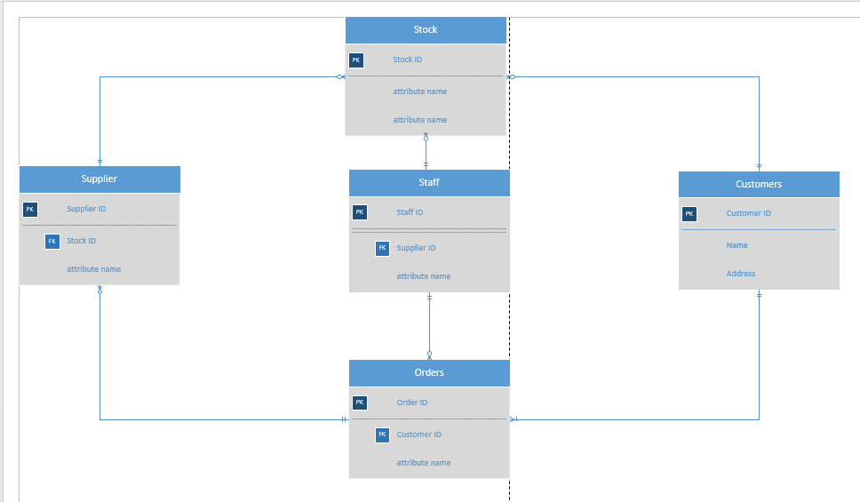
This is my Visio design that I created, as you can see from the image above the design is based off entity relations and was designed to implicate what was asked for from the assignment brief (The book store), did try to keep it as clean as possible to make it easier to read. Tried to keep it simple. The most important topic to have in this image is having all the correct entities, which are “Customer, Staff, Supplier, Orders and Stock”, those 5 are the most important topics throughout a business. The next question is how do they link together? Which is shown in the diagram, the next important part of this image is the relationship links between the entities, as you can see there are many different links between them, for example the link between “Customer and Order” customers can make Many orders, that is why the ending to each line is different. Another important factor about this image is the Primary Keys, these keys are vital to the diagram because they are needed in other areas of the images, for example the customer primary key would be used with the order field, that way you will know that the order is associated with the correct customer, but that primary key will become a foreign key when its used in another filed because it is associated with its original field, it cannot become a primary key elsewhere. Lastly another important factor to take into consideration is when adding fields to the entities, for example “Customer”, companies need to know where they are shipping these orders too in which you need to know the address of the customer, their name and so on. Another one is the “Supplier” they have to keep track of the stock they have, when there is an order made they need to ship the correct stock for the order, in which most companies use unique codes for every stock, that way you cannot get them mixed up with others.

Database (Book Store)
The database had to be built to suit the bookstore meaning it had to have relevant fields to be appropriate to this business and had to be built in a certain form for it to work.

Tables
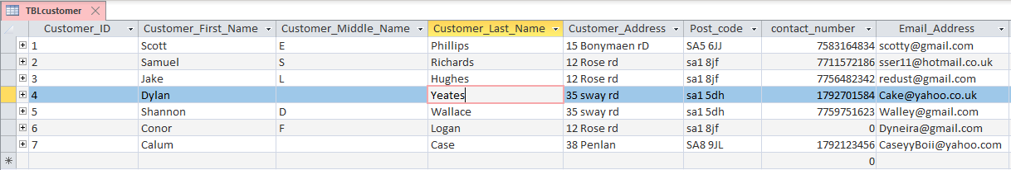
Tables are where the data is kept and held, and would be accessed via the staff when needed to be

This is one of the first Tables that was created, this table oversees keeping relevant data on customers that shop with this business. As you can see the tables holds important information on the customers that the business will need to process orders. The most important field to this table is the “Customer ID”, every customer has their own unique code, in which will save time and confusion. There is no way to mix a customer based on Customer ID no one else would have the same number to others, they are all different. There is other important information based in this tables, for example customer address and contact numbers, which companies need in order to ship stuff to them like there order, in which is essential to ensure that you get all of the correct information

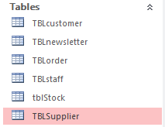
As you can see tables were made for all possibilities, each of them has their own fields made for purpose specifications, and different relevance. Each table has their own primary keys made as well so they can be foreign keys elsewhere, in which will link them together nicely, for example Customers has their own “Customer_ID” and that is currently a foreign key in orders, that is one relationship. Another Primary key which be involved in another table would be the “Stock” table, its primary key is label “ISBN”, which is commonly used for books in the real world and again this primary key would be used on another table such as the “order” table, however it would be called a foreign key on another table.

Menus
Menu’s are the front end of the business; it is where you start off and should have multiple options on where you would like to go throughout the business.
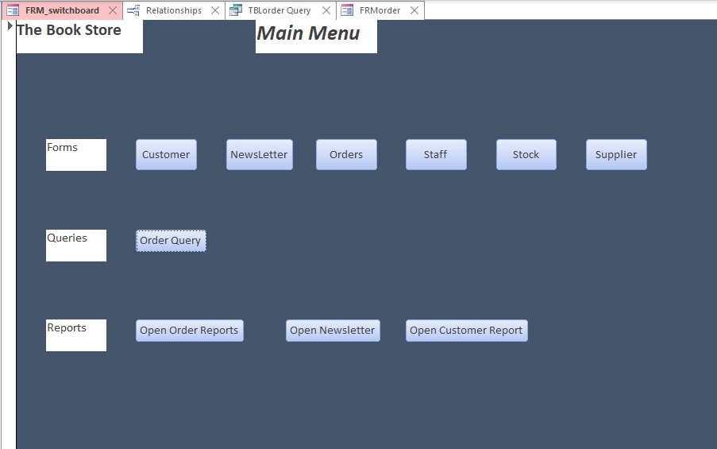

This is the Menu which was created for the database, when ever you open up the database this is the first page you will be directed too. Once you have been directed to this page you have multiple options in which you can go to, for example you can visit any of the tables which is on the first row, you can run a query on orders which is the second row, which are being processed through the company, lastly you can check some reports in which how the business is doing/performing. It is essential to have a functioning menu, because you need to be able to be redirected to the correct areas of the business, it helps the users save time and helps the business flow as it should.

Forms
Forms are created for the interaction, for example in a business people/staff will want to add data into the database, edit the data or even delete some, this is where they would go to do so. It is a much nicer front to the database and easier to look at from a staff members point of view.

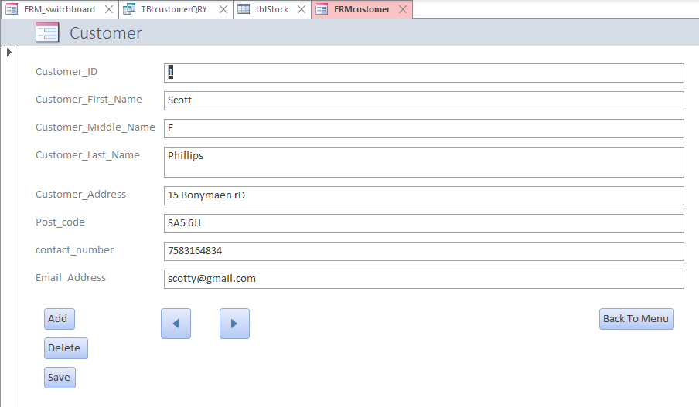

This is a from that has been created for “The Book Store” this form oversees customers that the business will interact with. With this form there is appropriate fields to enter data in about the customer, it is essential to fill out all the correct details on the customer in order to ship the order to the correct person.
There have been buttons added to the form as well, which will help the users navigate through forms to enter the data as well as edited them too. As well has having buttons to give the user the ability to edit the data add news and even use the back button to go back to the menu.

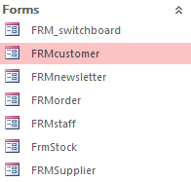
As you can see from the left, there has been multiple forms created for each table. Every one of them has different fields like specified earlier, however every single one of them has buttons added to them for navigation purposes and editing reasons as well, the reason for this is to help make the users life easier to add, change and delete data which isn’t necessary

Reports
Reports are used frequently, because it displays to the user the data that has been entered into the database, it is a very handy to tool to use because it saves time and effort and the database does it for you nice and easily. It is used a lot helps find errors or duplicates which the user can then fix.
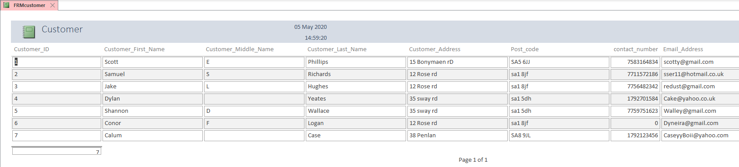

This is the report that has been created for the “The Book Store” this report has been created from the “Customer” table, in which as you can see the report has shown the user all of the data it has on customers, very handy tool because it demonstrates it nicely and neatly.

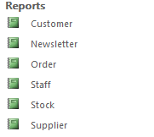
As you can see to the left, this is the list of Reports that have been conducted throughout the database, every report is different because it has been done on each table. Every report has shows different information of which has been entered into the database.

Queries
Queries are used to try and find error within the database such as duplicates, these can be entered twice by mistake, in which will take up space which isn’t necessary. Or possibly find data which is from months ago and that data isn’t needed to be kept anymore, which again would take up space which is needed
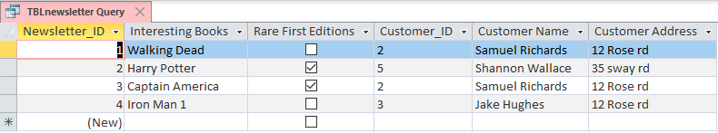

This is a query that was run through the database, originally the query was run to find anything that would flag the database, however the other purpose of the query was find any duplicates of order, or any reoccurring data going through. As you can see there weren’t.

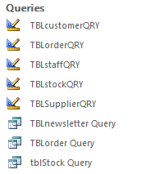
As you can see from the left there has been a few queries conducted through the database, the reason for these is to see if there were any errors within the database. There wasn’t any which flagged meaning all is good, but if there were any in another situation that would mean there were issues which needed attention to fix.

Relationships
Relationships helps combine data from two different tables. A relationship will consist of fields in in two different table which will result in the same data, for example when someone orders something they will have a customer ID number which will be them and on the order they make. A relationship is the only way of connecting two tables together with similar data.
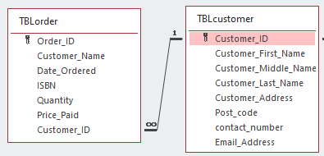
As you can see from the image above this is a kind of relationship that you would have in a database, a customer must have an account to shop with the business and every customer has their own unique code, when an order is processed then the customers ID will be on the receipt which is a new order linking them both together.
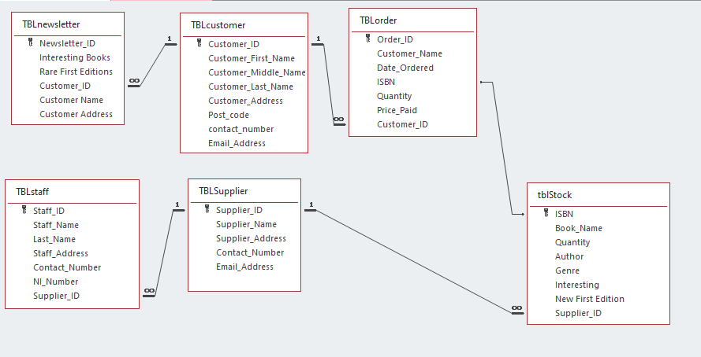

These are tables that were created in the database, in a relationship diagram, as you look at the image you can see the relationships, they have with one another.

Add records to tables with SQL
Adding records to tables using SQL would require entering tome specific code, in which the database will execute the code and would add some data to tables like the code asks it to do.
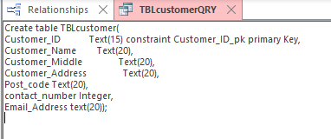

This is an example of records being added to a table using SQL, like previously being stated as you can see from the image, the type of data which is being entered is customer details, and at the start you can see where the table is being created beforehand, where the details be entered into afterwards.
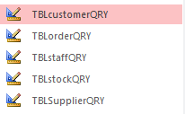
As you can see to the left the image shows that I did this for other tables as well, using SQL to try and add data to the tables like before.

Master and Embedded Forms
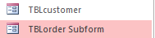
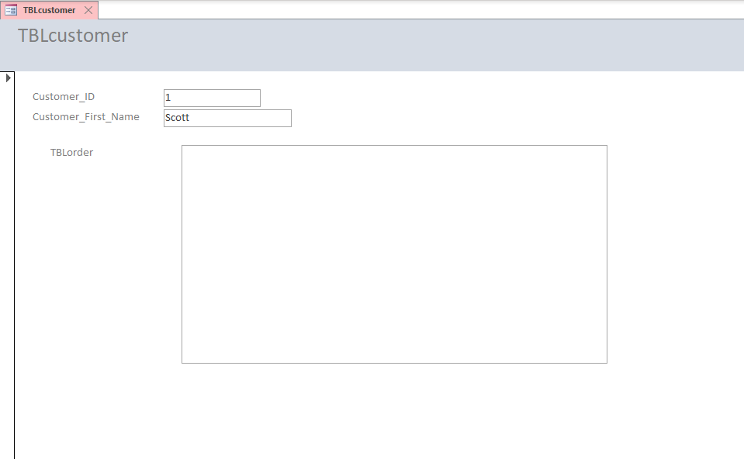

This is my master embedded form, this was meant to look a lot different what it is, unfortunately it did not produce the information it was supposed to, it was meant to display customer ID and the customer’s name and say what they ordered however it did not making it a failure. The user was meant to have the option to go through what everyone ordered, which it did not give the user the ability too.

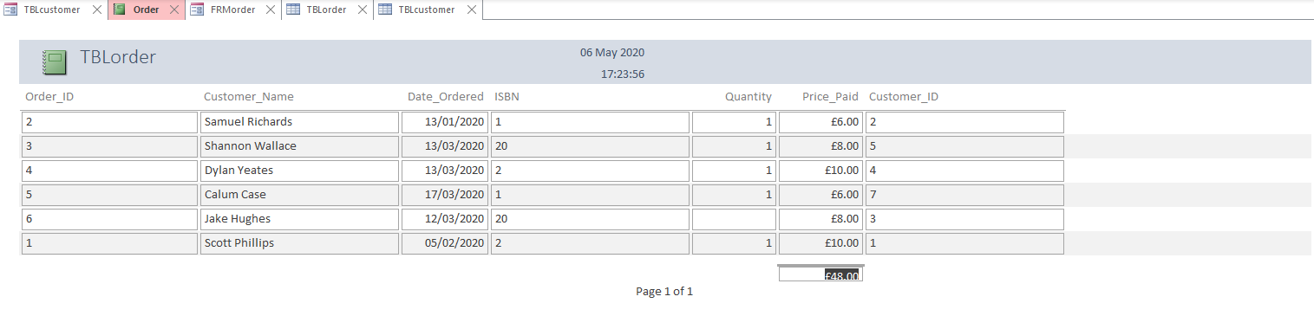
Produce calculation in a report

Producing a calculation in a report is getting a total amount of which was spent, this is a very handy tool to have in any kind of business let alone retail stores especially.
This is the report that was created for the database of “The Book Store” as you can see 4 customers have placed orders within the database which has been processed and completed, but the best thing about this report is that it gives you a total amount of which has been generated for the company. This is a good report to have because it saves the staff members the effort to tally up the amount made by each sale, which was £48.00

Producing a Report from a Query

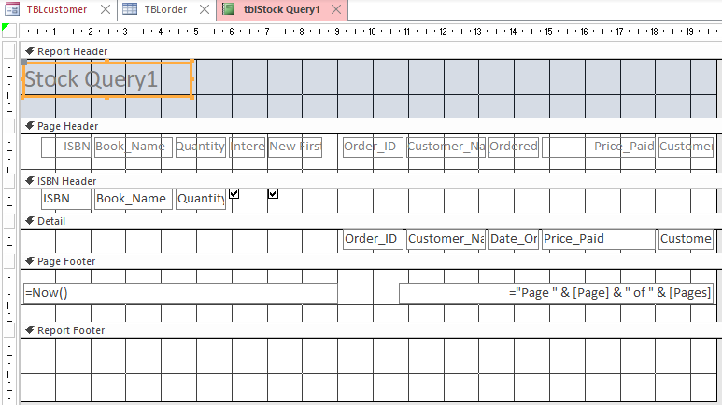
This is what was meant to be a Report based off one of the queries I had which was the “Stock Query” how ever something did not match or, didn’t not function as it should have as you can see from the image above. It was meant to display the query in a nice manner where the user could understand the information which was meant to be presented to them.

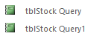
As you can see something didn’t not go down well with the Report Wizard and did not function as it should have.

