ANN NASH ID No 1605605

Digital Skills and Research Methods
Modern Technologies Within the Workplace
Lecturer – Renuga Jayakumar BMSK4003
Word Count 2011
Contents
Introduction 2
Section 1 2
Samsung Galaxy S8 Key Features and design 2
Samsung S8 Software 3
Disadvantages of Samsung S8 3
Section 2 3
Amazon Fire HD 10 Key Features and design 3
Amazon Fire HD 10 Software 4
Disadvantages of Amazon Fire HD 10 4
Using Amazon Fire HD 10 and Samsung S8 In the Workplace 5
Section 3 5
Comparison Table 5
Section 4 6
Yahoo Email 6
Google Mail 6
Section 5 8
Conclusion 10
References 11

Introduction
This report aims to evaluate the effectiveness of the use of modern technologies within the workplace and explore social media as a tool for marketing, information gathering and communication within the workplace. In the course of the report comparisons between Samsung Galaxy S8 and Amazon Fire HD 10 will be discussed and comparisons between Google mail and Yahoo mail will be made.

Section 1

Samsung Galaxy S8 Key Features and design

Tweedie (2015). Since the first Smartphone the ‘Simon Personal Communicator’ produced by IBM the world has moved on to produce more sophisticated and higher tech Smartphone’s such as Samsung Galaxy S8. Titcomb (2017) The Samsung Galaxy S8 stands at 5.8 inch and 6.2 inch. The main feature is its screen, which is called an infinity screen. It has rounded corners curve around the device making the device very attractive to look at. The phone has the option of a long screen which is good for scrolling through social media or watching videos and that of a smaller screen which is called a letter box view with black bars on the side. Due to its slick long screen it feels comfortable to hold and slides easily into a pocket. According to Samsung it is the first to be certified as “Mobile HDR Premium” meaning the display gives brilliant colours. The camera takes good pictures with a superb level of detail and there is a wide range of camera apps options. The home button is contained within the touch screen, it has the feel of a physical button. All the other Android buttons for opening apps are also part of the touch screen. There is the option of the use of the fingerprint scanner (at the back of the phone), iris recognition or facial recognition. Both of the latter are easy to set up. The Samsung S8 has the ability to split-screen which accommodates the ability to multi task. Battery Life on the Samsung S8 is enough to last twenty-four hours. It can be charged via USB or a wireless charging pad.
The Samsung S8 has a headphone jack and has 64GB of storage it also supports MicroSD cards up to 256GB and is water and dust resistant. The cost of the Samsung S8 is £689.

Samsung S8 Software
The interface of Samsung S8 has been improved from the previous version and although it has a number of apps the performance of the phone is exceedingly fast. One particular software feature is Bixby Samsungs integrated artificial intelligence assistant similar to Siri or Google Assistant. The Samsung S8 has a dedicated Bixby button to activate the voice assistant. There is also the Bixby camera which also uses artificial intelligence and when pointed at an image, or landscape for example will tell the user what it is. It will also transcribe or interpret text. The hello Bixby screen also contains news, calendar events, weather and a feed of reminders. The voice control on Bixby is currently unavailable in the United Kingdom and the United States.

Disadvantages of Samsung S8
One drawback of the S8 is it can be hard to reach the top of the tall screen when texting or dialling with one hand and the fingerprint sensor is at the back of the phone next to the camera, which means accidental fingerprints over the lens. The facial recognition can also pose as a security concern.

Section 2

Amazon Fire HD 10 Key Features and design
Gibbs (2018) The Amazon Fire HD 10 made by Amazon in 2017 is a full-size tablet with a speedy performance and a high definition display measuring 10.1 inches. The media viewing for The Amazon Fire HD 10 rivals top end competitors, it has a much improved, higher resolution screen, which displays crisper and brighter colours and it is under half the price of even the cheapest competitor. The viewing angles are good even in the sun. It navigates apps smoothly and can open multiple tabs effortlessly. The battery life will last 10 hours of mixed use. The Amazon Fire HD 10 takes approximately 10 hours charging time. The speakers run along the top edge and are clear and loud for a tablet. The buttons are along another edge together with the micro USB charging port and headphone socket. There is a 64GB version priced at £180 which supports a MicroSD card up to 256GB. The Body of the Amazon Fire HD 10 is plain there are thick bezels around the screen and it has a strong thick plastic shell that curves to meet the glass front. The Amazon Fire HD 10 comes in various colours and is very comfortable to hold.

Amazon Fire HD 10 Software
Alexa is Amazons hands free voice activated intelligent assistant. This software provides the ability to request songs, get news updates, and play games and answer questions amongst other various tasks. To activate Alexa simply say the name and then ask a command. Alexa can be used to search the internet, get a weather forecast, open apps or pause and start a movie. The respond from Alexa is also complemented by visuals from the display screen, an example being a calendar breakdown of plans for a workday. Amazons Fire HD 10 comes with Amazons Newest Fire OS software which allows the home screen interface to fill with sliding screens dedicated to all types of content which works well for a device that consumes a lot of media. It also has an improved ‘For You’ section that was called ‘Recent’ in a previous version. This section highlights the apps and content that has previously been viewed and learns what the user might like so it can make suggestions. There is no access to Google Play Store Apps are limited to Amazon App Store.

Disadvantages of Amazon Fire HD 10
Amazon Fire HD 10 tablet is slow to charge, the camera is not very powerful, the body of the tablet is thick and weighty. It does not have a twenty-four pin USB system for charging and transferring data. The Amazon Fire HD 10 contains an old version of Android and some universally used apps are not available from Amazon App Store.

Using Amazon Fire HD 10 and Samsung S8 In the Workplace
The Amazon Fire HD 10 calls into question what a user wants from a tablet. If the user only wants to watch videos, play games or browse the internet the Amazon Fire HD 10 tablet is ideal. For business use the user can browse the internet, send and receive emails and pictures and use social media but is not optimized for productivity. If the user wants to use the tablet for work, create things or use powerful tools the Amazon Fire HD 10 is not qualified for this. In comparison to the Amazon Fire HD 10 The Samsung S8 can do everything the Amazon Fire HD 10 can do and much more at a faster speed. The Samsung S8 has the ability to go from smartphone to a fully functioning computer using a dock named Dex, making the Samsung S8 ideal for the workplace.

Section 3

Comparison Table
Key specs | Samsung Galaxy S8 Amazon Fire HD 10
Feature
Email |  |  |  |  |  |  |  |  | 
Social media
Camera
Internet
Google Play Store |  |  |  |  |  |  |  |  |  |  |  |  |  |  |  |  |  |  |  |  |  |  |  |  |  |  |  |  | 
Phone calls
Videos
Manage Files |  |  |  |  |  |  |  |  |  |  |  |  |  |  |  |  |  |  |  |  |  |  |  |  |  |  |  |  | Limited
Connectivity |  |  |  |  |  |  |  |  | Wi-Fi, NFC, GPS, Bluetooth |  |  |  |  |  |  |  |  |  |  |  |  |  |  |  |  |  |  |  | Wi-Fi ac, Bluetooth
Weight |  |  |  |  |  |  |  |  | 155g |  |  |  |  |  |  |  |  |  |  |  |  |  |  |  |  |  |  |  | 500g
Price |  |  |  |  |  |  |  |  | £689 |  |  |  |  |  |  |  |  |  |  |  |  |  |  |  |  |  |  |  | £779

Section 4

Yahoo Email
Yahoo email is offered by Yahoo. It can be used with Yahoo Messenger, Flicker and many others. When logging into Yahoo it brings up a lot of information on the welcome page such as news, trending topics and recent updates. Yahoo is convenient to use for work because of its integration of instant messages, social networks, text messaging and emails. When attaching files in Yahoo it can only be done one file at a time.

Google Mail
Google Mail also known as Gmail can be used with Google docs and Youtube. When logging in to Google Mail it goes straight to the mail box and uploading of files with attachments is fast. To boost productivity in Gmail it can be linked to Rapportive. What Rapportive does is show information about the person the user is talking to, for example when the user opens up an email on the side it will show the senders picture, email, where they are, what they do, their Twitter, LinkedIn, Skype profile and if sender and receiver are connected. It will also show if the sender has commented on any videos the receiver has online and the receiver can choose to add the person to their circle or network. Tabs can be utilised to separate mail so the receiver only looks at the mail he wants to. Emails can be scheduled to send automatically and recurring at the senders chosen time and date using the Boomerang for Gmail app. The Boomerang app can be set to notify the sender if the recipient has not opened the email within a set amount of days. The app will notify the sender by sending a reminder email. This application can be useful if the sender wishes to use Boomerang as a sales tool. The labels and folders can be used to direct incoming mail straight into a folder this helps to keep the inbox clear. Forwarding can be set up to automatically forward emails to colleagues or team members, this has to be authorised first by the recipient. Auto advance is a time saver in the workplace, once the recipient receives an email and replies to it they click send and Auto advance moves on to the next email. Canned responses can be used if the sender is sending the same message time and time again. Canned responses save the sender typing the same message over and over. With the exception of Boomerang Google mail users can set all these up in settings or within Google mail.
Comparisons: Google is a big company that owns a lot of sites Yahoo is a smaller company. Google mails spam filter is very powerful. Yahoo offers lesser spam filter. While both have a similar interface Google mail offers POP access and email forwarding free. Yahoo do not offer free of cost POP (Post Office Protocol) access and email forwarding unless subscribed to the paid upgraded Yahoo Plus. Google mail is quicker to log into than Yahoo and quicker to delete spam messages. In Google mail the messages can only be marked as spam once opened. This can be a problem if the recipient is working in an open office an open in inappropriate email. Yahoo mail service started before Google mail service. Google mail has fewer users than Yahoo mail but it is quickly gaining ground. Both are popular emails and both are free. Google mail has some form of security with its encrypted email although it can be superseded. Yahoo offers plugins for Yahoo mail but is not as secure as Google mail.

Section 5

https://twitter.com/Nashville111
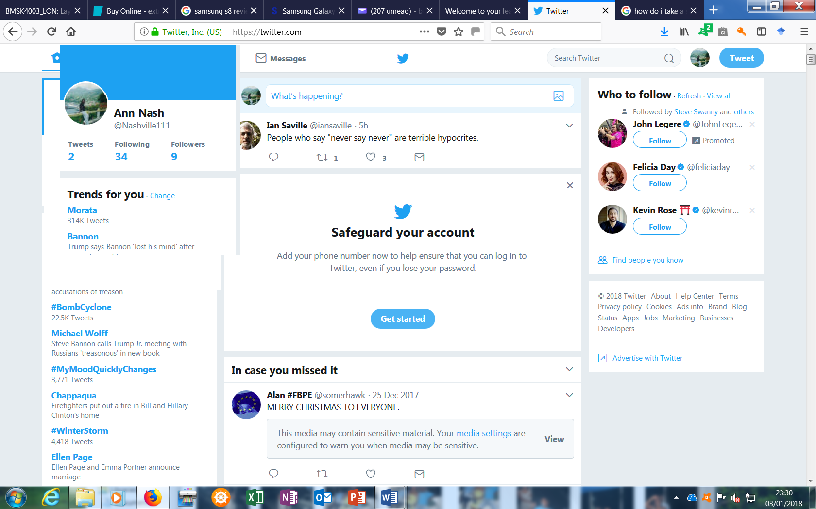

Having a Twitter account in the early days allowed businesses to attract a multitude of people, today things have changed and it is better to reach out to potential customers directly through Twitter. Jackson (2016).

https://www.linkedin.com/

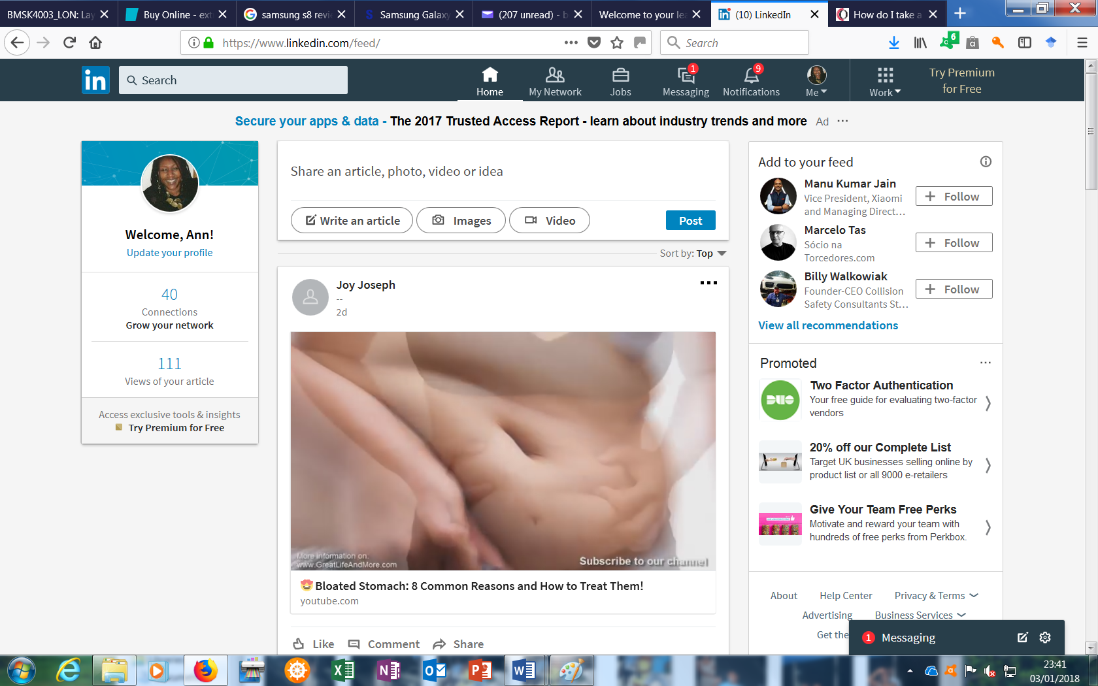

LinkedIn can help with promoting a business by attracting potential consumers, customers, and employees. It can also help jobhunters find their next job or business opportunity by connecting them to the right people Whitney L. (2014)

https://www.facebook.com/Sweet-Feet-1599701936766166/

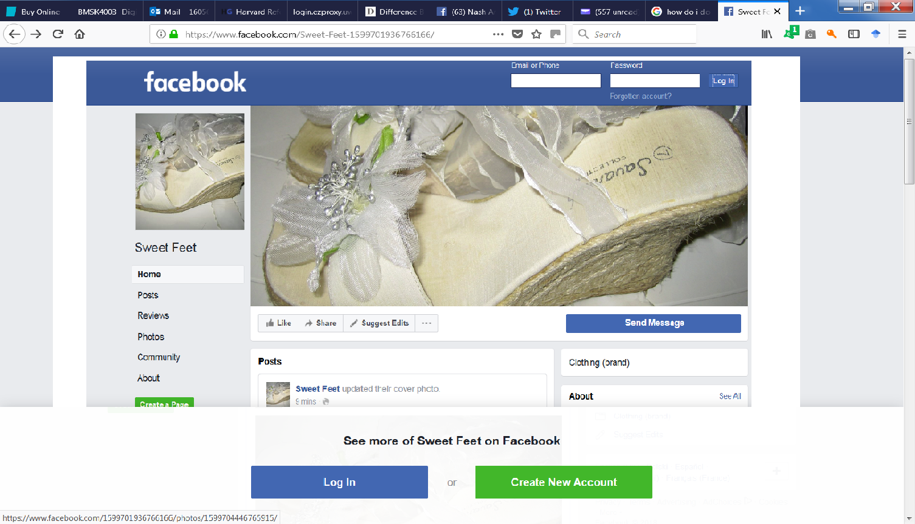
Every month Facebook is visited by 2 billion people who connect with friends and family. Marketing on Facebook helps reach and connects people worldwide to your business.

Conclusion
After comparing Amazons Fire HD 10 and Samsung S8 it was found that Amazon Fire HD 10 is good value for money but limited to how it can benefit the user in the workplace. With the endless variety of applications Google Store provides, my findings are that Samsung S8 is more suitable for the workplace. The Samsung S8 has the ability to split-screen which accommodates the ability to multi task. Alexa is Amazons hands free voice activated intelligent assistant is equal to Samsung S8 Bixby. Both software has the capability to request songs, get news updates, and play games and answer questions amongst other various tasks.

References

Gibbs, S. (2018). Amazon Fire HD 10 review: affordable tablet that's great for Netflix addicts, London: Guardian News and Media Limited .
Jackson, D. (2016). The Ultimate Guide to Twitter for Small Business in 2017. [Online]
Available at: https://sproutsocial.com/insights/twitter-for-small-business/
[Accessed 11 January 2018].
Titcomb, J. (2017). Technology. [Online]
Available at: http://www.telegraph.co.uk/technology/2017/04/18/samsung-galaxy-s8-review-worlds-best-designed-smartphone/
[Accessed 26 December 2017].
Tweedie, S. (2015). The world's first smartphone, Simon, was created 15 years before the iPhone. [Online]
Available at: http://uk.businessinsider.com/worlds-first-smartphone-simon-launched-before-iphone-2015-6
[Accessed 26 December 2017].
Whitney, L. 2014. Teach Yourself Visually LinkedIn The Fast and Easy Way to Learn. Indianapolis Canada: John Wiley & Sons Inc.

