

Student Name: Asma Begum
Student ID: 2503534
Module Name: Strategic Management
Module Code: LCMB7003
Lecturer’s Name : Amare Desta Zulf Khan

Table of Contents
1. Organisational Context and Overview 4
1.1 History, Mission, Vision, and Business Model 4
Figure 1: KFC’s Corporate Profile: History, Mission, Vision, and Franchise Model 4
1.2 Industry Overview, Competitors, and Market Position 5
Figure 2: Market Dynamics and Competitive Positioning in the Fast-Food Chicken Sector 6
2. External and Internal Environment Analysis 7
2.1 PESTEL Analysis: External Environment Impact 7
Figure 3: PESTEL Analysis of KFC’s External Environment 7
2.1.1 Political Factors 8
2.1.2 Economic Factors 8
2.1.3 Sociocultural Factors 8
2.1.4 Technological Factors 9
2.1.5 Environmental Factors 9
2.1.6 Legal Factors 10
2.2 Critical Success Factors and Strategic Challenges 10
2.3 Internal Environment: Resources, Capabilities, and Core Competencies 11
2.4 VRIO Analysis 11
Table 1: VRIO Analysis of KFC’s Strategic Capabilities 11
2.5 Contribution to Competitive Advantage 12
3. CSR and Sustainability Objectives 12
Figure 4: KFC’s CSR and Sustainability Strategy: Key Initiatives and Challenges 13
4. Comprehensive and Holistic View of the Organisation 14
Figure 5: Balanced Scorecard For KFC 14
4.1 Financial Perspective 14
4.2 Customer Perspective 15
4.3 Internal Business Processes Perspective 15
4.4 Learning and Growth Perspective 15
4.5 Overall Evaluation 16
5. Strategic Choices and Implementation 16
5.1 Evaluation of Strategic Choices 16
Figure 6: Porter’s Generic Strategies 16
5.2 Strategic Recommendation 17
5.3 Assessment of Change Management 17
6. Strategic Evaluation and Recommendations 18
6.1 Critical Evaluation of Strategy 18
6.2 Recommendations 18
6.3 Justification 18
7. Reflective Account (Gibbs’ Reflective Cycle) 19
Figure 7: Gibbs’ Reflective Cycle 19
7.1 Description 19
7.2 Feelings 20
7.3 Evaluation 20
7.4 Analysis 20
7.5 Conclusion 21
7.6 Action Plan 21
8. References 22

1. Organisational Context and Overview
This section examines KFC’s organisational background, strategic development, and competitive environment. Understanding both internal capabilities and external industry forces is essential for explaining how firms create and sustain competitive advantage in dynamic global markets (Johnson, Scholes and Whittington, 2020).

History, Mission, Vision, and Business Model

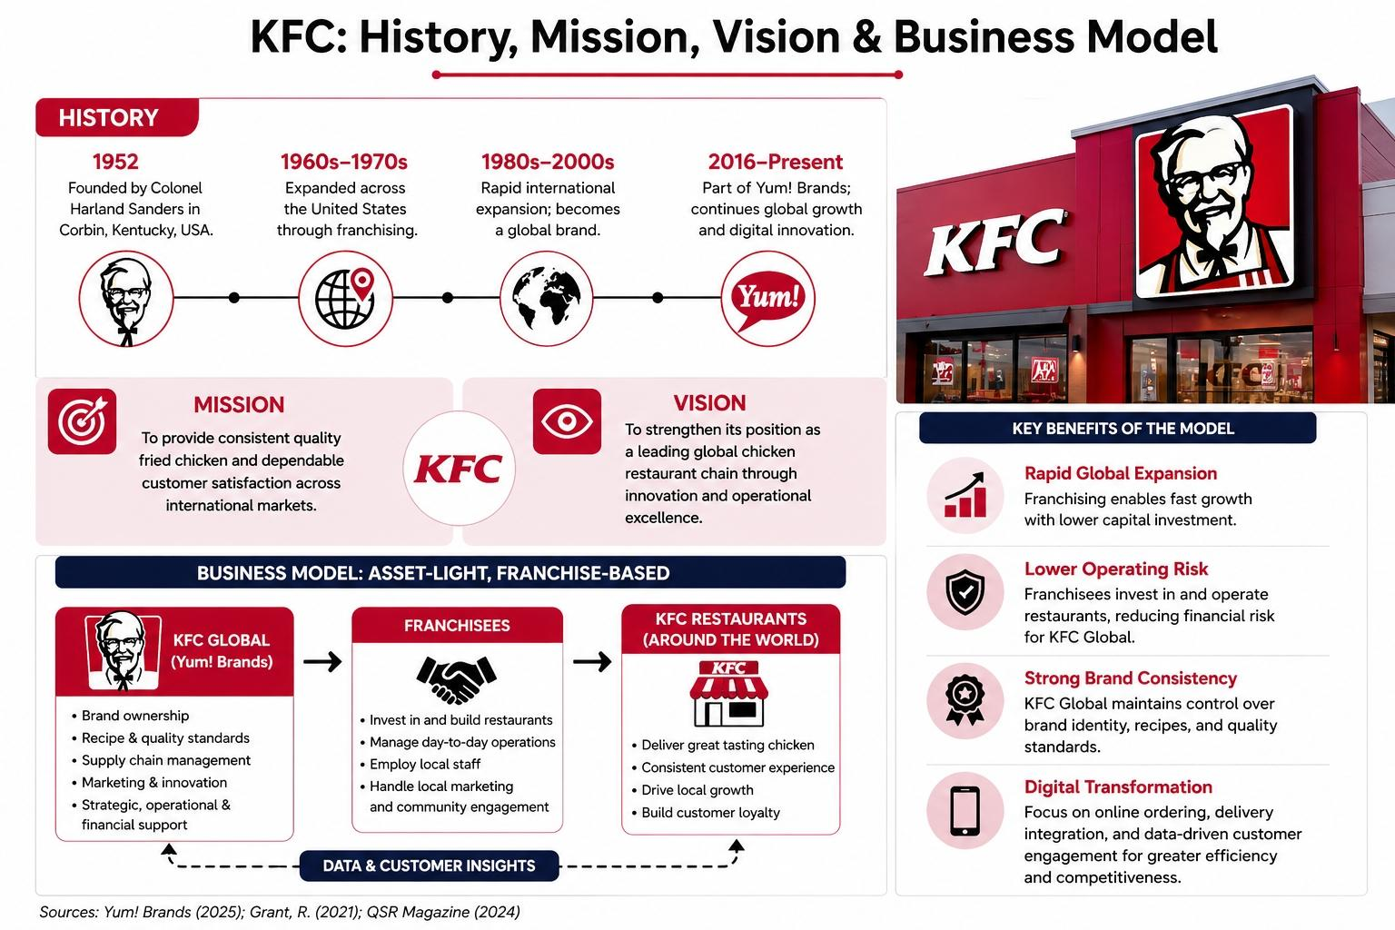
Figure 1: KFC’s Corporate Profile: History, Mission, Vision, and Franchise Model

KFC was founded in 1952 in the United States by Colonel Harland Sanders and has developed into one of the world’s most recognisable quick-service restaurant brands. The company expanded internationally through a franchising-led growth strategy and is now part of Yum! Brands, which provides strategic, operational, and financial support for its global business activities (Yum! Brands, 2025).
KFC’s mission is to provide consistent quality fried chicken and dependable customer satisfaction across international markets. Its vision is to strengthen its position as a leading global chicken restaurant chain through innovation and operational excellence (Grant, 2021). These statements reflect a strategy focused on brand consistency, market leadership, and long-term growth.
KFC operates an asset-light, franchise-based business model that supports rapid international expansion while limiting capital investment and operating risk. Under this model, franchisees manage day-to-day restaurant operations and local capital expenditures, while KFC Global retains control over brand identity, recipe standards, and supply chain quality. This structure enables scalability and preserves strong brand consistency across markets. In recent years, KFC has also increased its emphasis on digital transformation, with a growing focus on online ordering, delivery integration, and data-driven customer engagement to improve efficiency and competitiveness in the global QSR sector (QSR Magazine, 2024; Yum! Brands, 2025).

1.2 Industry Overview, Competitors, and Market Position
KFC operates in the global quick-service restaurant chicken segment, a major and expanding part of the fast-food industry. This sector has experienced sustained growth due to changing consumer preferences, especially the shift from red meat toward poultry, which is often viewed as affordable, convenient, and relatively healthier (Balsarini and Lambert, 2023; Food and Agriculture Organization, 2024). As a result, the industry continues to attract both established multinational brands and emerging regional competitors.
The global poultry market remains resilient and continues to expand, supported by strong demand for affordable protein and changing dietary behaviour (Market Data Forecast, 2026). At the same time, industry performance is increasingly shaped by digital engagement, delivery logistics, and supply chain efficiency. Firms that can maintain product consistency, traceability, and responsiveness are better positioned to protect market share and respond to changes in consumer demand (Balsarini and Lambert, 2023). However, the industry also faces challenges such as feed cost volatility, supply disruptions, and animal health risks, all of which can affect profitability and operational stability (USDA, 2025).

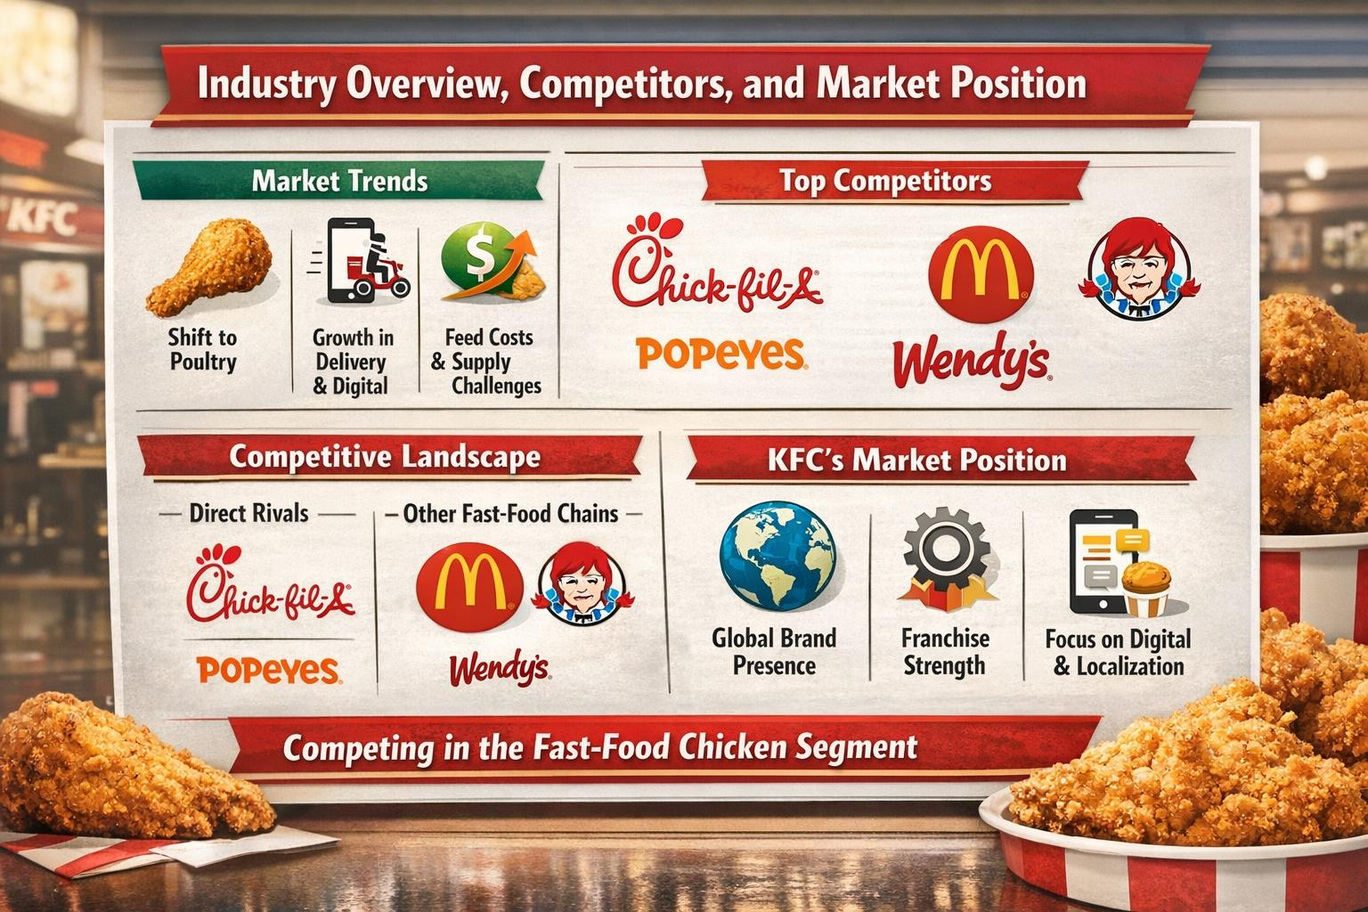
Figure 2: Market Dynamics and Competitive Positioning in the Fast-Food Chicken Sector

Source: Created by learner,2026

KFC operates in a highly competitive environment. It faces pressure from direct chicken specialists such as Chick-fil-A and Popeyes, both of which compete through brand loyalty, product innovation, and value-based offers (QSR Magazine, 2024). Chick-fil-A has achieved particularly strong U.S. sales performance, while Popeyes continues to expand its presence through menu innovation and aggressive positioning. KFC also competes with major general fast-food chains such as McDonald’s and Wendy’s, which have the advantage of scale, strong franchise systems, and extensive global reach (McDonald’s Corporation, 2025; QSR Magazine, 2024). In addition, regional brands such as Wingstop and Hardee’s are gaining visibility through delivery platforms, digital marketing, and younger consumer targeting (Statista, 2025).
Despite this pressure, KFC retains a strong market position through its global brand recognition and international franchise network. Its business model supports broad geographic reach, operational consistency, and continued service innovation (Yum! Brands, 2025). However, in mature markets such as the United States, KFC faces stronger rivalry and more limited differentiation than some of its specialist competitors. For this reason, the company has increasingly focused on digital ordering systems, menu localisation, and operational efficiency to strengthen customer convenience and defend its market position (QSR Magazine, 2024). Overall, KFC remains a powerful global brand, but its long-term success depends on its ability to respond to competition, shifting consumer expectations, and industry disruption.

2. External and Internal Environment Analysis
This section critically evaluates KFC’s external and internal environment using established strategic management frameworks. It applies the PESTEL framework to examine macro‑environmental influences, identifies critical success factors (CSFs) and strategic challenges, and evaluates internal resources and capabilities using the Resource‑Based View (RBV) and VRIO framework. Together, these tools provide a comprehensive understanding of how KFC develops and sustains competitive advantage in the highly competitive global quick‑service restaurant (QSR) industry (Johnson et al., 2017; Grant, 2019).

2.1 PESTEL Analysis: External Environment Impact
The PESTEL framework is useful for assessing the macro‑environmental factors that shape KFC’s strategic decisions across international markets. These external forces influence both short‑term operational choices and long‑term strategic direction. By systematically analysing political, economic, sociocultural, technological, environmental, and legal factors, it becomes possible to uncover the structural opportunities and threats affecting KFC’s global position.

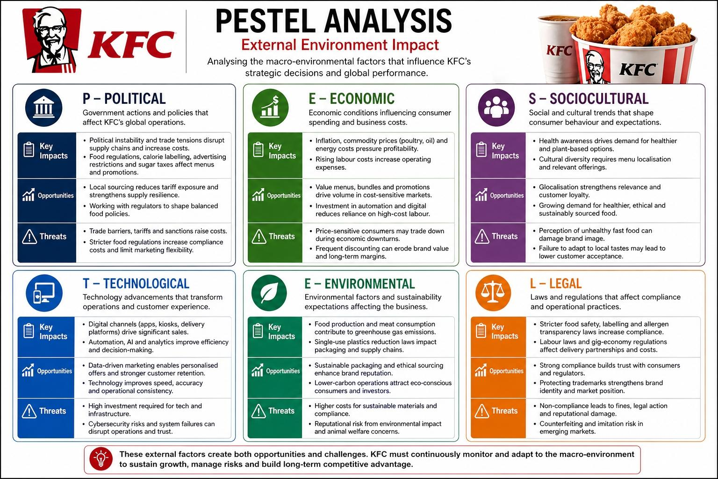
Figure 3: PESTEL Analysis of KFC’s External Environment
Source: Created by learner,2026

2.1.1 Political Factors
KFC operates in over 145 countries, which makes it highly exposed to political instability, trade policy, and regulatory differences (Yum! Brands, 2025). Because of its global footprint, even small changes in trade agreements, tariffs, or sanctions can disrupt supply chains and affect costs. For example, geopolitical tensions and trade fragmentation in regions such as Asia and Europe have encouraged global fast‑food firms to increasingly localise sourcing to reduce tariff exposure and minimise the risk of supply disruption (WTO, 2024). This shift not only protects margins but also improves resilience when international logistics are affected by conflict or customs delays.
In addition, governments worldwide are tightening food regulation through calorie labelling, advertising restrictions, and sugar taxes, which directly affect how KFC communicates with customers and designs its menu (OECD, 2024). In many countries, regulators now require chain‑restaurant menus to display nutritional information, and some jurisdictions have introduced taxes on sugary drinks or high‑salt foods. This forces multinational brands to adapt their products, promotions, and ingredient formulations to meet different legal requirements. For KFC, this means accepting that standardisation cannot be absolute; instead, the brand must balance global consistency with local compliance and consumer expectations.

2.1.2 Economic Factors
The fast‑food industry is highly sensitive to inflation, income levels, and commodity prices. KFC’s profitability depends on its ability to manage costs while maintaining acceptable prices for consumers. Global food inflation remains structurally higher than pre‑2020 levels, driven by energy costs, supply‑chain disruption, and agricultural volatility (FAO, 2025). Within this context, poultry and cooking oil are particularly important cost drivers for KFC, since they form the core of its product offering. When input prices rise, the firm must either absorb the cost (reducing margins) or pass it on to customers (risking lost demand).
At the same time, many consumers have shifted towards lower‑cost food choices during periods of economic pressure, which strengthens demand for value menus and bundled pricing strategies across QSR brands (Statista, 2025). This trend has prompted KFC and its competitors to design more value‑driven offers, such as combo meals, limited‑time promotions, and regional price‑tiering. However, this also creates a price‑sensitivity trap, where frequent discounting can dilute brand value and reduce long‑term profitability. Rising labour costs in major markets such as the US, parts of Europe, and some Asian economies have further increased operating pressure, pushing KFC and other QSR firms to invest in automation, self‑service kiosks, and digital ordering systems to reduce reliance on high‑cost labour (McKinsey & Company, 2024).

2.1.3 Sociocultural Factors
Consumer preferences are increasingly shaped by convenience, health awareness, and ethical consumption. The rise of the “health‑conscious consumer” has led to growing demand for healthier and plant‑based alternatives, which is reshaping expectations in the fast‑food industry (Bloomberg Intelligence, 2025). This trend challenges KFC’s traditional image as a brand centred on fried chicken, because it exposes the company to criticism over nutrition, saturated fat content, and perceived unhealthiest. If KFC does not adapt its menu, it risks falling behind rivals that are already offering plant‑based and lower‑calorie options.
At the same time, localisation remains essential in global fast food, as successful multinational chains often adapt products to regional cultures, dietary preferences, and taste expectations (Euromonitor International, 2025). In markets such as India, China, the Middle East, and parts of Africa, customers expect flavours, ingredients, and meal formats that reflect local cuisines. This makes glocalization—a blend of global brand standardisation and local adaptation—a critical success factor for KFC. For example, in the UK, KFC offers rice‑based meals and vegetarian side dishes, while in some Asian markets it introduces spicier recipes and regionally inspired side items. Such adaptations enhance relevance, improve customer satisfaction, and support long‑term brand loyalty.

2.1.4 Technological Factors
Technology has become one of the most transformative forces in the fast‑food industry. Digital channels such as mobile apps, kiosks, and third‑party delivery platforms now account for a significant share of QSR sales in developed markets, reshaping how customers interact with brands and place orders (Statista, 2025). This shift has reduced the role of physical ordering at the counter and increased the importance of online engagement, app‑based communication, and data‑driven decision‑making. For KFC, this requires continuous investment in platform integration, user‑experience design, and IT infrastructure, which can be capital‑intensive but also create long‑term competitive advantages.
Industry‑wide adoption of kitchen automation, predictive analytics, and AI‑driven demand forecasting is also improving operational efficiency and reducing labour dependency (McKinsey & Company, 2024). These technologies help restaurants manage peak periods more effectively, reduce waste, and maintain consistent product quality. For Yum! Brands and KFC, data‑driven marketing supports more personalised promotions and stronger customer retention across digital platforms (Yum! Brands, 2025). By analysing purchase patterns, timing, and regional preferences, the brand can tailor offers, loyalty‑programme rewards, and push notifications to individual customers, thereby increasing engagement and repeat business.

2.1.5 Environmental Factors
Environmental sustainability is now a major strategic constraint for the fast‑food sector. The global food system contributes a substantial share of greenhouse gas emissions, and meat production remains a significant contributor to this footprint (IPCC, 2023). As a poultry‑centric chain, KFC forms part of this broader environmental challenge, especially in regions where critics are calling for reduced meat consumption and lower‑carbon food systems. Environmental pressures are therefore not only reputational; they are also operational and regulatory.
In response, many regions are phasing out single‑use plastics and requiring food companies to adopt recyclable or compostable packaging materials (European Commission, 2025). This shift forces fast‑food chains to redesign their packaging supply chains, which can increase costs and complexity. For KFC, this creates a sustainability tension between cost efficiency, animal welfare standards, and emissions‑reduction targets, making environmental strategy both necessary and operationally challenging. The brand must balance short‑term profitability with long‑term expectations from consumers, regulators, and investors, who increasingly prioritise ethical sourcing, lower‑carbon logistics, and responsible supply‑chain management.

2.1.6 Legal Factors
Legal frameworks differ widely across markets and significantly influence fast‑food operations. Food safety and labelling laws are becoming stricter, requiring clearer nutritional disclosure and allergen transparency across menus (FDA, 2024; WHO, 2024). This increases compliance costs and forces KFC to adapt not only its products but also its communication strategies, including how information is presented in digital platforms, in‑restaurant displays, and on packaging. For example, some countries mandate that calorie counts appear on every menu item, while others regulate claims about health or nutrition, which can limit the wording of promotional campaigns.
Labour regulation is also tightening, especially around gig‑economy employment and delivery partnerships, which increases compliance costs and affects workforce flexibility (ILO, 2025). Many fast‑food operators now rely on third‑party delivery platforms, but regulatory changes in parts of Europe and North America are reclassifying delivery workers as employees rather than independent contractors, which raises labour costs and legal risk. In addition, as KFC continues to expand into new markets and product categories, protecting trademarks and brand identity becomes increasingly important because of imitation risk and the threat of counterfeit products in emerging‑market contexts.

2.2 Critical Success Factors and Strategic Challenges
KFC’s success in the global quick‑service restaurant industry depends on several critical success factors (CSFs). These are the conditions that must be present if the firm is to compete effectively:
- Strong brand recognition and consistency are essential in a market dominated by large global chains and aggressive local competitors.
- An efficient global supply chain is vital because chicken is KFC’s core ingredient, and price volatility can quickly affect margins (FAO, 2025).
- The ability to adapt menus to local markets is important in regions where consumer preferences differ significantly from KFC’s core Western product base (Euromonitor International, 2025).
- Digital and delivery capability has become a major CSF, because online ordering now plays a large role in QSR sales growth (Statista, 2025).
However, KFC also faces major strategic challenges. Competition in the QSR industry is intense, with established rivals and local brands constantly innovating on price, product range, and convenience (McKinsey & Company, 2024). Input‑cost inflation continues to pressure margins, particularly in poultry and cooking oil markets (FAO, 2025). Health and regulatory pressure are also increasing, especially around salt, fat, and calorie content, as well as responsible marketing practices (OECD, 2024). Finally, sustainability expectations create long‑term pressure, as consumers and regulators increasingly expect lower‑carbon sourcing and ethical supply chains (IPCC, 2023). These external forces show that KFC does not operate in a stable environment; instead, it must continuously adapt if it is to protect its position.

2.3 Internal Environment: Resources, Capabilities, and Core Competencies
KFC’s internal strength lies in a combination of brand equity, scale, and operational consistency. Its most important resources include:
- Global brand recognition
- A large franchise network
- Support from Yum! Brands
- Digital platforms that support mobile ordering and customer engagement (Yum! Brands, 2025; Statista, 2025)
These resources reduce risk, support international growth, and help the company maintain visibility in a crowded market. At the same time, KFC’s capabilities—its ability to do things effectively—include efficient franchise management, global supply‑chain coordination, strong localisation, and data‑driven marketing (McKinsey & Company, 2024; Euromonitor International, 2025). These capabilities allow KFC to operate at scale while still adapting its offer to different markets.
Its core competencies—the distinctive strengths that are difficult to imitate—are especially evident in fried chicken preparation, product standardisation, franchising, and high‑volume operational efficiency (FAO, 2025). These competencies form the foundation of KFC’s competitive advantage, because they underpin both cost efficiency and brand consistency. If competitors are unable to match KFC’s level of standardisation and scale, they will struggle to offer the same level of speed, reliability, and affordability.

2.4 VRIO Analysis
The VRIO framework evaluates strategic capabilities based on whether they are Valuable, Rare, Imitable, and Organised to capture value.

Table 1: VRIO Analysis of KFC’s Strategic Capabilities
Capability | Valuable | Rare | Imitable | Organised | Competitive Implication
Brand equity | Yes | Yes | No (Hard) | Yes | Sustained competitive advantage
Franchise system | Yes | Yes | Moderate | Yes | Sustained / temporary advantage
Supply chain efficiency | Yes | No | Yes (Easy) | Yes | Temporary competitive advantage
Digital ordering systems | Yes | No | Yes (Easy) | Yes | Competitive parity

When applied to KFC, it suggests that the firm has several strategic capabilities with different levels of competitive impact:
- Brand equity is valuable, relatively rare in the chicken QSR market, difficult to imitate, and strongly supported by organisational systems, making it a source of sustained competitive advantage (Yum! Brands, 2025; Barney, 1991).
- The franchise system is also highly valuable, because it allows rapid expansion with limited capital risk, although it is somewhat more imitable than brand equity (McKinsey & Company, 2024).
- Supply‑chain efficiency provides cost advantages but is easier for competitors to copy, which makes it a source of temporary advantage rather than sustained differentiation (FAO, 2025).
- Digital ordering systems are valuable and increasingly necessary, but because most major QSR brands now use similar systems, they provide only competitive parity or short‑term advantage (Statista, 2025).
Overall, KFC’s strongest sources of advantage are brand strength and franchising scale, not technology alone. This insight is important because it shows where KFC should focus its strategic investments if it is to extend its competitive edge.

2.5 Contribution to Competitive Advantage
KFC’s competitive advantage is largely built on its strong brand, international scale, and efficient operating model. Its global recognition reduces customer acquisition costs and supports consistent demand across markets, which strengthens pricing power and market resilience (Yum! Brands, 2025). As part of Yum! Brands, KFC also benefits from economies of scale in sourcing, shared systems, and franchise development, which improves efficiency and margins (McKinsey & Company, 2024).
The franchise model further supports growth with limited capital investment, while localisation helps the brand remain relevant across different regions (Euromonitor International, 2025). In addition, digital transformation strengthens customer convenience and improves operational performance, although it is not in itself a unique source of long‑term advantage because competitors are pursuing similar strategies (Statista, 2025). The combined effect of these internal strengths shows that KFC’s advantage is sustainable but not impregnable; it depends on continuous adaptation and investment if the firm is to maintain its position in an increasingly competitive and turbulent environment.

3. CSR and Sustainability Objectives
KFC’s CSR and sustainability strategy is closely linked to the wider priorities of Yum! Brands and is designed to support brand reputation, regulatory compliance, and long-term business resilience (Yum! Brands, 2025). In practice, this means that KFC’s approach to CSR is not separate from strategy; rather, it is used to strengthen trust with customers, investors, regulators, and franchise partners. Initiatives around responsible sourcing, packaging, and animal welfare also help the brand respond to increasing pressure for more ethical and environmentally responsible food production (Euromonitor International, 2025; IPCC, 2023). These CSR priorities and sustainability initiatives are summarised in Figure 4.

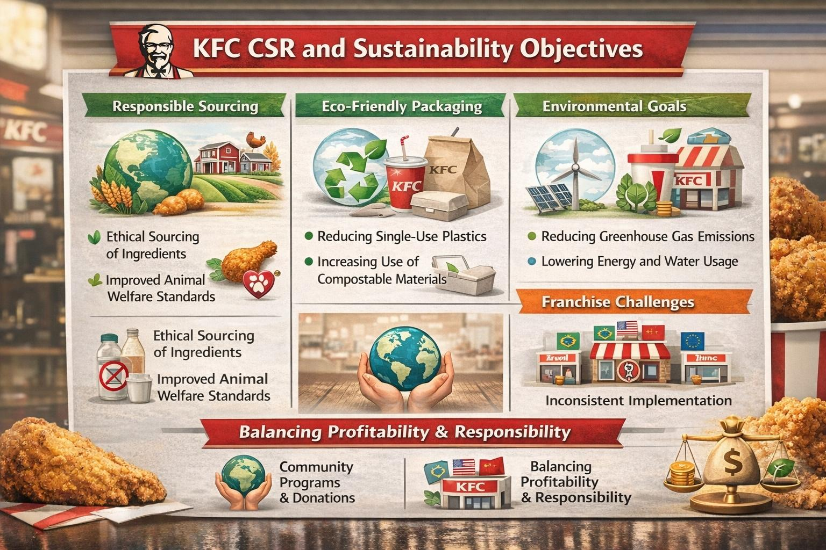
Figure 4: KFC’s CSR and Sustainability Strategy: Key Initiatives and Challenges

Source: Created by author based on Yum! Brands (2025), Euromonitor International (2025), and IPCC (2023)
From a strategic perspective, CSR can support KFC’s commercial objectives by reducing reputational risk and improving stakeholder confidence. Ethical sourcing and improved welfare standards help protect the brand in a market where consumers are increasingly sensitive to food origin, sustainability, and corporate behaviour. At the same time, efforts to improve packaging sustainability and reduce emissions are important because they can lower long-term regulatory and operational risk, especially in regions with stricter environmental requirements (European Commission, 2025). In this sense, CSR contributes not only to image management but also to operational continuity and strategic adaptation.
However, KFC’s franchised structure can make CSR implementation uneven across countries, because standards may not be applied with the same consistency in every market. This can weaken the overall impact of sustainability policies, particularly where local franchisees face cost pressures or where regulations are less strict. In addition, the environmental footprint of a global poultry-based business remains significant, so community programmes and donations, while valuable, do not offset the broader sustainability challenge facing the organisation (IPCC, 2023; McKinsey & Company, 2024). Overall, KFC’s CSR strategy supports business objectives, but its effectiveness depends on consistent global execution and a clear balance between profitability and responsibility.

4. Comprehensive and Holistic View of the Organisation
The Balanced Scorecard developed by Kaplan and Norton provides a useful framework for evaluating KFC’s performance across financial and non-financial dimensions. It links strategy to measurable outcomes through four perspectives: financial, customer, internal business processes, and learning and growth (Kaplan and Norton, 1992; Kaplan and Norton, 1996). For KFC, this is particularly relevant because success depends not only on profitability but also on customer experience, operational consistency, and organisational capability.

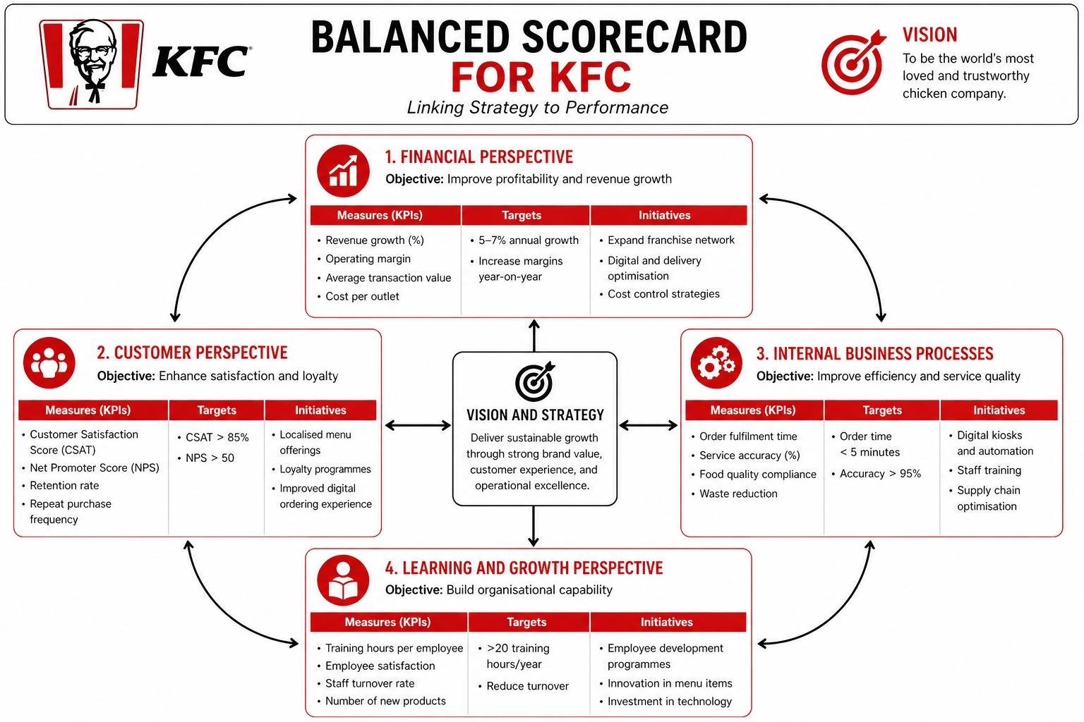
Figure 5: Balanced Scorecard For KFC
Source: Created by learner,2026

4.1 Financial Perspective
The financial perspective focuses on revenue growth, profitability, and cost control. For KFC, objectives such as annual revenue growth and strong operating margins reflect the importance of sustainable financial performance in a highly competitive and cost-sensitive market. These objectives are consistent with the wider strategy of Yum! Brands, which has continued to benefit from franchising expansion and digital development (Yum! Brands, 2023; Yum! Brands, 2025).
Key indicators in this area include average transaction value, sales growth, franchise income, and cost per outlet. These measures are important because they show whether KFC is generating strong returns while maintaining operational efficiency. However, the growing reliance on delivery platforms and digital channels may also create pressure on margins due to third-party fees and promotional costs. As a result, financial success depends not just on sales growth, but on the company’s ability to protect profitability while adapting to changing customer behaviour (Statista, 2024).

4.2 Customer Perspective
The customer perspective focuses on satisfaction, loyalty, and market growth. KFC’s objectives in this area include maintaining strong customer satisfaction, encouraging repeat purchases, and building long-term loyalty. These goals are central to a business that depends on high-frequency consumer purchases and strong brand recognition in a crowded market.
Useful KPIs include Customer Satisfaction Score, Net Promoter Score, retention rate, and repeat purchase frequency. These indicators help measure whether KFC is meeting customer expectations across different markets. KFC’s localisation strategy is especially important here, because adapting products to local tastes can improve relevance and customer satisfaction in diverse markets such as the UK, China, and the Middle East (Euromonitor International, 2025). Digital ordering also improves convenience and strengthens the overall customer experience, although over-reliance on digital channels may exclude some customers and reduce accessibility for less digitally engaged groups. Therefore, KFC needs to balance digital convenience with inclusive service delivery.

4.3 Internal Business Processes Perspective
The internal business processes perspective emphasises efficiency, quality, and operational performance. For KFC, objectives such as reducing order times, improving service accuracy, and maintaining consistent product quality are essential because the brand competes on both speed and reliability. In the fast-food sector, operational efficiency is a major source of competitive advantage because it affects both customer satisfaction and cost management (Slack and Brandon-Jones, 2019).
Relevant KPIs include order fulfilment time, service accuracy, food quality compliance, supply chain efficiency, and waste reduction. These measures show whether KFC is delivering on its brand promise consistently across outlets. Technologies such as kiosks, app ordering, and automated forecasting help improve performance and reduce delays. KFC’s standardised operating model is a major strength because it supports consistency across markets, while waste reduction initiatives also align with sustainability objectives and broader corporate responsibility goals (Yum! Brands, 2023). However, these improvements often require investment in systems, training, and infrastructure, which can create short-term cost pressure.

4.4 Learning and Growth Perspective
The learning and growth perspective is the foundation of the scorecard because it supports improvement in all other areas. For KFC, this includes employee training, retention, innovation, and digital capability. In a labour-intensive industry with high staff turnover, investment in workforce development is important for maintaining service quality and operational stability (Armstrong et al., 2020).
Relevant KPIs include training hours per employee, employee satisfaction, turnover rate, and the number of new product launches. These indicators show whether the organisation is building the capabilities needed for long-term competitiveness. Training and leadership development improve staff confidence and service quality, while innovation helps KFC respond to changing consumer preferences. Introducing new products regularly also supports relevance in a market where tastes shift quickly. Nevertheless, these initiatives require ongoing investment, and the benefits may only be realised over the longer term (Kaplan and Norton, 1996). Therefore, KFC’s learning and growth strategy should be seen as an enabler of future performance rather than an immediate financial return.

4.5 Overall Evaluation
Overall, KFC’s Balanced Scorecard reflects a strategy that aims to connect financial performance with customer value, process efficiency, and organisational learning. The framework shows that the company’s success does not depend on one area alone, but on the alignment of all four perspectives. Strong financial results are supported by customer loyalty, efficient processes, and workforce capability, while weaknesses in any one area can affect the whole system. For KFC, the Balanced Scorecard therefore provides a practical way of translating strategy into action and monitoring whether the organisation is building sustainable competitive advantage (Kaplan and Norton, 1992).

5. Strategic Choices and Implementation
At the business level, KFC navigates a highly competitive quick-service restaurant industry by balancing cost efficiency with differentiation. This hybrid approach allows the brand to maintain price competitiveness in sensitive markets while preserving its distinct identity.

5.1 Evaluation of Strategic Choices

Figure 6: Porter’s Generic Strategies
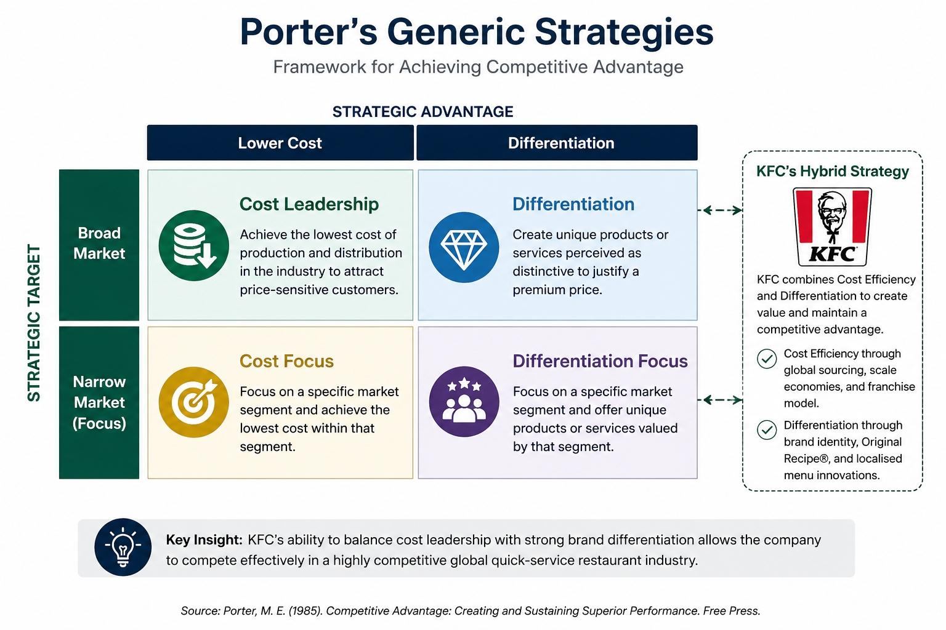
KFC’s cost efficiency is primarily driven by its global franchising model, which mitigates capital expenditure and operational risk for the parent firm, Yum! Brands (McKinsey & Company, 2024). Standardised procurement systems and large-scale global sourcing further provide economies of scale, essential for maintaining profitability in the face of inflation and commodity price volatility. However, relying too heavily on cost leadership can be risky; rising food and energy costs continue to threaten margins, necessitating a move beyond simple cost-cutting to maintain a competitive price point (Porter, 1985).
Differentiation remains the foundation of KFC’s competitive edge. The brand’s identity, anchored by the iconic Colonel Sanders branding and the "Original Recipe," creates strong consumer recognition. More importantly, KFC’s localisation strategy—adapting menus to suit regional culinary preferences in markets like Asia, the Middle East, and Europe—significantly improves market penetration (Euromonitor International, 2025). Furthermore, digital innovation, including mobile loyalty apps and integrated delivery partnerships, enhances convenience and differentiation. In an increasingly digital QSR landscape, these tools are essential for maintaining customer engagement and convenience (Statista, 2024; Armstrong et al., 2020).
At the corporate level, Yum! Brands employ a related diversification strategy, balancing KFC with other major brands like Pizza Hut and Taco Bell. This structure reduces financial risk by spreading exposure across multiple food categories, though it leaves KFC’s specific growth highly dependent on the fried chicken segment. International expansion remains the core corporate engine, driven by the scalability of the franchise model. While this strategy has enabled rapid global growth, it also poses challenges, including the need for cultural adaptation and the risk of inconsistent operational standards across diverse regulatory and legal environments (Yum! Brands, 2023).

5.2 Strategic Recommendation
KFC should adopt a hybrid strategy that prioritises innovation-led differentiation over traditional cost leadership. Specifically, the brand should accelerate its diversification into healthier and alternative-protein products, such as plant-based chicken, to align with shifting health consciousness and sustainability expectations. This shift would mitigate the risks associated with the brand’s high reliance on traditional fried chicken. At the corporate level, Yum! Brands should continue its expansion into high-growth emerging markets while simultaneously increasing investment in alternative food categories to build greater resilience against changing consumer behaviours (Yum! Brands, 2023).

5.3 Assessment of Change Management
KFC has proven effective at managing the shift toward digital transformation, as seen in its rapid adoption of omnichannel ordering, mobile apps, and self-service kiosks. These changes have improved operational throughput and service accessibility, directly supporting revenue and customer satisfaction goals (Statista, 2024). However, implementation remains uneven across markets; while developed regions have integrated these systems effectively, emerging markets often face infrastructure and digital literacy constraints that lead to inconsistent experiences.
Furthermore, digital transformation often encounters internal resistance, as staff must adapt to new, technology-dependent roles. According to Kotter’s (1996) change model, successful implementation requires not only technological investment but also robust communication and workforce engagement to ensure frontline staff are fully aligned. Without sustained investment in employee training and digital infrastructure, the operational gains from these changes may not translate into a long-term competitive advantage (Armstrong et al., 2020).

6. Strategic Evaluation and Recommendations
KFC’s current strategy is a robust blend of established global brand equity and aggressive market penetration, though it faces long-term risks related to product specialisation and sustainability.

6.1 Critical Evaluation of Strategy
From a SWOT perspective, KFC’s core strengths include its globally recognised brand, an efficient franchising model, and strong supply chain coordination provided by Yum! Brands (Yum! Brands, 2025). These factors allow for rapid market development with limited capital risk. Furthermore, the brand’s increasing digitalisation—through mobile apps, kiosks, and delivery integration—has significantly enhanced its accessibility and convenience (Statista, 2024).
Conversely, KFC’s weaknesses include its heavy dependence on fried chicken, which makes it vulnerable to shifting health trends and the rising popularity of plant-based diets. Additionally, while the franchise model is scalable, it can lead to uneven service quality across different regions (Armstrong et al., 2020). Opportunities for growth are clear in emerging markets such as Africa and Southeast Asia, where urbanisation and increasing disposable incomes are fuelling QSR demand. Threats, however, remain significant; these include fierce competition from established giants and local brands, alongside the growing regulatory burden surrounding carbon emissions and food health standards (Porter, 1985; IPCC, 2023).
Using Ansoff’s Matrix, it is evident that KFC’s growth is primarily driven by market penetration and market development. While successful, this strategy relies heavily on existing products. Limited diversification into healthier food categories leaves the brand exposed in a market increasingly prioritising nutritional value and sustainable sourcing (Ansoff, 1957).

6.2 Recommendations
To sustain competitive advantage, KFC should transition toward a more balanced growth strategy:
- Product Development: Accelerate diversification into plant-based chicken and healthier protein alternatives. Competitors such as McDonald’s have successfully integrated plant-based options, proving the viability of this strategy for mainstream QSR brands (McDonald’s, 2023).
- Digital Ecosystem Strategy: Evolve the mobile app functionality to include AI-driven personalisation and loyalty integration. This shift would transform the app from a simple ordering tool into a data-driven engagement platform that enhances customer retention (Statista, 2024).
- Strategic Expansion: Pursue controlled growth in high-potential emerging markets with strong localisation strategies to ensure cultural relevance, supported by improved supply chain resilience to mitigate global inflationary risks (Yum! Brands, 2025).

6.3 Justification
These recommendations are grounded in the Resource-Based View (RBV), which posits that sustained competitive advantage arises from resources that are valuable, rare, and difficult to imitate (Barney, 1991). By leveraging its massive customer data infrastructure to drive personalisation, KFC can better exploit its existing brand value. Furthermore, moving beyond simple market penetration to include product development and controlled diversification mitigates the risks of a saturated market, as suggested by Ansoff’s (1957) framework. Real-world examples from Starbucks and Burger King demonstrate that digital loyalty ecosystems and product-range diversification are effective tools for maintaining relevance and revenue growth in modern QSR environments.

7. Reflective Account (Gibbs’ Reflective Cycle)
This reflective account uses Gibbs’ Reflective Cycle (1988) to examine the process of researching, analysing, and preparing the strategic evaluation of KFC. The model provides a structured way to reflect on experience by considering description, feelings, evaluation, analysis, conclusion, and an action plan. Using this approach allows me to move beyond simply describing what I did and instead understand what I learned and how I can improve in future work.

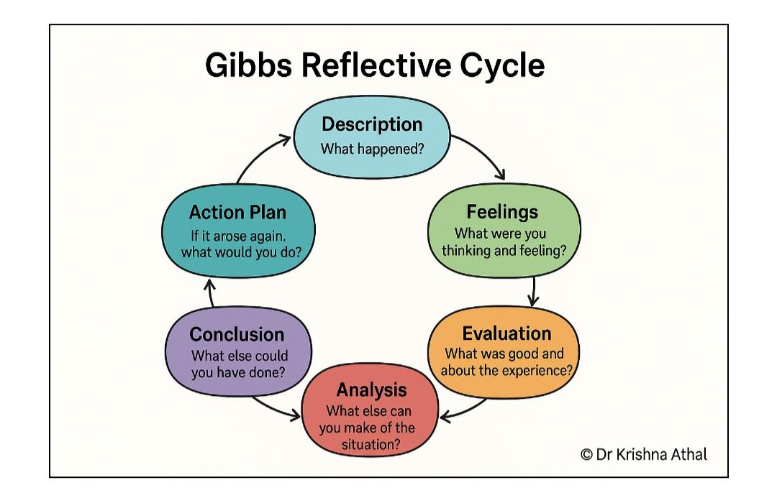
Figure 7: Gibbs’ Reflective Cycle

7.1 Description
The aim of this assignment was to critically analyse KFC’s strategic management within the global Quick Service Restaurant (QSR) industry. The task required an evaluation of the organisation’s external environment, internal capabilities, and strategic choices, supported by relevant academic theories. To complete this, I applied several frameworks, including PESTEL, VRIO, the Balanced Scorecard, SWOT, and Ansoff’s Matrix.
The process began with secondary research, using a combination of academic books, journal articles, and industry sources such as Statista and corporate reports from Yum! Brands. This helped me understand both the theoretical background and the practical context of KFC’s strategy. After gathering the information, I organised the assignment into structured sections, applied each framework to the organisation, and developed recommendations based on the analysis. Finally, I completed this reflective section to evaluate my learning process.

7.2 Feelings
At the beginning, I felt overwhelmed and uncertain. The assignment required the use of multiple frameworks, and I was unsure how to apply them without repeating similar points. I also found it difficult to balance description and critical analysis, which made it challenging to start writing confidently.
As I progressed, my feelings changed. I became more confident and focused once I understood the purpose of each model. For example, PESTEL helped me analyse external factors, while VRIO allowed me to evaluate internal strengths, and the Balanced Scorecard linked strategy to performance. This understanding made the assignment more manageable and reduced my initial stress.
By the later stages, I felt more engaged and comfortable with the task. I particularly enjoyed linking theory to real-world examples, such as KFC’s digital transformation and franchise model, as this made the work more meaningful and practical.

7.3 Evaluation
One of the main strengths was the integration of multiple strategic frameworks. Using several models allowed me to build a more comprehensive and balanced analysis of KFC’s position rather than relying on one perspective. Including real‑world examples, such as KFC’s digital transformation and Yum! Brands’ corporate strategy made the analysis more practical and relevant. This combination of theory and practice also helped the assignment feel more authentic and less like an abstract exercise.
Another strength was the improvement in my understanding of strategic management. I learned how organisations like KFC combine different strategies—such as cost efficiency and differentiation—rather than following a single generic approach. This helped me move beyond simple description to a more analytical evaluation of the organisation’s choices. The reflective process also highlighted how much faster my critical‑thinking skills improved once I moved beyond “what” KFC is doing to “how” and “why” its strategies might work or fail.
However, there were also limitations. At the start, I focused too much on describing models and company information rather than critically evaluating them. This reduced the depth of analysis in some sections. I also struggled with time management. I spent more time on research and less on drafting, which meant some sections needed revision to improve clarity and critical focus. Finally, balancing academic tone with personal reflection was challenging, and the reflective section sometimes felt a bit too formal or too informal.

7.4 Analysis
This assignment highlighted that strategy is not about following a single model, but about combining different perspectives. For example, SWOT gave a broad view of KFC’s strengths and weaknesses, while VRIO helped me assess whether those strengths could create sustainable competitive advantage. The Balanced Scorecard then linked those insights to specific performance measures, showing how strategy connects to financial and non‑financial outcomes. This showed me that frameworks are most powerful when used together, not in isolation.
I also realised that critical thinking is essential. Instead of just repeating definitions, I needed to ask questions such as: How useful is this model here? What are its limitations? How does it fit with other frameworks? This shift improved the quality of my analysis and helped me engage more deeply with the subject. The reflection also helped me see that KFC’s digital transformation can be better understood through change‑management theory, and that its franchise model can be analysed using resource‑based theory. This made the assignment more meaningful and showed me how theory can be translated into practical insight.
In addition, the process helped me recognise that reflection is not just about describing events, but about interpreting them. By thinking carefully about how I felt, what worked well, and what did not, I was able to turn an ordinary assignment into a learning experience rather than just a task to complete.

7.5 Conclusion
Overall, this assignment has significantly improved my understanding of strategic management and its real‑world application. I now feel more confident in using multiple frameworks, structuring a long‑form report, and balancing description with critical analysis. The reflective process has also helped me see the value of planning, time management, and consistent referencing in academic work. By using Gibbs’ cycle, I have been able to turn the whole experience into a structured narrative that shows not only what I did, but what I learned from it.

7.6 Action Plan
For future assignments, I will focus on the following improvements:
- Improve critical analysis: I will aim to evaluate ideas from the beginning rather than focusing mainly on description.
- Better time management: I will plan my work more effectively by allocating specific time for research, writing, and revision.
- Stronger integration of frameworks: I will link different models more clearly to produce a more connected analysis.
- Consistent referencing: I will check citations during the writing process to avoid errors at the end.
By applying these improvements, I will be able to produce more structured, analytical, and effective academic work in the future.

8. References
- Ansoff, H.I. (1957) ‘Strategies for diversification’, Harvard Business Review. Available at: https://hbr.org/1957/09/ strategies-for-diversification (Accessed: 5 March 2026).
- Armstrong, G., Kotler, P., Harker, M. and Brennan, R. (2020) Marketing: An Introduction. 4th edn. Harlow: Pearson.
- Balsarini, J. and Lambert, D. (2023) Global poultry market outlook. Available at: https://www.usda.gov (Accessed: 10 March 2026).
- Barney, J. (1991) ‘Firm resources and sustained competitive advantage’, Journal of Management, 17(1), pp. 99–120. Available at: https://journals.sagepub.com (Accessed: 12 March 2026).
- Bloomberg Intelligence (2025) Plant‑based food market growth report. Available at: https://www.bloomberg.com/professional (Accessed: 15 March 2026).
- Euromonitor International (2025) Fast food global industry analysis. Available at: https://www.euromonitor.com (Accessed: 18 March 2026).
- European Commission (2025) Packaging and waste regulations. Available at: https://ec.europa.eu (Accessed: 20 March 2026).
- FAO (2025) Food price index and agricultural outlook. Available at: https://www.fao.org (Accessed: 14 March 2026).
- FDA (2024) Food labelling and nutrition guidelines. Available at: https://www.fda.gov (Accessed: 6 March 2026).
- Food and Agriculture Organization (2024) Global meat consumption trends. Available at: https://www.fao.org (Accessed: 7 March 2026).
- Grant, R.M. (2019) Contemporary Strategy Analysis. 10th edn. Oxford: Wiley.
- Grant, R.M. (2021) Strategic management foundations. Available at: https://www.wiley.com (Accessed: 8 March 2026).
- ILO (2025) Global labour market trends. Available at: https://www.ilo.org (Accessed: 19 March 2026).
- IPCC (2023) Climate change and food systems report. Available at: https://www.ipcc.ch (Accessed: 9 March 2026).
- Johnson, G., Scholes, K. and Whittington, R. (2017) Exploring Strategy: Text and Cases. 11th edn. Harlow: Pearson. Available at: https://www.pearson.com/en-gb/subjects/business/strategy/exploring-strategy.html (Accessed: 2 March 2026).
- Johnson, G., Scholes, K. and Whittington, R. (2020) Exploring Strategy. 12th edn. Harlow: Pearson.
- Kaplan, R.S. and Norton, D.P. (1992) ‘The balanced scorecard’, Harvard Business Review. Available at: https://hbr.org (Accessed: 4 March 2026).
- Kaplan, R.S. and Norton, D.P. (1996) The Balanced Scorecard: Translating Strategy into Action. Boston: Harvard Business School Press.
- Kotler, P. and Keller, K.L. (2016) Marketing Management. 15th edn. Harlow: Pearson.
- McDonald’s Corporation (2025) Annual report. Available at: https://www.mcdonalds.com (Accessed: 11 March 2026).
- McKinsey & Company (2024) Global fast food industry trends. Available at: https://www.mckinsey.com (Accessed: 16 March 2026).
- OECD (2024) Global nutrition policy report. Available at: https://www.oecd.org (Accessed: 13 March 2026).
- Porter, M.E. (1985) Competitive Advantage. New York: Free Press.
- QSR Magazine (2024) Top QSR brands and industry analysis. Available at: https://www.qsrmagazine.com (Accessed: 17 March 2026).
- Statista (2024) Online food delivery and QSR digital sales. Available at: https://www.statista.com (Accessed: 2 March 2026).
- Statista (2025) Global fast food market statistics. Available at: https://www.statista.com (Accessed: 18 April 2026).
- USDA (2025) Livestock and poultry outlook. Available at: https://www.usda.gov (Accessed: 12 March 2026).
- WHO (2024) Food safety and nutrition guidelines. Available at: https://www.who.int (Accessed: 6 March 2026).
- WTO (2024) Global trade report. Available at: https://www.wto.org (Accessed: 3 March 2026).
- Yum! Brands (2023) Annual report. Available at: https://www.yum.com (Accessed: 10 April 2026).
- Yum! Brands (2025) Corporate strategy and sustainability report. Available at: https://www.yum.com (Accessed: 20 April 2026).

