

Engine Performance Characteristics
(ACHA4003/4004/4012)

Harvey Hodge
2305884

University of Wales Trinity Saint David
School of Engineering
Motorsport Engineering

13/03/2023

Contents
Introduction 1
Method and Testing Equipment 2
How The Engine Dynamometer Works 2
Graphical Results 3
SFC Against Engine Speed 3
Brake Power Against Engine Speed 4
Torque Against Engine Speed 5
Evaluation 5
Table Of Figures 6
Bibliography 6
Results Table 7

Introduction

The aim for the test conducted below is to gather raw data from the Eddy-current Dynamometer and calculate the engine’s, corrected power, BMEP, Torque, SFC and Overall Efficiency. The raw data collected includes the engine’s Load (Nm), Dyno Speed (RPM), Fuel Flow Rate (l/min) and Lambda. Separate raw results gathered are engine, Humidity (%), Ambient Temp (Deg C) and Baro (mBar). This data then needs to be compared and evaluated to show the relationship between engine outputs.
The engine dynamometer testing is a crucial took in the research and development phase of new engine designs or technologies. This allows engineers to experiment with different configurations and assess the impact on performance and efficiency for specific applications or requirements.

Method and Testing Equipment

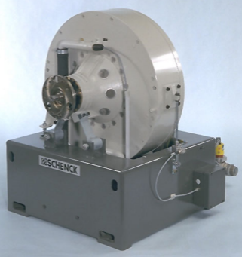
The following results provide information from a Honda Civic Coupe CRX Engine using an engine Dynamometer (Figure 1). In engine testing eddy-current dynamometers are used as load units for the test specimen. The W series eddy-current dynamometers are especially used for:
- Development and testing all kinds of power engines.
- Quality control, running-in and endurance testing of combustion engines.
- Component testing like valve actuation, injection systems and ignition systems.
Figure 1 (H.J.Dadt, 2001)
- Fuel and lubrication oil tests with engines.
As well as this, engine dyno testing allows engineers to assess and fine-tune different aspects of engine performance. This could be, power output, torque curve, fuel efficiency and emissions. The W series dynamometer stands out the most for the following features:
- High torques at very low speeds for commercial vehicle engines.
- Low inertia at high power.
- Suitable for two rotating directions.
- High measuring accuracy due to contact-free speed measurement via a pulse generator as well as a torque measurement via load cells.
- Easy maintenance.

How The Engine Dynamometer Works

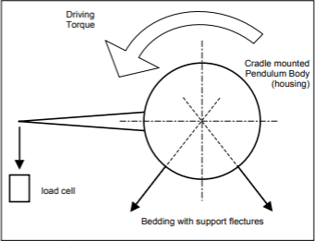
The test engine drives the dynamometer, this absorbs the power and transforms it into heat energy. The test stand controller ‘x-act’ controls the desired speed and torque of the engine. For the test engine, this can be carried out via a throttle position control unit. Via a shaft and flange, the engine is connected to the rotor of the dynamometer. The special bedding of the dynamometer with flexure strips only takes up the weight force of the pendulum body and the countervailing force to the load cell. The complete torque acts on the load cell by the lever arm. As a result, the measured force is proportional with the braking moment.
Figure 2 (H.J.Dadt, 2001)

Graphical Results

SFC Against Engine Speed
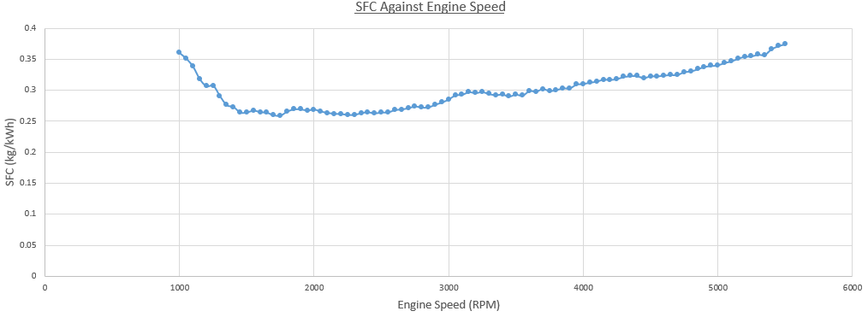
Figure 3

SFC – Specific Fuel Consumption is measured in kilograms of fuel used per kilowatt hour (kg/kWh) and is an important measure of an engines efficiency in producing power. The graph above shows the Specific Fuel Consumption in relation to the Engine Speed. Firstly, from 1000 RPM the scatter graph shows the fuel consumption as decreasing until roughly 1700 RPM this is due to various factors as the engine leaves idle. A reason for this is a change in engine combustion efficiency, this is because the combustion cycle becomes more complete, which leads to better fuel utilization as shown by a decrease from 0.36 Kg/kWh to 0.26 Kg/kWh. The cycle being more ‘complete’ means that when increasing the RPM from idle different factors become more efficient, this can be; Better air to fuel ratio, a reduction in heat loss due to less heat dissipating from the surrounding components and overall optimized engine operation such as ignition timing, valve timing and fuel injection timing which are all optimized for higher speeds. These factors are why there is a drop within the first 1800 RPM. Furthermore, it can be analysed that as the RPM increases so does the SFC; this means that the engine uses more fuel at a faster rate as the combustion rate increases. As this engine is N/A the line steadily increases, if the engine used a turbo intake the graph would show a steeper line as the fuel consumption would be quicker. Due to the engine being a VTEC it has a much better fuel economy compared to other engines in the lower rev range due to it being able to output a higher amount of torque in a low rev range.

Brake Power Against Engine Speed
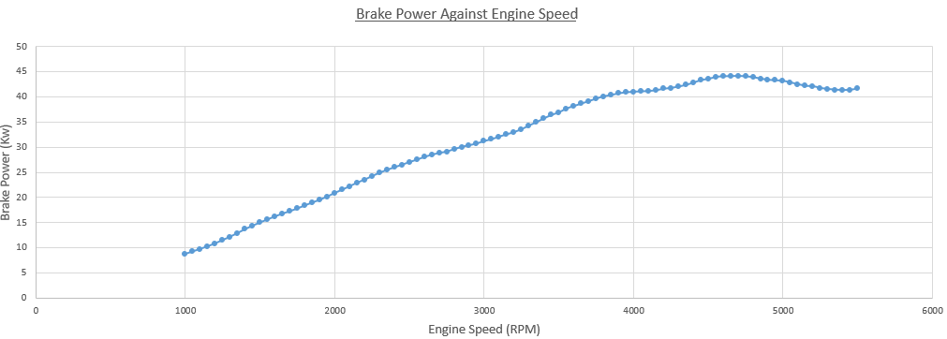
Figure 4

Firstly, it can be examined that up to 3000 RPM the Brake Power increases linearly in respect to the engine speed. Further from this point the graphs begins to bow as the maximum power able to be produced by the engine is reached. This graph links to the SFC and torque graphs both above and below. When comparing the graphs, it can be analysed that as the engine speed is at idle the car has the least amount of power, after 2000 RPM the SFC shows more fuel is being burnt hence the increase in brake power. The dip of brake power after 5000 RPM indicates that the engine has surpassed its peak mechanical efficiency, this means that although the engine is rotating faster frictional losses increase around bearings and connecting rods as well as this, it becomes harder for the engine to get the optimal amount of air and fuel into the cylinder and burn it at the optimal rate. Therefore, the faster the engine revs, the less time it has to ‘suck, squeeze, bang, blow.’ (Motor Vehicle, 2017) In addition, this graph is clear to be a natural aspirated engine due to no sudden increase in brake power, if this engine had a turbo a great increase in RPM and Brake Power would be seen between 2800 RPM and 4300 RPM.

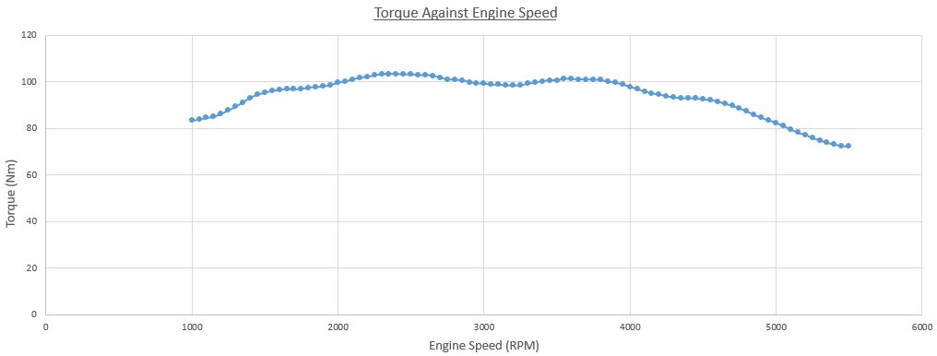
Torque Against Engine Speed
Figure 5

All three graphs are linked in the sense that if one value changes the other graphs change as well. For example, if an engine has an increased load it is required to produce more torque and a higher load requires a higher twisting force to maintain the same RPM. This results in the engine having to burn more fuel to generate the necessary torque. Torque reaches its peak operation early in the RPM range due not needing a great amount of power the indication of an efficient engine is how long this peak torque value can be maintained before reducing. In the graph above it can be noted that from 200 RPM the torque varies between 105Nm and 98Nm until decreasing at 4000 RPM this is due to the same reason as brake power decreasing at a high RPM. Being the engine has surpassed its mechanical efficiency and cannot ‘breathe’ as well. This means that the ‘suck, squeeze, bang, blow’ process cannot occur fast enough to benefit the engine anymore. In this case, the engine is a VTEC resulting in a high torque output without added boost compared to other engines. (Linkedln, 2023)

Evaluation

Overall, the tests conducted on the dynamometer did provide a good visual into the engine’s outputs depending on fuel, load and RPM although improvements can always be made with any test conducted. As this test was conducted manually anomalies can occur depending on the rotation of the dials, this can be seen on the brake power against engine speed graph where the line dips slightly between 3000 and 4000 RPM. If this engine was being tested to find its true outputs after the amount of stress its withstood previously, multiple tests with a comparison would ensure the most accurate value for BHP/Fuel efficiency is gained. As well as this, the Dynamometer Step process would make it easier to compare the operation of the engine to other engines tested. This process uses an algorithm to bring the engine to a specific RPM/Load and over time fluctuate these values so the performance can be analysed; the same step process can then be ran on another engine allowing the engines to be compared at the same specific points where they were both under the same RPM/Load. On the other hand, manual processes do provide a positive to engine testing; this process allows for more freedom when setting the RPM/Load, this is because using the step setup the system cannot go below 100 RPM and only increases/decreases in this increment size. The manual testing we conducted also has a downside as we had two engineers controlling the Load and RPM value, this resulted in it being difficult to reach a desired value as heavy/light handed individuals struggled to work together.

Table Of Figures
Figure 1 (H.J.Dadt, 2001) 2
Figure 2 (H.J.Dadt, 2001) 3
Figure 3 3
Figure 4 4
Figure 5 5

Bibliography
H.J.Dadt. (2001, 05 01). W230 Dynamometer.
Linkedln. (2023, 05 22). RPM and Torque in Engines: Understanding the Relationship. Retrieved from https://www.linkedin.com/pulse/rpm-torque-engines-understanding-relationship-muhammad-aqib
Motor Vehicle. (2017, 09 14). Engine Output Graphs. Retrieved from Engine Output Graphs: https://mechanics.stackexchange.com/questions/18681/why-does-the-power-output-peak-and-then-drop-as-engine-speed-increases

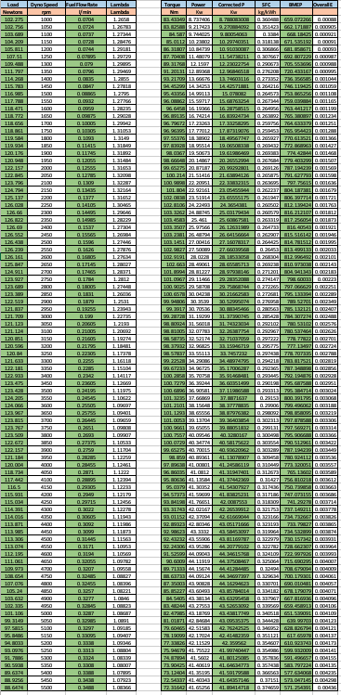
Results Table

