Name: Amy Corbett

Lecturer name: Mohammed Kalam

Module name: Knowledge Information Management

Module code: BMSW5106_LON

Table of Contents

Executive Summary
3.1Introduction
Knowledge and Information Management
4.1 Amazon.com History
4.2 What is Knowledge Management (KM)
5.1 Importance of Knowledge Management within an Organisation
5.2 What impact does Knowledge Management have on customers and competitor advantages.
Evaluation of knowledge and Information Management Models
6.1 BUKOWITZ and WILLIAMS Model
Investigating of KM techniques used by Amazon.com
8.1 Importance of knowledge within Amazon.com Standard Operating Procedures (SOP)
8.2 Achieved outcomes Amazon.com got using Standard Operating Procedures
9.1 Improvements Amazon.com can make in order to overcome their challenges
9.2 Conclusion
9.3 Recommendation
11.1 References

Executive Summary

Introduction

Different business environments around the world stand the risk of their business being negatively impacted by internal and external factors, these circumstances can hinger the operations and profitability of your business; contributing factors could be those that are political, environmental or social. Moreover, political situations could be changes in government or government policies and legislation (KPMG, 2013) One environmental factor which shook the global economy was the COVID-19 virus, during the pandemic whilst many companies had an devastating time making profits and having a hard time adjusting to the further political changes, Amazon became a top supply chain competitor for many businesses due to the amount of services they can offer all in one place; making it fairly convenient for their customers and extremely hard to compete. The pandemic affected a lot of businesses in a bad way, forcing many big companies to go bust but for Amazon this only accelerated the business at an incredible rate; Takefman (2021) comments on how the multinational tech company reported a 70% rise in profits three quarters in to the year of 2020. In addition to the profit increase, Amazon also intend to hire further bringing their total employee count to 55,000.
The purpose of this report is to identify different Knowledge Management principles and Information Systems tools that have best served towards the accomplishment of Amazon(s) global success. Analysing different advance knowledge-management techniques Amazon.com have utilised to identify how these techniques can best serve the buyer-seller relationship, Mariano Rodriquez (2020) explains how it can often cost between 5 and 25 times more expensive to acquire new customers which means customer retention is important in supporting the longevity and sustainability of the e-commerce business, focusing on the customer experience and user friendliness.
Knowledge management models being exampled today to support thy effectiveness of this strategy is the BUTOWITZ and WILLIAMS Model and looking further in to knowledge management components; People, Process, Technology (PPT) to understand the importance these Knowledge and Information systems are to e-commerce businesses and how these theories can be applied to enhance the value of the company not only increasing customer satisfaction but also employee satisfaction
Analysing the strategies used will give a better insight in to how Amazon.com manages such a wide customer base, working to simplify the process of searching, purchasing and delivering products whilst also offering a variety of other services all through the same website and how knowledge management is key to offering a smoothly running service benefiting both Amazon.com and the customers.

Knowledge Management (KM)
Amazon.com history
Although Amazon.com CEO Jeff Bezos initially founded the company in 1994 the company did not go public until 1997, Share prices started at $18 however, by the -end of the day the share value increased to more than $24 rising the value of the company by $54 million solidifying his place as ”king of cybercommerce” in Time Magazine (Armstrong, n.d.).
Before Amazon.com became the global success they have today in the 21st century, Amazon.com only product available was books however, Bezos always argued that the company business was in fact a method of increasing online transactions for consumers (Hall, n.d.) Bezos was indeed correct, today Amazon.com is not only a direct seller, but also a middle-man for sellers worldwide now shipping products such as garden equipment, luggage, CD(s), toys and many more. Jeff Bezos understood that there was a cap in the market for such a business whether it was simply due to the convenience for the customers, or the simplicity of acquiring multiple items from around the world through one platform with a click of a finger it was something that benefited the people involved.
In 2007 Amazon released its first e-reader allowing anyone to publish and sell for free, this was a movement that paved the way for many independent authors making eBook self-publishing a $1 billion industry (Yahoo, 2017). Amazon.com further expanded in to creating further technology products such as Amazon Echo or Dot (WorldAtlas, 2020)
What is knowledge management
Knowledge management (KM) is the process of identifying, organizing, storing and disseminating information within an organization. Many companies like amazon use this kind of system in order to improve customer satisfaction by learning the patterns and interests of its customers in a time effective way leading to improve operational efficiencies (IBM, n.d.) Accessing amazon’s services through one system enables them to do this, and the more frequently you use the system the more relevant information it gathers to tailor the shoppers experience enabling them to interact with their customers by offering suggestions based on previous interests, or the options to add to wish list for time efficient future purchases; this increases customer satisfaction and experience.
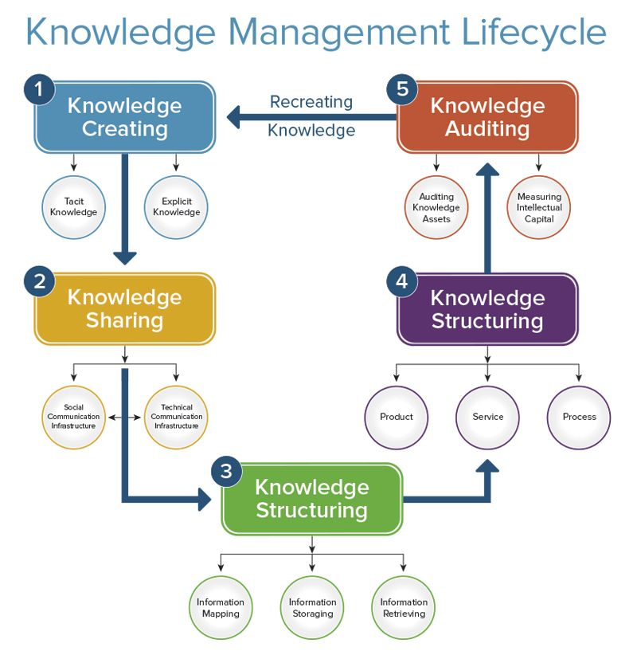

Source: (Smartsheet, n.d.)
Importance of Knowledge Management within an Organisation
Knowledge Management is important for any business that handles information, it would be time consuming and costly to continuously be gathering information and not storing it in an accessible manner, in addition to this priority objectives can then be focused on like minimising call centre enquiries by create a one portal one interface platform that can be recognised regardless of the Amazon services you are using, making it more incising for the customer to explore different available services or products of focus such as wish list, or different business segments such as prime and kindle.
There is two different categories that knowledge can fall under and that is tacit knowledge and explicit knowledge; Tacit knowledge what resides inside of the practitioner, something learned or developed through experience and practice whereas, explicit is organisational knowledge such as information databases and documents where IT is essential for transfer and storage, knowledge possessed by your peers is your organisations valuable; asset, therefore being able to store this in order to transfer is crucial (Oraguri, 2020)
What impact does Knowledge Management have on customers and competitor advantages.
Knowledge management capabilities enable a business as Amazon.com have shown can simplify the process of transactions by storing information on a system that is accessible to the necessary to help support employees in their daily tasks or a customer on their routine shop. Such a process creates operational efficiency, organisational value and outstanding performance allowing organizations competing in fast changing dynamic markets as KM capabilities enable organizations to react to changing market conditions, and achieve and sustain competitive advantage (Dalcher, Sandhawalia, 2011)
Examples of these advantages against competitors is the ability to process information in a system designed to serve for the objective of the business, removing the worthless data which doesn’t benefit the organisations interests; this allows companies to then focus on other business enhancing objectives referring to the PPT principle which is People, Process and Technology to develop further idea’s which heighten a service user experience.
Although the PPT framework initially had four elements people, structure, tasks and technology being called Levitt’s Diamond Model when it first came around in the middle 1900’s, it associated elements with aspects of historian development rather than the modern day development so the model went through a sort of renaissance in the 1990’s by computer security and privacy specialist Bruce Schneier helped make people, process, technology in the 1990s; moreover this modified the four elements to three which is now what we know as PPT or as some refer as the Golden Triangle (Smartsheet, 2019)

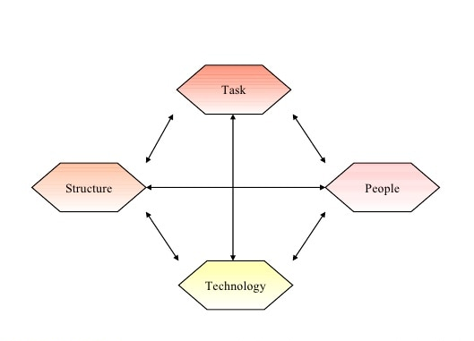
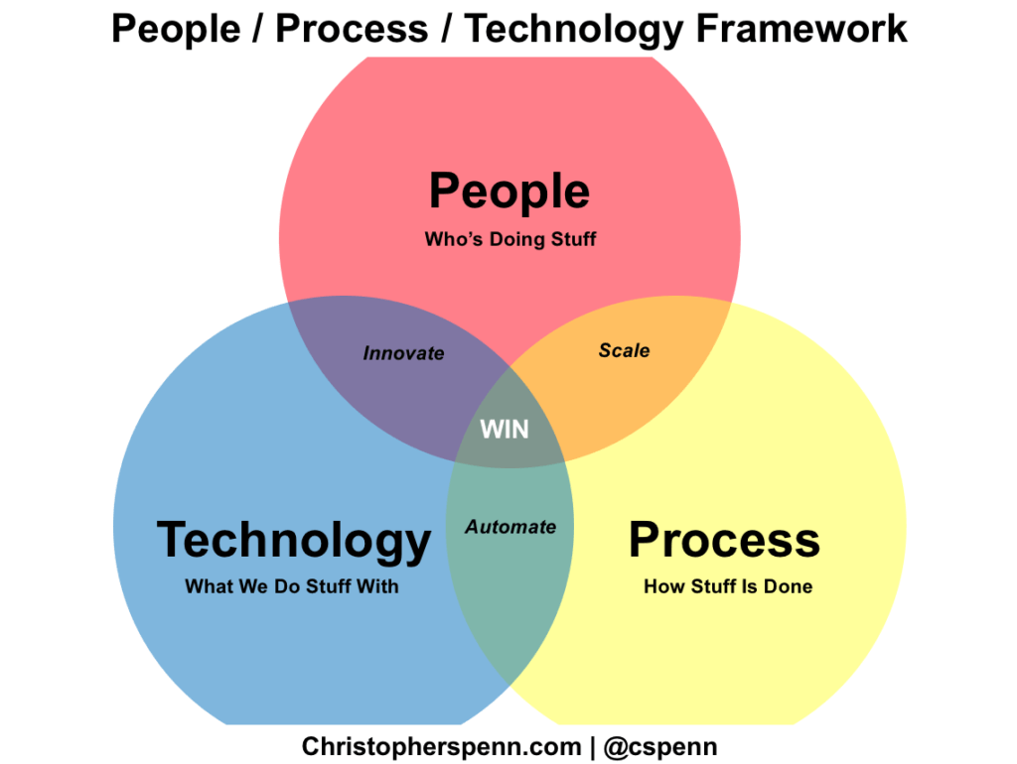
Source: (Penn, 2021) Source: (SlideShare, 2011)

Evaluation of knowledge and Information Management Models

BUKOWITZ and WILLIAMS Model
Bukowitz and Williams portray a knowledge management process framework which identifies how organisations generate, maintain and expand on strategically gathered knowledge to create value (Zaman, 2016).
This Knowledge management framework has numerous stages involved, a few being the get stage which is the stage where information is gathered that would be required in order to innovate suitable ideas, or to solve problems and make decisions. The second stage is the use stage which refers to the combining of information that generates new and interesting idea’s to capture and foster organisational goals. Third stage follows as The Learn stage, this consists of learning from experience as a method of creating a competitive advantage on your competitors. In enterprises its important to learn from previous experiences allowing it to serve as a transition step between the application of ideas and the generation of new ones (Zaman, 2016). Lastly we have the contribution stage which ends the knowledge management cycle with encourages transferring gained knowledge to the community, only this way individual knowledge can be combined as a communal knowledge where and when necessary for increasing business expertise.
Amazon.com depend on a framework like Bukowitz and Williams for the purpose of generating new customer retention and employee retention strategies, it’s something that could be used for different operational departments within the company making it a well-functioning framework for the organisation. Using this information, learning in the present from the past Amazon.com has been able to build an incredible empire, focusing on creating better customer experiences and value by personalizing each individuals users time on the site, creating modular content which is easy to read, optional to see creating the opportunity to explore without applying the pressure of mandatorily making the customer view, and making all services accessible from one familiar space, formally known as one portal, one interface. This information process allows the user to find only what they desire rather then wasting time searching through documents or pointless information (Rosenburg, 2014) aligning the action along with the company objective.
This framework is also an example of the process of emotional intelligence being demonstrated by recognising the customers emotions, understanding their desires and to communicate these wants in order to manage buyer and consumer relationship better increasing performance for the organisation (Mindtools, n.d.) Once such understanding is distinguished Amazon.com are able to continue to use this information to personalise, adapt, manage and create experiences for their customers giving them a competitive advantage.

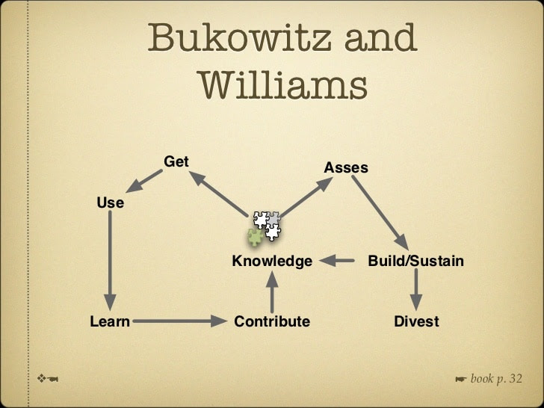

Source: (Rabu, 2016)

Investigating of KM techniques used by Amazon.com

Importance of knowledge within Amazon.com Standard Operating Procedures (SOP)
A standard operating procedure formally known as SOP describes the process an individual needs to follow when completing a task, defining standards and practices expectations; these steps are usually in accordance with industry regulations, laws and company own standards (BIT.AI, 2021)
Distinguishing what needs to be completed to achieve goals or to help correct problems that arise within an organisation, applying standard operating procedures in place allows there to be a mutual understanding between all members of staff, pushing a specific imagine or standard in projection of the organisations own mission goal making the work being completed more efficient, and efficiency always lead to consistency and reliability resulting in profitability (BIT.A1, 2021)
Achieved outcomes Amazon.com got using Standard Operating Procedures.
Outcomes achieved using such procedures include the overall positive impact Covid-19 had on Amazon.com focusing on the ability the company had in overcoming the crippling affect it imposed and long term threat it poses on the World wide economy. Whilst Covid-19 continues to affect the industry Amazon.com as mentioned previously continue to grow their company, fulfilling a larger than normal amount of orders leading to a 220% rise in profits as pandemic drives shopping online. Amazon.com being a supply chain business saw an increase of 64% in revenue earned by merchants listing items on its website as well as using their warehouse, bringing the value up to $23.7 billion, although Amazon.com have multiple business segments their “other” highly profitable one was their lucrative advertisement business which increased by 77 percent, to almost $7 billion (Weise, 2021)
Worldwide regulations and laws were added or changed to accommodate this modern day crisis in order to keep going, also phrased as business as usual. This included a routinely test system to identify those affected by the illness to help isolate and contain any outbreaks within the organisations with could damage the functional ability of the business. Other measures including social distancing and updated full PPE were include in the steps as a way of minimising transmission of germs from one another again minimising the risk of impact to the working departments of the company only completing necessary activities which contribute to the success of the objective, allowing Amazon.com to maintain there consistency and reliability showing there strength as an organisation, using such systems allow them to adapt to their surrounding environment both internally and externally.

Improvements Amazon.com can make in order to overcome their challenges.
A challenge which Amazon.com faces which has brought the company under scrutiny, particular throughout the pandemic is the treatment towards workers. In 2020 Amazon.com hired 500,000 people, bringing its total workforce to nearly 1.3 million (D’Innocenzio, Pisani, 2021) so it is no doubt that problems are going to arise with such a huge workforce.
However, Bezo’s “Discovered what he believed was an ineffieceny worth eliminating; hourly employee’s who spent years for the same organisation”, he’s theory was that over time workers become complacent, meaning wages increase and productivity decreases. Bezo’s solution for this was replacing workers before their productivity reduced and pay increased. After three years on the job employee’s stopped receiving automatic pay increases and Amazon.com even went to the extent of offering bonuses for employee’s to quit (Kelly, 2021)
Continuing, if Amazon.com dedicated more focus to their employees satisfaction the company could excel and achieve further; fulfilling employees desires such as training to develop their skills further or acquire knowledge which could enable them to progress further within their career. When an organisation supports their workers needs and desires, in return employee’s productivity levels increases, improving performance for the company. American Society found that the companies who invested the most into their workplace learning yielded higher net sales per employee, and a higher ratio in market-to-book values (Schoox, 2016)
Conclusion
To conclude, Amazon.com utilise knowledge management principles and apply them in to the company’s business operating structure to increase company value in all operational areas of the business; working out how to best gather, store and create using KM frameworks is a key factor for Amazon.com success and continues to be a dominating aspect of the Amazon.com business improvement approach allowing there customers a unique experience.
By carefully identifying the best process for KM lifecycle Amazon.com have been able to continue to adapt to surrounding affecting factors and create innovating idea’s to create user experience and competitor advantage. Amazon three objectives are reducing cost and time and increasing quality, sometimes decisions are made or decided on that might not balance out accordingly for the better of the organisation; by Amazon.com cutting automatic pay increases and offering bonuses to those as an incentive quit they was only communicating the neglect and disregard to the local employees who had dedicating years helping to contribute to the success of the business. When in fact long term it could potentially end up working against the benefit of the organisation by limiting expertise and value.
Recommendation
By providing on-going training for their employees’ Amazon.com can increase employee productivity eliminating their concern of decreased performance. Doing this enables Amazon.com to increase company knowledge increasing value, across the board acquired knowledge allowing the workers the opportunity for career progression.
Continuing, if workers decided against progressing in their career and wished to maintain the initial job role assigned then Amazon.com could cap a maximum wage for a specific job role, developing and communicating an SOP so employees can clearly understand what activities will be completed for the wage projected leaving it to the decision of the individual to proceed further with their employment.
For this Purpose I would recommend the WIIG knowledge management Model being incorporated in the operations of Amazons HR operations, focusing on building both implicit and explicit knowledge through training and peers, to hold in people, documents creating a intranet or information base which is accessible to the required individuals; to then embed this knowledge into increasing performance and creating organisational value.
The WIIG KM Model consists of four segments which identify the use of gathering information, selecting the important elements of the information then finding a way to store and relay in order to reduce time, cost and increase service quality and productivity (Essekia, n.d.)

References
Armstrong, C. (n.d) The History of Amazon.com. Available at: https://www.techwalla.com/articles/the-history-of-amazoncom (Accessed 19 November 2021)
BIT.AI, (2021) Collaboration, Document: 5 standard Operating Procedure Examples You Can Use Today!. Available at: https://www.blog.bit.ai/standard-operating-procedure-examples/ (Accessed 31 December 2021)
D’Innocenzio, A. Pisani, J. (2021) E-commerce: The Biggest Challenges for Amazon’s New CEO. Available at: https://www.manufacturing.net/e-commerce/news/21259751/the-biggest-challenges-for-amazons-new-ceo (Accessed 31 December 2021)

Essekia, Paul. (n.d.) 4 Knowledge Management Models That Can Supercharge Your Organisation. Available at: https://www.helpiewp.com/knowledge/management/models (Accessed 31 December 2021)
Hall, Mark (n.d.) Amazon.com: American Company. Available at: https://www.britiannica.com/topics/amazoncom
IBM, (n.d.) Knowledge Management. Available at: https://www.ibm.com/topics/knowledge-management
Kelly, Jack. (2021) Forbes: A Hard-Hitting Investigative Report Into Amazon Shows That Workers’ Needs Were Neglected In Favour Of Getting Goods Delivered Quickly. Available at: https://www.forbes.com/sites/jackkelly/2021/10/25/a-hard-hitting-investigative-report-into-amazon-shows-that-workers-needs-were-neglected-in-favour-of-getting-goods-delivered-quickly (Accessed 31 December 2021)
Mindtools, (n.d.) Emotional Intelligence: Developing “People Skills”. Available at: https://www.mindtools.com/pages/articles/newCDV_59.htm (Accessed 30 December 2021)
Oragui, D. (2020) Tacit Knowledge: Definition, Examples and Importance. [blog] Helpjuice. Available at: https://www.helpjuice.com/blog/tacit-knowledge Accessed 19 December 2021
Rabu, (2016) My Knowledge: The Knowledge Management Cycle. Available at: https://www.febiotampi.blogspot.com/2016/01/the-knowledge-management-cycle.html (Accessed 30 December 2021)
Rodriguez, M. (2020) ‘How Amazon Maintains over 90% Customer Retention’ Getbeamer [blog]. Available at: https://www.getbeamer.com/blog/how-amazon-maintains-over-90-customer-retention-year-over-year (Accessed: 04 November 2021)
Rosenburg, M. (2014) Learning Sources: The Knowledge Management Genius of Amazon.com. Available at: https://www.learningsolutionsmag.com/articles/1480/the-knowledge-management-genius-of-amazoncom (Accessed 30 December 2021)
Schoox, (2016) Corporate Training: Hoe Employee Training Boosts On-the-Job Porductivity. Available at: https://www.blog.schoox.com/how-employee-training-boosts-on-the-job-productivity (Accessed 31 December 2021)
Simon, B. (2020) Knowledge Management Life cycle. [image] Available at: https://www.smartsheet.com/knowledge-management-101 [Accessed 19 December 2021]
Singh Sandhawalia, B. and Dalcher, D. (2011), “Developing knowledge management capabilities: a structured approach”, Journal of Knowledge Management, Vol. 15 No. 2, pp. 313-328. Available at: https://doi.org/10.1108/13673271111119718
Smartsheet, (n.d.) KM Life Cycle. Available at: https://www.smartsheet.com/sites/default/files/styles/900px/public/IC-KM-life-cycle.jpg?itok=A4VWOp7R (Accessed 31 December 2021)
Takefman, B. (2021) Amazon profits increased nearly 200% since start of Covid-19 Pandemic. Available at: https://researchfdi.com/amazon-covid-19-pandemic-profits/ (Accessed: 04 November 2021)
Weise, K. (2021) Amazon;s profit soars 220 percent as pandemic drives shopping online. Available at: https://www.nytimes.com/2021/04/29/technology/amazons-profits-triple.amp.html (Accessed 31 December 2021)
WorldAtlas, (2020) The History of Amazon. Available at: https://www.worldatlas.com/the-history-of-amazon.html (Accessed 19 December 2021)
Yahoo, (2017) The Kindle Effect. Available at: https://uk.news.yahoo.com/kindle-effect-190733501.html (Accessed 19 November 2021)
Zaman, P. (2016). Model of KM life cycle. Available at: https://www.zamanputra.wordpress.com/2016/06/08/models-of-km-life-cycle/ (Accessed 30 December 2021)

Practical Evaluation of the Proposed Knowledge Management Framework for Amazon



