
Programme name: Master of Business Administration
Module name and code: International Business Concepts LCMB7034
Lecturer’s name: Gladius David Kulothungan
Student ID:2432626

Table of Contents
Section 1: International Business Report 3
1. Introduction 3
2. Industry and Country Overview 3
2.1 Industry Context in India 3
2.2 Size, Scope, and Economic Importance 4
2.3 Key Firms and Competitive Landscape 5
3. Porter’s Diamond Model Analysis 7
3.1 Factor Conditions 7
3.2 Demand Conditions 8
3.3 Related and Supporting Industries 9
3.4 Firm Strategy, Structure, and Rivalry 11
3.5 Government Role and Chance 12
4. Evaluation of TCS in India 13
4.1 Overview of TCS’s Operations 13
4.2 Application of Eclectic Theory (OLI Framework) 14
4.3 Location Hypothesis 17
4.4 Internalisation Hypothesis 18
4.5 Political Factors 20
4.6 Economic Factors 21
4.7 Legal Factors 22
4.8 Cultural Factors 23
4.9 Market Attractiveness and Risks 23
5. Conclusion 24
Section 2: Reflective Account (Gibbs Cycle) 25
Description 25
Feelings 25
Evaluation 26
Analysis 26
Conclusion 27
Action Plan 27
References 29

Section 1: International Business Report

1. Introduction
The Indian information technology (IT) services industry has become one of the biggest outsourcing, consulting, and digital transformation service providers worldwide. It currently plays a vital part in the economic development, creating job opportunities (Li, 2022). Thus, making India one of the world leaders in the area of the use of technologies and digital services. The report analyses the Indian context of the industry, taking a specific interest in Tata Consultancy Services (TCS), which is one of the largest global companies in the field of IT services. The analysis of the industry structure, scale and competence is examined under Porter's Diamond Model in addition to major theories in international business like the Eclectic Theory, Location Hypothesis and Internalisation Hypothesis. Also, the report critically discusses the operations of TCS by looking at the macro-environmental factors such as political, economic, legal and cultural factors to evaluate its performance, its strategic positioning and long-term sustainability in an ever-competitive global market environment.

2. Industry and Country Overview

2.1 Industry Context in India
The development of the Indian IT services sector has evolved into an international outsourcing destination. This is mainly after economic liberalisation in the 90s due to telecommunications technical education. It is very diversified and global, with the industry comprising IT consulting, software development, cloud computing, cybersecurity and business process outsourcing (BPO) (Mehta and Baskaran, 2023).
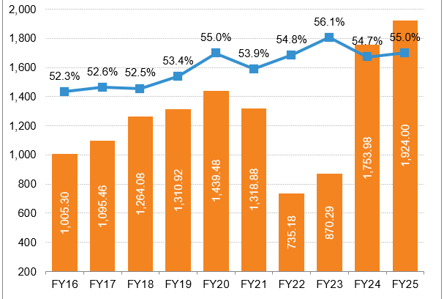
Figure 1: Indian IT sector growth
Source: (IBEF, 2025b)
In the global challenging outsourcing market, India accounts for about 55% of all IT outsourcing, and this is instrumental in expressing its dominance in the delivery of services internationally (IBEF, 2022). Global Capability Centres (GCCs) opened by multinational corporations are also present in the country and indicate its role as one of the world's technology startup locations. Such strengths are fueled by cost-efficiency, scalability, and a large English-speaking labour force, but growing automation is starting to transform classic models of service.

2.2 Size, Scope, and Economic Importance
The Indian IT sector ranks as one of the sectors that have contributed to economic development, exports and jobs. It is at the core of digital transformation in all industries, but at the same time, it earns a lot of foreign exchange. The industry has a macroeconomic value of about 7.5% of the GDP of India (Angelone, 2024).
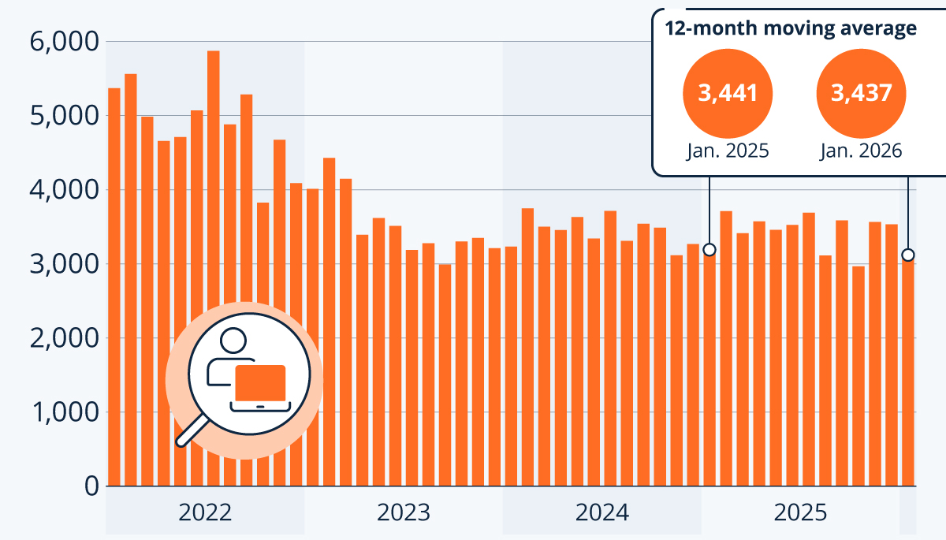
Figure 2: Indian IT sector hires
Source: (Gaudiaut, 2026)
The number of IT sector hires in India had reached an average of 5,000 hires, but it later stabilised with time, falling to a more consolidated and medium-based close to 3,441 (Gaudiaut, 2026). The export of IT services in India is growing annually, showing that the services are in high demand in the global market. Another weakness, however, is that the industry is dependent on exports and therefore prone to the global economic decelerations, especially in the major markets, including the United States and Europe. Such dependency exposes firms to many external shocks like recession, currency fluctuations and decreased IT expenditure by international clients. In one example, in times of economic crunch, employers tend to reduce technology spending on discretionary items, which has a direct effect on the service providers (Sarial‑Abi et al., 2021). As a result of the Internationalisation of domestic markets, high-value digital services have gained greater importance in the long-run stability.

2.3 Key Firms and Competitive Landscape
The IT services sector is a highly competitive and dynamic industry in the world in which both large multinationals and strong domestic firms are present. Infosys and Wipro are the leading Indian firms competing with the global players like TCS and IBM (Mehta and Baskaran, 2023). The scale and strategic significance of the IT services market are estimated to be among the highest on a global scale.
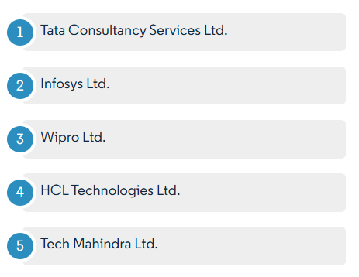
Figure 3: IT industry competitors in India
Source: (Mordor Intelligence, 2025)
Infosys is worth $158 million and aims at targeting the cloud division, while HCLTech will create greater integration depth (Mordor Intelligence, 2025). TCS is generally perceived as a market leader because of its size, diversified business and good client retention policy. Through its Global Delivery Mode, TCS is able to deliver services at low costs and yet with high quality (TCS, 2025b). Hence can be classified as both a cost leader and a value provider. Infosys, by contrast, has emphasised itself as a digital-first, automation-based, artificial intelligence-based, and cloud-based company.
On the other hand, Wipro has engaged in reorganisation and strategic acquisitions in an attempt to enhance efficiency in its operations to restore competitiveness (Wipro, 2024). Indicatively, in its investments in consulting capabilities, it is seeking to enhance its position in high-value segments of services (Daniels et al., 2022). Other multinational companies can distinguish themselves by offering premium consulting and end-to-end digital transformation services, serving high-margin customers. The revenues of TCS are $137.18 billion worldwide, mirroring its leading position in the premium market (Suresh and Ishwarbharath, 2026).
There is a strategic gap shown in the competitive positioning of these firms. Indian companies have a history of cost-effectiveness and scalability, whereas multinational corporations are oriented towards innovation, consulting skills and branding. However, this difference is becoming narrower as Indian companies invest in new cutting-edge technologies (Cammarano et al., 2024). The competition is ever-growing in the IT services industry, with firms operating worldwide. As a result, requiring business organisations are required to keep evolving in their approach in order to ensure their relevance and profitability.

3. Porter’s Diamond Model Analysis
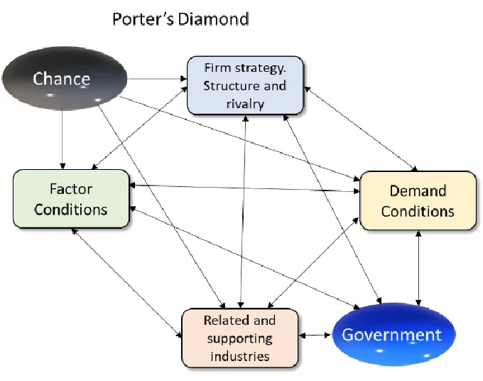
Figure 4: Porter’s Diamond Model Analysis
Source: (Zonnenshain, 2020)

3.1 Factor Conditions
The main competitive strength of India in the IT services sector is the large and well-trained human capital base, which facilitates scalability and global service offering. The trend towards engineering and technical education has enabled the country to generate a powerful talent pipeline. Each year, India graduates more than 1.5 million engineering graduates, so there will always be a supply of skilled professionals (Sharma, 2025).
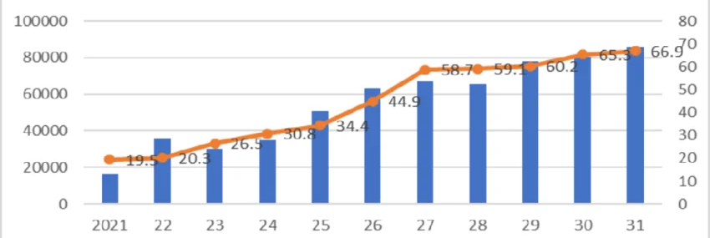
Figure 5: Graduate growth in India
Source: (Ye et al., 2024)
Moreover, the IT sector has a higher number of employees estimated at over 5.8 million, which is a sign of its size and ability to take on global projects (The Economic Times, 2025a). The standard of skills, however, is still challenged. Mainly with a good percentage of graduates still lacking the trainee skills necessary to fit into the industry (Ye et al., 2024). Moreover, unequal distribution of infrastructure in urban IT centres like Bengaluru and rural areas restricts balanced development and the intense concentration and high operation costs in urban areas.

3.2 Demand Conditions
India has witnessed a rapid growth in domestic IT services demand as sectors and organisations like banking, healthcare, retail, and government services follow a digital transformation. Programmes such as Digital India have also helped to speed up the use of technology. By 2030, the digital economy of India is likely to be $1 trillion, which will dramatically demand more IT services (Sen, 2023).
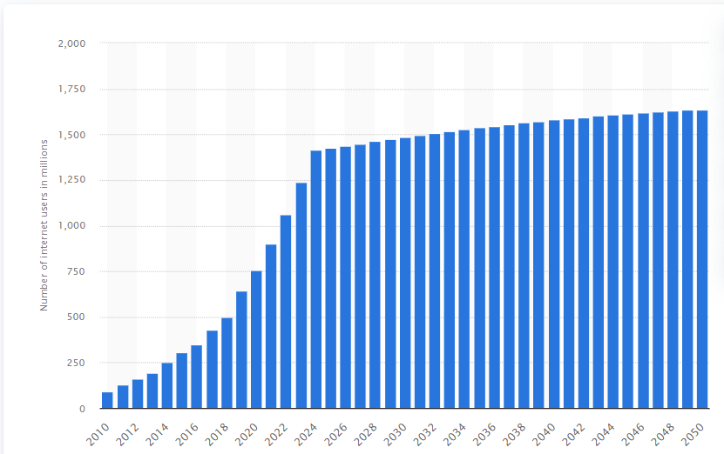
Figure 6: Internet users in India
Source: (Tila, 2025)
Also, the number of internet users in India reached over 1.6 billion (Tila, 2025). This contributes to the growth in digital consumption and opens new perspectives for the IT companies. With this growth, domestic demand is less advanced than in developed markets like the United States and Europe. This restricts the level of innovation that can be carried out by Indian companies on local markets (Mulyono and Rolando, 2024). To such a point that it will greatly depend on foreign customers, who will provide them with increased technological advancement.

3.3 Related and Supporting Industries
The level of related and supporting industries is strong, which maximises the competitiveness of the IT sector in India. They are telecommunications, education, startups, and financial services, all of which affect the presence of a strong innovation ecosystem. India boasts of more than 100 unicorn ventures, most of which highly depend on IT services to run and develop their business (PIB, 2025b).
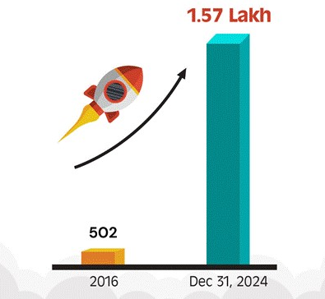
Figure 6: Unicorn growth in India
Source: (PIB, 2025b)
Moreover, there are over 1700 Global Capability Centres (GCCs) developed by multinational companies in the country, which enhances cooperation of local and international companies (PIB, 2025a). Nevertheless, the constrained infrastructure, investment in research and development (R&D) and in terms of innovation limit the overall potential of these linkages.
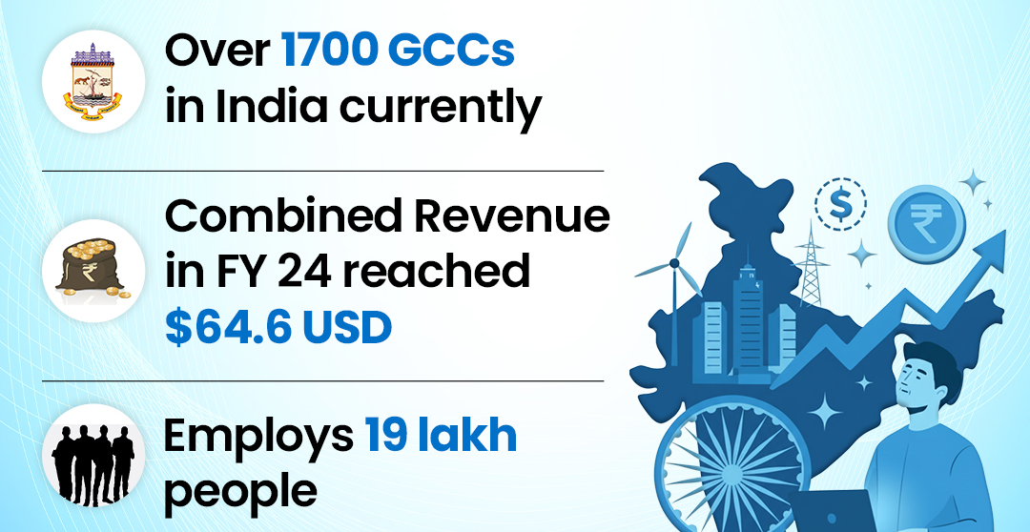
Figure 7: GCCs growth
Source: (PIB, 2025a)
The amount of R&D spending is still comparatively low in India compared to developed economies, which is limiting technological development, even relating to high-end areas like artificial intelligence and deep-tech innovation.

3.4 Firm Strategy, Structure, and Rivalry
Increased competition between domestic and multinational companies defines the Indian IT industry and promotes efficiency, innovativeness, and internationalisation. Enterprises are constantly investing in digital transformation, automation, and new technologies to ensure that they remain competitive. The industry has one of the highest amounts of companies with combined revenue of $19.93 billion in 2025, which makes it very competitive (IBEF, 2025a).
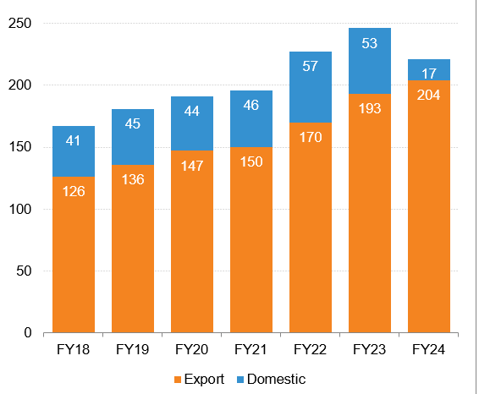
Figure 8: Revenue growth of the IT sector
Source: (IBEF, 2025a)
Moreover, the exports of Indian IT are over US$ 100 billion annually, which indicates the level of globalisation and integration of the industry (IBEF, 2025a). Although vigorous competition fosters innovation and cost effectiveness, it also causes margin pressures, especially in the conventional outsourcing services (Collinson et al., 2020). Businesses are increasingly flipping over to high-value services like cloud computing and artificial intelligence to continue to maintain profitability and perceive themselves as a unique entity in a saturated market.

3.5 Government Role and Chance
The government of India has engaged in policy development, infrastructure development, and investment facilities in fostering the development of the IT industry. Such programs as Digital India and Future Skills Prime have promoted the use of technology and entrepreneurship (PIB, 2025a). India is an appealing location for FDI inflows of more than $85 billion in a single year, and a high percentage of this investment is in the technology and digital industry (Kumar, 2024).
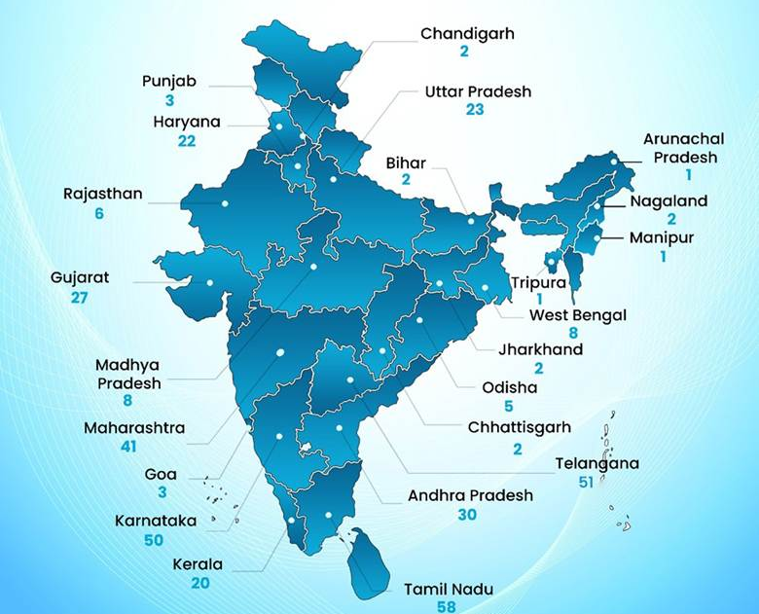
Figure 9: SEZs across India
Source: (PIB, 2026)
Also, the government has set up many Special Economic Zones (SEZs) to facilitate IT exports and investment (PIB, 2026). Nevertheless, one of the challenges is the complexity of regulation, bureaucratic inefficiency, and the lack of infrastructure. The industry also faces external influences of world economic conditions, technological upheavals, and geopolitical turbulences, which touch on the path of growth and thus the factor of chance plays in competitiveness.

4. Evaluation of TCS in India

4.1 Overview of TCS’s Operations
Tata Consultancy Services (TCS) has built India to be the hub of its worldwide IT services delivery network. It has gained this with the advantage of the talents of India and cost benefits to serve the global market. TCS, being a part of the Tata Group, has earned reliability and scale in IT services. The corporation has more than 600,000 employees globally, with a great percentage being based in India, illustrating that the country is at the centre of their operations (Tata Consultancy Services, 2025). As an illustration, TCS has large delivery centres in such cities as Bengaluru and Hyderabad, which allow it to provide a 24/7 service to international customers.
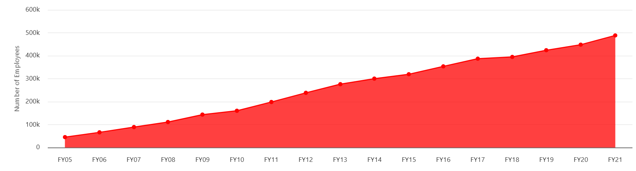
Figure 9: TCS Employees
Source: (Dazeinfo, 2020)
TCS offers services in consulting, cloud computing, artificial intelligence, and enterprise solutions. It has a diversified portfolio, which enables it to serve other industries like the banking and health sectors. The company registered a revenue of over $29.1 billion in 2024, which demonstrates its power on a global scale (TCS, 2024b).
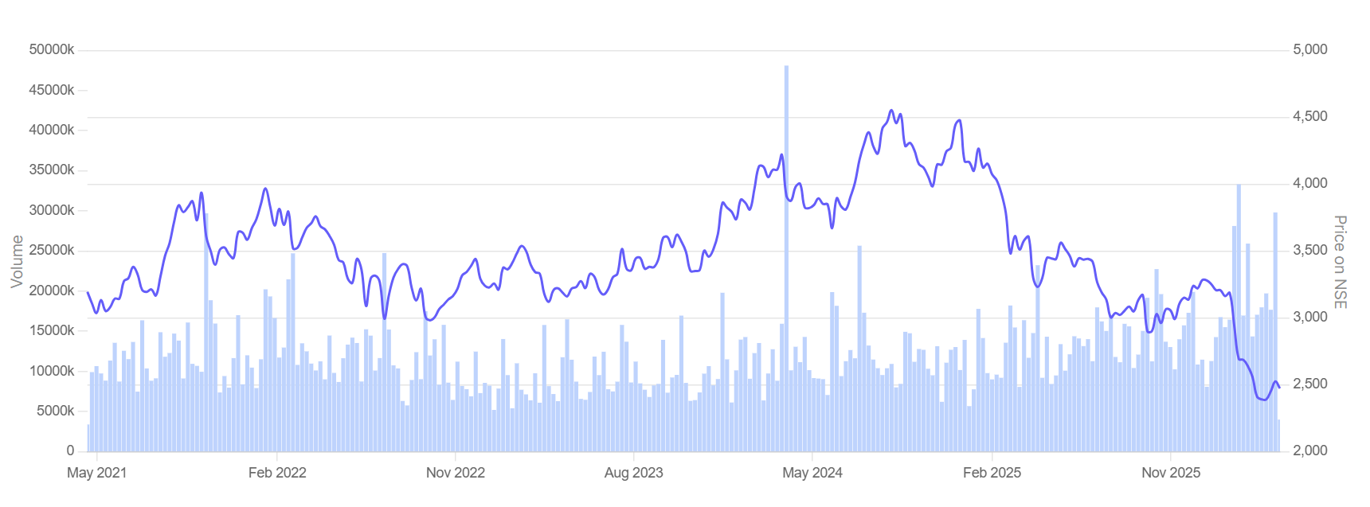
Figure 10: TCS Revenue
Source: (TCS, 2026)
As an example, TCS has long-term relations with international banks, to which it supplies core banking solutions via its BaNCS platform (TCS, 2025a). In spite of its size, TCS is under more competition pressure from other companies such as Infosys and Wipro and needs to constantly innovate. There are many other Indian IT companies, which add to the competition. Infosys, as a case in point, has spent a lot of money on digital transformation platforms, and it competes with TCS in segments of the high-value service.

4.2 Application of Eclectic Theory (OLI Framework)
The Eclectic Theory explains the organisation's global success through ownership, location, and internalisation advantages (Rochayatun et al., 2022). These elements collectively enable the firm to compete effectively in international markets.
Ownership Advantages
The company has high ownership advantages as Tata Consultancy Services (TCS) has a global brand reputation, proprietary platforms, and long-term relationships with clients. Its membership in the Tata Group boosts its trust and credibility in the global markets. TCS invests $415 billion in research and development every year, which promotes unremitting improvement and technological progress (TCS, 2025).
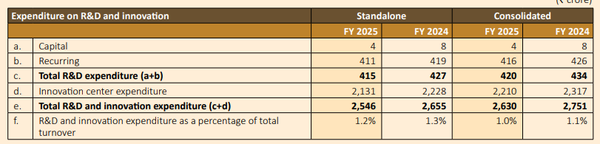
Figure 11: TCS R&D expenditure
Source: (TCS, 2025)
As an example of its technological prowess, its TCS BaNCS platform is popularly employed by international banks in their core banking activities (TCS, 2025a). The company has one of the highest global customer bases, an indication of its rich outreach and good customer base. An example is TCS, which offers multinational corporations end-to-end IT solutions across various industries like banking and retail, and reinforces long-term relationships. Hence it is capable of providing major projects in an efficient manner. Additionally, TCS reported an operating margin of 24.3%, highlighting its financial strength and market leadership (TCS, 2025). Resulting in its long-term agreements with financial institutions, guarantee the continuity of revenues and customer attraction.
Location Advantages
The location benefits in India are quite beneficial to TCS, especially with cost-effectiveness and availability of skilled labour. The IT environment in the country encourages mass service provision and development. The IT services exports of India are over 11.70 lakh crores, supporting its status as a world outsourcing destination (PIB, 2026). Indicatively, TCS has used delivery centres in such cities as Bengaluru and Pune to cater for clients in North America and Europe at an affordable cost.
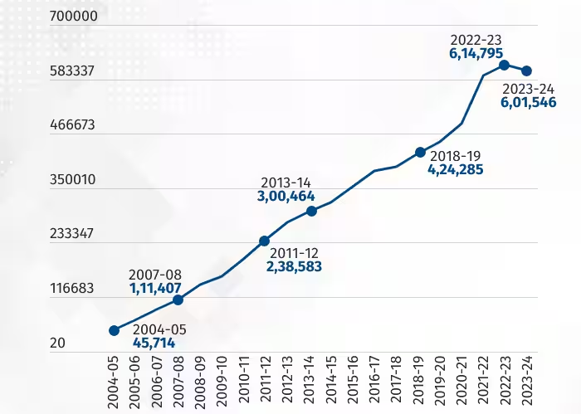
Figure 12: TCS hiring growth.
Source: (Shaw, 2024)
The Indian population represents a huge talent source for organisations such as TCS. In an example, TCS hired 6,01,546 engineering graduates annually to support its business (Shaw, 2024). These benefits, however, are slowly draining out because of increased costs and talent competition. The annual wage growth in the IT sector contributes to rising operational costs. To illustrate, TCS has introduced retention efforts to curb employee turnover rates, which have been high in recent years.
Internalization Advantages
The internalisation strategy of TCS aims at putting control over the operations to secure quality, data protection and protection of intellectual property. It is especially so in knowledge-intensive sectors like IT services. The market of outsourcing IT is $3.8 trillion globally in 2024, and it is crucial to raise efficient and reliable models of service delivery (Grand View Research, 2025). For example, TCS does not outsource the key processes; rather, it operates captive delivery centres, which provide uniformity in the service delivery.
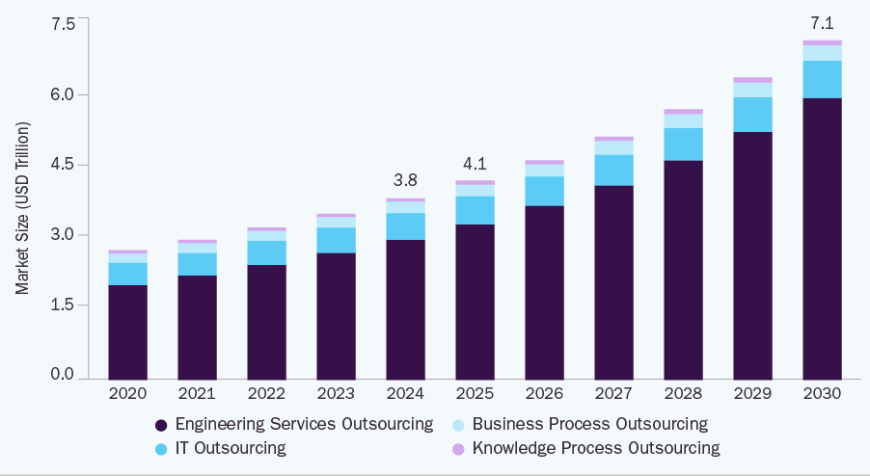
Figure 13: IT outsourcing market growth
Source: (Grand View Research, 2025)
The internalisation saves transaction costs and increases the efficiency of operation. TCS employs many engineers and is able to provide integrated solutions in more than one geography. Indicatively, its Global Network Delivery Model™ will enable the teams across time zones to have a coordinated effort (TCS, 2024a). However, it also makes operations more complex.
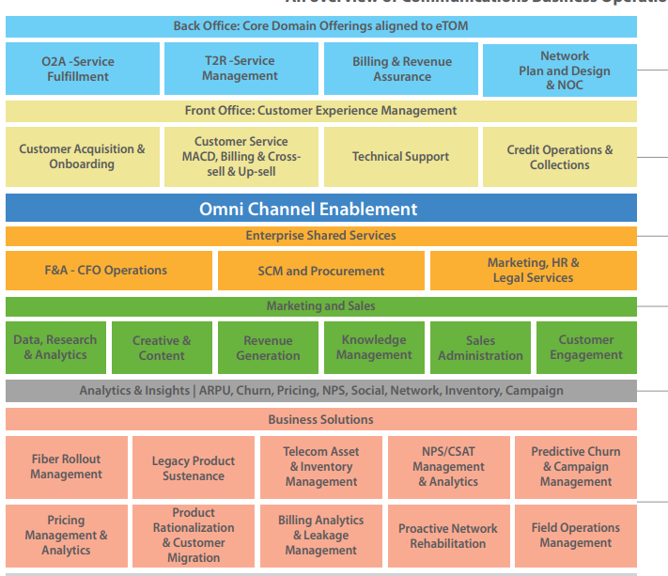
Figure 14: Global Network Delivery Model™
Source: (TCS, 2024a)
The large-scale internal operations demand large investments in infrastructure and technology. Indicatively, TCS has a significant investment in digital media to enhance teamwork and efficiency in project management to ensure successful international operations.

4.3 Location Hypothesis
The Location Hypothesis underlines the role of geographical influence in the determination of business success. India has cost and talent leverage, which makes it a strategic destination for TCS. The Indian IT industry has brought $90.2 billion in revenue during 2025 and will have USD 232.2 billion in revenue in 2033 (Grand View Research, 2026). Indicatively, TCS takes on graduates every year to sustain its business by graduating students from the engineering institutions.
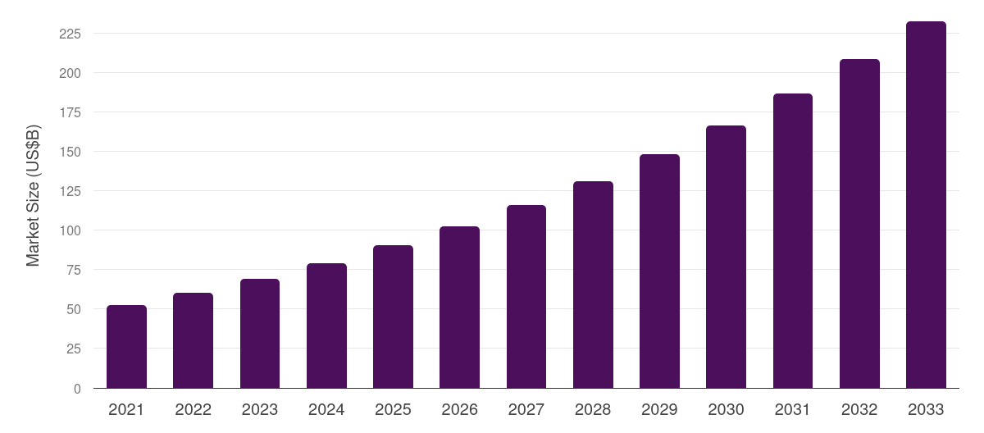
Figure 15: Indian IT service market growth
Source: (Grand View Research, 2026)
A major strength has been the cost efficiency, as the salaries paid to an Indian IT worker are 40% less than those paid in the United States (The Economic Times, 2025b). This will allow TCS to provide competitive prices to the clients. To allow TCS to delegate IT services to TCS in a bid to minimise operational expenses. Nevertheless, these benefits are being challenged by new wage demands and stiff competition for skilled workers. In recent years, attrition rates in the IT sector have been close to 20%, which has escalated the cost of hiring (Sengupta, 2022). As a result, TCS has established retention initiatives to deal with employee turnover. Moreover, there can be geopolitical risks, and protectionist moves in the developed markets to hinder the advantages of the location. Likewise, the capacity of Indian companies to transfer workers to foreign countries has been impacted due to visa restrictions in the US.

4.4 Internalisation Hypothesis
Tata Consultancy Services (TCS) has a great match with the Internalisation Hypothesis through outsourcing, being their decision to keep internalisation of its operations. With such a strategy, the firm can sustain a high degree of efficiency, quality of service provision and control over key business operations, especially in knowledge-intensive sectors like IT services.
Tata Consultancy Services (TCS) serves over 1,200 active clients globally, many of whom require secure and reliable IT services (TCS, 2025). Indicatively, in the banking industry, TCS handles sensitive financial information via their platforms, such as Banks. Therefore, the need to control internal controls is critical to maintain data security and compliance (Kumar, 2026). Internalising operations allows the reduction of dependency on third-party vendors and also eliminates all possible risks of outsourcing.
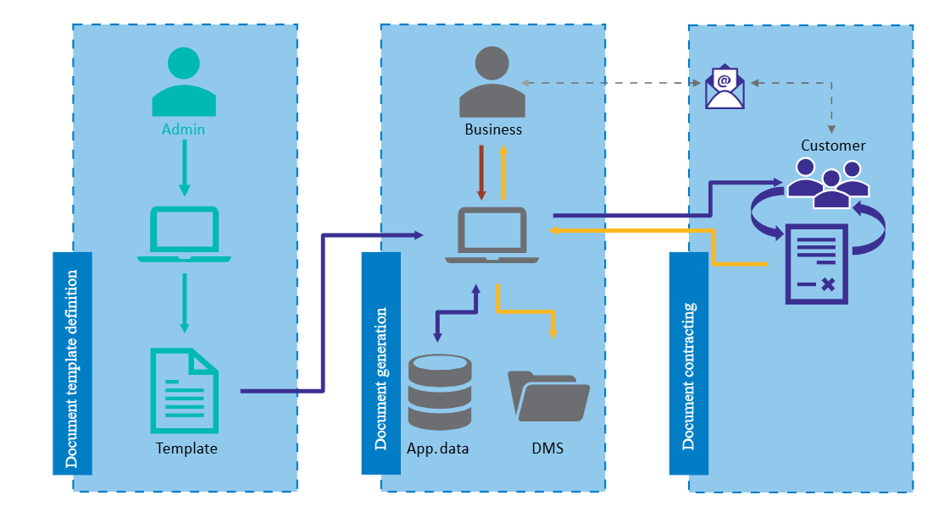
Figure 16: TCS BaNCS
Source: (Kumar, 2026)
Globally, the ICT outsourcing business is valued highly, which evaluates the significance of effectiveness and trustworthiness in operations. As an example, TCS can use its Global Delivery Model to coordinate its services to several geographic areas. It is so that coordination of the activities may be eliminated and sustained service delivery achieved. This method also contributes to lower transaction costs and increases the confidence between clients via uniform procedures. Nevertheless, the internalisation does add more operational complexity and costs. Tata Consultancy Services (TCS) has about 593,000 professionals in various locations around globally (Das, 2025). This means that it needs to invest heavily in infrastructure, training, and management systems.
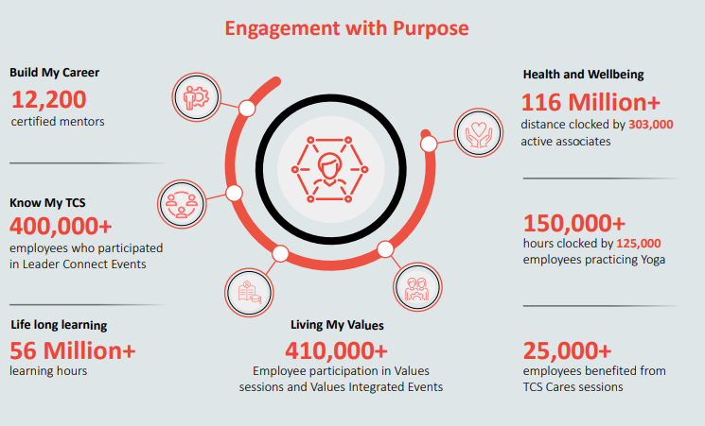
Figure 17: Engagement with Purpose
Source: (TCS, 2025)
As an illustration, the company invests in online teamwork platforms for employees to harmonise teams in various time zones. More than 25,000 employees benefited from TCS Cares sessions through its “Engagement with Purpose” (TCS, 2025). which justifies its financial capability to hold on to such mass-level internal activities and remain competitive in the IT services market globally.

4.5 Political Factors
The political climate in India is conducive to the expansion of the IT industry because it has pro-business policies and government-driven initiatives. Such programs as Digital India have contributed to the speed of digital adoption. India has an inflow of $1.14 trillion annual FDI, which means that it is very attractive to investors (IBEF, 2026).
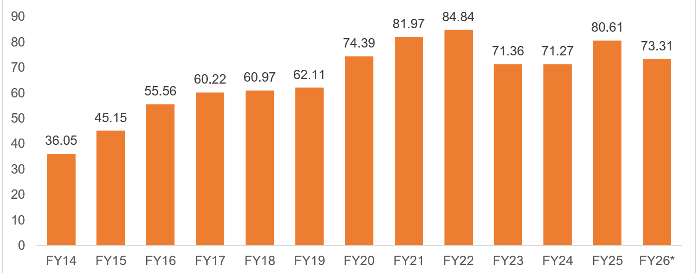
Figure 18: India FDI Inflow
Source: (IBEF, 2026)
As a case in point, multinational technology companies are ever increasing their business activities in India because of the conducive policies. Nevertheless, regulatory complexities and bureaucratic inefficiencies might be problematic. As an example, approvals and compliance delays may impact the project timetables in companies such as TCS. Also, international political trends like trade policies and visa restrictions facilitate these (Seyfi et al., 2020). Indicatively, shifts in the US immigration policies have affected TCS's ability to hire workers abroad. This highlights the role of political factors within the PESTLE framework in shaping business operations.

4.6 Economic Factors
The economic development of India provides an opportunity for the expansion of IT services. The rising digital economy in the country augments the need for technology solutions. GDP growth of India is averaged at 6.5–7% a year, which is favourable to a business (PIB, 2024). To illustrate, the digital transformation in other areas, such as banking, has opened a new opportunity to TCS.
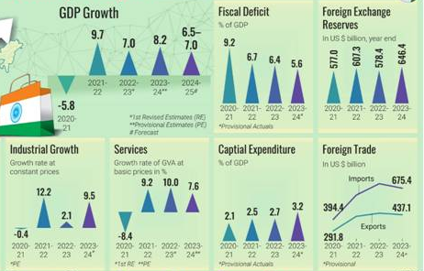
Figure 19: Indian Economy showcase
Source: (PIB, 2024)
Nevertheless, economic issues like inflation and currency may influence profitability. As an example, weakening the Indian rupee can boost the revenues on export but also lead to higher expenses on imported technology. An increase in wages will also affect the cost competitiveness in the IT sector, which is at 6-10% per year (The Financial Express, 2026). As an illustration, TCS has no option but to re-adjust its pricing approaches to ensure that it keeps its margins. This demonstrates how economic factors within the PESTLE framework influence industry performance and firm profitability.

4.7 Legal Factors
Improvement of the legal system in India has especially been experienced in intellectual protection and privacy of data, thus saving IT companies from an inhospitable environment. Stricter regulations on compliance costs have risen by 10-15 per cent. Every year, a large data technology company. In this example, TCS has to ensure that it adheres to the Indian and foreign this protection regulations, including GDPR. Nevertheless, the disparities in the laws of different nations pose problems to international business. As an example, TCS has to modify its practices to fit different rules and controls in Europe and the United States. This reflects the importance of legal factors within the PESTLE framework in shaping global business operations.

4.8 Cultural Factors
Cultural factors are very relevant in the international activities of TCS, especially in the management of a diverse workforce and client base. In the country, there are more than 1,528 million English speakers, and it is easy to communicate with international clients (Galan, 2025).
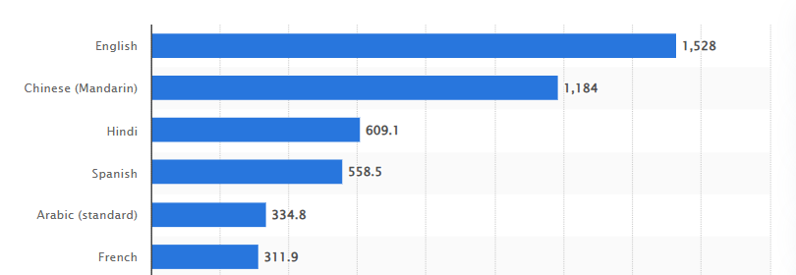
Figure 20: Language speaking preference.
Source: (Galan, 2025)
Thus, TCS teams are working with the clients in North America and Europe without a big language barrier. Nevertheless, the differences in culture in the work practices and ways of communicating might present a challenge (Wild and Wild, 2023). Indicatively, disparities in decision-making styles between the Indian and Western teams might come into decision-making implementation. TCS provides solutions to these challenges by training employees on cross-cultural and global mobility programs, which are crucial towards ensuring successful collaboration.

4.9 Market Attractiveness and Risks
The talent base and potential growth of the IT industry in India are quite appealing. The industry is projected to be at a point of $315 billion, meaning that there will be high growth in the industry (Suresh and Ishwarbharath, 2026). To illustrate, the rising need to use cloud computing and artificial intelligence has opened new sources of revenue to TCS. Nonetheless, the risks in the market also exist, such as high competition and technology displacement. The traditional outsourcing services are becoming less in demand due to automation and AI (Spring et al., 2022). The IT industry has a large workforce, as a result of which competition is strong. Additionally, regulatory changes and cybersecurity risks pose challenges. Examples include data breaches, which may destroy the confidence of the clients and cause legal implications. TCS has strong capabilities and flexibility, allowing it to continue growing despite these risks.

5. Conclusion
The IT services industry continues to be among the most competitive sectors in the global market with the support of a massive skilled labour force, cost efficiencies, and a well-developed, strong digital ecosystem in India. The advantages are good utilisation by companies like Tata Consultancy Services, which have found utilisation of leaders in global markets. The Diamond Model by Porter reveals that, despite the advantageous factor conditions and increased demand prospects, challenges like lack of infrastructure and regulatory complexities remain a problem in India. The critical analysis process of TCS brings out issues on how international business theories- specifically the Eclectic Theory, Location Hypothesis, and Internalisation Hypothesis explain why India is appealing as a destination for investment. Nonetheless, the threat of growing competition, wage pressures and changing regulatory systems is a constant issue. Generally, India still presents regulatory opportunities for IT services companies, and its growth prospects are solid in the long run, should the companies remain strategic in adapting to new challenges and global technological changes.

Section 2: Reflective Account (Gibbs Cycle)
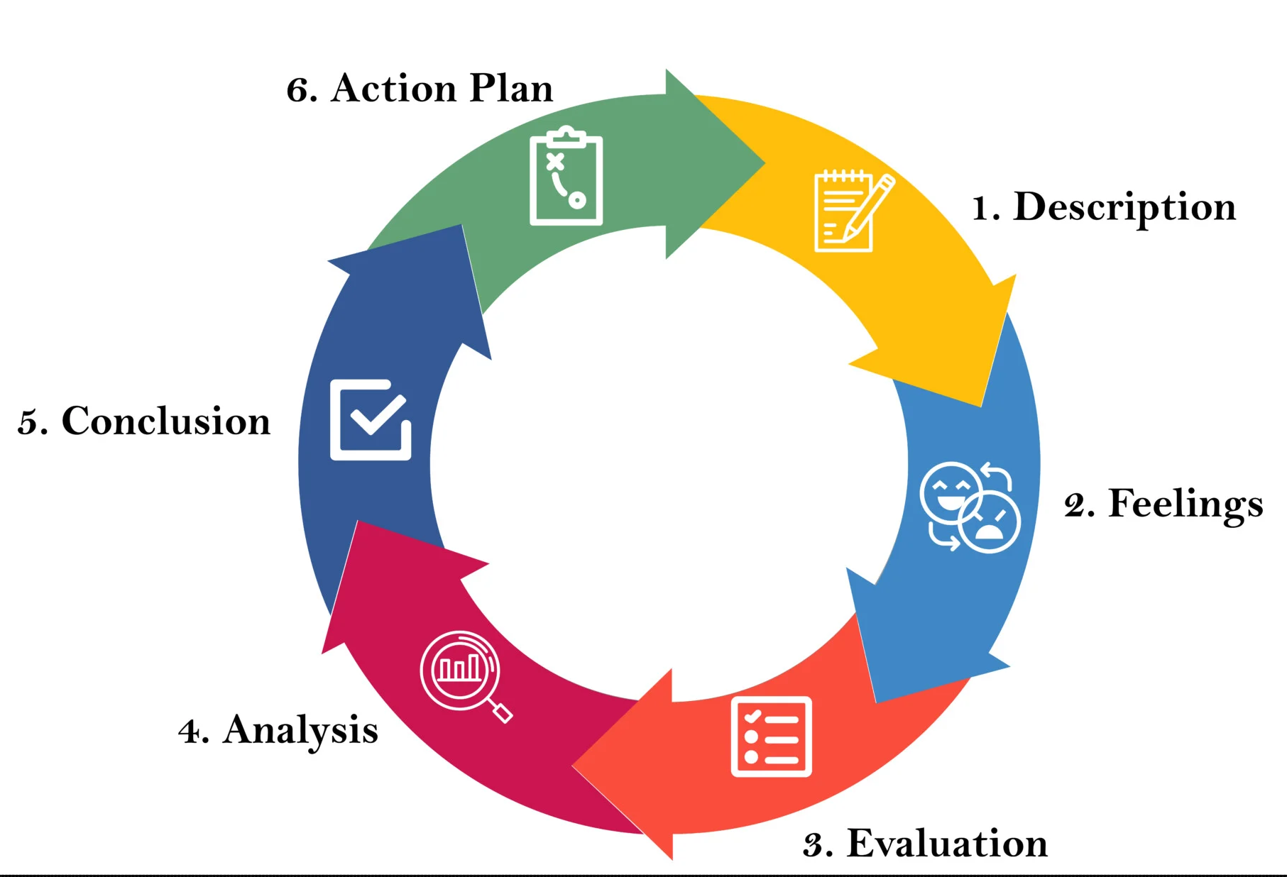
Figure 20: Gibbs Reflection Model
Source: (McLeod, 2025)

Description
The completion of this report involved a structured and multi-stage research process focusing on India’s IT services industry, with particular emphasis on Tata Consultancy Services (TCS). The task required integrating theoretical frameworks such as the Diamond Model with real-world industry data, while also applying international business theories, including the Eclectic Theory, Location Hypothesis, and Internalisation Hypothesis. I began by gathering secondary data from international company annual reports and academic literature. A significant part of the process involved selecting relevant statistics to support arguments, such as industry contribution to GDP, export figures, and employment levels. I then structured the report into key sections, ensuring logical flow and alignment with the assignment requirements. The most demanding part was Section 4, where I critically evaluated TCS’s operations in India using both theoretical and macro-environmental frameworks.

Feelings
First, when I came to the assignment, I was overwhelmed with the scope and complexity of the task. The necessity to integrate theoretical and practical business analysis initially appeared to be challenging, in particular in choosing the most suitable theories and using them appropriately. My behaviour as to how to balance between descriptive content and critical behaviour was also uncertain. However, as I went on, my self-esteem was slowly boosted. During the process of working on the Diamond Model offered by Porter, I started to realise that it is possible to describe the dynamics in the industry, relying on the models. This fact rendered the task more engaging and thought-provoking (Lehene et al., 2024). In the construction of Section 4, I was somewhat frustrated by the level of critical analysis demanded. It was critical to think and come up with several revisions when analysing the political, economic, legal and several sectors in a coordinated fashion. Nonetheless, by doing this, I felt accomplished after completing the section because I could relate theory to real-world business situations.

Evaluation
The fact that the arguments were supported by the use of statistical data regularly was one of the main strengths of my approach. Adding the quantitative data, including the figures of IT export and employment, made the report more credible and more scholarly. Also, I effectively put into practice three international business theories, and this assisted me in understanding why multinational companies are investing in the Indian market. The other strength was that the report was well organised. The grouping of the information into different parts, including an overview of the industry, Porter's analysis and an evaluation of MNCs, contributed to clarity and flow (Pangarkar and Prabhudesai, 2024). This helped to express complicated concepts logically. Nonetheless, it had some lapses as well. Sometimes, I became too descriptive and sometimes too not critical. To illustrate, in the earlier version, my description of TCS operations did not delve more into risks and strategies. Time management was another constraint (Melgaard et al., 2022). I used a lot of time in the collection of time collecting data, leaving less time to accomplish a lot of analysis and refinement. This influenced the depth of certain areas.

Analysis
The assignment also contributed a lot to my knowledge of the applicability of theoretical frameworks in the business world. To illustrate, the use of the Eclectic Theory (OLI framework) allowed me to realise the impacts of the ownership, location and internalisation advantages alongside the determination of foreign direct investments (Ren, 2024). I came to understand that the success experienced by TCS in India is beyond what is achieved through the aspects of cost-advantage. However, also through its capacity to capitalise on proprietary-technologies and exercise some level of control, capitalising on proprietary technologies, applying the Diamond Model presented by Porter helped me to critically examine the competitiveness of the Indian IT industry. I also discovered that India experiences both good factor conditions, like a skilled workforce, but also experiences other challenges, gaps in infrastructure and increased costs of labour. This moderated outlook enhanced my critical evaluation of industrial labourers, as opposed to describing industries. The application of the Gibbs Reflective Cycle on its own was valuable (Nurlatifah et al., 2023). It helped me to think about my learning process systematically, see my strengths and weaknesses, and create some improvements. I understood that critical thinking is not only the process of analysing the information outside but also considering how one embraces an approach to learning and problem solving.

Conclusion
On the whole, this assignment was a good learning experience and enhanced my academic and practical skills. It helped me become more efficient in doing my own research, interpreting intricate information, and putting the theory into practice. I also gained an improved insight into the global business of the IT services industry and what drives the competitiveness. Notably, the assignment also emphasised the necessity of a balanced consideration of both descriptive and critical analysis. It also made the role of effective time management and planning in the accomplishment of complex tasks important (Ghafar, 2023).

Action Plan
I intend to be more organised in my time management process by setting up definite periods concerning research, analysis and writing in future assignments. This will aid me in making sure that I allocate enough time to critical assessment as opposed to spending too much time gathering information. Another thing that I want to enhance is my critical thinking, and I will do this by becoming more interested in academic books and challenging the assumptions that I will be making in my analysis. To illustrate, rather than merely enumerating the benefits of a market, it is better to work on assessing possible dangers and long-term consequences (Simon and Dzreke, 2025). Also, I will practice being able to combine theory and practice better. This involves the choice of the most appropriate frameworks and the use of the same in a more analytical approach. Lastly, to add more depth and credibility to my work, I will rely on a broader scope of sources such as academic journals and industry reports.

References
Angelone (2024). India’s IT Sector Analysis: A Powerhouse Driving Economic Growth. Available at: https://www.angelone.in/news/share-market/india-it-sector-analysis-economic-growth. [Accessed on 10th April 2026]
Cammarano, A., Varriale, V., Michelino, F. and Caputo, M. (2024). Discovering technological opportunities of cutting-edge technologies: A methodology based on literature analysis and artificial neural network. Technological Forecasting and Social Change, 209, p.123811. doi:https://doi.org/10.1016/j.techfore.2024.123811.
Das, A. (2025). TCS headcount drops to less than 600k due to restructuring and layoffs. @bsindia. Available at: https://www.business-standard.com/industry/news/tcs-headcount-falls-below-600000-after-layoffs-in-july-2025-125100901286_1.html [Accessed on 11th April 2026]
Dazeinfo (2020). Number of TCS Employees by Year: FY 2005 - 2021. Dazeinfo. Available at: https://dazeinfo.com/2020/05/26/number-of-tcs-employees-worldwide-by-year-graphfarm/. [Accessed on 10th April 2026]
Galan, S. (2025). The most spoken languages worldwide 2025| Statista. Statista. Available at: https://www.statista.com/statistics/266808/the-most-spoken-languages-worldwide/?srsltid=AfmBOoqLqFRAf15dH-xoJZTDtD-KclS-LVraIMor954zag6XdU8eSFls [Accessed on 11th April 2026]
Gaudiaut, T. (2026). Infographic: India IT Hiring Holds Steady, but Stays Below Peak. Statista Daily Data. Available at: https://www.statista.com/chart/35855/it-hirings-tech-industry-india/?srsltid=AfmBOopB4gjxaBjKEWyNDo3MkvkXysQYhzKC-IrWCtLpoR1l44Cu26oE [Accessed on 12th April 2026]
Ghafar, Z.N. (2023). The Relevance of Time Management in Academic Achievement: a Critical Review of the Literature. International Journal of Applied and Scientific Research, 1(4), pp.347–358. doi:https://doi.org/10.59890/ijasr.v1i4.1008.
Grand View Research (2025). Outsourcing Services Market Size | Industry Report, 2030. Grandviewresearch.com. Available at: https://www.grandviewresearch.com/industry-analysis/outsourcing-services-market-report. [Accessed on 13th April 2026]
Grand View Research (2026). India IT Services Market Size & Outlook, 2030. Grandviewresearch.com. Available at: https://www.grandviewresearch.com/horizon/outlook/it-services-market/india. [Accessed on 10th April 2026]
IBEF (2025a). IT & BPM Industry in India: Market Size, Opportunities, Growth, Report | IBEF. www.ibef.org. Available at: https://www.ibef.org/industry/information-technology-india. [Accessed on 11th April 2026]
IBEF (2025b). Services Sector in India: Overview, Market Size, Growth, Companies...IBEF. India Brand Equity Foundation. Available at: https://www.ibef.org/industry/services.
IBEF (2026). FDI in India: Foreign Direct Investment Opportunities, Policy | IBEF. www.ibef.org. Available at: https://www.ibef.org/economy/foreign-direct-investment. [Accessed on 11th April 2026]
Kumar, K. (2026). Digital Contracts: TCS BaNCS’ Blueprint for Seamless Contracting. Tcs.com. Available at: https://www.tcs.com/what-we-do/products-platforms/tcs-bancs/articles/bancs-revolutionizing-digital-contracts [Accessed on 10th April 2026]
Kumar, P. (2024). STUDY FOREIGN DIRECT INVESTMENT (FDI) IN INFORMATION & TECHNOLOGY (IT) AND ITeS SECTOR IN INDIA. Online) Shodh Samarth-Research Journal of Commerce, 1(2), pp.65–79. Available at: https://sdsuv.co.in/commerce_journal/Research%20Paper%206-2.pdf.
Lehene, C.F., Jaradat, M. and Nistor, R.L. (2024). An interdisciplinary and multilevel analysis of local economy determinants and their impact on firm performance—Considering Porter’s diamond model, clusters, and industry. Systems, 12(3), p.82.https://www.mdpi.com/2079-8954/12/3/82?trk=organization_guest_main-feed-card-text
Li, L. (2022). Reskilling and Upskilling the future-ready Workforce for Industry 4.0 and beyond. Information Systems Frontiers, 24(3), pp.1–16. doi:https://doi.org/10.1007/s10796-022-10308-y.
McLeod, S. (2025). Gibbs Reflective Cycle. Simply Psychology. Available at: https://www.simplypsychology.org/gibbs-reflective-cycle.html. [Accessed on 12th April 2026]
Mehta, S. and Baskaran, A. (2023). Upgrading within Global Value Chains and Innovation Capabilities: Lessons from Indian Information Technology Sector. Institutions and Economies, pp.113–140. doi:https://doi.org/10.22452/IJIE.vol15no4.5.
Melgaard, J., Monir, R., Lasrado, L.A. and Fagerstrøm, A. (2022). Academic Procrastination and Online Learning During the COVID-19 Pandemic. Procedia Computer Science, 196, pp.117–124. doi:https://doi.org/10.1016/j.procs.2021.11.080.
Mordor Intelligence (2025). India IT Services Market Size, Share & 2030 Trends Report. Mordor Intelligence. Available at: https://www.mordorintelligence.com/industry-reports/india-it-services-market. [Accessed on 13th April 2026]
Mulyono, H. and Rolando, B. (2024). Savoring The Success: Cultivating Innovation And Creativity For Indonesian Culinary MSMEs Growth. Economics and Business Journal (ECBIS), 2(4), pp.413–428. doi:https://doi.org/10.47353/ecbis.v2i4.142.
Nurlatifah, L., Purnawarman, P. and Sukyadi, D. (2023). The implementation of reflective assessment using Gibbs’ reflective cycle in assessing students’ writing skill. Nucleation and Atmospheric Aerosols, 2621(1). doi:https://doi.org/10.1063/5.0143375.
Pangarkar, N. and Prabhudesai, R. (2024). Using Porter’s Five Forces Analysis to Drive Strategy. Global Business and Organizational Excellence, 43(5), pp.1–11. doi:https://doi.org/10.1002/joe.22250.
PIB (2024). INDIA’S REAL GDP PROJECTED TO GROW BETWEEN 6.5–7 PER CENT IN 2024-25. Pib.gov.in. Available at: https://www.pib.gov.in/PressReleasePage.aspx?PRID=2034973. [Accessed on 13th April 2026]
PIB (2025a). From Policy to Prosperity: GCCs Leading India’s Growth Journey. Pib.gov.in. Available at: https://www.pib.gov.in/PressReleasePage.aspx?PRID=2202046®=3&lang=2 [Accessed on 13th April 2026]
PIB (2025b). India’s Startup Revolution. Pib.gov.in. Available at: https://www.pib.gov.in/PressReleasePage.aspx?PRID=2098452. [Accessed on 14th April 2026]
PIB (2026). Union Budget 2026–27: Strengthening SEZs for Global Competitiveness & Growth. Pib.gov.in. Available at: https://www.pib.gov.in/PressReleasePage.aspx?PRID=2246386 [Accessed on 14th April 2026]
Ren, Y. (2024). A Review of the Determinants of Outward Foreign Direct Investment (FDI): From the Perspective of the Eclectic Paradigm. Academic Journal of Business & Management, 6(11), pp.128–132. doi:https://doi.org/10.25236/AJBM.2024.061119.
Rochayatun, S., Sudarmiatin and Bidin, R. (2022). Mode of Entry Strategy on SMEs Internationalization in East Java. Article7submit.com. doi:http://artix.article7submit.com/id/eprint/1236/1/720-Article%20Text-1255-1-10-20221003.pdf.
Sarial‑Abi, G., Ulqinaku, A., Viglia, G. and Das, G. (2021). The effect of financial scarcity on discretionary spending, borrowing, and investing. Journal of the Academy of Marketing Science. doi:https://doi.org/10.1007/s11747-021-00811-0.
Sen, A. (2023). India’s internet economy to hit $1 trillion by 2030: Report. IndBiz | Economic Diplomacy Division. Available at: https://indbiz.gov.in/indias-internet-economy-to-hit-1-trillion-by-2030-report/. [Accessed on 14th April 2026]
Sengupta, D. (2022). IT attrition rates likely to remain high at 20%. mint. Available at: https://www.livemint.com/companies/news/it-attrition-rates-likely-to-remain-high-at-20-11665514645923.html [Accessed on 13th April 2026]
Seyfi, S., Hall, C.M. and Shabani, B. (2020). COVID-19 and international travel restrictions: the geopolitics of health and tourism. Tourism Geographies, 25(1), pp.1–17. doi:https://doi.org/10.1080/14616688.2020.1833972.
Sharma, N. (2025). Why are so many of India’s 1.5 million fresh engineers every year unemployable? Forbesindia.com. Available at: https://www.forbesindia.com/article/upfront/column/why-are-so-many-of-indias-1-5-million-fresh-engineers-every-year-unemployable/2988705/1. [Accessed on 13th April 2026]
Shaw, R. (2024). TCS full-year net headcount declines first time in 19 years; ends FY24 with 601,546 employees. Moneycontrol. Available at: https://www.moneycontrol.com/news/technology/tcs-full-year-net-headcount-declines-for-first-time-in-19-years-ends-fy24-with-601546-employees-12625311.html. [Accessed on 14th April 2026]
Simon, S. and Dzreke (2025). The Competitive Advantage of AI in Business: A Strategic Imperative. IJFMR250450400, 7(4). Available at: https://www.ijfmr.com/papers/2025/4/50400.pdf.
Spring, M., Faulconbridge, J. and Sarwar, A. (2022). How information technology automates and augments processes: Insights from Artificial‐Intelligence‐based systems in professional service operations. Journal of Operations Management, 68(6-7), pp.592–618. Available at: https://onlinelibrary.wiley.com/doi/pdfdirect/10.1002/joom.1215.
Suresh, H. and Ishwarbharath , S.B. (2026). India’s TCS tops estimates, says new AI models did not dent services demand. Reuters. 9 Apr. Available at: https://www.reuters.com/world/india/indias-tcs-beats-fourth-quarter-revenue-view-2026-04-09/. [Accessed on 12th April 2026]
Tata Consultancy Services (2025). TCS Ranked Among Top 20 Global Technology Brands in Brand Finance Tech 100 2025 List. Tcs.com. Available at: https://www.tcs.com/who-we-are/newsroom/press-release/tcs-ranked-top-20-global-technology-brands-in-brand-finance-tech-100-2025. [Accessed on 14th April 2026]
TCS (2024a). Business Operations Communications Business Operations. Available at: https://www.tcs.com/content/dam/global-tcs/en/pdfs/insights/solution-details/communication-business-op.pdf. [Accessed on 15th April 2026]
TCS (2024b). Integrated nnual Report Backdrop: TCS Gitanjali Park Campus, Kolkata, India. Available at: https://www.tcs.com/content/dam/tcs/investor-relations/financial-statements/2023-24/ar/annual-report-2023-2024.pdf. [Accessed on 14th April 2026]
TCS (2025). 2024-25 Integrated Annual Report. Available at: https://www.tcs.com/content/dam/tcs/pdf/discover-tcs/investor-relations/faq/tcs-integrated-annual-report-2024-2025-2pager.pdf. [Accessed on 15th April 2026]
TCS (2026). Tata Consultancy Services Ltd financial results and price chart - Screener. www.screener.in. Available at: https://www.screener.in/company/TCS/consolidated/. [Accessed on 14th April 2026]
TCS (2025a). TCS BaNCS for Banking: Accelerating Digital Transformation of Banks. www.tcs.com. Available at: https://www.tcs.com/what-we-do/products-platforms/tcs-bancs/solution/banking-solutions [Accessed on 13th April 2026].
TCS (2025b). TCS to Provide End-to-End Application Development and Maintenance Services to Air Liquide in the Americas. www.tcs.com. Available at: https://www.tcs.com/who-we-are/newsroom/press-release/tcs-end-to-end-application-development-maintenance-services-air-liquide-americas. [Accessed on 11th April 2026]
The Economic Times (2025a). India’s IT workforce: A strategic asset in a fragmented world. The Economic Times. Available at: https://m.economictimes.com/small-biz/security-tech/technology/indias-it-workforce-a-strategic-asset-in-a-fragmented-world/articleshow/124937558.cms. [Accessed on 14th April 2026]
The Economic Times (2025b). India’s tech professionals see 40% pay drop; US salaries rise 23% to record highs. The Economic Times. Available at: https://m.economictimes.com/jobs/hr-policies-trends/indias-tech-professionals-see-40-pay-drop-us-salaries-hit-record-highs/articleshow/124872435.cms [Accessed on 14th April 2026]
The Financial Express (2026). The new baseline: Why 10% is the minimum hike for India’s top talent in 2026. Financialexpress.com. Available at: https://www.financialexpress.com/business/news/the-new-baseline-why-10-is-the-minimum-hike-for-indias-top-talent-in-2026/4161592/ [Accessed on 15th April 2026]
Tila, C. (2025). India: number of internet users 2050| Statista. Statista. Available at: https://www.statista.com/statistics/255146/number-of-internet-users-in-india/?srsltid=AfmBOopBfd-jbG_0KLoGY77Yk0_xzkXi_4WxtnQTU_LiRwWVlanGFgPh [Accessed on 12th April 2026]
Wipro (2024). Wipro in the News: Insights and Highlights from Recent Coverage. Wipro.com. Available at: https://www.wipro.com/newsroom/wipro-in-the-news/. [Accessed on 13th April 2026]
Ye, M., Ji, F., Qi, T., Xu, Y., Liang, Y., Meng, Y. and Zhang, L. (2024). An evaluation and comparative analysis of higher education health and sustainability: India’s performance and global. Journal of Infrastructure Policy and Development, 8(12), p.9302. doi:https://doi.org/10.24294/jipd.v8i12.9302.
Zonnenshain, R.S. (2020). REGIONAL DEVELOPMENT IN THE ERA OF INDUSTRY 4.0. DOAJ (DOAJ: Directory of Open Access Journals). doi:https://doi.org/10.17708/drmj.2020.v09n02a02.
Retrieved from Lecture
Collinson, S., Narula, R., and Rugman, A. M., 2020. International Business. 8th ed. Essex: Pearson Education Limited.
Daniels, J. D., Radebaugh, L. H., Sullivan, D. P., and Click, R. W., 2022. International Business: Environments and Operations. 17th ed. Essex: Pearson Education Limited.
Wild, J. J. and Wild, K. L., 2023. International Business: The Challenges of Globalisation. 10 ed. Essex: Pearson Education Limited.

