
Skills for the Workplace
Module Assignment Submission
Student Name: | Callum Jennings
Student Number: | 2007363
Module No: | BMSK4002
Module Title: | Effective Team Working and Communication  Part 2

Statement of Confirmation of Authenticity
By the act of making this submission, the student declares that this is the work of the student named above. The work has not, in whole or in part, been knowingly presented elsewhere for assessment, or where assessment has been built on a previous assessment, this has been identified. Where materials have been used from other sources it has been properly acknowledged. If this statement is untrue, the student acknowledges that an assessment offence has been committed.
Attention is drawn to the plagiarism and unfair practice policies of both the University and of ILM.

Table of Contents
Introduction. 3
Part 2 3
Communication 3
Types of Communication 3
Assessing Own Communication Skills 7
Conclusion 9
References 10

Introduction.
Continuing in Part 2 form the presentation, in this assignment I will be discussing the different types of communication and different communication models created by different Professors over the years. Once I have researched this information I will discuss what each model contains and what they mean. I will then be discussing Part 1 of this assignment being the presentation. Talking about feedback and overall performance of the presentation and using this as a method of creating a Personal development plan and use this to show how feedback and looking at personal development can have a positive outcome on effective teamwork. Concluding with how I feel about communication and what impact I believe it has on effective teamwork.

Part 2

Communication
Communication within the workplace and day to day life is important, but communication, if not done correctly can cause complications. (Connelly, 2020) talks about Stephen Covey 7 habits of highly effective people, (Covey, 2003) within this book Covey talks about many different habits of effective people but, one habit relates to communication. Habit number five is titled ‘Seek first to understand, then to be understood’. This habit is about communicating with others. It is about developing the habit of listening carefully and really understanding the other person before giving your thoughts.
A personal example of this is just a few weeks ago I started a new job. Being in a new job role with a whole new team can be challenging when it comes to communication. However, talking a step back and letting others talk and discus scenarios or situations, allowed for me to break down, analyse and understand where that person’s thoughts or opinions came from, allowing me to communicate effectively and using the correct channel of communication.

Types of Communication

There are four different types of communication and ways to use them, each with their own requirements or guidelines.

(Team, 2021)

Verbal | Nonverbal | Visual | Written
- Use a strong, confident speaking voice.  - Use active listening.  - Avoid filler words.  - Avoid industry jargon when appropriate. | - Notice how your emotions feel physically.  - Be intentional about your nonverbal communications.  - Mimic nonverbal communications you find effective. | - Ask others before including visuals.  - Consider your audience.  - Only use visuals if they add value.  - Make them clear and easy-to-understand. | - Strive for simplicity.  - Do not rely on tone.  - Take time to review your written communication.  - Keep a file of writing you fine effective and enjoyable.

The 7 38 55 rule of communication.

Albert Mehrabian is a psychology professor who created the Mehrabian Formula.
(Mulder, 2013) article discusses the Mehrabian formula from Albert’s book, (Mehrabian, 1972)
It explains what elements Albert Mehrabian believed; effective communication consisted of.
Professor Mehrabian believed that what the listener hears will differ depending on what the speaker’s nonverbal communication technique is used. Meaning, the listener will focus on the 55% and the 38% of nonverbal communication as supposed to actually listening to what is being said (7%).

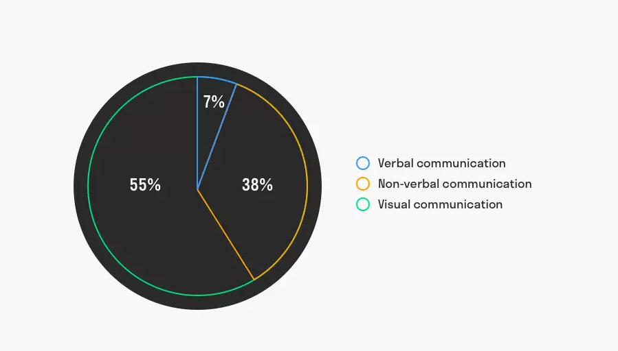

“The fundamental problem of communication is that of reproducing a message sent from one point, either exactly or approximately, to another point” (Weaver, 1948)
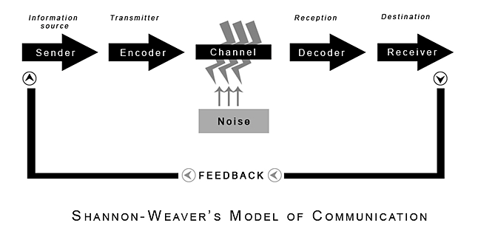
(Shannon and Weaver, 1949)

A breakdown for this model looks like this –
1) Sender (information source).
This is where the information starts, they are the person or object or thing – any information source who has the information to start with. The send then chooses who to send the information to by choosing what form of communication to use, it may be orally, in writing or through body language.
2) Encoder (Transmitter).
The next step in Shannon Weaver’s model is the ‘encoder’. The encoder is the machine (or person) that converts the idea into signals that can be sent from the sender to receiver. The Shannon model was designed originally to explain communication through telephones and computers which encode our words using codes like binary digits or radio waves. However, the Encoder can be a person that turns an idea into spoken words, written words, or a sign language to communicate an idea to someone who is deaf or hard of hearing. For example, when we use the telephone, the telephone coverts our voice into binary 1s and 0s and sent down telephone lines (the channel). Another may be via radio waves, in which a microphone turns sound into radio waves and is converted back into sound again.
3) Channel.
The Channel of communication is the infrastructure that gets information from the sender and transmitter through the decoder and receiver. This is also known as ‘the medium’.
4) Noise.
Noise interrupts a message while it is on the way from the sender to receiver. It is named after the idea that ‘noise’ could interrupt any understanding of a message. There are two types of noise.
The first is internal. This happens when a sender makes a mistake encoding the message or a receiver makes a mistake decoding the message. Two points where this could happen is,
- At the point of encoding e.g., a spelling mistake.
- At the point of decoding e.g., if someone misinterprets a sentence when reading it.
The second is external noise. This type of noise is not in control of the sender or receiver. For example, if something interrupts or impedes the message.
- When having a conversation next to a busy road or somewhere with a lot of background noise causing things to be misheard.
5) Decoder.
Decoding is the complete opposite to the encoder. If communication is made using technology a decoder is needed to change the binary 1’s and 0’s back into the language or format that was originally used so that the message can be understood by the receiver.
If communication is made without technology there may still be a need or use for a decoder. For example, turning written words into something that makes sense in your head by reading things out loud.
6) Receiver (Destination)
The receiver is the step where the person finally gets the message, or what is left of it after accounting for noise.
For example, the person at the other end of the phone call or the person that is reading the email that has been sent to them.
7) Feedback
The final step in the Shannon and Weaver is feedback, which originally was not part of the original proposal for the model in 1949. Norbert Wiener came up with the feedback step in response to criticism of the one-way nature of the approach to communication. Feedback happens when the receiver responds to the message sent by the Sender to let them know that they have got the message clearly without any noise. Allowing the closure of the communication loop.

Assessing Own Communication Skills

One type of communication that is used daily is written communication. Written communication can be used for many things, Email, text, letters and feedback sheets. An example of this is recently I conducted a presentation and asked the audience to fill out a feedback sheet that I had created, allowing me to then create a Personal Development Plan (PDP) to see how could better myself should I be in a presentation scenario again.

This is the feedback sheet from one member of the audience-
 | Weak | Fair | Good | Excellent
Prepared for Presentation. |  |  | yes
Presented in an interesting way. |  | yes
Objectives of the presentation are clear. |  |  | yes
Used visual aids effectively. |  | yes
Organised the presentation logically. |  |  |  | yes
Made eye contact with audience. |  | yes
Presented without reading. |  | yes
Spoke loudly enough. |  |  |  | yes
Spoke slowly and clearly. |  |  |  | yes
Presented within appropriate time. |  |  | yes
Responded to questions accurately. | No questions
Gareth Thomas completed feedback sheet for Callum Jennings. 23 05 21

I created the PDP to reflect on how I can get from anything below ‘Excellent’ up to ‘Excellent’.

(PDP)

Skill | Current Response. | Desired Response. | How to obtain
Presented in an interesting way. | Fair. | Excellent. | Asking my audience what would need to be added so that they might find it interesting and incorporate their responses.
Prepared for the presentation. | Good. | Excellent. | Take more time prior to presentation date to prepare material.
Objectives of the presentation are clear. | Good. | Excellent. | Add in a lesson plan and talk over what will be discussed throughout the presentation before starting any slides.
Used visual aids effectively. | Fair. | Excellent. | Add in more charts/graphs or incorporate more diagrams and images.
Made eye contact with audience. | Fair. | Excellent. | Use a better webcam and check lighting of the room so that all members of the audience can see me.
Presented without reading. | Fair. | Excellent. | Take time prior to presentation to practice the script and learn it off by heart.
Presented within appropriate time. | Good. | Excellent. | Run time for presentation was 9min (target was 8-12min) add more slides to bulk up the presentation and push more towards the maximum run time.

Creating a PDP will allow me to see where I went wrong and look at how I can better myself in future. Using feedback sheets and PDP’s will always allow for a stronger team connection as it reenforces the fact that honest and fair opinions on each other’s work will allow people to evolve and develop skills they might have thought they were already good at. An example of this is recently at work I was feeling down because I thought my overall performance was not up to scratch and that I was not meeting the requirements for the company. After discussing this with my team leader he explained that I was actually hitting target and that it was only the last couple days that my performance was little below optimum. He went on to explain that I am one of his best agents and explained a few things I can do to remain at the top of the teams’ targets. Since then, I have implemented the information he gave me, and I have continued to hit target and feel a stronger connection within my team.

Conclusion

Good communication is essential in the workplace as it allows all team members to be aware of what is going well or going bad. My overall preference for communication types would be Verbal. I believe that although nonverbal communication is effective and immensely helpful for long distance communication, nonverbal communication lacks a more personal touch or emotional connection between the sender and receiver, which I believe, more often than not, leads to a breakdown in understanding the information given which would lead to a breakdown in effective working further down the line.

References

Connelly, M. (2020). Stephen Covey: Discover The 7 Habits of Highly Effective People. [online] Change Management Coach. Available at: https://www.change-management-coach.com/stephen-covey.html#:~:text=Stephen%20Covey%20believes%20this%20principle%20is%20the%20key [Accessed 28 May 2021].
Covey, S.R. (2003). The 7 habits of highly effective people personal workbook. New York: Simon & Schuster.
Team, I.E. (2021). 4 Types of Communication (With Examples). [online] Indeed Career Guide. Available at: https://www.indeed.com/career-advice/career-development/types-of-communication#:~:text=Types%20of%20communication%201%20Verbal.%20Verbal%20communication%20is [Accessed 28 May 2021].
Mulder, P. (2013). What is the 7 38 55 rule of Communication? Mehrabian Theory. [online] toolshero. Available at: https://www.toolshero.com/communication-skills/7-38-55-rule/ [Accessed 28 May 2021].
Mehrabian, A. (1972). Nonverbal communication. Chicago: Aldine-Atherton.
Weaver, S. (1948). A Mathematical Theory of Communication.
Shannon, C. and Weaver, W. (1949) The Mathematical Theory of Communication. Urbana: University of Illinois Press.
UKEssays. November 2018. Personal development plan. [online]. Available from: https://www.ukessays.com/essays/human-resources/personal-development-plan.php?vref=1 [Accessed 30 May 2021].

