Academic Skills - LCBB4000

Lecturer - Alexander Worth

Student - Florin Daniel Baleanu 2109714

Apps to increase interactivity during online learning

Executive summary
The report has involved discussion based on the use of Apps to increase interactivity during online learning. For this purpose, different names of apps such as courser, edX as well as Future Learn and Open Learn have been mentioned in brief. It is highlighted that there are prominent positive and negative aspects to effectively using online learning tools. The positive aspects based on the use of online learning apps center on the development of interactivity between students and their mentors from a distant location. On the other hand, the development of internet addiction is a negative aspect of online learning. Additionally, the Connectivism Learning Theory and Enriched Virtual Model of Blended Learning have been incorporated into the discussion.
Table of Contents
Introduction 4
Discussion 5
Different apps to interact during online learning and their activity 5
Positive and negative aspects for using these apps 5
Application of Connectivism Learning Theory and Enriched Virtual Model of Blended Learning 6
Conclusion 9
Reference list 10

Apps to increase interactivity during online learning

Introduction
In the pandemic situation, online learning has occupied an effective position in the modern educational system. To maintain consistency in the educational system, technology has come forward. Different apps have been invented which are now being utilized widely for managing interactivity during the online learning procedure. This academic report has involved discussion based on different apps and their functions in online learning systems along with positive and negative aspects for using these apps. Additionally, learning theory and model have been incorporated to be aligned with the topic, so that the credibility of the area of discussion can be proved.

Discussion

Different apps to interact during online learning and their activity
There are several apps in the field of online learning. As per the information of Readdle (2020), courser, edX, as well as Future, Learn and Open Learn are some of the effective apps for online learning. It can be presented that one of the world's best-known online learning resources, Coursera has several thousand courses from leading educational providers. During the pandemic, it seems to be a good source for the students to know about lots of happening in the surrounding world. On the other hand, edX has collaborated with several world-famous universities such as Harvard and it mainly deals with humanities and natural sciences. As mentioned by Andrew (2019), the arrival of advanced information technologies has changed the skills needed of students in the 21st century. It is now prominent that the students throughout the globe are focused to use the tech-based system to gather knowledge. It is seen that Future Learn is effective to provide scopes to students to be engaged in several short courses. The length of the courses determines whether the student wants to go to the depth or not. Several Google learning apps are easier for the students to access at any time and search on the area which they want to explore. For example, the Open learn online learning platform provides scopes for free engagement in a course. From this discussion, it is quite clear that in the pandemic situation, IT has come forward to help students to be involved in different practical and theoretical sources. These apps are also helpful for the students to interact with different university authorities and thus, solving queries is not an issue now anymore.

Positive and negative aspects for using these apps
The positive aspects based on the use of online learning apps center on the development of interactivity between students and their mentors from a distant location. Secondly, it can be highlighted that the students can use the platform any time and can access the lecture sessions so that it has become the way of developing the circle of knowledge even during a lockdown session. In the comments of Baker-Eveleth and Stone (2020), quick delivery of lessons and maintaining consistency in the educational process are the reasons for developing the use of online learning platforms in the current time. Often it is seen that students can participate in different seminars and webinars through online learning platforms which makes the use of online learning apps clear for increasing interactivity. Online learning apps are a kind of innovative collaboration tool which is sophisticated but essential enough to maintain the stability of the educational system. At present, several tech-based companies throughout the globe have taken initiatives to frame different software which are helpful to support interactivity during online learning. Though there are lots of positive aspects of using the apps, there are lots of disadvantages also. Among the drawbacks of using online learning apps, it can be mentioned that it may increase the addiction of students to search the internet frequently and thus, they may develop the intention to find out irrelevant things over the internet. The most prominent disadvantage is that the students may be socially isolated by being internet addicted. In the explanation of Panigrahi et al. (2018), developing self-centered ideas is very common in socially isolated young, aged individuals. It is assumed that the use of online learning platforms has both positive and negative impacts on the psychological, behavioral as well as mental strengths of a student.

Figure 1: Positive and negative aspects for using online learning apps
(Source: Developed by author)
Therefore, the above discussion has made it clear that the use of online learning platforms is effective to enhance interactivity, but it may impact students' psychology also. As opined by Nambiar (2020), the development of the social skills of students is hampered when they become internet-addicted entities. During the pandemic era, online learning platforms have become the way for students to maintain steady interaction with their mentors. It is suggested that if these tech-based tools are used properly, then the negative impacts can be managed, and interactivity can be flourished.

Application of Connectivism Learning Theory and Enriched Virtual Model of Blended Learning
Connectivism is a relatively new learning theory that suggests students should combine thoughts, theories and general information in a useful manner. As mentioned by Utecht and Keller (2019), social skills are necessary to be developed in students and it is evident that if the student can be able to think independently, he or she can frame the learning topic easily. Therefore, it can be mentioned that the online app-based interactivity can be helpful for students to know about plenty of theories related to a topic that supports the principle of the theory. Besides, the theory strongly accepts that technology is an integral part of learning, and the modern learning process is impossible without taking help from technology. In this way, app-based interaction during online learning helps students to develop their skills and make them adjustable to the current needs of education. Additionally, the constant connectedness is effective to give opportunities to test the gathered knowledge and credibility in a real-world example.
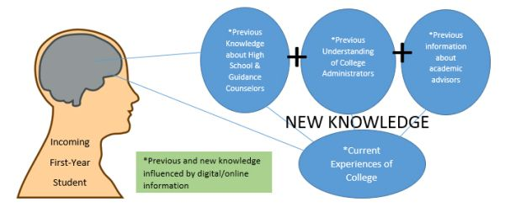
Figure 2: Connectivism learning theory
(Source: Utecht and Keller, 2019)
Apart from this, the Enriched Virtual Model of Blended Learning sheds light on the fact that students need to divide their time between learning remotely and attending a brick-and-mortar school. As per the comments of Krismadinata et al. (2020), in the era of the pandemic, students need to be well accustomed to the developed technology and its use for managing interactivity. From this point of view, the theory seems to be appropriate in terms of explaining the effectiveness of online apps in managing students' interactivity with the educational institution or the moderators. The model has made it clear that both manual and virtual learning system is important for students to manage the interaction thoroughly. In the current situation of the pandemic, it is common that if the students face hurdles to maintain a constant flow of communication, the interactivity can be hampered by any means. For managing communication, online apps are playing a great role.
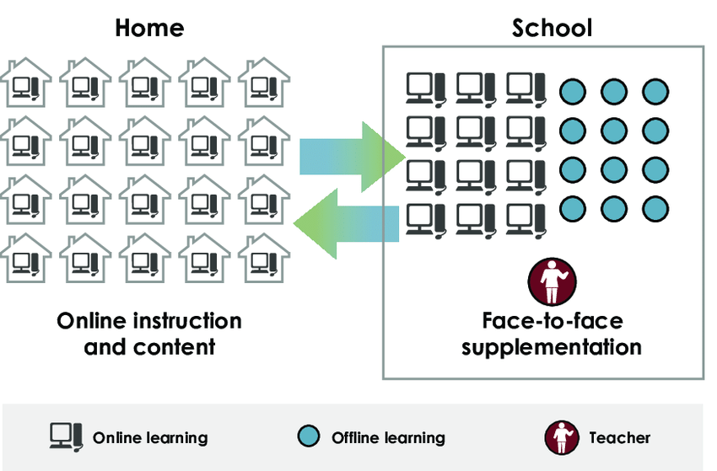
Figure 3: Enriched Virtual Model of Blended Learning
(Source: Krismadinata et al. 2020)

Conclusion
Thus, it can be concluded that the online apps are very much useful for the students to maintain interactions with the assessors from a distant location. Though it is evident that the negative aspects are prominent for being over addicted to using online apps, still the positive sides are mentionable. Many online learning apps are now widely used by students in almost all countries. There is no doubt that this help manage interactivity, but optimum and proper use is needed.

Reference list
Andrew, M., 2019. Collaborating online with four different google apps: Benefits to learning and usefulness for future work. Journal of Asia TEFL, 16(4), p.1268.
Baker-Eveleth, L., and Stone, R. W. 2020. User's perceptions of perceived usefulness, satisfaction, and intentions of mobile application. International Journal of Mobile Communications, 18(1), pp.1-18.
Krismadinata, U.V., Jalinus, N., Rizal, F., Sukardi, P.S., Ramadhani, D., Lubis, A.L., Friadi, J., Arifin, A.S.R. and Novaliendry, D., 2020. Blended Learning as Instructional Model in Vocational Education: Literature Review. Universal Journal of Educational Research, 8(11B), pp.5801-5815.
Nambiar, D., 2020. The impact of online learning during COVID-19: students’ and teachers’ perspective. The International Journal of Indian Psychology, 8(2), pp.783-793.
Panigrahi, R., Srivastava, P.R. and Sharma, D., 2018. Online learning: Adoption, continuance, and learning outcome—A review of literature. International Journal of Information Management, 43, pp.1-14.
Readdle, 2020. The 8 Best Free Educational Apps and Websites for Online Learning. [online] Readdle. Available at: <https://readdle.com/blog/free-educational-apps> [Accessed 16 October 2021]
Utecht, J. and Keller, D., 2019. Becoming Relevant Again: Applying Connectivism Learning Theory to Today's Classrooms. Critical Questions in Education, 10(2), pp.107-119.

