Xenia Eniko Gyorgy
Student ID 1921775

Jun21Term1
BMSW5105_LON
Lecture
Md Kalam
Table of Contents
Itroduction………………………………………………………………………………….1
Aim of the study 3
Objectives of the study 3
Brief introduction about the key analytical tools 3
Evaluation of the organisation within its broader environment by using appropriate environmental and organisational analysis techniques/tools 4
PESTLE framework 4
Porters 5 forces 5
Key drivers influencing cultural changes 7
Detailed analysis of the culture of Amazon, UK 10
Critical evaluation of the relationship of amazon’s workplace culture in achieving financial and non-financial performance 12
Conclusion 14
References 16

Introduction
The covid-19 pandemic situation has significantly changed the standard performance-based architecture that is being maintained by multiple organisations. The standard procedures associated in this regard remains directly related to the different types of operational aspects that have been structured by the upper management of the company. According to the case study provided above it can be observed that the covid-19 pandemic situation has significantly changed the corporate world who is operated previously in a different manner. The conventional method has been observed with a significant amount of replacement by the specific implementation of different types of remote-based operations which have been performing by multiple organisations.
The study will focus on providing clarified information of workplace culture transition by a thorough analysis of the organisation of Amazon UK during the pendency situation. The entire analysis and assessment process will be carried out through the form of predictive study which will help in identifying the conventional as well as the new methods with their respective effectiveness in the corporate grounds.

Aim of the study
The study aims to identify different attributes that remain related to the workplace culture of Amazon UK and provide proper clarification regarding its impact on the efficiency of the company.

Objectives of the study
The objectives are:
- To identify the variable properties of the workplace culture and its respective components.
- To identify the different external as well as the internal factors which influences the workplace culture of the organisation of Amazon UK.
- To identify the impact of the Amazon new what is culture with that of its productivity and efficiency.

Brief introduction about the key analytical tools
For the analysis of the entire context, multiple theoretical frameworks will be consistently assessed who identify the different types of subjective aspects that remain associated with the workplace culture. For instance, the theory of organisational culture contingency theory and theory of reasoned action will be cognitively utilised to identify the different aspects that remain associated with the company. The context will also utilise theoretical frameworks like PESTLE and Porter's five forces model for the analysis of the external factors operating across the environment of Amazon UK. Additionally, it also assesses the differential aspects that remains associated with the competition operating within the market. The utilisation of these theoretical frameworks integrated with real-time data and quantitative analysis will help in clarifying all major forms of prospects associated with the workplace culture of the organisation and its impact on the efficiency of the company.

Evaluation of the organisation within its broader environment by using appropriate environmental and organisational analysis techniques/tools

PESTLE framework
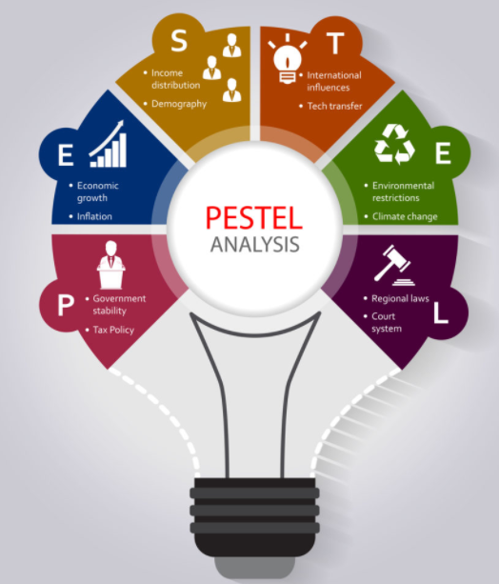
Figure 1: PESTLE Framework
(Source: As Influenced by Thakur, 2021)

Porters 5 forces
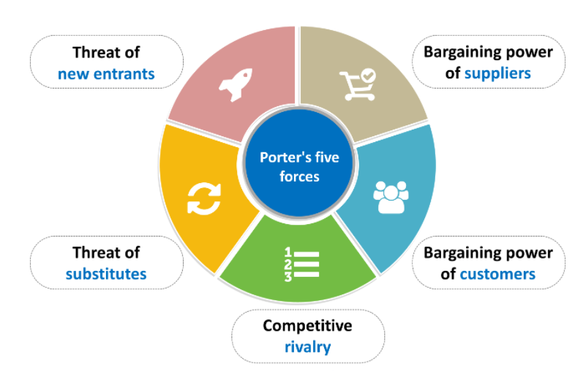
Figure 2: Porters 5 forces
(Source: As Influenced by Delfanti, 2021)
Competition in Industry
The competition present in the industry operates to be one of the major driving aspects that orient the working culture of the organisation of Amazon UK. It can be observed that corporate organisation like Amazon maintains a specific vigilance over the different two men operates and identify the different types of innovative aspects that has been introduced by its competitor companies. With the limited number of consumers during the pandemic situation and the consistent degradation of the financial reserves of the main client base, the end competitive aspect for large-scale organisations like Amazon UK has increased at a significant rate (Delfanti, 2021). The competitors provide a very strict understanding of the different types of changes that might be observed in the specific corporate domain.
The threat of new Entrants
The entry of new firms with minor or major integrative and innovative aspects of the organisation operates to be a major threat in the operational aspects that involves acquiring consumers within the business grounds. The threat to new entrants operates to be one of the major driving factors which constantly motivates the organisation of amazon UK to maintain innovative implementation within the company (Cockayne, 2018). It will be carried out so that they remain unaffected by the entry of new competition within the market. For such reason, the organisation also utilizes the Blue Ocean strategy to separate itself from this aspect of competition.
power of suppliers
The power of suppliers corporate to be one of the major burgeoning forces that operate in the competitive aspects of the organisation. The power of the company in acquiring its resources and channelling them based on necessity provides a proper picture of efficiency even within the competitive market of the organisation. The identification of the suppliers to be one of the major driving forces which determine the ability to maintain the conversion ratio within the organisation of Amazon UK (Hahtela et al., 2017).
Power of customers
Consumers are one of the major determining factors which provide the specific understanding of the different valuations of commodities that will be provided by the organisation. Amazon usually maintenance both the consumer paste clients as well as the premium plants who add to specific forms of services and operate to be one of the major determining factors behind the proper stability that will be gained by the company within its corporate grounds.
Substitution threat
This thread relates directly to the replacement of different services provided by an organisation with a totally entirely new form of service or product that is provided by a different or a new company. The order services a product operates to be a major risk but under certain specific situations the successful innovations of intent to replace the older commodities that have been operating within the market. This replacement of products or services operates to be a major threat for the organisation of Amazon UK for which they consistently maintain innovation across multiple services and products provided by them (Schein, 2017).

Key drivers influencing cultural changes
The key drivers that influence the cultural changes are:
behaviour – The behaviour and the perception of the employees towards the management exercised by the organizations operated to be a major driving factor that laid out a major impact on the cognitive aspect of the organizations. The specific convenience and the inconvenience were prerogatives identified by the organization of amazon UK to orient the working culture that yields the maximum output with a high amount of efficiency (Kurjenluoma et al., 2017).
techniques – The development of new remote operational techniques operated to be another major driving factor that influenced the change in the working culture of the company (Angouri, 2018). It was observed that the organization’s requirement to an increased output during the remote working operated to be a major caused that influence the key driver of technique to improve itself within the organization.
Workplace- The absence of a specific work culture due to the work from home concept operated to be one of the major attributes that significantly influenced certain aspects of multiple organizations operating on corporate grounds (Lucas, 2017). The working culture had to be reformulated by multiple companies to cope with the drastic mindset that was observed across the employee base during the pandemic situation. Amazon UK’s key driver for cultural change was specifically centred around improving the workplace culture so that the employees remain motivated towards executing their allocated tasks.
Assessment on the workplace culture of Amazon, UK
The organisational culture of Amazon, UK is very much dedicated to responding to the requirements of the global e-commerce marketplace. The behaviour of the employee base of Amazon, UK gets influences by the values and traditions defined by the corporate culture of the company. As opined by Hur et al., (2019) the workplace culture of Amazon, UK persists in the employee base to work beyond the limits and conventions in order to structure innovative solutions and ideas for the business growth of the company. Fresh talents are always searched for induction by the management of the world’s topmost online retailer. The management is always on the verge to reinforce its workplace culture to structure its Human Resource department to gain competitive benefits on a long-term basis. As stated by Catling et al., (2017) the organisational culture of Amazon, UK always forces its employee base to explore and innovate by taking solvable risks. Several new opportunities can be acquired by the management of the company so that data-intensive processes can get utilised to endow effective and affluent online retail services.
The workplace culture of Amazon, UK can be categorised as Adhocracy culture as it is generally rooted in innovation. Since Amazon is currently recognised to be operating at the cutting edge of the industry, so the next big things always get launched from their side before any other companies can think of. As underpinned by Masimula et al., (2021) the employee base is very much encouraged to take risks by valuing respective individuality to think innovatively to project the ideas on the platform to get applied. The organisational culture of Amazon, UK can be categorised under the differentiation category and falls for the external focus so that new and innovative ideas can facilitate company success and market growth.
The paradigm of Amazon, UK states that they are an organization of pioneers. They must make intense wagers, and get their energy from designing for clients. Achievement is estimated against the conceivable, not the plausible. For the present pioneers, that is actually why there's no spot on Earth they'd prefer work than Amazon. Based on the above statement, the workplace culture of Amazon can be reckoned based on three prime aspects
- Boldness: The characteristic of boldness is promoted widely and evenly among the worker base of Amazon, UK. This helps the management in order to pioneer the sales of items on the online portal with the help of data-intensive technology. According to Kurjenluoma et al., (2017) this attribute of boldness compels the worker base in taking organisational risks from a positive perspective to facilitate innovative ideas for promoting organisational diversity.
- Customer Centricity: The vision statement of Amazon, UK is very much directive towards the centrality of the targeted customer base on a global scale. This is done when the management of the company emphasizes the employee's Focus on Customers requirements and demands. As opined by Braithwaite et al., (2017) the changes and trends for the preferences of the customer base are effectively analysed and determined to apply the same on the online retail services. This facilitates the management in order to maintain the customer satisfaction and loyalty factor in compliance with the workplace culture.
- Peculiarity: The attribute of Peculiarity in the workplace culture of Amazon, UK deals with the modulation of challenging conventions for the growth of the business. This is done by letting the employee base in assessing themselves and their respective productivity in different ways than the conventional ones. As stated by Haine-Bennett et al., (2020) this is because, the management of Amazon, UK works on the notion that the potential business growth gets limited by the market conventions. This facilitates and motivates the employee base to think of something innovative "Out Of The Box" in order to protect the business on its highest potential
There are several theories and models drafted by the industrial experts in order to define, evaluate and deliver judgements on the organisational culture and performance of a particular company. The most commonly used model for organisational and workplace culture is discussed below.
Beer’s Model: Several business-oriented barriers were identified by Michael Beer, Professor of Business Administration, Harvard Business School which can get projected as threats to the performance and productivity of a company. The barriers are listed below
- Ineffective Managerial Team
- Abrupt values and strategies leading to conflicting priorities
- Top-down or Laissez-Faire approach to the Leadership and Management
- Poor Management, Leadership and Organisation
- Poor horizontal communication and coordination
- Poor and enclosed vertical communication and coordination
According to the Beer’s Model, the management of Amazon, UK needs to endorse honest and open-ended communication at the time of underperformance of the team in order to facilitate the issue of high productivity. As underpinned by Ariga et al., (2020) the Senior Executives of Amazon, UK should work for establishing the priorities of the team as well as appropriate expectations.

Detailed analysis of the culture of Amazon, UK
The Cultural Web defines a structured way in order to understand the corporate and its impact of Amazon, UK where in the first hand, the culture is being analysed. The management always define the scaffold of the company as
- World's most customer-oriented company
- Growth is driven through low prices
- Large platform of options and choices for the targeted customer base
- Vision oriented and flexible on the details of the management
There are 6 primary components that are defined through the Cultural Web paradigm of any organisation which are as follows
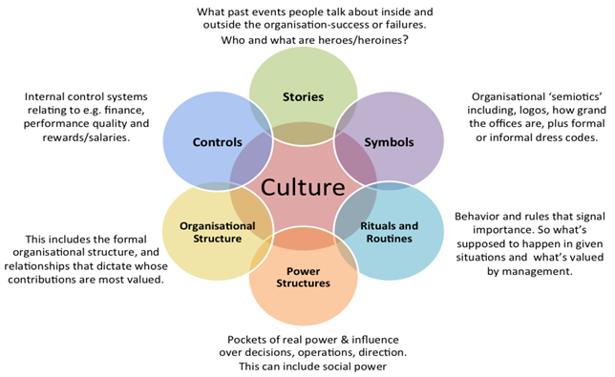
Figure 3: Cultural Web and its components
(Source: Retrieved from Shier et al., 2019)
- Stories: The story of the journey of Amazon, UK is much related to that of its founder, Jeff Bezos. The story initiated with the matter of projecting annual web productivity of 2300% to indicate that online business cab gets acknowledged as the future of the global business scope. The business started with online sales of books, which was not expected to project profitability for the first 4-5 years. As opined by Siddiqui and Fitzgerald, (2017) the scenario of the business turned its direction in a positive way in the 21st century, which set the benchmark that business can be a huge player in the market with the help of innovative approaches.
- Rituals and Routines: The most prominent ritual and routine of Amazon, UK is its approach of inducing potential candidates to fit in the roles of higher-level jobs for the company. According to Shier et al., (2019) the internal employee base of the company plays the role of the bar raisers in order to induct new candidates in the infrastructure of the company even when some candidate may not be of the background to which he or she has opted for the job role. Mostly the routine of Amazon focuses on the induction of candidates who are not previously experienced with respect to the addressed job role.
- Symbols: Being an online retailing company, the logo and brand name of Amazon, UK is very much significant to facilitate the visual presentation of the company. The company’s name has been tactically planned and created in order to make it appear earlier according to alphabetic order. As underpinned by Hardiman and Dewing, (2019) the logo also contains a symbol of a curved arrow, which looks like a smile starting from the letter A and ending to the letter Z which signifies that the targeted customer base will get an A to Z satisfaction while ordering products for the company. The warehouse and stores of Amazon also operate in a virtual manner to give complete assistance to its customer base.
- Organisational Structure: Based on the Corporate Hierarchy of Amazon, UK, the organisational structure can get attribute as a complex hierarchical structure that allows it to operate all over the world. According to Di Stefano et al., (2019) there are a total of seven operational segments which are very much responsive towards the commands from management and is basically driven towards collaboration rather than competition.
- Control System: Several key metrics have been developed by the management of Amazon, the UK to maintain a high level of productivity and quality across the distribution centres. The employee base’s performance and productivity, sales of items per hour and inventory precision are measured with the help of these metrics. As opined by Masoud and Tariq, (2020) the company suffered a huge business in the year 1999 on the basis of its aim to deliver the products at any cost even though it achieved its market growth. This led to the urgency for the introduction of the metrics
- Power Structures: The power or authority inside the working culture of Amazon, UK gets distributed from its top-level management. Jeff Bezos happens to be very much reluctant to distribute the power and acts as the source for the same. As stated by Smith et al., (2019) this is the reason, why the role of Chief Operation Officer is not given so much acknowledgement in Amazon, UK as Bezos has reserved this role for himself with other designations like CEO, Chairman and President.
Analysis
From the above discussion, it can be clearly analysed that the workplace culture of Amazon prioritises the strategies which are very much directed to customer satisfaction and making the organisation more resilient. This especially happens when the management works in the backward direction so as to satisfy the requirements of the targeted customer base. The management of Amazon, UK is very much in need of enhancement in the diversity of employee base so as to promote innovation for top management positions and priorities.

Critical evaluation of the relationship of amazon’s workplace culture in achieving financial and non-financial performance
The workplace culture that is maintained by Amazon UK maintains the Adhocracy organisational culture which involves the concept of consistent innovation and creativity within the company. As described in the previous question this organisational culture maintains a significant relationship with the kind of workplace environment that will be implemented within your organisation (Chakraborty et al., 2021). It has been observed that the organisation of Amazon UK specific relief with innovations and creativity that is observed within the company. The organisation of Amazon UK maintains a highly profound financial channelling to ensure a flop and contingency than for the risk that Indians related while implementing innovation within the services or product provided to its customers. This aspect can be divided into two major parts financial performance and non-financial performance.
Financial performance
The financial performance of the organisation of Amazon UK has improved significantly after the implementation of the Adhocracy organization culture. The improved level 9 allows for a proper streamlining behind the innovative aspects that can be implemented by the organisation of Amazon in different forms of commodities and help in developing specific contingency plans that would improve the organisational stability of the firm (Braithwaite et al., 2017). With the consistent implementation of adhocracy organizational culture, the company was able to maintain specific stability in the aspect of maintaining its financial reserves channelling its monetary assets for different types of innovative purposes as well as standard production purposes. This aspect helps in improving the organisation's revenue streamlining which can be considered as a highly improved financial performance by the organisation of Amazon UK.
Non-financial performance
The non-financial performance relates to the operational efficiency and the output that is specially created by the company of Amazon UK. The aspect also relates to the kind of employee’s perception that is maintained by the company. The ability of the organisation to consistently maintains the adhocracy culture allows the employees of the company to remain motivated with the talk and from the monotonous work culture that is often observed in large scale companies. The ability of the company to retain its employees and ensure a proper working environment for its work base operates to be one of the major non-financial performances that are performed diligently by the organisation of Amazon UK. The organisation and also ensure to meet their employee's demands from time to time which helps the company to improve its reputation not only within the consumer days but also across the corporate employment area. This aspect can also be considered as a non-financial 0erformance that is executed efficiently by the organization of Amazon UK
Ethical Dilemma
The ethical dilemma remains refers to the consequences of the course of action that might be beneficial for the organizations (Puddifoot, 2017). This aspect relates with the ethical aspects of maintaining integrity behind the concept of difficult decision making behind two actions.
The two prominent ethical dilemmas surrounding the organization of amazon UK are:
Maintaining innovation even under a difficult financial situation
It is noticeable that the organizations often face the risk of encountering major financial loss during the implantation of innovation. Utilizing the strategy of downsizing is often the only alternative strategy under such a situation. This operates to be the major ethical dilemma that remains related to the organizations of Amazon.
Usage of certain employee knowledge for self-profit
Specific management department is often observed with practising certain unethical methods that allow the managers to increase their profit at a faster rate (Garg, 2019). Though the entire organization benefits from it, it becomes morally wrong to use the employee for organizational benefit. This operates to be a major ethical dilemma that is faced by the organization of Amazon UK.
Choice of Action
The only choice of action in the first scenario would be to improve the revenue streamlining for better funnelling of the financial assets to resources. This will not only allow the organization to avoid downsizing but also maintain a steady pace towards improvement. In regards to the second ethical dilemma, the development of proper policy by the organization would help the company to improve the situation of the employees from getting exploited. this would reduce the company’s profit but would help the employees to remain motivated towards the tasks allocated.

Conclusion
The entire context remains directly related to identifying specific aspects that remain related to the organizational culture of the firm. The context provides a very descriptive understanding of the different variants that remains related to the external as well as the competitive factors that impacted the work culture during the Covid-19 pandemic. The identification of the analytical framework has been properly described in this context and provides a proper understanding of the organizational culture maintained in Amazon UK. The different segment of the organizational culture has been elaborately illustrated to get a proper understanding towards the different changes that remains associated with the firm. The proper concept concerning the ethical dilemmas encountered by the organization of amazon UK has been described that helps in understanding the progressive aspects that remain associated with it. It can be concluded that an organization’s workplace culture remains directly related with both the external as well as the internal factor correlating directly with the organization’s objectives.

References
Angouri, J., 2018. Culture, discourse, and the workplace. Routledge.
Braithwaite, J., Herkes, J., Ludlow, K., Testa, L. and Lamprell, G., 2017. Association between organisational and workplace cultures, and patient outcomes: systematic review. BMJ open, 7(11), p.e017708.
Braithwaite, J., Herkes, J., Ludlow, K., Testa, L. and Lamprell, G., 2017. Association between organisational and workplace cultures, and patient outcomes: systematic review. BMJ open, 7(11), p.e017708.
Catling, C.J., Reid, F. and Hunter, B., 2017. Australian midwives’ experiences of their workplace culture. Women and Birth, 30(2), pp.137-145.
Chakraborty, T., Tripathi, M. and Saha, S., 2021. The Dynamics of Employee Relationships in a Digitalized Workplace: The Role of Media Richness on Workplace Culture. In Critical Issues on Changing Dynamics in Employee Relations and Workforce Diversity (pp. 175-205). IGI Global.
Cockayne, D.G., 2018. Underperformative economies: Discrimination and gendered ideas of workplace culture in San Francisco’s digital media sector. Environment and Planning A: Economy and Space, 50(4), pp.756-772.
data.worldbank.org, 2021 GDP growth (annual %) - United Kingdom [Online] Available at: https://data.worldbank.org/indicator/NY.GDP.MKTP.KD.ZG?locations=GB [Accessed on: 24th July 2021]
David, J., 2019. PESTEL analysis of the UK. Retrieved October, 30, p.2019.
Delfanti, A., 2021. Machinic dispossession and augmented despotism: Digital work in an Amazon warehouse. New Media & Society, 23(1), pp.39-55.
Di Stefano, G., Scrima, F. and Parry, E., 2019. The effect of organizational culture on deviant behaviors in the workplace. The International Journal of Human Resource Management, 30(17), pp.2482-2503.
Garg, N., 2019. Xenic insurance company: ethical dilemma of an employee. Rajagiri Management Journal.
Hahtela, N., McCormack, B., Doran, D., Paavilainen, E., Slater, P., Helminen, M. and Suominen, T., 2017. Workplace culture and patient outcomes: What's the connection?. Nursing management, 48(12), pp.36-44.
Haine-Bennett, E., Bergsieker, H.B., Coe, I.R., Koch-Kraft, A., Langelier, E., Morrison, S., Nikoleyczik, K., Schmader, T., Trivailo, O., Twine, S. and Decker, J.E., 2020. Enacting workplace culture change for excellence in research: a gender lens. FACETS, 5(1), pp.228-233.
Hardiman, M. and Dewing, J., 2019. Using two models of workplace facilitation to create conditions for development of a person‐centred culture: A participatory action research study. Journal of clinical nursing, 28(15-16), pp.2769-2781.
Hur, J.Y., Cho, W., Lee, G. and Bickerton, S.H., 2019. The “smart work” myth: how bureaucratic inertia and workplace culture stymied digital transformation in the relocation of South Korea’s capital. Asian Studies Review, 43(4), pp.691-709.
Jia, Y., Fu, H., Gao, J., Dai, J. and Zheng, P., 2018. The roles of health culture and physical environment in workplace health promotion: a two-year prospective intervention study in China. BMC public health, 18(1), pp.1-10.
Kurjenluoma, K., Rantanen, A., McCormack, B., Slater, P., Hahtela, N. and Suominen, T., 2017. Workplace culture in psychiatric nursing described by nurses. Scandinavian journal of caring sciences, 31(4), pp.1048-1058.
Kurjenluoma, K., Rantanen, A., McCormack, B., Slater, P., Hahtela, N. and Suominen, T., 2017. Workplace culture in psychiatric nursing described by nurses. Scandinavian journal of caring sciences, 31(4), pp.1048-1058.
Lucas, G., 2017. Effects and risks of workplace culture. In Addiction at Work (pp. 59-70). Routledge.
Masimula, Q.K., van der Wath, A. and Coetzee, I., 2021. Promoting a person-centred workplace culture in a public nursing education institution in South Africa by fostering effective teamwork amongst nurse educators. Nurse Education Today, 99, p.104783.
Masoud, M.A. and Tariq, M.U., 2020. IMPROVING EMPLOYEE INDUCTION AND WORKPLACE CULTURE DEVELOPMENT PROCESS USING LEAN SIX SIGMA METHODOLOGY. Journal of Critical Reviews, 7(15), pp.5025-5036.
Pheko, M.M., Monteiro, N.M. and Segopolo, M.T., 2017. When work hurts: A conceptual framework explaining how organizational culture may perpetuate workplace bullying. Journal of Human Behavior in the Social Environment, 27(6), pp.571-588.
Puddifoot, K., 2017. Dissolving the epistemic/ethical dilemma over implicit bias. Philosophical Explorations, 20(sup1), pp.73-93.
Schein, A., 2017, September. Taylorism and Amazon: Scientific management at the world's most successful retail company. In 10th Annual Conference of the EuroMed Academy of Business (pp. 1554-1564).
Shier, M.L., Turpin, A., Nicholas, D.B. and Graham, J.R., 2019. Dynamics of a culture of workplace safety in human service organizations: A qualitative analysis. International Social Work, 62(6), pp.1561-1574.
Siddiqui, N. and Fitzgerald, A., 2017. Patient-centric workplace culture: a balancing act for nursing leaders. American Journal of Nursing Research, 5(5), pp.165-172.
Smith, E.F., Gilmer, D.O. and Stockdale, M.S., 2019. The importance of culture and support for workplace flexibility: An ecological framework for understanding flexibility support structures. Business Horizons, 62(5), pp.557-566.
Thakur, V., 2021. Framework for PESTEL dimensions of sustainable healthcare waste management: Learnings from COVID-19 outbreak. Journal of cleaner production, 287, p.125562.

