Effective Team Working and Communication
(BMSW4002_BIRM) Assignment for Component 1

My name: Petko Tonev Petkov

My student number: 2125440

Module name: Effective Team Working and Communication

Module code: BMSW4002_BIRM

Lecturer name: Hafiz Rahmani

Assignment Tittle: Effective Team Working for business success

Summary of report

This report focuses on enhancing the importance of effective team working and communication. It demonstrates and depicts the key aspects of team working in general and the role of a team as well as different ways a team could work in order to achieve their objectives in the most effective way possible. This is all in relation to the company Amazon and their case of expanding their influence around a few capital cities in Europe.

Table of contents:

- Introduction………………………………………….. 3
  - What is a team?.................................................3
  - Characteristics of team and team work…………4
- Main model of teamwork development………........5
  - What the model Illustrates………………………..5
  - An alternative model……………………………..6
- Team roles and importance of team roles………………6
- Impact of effective team work in team success……………..…………6
  - Advantages of effective team-working………….7
  - Discussion of barriers to teamwork in the case study………….7
5.Conclusion and Recommendations………… 7
6. Reference list…………………8
1.Introduction

A brief introduction of this report: A team is usually a group of people with common goals who combine knowledge, experience and individual intelligence and qualities in similar or different spheres of work in order to achieve the set target or goal. The case of Amazon with the leader Tom, who has been appointed as a leader who needs to lead a team with the collective goal to open 3 warehouses in cities in Europe. Berlin, London and Paris are the three capital European cities where the company of Amazon wants to extend their production into. One of the most important and essential elements of team work is the united commitment and from what we understood about Toms team so far is that the team lacks communication between all the members. This created internal problems and the team is not as effective as it should be when it comes to a wide company such as Amazon. Therefore further down are a few ways in which a team can be compiled and worked up to as effective as possible and become capable of achieving the goal. In the following report a few of these (Tuckman’s model of Team Development, the book “wisdom of teams” written by Jon Katzenback and Douglas Smith, Susan Wheelan’s model (2005), Belbin’s 9 team roles) and few other models and theories will be explored and discussed in order to examine which of them suits the case of Tom and his Amazon team perfectly.

1.1 First let's begin with the defining what a team is and what it should look like. In their best-selling business book The Wisdom of Teams (Harper Business Books 1994), Jon Katzenbach and Douglas Smith define a team as:
· ‘A small number of people with complementary skills who are committed to a common purpose, a set of performance goals and an approach for which they hold themselves mutually accountable’
This is a similar approach to: “A team is group of people who exist to accomplish specific task that are related to common goals.” (Maund et al 2017). Both of these flawlessly define what a team is, also they are a good combination of definitions because they both depict one of the most important aspects of a team which is the common shared goal that they have to work together in order to have success and achieve it.
1.2 In order for a certain team to be effective they need to have clear goals, the team also needs to be united in their thinking and their commitment and communication because the members in that team have to be able to cooperate properly with each other and communicate and discuss their ideas and viewpoints in order to conclude the perfect one to execute their united goal. Whenever there is communication and civility within the team, this makes the atmosphere way more comfortable for each and every member of the team to open up their potential and fulfill the needs of the certain operation. In this case, Tom is the leader. An effective leader according to (Griffith, BA, & Dunham, EB 2014) should “pay attention to both the task and relational dimensions of the team”.

2. One of the most accurate models of effective team work and creating the perfect team would be the model of team development by Bruce Tuckman. In his model he explores 5 stages of development:

Follow the model in figure 1 below:

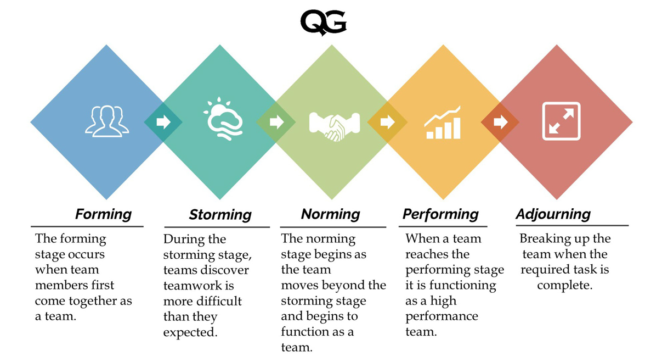

2.1 First stage of developing a team is when the members come together and get to know both each other and the goal they will have to achieve. As it says in the figure above, the team moves onto the Norming stage after they have passed the Storming stage, this is what lacks in Tom’s team. They have not yet covered the importance of Storming stage, which is the understanding and acceptance of the fact that Teamwork as it says in Tuckman’s model is harder than they would expect. This is where the communication is lost and by using this Model, it could be regained.
The rest of the stages are pretty simple and straightforward. Performing stage is uniting powers to perform the action and perform it to the best of your ability by functioning together as a team. The last but not least stage is when you all are satisfied with the results and can wrap your success up properly with your team members. As Bruce Tuckman says: “a team at the Norming stage will have much to offer in terms of experience and ideas which, if accessed, can save leaders time and energy, leaving them free to focus on the wider horizon.” This is a very important stage as it allows the team members/colleagues to engage between themselves and provide understanding towards each other's viewpoints and also ways of working and approaching such a project.

2.2 Another very applicable and effective model of team development would be the the team development model of (Susan Wheelan, 2005). The four stages of this model are:

1. Dependency and Inclusion
2. Counter Dependency and Fighting
3. Trust and Structure
4. Work and productivity

As you can see, this model is slightly different to the previous one as it demonstrates the struggles of teamwork more and also it depicts the importance of the trust and bond between team members and how they can effectively contribute towards the united commitment and achievement of the goal. The relevance and purpose of this stage is that the trust and bond between team members is very important for a team to function effectively and achieve the common goal. It also mentions structure as well as trust, which would mean everybody in the team must know their responsibilities and be ready to participate in discussions and arguments freely with the other members of the team. The responsibilities should be divided fairly between all the members so that they don’t lose structure and therefore miss the opportunity to work and progress equally together.

See model in figure 2 below:
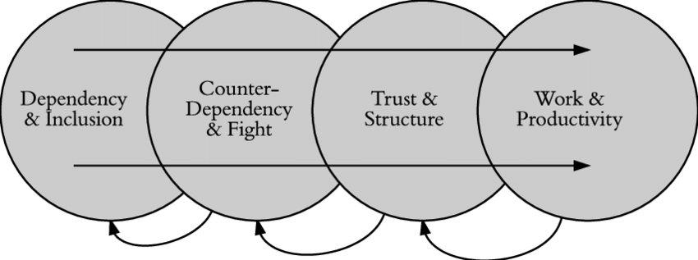

Tuckman’s model is the chosen one in this case because of a few visible reasons. Although Wheelan’s model is more recent, I feel like it does not fully attach the importance of the stage that Tuckman’s model has. This stage is Norming. The pact, the agreement between all members of a team should exist in every team working organisation. Having communication and coordination within a team is an existential part of developing an effective relationship between that team and for the amount of time needed to be able to healthily participate in this team with other members. This is what makes Tuckman’s model more effective and reliable than Wheelan’s.

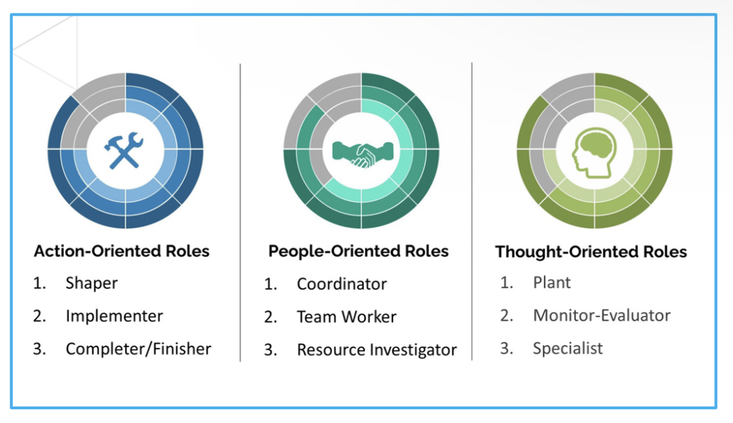
3. Belbin’s 9 team roles figure 4:
Roles are an existential part of the the way a team is structured and the whole composition of separate jobs and roles within it. According to Belbin’s 9 team roles concept, there are 9 roles divided into 3 categories; action oriented, people oriented and thought oriented. The action oriented is the role which usually belongs to people who usually perform a physical task within a team. An example of this would be in this case the workers in amazon. The people who produce and compile products and deliver to other people for example. The action being done. The next role of people would be the people oriented role, which is a verbatim for what it stands for. The role is given to people who investigate, who deliver feedback, people who coordinate the action of the action oriented role. The last but not least is the thought oriented role. People who take onto that specific role are those who are capable of planning, those who are specialised in a certain sphere and know how to monitor the work of others and the progress of the whole team.

4.Next stage is the process of creating the most effective team. This will be achieved through The Culture Code by Coyle which he wrote in 2018. It consists of three Skills:
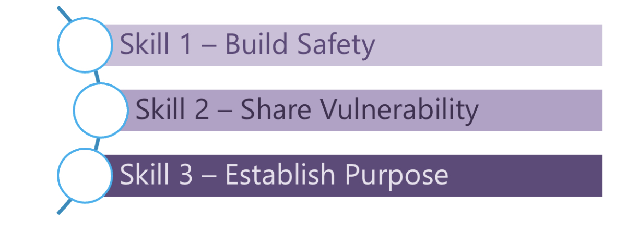
4.1 According to Daniel Coyle good team should build safety, in other words, a good team member is in the first place being communicative and attentive in their actions. Also understanding that there are different viewpoints within the working environment in order to discipline themselves into effective team working. Also accepting and take into account the positive as well as the negative feedback. A team leader should be 100% honest with their team members, because this leads to effectiveness and success within the set team tasks.

4.2 What are the complications of creating and gathering an effective team? Well there are a few complications that every team leader or organisation should know about and these are: low levels of commitment and therefore low productivity, lack of communication and understanding between team members leading to negative outcomes and barriers which confront with the end target. Every leader such as Tom must be aware of the complications of gathering a team in order to avoid any mistakes in the process of creating and working in one. In relation to the case study, it can also be said that Mihaela and Spenser who are the problematic ones in the team could possibly learn how to communicate their viewpoints across to the other members of the team as well as the leader Tom. The leader has to push their team members to be more proactive into the decision making process.

5.Conclusion: As a matter of fact Amazon is a world wide chain and it is a very large organisation which requires a lot of expertise and also it requires calm and collected, responsible people who can achieve the goal of opening 3 new warehouses in 3 ruling capital cities in Europe. This means that the team of Tom has to actively contribute towards the appreciation of each other’s opinions and achieve the main common goal as they allow themselves to consider and evaluate a range of different ways to success as it says in the main model of teamwork development used at the beginning of this report.

6.Reference list:

book “wisdom of teams” written by Jon Katzenback and Douglas Smith

Coyle, D. (2018), The Culture Code, London, Random House Business.
Maund, A. et al. (2017) Certificate in higher education : skills for the workplace student yearbook. London: sage
Griffith, Brian A., and Ethan B. Dunham. Working in Teams : Moving From High Potential to High Performance, SAGE Publications, 2014.
Belbin, M., (2010), Team Roles, eBook Collection (EBSCOhost), Routledge
Belbin, M. (2016) Team roles, Available: https://www.belbin.com/media/2302/belbin-team-role-circle.pdf ).
Griffith, B., and Dunham, E., (2015), Working in Teams: moving from high potential to high performance Los Angeles

