

Programme: Master of Business Administration
Module: Marketing management
Module code: LCMB7024
Word count:
Student Id: 2504020
Name: Shubham Yadav
Professor: Jayalakshmi Gopalkrishna

Table of Contents
- Introduction…………………..3
- Conceptual and Theoretical Framework…………………..4
- Task 1: Macro Factors…………………..5
3.1 Macro Factors A: Political and Technological Factors…………………..5
3.2 Macro Factors B: Sustainability and Environmental Regulations…………………..6
- Task 2: Strategic Responses to External Factors…………………..8
4.1 Strategic Responses to Political and Technological Pressures…………………..8
4.2 Strategic Responses to Sustainability and Environmental Regulations…………………..8
4.3 Integration of Strategic Models…………………..9
4.3.1 Porter’s Generic Strategies…………………..9
4.3.1.1 Nestlé Differentiation Strategy…………………..9
4.3.1.2 Unilever Differentiation Focus with Cost Elements…………………..9
4.3.2 Ansoff’s Growth Matrix…………………..10
4.3.2.1 Nestlé Product Development and Market Development…………………..10
4.3.2.2 Unilever Market Penetration and Product Development…………………..10
4.4 Strategic Implications…………………..11
- Recommendations…………………..12
5.1 Recommendations for Nestlé (Pioneer) …………………..12
5.2 Recommendations for Unilever (Follower) …………………..12
- Conclusion…………………..14
- Reference List…………………..15

- Introduction

The global market for plant based food and beverages has expanded quickly as governments, consumers and producers respond to changing dietary habits, new technological possibilities and stronger expectations for environmental responsibility. Growing political interest in public health, food security and sustainable methods of production has begun to reshape competition in the industry. At the same time, continuing progress in alternative protein technologies has opened new directions for product development and market growth. In this environment, large multinational companies must adjust their operations, supply networks and innovation approaches in order to remain competitive and relevant.

Nestlé has established itself as an early leader in the plant based sector, supported by significant research capacity and the development of product lines such as Garden Gourmet and the plant based additions to the Nescafé range. Unilever entered the market later but has strengthened its presence through the acquisition of The Vegetarian Butcher and by expanding plant based options within well known brands such as Hellmann’s and Ben and Jerry’s. Both companies operate in a sector influenced by shifting political pressures, rapid technological progress and increasing sustainability and compliance demands. Their different positions in the market offer useful insight into how major food manufacturers respond to the changing landscape of plant based products.

- Conceptual and Theoretical Framework

The plant based food industry is influenced by a mix of political, technological and environmental factors, and these can be better understood through established strategic models. The PESTEL framework provides a clear way to examine how government decisions, technological progress and sustainability regulations shape the behaviour of organisations. The timing of market entry can be explained through first mover and follower strategy theory, which shows that early entrants may gain innovation advantages but also face uncertainty from evolving regulations and high development costs. The Resource Based View adds to this by explaining how firms rely on distinctive assets, including research capability, specialised technologies and global supply chains, to build and maintain competitive advantage. In fast changing and heavily regulated markets, dynamic capabilities theory highlights the importance of a firm’s ability to adjust and reorganise its resources to respond to political changes and environmental expectations. Together, these frameworks form the basis for analysing how organisations behave and make strategic decisions within the plant based sector.

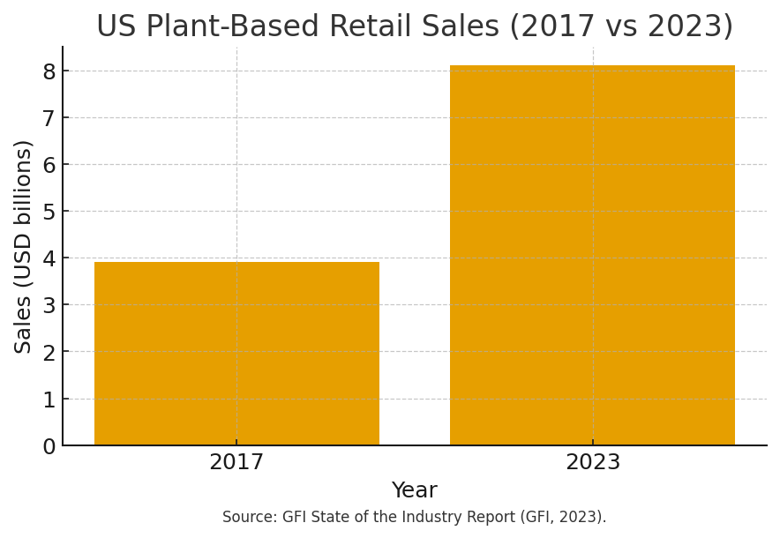

- Task 1: Macro Factors
3.1 Macro factors A: Political + Technological Factors

Political and technological developments work together to shape the competitive landscape of the plant based food industry, especially as governments attempt to influence eating habits, sustainability expectations and changes in agricultural systems. Measures such as front of pack nutrition labels, limits on environmental claims and incentives for low carbon protein development increasingly define the conditions under which producers must operate. These interventions occur at the same time as rapid progress in extrusion methods, precision fermentation and ingredient biotechnology, which continue to expand the potential for innovation in this market (Teece, Pisano and Shuen, 1997, p. 514).

For Nestlé, these developments offer both strategic advantages and higher risks. As an early entrant, the company uses its strong research capability and early investment in alternative protein technologies to shape emerging regulatory expectations. Nestlé’s CDP climate disclosures highlight its continuing commitment to plant based innovation and improvements to sustainable packaging, demonstrating a clear effort to align with future policy direction (Nestlé, 2024). However, early entry also introduces structural vulnerability. First mover theory states that pioneers experience significant uncertainty because regulatory systems and technical standards are still taking shape in the early stages of market development (Lieberman and Montgomery, 1988, pp. 45–47). As a result, major research and development investments may become mismatched with new regulations or overtaken by more advanced technologies. These challenges are reflected in ongoing debates about acceptable ingredient processing, sustainability assessment and protein classification.

Unilever adopts a more cautious follower strategy. Instead of investing early in new technologies, the company usually waits for political and regulatory priorities to stabilise before committing larger resources. This approach is visible in its partnerships with biotechnology companies, including efforts to develop fermentation based ingredients (Unilever, 2022). These collaborations help reduce uncertainty and allow Unilever to benefit from proven innovations without carrying the full financial burden of early stage development. Yet follower theory highlights clear limitations. Although followers face lower risk, they have limited influence over the regulatory environment and often struggle to build strong differentiation (Barney, 1991, pp. 106–108). Recent reports on changes to Unilever’s plant based product portfolio suggest that entering later can restrict long term strategic positioning as consumer expectations evolve (Reuters, 2025).

Overall, the political and technological environment places heavier demands on pioneers such as Nestlé, who benefit from strategic influence but face greater exposure. In contrast, followers such as Unilever experience lower risk but lose opportunities for strategic leadership and greater autonomy.

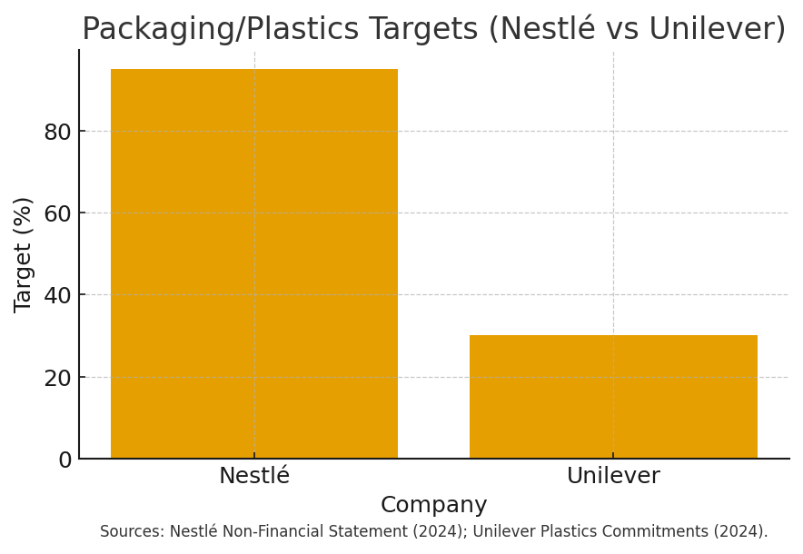

3.2 Macro Factors B: Sustainability & Environmental Regulations

Sustainability and environmental regulation now play a central role in shaping the plant based food industry, as governments aim to respond to climate change, reduce waste and improve transparency across supply chains. Regulations such as the EU Packaging and Packaging Waste Regulation, Extended Producer Responsibility schemes and global actions to address plastic pollution increasingly determine how firms design, package and distribute plant based products (European Commission, 2023). These developments also coincide with stricter requirements for climate reporting, which oblige companies to measure and reduce Scope 1 to 3 emissions (Teece, Pisano and Shuen, 1997, p. 518).

For Nestlé, these regulatory changes bring both opportunities and significant challenges. As an early entrant, the company has set ambitious sustainability goals, including making ninety five percent of its plastic packaging recyclable by 2025, cutting virgin plastic use by one third and supporting international agreements aimed at plastic reduction (Nestlé, 2024a). Its CDP Climate Questionnaire shows major investment in decarbonisation and regenerative agriculture (Nestlé, 2024b). These actions strengthen its position as an industry pioneer, but they also place considerable financial and operational pressures on the business. First mover theory explains that leaders face higher compliance risks when regulatory frameworks are still evolving (Lieberman and Montgomery, 1988, pp. 46–47). Nestlé openly recognises that shifting rules on packaging and deforestation free sourcing create material risks for product reformulation and supply chain costs (Nestlé, 2024a).

Unilever, as a follower, has introduced sustainability targets that are aligned with industry trends but are less ambitious than those of Nestlé. Its commitments include reducing virgin plastic use by thirty percent by 2026 and ensuring that all rigid plastic packaging is reusable, recyclable or compostable by 2030 (Unilever, 2024). This gradual approach allows the company to monitor how regulations develop before making major investments, reducing exposure to uncertainty. However, follower strategy theory suggests that such caution can weaken differentiation in markets where sustainability performance is becoming more important to consumers and regulators (Barney, 1991, pp. 103–105). Recent reports indicate that Unilever has softened some of its environmental targets, showing the difficulty of meeting expectations while managing costs (Financial Times, 2024).

Overall, environmental regulation rewards pioneers such as Nestlé for their early efforts and regulatory alignment, but it also places them under greater cost and reputational pressure. Followers like Unilever benefit from reduced uncertainty but risk being viewed as less ambitious, limiting their ability to shape sustainability standards or appeal to environmentally conscious consumers.

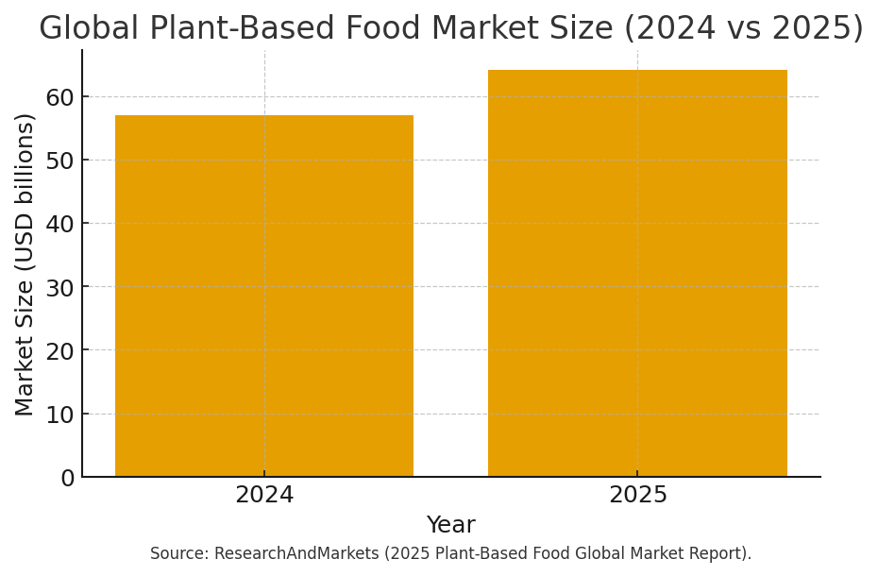

4. Task 2: Strategic Responses to External Factors

Strategic responses to political, technological and environmental pressures vary significantly between pioneering firms and follower organisations in the plant based food industry. The contrasting approaches of Nestlé and Unilever show how a company’s strategic position influences the way it interprets emerging opportunities, manages risks and chooses its innovation direction.

4.1 Strategic Responses to Political + Technological Pressures

Nestlé follows an innovation driven and policy aware strategy that reflects its position as a pioneer in the plant based sector. The company draws on its large global research and development network to advance precision fermentation, alternative protein development and new processing techniques. Evidence from Nestlé’s CDP Climate Questionnaire shows targeted investment in emerging technologies, demonstrating strong dynamic capabilities that allow the firm to adjust its strategy in response to technological change (Nestlé, 2024b; Teece, Pisano and Shuen, 1997, p. 520). Nestlé also participates actively in regulatory consultations, supporting initiatives such as the United Nations Treaty on Plastic Pollution. This involvement strengthens its credibility but also increases exposure to regulatory uncertainty.

In contrast, Unilever adopts a more cautious follower approach. Instead of committing early to new technologies, the company depends on strategic partnerships, including its collaboration with Geno, to access innovation without taking on the full cost of early development (Unilever, 2022). This behaviour is consistent with follower strategy theory, which suggests that firms seek competitive parity while reducing risk (Barney, 1991, pp. 106–108). However, this reactive stance can limit organisational flexibility and reduce the firm’s ability to shape policy outcomes, especially at a time when governments are accelerating sustainability focused regulation.

4.2 Strategic Responses to Sustainability + Environmental Regulations

Environmental regulation leads to different strategic responses from firms in the plant based sector. Nestlé takes an anticipatory approach, shown through its commitments to achieve ninety five percent recyclable packaging by 2025 and to make substantial reductions in virgin plastic use (Nestlé, 2024a). This form of leadership strengthens the company’s differentiation but also increases its exposure to regulatory developments and cost pressures. Its large investments in regenerative agriculture and in systems that enhance supply chain traceability further illustrate a proactive stance that aligns with the behaviours typically associated with first movers (Lieberman and Montgomery, 1988, pp. 46–47).
Unilever adopts a more gradual compliance strategy. It aims for a thirty percent reduction in virgin plastic by 2026 and for full recyclability of rigid plastic by 2030 (Unilever, 2024). Although this reduces risk, it has drawn criticism after the company softened several of its environmental targets (Financial Times, 2024). These incremental adjustments show a cautious operational approach, which may weaken perceptions of leadership in markets where sustainability expectations continue to rise.

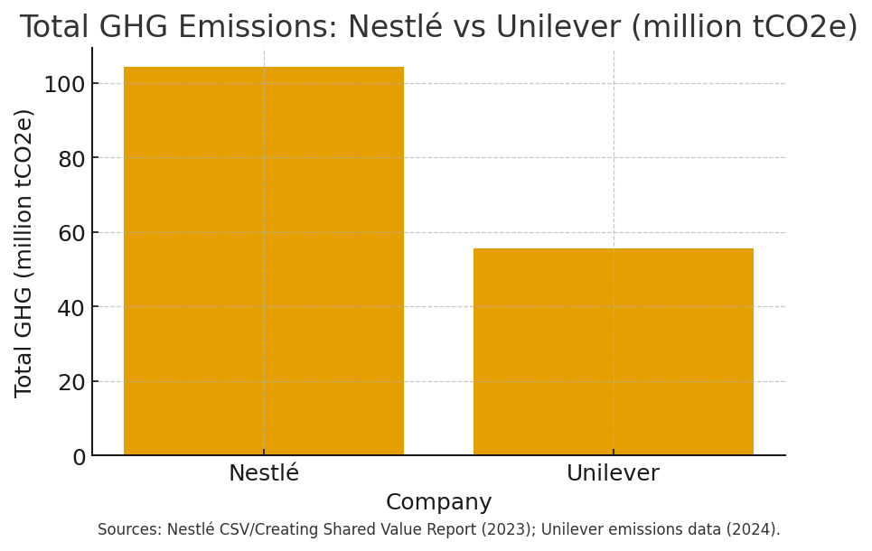

4.3 Integration of Strategic Models

4.3.1 Porter’s Generic Strategies

4.3.1.1 Nestlé Differentiation Strategy
Nestlé’s early commitment to advanced technologies and the development of circular packaging is strongly aligned with Porter’s Differentiation Strategy. The company aims to build competitive advantage by offering high product quality, strong sustainability performance and a continuous focus on innovation (Nestlé, 2024a). This approach is supported by the firm’s well established brand portfolio and extensive research capability, although it also demands consistent investment and increases the organisation’s exposure to changing regulatory conditions.

4.3.1.2 Unilever Differentiation Focus with Cost Elements
Unilever’s strategy reflects a focus on differentiation, as it expands plant based versions of well known brands such as Hellmann’s and Ben and Jerry’s (Unilever, 2024). However, its dependence on partnerships and gradual product improvements introduces elements of cost focused behaviour, which is typical of follower firms that aim to manage risk. Porter argues that such hybrid strategies can weaken the clarity of a company’s competitive position, and this is evident in Unilever’s more cautious sustainability progress.
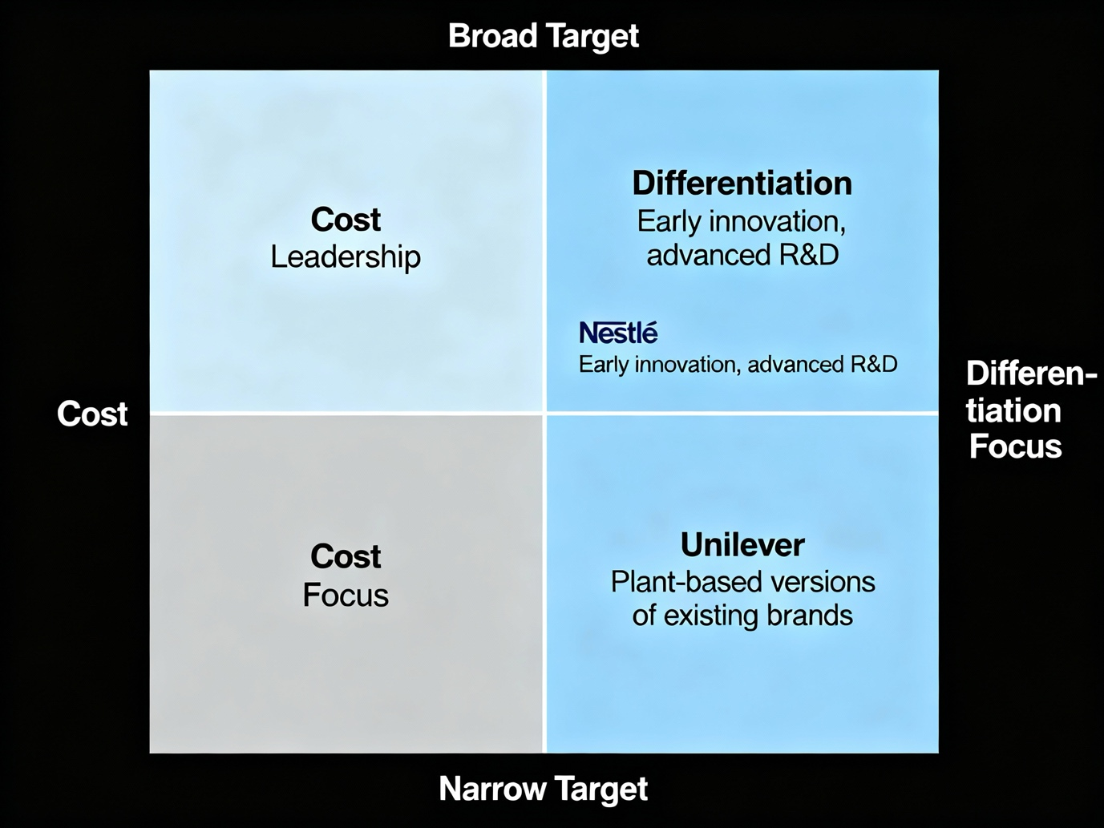

4.3.2 Ansoff’s Growth Matrix

4.3.2.1 Nestlé Product Development + Market Development
Nestlé follows a dual strategic approach. Its focus on Product Development is reflected in continued innovation in protein science and the advancement of more sustainable packaging solutions. At the same time, its Market Development efforts can be seen in the expansion of plant based products into new regions and consumer segments. This combination is consistent with the behaviour of a pioneering firm, although it increases the level of resources required to sustain this momentum.

4.3.2.2 Unilever Market Penetration + Product Development
Unilever places greater emphasis on Market Penetration by using the strength of its well known brands to expand plant based product lines. Its efforts in Product Development are more gradual and largely supported through external partnerships rather than internal research, as shown in its collaborative projects (Unilever, 2022). In line with Ansoff’s framework, this approach reflects the behaviour of fast follower firms that aim to achieve growth while limiting exposure to major strategic risk.

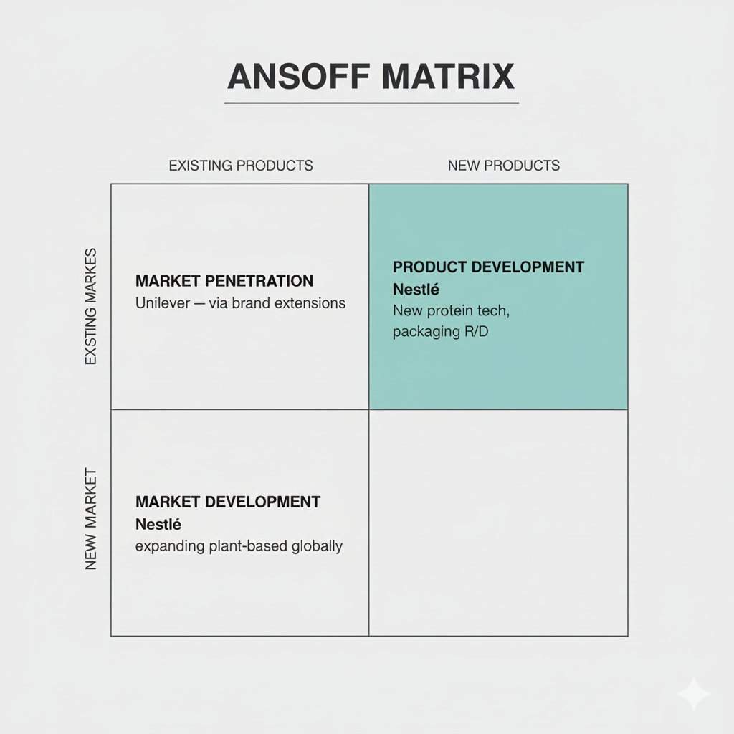

4.4 Strategic Implications

Overall, Nestlé’s strategy is centred on sustained innovation, active involvement in regulatory discussions and the development of long term organisational capabilities. Unilever, on the other hand, focuses on controlled expansion, operational flexibility and adjustments based on market conditions. The analysis shows that each firm’s future competitiveness in the global plant based sector will depend on how effectively it combines political awareness, technological preparedness and compliance with environmental requirements..

5. Recommendations

The comparative analysis shows that both firms operate under increasing political, technological and environmental pressures that require them to strengthen their competitive positions. The recommendations outlined below are intended to address the specific strategic challenges faced by Nestlé and Unilever and to support their ability to respond effectively to these external demands.

5.1 Recommendations for Nestlé (Pioneer)

Diversify Technological Pathways to Reduce Regulatory Exposure
Nestlé should expand its innovation portfolio beyond precision fermentation and plant based extrusion by investing in areas such as microbial proteins, cultivated ingredients and artificial intelligence assisted formulation tools. Broadening its technological base would reduce the risk of becoming dependent on any single method, which is particularly important in regulatory environments that remain uncertain and subject to change (Teece, Pisano and Shuen, 1997, p. 523).
Strengthen Policy Advocacy through Multi Stakeholder Coalitions
As an early entrant, Nestlé is well positioned to influence emerging policy frameworks. The company would benefit from deeper collaboration with regulators, non governmental organisations and industry groups such as the European Plastics Pact. Such engagement would help stabilise regulatory expectations and reduce exposure to the risks typically faced by first movers (Lieberman and Montgomery, 1988, pp. 46–47).
Accelerate Supply Chain Decarbonisation and Traceability
Improving digital traceability systems, including technologies such as blockchain based certification, would support compliance with deforestation free sourcing rules and Scope 3 emission requirements (Nestlé, 2024b). Strengthening transparency in this way would also reinforce Nestlé’s credibility in markets where sustainability concerns strongly shape purchasing decisions.
Improve Cost Efficiency in Sustainable Packaging
Working more closely with recyclers and packaging innovators would help reduce the significant costs associated with meeting circular packaging requirements. Joint investment in these areas could improve long term cost competitiveness while supporting progress toward Nestlé’s sustainability goals (Nestlé, 2024a).

5.2 Recommendations for Unilever (Follower)

Increase Investment in Internal Research and Development
Although partnerships help reduce uncertainty, they also limit Unilever’s ability to develop distinctive capabilities. Increasing investment in its own research and development activities would allow the company to move beyond imitation and strengthen unique competences that support long term competitiveness (Barney, 1991, pp. 103–105).
Adopt More Ambitious and Time Bound Sustainability Targets
Unilever has faced criticism for softening some of its packaging and emissions commitments (Financial Times, 2024). Introducing clearer and more ambitious targets would enhance the company’s reputation and ensure stronger alignment with the tightening environmental regulations emerging across global markets.
Accelerate Reformulation of Established Brands Using Plant Based Innovation
Unilever can make greater progress by reformulating more of its well known brands to include plant based alternatives. This would enable significant market penetration while avoiding the high costs associated with developing completely new brands.
Expand Scenario Planning for Political and Regulatory Change
Given its generally reactive approach, Unilever would benefit from greater investment in foresight and scenario planning tools. Strengthening its capacity to anticipate policy and regulatory shifts would support more proactive and resilient strategic decision making.

6. Conclusion

The analysis shows that political, technological and sustainability driven environmental pressures shape competition in the plant based food industry in significant but uneven ways. Nestlé and Unilever respond to these forces from different structural positions, which reflect their distinct capabilities and strategic priorities. As a pioneering firm, Nestlé draws on early technological investment, substantial research capacity and active engagement with regulators to influence emerging industry standards. However, this leadership also exposes the company to higher regulatory uncertainty, large capital demands and the risk that its efforts may not fully align with future policy developments. In contrast, Unilever’s follower position reduces technological and regulatory risk through gradual adoption and reliance on strategic partnerships, yet this reactive stance limits its influence on policy and weakens its ability to differentiate itself in markets where sustainability expectations are becoming more important.
Across both organisations, the findings highlight that long term competitiveness depends on the ability to recognise and anticipate changes in political, technological and environmental conditions. Looking ahead, Nestlé must continue to manage the vulnerabilities that come with being a first mover while sustaining its innovation strength. Unilever, meanwhile, needs to shift towards a more proactive development of internal capabilities to remain competitive in a regulatory and consumer environment that is changing quickly. Overall, success in the plant based sector will rely on the effective integration of technological innovation, regulatory understanding and sustainability commitments into coherent and forward looking strategic approaches.

7. Reference list

- Barney, J. (1991) ‘Firm resources and sustained competitive advantage’, Journal of Management, 17(1), pp. 99–120.
- European Commission (2023) Packaging and Packaging Waste Regulation (PPWR) Proposal. Available at: https://environment.ec.europa.eu (Accessed: 20 November 2025).
- Financial Times (2024) ‘Unilever criticised for softening environmental targets’. Financial Times, 25 April. Available at: https://www.ft.com (Accessed: 16 November 2025).
- GFI (2023) State of the Industry Report: Plant-Based. Good Food Institute.
- Lieberman, M.B. and Montgomery, D.B. (1988) ‘First-mover advantages’, Strategic Management Journal, 9(S1), pp. 41–58.
- Nestlé (2023a) ‘Nestlé reduces its greenhouse gas emissions in 2023 and delivers significant progress against its net zero ambition’, WBCSD. Available at: https://www.wbcsd.org/news/nestle-reduces-its-greenhouse-gas-emissions-in-2023-and-delivers-significant-progress-against-its-net-zero-ambition (Accessed: 15 November 2025).
- Nestlé (2023b) Creating Shared Value and Sustainability Report. Nestlé Global.
- Nestlé (2024a) Non-Financial Statement 2024. Available at: https://www.nestle.com (Accessed: 14 November 2025).
- Nestlé (2024b) CDP Corporate Questionnaire 2024. Available at: https://www.nestle.com (Accessed: 14 November 2025).
- Nestlé (2024c) Non-Financial Statement 2024. Nestlé Global.
- Nestlé (n.d.) ‘Packaging Strategy: Packaging that is recyclable, reusable and/or compostable’. Available at: https://www.nestle.com/sustainability/waste-reduction/packaging-strategy (Accessed: 18 November 2025).
- Nestlé UK & Ireland (n.d.) ‘Nestlé signs the European Plastics Pact’. Available at: https://www.nestle.co.uk/en-gb/media/pressreleases/allpressreleases/nestle-signs-eppr-commitment-to-reduce-virgin-plastics (Accessed: 17 November 2025).
- ResearchAndMarkets (2025) Plant-Based Food Global Market Report 2025. Research and Markets.
- Reuters (2025) ‘Unilever faces battle to reduce plant-based meat exposure’. Available at: https://www.reuters.com (Accessed: 19 November 2025).
- Teece, D.J., Pisano, G. and Shuen, A. (1997) ‘Dynamic capabilities and strategic management’, Strategic Management Journal, 18(7), pp. 509–533.
- Unilever (2022) ‘Unilever and Geno launch venture to scale alternative ingredients’. Available at: https://www.unilever.com (Accessed: 19 November 2025).
- Unilever (2024a) Plastics and Packaging Sustainability Commitments. Available at: https://www.unilever.com (Accessed: 14 November 2025).
- Unilever (2024b) Climate Transition Action Plan. Unilever PLC.
- Unilever (2024c) Plastics and Packaging Commitments. Unilever PLC.

