Driver analysis using Motec

University of Wales Trinity Saint David
School of Engineering
Motorsport engineering
Oliver gordon
P150782
07/12/19
Race Engineering
Tim Tudor

Table of Contents
1 Introduction 3
2 Session Plan & Aims 4
3 Session 1 analysis 5
3.1 Driver 1 5
3.2 Driver 2 6
3.3 Driver 3 7
4 Session 2 analysis 9
4.1 Driver 1 9
4.1.1 Session 1 – Session 2 run 1 comparison 9
4.1.2 Session 2 run 1 – run 2 11
4.1.3 Session 2 run 2 – run 3 12
4.2 Driver 2 12
4.2.1 Session 1 – Session 2 run 1 comparison 12
4.2.2 Session 2 run 1 – run 2 13
4.2.3 Session 2 run 2 – run 3 14
4.3 Driver 3 14
4.3.1 Session 1 – Session 2 run 1 comparison 14
4.3.2 Session 2 run 1 – run 2 14
4.3.3 Session 2 run 2 – run 3 15
4.4 Overview comments 16
5 Motec figures 16
6 Conclusion 21
7 References 22
8 Bibliography 23

Introduction
This report consists of drivers’ data analysis from different sessions from a driver in the loop simulator. The Drivers are at different levels of capabilities and with the application of Motec i2 Pro software concise driver improvements can be outlined and potentially implemented through the course of multiple driver stints. Using knowledge and understanding of data analysis the extent to which the advice implemented effects to overall sector and lap time can be concluded. A concise plan for both sessions and clear simple improvements will be provided for the drivers in the second session. Analysis of how the improvements were implemented individually and then a brief overview will be conducted. Also going into the workshop to measure the wheelbase of the MCR race car.

Session Plan & Aims
The plan for the first session was simple, go in get the first driver in, in our case Davis Watkins and do 3 warm-up/ practice laps and then 10 timed laps, the same with driver 2 and 3. Driver 3 being the overall benchmark being the more experienced driver. We wanted consistency from the drivers, problem with this is that driver 1 quickly displayed an attitude of racing himself and lost the overall vision for this first session and aim the group wanted to complete.
Driver 2, Michael Cunniffe, wasn’t exceeding himself with lap times, just struggled keeping a consistent line and had a couple offs during the timed laps, but of the consistent laps he did complete they were similar time. And Driver 3 did have a big spin at the start of his stint in session 1 but otherwise very consistent.
Session 2 was where we had 2 or 3 improvements for each driver, which we organised into 3 timed laps in 3 runs each as a chance to complete the task given. The improvements given to each driver are further into this essay.
Also measure the wheel base of the MCR to be 2.62m

Session 1 analysis
Driver 1: Davis Watkins
Driver 2: Michael Cunniffe
Driver 3: Tim Tudor
Track: Brands Hatch Indy

Driver 1
Session one, this section is about what we will be looking at the drivers 3 fastest time in the first session and seeing what improvements can be made.
Driver 1 analysis. As an initial view point on the way the driver was performing is that it was very clear the goal of the session wasn’t clear in his mind, as previous stated it was to gain consistent data of three drivers doing laps of a track to review driver profile and what improvements could be implemented into a second session, with the same car on the same track using a simulator. The 3 laps that will be compared are the 48.289, 48.392 & 48.691 seconds. On the slower of three laps driver one is off the throttle 32 metres earlier than the quickest lap, and the second quickest is 30 metres before the quickest. Also on the middle lap the driver gives a little burst of the throttle before fully decelerating.
On the second fastest lap the driver gets on the brakes earlier and does slightly gain time so this could be something the driver could do again. Irregular accelerating during turn one and there also being a nasty bump on corner entry for the drivers to avoid, driver one does deal with the bump well but from looking at the data below that getting the braking done just before the initial turn in too turn one should be advised & then getting on the throttle quick but also smooth application.
Going towards turn 2, driver one needs to stay nice and wide before turning in, get all initial braking done before turning. This is something the driver needs to improve, as well as getting down the gears a little earlier. Again driver one needs to be smoother on the throttle.
Turn 3, is somewhere where improvement can be easily obtained, by simply getting off the throttle at the same point just quicker, and then quick sharp braking then turn in and apply the throttle nice and smooth. Onto turn for where the driver is extremely erratic with getting off the throttle, advice would be down to a steady half throttle, no braking and make the turn then back onto the power towards the braking zone for the final corner.
The final corner, on the slowest of the three laps, driver 1 gets on the power nice and to accelerate through the corner but is too early because the driver as to back off the throttle by 20% and there is also a dip in the steering percentage mid corner indicating oversteer.
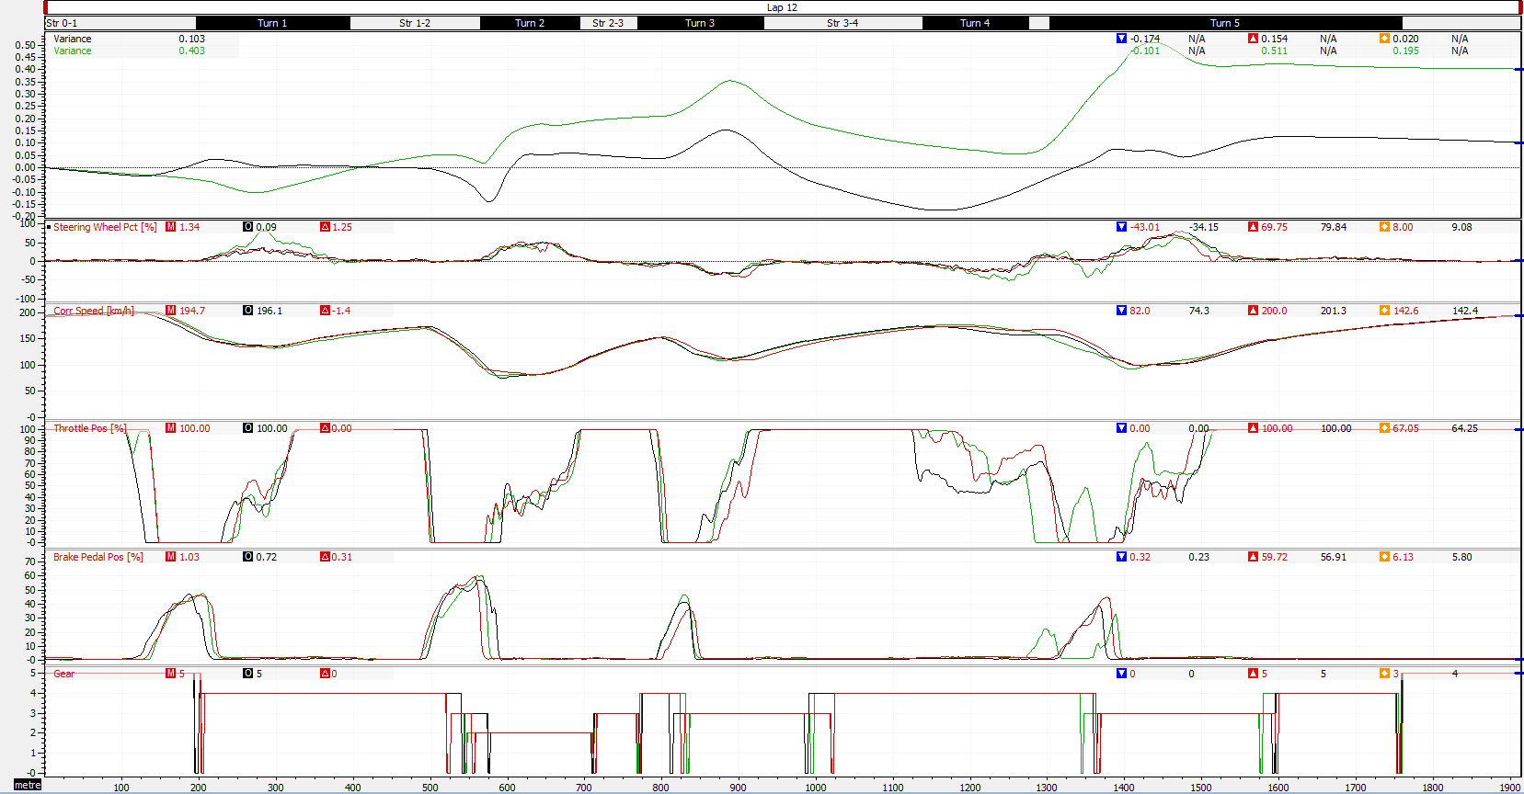
On the right is the data tables for driver session analysis, with the Variance in time at the top then Steering pct., Corr speed (km/h), Throttle pos (%), Brake pedal pos (%), and the Gear.

The circles are the point discussed above starting from left to right.

Driver 2
Figure 1 - session 1 analysis driver 1
Driver 2 analysis.
With driver two, an initial analysis from the data was that the driver couldn’t hit full throttle due to the pedal position of the simulator, so that needs sorting for the next session. The lap times that will be analysed are, 48.424s, 48.566s and 48.697s.
With the first corner the steering fluctuates which means that the driver hits the bump on the entry of turn 1, the driver also down shifts a bit too early which unsettles the car. So later down shifts and avoid the bump on entry by turning a little later.
Driver 2 needs to steer less aggressively into turn 2 because he’s experiencing lots of oversteer and does it on two of the three laps in the data below.
For turn 3, just carrying a little more speed otherwise it’s pretty good.
Then into turn 4 where good smooth steering, and nice coasting to half throttle then back onto the power towards the next braking zone, keep this consistent for session two.
Driver 2 at the final corner just needs to keep it smooth and slightly early up shifts are required, and could also down shift earlier, but otherwise smooth steering and acceleration would tidy up the laps.
Below are the 3 fast laps from session one for driver 2 data tables for driver session one analysis, with the Variance in time at the top then Steering pct., Corr speed (km/h), Throttle pos (%), Brake pedal pos (%), and the Gear.
The circles are the point discussed above starting from left to right.
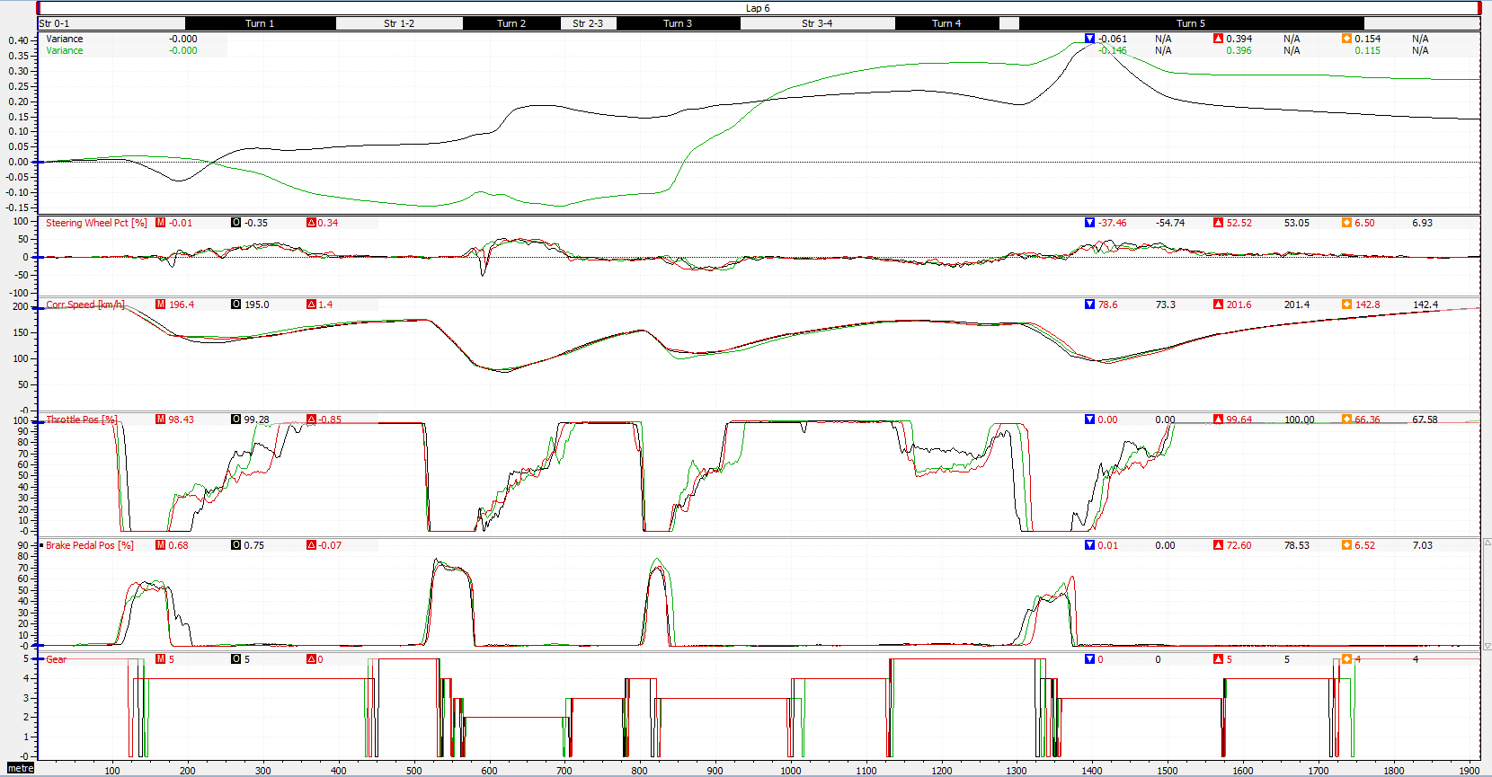
Figure 2- session 1 analysis driver 2

Driver 3
Driver 3 analysis from session one on the simulator @ Brands Hatch Indy.
The lap fastest three times that were set by driver 3 were, 47.428s, 47.502s and a 47.513s in addition to this driver set lap times under 48 seconds in half of the 13 timed laps from the session, showing a heap of experience and confidence in the car.
Also something we saw the driver do off his own back that nobody had asked and that the two other drivers didn’t do was a warm-up lap for the tyres and brakes. This helps because his two quickest laps are on lap 2 and 3, so right at the start of the session.
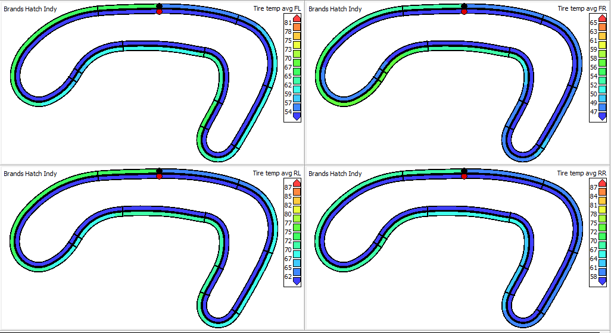

On the right is driver 3 tyre warm up from the out lap and lap one. The fronts get too 53 & 46 FL and FR. 60 & 56 on the RL & RR,
Figure 3- tyre warm up driver 3 (benchmark driver) (Tmpleman, 2008)

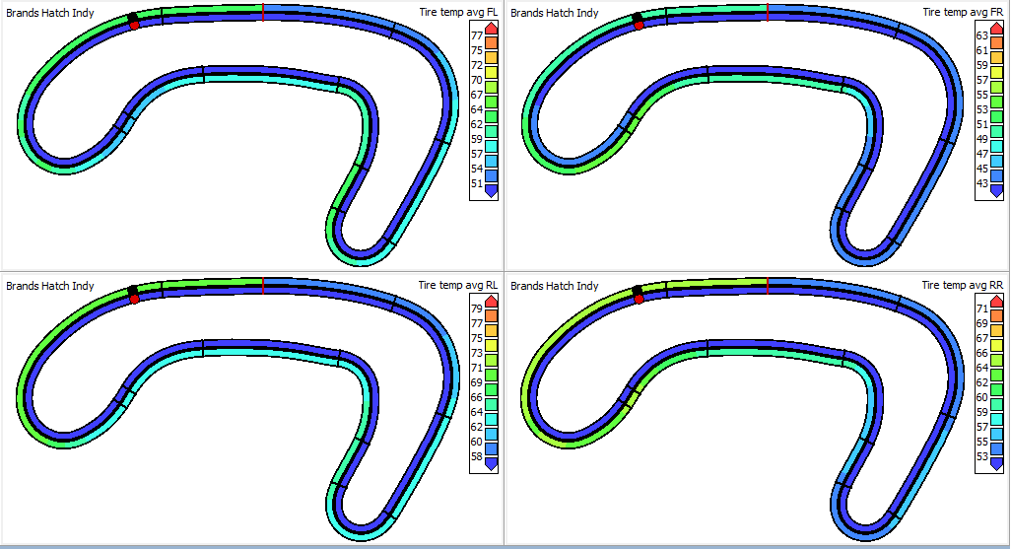

On the right is driver 1 tyre warm-up on the out lap and first lap. The fronts being 4 degrees colder just on out lap alone and around the rears, 5 degrees colder.
Figure 4- tyre warm up driver 1 (Tmpleman, 2008)

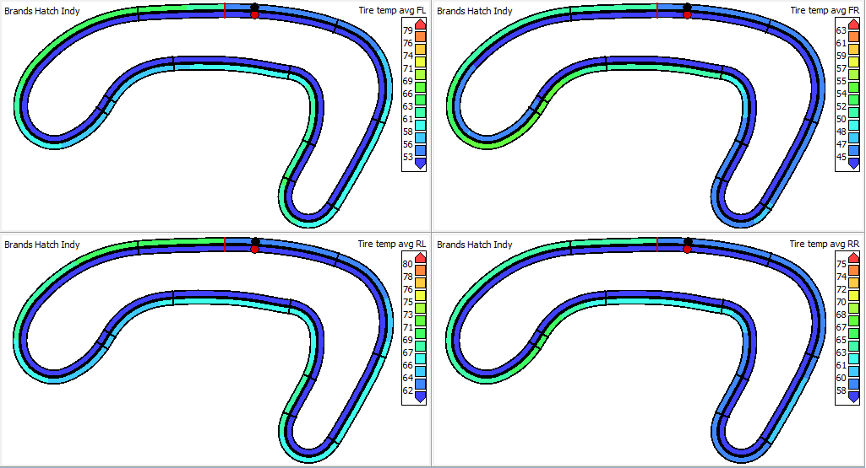

This rainbow track map is driver 2 tyre warm-up fro out lap and lap 1, where the rears did end up on the same temperature but the fronts are 2/3 degrees colder that driver 3.
Figure 5- tyre warm up driver 2 (Tmpleman, 2008)

When driver 3 gets too turn 1 throttle and steering is good but could have applied the brakes harder for a little longer. This would allow the throttle to be applied even quicker on exit.
In turn 2 the driver gets on the accelerator too early causing it to be too erratic on the exit, smooth the accelerating out on the exit of turn too will yes the driver benefit into turn 3.
Turn 3 steering and braking is perfect just smoother acceleration on exit required.
Gets off the throttle too early for turn throttle and also applies the brakes for turn 4 which isn’t necessary at all. And for turn 5 there really isn’t much improvement required just keep it consistent and smooth on entry and exit with the throttle.
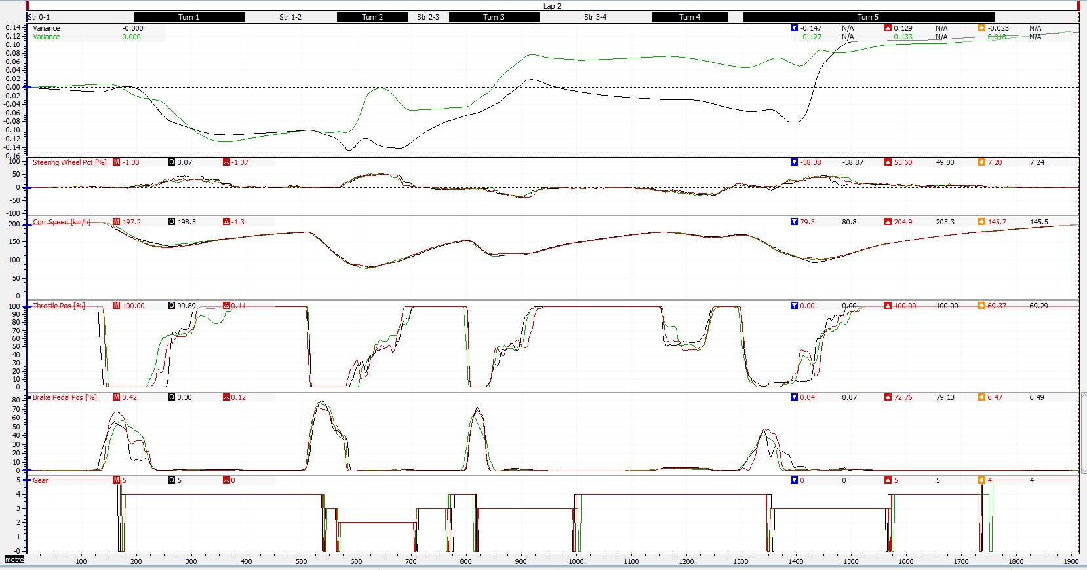
Below is the data of driver 3, three fastest lap times. Along with the circled points that are discussed above.
Figure 6- Session 1 analysis driver 3 (benchmark driver)

Session 2 analysis

The order of the analysis will be: driver 1 Session 1 in comparison to Session 2 run 1 fastest laps. Then run 1 to run 2 fastest laps and the same with run 2 to run 3 fastest. Three separate individual driver analysis. Then it will be the same driver 2 and driver 3. Involved in the comparison will be what changes were asked to change for the drivers and were they successfully implemented. And if they made other mistakes or improved anywhere and look at where they could improve in the future. 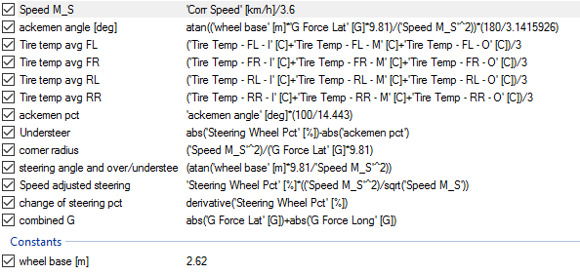
Figure 7- math channels Motec (Motorsport, 2006) (Anon., n.d.)

Driver 1

Session 1 – Session 2 run 1 comparison
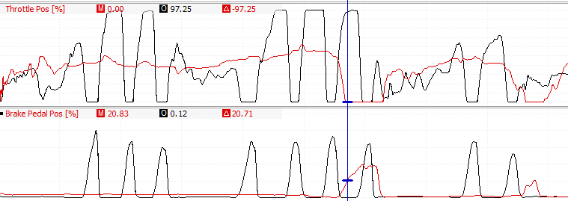
In this section, the analysis will be on the lap comparison as a whole and did the driver implemented the change, in this run the changes that were asked of the driver were, on the out lap a good tyre and brake warm-up lap is required and in turn 4 go too half throttle then back on the throttle once turn in is complete.
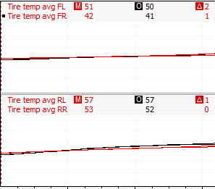
Let’s start with the implementations and weather the driver achieved the targets set. On the right shows that driver 1 has implemented the request of a warm-up lap for his out lap. Demonstrated by the throttle and braking application (black erratic lines). But when reviewing the data the tires still don’t get up too temperature. At the end of the out laps the tires are in fact 1 degrees colder on three of the four tyres.
Figure 8 - session 2 run 1 driver 1 warm up
Figure 9- tyre temps driver 1
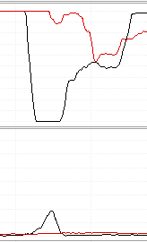
Onto the turn 4 improvement, which was not implemented correctly, the driver came fully off the throttle, when he was only meant to go to 50% throttle and also applied the brakes when they aren’t required for this corner. On the right will show the second session lap time as the black line, throttle percentage at the top and brake application the bottom column, as you can see the black line for throttle percentage flat lines at the bottom of the scale, and this is the same part where the brakes get applied which results in the car slowing by 12 km/h.
Figure 10- turn 4 analysis driver 1
Now the lap as a whole in comparison to the first session. Driver 1 gets off the throttle too early into turn 1, also applies too much braking as well, this could be down to being the first timed laps of the session and is getting used to the car again. Irregular throttle application on all of the 5 corners. Turn 3 was smoother than session 1 but was off the throttle too early. Does end up carrying more speed out of the corner, but this is wasted by getting off the throttle in turn 4 and then loses all the time the driver gained. Gets on the throttle 25m earlier than the session 1 lap but this seems to be too early because of the erratic nature it’s applied and the dip in steering percentage mid corner does prove this statement. Because of this the run from the corner exit to finish line was identical in speed and steering.
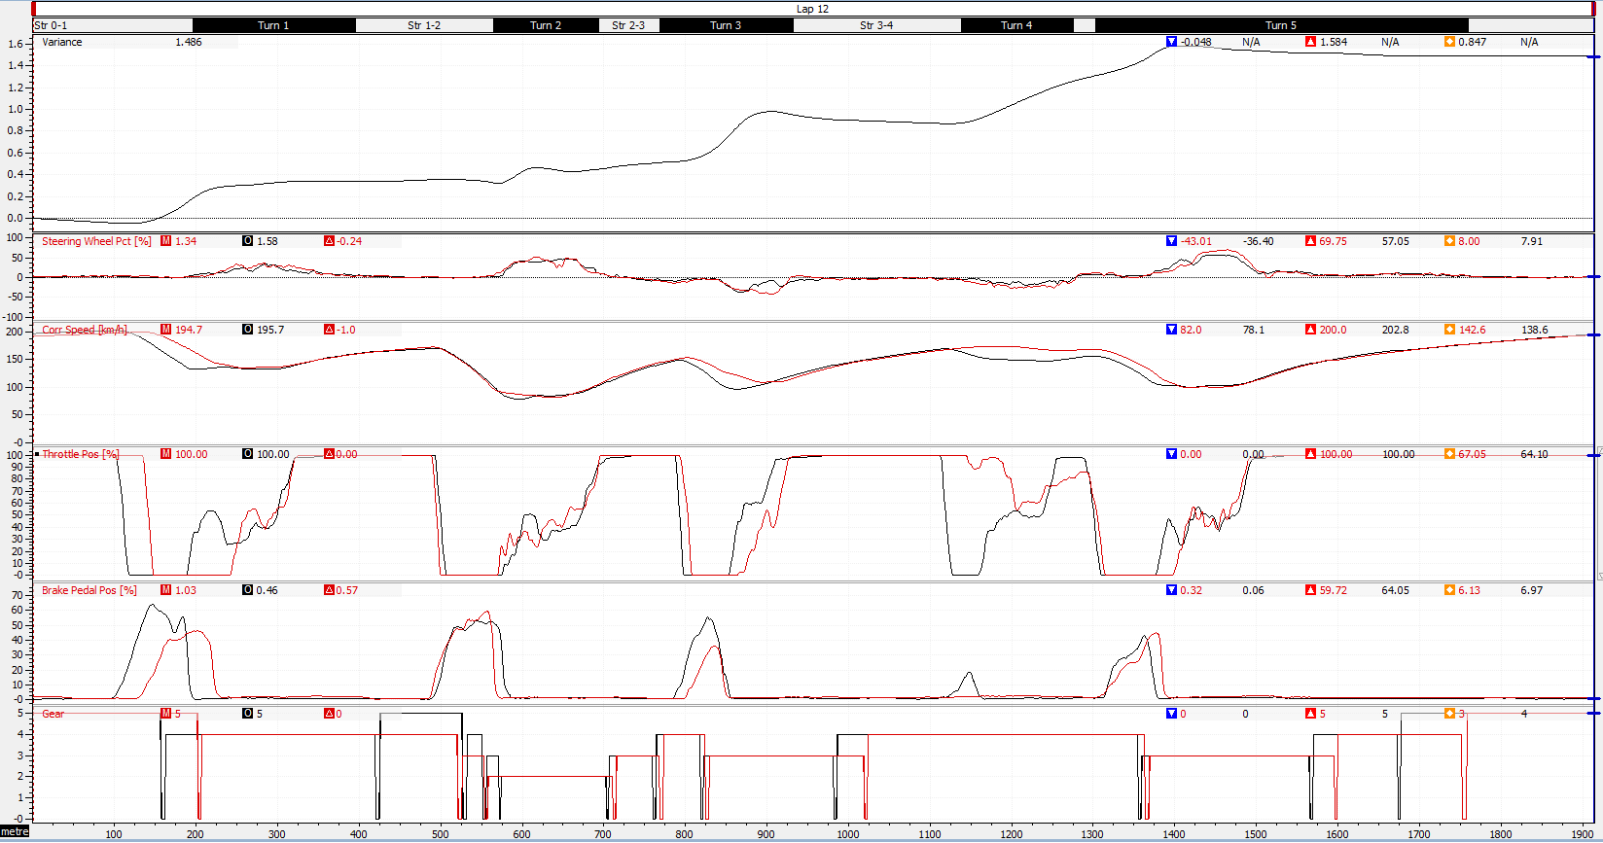
Figure 11- session 2 compare to session 1 fastest laps driver 1

Session 2 run 1 – run 2
In the second run for driver 1 the improvement was to fix the brake zone for turn 2 and also general tidy up of the lap as whole.
At the start of the lap it was clear to see that confidence had grown from already having a stint in the sim because of the first corner braking, run 1 is at 95m and run 2 is at 131m which in turn allows the driver to carry 30 km/h more speed throughout the corner, braking is smooth and short, but the throttle application on the exit is untidy.
The turn 2 changes were implemented, brakes slightly later as requested and brakes harder too but does also need to be smoother on the throttle on the exit of the corner, then braking later into turn 3 and smooth on throttle on the exit. Gets turn 4 change from the previous run implemented in this run too. Goes to half throttle for turn 4 and doesn’t apply the brakes and is smoother on the exit with the throttle. This lap in run 2 ends up being driver 1 fastest overall lap with a time of 48.285s.

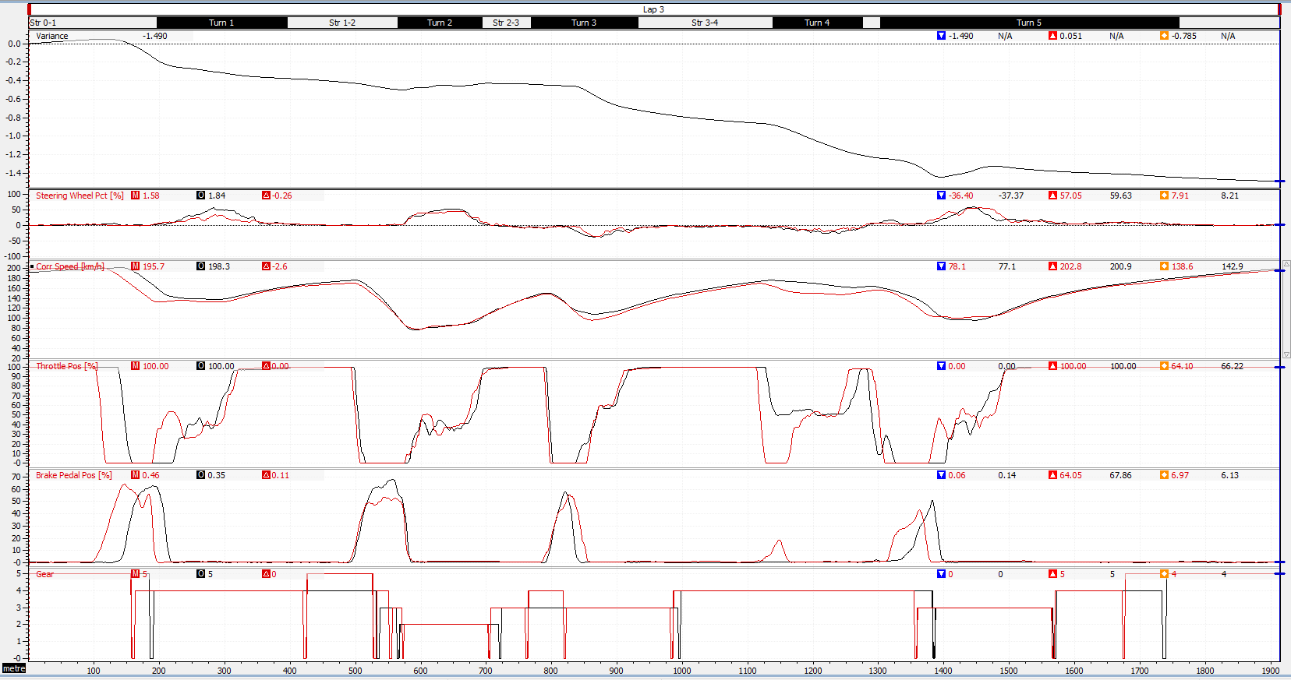
Figure 12- driver 1 session 2 run 1 compared to run 2 analysis

Session 2 run 2 – run 3
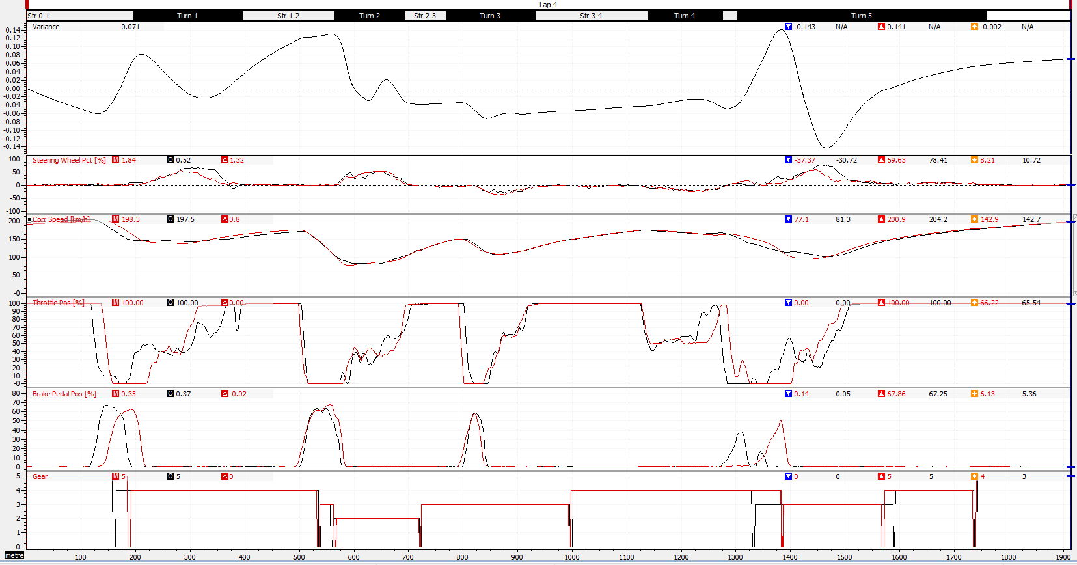
On the fastest lap for run 3 turn 1, Driver 1 gets off the throttle too early again and it’s far too erratic on the throttle on the exit. Off the throttle even later than run 2 but the application of the throttle is erratic but this is also because of an aggressive initial turn in and to points of oversteer, see below at the steering pct., this will show to two points of counter steering to rectify this. Turn 3 is good and an overall improvement to take from the lap. Turn 4 was good too but off the power too early into turn 5 and the throttle application is too early mid corner and ruins the final part of the lap altogether.
Figure 13- driver 1 session 2 run 2 compared to run 3 analysis

Driver 2

Session 1 – Session 2 run 1 comparison
The change tasked to the driver to be implemented, to get pedals in the correct position so full throttle and brake are able to be applied. Then see how the lap times change.
Tyre warm-up like driver 1 did and again no real improvement to the tyre temps, very strange to find this in the data and not to find this in the live session.
Turn 1 showing huge amounts confidence, getting off the throttle 33m later and then getting on the brakes later and smoothly on the throttle towards turn 2. In turn 2, with good speed on entry but gone into the corner slightly too quick, causing big over steer and also counter steer. Throttle on exit a little early and has to back off slightly to regain the grip of the tyres.
In turn 3, there are three points of counter steer which along with a constant speed being applied would lead me to believe that the driver has gone onto the grass or slightly off track mid corner.
Turn 4 is good but the brakes are applied and like we learnt with driver 1, you do not require the brakes for turn 4. And then on the throttle too early on turn 5 and has to slightly back out of throttle.
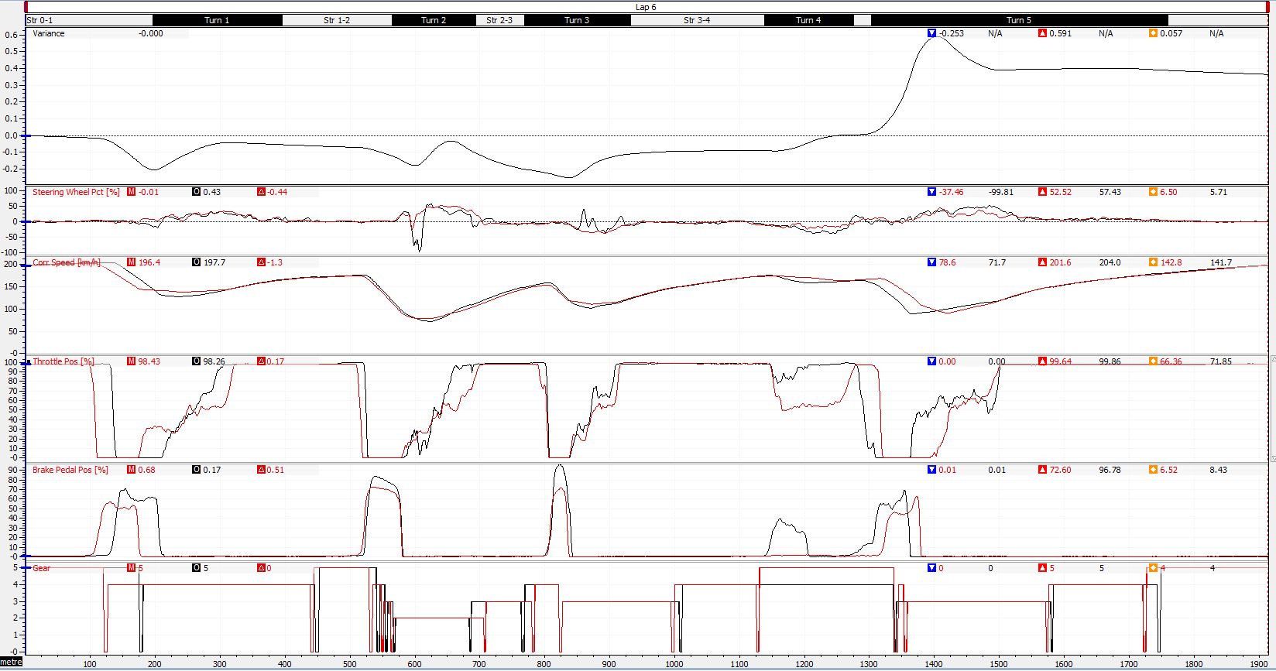
Figure 14- driver 2 session 1 fastest compare to session 2 run 1 fastest analysis

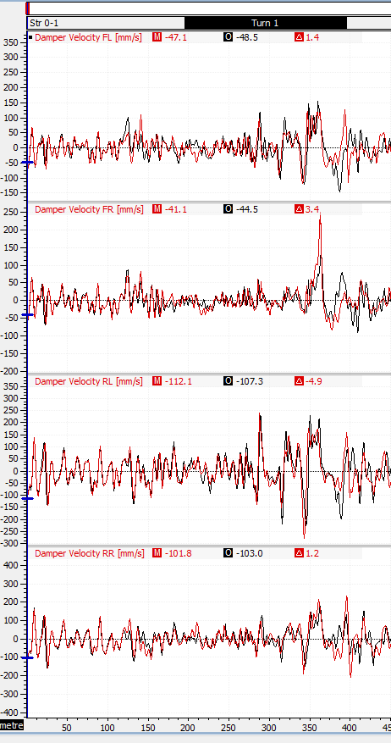
Session 2 run 1 – run 2
Figure 15- damper velocity analysis
In the second run for driver 2, the improvement was too manage the bump into turn 1 because this was something this driver struggled with in the first session.
On the right is a damper velocity over distance graph, specifically looking at the start of turn one, looking for any spikes in the velocity too show any sudden movement and as you can see the red line fluctuates a lot meaning the driver hit the bump, but the black line does fluctuate in the same way and this mean we can assume the drive didn’t hit the bump. This means the improvement was correctly implemented.
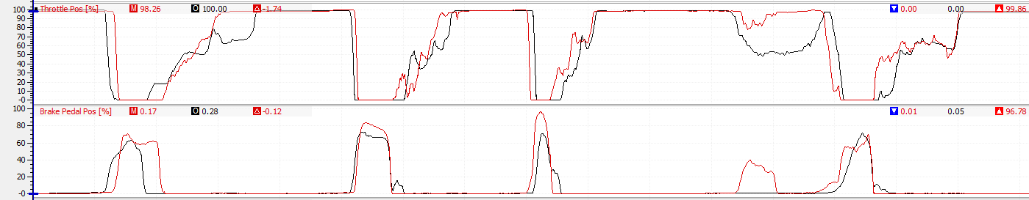
The throttle application on the exit of turn 1 is erratic but apart from that the rest of the lap is smooth and similar to other smooth lap the driver previously produced. Turn 5 could still do with improvement on the throttle application on exit of the corner.
Figure 16- driver 2 session 2 run 1 compared to run 2 analysis

Session 2 run 2 – run 3
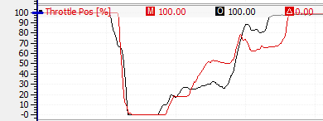
In run 3 fastest lap, the exit is extremely erratic, seems to be a struggle for this particular driver, but the rest of the lap and over the course of the lap the driver regains the time lost from the turn 1 throttle application issues.
Figure 17 run 2 to run 3 throttle position
Another note to take for driver too the simulator software did crash through the third timed lap. This did hinder the driver on improving his lap time.

Driver 3

Session 1 – Session 2 run 1 comparison
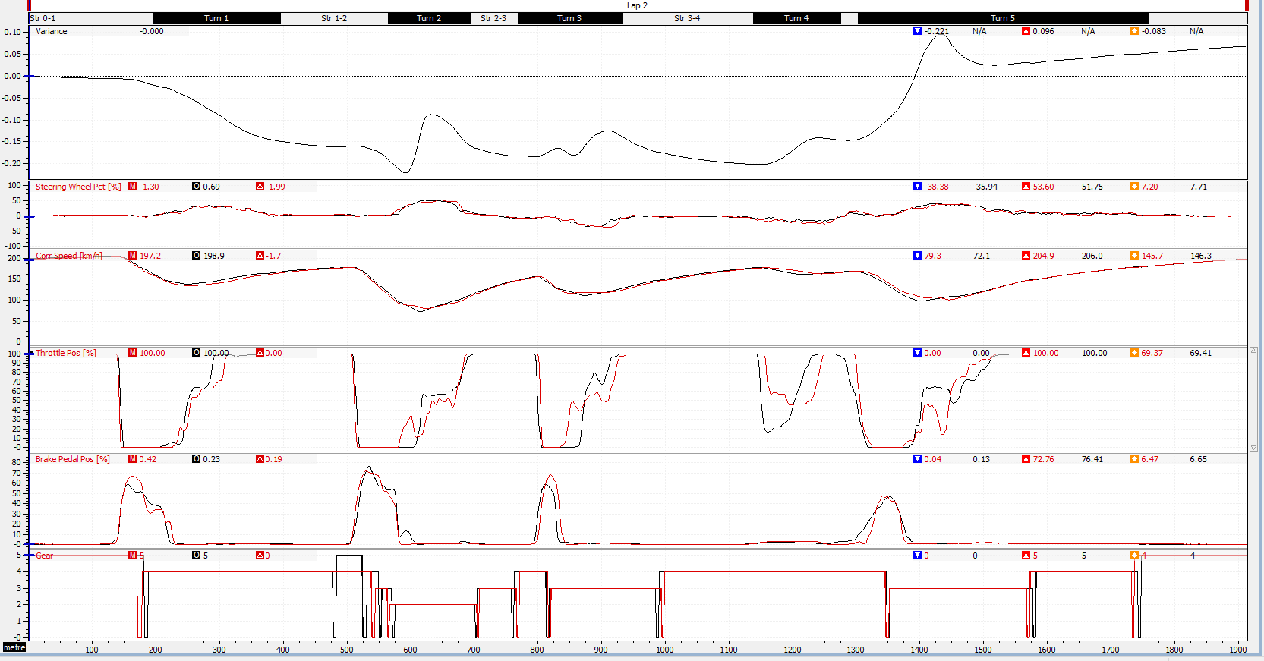
Driver 3 improve on run 1 was carry more speed into turn 3, which he does achieve on the mid part of the corner, but in turn1 and 2 the driver matches exactly what he does from the previous session. Does get off the throttle too much in turn 4 and rest his foot on the brake which isn’t needed. And could be smoother on exit of turn 5.
Figure 18- driver 3 session 1 compared to session 2 run 1

Session 2 run 1 – run 2
In the second run for driver 3 the improvement to apply the throttle earlier on the exit of turn 2 to carry more speed towards turn 3. It’s not smooth throttle application but the driver does achieve what is asked of him. With the rest of the lap, turn 1 is tidy and consistent as is the entry of turn 2, could improve on turn 3 tidiness but otherwise pretty good, and does gain time compared to the run 1 time.
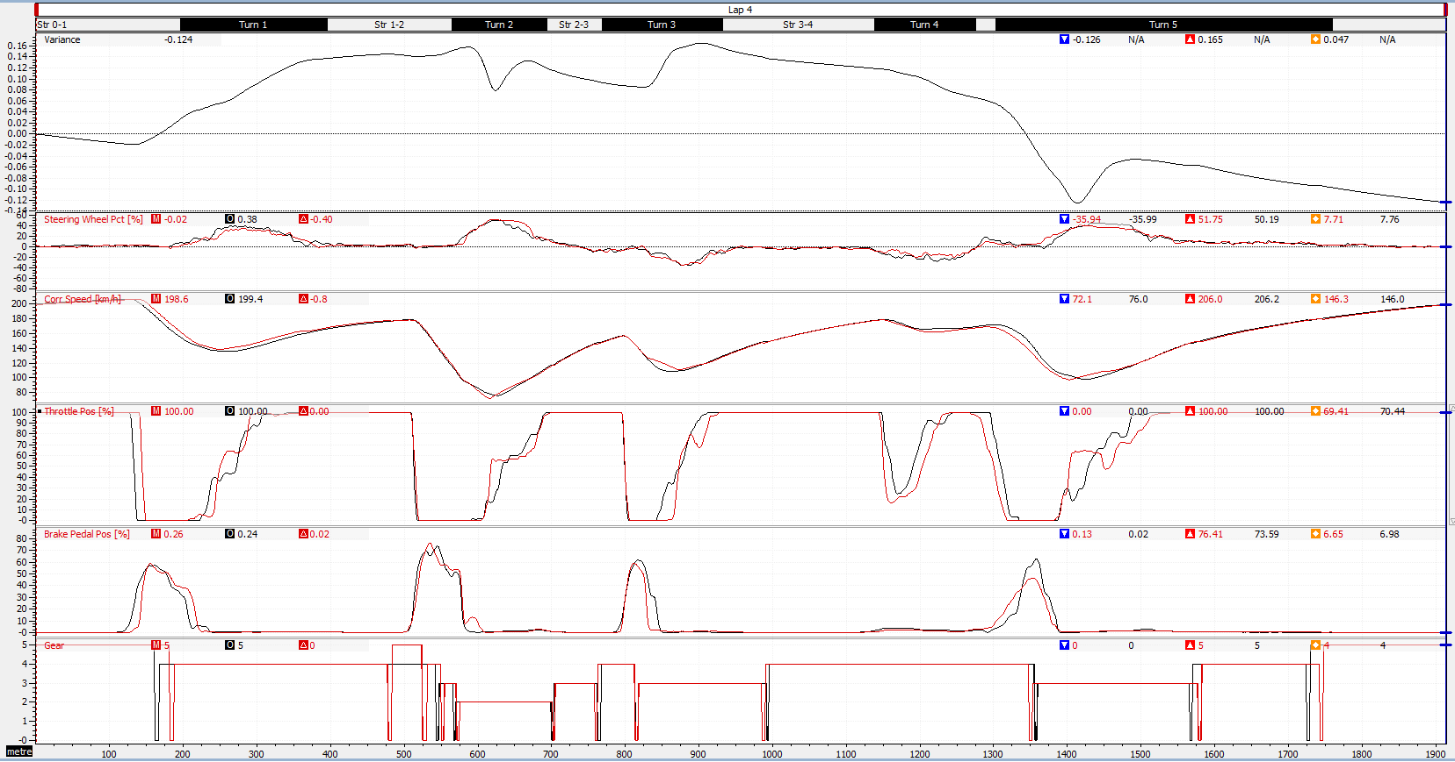
The first half of the lap is quite untidy but with extremely smooth throttle on the exit of turn 3 and then nails turn 4 and turn 5, gains him a whole 0.289s on the second half of the lap.
Figure 19- driver 3 session 2 run 1 compared to run 2

Session 2 run 2 – run 3
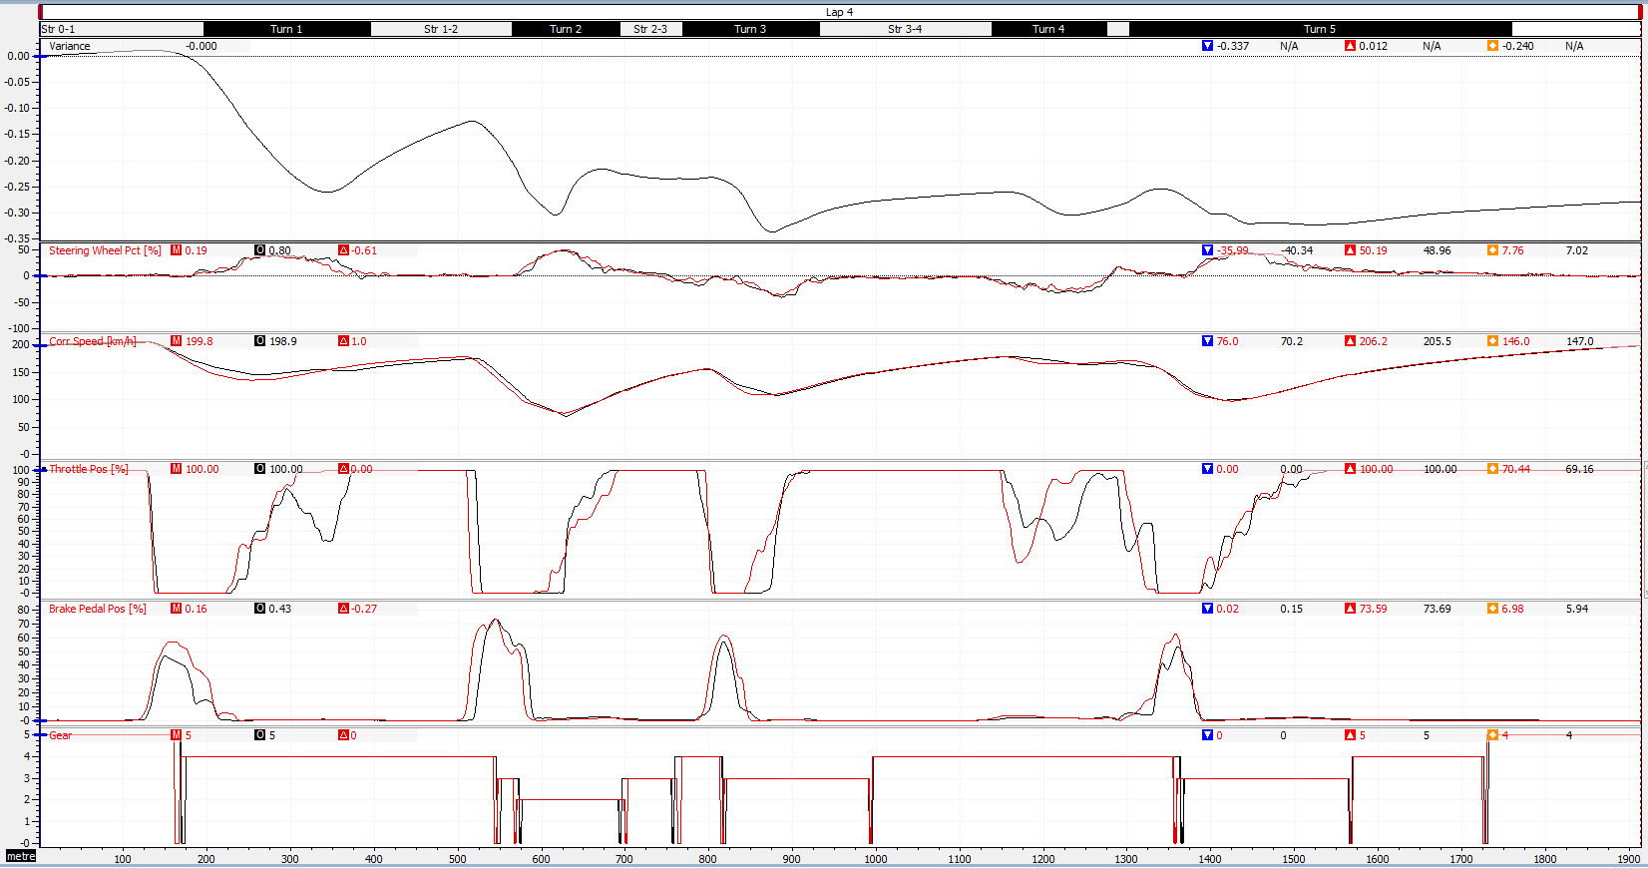
In run 3 the improvement that driver 3 was asked to implement was to tidy up the lap and blend some previous sectors together, this was after an in session discussion with the driver in between runs. Which the driver executes perfectly because from the initial turn in at turn 1 the driver gains time at every corner. Turn 1 is a little unbalanced on the exit but apart from that no other comments needed.
Figure 20- driver 3 session 2 run 2 compared to run 3

Overview comments
Driver 3 was the better driver at listening to instructions and implementing them into the stints on the simulator. This is also down to driver 3 being the more experienced driver and has also but more hours into the sim over the years, and Group A also used the same driver (Driver 3: Tim Tudor) in the session before our groups so the driver was also already warmed up.

Motec figures

Figure 1 - session 1 analysis driver 1
Figure 2- session 1 analysis driver 2
Figure 3- tyre warm up driver 3 (benchmark driver)
Figure 4- tyre warm up driver 1
Figure 5- tyre warm up driver 2
Figure 6- Session 1 analysis driver 3 (benchmark driver)
Figure 7 - session 2 run 1 driver 1 warm up
Figure 8- tyre temps driver 1
Figure 9- turn 4 analysis driver 1
Figure 10- session 2 compare to session 1 fastest laps driver 1
Figure 11- driver 1 session 2 run 1 compared to run 2 analysis
Figure 12- driver 1 session 2 run 2 compared to run 3 analysis
Figure 13- driver 2 session 1 fastest compare to session 2 run 1 fastest analysis
Figure 14- damper velocity analysis
Figure 15- driver 2 session 2 run 1 compared to run 2 analysis
Figure 16 run 2 to run 3 throttle position
Figure 17- driver 3 session 1 compared to session 2 run 1
Figure 18- driver 3 session 2 run 1 compared to run 2
Figure 19- driver 3 session 2 run 2 compared to run 3
Figure 7- math channels Motec

Conclusion

To conclude this report on driver analysis using Motec i2 Pro to analysis 3 drivers in the same vehicle and same track. The aim was to find points where the drivers could improve so in session 1 the 3 drivers had a long stint each to set consistent lap times and then in between session the group goes away to look at the drivers times individually and compared to each other to give points of improvements. These improvements could be too difficult because of the time constraint on the session time, so we decided on 2/3 improvements per driver and for each driver to do a 3 timed lap stint 3 times each. With a new improvement in each stint. With any in session points that come up discussed during the session and the improvements could have change, in fact with driver there wasn’t a run 3 improvement to implement but during the session it was discussed that the driver himself felt to odd mistake was made and that the laps just needed sowing together, that’s just one example. A good level of understanding and knowledge shown on how to use Motec i2 Pro and a good use of math channels to review data. Driver 1 made an overall slight improvement in lap time but didn’t really achieve the Improvements in the second session, driver 2 implemented the changes well but the lap times didn’t follow suite, this could be due to the improvements being the wrong ones. And the final driver implemented the changes well and ended up improving his lap time too.

References
Anon., n.d. Motec i2 Pro. s.l.:s.n.
Motorsport, T., 2006. MoTeC i2 Pro Beginners Guide, s.l.: s.n.
Tmpleman, G., 2008. The Competition Car Data Logging Manual. s.l.:s.n.

Bibliography
Anon., n.d. Motec i2 Pro. s.l.:s.n.
Motorsport, T., 2006. MoTeC i2 Pro Beginners Guide, s.l.: s.n.
Tmpleman, G., 2008. The Competition Car Data Logging Manual. s.l.:s.n.

