

LEVEL 4

SEMESTER 1

MODULE CODE: SHSS4077
Making Safety Personal
aSSESSMENT TYPE: Project
Assessment/Component: 2

COMPONENT WEIGHTING: 30 %

WORD COUNT: 1,500 WORDS

MODULE TUTOR: Graham Harvey

SUBMISSION DETAILS:
Work as part of a small team (between three and five people) to produce an interpretive brochure/ leaflet/ poster relating to a site that you have visited for outdoor pursuits.
Your publication MUST provide details of:
- the natural environment at the site (specific species, ecosystems etc.).
- how outdoor practitioners should behave at the site in order to minimise their environmental impact
- key safety considerations for individuals participating in specific activities at the site
Each team member will submit a copy of the completed leaflet AND a 500-word summary/ reflection of his or her personal contribution to the project. The summary must also include a full list of reference material used in preparing the leaflet.
Submit via Turnitin
6th December 2019

School of Sport, Health & Outdoor Education

Assessment Feedback Sheet

Student No./ Name: 1800402 / Dominic Hole

Personal Evaluation – to support your academic progress please complete the section below BEFORE submitting your work.
What do you consider to be the best aspects of this work? |  |  | I believe the quality of information provided for the leaflet was my best aspect.
Which aspects do you consider could have been improved in this piece of work? |  |  | I feel I could have improved on my ability to summarise and reflect on my work effectively.
What have you found most satisfying whilst undertaking this submission? |  |  | I found the reading for the research to be the most satisfying part of this work.
ASSESSMENT CRITERIA | Learning  Outcomes |  | GRADE
ASSESSMENT CRITERIA |  |  | Poor  < 20% | Weak  20-29% | Unsatisfactory  30-39% |  | Satisfactory  40 – 49% | Good  50 – 59% | Very Good  60 – 69% | Excellent  70 – 84% |  | Exceptional  85– 100% | %
Identify the key natural features of the chosen site | 4 |  |  |  |  |  |  |  |  |  |  |  | 20%
Clearly outline a code of environmentally sensitive practice for outdoor practitioners s using the site | 1,4,5 |  |  |  |  |  |  |  |  |  |  |  | 20%
Clearly outline safety guidelines for individuals participating in outdoor activities SPECIIFCALLY at the site. | 1,2,3,4 |  |  |  |  |  |  |  |  |  |  |  | 20%
Reflection on personal contribution to the project | 1 |  |  |  |  |  |  |  |  |  |  |  | 20%
Evidence of research and reading relevant to both the activity and venue | 2,3, 4, 5 |  |  |  |  |  |  |  |  |  |  |  | 20%
It is expected that students will present work that is proof read, correctly referenced and adheres to the Assessment Checklist. Therefore a range of 0 – 10 marks will be deducted for non-completion of any of the points on the checklist below.
TUTOR COMMENTS:

Submission date:  via Turnitin |  | Return date:  (at least within 4 weeks) |  |  |  | Tutor: |  |  |  |  | Mark:

Assignment Checklist

- Please complete the Personal Evaluation section of the Assessment Feedback sheet, add your name and details, and paste the whole of this assignment document into the front of your assignment

- Submission is a single word file, clearly labelled with your name and module code
- Font style - Times New Roman, size -12 for text and 14 for headings
- Ink colour – black only
- Line spacing – 1.5 line spacing and 2cm- 2.5cm page margins
- Quotations more than three lines to be indented 1 line spacing
- One line space between paragraphs, paragraphs must be left aligned
- Pagination (your assignment should have page numbers)
- All tables and figures are internally referenced and have a title
- Word count checked and written at end of text (before references and any appendix)
- Assignment is within 10% of the word limit (excluding references and any appendices)
- All references in the text are included in the reference list
- Correct referencing following the Harvard style, as described in the Palgrave study skills book ‘Cite them Right’.
- Correct spelling using UK English
- Correct use of punctuation
- Grammar and syntax correct- double check anything that has a green line under it
- I have read my assignment out loud to myself and it makes sense and is easy to read
- Somebody else has read my work and it makes sense to him or her!
- I have checked and I have not plagiarised
Failure to follow these guidelines will cost you marks!
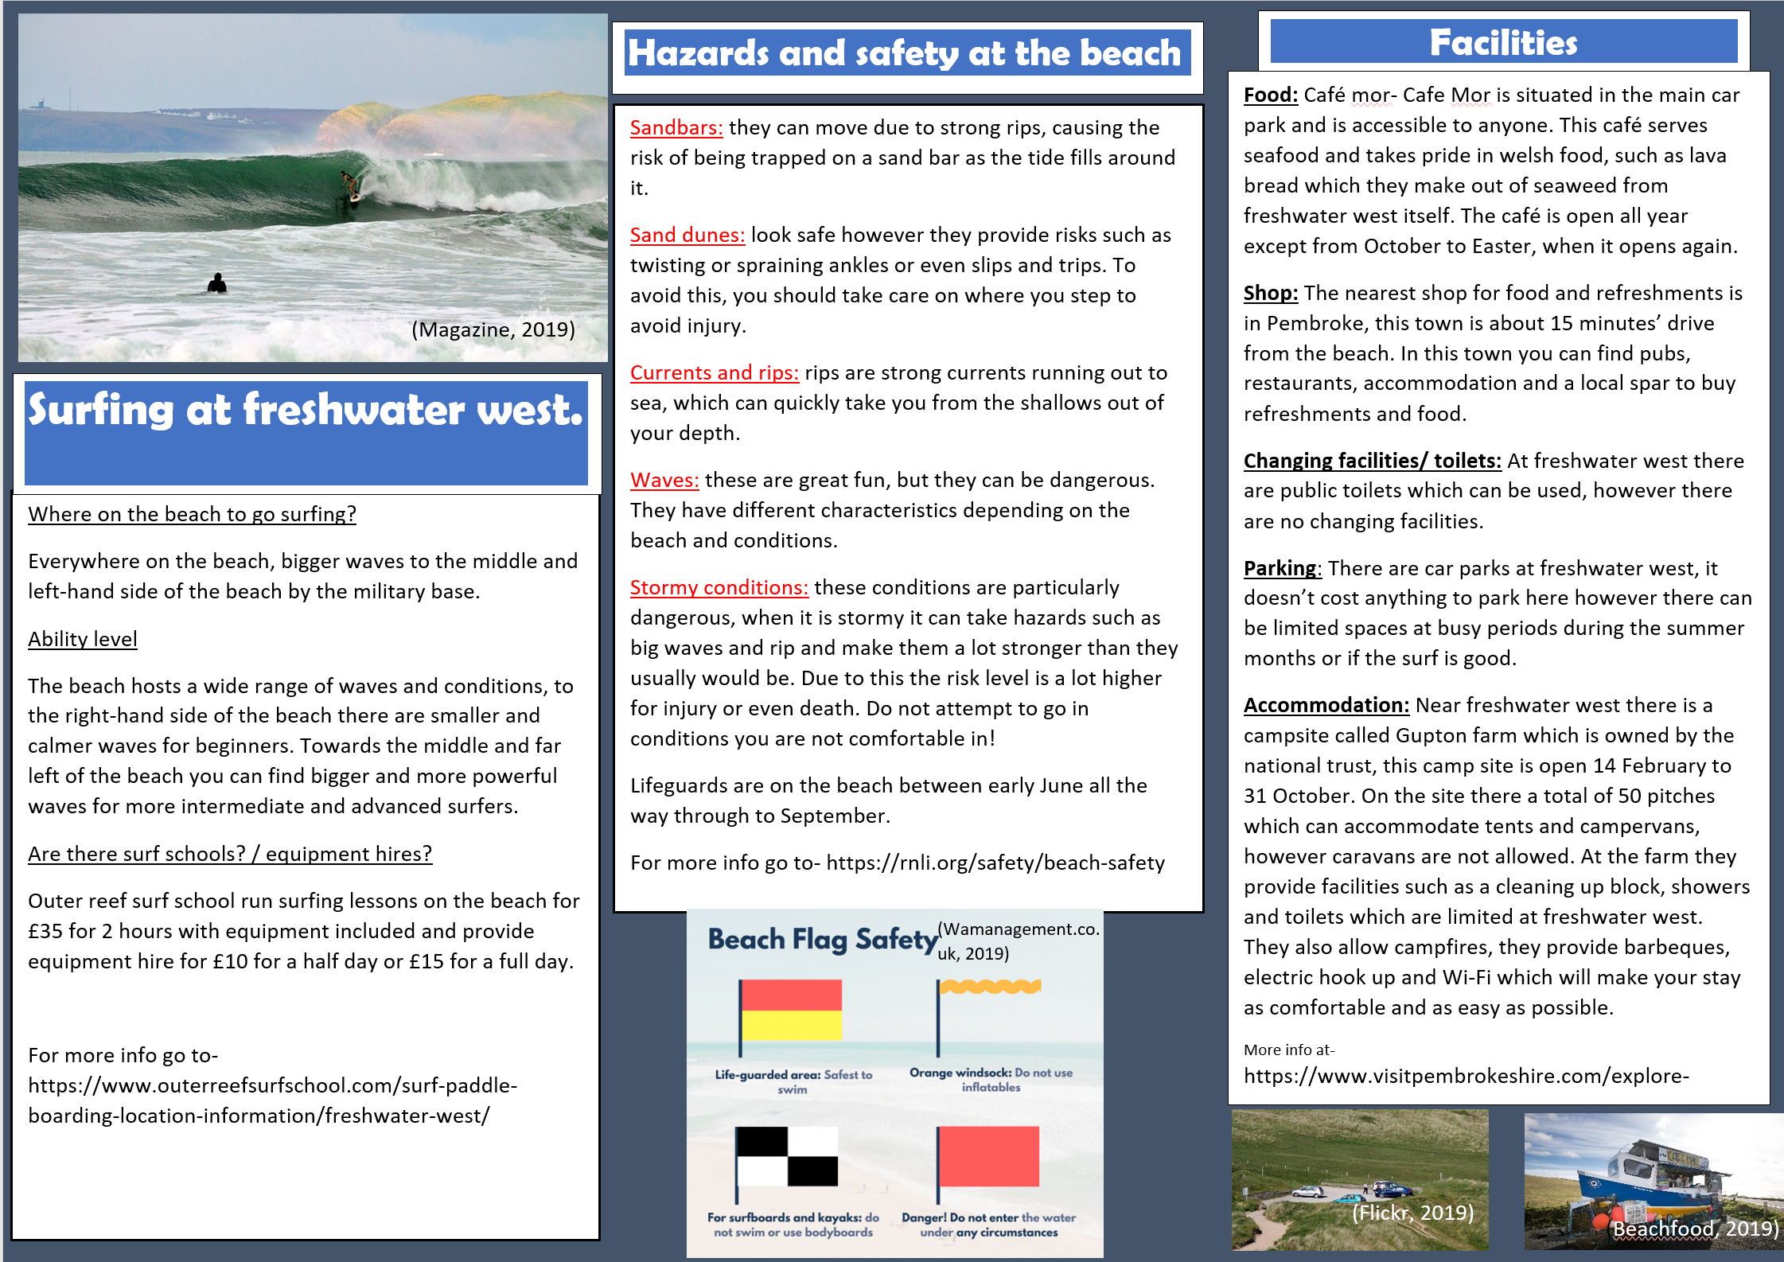
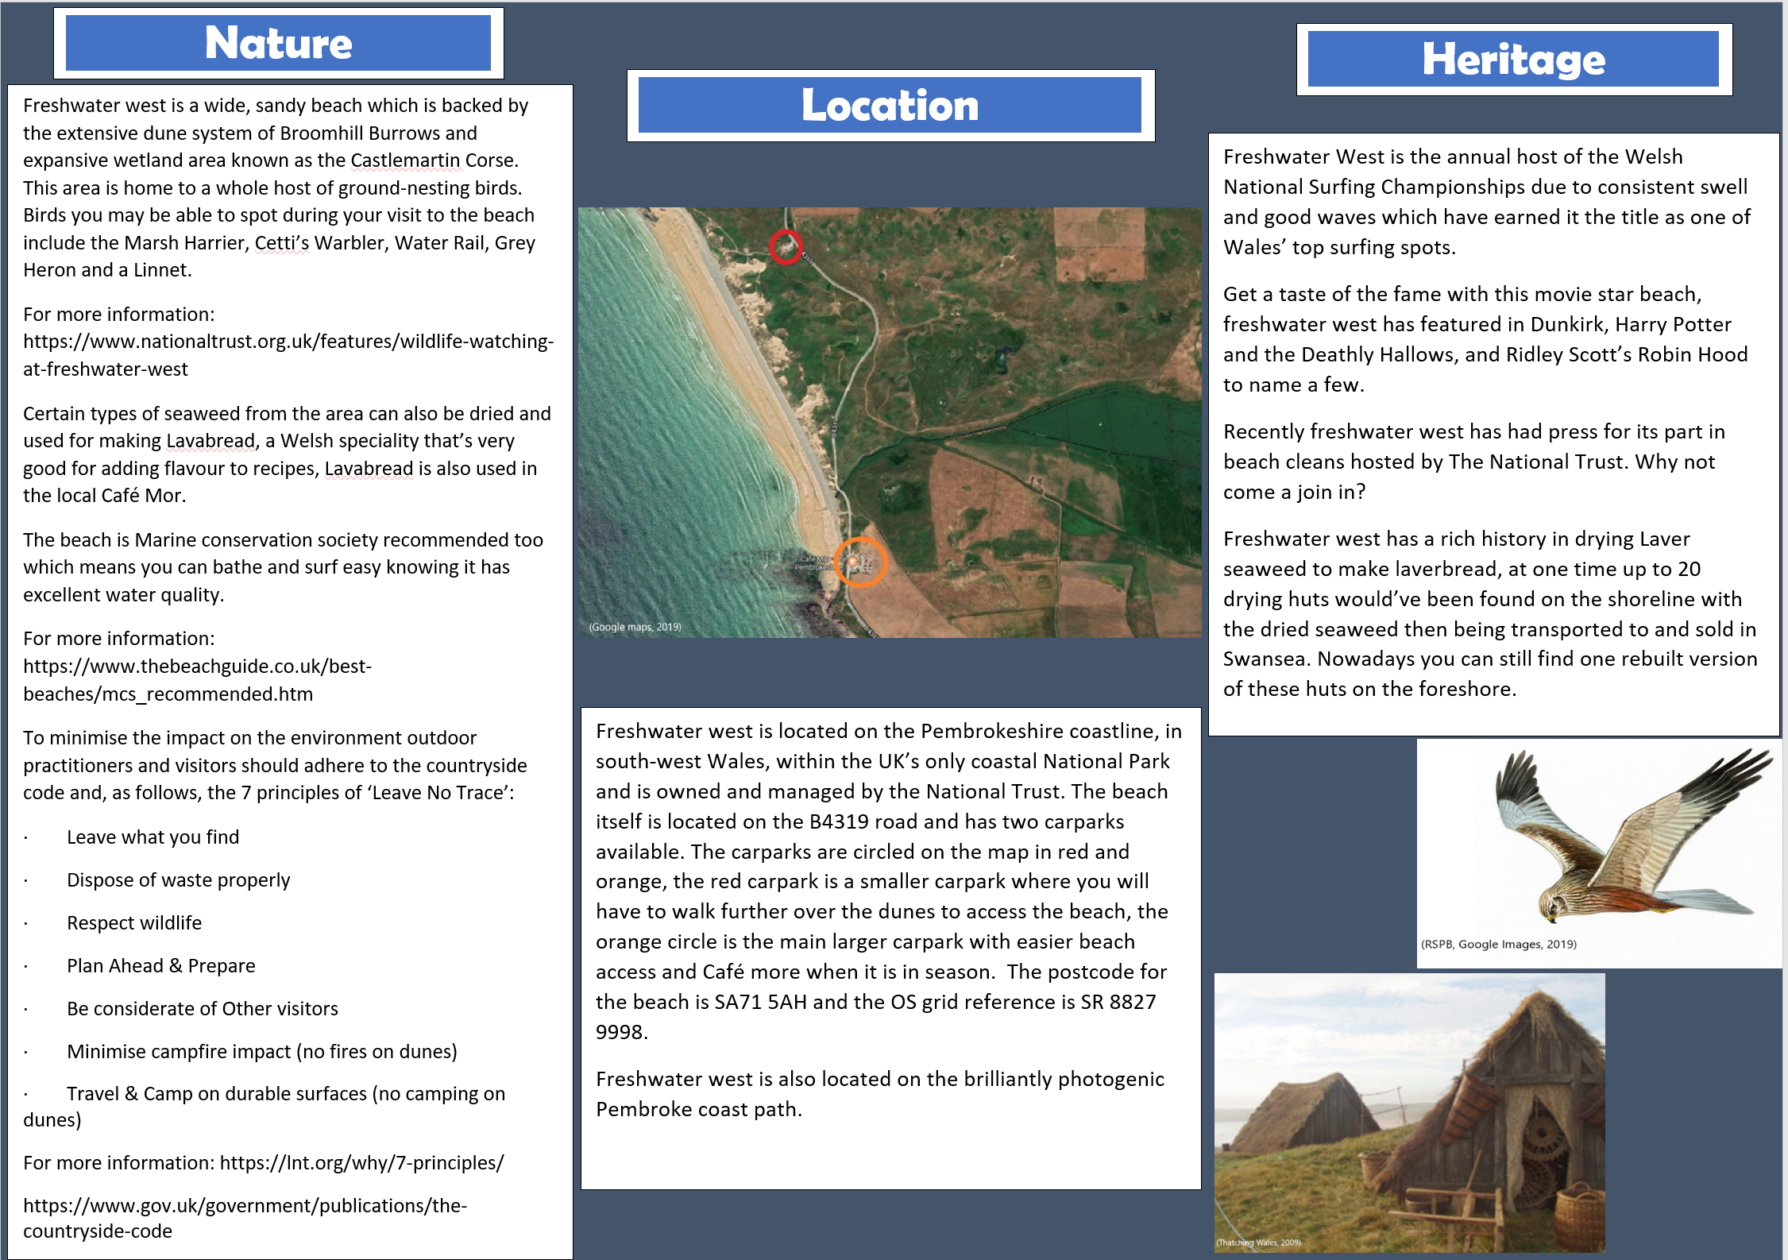
Personal reflection:
To begin the essay, we first had to decide on a location, after a few options we settled on Freshwater West due to a joint interest in both the coastal environment and the activity of surfing for which Freshwater West is locally famous. The following weekend we travelled as a group to Freshwater West to get a first-hand sense-of-place experience of its features and local environment to allow us to have a better-quality leaflet about Freshwater West than could be managed just by researching it online. At first after experiencing the chosen location we decided who in the group would be researching which aspects of the leaflet, I personally researched the nature, location and heritage aspects. I chose these aspects as they have a lot of interlinking features between them such as, the laverbread seaweed local to that area being a key part of their heritage, and the local birds surviving due to the Castlemartin Corse wetlands behind the dunes. My group mate Aaron researched the surfing, safety/hazards and facilities aspects, these again were chosen due to their interlinking aspects and that Aaron was able to go surfing and I was not so therefore he could garner the first-hand experience of how good it was at Freshwater West and the best parts of the beach to do it. I met up with my group on multiple occasions to work on the leaflet as a group, I also did a lot of the research for my aspects of the task independently and I felt we met up enough times to produce our leaflet together without issue. I believe that I personally made a good contribution to our leaflet providing high quality research to my aspects of work and that we did well to evenly divide the workload between the group. The most fulfilling aspect of research for me was the heritage aspect relating to Freshwater West as the reading gave an interesting perspective on how the environment, location and nature of the area have worked together over the years to form how people use the area from when laverbread seaweed production were used to make a living in the past to present day where it is used for outdoor adventure activities such as surfing, including large surfing competitions. If I could improve on any section of my work it would be to improve the amount of variety in information that I could introduce to the leaflet without it ending up having too many words and overloading the reader. For instance, in the heritage section if I had had more space, I could’ve written about the shipwreck that comes uncovered with certain tides on the beach and the various reasons it is said to have ended up on the beach in the first place.
Word Count: 462

References:
Flickr (2019) Car park at Broomhill Burrows. Available at: https://www.flickr.com/photos/lotw1952/4660757949 (Accessed: 1 Dec. 2019).

Gov.uk (2014) The Countryside Code. Available at: https://www.gov.uk/government/publications/the-countryside-code (Accessed: 2nd December).

Leave No Trace (2019) The 7 principles. Available at: https://lnt.org/why/7-principles/ (Accessed: 2nd December).

National Trust (2019a) Freshwater west beach. Available at: https://www.nationaltrust.org.uk/features/freshwater-west-beach (Accessed: 2nd December 2019).

National Trust (2019b) Surfing at freshwater west. Available at: https://www.nationaltrust.org.uk/features/surfing-at-freshwater-west (Accessed: 2nd December 2019).

National Trust (2019c) Wildlife watching at Freshwater West. Available at: https://www.nationaltrust.org.uk/features/wildlife-watching-at-freshwater-west (Accessed: 2nd December).

Outer Reef Surf School (2019) Surfing Lessons Freshwater West Pembrokeshire | Surf Courses & Surf Hire. Available at: https://www.outerreefsurfschool.com/surf-paddle-boarding-location-information/freshwater-west/ (Accessed: 1 Dec. 2019).

RNLI (2019) Beach Safety – Advice and Tips to Keep You Safe At The Beach. Available at: https://rnli.org/safety/beach-safety (Accessed: 1 Dec. 2019).

RSPB (2019) Marsh harrier. Available at: https://www.rspb.org.uk/birds-and-wildlife/wildlife-guides/bird-a-z/marsh-harrier/ (Accessed: 2nd December).

Thatchingwales.com (2009) Film set work on Seaweed Drying Huts for the 2009 Robin Hood Film. Available at: http://www.thatchingwales.co.uk/film-theatrical-thatching/robin-hood-filmset-freshwater-west.php (Accessed: 2nd December).

The Beach Guide (2019a) Freshwater West Beach. Available at: https://www.thebeachguide.co.uk/south-wales/pembrokeshire/freshwater-west.htm (Accessed: 2nd December).

The Beach Guide (2019b) 2019 Marine Conservation Society Recommended beaches. Available at: https://www.thebeachguide.co.uk/best-beaches/mcs_recommended.htm (Accessed: 2nd December).

The Pembrokeshire Beachfood Company (2019) Café Môr - Beachfood. Available at: https://beachfood.co.uk/wp/cafe-mor/ (Accessed: 2 Dec. 2019).

Visitpembrokeshire.com (2019) Freshwater West beach. Available at: https://www.visitpembrokeshire.com/explore-pembrokeshire/beaches/freshwater-west (Accessed: 2nd December).

WAmanagement.co.uk (2019) Life’s a Beach. Available at: https://www.wamanagement.co.uk/2018/07/31/lifes-a-beach/ (Accessed: 2 Dec. 2019).

Wavelengthmag (2019) Wavelength - Europe's Longest Running Surf Magazine. Available at: https://wavelengthmag.com/welcome-south-pembrokeshire/ (Accessed: 1 Dec. 2019).

White Gate Caravan park (2019) A shipwreck exposed and a slice of laverbread history….. Available at: http://www.whitegatecaravanpark.co.uk/a-shipwreck-exposed-and-a-slice-of-laverbread-history/ (Accessed: 2nd December).

