COEGNANT PRIMARY SCHOOL

2020/21 PROSPECTUS



Contents

School logo and school name : 1

Contact us : 3

Introduction : 3-4

Mission statement : 4

Headteacher statement : 5

Admissions : 5

Student: teacher ratio : 6

School structure : 7

Attendance : 7-8

Uniform : 8

School rules : 9

Health, well-being and safety : 10-11

Accessibility : 11

Curriculum : 12-15

Assessment : 15-16

Confidentiality : 16

Pedagogy : 16

Extra-curricular : 16-17

Why us? : 17


Contact us

Information for parents

School Name: Coegnant Primary School

Address:
Coegnant Primary School
Coegnant Road
Bridgend
CF340TW

Telephone Number: Phone: 0000124656

Email: CoegnantPrimarySchool@school.uk

School Language: English Medium

Age Range of students: 3-11

Introduction

This prospectus aims to provide you with detailed knowledge of our school, what we are about and how we promote and envision learning. Coegnant Primary School is surrounded by trees and mountains, we are situated within the small town of Maesteg (outlined below). Maesteg once belonged to the Coegnant Colliery which closed in 1981 and ownership of the land was given to the local authority. The land stretches for 1km and 175m wide, while our school only sits upon a fraction of the land, the views of the Valley surround us.
(Brown, J. Heal, J 2008)

Our school logo is a representation of the colliery, the background being part of the colliery and the tree representing outdoor learning. We are proud that our logo is unique and shows our dedication to history.
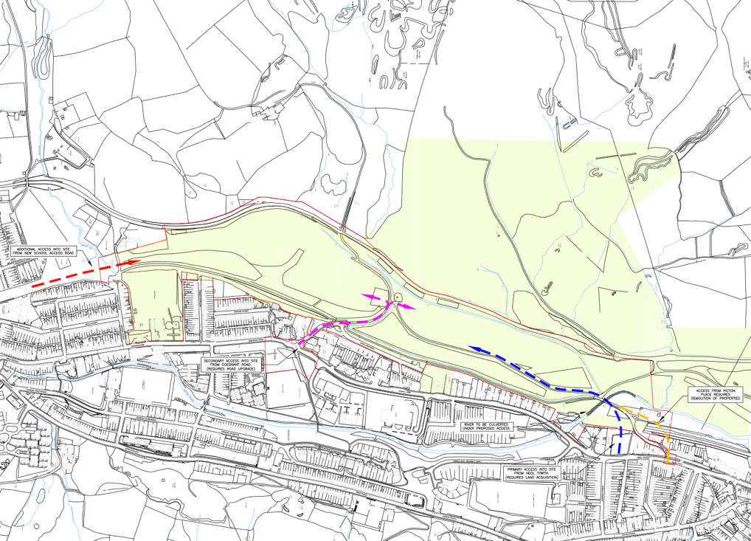

(Brown, J. Heal, J 2008)

Our Prospectus aims to inform you of the contact details so that you will always be able to contact us if need be. The mission statement of our school, our headteachers statement and our admissions section. Furthermore, you will learn all about the ratio between teachers and students, you will learn all about our school structure and attendance. Our uniforms will be discussed as well as our school rules. A child’s health, well-being and safety are vital to us; therefore, you will be able to learn all about what is in place for our pupils that need them. We discuss our accessibility throughout the school. Then, there will be a section explaining our curriculum and how we implement it and how we assess our pupils. Next we mention our pedagogy, extra-curricular and then finally why you should choose our school for your child.

Mission Statement

At Coegnant Primary School, our aim is to support pupils to grow to be independent and confident learners. Our hope is that they thrive in an environment that encourages their physical, mental, emotional and intellectual well-being.

Headteacher statement

At Coegnant Primary School, we welcome all children aged 2-11. We aim to make your time at our school successful and fun.
We believe that school should be exciting and a place that children look forward to going. Here at Coegnant, we bring children’s views and opinions together to create our day to day lesson plans. Our curriculum brings outdoor learning to a new level. We encourage our students to play in the rain, to build with natures building blocks, such as sticks and leaves.
We use our outdoor classrooms to enhance our students’ relationships with the outdoors. We also spend one hour every day exploring the school garden.
Our prospectus is here to inform you, parents and carers of the day to day life at school, the benefits of outdoor learning and the benefits of your child attending our school.
We appreciate your input and value your involvement within the school and strive to encourage parents to continue developing their child’s skills outside of school as well as encouraging them to enjoy school.

If you have any queries after reading this prospectus, please do not hesitate to contact the school.
We will be more than pleased to meet with you to answer any questions you may have.
Yours sincerely
Headteacher.

Admission’s

We encourage parents and children to visit our school when you are considering our school for your child, we offer a tour of the school, where your child will be able to sit in on a lesson or join in on an activity on our school yard, parents are able to meet with teachers to discuss their child and we have our school nurse meet parents so that they are able to put their trust in our nurse if need be.
We offer placements to all children, given we have the space to do so.

Our teacher: student ratio

Part time nursery for children aged between 2-3 years:

This class has a ratio of 1:4, this means that there is one teacher for every four children. This gives the children the best opportunities where they are able to grow as individuals, learn to solve problems and show initiative in their first few years.

Full time nursery for children aged 3-4:

This class has a ratio of 1:8, the children will have a little more freedom, eight children per one teacher. The children are able to explore the garden and thrive in the best possible environment for themselves.

Reception for children ages 4- 5:

Our reception class has a ratio of 1:10, our students are more independent at this stage of their schooling. There are three teachers in our reception class that supervise the children’s learning and encourage their dreams.

Year 1 for children aged 5-6:

Once again, our children in year 1 will be able to explore and learn while supervised by teachers. Our year one classes are supervised by two teachers, meaning that there is a ratio of 1:15.

Year 2 is similar to year 1 with a ratio of 1:15, the difference being that the children are aged 6-7 and they focus more on the education side of the outdoors rather than simply exploring. Their exploration is a little more independent than those in the lower years, they are able to thrive in the gardens with more initiative.

Year 3 for ages 7-8:

More time in the outdoor classrooms, weather permitted. At this age, there is only one teacher per class supervising the children throughout the day. Occasionally, there is a teaching assistant in the classes so that the children can access extra support where needed. The class has a 1:25 ratio.

Year 4, 5 and 6 for ages 8-11:
Learning will be academic, subject specified focused. We work with the children to achieve all of their goals within their final years with us. These are the years where they thrive the most, proving to be successful in their studies and gaining confidence in their own abilities. Just like year 3, these classes have a 1:25 ratio.

School structure

Part time nursery | 12:00PM-2:00PM
Full time nursery-year 6 | 9:00AM-3:00PM | Our doors open at 8:50AM so that children can get situated in class before registration.
Break Times and snack time | 10:30AM-10:45PM -first break and snack time  2:30PM-2:45PM | We provide our children with two break times throughout the day, not including lunch. During these times, the children are able to recharge and get ready for the following sessions.  We encourage that you send in a healthy snack for your child, this gives them energy for the rest of the day ahead.
Lunch Times | 12:00PM-1:00PM | We deliver a one-hour lunch period so that children can eat their lunch and refuel for the rest of the day.

Attendance

Late Arrivals

School starts at 9:00AM, we require that all pupils be on time, our school doors open at 8:50PM, giving enough time for the children and parents to get to school on time.
We allow for a child to be late up to ten times one after the other before we bring it up as an issue. We understand that some circumstances cannot be helped such as weather and traffic, that is taken into account when attendance is checked. Repeated lateness is monitored by our headteacher.
We strive for 100% attendance in every year group.

Attendance | 2015/16 | 2016/17 | 2017/18 | 2018/19
 | 98.5% | 98.2% | 99.5% | 99.9%

We take attendance seriously, therefore, we celebrate weekly attendance with extra break time and yearly attendance with trips.
Late arrivals must sign in at reception where they will then be taken to their class so that they can join in with the rest of their class.
Furthermore, we require parents or carers, to phone the school if their child is ill and require a day off. This allows us to inform class teachers of any absences.
Uniform

We are delighted to inform you that our uniforms are unisex, meaning that no matter your child’s gender, all students will feel welcomed and appreciated.
Our uniforms consist of:
Black trousers or tracksuit bottoms
White polo shirts- with or without the school logo
Royal blue jumper or hoodie- with or without logo
We also allow royal blue cardigans if children feel more comfortable wearing them, again this can be with or without the logo.
Shoes must be suitable for school; however, this doesn’t have to be simple black school shoes, your child may wear trainers if they so wish. This allows them to be comfortable throughout the day and keeps them safe during our outdoor sessions.

We have a uniform for the benefit of our school looking presentable and give the children the learning mindset.
We provide children with outdoor waterproof clothing that the children wear over their uniform. This protects them from the rain, simply preventing them from sitting in wet uniform all day.

We ask that children bring in PE kit of leggings/shorts/jogging bottoms and a t-shirt on the days that they have PE, this ensures that they are in appropriate clothing to participate in.

We suggest that all clothing be labelled on the inside with your child’s name, this prevents anything from getting lost.

Furthermore, we provide a school uniform bank, we ask that if possible, old uniform be donated to the school to help families in need for the next year, this takes away the stress that comes with the new school year for some families.
This is all confidential and easy to access.

BE INCLUSIVE!

EMBRACE NEW SKILLS
RESPECT ONE ANOTHER

SCHOOL RULES

SHOW INITITIVE
BE POLITE

BE KIND TO NATURE

ALWAYS BE KIND
BE CREATIVE

Health, well-being and Safety

We welcome children of all abilities and health issues. 1:1 support is provided for each child that requires it

Autism: we have a sensory room in our school so that children with Autism have a safe place to calm their minds and give them sensory toys and light so that the children are able to relax their senses and stimulate their mind.
ADHD: we support children with ADHD in any way we possibly can.

We also support children with complex medical needs with our nurse’s office and trained school nurse.
Such as:

Type one diabetes: our nurse is trained in giving insulin injections and testing blood sugars, also changing insulin pumps and CGM’s if need be. We have a fridge specifically for children’s insulin throughout the day so that it stays at the proper temperature, blood sugars are checked here if possible, however, we understand that it is not always going to be possible to make it to the nurse in an emergency, that is why class teachers are also trained in checking blood sugars, emergency low treatments are kept at the teachers desk and can be given if needed.

Asthma: we require children to keep one asthma pump in the nurse’s office and a backup in the classroom in case a child requires emergency treatment.

Allergies: a child with severe allergy is required to have an Epi-pen in school at all times, we train all staff in the administration of epi-pens. We keep them in the nurse’s office, however during lunch, the Epi-pen is taken with the child in case of emergency.

All other medical issues and additional learning needs are catered to and accepted here at Coegnant Primary School.

We provide 1:1 session’s with children who require specialist support, targeting their main areas of concern.

Contact the school if you would like to discuss your child’s medical needs and how we can cater to their needs.

Furthermore, our school ground is surrounded by 6ft fences that have an electronic lock on the gates so that nobody can enter the school without permission, members of staff have a key card that is coded to unlock the gates for them. These gates are locked at 9:05AM, after this time, parent need to ring the bell and get let in by reception.

We require all visitors to sign in at reception upon entry of the school and sign pout upon departure.

Next is lockdown procedures. We ensure that our students’ safety is one of our priorities, therefore we have a lockdown procedure in place to protect the children in case of an emergency. All doors and windows will lock automatically once the procedure is in place, next the children will be ushered into a safe place, this is in lace so that we can keep our student’s safe if need be.

Next we have the fire procedure. We have fire alarms set at even intervals around the school, along with fire extinguishers that are easily accessible. We have a designated meeting point for when a fire alarm is set off. Children are asked to stay with the class teacher so that they are able to be registered. This ensures that no child is left in the building. Any members of the public, e.g. parents, will be directed to a section specifically for them, this way they are able to be found through their sign in sheet.

We at Coegnant Primary base everything we do upon the rights of the child; therefore, we use the UNCRC as a guideline for everything we do.

Accessibility

We understand that there are schools that do not cater to children who need extra support, that is why we provide accessible buildings, ramps into every entrance and exit, larger classrooms to make room for wheelchairs, crutches, walkers and any other equipment our pupils may require on a day to day basis. we also have accessible toilets and changing areas.
We understand that some children need support in more areas than others and we encourage all students to be inclusive and help everyone, no matter their ability.
We also provide a loop system for our children with hearing loss. These loops connect to hearing aids and cochlear implants that then connect to a microphone that sits around the class teachers’ neck, this allows the students to be included in the lessons and not miss any information.
We refer to article two in the UNCRC of non-discrimination, when putting our accessibility options in place.

Curriculum

Our classes:

Mathematics
English
Science
PE
Arts and Crafts
History
Geography
Music/ Drama
IT
Welsh
Exploration

Here at Coegnant Primary School, we pride ourselves with the best learning environment we can offer. We cater to a six-hour day where the children alternate between different lessons, with some form of Mathematics and English incorporated in everyday whether it is through sitting and being taught or being given an activity during Exploration.
Our curriculum enhances the experience for our pupils, it encourages growth and personal development.
We pull parts of our curriculum from Successful Futures created by Donaldson.
His curriculum looks at four different objectives. These objectives equip the children for the future. The curriculum was originally set out for students aged 3-16 (Welsh Government, 2020). In addition to following the curriculum, we also incorporate parts of Montessori’s theory of learning. The Montessori curriculum is created around six areas of learning.
- Practical life: a child’s motor skills are vital for their development. They develop their confidence and independence.
- Sensorial: activities that help children develop their senses. Activities such as building blocks.
- Culture: this covers the majority of subjects.
- Maths: building maths into everyday life. Using equipment to bring a visual to math.
- Language: all activities in the classrooms are centred around language development.
- Art and Creativity: a variety of supplies available for creative expression.
The Montessori curriculum is a unique way of teaching children. (The Children’s Room 2014)
Furthermore, we also incorporate Donaldson’s ‘successful Futures’ Curriculum into ours, this curriculum includes four purposes that are important for a child’s future.
These are:
- Ambitious and capable learners
- Ethical and informed citizens
- Enterprising and creative contributors
- Health and confident individuals. (Welsh Government, 2018)
These areas work alongside the six areas of learning through this curriculum. Once again these are all similar to Montessori’s areas of learning and therefore and incorporated together in order to blend smoothly into one.
We at Coegnant Primary School use this Curriculum in our own way, incorporating the six areas of learning and designing our lessons using them.
Below is a summary of how our lessons are set up.

MATHS:
Mathematics is taught in different forms. It slowly advances in skills as the children grow and their intellectual abilities expand.
We make our Math lessons as fun as possible, we incorporate objects into the sessions so that our pupils are able to create while learning.
Some of these objects include, blocks, counters and dice. These objects allow the children to use their unique skills and develop them with help from our class teachers.

ENGLISH:
Similar to our Maths lessons, our English lessons are FUN! We write stories, learn how to spell, how to write, we create poems and so much more.
We change the challenge of work depending on the age of the children and support them throughout.

SCIENCE:
Our science lessons are tailored to each year group, using all their skills combined to gain more knowledge and create fun and age appropriate experiments.

ARTS AND CRAFTS:
We encourage our student to be as creative as possible, we provide a number of different art medias for our students to create.
These involve:
paper
pencils
pens
crayons
paints
paintbrushes
Our students find that these help them express their inner creativity.

Nia Thomas. Aged 6. Year 2.
The different medias available were mixed together so that she could create an image of her own creation.

“I love craft time! I can draw really good”



Jaxson Shaw. Aged 3. Nursery.
We encourage all children express their creativity, our Nursery class focus mainly upon creativity and how the children are able to develop their fine motor skills through holding different objects between their fingers and create a masterpiece of their own.

“It is fun”

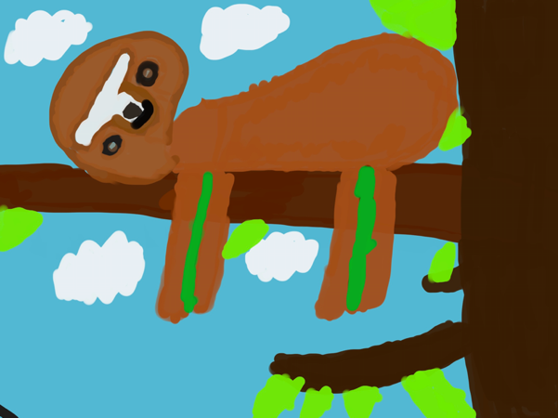
Ava Shaw. Aged 8. Year 4.
No matter what age our students are, we provide time throughout the day for them to get creative, they are able to grow and develop while expressing themselves in their own drawings.

“I can show what I love through art”

When asking our students what they enjoy about creating they answered as above. Our sessions give them a chance to calm their minds, express their inner creativity and continue developing and improving their fine motor skills during the process.

PE:
We believe that physical education is vital for a child’s well-being, that is why we provide a fun and unique PE programme. We have various different equipment to provide a stimulating and fun PE sessions.

HISTORY:
We are built upon historic land; therefore, our history lessons are very important to us. We teach local history alongside global history.

GEOGRAPHY:
While we live in an ever evolving digital world, at Coegnant Primary school, we feel it is vital that children and young people need to know how to read maps and navigate using the maps if need be, therefore, out geography sessions are focused on learning how to read maps and practicing their newfound skills in a controlled environment, this is done by placing an object in our school and providing a map for the children to search. This helps them gain confidence in their own abilities.

MUSIC/DRAMA:
Expressing oneself through music and drama is important to us, we use different props and musical instruments in order to allow our pupils to express themselves. They get the choice of music or drama and we then allow them to lead the session.

IT:
We live in a digital world, therefore, we feel it is important that our pupils learn all about the different types of electronics and how to use them, therefore we spend some time using IPad’s, Laptops and computers, occasionally we combine English and IT so that the children are able to learn how to write digitally.

WELSH:
Living in Wales, we feel it is important for our pupils to learn the basics in Welsh so that they can learn all about the culture.

EXPLORATION:
Our curriculum is based on outdoor learning and how it can enhance a child’s educational experience, we allow our pupils to spend at least an hour exploring the gardens and yard, looking for bugs and twigs and sometimes they look for objects that they can reuse in an arts and craft project.

Our outdoor classes are used by all year groups, giving them all the chance to work alongside nature.
furthermore, we take pieces of the Foundation Phase because of the emphasis on children’s needs and the development of the link to Donaldson’s ‘Successful Futures’.
The three frameworks together create one long term curriculum that supports the needs and development of our students.
Assessment

We use observation as one of our ways to assess our pupils. Observing their work and record results, through this method we are able to understand if a child needs extra support or if they need more challenging work.
This form of assessment allows us to see if:
- They can work independently
- They are able to stay on task
- They can question their work
- They can work productively
This is non-intrusive, and the children are able to continue learning without interruption.
(ISMS, 2020)

Furthermore, while we follow Montessori, Donaldson and the Foundation Phase, we still have our children complete the national tests at the end of KS1 and KS2.
We have a 90% above average results in our school.
We also assess pupils in reception, we do this as a baseline, this is so we are able to understand where the child is in their development. We use the results of our assessments to understand if we need to step in with extra support.
We keep detailed records on each child’s assessment throughout their time at our school, including any progression and noticeably impressive pieces of work. These are available for parents or carers to view as they wish, however, they’re only able to view their child’s folder due to confidentiality.

Confidentiality

We take Confidentiality seriously at our school. We follow the Data Protection Act 2018. With our school providing so many digital options, we swear by the Data Protection Act, keeping our students information safe is vital to us, we have high protection on all devices, firewalls that are high security. Furthermore, we use numerous passwords to protect data, this way you never have to worry about your child’s information being left in the open.

Pedagogy

Pedagogy is a way of teaching. Our school base our Pedagogy upon Montessori (1870-1959) and Donaldson. Montessori was an extraordinary woman, she started her career working with children who have intellectual disabilities, during this time she came to realise that they needed proper pedagogy. She began to develop her pedagogy in 1900 while she was in Rome. Montessori created the children’s house for children aged 3-7 in 1907. (Marshall, C. 2017)
The environment is always catered to the children, giving it a child cantered environment. (The Children’s room, 2014)
Following the Montessori pedagogy, here at Coegnant Primary School we encourage self-directed learning, children are able to focus longer on something that they are actively interested in. giving them different materials to interact with. They are able to self-direct their own activities for play. (Marshall, C. 2017)
We believe in a child centred approach at our school, ensuring that the children are able to learn independently while also being there for them when needed, we do however have taught sessions that the children engage in thoroughly, these sessions allow the children to use the knowledge that they gain from their own activities and develop their skills in a teacher-led session.
Extra-Curricular

We offer a wide range of after school extra-curricular activities, arts and crafts: Jewellery making, educational Minecraft for our pupils who enjoy playing the game, this session involves solving Math problems and building, they are not able to continue the game until they complete the problem, each child’s game is programmed specifically to their abilities.
We provide an after-school gardening club, music, academics and film making.
We offer a range of activities for the pupil’s enjoyment and also so that the parents have more flexible pick up times.
We have a high attendance rate at our afterschool clubs, our student’s love spending extra time with the teachers and each other, we encourage their love for extra-curricular by taking their ideas into account, we try to incorporate their ideas every other term so that there are continually different activities available.

Why our School?

This prospectus is aimed to show you that our school has a unique spin on the average school. We pride ourselves on providing a school environment that children enjoy attending. From the prospectus you can see we differ from the average school in ways of how we run.
We are situated on historic land, meaning we have a very historic background and our pupils are taught about the history of the land and it gives them the knowledge of the area. Our school logo is created in honour of the Colliery and the history is represents. Our mission is not simply for a child to thrive but also to grow independent and trust in themselves. We have an admissions process that the child is able to interact in. furthermore, we have a student: teacher ratio that supports the children in the best possible way. Our school has high attendance rates, children enjoy attending, therefore that number of absences has decreased every year, we have a uni-sex uniform and provide children with waterproof clothing for children so that they can still go outside in the rain.
Our school rules are unique to us, we engrain the rules into our students as soon as possible so that they’re able to grow around them, while following them throughout their life.
Our school nurse gives us a unique space of healing, treating and learning. We are in high demand because of the access to a qualified nurse permanently on the school grounds, parents have piece of mind knowing that their child is in safe hands and will be taken care of, our fire and lockdown procedures also give piece of mind, knowing that children are always put first in case on emergency. Next we have our accessibility, there are not many schools around that provide a fully accessible learning environment, which is why we ensure that children of all needs and abilities are catered to and supported throughout their time at our school. This all works alongside our curriculum, which is child-centred and fun. Here at Coegnant Primary School, we ensure that children are happy and safe while learning with us. We assess our children with different assessment methods and keep a detailed record that parents can access if need be, our Pedagogy is based upon Montessori, meaning we are a child-centred and created around the child.
Finally, we have our extra-curricular activities that we rotate ever other term, giving children opportunities to try different activities and have their hobbies grow.
Our school is an exciting place to learn, develop and thrive.
Contact us to arrange a tour!
REFERENCES:
Welsh Government, (2020) ‘Introduction to Curriculum for Wales guidance’ Available at: https://hwb.gov.wales/curriculum-for-wales/introduction/ (Accessed: 21/10/20)

Marshall, C, (2017) Montessori education: a review of the evidence base, npj Science Learn 2, 11, Available at: https://doi.org/10.1038/s41539-017-0012-7 (Accesssed: 22/10/20)

The Children’s Room, (2014) ‘Montessori Nursery School’ Available at: https://www.the-childrens-room.co.uk/wp-content/uploads/2014/07/the-Childrens-Room-Brochure-Swansea.pdf (Accessed: 23/10/20)

Welsh Government, (2018) ‘Successful Futures’ Available at: https://gov.wales/sites/default/files/publications/2018-03/succesful-futures-a-summary-of-professor-graham-donaldsons-report.pdf (Accessed: 08/10/20)

ISMS, (2020) ‘Assessment of learning’ Available at: https://www.isms.nsw.edu.au/montessori-learning/the-montessori-method/assessment-of-learning/ (Accessed: 24/10/20)

Coegnant Colliery site, Caerau, Available at: https://www.bridgend.gov.uk/media/2003/sd70.pdf (Accessed: 10/10/20)

Welsh Government, (2015) Foundation Phase Framework, Available at: https://gov.wales/sites/default/files/publications/2018-02/foundation-phase-framework-revised-2015.pdf (Accessed: 10/10/20)

European Commission, (2019) Assessment in Primary Education, Available at: https://eacea.ec.europa.eu/national-policies/eurydice/content/assessment-primary-education-50_en (Accessed: 25/10/20)

Gov.uk, (2018) Data Protection Act 2018, Available at: https://www.gov.uk/government/collections/data-protection-act-2018 (Accessed: 25/10/20)

Unicef, (2019) A Summery of the UN Convention on the rights of the child, Available at: https://downloads.unicef.org.uk/wp-content/uploads/2019/10/UNCRC_summary-1_1.pdf?_adal_sd=www.unicef.org.uk.1603676022010&_adal_ca=so%3DGoogle%26me%3Dorganic%26ca%3D(not%2520set)%26co%3D(not%2520set)%26ke%3D(not%2520set).1603676022010&_adal_cw=1603676018728.1603676022010&_adal_id=e8f9916e-d921-496e-ab79-31fda0ede46e.1603676019.2.1603676019.1603676019.378d7ca6-f68c-4566-8037-23c8f4c0cbbf.1603676022010&_ga=2.259884362.1500835597.1603676018-502153463.1603676018 (Accessed: 26/10/20)

