Create Groups

QUESTION 1 . Record the command you used to create and verify Groups with the group ID.
Command to create a group
- groupadd [<groupname>]
Command to verify the group
- cat /etc/group (scroll to bottom to see latest added)
Group ID for MGT
- 1006
Group ID for EMPGA
- 1007
Group ID for EMPGB
- 1008
Group ID for EMPGC
- 1009

Verify Users

QUESTION 2. Record the list of users.
In passwd file
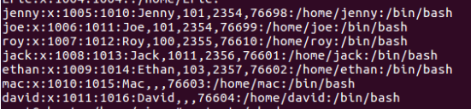
In shadow file
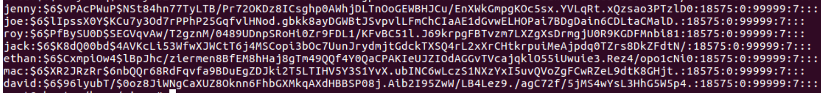

Absolute Permissions
Question 3. Print your current working directory.
COMMAND :- joe@ubuntu:~$ pwd
OUTPUT :- /home/joe

Question 4. Go back one directory level to the /home directory
COMMAND :- joe@ubuntu:~$ cd ..
OUTPUT :- joe@aubuntu:/home$

Question 5. List all directories and their permissions in the current working directory
COMMAND :- joe@ubuntu:/home~$ ls-l
OUTPUT :- total 32
drwxr-xr-x 18 cisco cisco 4096 Nov 9 05:19 cisco
drwxr-xr-x 2 david david 4096 Nov 9 05:30 david
drwxr-xr-x 2 ethan ethan 4096 Nov 9 05:29 jack
drwxr-xr-x 2 jack jack 4096 Nov 9 05:29 jack
drwxr-xr-x 3 jenny jenny 4096 Nov 9 05:46 jenny
drwxr-xr-- 3 joe joe 4096 Nov 9 05:47 joe
drwxr-xr-x 2 mac mac 4096 Nov 9 05:30 mac
drwxr-xr-x 2 roy roy 4096 Nov 9 05:29 roy

FINAL TASK – Complete the following and submit the lab document with all the directory details as required

JENNY (HR Group)
- Permissions applied and view file document content
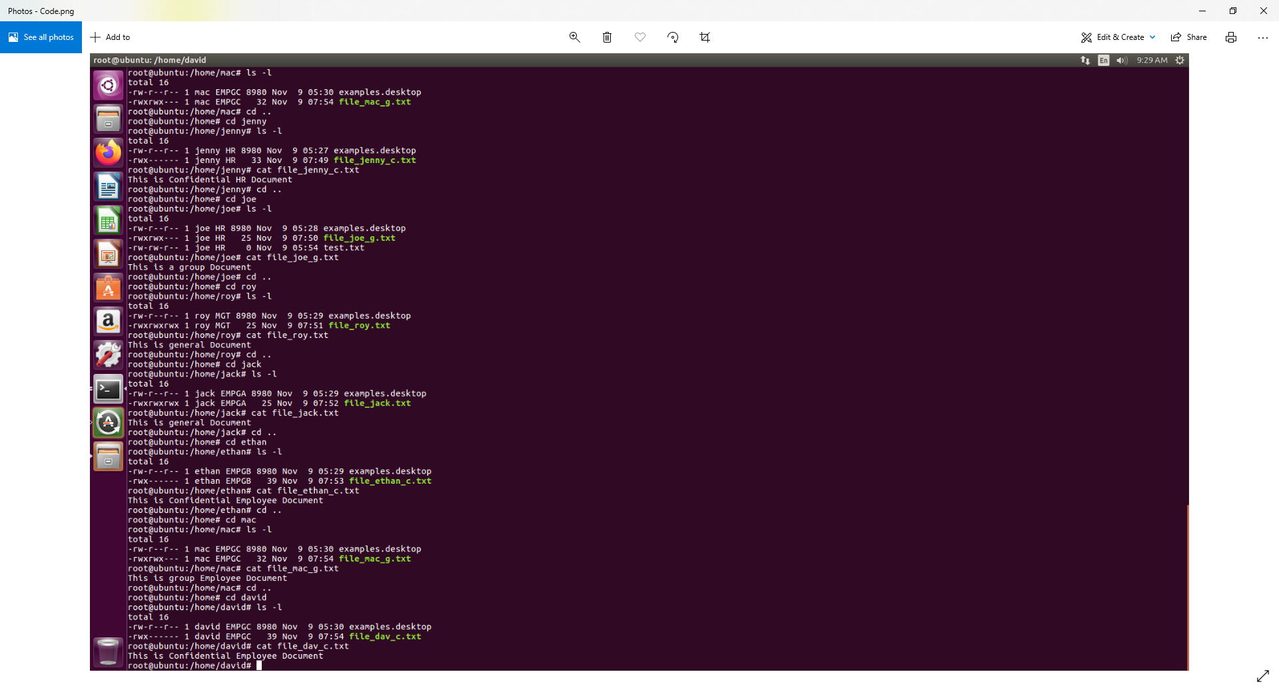
- Access as Joe (HR Group) and attempt to view file content, proving group and user cannot access
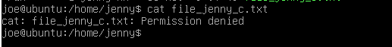

JOE (HR Group)
- Permissions being applied and view file document content
- Access as Jenny (HR Group) and attempt to view file content, proving group can access
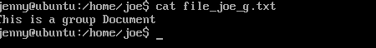
- Access as Roy (MGT Group) and attempt to view file content, proving group cannot access
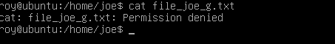

ROY (MGT Group)
- Permissions being applied and view file document content
- Access as Jenny (HR Group) and attempt to view file content, proving others can access
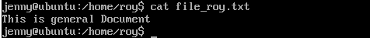

JACK (EMPGA Group)
- Permissions being applied and view file document content
- Access as Jenny (HR Group) and attempt to view file content, proving others can access
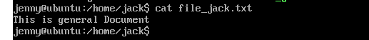

ETHAN (EMPGB Group)
- Permissions being applied and view file document content
- Access as Jenny (HR Group) and attempt to view file content, proving others cannot access
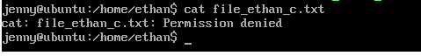

MAC (EMPGC Group)
- Permissions being applied and view file document content
- Access as Jenny (HR Group) and attempt to view file content, proving others cannot access
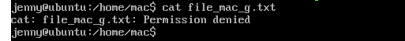
- Access as David (EMPGC Group) and attempt to view file content, proving group can access
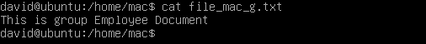

DAVID (EMPGC Group)
- Permissions being applied and view file document content
- Access as Jenny (HR Group) and attempt to view file content, proving others cannot access
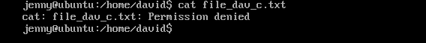
- Access as Mac (EMPGC Group) and attempt to view file content, proving group cannot access


