STUDY SPACE


Your future to Build
LEARN TODAY, LEAD TOMORROW
Friendly tutors. Personal support better results

ABOUT US
Study Space is a professional tutoring service dedicated to helping students of all ages and abilities achieve their academic goals through personalised, high-quality learning support.
At Study Space, we believe every student has the potential to succeed. Through personalised guidance, expert teaching, and a supportive learning environment
We provide the encouragement, resources, and confidence students need to overcome challenges; we develop their skills, to achieve their academic goals, and become independent, lifelong learners.
We believe every student can achieve their goals with the right support, encouragement and resources. (Hattie, 2009). Research highlights that effective feedback, teacher support and positive learning environments have a significant impact on student achievement.
Furthermore. (Vygotsky ,1978) emphasises the importance of guidance and support in helping learners develop their abilities, while (Bandura,1997) shows that encouragement can strengthen students’ confidence and belief in their capacity to succeed.”
Our experienced tutors create a positive learning environment where students feel comfortable, motivated and inspired to reach their full potential.
Whether you need help catching up, staying on track, or aiming for top grades - At Space Study, “We help you to achieve your goals with the right support, encouragement and resources. Learn with us grow with us grow in confidence.

SUBJECTS WE TEACH
English:
- improving reading, writing
- Grammar and communication
Maths:
- Build strong skills and solve problems with confidence
Science:
- Explore, understand and succeed in science
Business Studies:
- Learn key business concepts for school and beyond
Digital Skills:
- Develop essential digital skills for today’s world.
Prices
- Personal tutoring - £19 per hour
- Group sessions - £11 per hour

WHAT MAKES US DIFFERENT
Personal approach:
- We tailor our teaching to suit each student’s needs and goals.
Experienced Tutors
- Qualified, friendly and passionate about helping students succeed.
Proven Results
- We help students build confidence and achieve better grades.
Supportive Environment
- A safe, positive and encouraging space to learn and grow.
- Beyond the classroom: We build skills for school, life and the future.

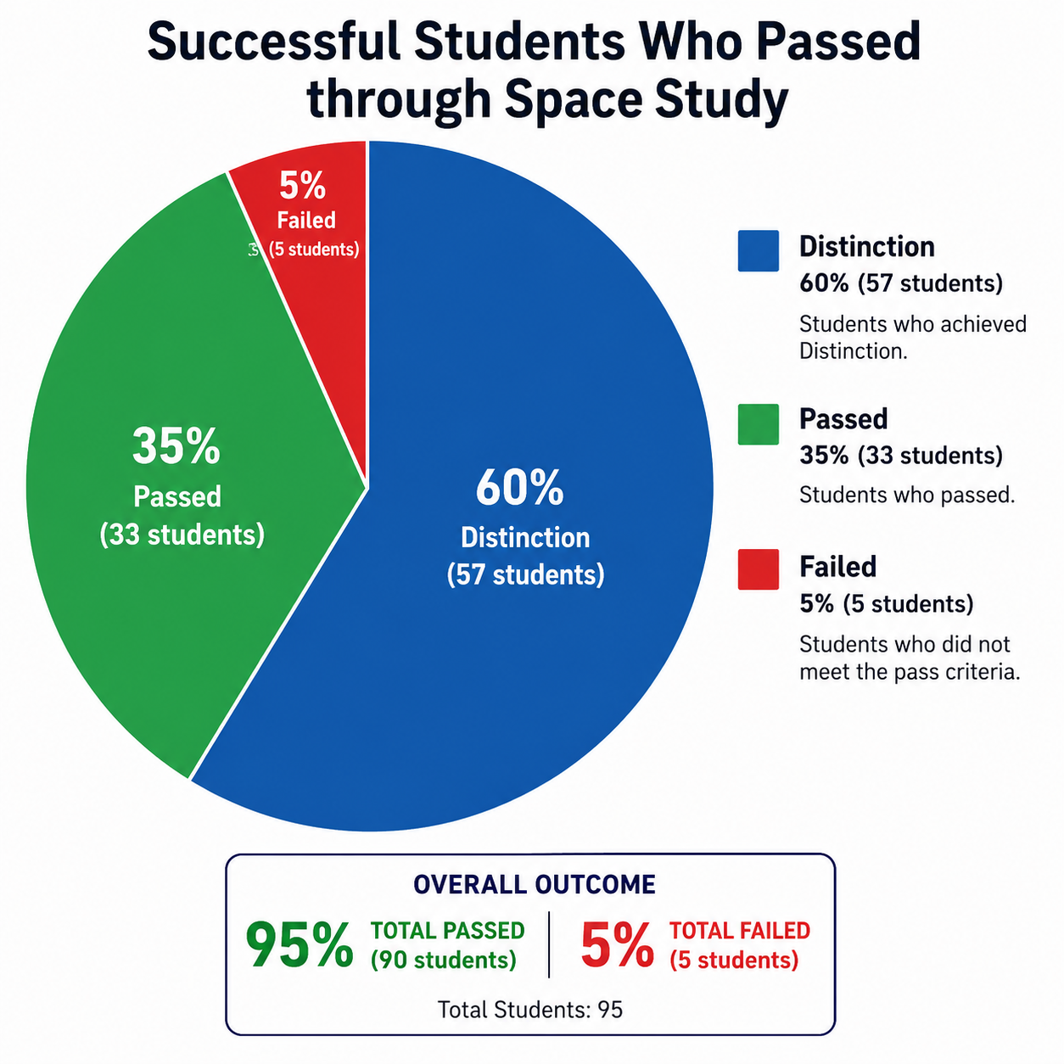
CONTACT US
Email: study.Space @outlook.co.uk
Phone 07344766689
Location;
Study Space Learning Centre
7 Westbury Terrace, Upminster
Essex
RM14 3ND

SHORT LOG
Study Space Digital Information Sheet

I created a digital "About Us" information sheet for a small tutoring service called Study Space. The aim is to showcase the institution’s success story while providing the prospective and new Students with clear, accurate, and accessible information about the services offered, subjects available, tuition fees, opening hours, and contact details.

The information is presented in a professional, welcoming, and well-structured format to help students make informed decisions, promote confidence in the institution, and enhance their overall experience. Clear communication is important for improving access to information and support positive student engagement. (Kotler & Fox,1995).

Why I Chose My Tool

I chose Microsoft Word because it is easy to use, widely available, and suitable for creating both digital and printed documents. It also provides tools for adding images, icons, colours, and headings to improve the overall design.

Information I Used

I used the details provided by the client, including the subjects taught, tutoring prices, opening hours, contact information, and the features that make Study Space different from other tutoring services. I also created a pie chart to show successful students who passed through Space Study.

How I Created My Artefact

I organised the information using clear headings, simple language, colourful icons, and a professional layout. I also designed a modern logo and selected colours that create a friendly and welcoming appearance for new students.

Feedback I Used

The feedback suggested making the document more modern, colourful, and visually appealing. I improved the design by adding branding, icons, a professional logo, and a brochure-style layout.

Final Explanation

The finished information sheet is easy to read, visually attractive, and suitable for both digital sharing and printing. It clearly presents all the essential information and reflects the professional and supportive image of Study Space.
Reference:
- Hattie, J. (2009) Visible Learning: A Synthesis of Over 800 Meta-Analyses Relating to Achievement. London: Routledge.

- Bandura, A. (1997) Self-Efficacy: The Exercise of Control. New York: W.H. Freeman.

- Vygotsky, L.S. (1978) Mind in Society: The Development of Higher Psychological Processes. Edited by M. Cole, V. John-Steiner, S. Scribner and E. Souberman. Cambridge, MA: Harvard University Press.

- Kotler, P. and Fox, K.F.A. (1995) Strategic Marketing for Educational Institutions. 2nd edn. Upper Saddle River, NJ: Prentice Hall.

