MOHAMMAD JAHAN SHARIF
UNIVERSITY OF WALES
TRINITY SAINT DAVID
STUDENT NUMBER:1806271
JANUARY9,2019.

Digital Skills & Research Methods

Table of contents

Abstract 2

Technology 2

Modern technology 2

Effective use of technology at workplace 3

Social media 5

Effective use of social media 6

Creating online presence 8

Conclusion 9

References 10

Abstract: Digital skills are an individual's capability to find, assess, produce and communicate information and knowledge through verbal and non-verbal communication on numerous modern channels. Modern skill highlights an individual’s ability on IT, writing, and typing skills on various platforms, such as smartphones, tablets, laptops, desktop PCs, social media and blog sites. Digital knowledge has a big impact in work, education, health, transport, agriculture, leisure, social sectors etc. in order to develop ourselves and become more productive. (Google.co.uk, 2018)
Technology: Technology is the application of scientific knowledge and resources in various sectors. It is used for creating tools and materials and for easily completing everyday tasks. Technology depends on human knowledge which invent systems and tools after completing research. We use technology in every aspect of life. In an ideal competitive world, organisations depend so much on technology in order to gain competitive advantage. Computers and the Internet are a good example of technology. (Use of Technology, 2018)
Modern Technology: Modern technology is the latest upgrade of traditional technology with more actions, features, alterations and additions. Modern technology has a big impact in the global world in all sectors. Technology has changed a lot since the last decade. Now in the 21st century, any device or tool around us is the invention of modern technology. For example, we can talk about smartwatches. A smartwatch looks like an ordinary watch but it has lots of features. By smartwatch, we can have conversations and text messages, we can also browse the Internet, take pictures and pay with a simple touch. People don’t need to take out their smartphone to receive a call, they can do all the upgraded activities on their smartwatch. Samsung Gear S3 and Apple Watch Series 2 creates a revolution of smartwatches. The modern world becomes so much faster and innovative that people just touch and go in most of the places. (Tech Quintal, 2018)

Effective use of modern technology at workplace: New technology is always emerging in order to solve problems quickly and efficiently, as well as increasing productivity. That is why, it is very important for all organisations to be aware of new technology and what they offer. Then they can decide which technology will be more suitable in terms of productivity and staff adaptability. Below, I am going to describe how modern technology can be used effectively within a workplace:
Cloud Computing: The Cloud is a combination of hardware and software that works together to deliver various activity over a network. Cloud computing is widely known as a service provider over the internet while people can access or share files from any device. For example, we can speak about Google Gmail. The person who has a Gmail account can access the files and applications from any technology device in Google through internet. We might use cloud computing when we use Facebook for status, updating or when we check balance to our bank account by mobile. (Lenovo.com, 2018)
According to Salesforce.com, (2018) Cloud Computing can be used effectively within workplaces in the following ways:
Cost savings: Cloud computing can save time and money for an organisation when they have access over data. Most Cloud computing companies provide pay as you go services towards the organisation. That means the company do not need to need pay any extra money if they decide not to upgrade or they do not want Cloud computing. Cloud computing also offers data storage space to stakeholders and clients. Organisations can have lower costs and higher returns by adopting Cloud system.

Security: Cloud computing offers high sense of security towards the organisation. In order to protect organisation documents, they need to keep their file, data, their programme in a safe place and a Cloud host is appointed to monitor security. The host can stop any suspicious activity so that hackers and unauthorized people have less chance to view or steal any documents. Another advantage the company or the user can ser the type of security they want.
Flexibility: Organisations do not need to spend so much time and attention for data storage due to the introduction of Cloud computing. They can focus more on customer service, business targets and customer demands. Thus, Cloud computing offers more flexibility towards organisations.

Mobility: Cloud computing makes sure each of everyone can use their facility. Smartphones and tablets are allowed to access business data, information, if any staff has a busy schedule or stay far from work. They can still keep in touch with colleagues and customers by using Cloud computing. It provides better work-life balance especially for those who travel, freelance employees or work at home.

Increased collaboration: Cloud computing creates effective collaboration between the staff and management. Every member of the organisation can share their view and information and connect with other employers.

Quality control: Cloud computing stores data and documents in one place. When every staff has access, we can be given perks such as being able to maintain data, less human mistakes and recording updating data.

.
Disaster recovery: Organisations can face situations out of control if they lose their data. It can cause losing revenue and productivity along with business reputation. Cloud computing services are able to save the organisations from disaster by providing quick data recovery.

Loss prevention: If we keep our valuable file, documents and data on a normal computer, we are taking risk to losing the data permanently because it can be stolen by someone, have a user error or have hardware deterioration. If the organisations are with Cloud computing they are safe from losing information.

Automatic software updates: Cloud computing is a blessing to IT staff because it saves their time and money. Cloud computing features automatic upgrades and refreshes their systems.

Competitive edge: Business who have adopted early modern technology like Cloud computing have huge competitive advantages.

DROPBOX: Dropbox is another feature of modern technology for sharing files in organisations. It is very popular among business areas for its pricing, simplicity and functionality. Dropbox offers the organisation to use it securely in file sharing, sync features, collaboration between the employee and 24-hour live support. We can monitor user activity, business information and work smoothly with various systems with Dropbox. Big organisations like Yahoo, National Geographic and News Corp are using Dropbox. Dropbox gives plenty of space to store files which will suit big organisations. Dropbox is very unique in terms of pricing so that everyone can afford to use it. The file sharing market becomes very competitive because of the business demands that have a big impact in global market. Dropbox provides us the access to recover files even we deleted the data a long time before. Dropbox allows us to protect all secured documents by a password link in order to make sure only authorized people are able to view, share, edit and delete files. If the company lost their device, they can still delete them and stop others to use that device due to the introduction of the remote wipe system. In the meantime, organisations can seek advice from customer support which is reliable and has full control of administrator systems and has the solution of any problem. (Financesonline.com, 2018)

Social media: Social media is a type of medium where people can interact each other, share their view and receive information from others. Social media like Facebook, Twitter, Instagram and Snapchat is so popular and common due to the introduction of modern technology. (Life wire, 2018)

Below, I am going to describe/explore how social media can be used as a tool within a workplace for marketing, information gathering and communication.
Marketing: According to Digital Marketing Blog (2019), social media can use for marketing in several ways:

Increase Sales on Website: If we advertise on social media for marketing activity, we will be able to look and track how many people see the ad, how many people click on the ad and what action people do. Traditional types of marketing do not have this luxury. These types of information are so meaningful and important to create a strategic and eye-catching marketing campaign so that people can show more interest.

Target Audience: Social media can connect with audiences with one click. We can observe what the audience likes most and who is the most responsive target audience. Social media helps us to break down targeted customers by their gender, age, location, religion or by any demographic trend.

Expanding businesses: The more we use social media for marketing, the more we will be able to find out our target audience. Once we know our target customer, we can expand our business rapidly. We can create a lookalike audience as an existing audience on social media advertising platforms. Social media like Facebook and Instagram track the data of existing audiences and can find out how many social media users have the same characteristics and choices.

Improve Customer Retention: At a business point of view, we need to make sure our customers visit us time and time again. Social media for marketing allows us to maximize retargeting ads, and retargeting customers. Retargeting is when we publish an ad to a particular person/company who is already familiar with our business. We can collect customer email lists from people who follow us on social media or engage our previous ad and retarget them. Retargeting audience is part and parcel to bring new customers in and forcing existing clients to become repeated audiences. We could introduce discount systems or gift vouchers for retargeting ads and encourage existing customers. We can also offer big discount for referring a friend in our retargeting activities. The biggest strength in social media is we can track all the customers and follow up with them with various strategies.

Customer Loyalty: Social media gives us the platform to create a relationship between the business and customers. People always look at social media posts and make a comment or pass a message which bring other people to get in touch with the business. Social media is open for 24 hours and if anyone wants to contact with us, we can respond immediately which gives customer satisfaction because we are here and we care about you. Social media also allows the clients to directly contact with their favourite brands. The key for marketing in social media is to choose the right strategy and having good knowledge about social media. (Digital Marketing Blog, 2019)

Information gathering: Social media gives us the opportunity to look for wide audiences to send our message and react to our message from the organisation. According to Corporation (2019), social media helps organisations to gather more information in the following ways:

- Market research: classify and recognize our target market and key demographics
- Customer insights: discover key discussions, chat style, insights or directions
- User experience: understand how our users are interacting with our business.
- Consumer engagement: understand what topics will increase customer interest, customer involvement and brand loyalty
- Evaluation: Find out the current business campaign and how successful they are.

Communication: According to Eichmann (2019), this is how social media is changing the way we communicate:
- Brands can talk directly to their audiences
- Personally, connect with unhappy consumers to resolve a negative experience.
- Sending positive messages as viral messages and publish every social media. Communicate and coordinate with customer for media exposure.
- Brands can create good relation with media people.
- Create awareness about the influencers.

Creating online presence:

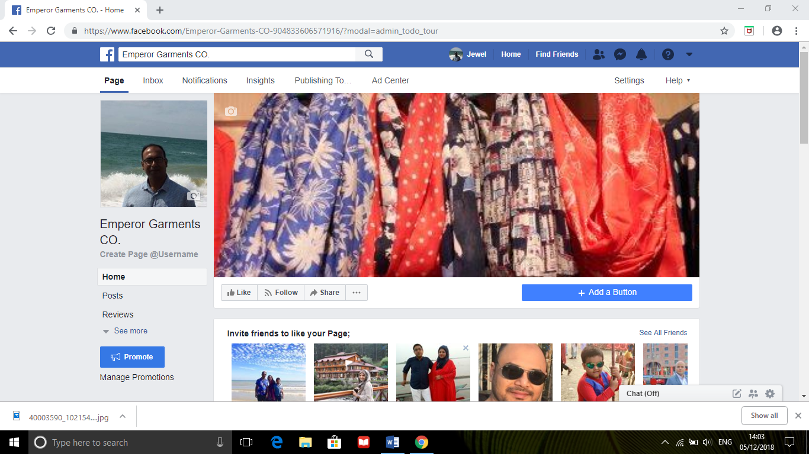

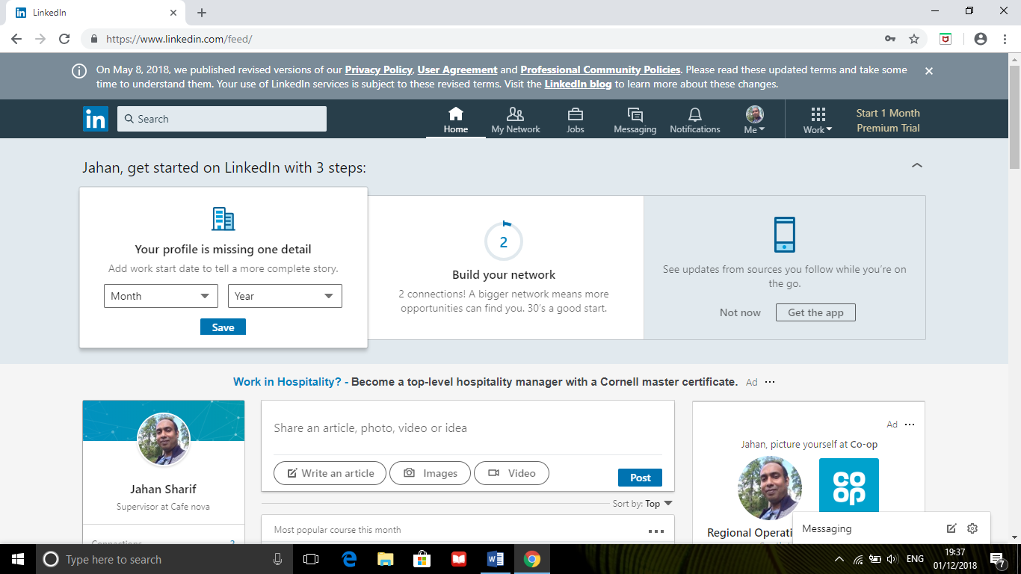(Linkedin.com, 2018)

Conclusion: The rapid development of technology gives a big boost to organisations. Organisations should use modern technology in an effective way to take their business to the next level. Digital technology has a big impact in every sector like work, education, health, transport, agriculture, leisure.

.

References:

Google.co.uk. (2018). digital skill definition - Google Search. [online] Available at: https://www.google.co.uk/search?safe=strict&source=hp&ei=sBwpXIHwBoGkadegj4AG&q=digital+skill+definition&btnK=Google+Search&oq=digital+skill+definition [Accessed 30 Dec. 2018].
Use of Technology. (2018). What Is Technology - Meaning of Technology and Its Use - Use of Technology. [online] Available at: https://www.useoftechnology.com/what-is-technology/ [Accessed 30 Dec. 2018].
Tech Quintal. (2018). Modern Technology Definition and Everything you Need to Know - Tech Quintal. [online] Available at: https://www.techquintal.com/modern-technology/ [Accessed 31 Dec. 2018].
Lenovo.com. (2018). What is Cloud Computing? | Lenovo India. [online] Available at: https://www.lenovo.com/in/en/faqs/laptop-faqs/what-is-cloud-computing/ [Accessed 31 Dec. 2018].
Salesforce.com. (2018). [online] Available at: https://www.salesforce.com/hub/technology/benefits-of-cloud/ [Accessed 31 Dec. 2018].
Financesonline.com. (2018). Dropbox Business Reviews: Overview, Pricing and Features. [online] Available at: https://reviews.financesonline.com/p/dropbox-business/ [Accessed 31 Dec. 2018].
Lifewire. (2018). Serious Question: What Exactly Is Social Media?. [online] Available at: https://www.lifewire.com/what-is-social-media-explaining-the-big-trend-3486616 [Accessed 31 Dec. 2018].
Digital Marketing Blog. (2019). How Using Social Media For Marketing Can Transform Your Business. [online] Available at: https://www.lyfemarketing.com/blog/using-social-media-for-marketing/ [Accessed 1 Jan. 2019].
Corporation, M. (2019). Why You Should Gather Information From Social Media. [online] Medium. Available at: https://medium.com/xplenty-blog/why-you-should-gather-information-from-social-media-cccdbb576713 [Accessed 1 Jan. 2019].
Eichmann, L. (2019). How Social Media is Changing Communication. [online] B2B Tech PR Agency and Digital Marketing Firm. Available at: https://www.walkersands.com/how-social-media-is-changing-communication/ [Accessed 1 Jan. 2019].
Maund, A., Schriek, M. and Tinker, P. (2017). Certificate in Higher Education: Skills for the Workplace Student Yearbook. 1st ed. London: SAGE Publications Ltd.
Linkedin.com. (2018). LinkedIn. [online] Available at: https://www.linkedin.com/feed/ [Accessed 1 Dec. 2018].
Facebook.com. (2018). Emperor Garments CO. [online] Available at: https://www.facebook.com/Emperor-Garments-CO-

