Vincent David Li Ah Choon
Determining The Best Method For Multi-Skilling In The Front Office Department

Course: Work-Based Learning
Submission Date: 22.04.19
Module: BMPF4008
Student no: 1715709
Word Count: 3473

Table Content Page Number
Section1 Project Proposal. 2

Section 2 Project Report
- Introduction 4
1.1 Literature Review 4-5
1.2 Methods 5-6
1.3 Findings 6-11
1.4 Conclusion and Recommendations 11
1.5 References 12

Section 3 Appendices
Appendix A 13-16
Appendix B 17-22
Section 4 Ethics Form 24-45

PROJECT PROPOSAL
Determining The Best Method For Multi-Skilling In The Front Office Department
After years since the re-opening of LUX* Grand Gaube, as Assistant Front Office Manager, the researcher noticed the level of service in the Front Office Department has dropped. The main reason being the recent change in the front office structure and the lack of preparation of our team members to work in this new environment.

Before the renovation it was ideal to work with specialised team members, as each sub department was dedicated to a specific task, however this does not work well within the current structure. With the new Front Office structure, the team members now have to carry out tasks which were not part of their duty before. Previously the team members were considered specialists in their specific jobs but now they have to perform varied duties. The main cause of this is the lobby design where all desks have been removed and been replaced by 3 Pods for Concierge and Guest Relations. Before the renovation the Reception was recognized as the heart of the lobby, now it has been replaced by a private Cashier Office, dedicated for money transactions. A special feature at the LUX* is that everyone wears the same uniform
and the guests are unable to distinct between Concierge and Guest Relations when they are at the pods.

The researcher believes that a multi-skilled team would be more effective with the current open design of the hotel lobby. Therefore, there is a need to seek the right training methodology which will be both adaptable and welcomed by all parties.

Once the team members are more multi-skilled, the level of service should increase and guests will benefit from it. Team Members should become more confident and this would add value to their career. The hotel is also likely to be recognized for the excellent service standards.

The Outlined Intention
The researcher engaged all concerned parties, the Managers and Supervisor and the survey participants in order to have qualitative and quantitative data. A Focus group interview was organized to gather all Front Office Department Managers and Supervisors together to have their opinions, idea and their perceptions on the best method to apply for multi skilling the survey participants; the researcher took note of all vital points during the discussion.

For the survey participants a survey organized with 9 specific questions related to best methods of multi- skilling and this survey allowed us to have statistics on how many survey participants were eligible to acquire different techniques using the following four trainings method that is, role play, coaching, shadowing, on-the-job training.

For ethical purpose all the data gathered through surveys will be kept securely in the cashier lounge office and access will be limited to myself. After one month all related information will be destroyed.

As an insider researcher this will be an occasion to make deep research about the benefits of multi-skilling and to adapt the methods to each front liner taking into consideration that each person has a preference for one or more training methods. For the personal learning outcomes, the researcher expected to learn how to adapt the best training method to the team by analyzing careful the outcome of the survey questionnaire and the the focus group survey. Also to learn how to do efficient training plan taking into consideration team members willing to share their knowledge to others.

1.0 INTRODUCTION

One of the fundamental roles of a Manager is to always ensure that the service level of the company is being uplifted. However the team members play a crucial role in the success of the Manager and the organization. The researcher noticed with the new lobby design, specialized skills are not sufficient to maintain consistent level of service in the Front Office Department. One of the solutions to overcome this situation is to train the survey participants and assist them to become multi-skilled. There are several advantages for the organization to invest in multi-skilling however the challenge will be to adopt the right strategy and to work on a planning within a specific period of time. The Managers and the Supervisors have the responsibility to convince all the participants and explain to them how they will benefit from this transformation in the short and long run.

1.1 LITERATURE REVIEW
Cesar (2015) has done a detailed study on multi-skilling, cross –training and personal scheduling. The study explains why at an international level various sectors have opted for multi-skilling the labor force. The world is moving fast and with the impact of technology, one skill is no longer sufficient to be effective in the workplace. For a professional worker to survive, he has to re-adapt himself and needs cross domain knowledge and cross functional skills to remain relevant and competitive in his domain. The service sector which includes industries such as health, retail, and call centers in the past ten years faced similar situation as the tourism industry currently. When you have specialized labour force, you can be overstaffing or understaffing which impacts your rostering and your service delivery.
Li-Cheng (2009) mentions that the there is a very high demand for trained employees as the labor turnover in the hospitality industry is too high due to the work environment. One of the solutions is to opt for multi-skilled labor force that do various duties and in return receive self-satisfaction, praise and recognition.
As per (Googoolye, 2013), a research done by the Human Resource Development Council in 2011 in Mauritius, highlights a crucial point regarding the imbalance in skills and availability on the labour market. Various sectors are in constant struggle as they are trying to find a balance between the demand and supply of the labour force. There are 3 major sectors that suffered from the mismatch in skill, Tourism Industry, Construction and Manufacturing. One of the solutions is to review our training system and to adapt to the market demand. Among the professionals in the Human Resource, the question was raised on what could increase the chance for a person to get a good job, 65 % answered the chance would increase if the person is multi-skilled, followed by the person who has the right attitude with 56 %. For organisations to excel, it is important to re-evaluate the skills and talent of each individual and through multi-skilling our team members will be able to close the gap where we have more demand.
Multi skilling could bring more engagement to our team members in their day to day work. It broadens the knowledge and it is productive. Repetitive tasks can be boring in the long run. “Variety keeps people healthy and happy. Physical activity is a nice break if you’ve been sitting at a desk for a while.” HRmagazine.co.uk (Roper, Case study: Total pay equality and multi-skilling at a workers' co-operative, 2016)
1.2 Methods
For the purpose of this project the researcher decided to use two types of methods to collect data from the survey participants and the front office management team.
- For the survey participants a questionnaire with nine questions related to their work was designed to know if they are interested to learn new tasks and become multi- skilled. The questions also helped to know if the survey participants who have mastered a specific task were ready to share their know-how and train other survey participants to help them to uplift their knowledge and skills. A total of 26 survey participants were included of which 24 responded.
- For the Front Office Managers and Supervisors’ a Focus Group meeting was set with 5 participants.

The researcher used a quantitative survey questionnaire to gather information from the front office team members. As the survey questionnaire was anonymous, the participants had no pressure and felt free to answer the questions. For the researcher, the survey questionnaire helped to have precise information as the questions were directly linked with multi-skilling and it was an easy way to gather data. The researcher had the option to use the correlational survey where it would help to measure the relationship between two groups, for a group of front liners who are already multi -skilled and a group of front liners who are specialized in one task. However it was not an efficient way to collect data as the group of multi skilled team members was too small, as only three among the twenty six front liners.
For the qualitative part a Focus Group meeting was organized for the managers and supervisors. It helped to save time and money compared to individual interview. As all participants are on supervisory and management level, the meeting was useful to have their thoughts and hence it offered the opportunity to seek clarification. The participants were provided a wider range of information on this specific topic as everybody in this group spoke the same language. The researcher could have organized individual interviews among supervisors and managers but unfortunately it would have been time consuming in terms of setting up, location and analysis.
Concerning the ethical part, for the 26 survey participants who participated in the survey there was no pressure and obligation for them to complete the survey questionnaire and no personal data such as name, age, gender and position had to be declared on the survey. For the Focus Group meeting, an invitation was sent five days before the meeting.
One of the biggest risks of the survey questionnaire was that the participants who have not understood a particular question might have chosen the answers randomly. This could mislead the researcher in his project. For the Focus Group survey, for managers and supervisors who have a preference for specialization could bring arguments only about the negative impact of multi-skilling.
If ever there had been a participation lower than 50% for the survey and the focus group, the researcher would have definitely organized a second survey and postponed the meeting and launched a second invitation for the focus group.
1.3 FINDINGS

For the purpose of the findings, a survey questionnaire with 9 questions was distributed among all the survey participants and 88% of the participants returned back the questionnaire and 2 participants only were unable to participate in the survey as they were on leave for that particular period. From the two participants one is from Cashier and one from Concierge.
For the Front Office Management team including the Supervisors, I conducted a Focus Group meeting where I have 100% participation. Guest Relation Officers were the major participants in this survey representing 33 %, followed by Cashier Team representing 25 %, Porters 21 %, Telephone Operators 13%, Concierge 4 %, Reservations 4%. Full tabulated responses are in Appendix A.
When comparing the survey questionnaire and the focus group it is noted, 96 % of the survey participants agreed that multi-skilling will improve their performance and career prospects while 80% of the Focus Group participants responded that multi-skilling will be a positive thing for the team to move forward.
About the training method to be adopted, 67 % of the survey participants prefer to do on-the-job training and during the focus group all the participants mentioned on the top list that the best way to train our Team Members to become multi –skilled is to use the on-the-job training method. Two survey participants believed for them the best way to acquire more skills is to organize role plays. The focus group participants mentioned the importance of role plays during the meeting, where it will be easy to observe and give feedback on performance. 21 % stated coaching would be the solution to help them to become multi-skilled, however none of the managers & supervisors identified this method during the focus group discussion. Among those surveyed, 83 % of them believe that LUX* Grand Gaube and the guests will benefit if we train our Team Members to become multi-skilled, our head Concierge put forward 5 reasons, and explained clearly how multi-skilled Team Members will impact the service and the resort in a positive way.

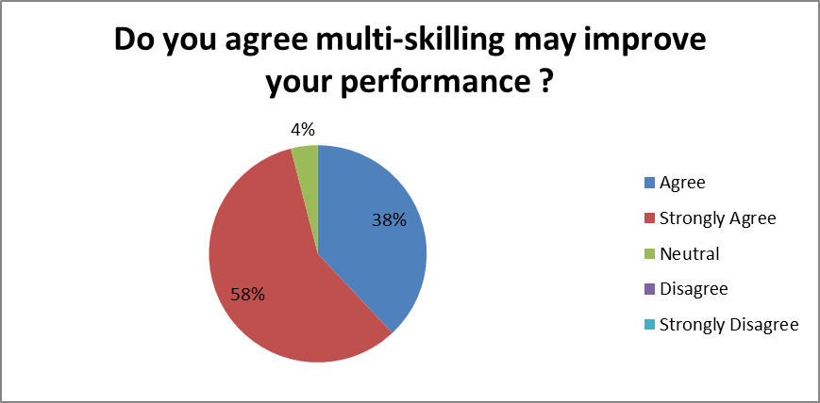

Table 1
Table 1
Table 1 shows us that we have only 4% (ie, one front liner) that has no a clear idea if multi-skilling may help him to improve his performance. 38% representing 9 survey participants agreed that multi-skilling may improve their performance and 58% representing 14 survey participants strongly agree that multi-skilling may improve their performance.

Among those surveyed 38% have worked more than 1 year, 29% less than 1 year, 6% more than 5 years and 8% more than 10 years. The survey shows that even though the years of service varies from less than 1 year experience to more than 10 years, 96% among them is in favour of becoming multi-skilled.

Question 5: This question related to cross exposure in another sub department, where 39% of the Front Office Team Members would like to be at the Cashier Lounge and only 1 Porter with more than 1 year experience selected to be at Guest Relations for cross exposure training. One Cashier with less than one year of experience selected all the four answers on the survey (Telephone Operator/Cashier Lounge/Reservation/ Concierge). Of the two survey participants with more than 10 years, one has chosen Concierge and one Cashier.

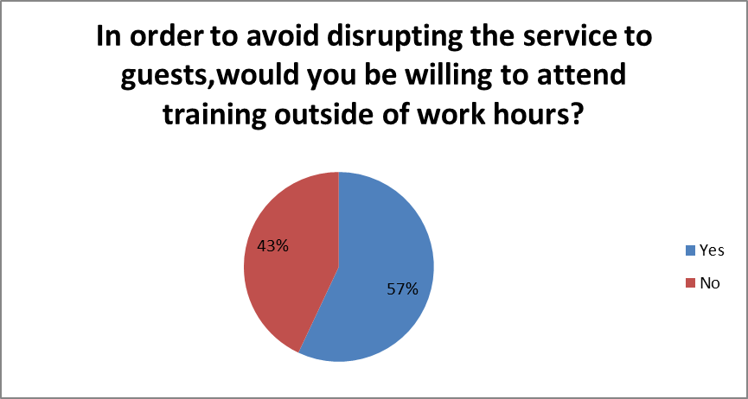
Table 2
For Question 7, table 2 shows if team members are ready to stay beyond working hours to participate in training sessions, 13 among them were in favour staying odd hours where 10 team members declined. In term of percentage 57% agreed and 43% disagreed. In total we have 8 survey participants who have worked for more than 5 years and 50% among them declined to stay after their shift for training purposes. One Front liner had declined to answer this question.

Question 8, in the survey questionnaire, was about survey participants who are eager to share their knowledge by giving training to their colleagues. 88% are interested to provide training but 3 team members had not replied to this question. These 3 team members were from 3 various sub departments, 1 Cashier, 1 Guest Relation and 1 Concierge.

For Question 9, in the survey questionnaire, 17% of the survey participants had no idea if LUX* Grand Gaube and our guests will benefit from multi skilled Team Members. Two survey participants had worked for 1 year, 1 participant for more than 5 years and one participant for more than 10 years. One of the survey participants had not answered this part of the question.

Concerning my project I as the researcher expected 50% of Team Members to complete and return back the survey; at the end the researcher was more than satisfied as in total 24 survey participants had completed the survey and it represents 89% of participants. Among these 24 survey participants, 23 agreed that multi-skilling will bring and benefit to their career and at the same time offer better quality service to our guests. The more interesting fact is that 95 % of the survey participants are ready to make this project a reality as they are ready to share their knowledge and provide workplace training.

During the Focus Group, which was a very successful meeting, at the beginning as the researcher I was expecting 50 % of the Front Office Management team together with Supervisors to participate, in the debate. The final participants present were the Room Division Manager, Front Office Manager, Assistant Front Office Supervisor, Front Office Supervisor and Head Concierge. They were very attentive and during the question time everyone was participative and everyone shared their respective ideas on how multi-skilling will be useful for our department. Concerning question about best method to be used, all the managers and supervisors suggested on-the-job training on top of the list. However one participant mentioned quiz competition as one of the best way to check effectiveness of on-the-job training. The quiz with 5 simple’s questions will help the trainer to have a clear idea if the front liner has assimilated the knowledge and he said reward is a key factor to encourage survey participants participate more actively as it will develop a sense of fair competition among them.

While there was agreement on the importance of multi-skilling, one participant mentioned the possible risk that when people have acquired several skills they may leave the company. However, this should not be a barrier if we have a clear development path for each team member and do an individual assessment for everyone. Also another aspect to consider is for front liners who are specialists and performing very well in doing one single task, may not be interested in multi-skilling and choose to leave. The role of each Manager is to encourage Team Members to learn more and equip them to face the daily job exigencies and also create a bank of talents who are ready to step up whenever a Supervisor or Manager is leaving the company.
Everybody during the group meeting made an observation that all of the focus group participants are multi skilled. Overall front office team members have to understand if they are ambitious and want to be promoted, multi-skilling will be a huge advantage. Multi-skilled team members acquire experience in different fields and can contribute more in the work. One participant spoke about the importance of the work atmosphere, how to create a perfect environment, while another participant pointed out how important it is to have happy team members. Multi skilling is known to be one of the major factors that can encourage happiness and self-satisfaction. This happiness will be reflected in the atmosphere at the job place and also reflect on the guests too.
The distribution of the survey was a real challenge as the researcher started his shift in the evening and reached work at 15h30 when most day shift people have already left. Next time the researcher will plan better by gathering maximum team members in one place, explaining the purpose of this survey and do the distribution at the end of the meeting.

For the Focus Group meeting, the researcher faced a difficulty at the last minute as the location that was chosen was occupied on the day and the meeting had to be delayed. As a result the duration of the meeting was shortened by 15 minutes. Next time taking into consideration last minute unexpected situations, it will be better to plan the meeting in the early afternoon to avoid clash with the second shift where the morning shift has to handover to evening shift.
In general everyone was participative in the focus group, the researcher felt on few questions, the Supervisors were reluctant to express themselves as they were overshadowed by the Managers and they just followed the trend set by the Managers. The researcher could have organized a one to one interview for the Supervisors, the platform could be more appropriate for them where they will have the liberty to express themselves openly.

For question 9 on the survey questionnaire concerning benefits of multi-skilling - 13% of the participants refrained from answering. This may be because they did not have a clear view of benefits. However 96% answered positively and are interested to become multi-skilled as they may have intrinsic motivation. 29% among these have worked only less than 1 year and 38% more than 1 year. Among these, 3 team members had done tertiary education and their goal is to be at the Supervisory Level within 1 year and multi skilling will give them a boost to attain their objective faster.

1.4 Conclusion and Recommendations
After analyzing the survey questionnaire and the focus group notes, the researcher can conclude that there is a willingness for team members to become multi-skilled and that team members have understood the importance of the project. Irrespective of years of service 96% agreed that multi skilled will improve their performance. However team members with more than 10 years of experience, don’t consider that multi-skilling will improve their career prospect. For the timing of training, special attention has to be given as there are 53% of team members who agreed to stay after working hours and 47% rejected the idea. This factor has to be considered in order to avoid penalizing these 10 team members. Overall 17% team members who have no idea how our guests and the company will benefit from multi-skilled.

The researcher recommends to organize several sessions of detailed presentations in order to convince the 17% of survey participants and team members with more than 10 years of experience and explain them how multi-skilling will impact on their day to day work, service to guests as well as their. A pilot project will be launched to start multi-skilling by selecting 3 team members from three sub-departments (Guest Relation, Concierge, Cashier). Training will be on-the-job for a duration of 30 minutes after the working hours. Once this is tested, more team members will be included in the multi-skilling program.

1.5 References
César Augusto Henao Botero, J. C. (2015). The impact of multi-skilling on personnel. Journal of the Operational Research Society, 2.
Googoolye, V.-R. S. (2013). Labour and Skills Shortage in Mauritius - a Cross-sectoral Analysis. International HRD Conference, Mauritius 2013: Excellence in HRD for sustainable growth (pp. 32-33). Human Resource Development Council.
Li-Cheng Chen, M. W. (2009). Multiskilling in the hotel industry in Taiwan . 2.
Roper, J. (2016, September 01). Case study: Total pay equality and multi-skilling at a workers' co-operative. Retrieved February 20, 2019, from HRmagazine: http://www.hrmagazine.co.uk/article-details/case-study-total-equality-of-pay-and-multi-skilling-at-a-workers-co-operative

APPENDIX A
We would like to improve service in the Front Office Department; you are invited to complete this survey questionnaire. We need your vital opinions. Kindly note all answers will remain confidential.
Please tick your answers.
- How long have you worked in the Front Office Department?

A Less than one year

B More than one year

C More than five years

D More than 10 years
- What is your specific role in the Front Office Department?

A Cashier

B Guest Relation

C Telephone Operator

D Porter

E Reservation Clerk

- Do you agree multi-skilling may improve your performance?

A Agree

B Strongly Agree

C Neutral

D Disagree

E Strongly Disagree

- Do you agree multi-skilling may improve your career prospect ?

A Agree

B Strongly Agree

C Neutral

D Disagree

E Strongly Disagree

- If ever you get the opportunity to do a cross exposure in a sub department in the Front Office which one would you choose?

A Telephone Operator

B Cashier Lounge

C Reservation

D Concierge

- Which method of training do you prefer to acquire workplace and knowledge?

A Role Play

B Coaching

C Shadowing

D On the job training

- In order to avoid disrupting the service to guests, would you be willing to attend training outside of work hours?

A Yes

B No-

- Are you interested in sharing your knowledge and assisting with workplace training of your colleagues?

A Yes
If yes please precise in which field.

B No

- Our Guests and LUX* Grand Gaube team will benefit from a multi-skilled Front Office Team Members?
A Agreed
B Strongly Agree
C Neutral
D Disagree
E Strongly Disagree

Survey Questionnaire Analysis

Appendix B
Focus Group Meeting
Questions:
- What do you think if we train our Team Members to become multi-skilling?
- How our department will benefit from it?
- What can be the challenges to transform the team into a multi skilling Team?
- What will be the best method to adopt for the training?
- How we will handle team members who are reluctant to become multi skill?

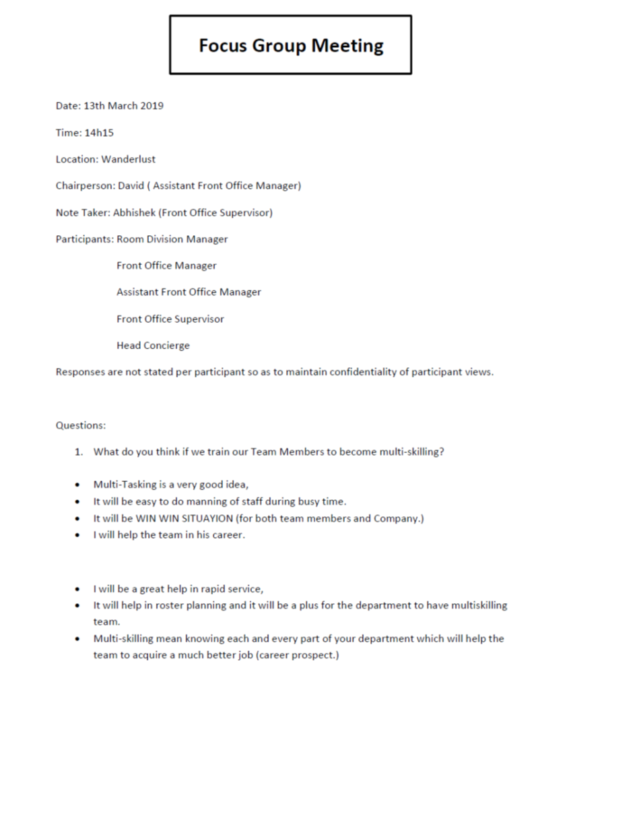

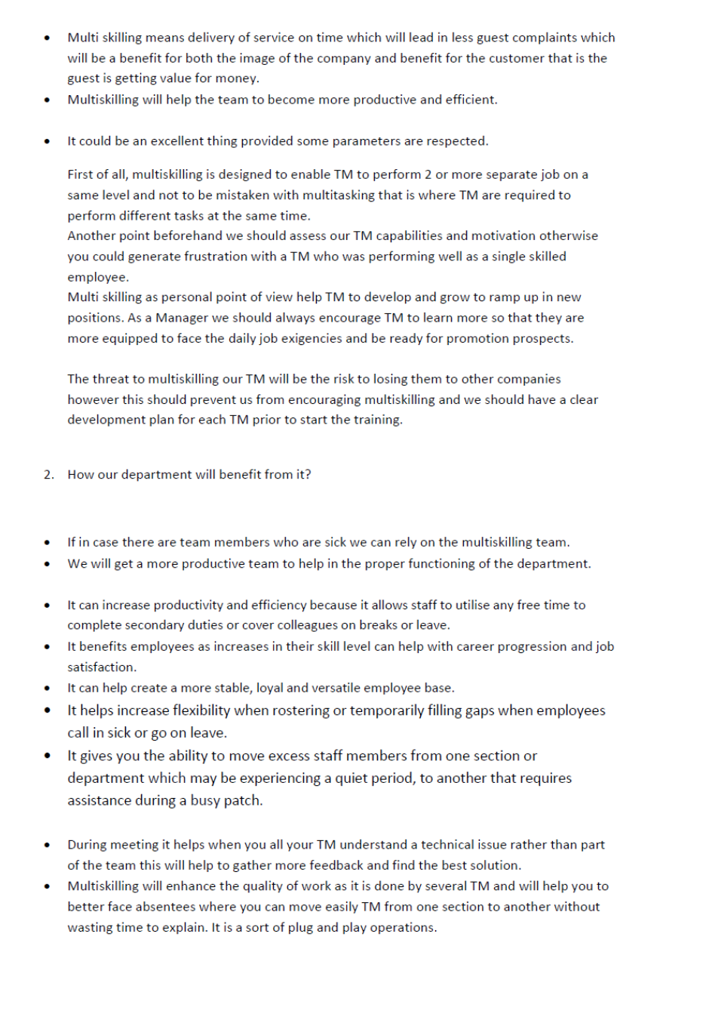

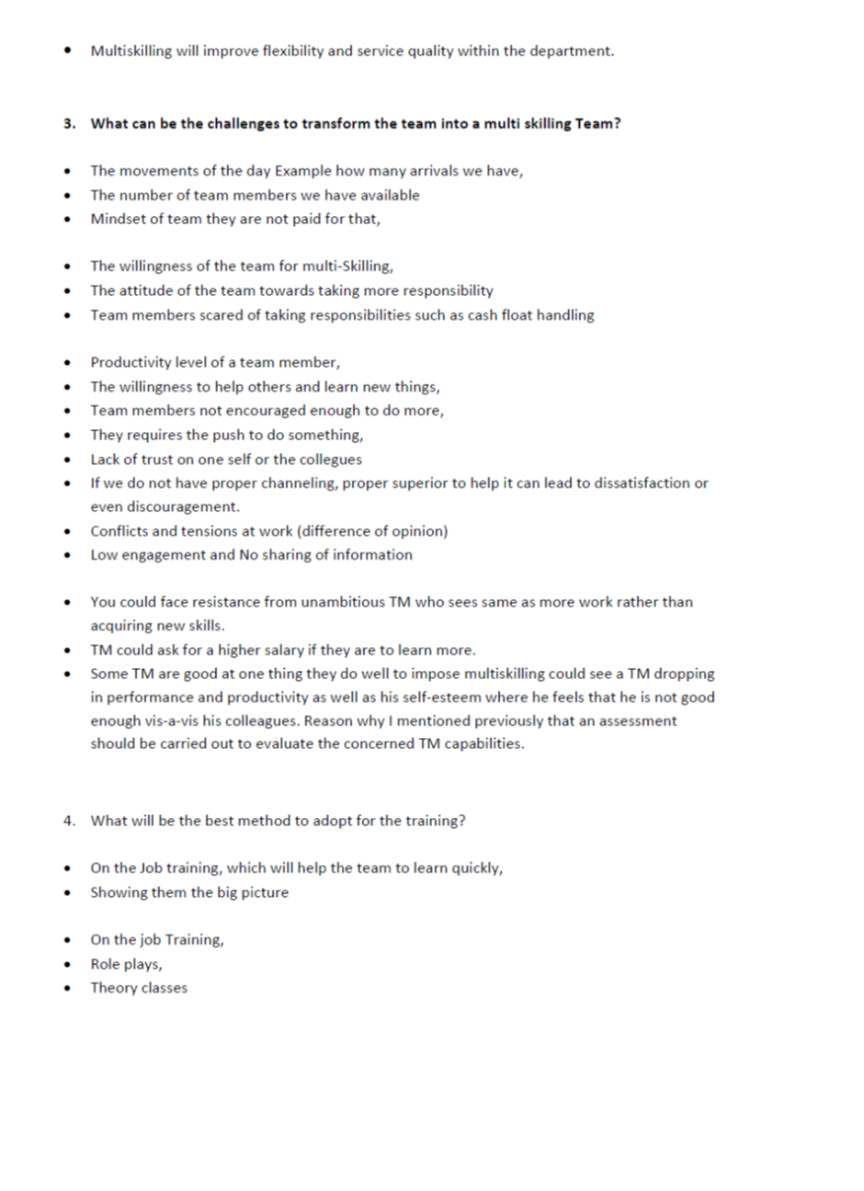

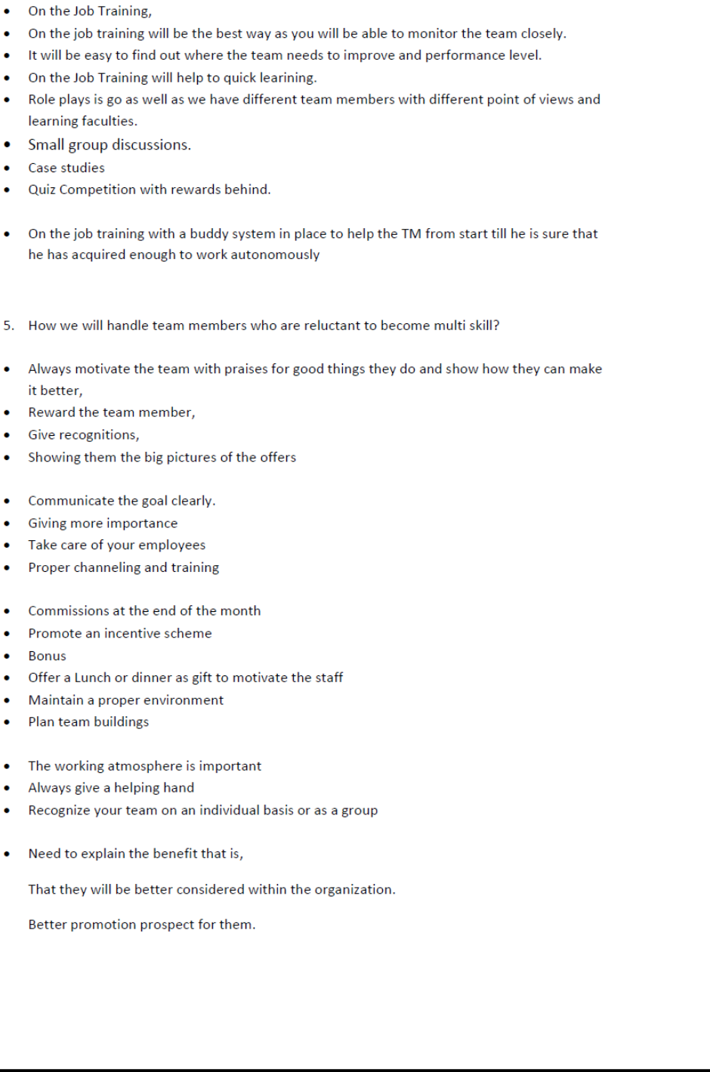

APPLICATION FOR ETHICAL APPROVAL

In order for research to result in benefit and minimise risk of harm, it must be conducted ethically. A researcher may not be covered by the University’s insurance if ethical approval has not been obtained prior to commencement.

The University follows the OECD Frascati manual definition of research activity: “creative work undertaken on a systematic basis in order to increase the stock of knowledge, including knowledge of man, culture and society, and the use of this stock of knowledge to devise new applications”. As such this covers activities undertaken by members of staff, postgraduate research students, and both taught postgraduate and undergraduate students working on dissertations/projects.

The individual undertaking the research activity is known as the “principal researcher”.

Ethical approval is not required for routine audits, performance reviews, quality assurance studies, testing within normal educational requirements, and literary or artistic criticism.

Please read the notes for guidance before completing ALL sections of the form.

This form must be completed and approved prior to undertaking any research activity. Please see Checklist for details of process for different categories of application.

SECTION A: About You (Principal Researcher)

Full Name: |  |  | Vincent David Li Ah Choon
Tick all boxes which apply:
Member of staff: | ☐ | Student: |  | ☒ | Honorary research fellow: | ☐

Faculty/School/Centre: | WIWBL
Campus: | Carmarthen
E-mail address: | David.liahchoon@luxgrandgaube.com
Contact Telephone Number: | 230 5751 9398/ 230 5919 3282
For students:
Student Number: | 1715709 | Undergraduate | ☒
Programme of Study: | Cert-HE IN Professional Practice | Taught Postgraduate | ☐
Director of Studies/Supervisor: | Tessa Oosthuizen | Research | ☐

SECTION B: Approval for Research Activity

Has the research activity received approval in principle?  (please check the Guidance Notes as to the appropriate approval process for different levels of research by different categories of individual) |  | YES | ☒ | NO | ☐
 |  |  |  | Date
If Yes, please indicate source of approval (and date where known): | Research Degrees Committee |  | ☐
 | Faculty Research Committee |  | ☐
 | Other (write in)  WIWBL Ethics Board Representative |  | ☒
Approval in principle must be obtained from the relevant source prior to seeking ethical approval.

SECTION C: External Ethical Guidance Materials

Please list the core ethical guidance documents that have been referred to during the completion of this form (including any discipline-specific codes of research ethics, and also any specific ethical guidance relating to the proposed methodology). Please tick to confirm that your research proposal adheres to these codes and guidelines.
DATA PROTECTION ACT 2017 | ☒
LUX*Resorts and Hotels Code of Conducts and Ethics | ☒
 | ☐

SECTION D: External Collaborative Research Activity

Does the research activity involve collaborators outside of the University? |  | YES | ☐ | NO | ☒
If Yes, please provide the name of the external organisation and name and contact details for the main contact person:
Institution
Contact person name
Contact person e-mail address

Where research activity is carried out in collaboration with an external organisation
Does this organisation have its own ethics approval system? | YES | ☐ | NO | ☐
If Yes, please attach a copy of any final approval (or interim approval) from the organisation

SECTION E: Details of Research Activity

Indicative title: | Determining The Best Method For Multi-Skilling In The Front Office Department at LUX* Grand Gaube
Proposed start date: |  | Proposed end date:
Purpose of research activity (including aims and objectives)
Outline the purpose, aims and objectives of the research activity, including key research questions. Show briefly how existing research has informed the proposed activity and explain what the research activity will add and how it addresses an area of importance. (Maximum 300 words)
Background
I work in the Front Office Department at LUX* Grand Gaube as Assistant Manager,I have under my responsibility 6 sub departments ( Cashier Lounge, Guest Relations, Concierge, Porter, Reservation, Telephone Operator), we have specialized Team Members in each sub department, with the new setup of the infrastructure and with the new trend , it will be better to have multi- skilled Team Members where it will be more productive for the organization and by the way resolves the problem absenteeism that is becoming a recurrent issue.

Aims
The aims of research will bring,
- To determine the best methods to multi skill Team Members within the Front Office Department.
- To identify Team Members with some special skills which can be used within the Front Office Department.
- To discover different talents in the Front Office Department and guide them in their career path.

Personal Learning Outcomes:

- To learn strategies to make full use of human resources in the Front Office Department.
- Improved rostering skills.
- Understand how to help to create a real Team Spirit among all of the Front Office Team Members.

Previous Research:
Research done on Drivers of Productivity Improvement in Tourism and Hospitality by Prof. Peter Jones of University of Surrey (Jones, 2007).

Reference:
Jones, P. (2007). Drivers of Productivity Improvment in Tourism and Hospitality. Retrieved November 28, 2018, from core.ac.uk: https://core.ac.uk/download/pdf/102693.pdf

Proposed methods
Provide a brief summary of all the methods that may be used in the research activity, making it clear what specific techniques may be used. If methods other than those listed in this section are deemed appropriate later, additional ethical approval for those methods will be needed. (Maximum 600 words)
Methodological Position
The research will be both quantitative and qualitative and will use two groups Managers & Supervisors and Team Members

Participants
Participants will include 7 Managers& Supervisors for the focus group and for the survey 26 Front Office Team Members are concerned.

Methods

- Focus Group: To regroup Supervisors and Managers of the Front Office Department in this meeting, this will permit to have the opinion of people who are used to supervise a team. All feedback will be recorded by means of interviewer notes.

- Survey: A questionnaire will be prepared with approximately ten specific questions about multi skills, and the questionnaire will be distributed among the 26 Front Office Team Members at the end of their respective shift. Team Members will fill their survey at home without any work stress and without any colleague influence. I expect to receive about 13 questionnaires back to analyse in term of quantitative. No personal information will be gathered on the questionnaire such as in which department you are working, gender, age.

Analysis
- Focus Group : responses will help me to determine the best possible methods of multi skilling that can be adaptable to the current situation and more importantly would be welcomed by the Team Members

- Survey: responses will help me to know if they are willing to acquire new skills and which methods they prefer to acquire those skills.

Location of research activity
Identify all locations where research activity will take place.
At LUX* Grand Gaube

Research activity outside of the UK
If research activity will take place overseas, you are responsible for ensuring that local ethical considerations are complied with and that the relevant permissions are sought. Specify any local guidelines (e.g. from local professional associations/learned societies/universities) that exist and whether these involve any ethical stipulations beyond those usual in the UK (provide details of any licenses or permissions required). Also specify whether there are any specific ethical issues raised by the local context in which the research activity is taking place, for example, particular cultural sensitivities or vulnerabilities of participants.
It will be in the Front Office Department of LUX*Grand Gaube only in Mauritius

SECTION F: Scope of Research Activity

Will the research activity include: | YES | NO
Use of a questionnaire or similar research instrument? | ☒ | ☐
Use of interviews? | ☒ | ☐
Use of diaries? | ☐ | ☒
Participant observation with their knowledge? | ☐ | ☒
Participant observation without their knowledge? | ☐ | ☒
Use of video or audio recording? | ☐ | ☒
Access to personal or confidential information without the participants’ specific consent? | ☐ | ☒
Administration of any questions, test stimuli, presentation that may be experienced as physically, mentally or emotionally harmful / offensive? | ☐ | ☒
Performance of any acts which may cause embarrassment or affect self-esteem? | ☐ | ☒
Investigation of participants involved in illegal activities? | ☐ | ☒
Use of procedures that involve deception? | ☐ | ☒
Administration of any substance, agent or placebo? | ☐ | ☒
Working with live vertebrate animals? | ☐ | ☒
Other primary data collection methods, please explain in this box | ☐ | ☐

If NO to every question, then the research activity is (ethically) low risk and may be exempt from some of the following sections (please refer to Guidance Notes).

If YES to any question, then no research activity should be undertaken until full ethical approval has been obtained.

SECTION G: Intended Participants

Who are the intended participants: | YES | NO
Students or staff at the University? | ☐ | ☐
Adults (over the age of 18 and competent to give consent)? | ☒ | ☐
Vulnerable adults? | ☐ | ☒
Children under 18? | ☐ | ☒
Prisoners? | ☐ | ☒
Young offenders? | ☐ | ☒
Those who could be considered to have a particularly dependent relationship with the investigator or a gatekeeper? | ☐ | ☒
People engaged in illegal activities? | ☐ | ☒
Others (please identify): | ☐ | ☒

Participant numbers and source
Provide an estimate of the expected number of participants. How will you identify participants and how will they be recruited?
Participants will be from Front Office Department only at LUX* Grand Gaube, 7 Managers & Supervisors and 26 Team Members.

Information for participants: | YES | NO | N/A
Will you describe the main research procedures to participants in advance, so that they are informed about what to expect? | ☒ | ☐ | ☐
Will you tell participants that their participation is voluntary? | ☒ | ☐ | ☐
Will you obtain written consent for participation? | ☐ | ☐ | ☒
Will you explain to participants that refusal to participate in the research will not affect their treatment or education (if relevant)? | ☒ | ☐ | ☐
If the research is observational, will you ask participants for their consent to being observed? | ☐ | ☐ | ☒
Will you tell participants that they may withdraw from the research at any time and for any reason? | ☒ | ☐ | ☒
With questionnaires, will you give participants the option of omitting questions they do not want to answer? | ☒ | ☐ | ☐
Will you tell participants that their data will be treated with full confidentiality and that, if published, it will not be identifiable as theirs? | ☒ | ☐ | ☐
Will you debrief participants at the end of their participation, in a way appropriate to the type of research undertaken? | ☒ | ☐ | ☐
If NO to any of above questions, please give an explanation
(this box should expand as you type)

Information for participants: | YES | NO | N/A
Will participants be paid? | ☐ | ☒ | ☐
Is specialist electrical or other equipment to be used with participants? | ☐ | ☒ | ☐
Are there any financial or other interests to the investigator or University arising from this study? | ☐ | ☒ | ☐
Will the research activity involve deliberately misleading participants in any way, or the partial or full concealment of the specific study aims? | ☐ | ☒ | ☐
If YES to any question, please provide full details

SECTION H: Anticipated Risks

Outline any anticipated risks that may adversely affect any of the participants, the researchers and/or the University, and the steps that will be taken to address them.

If you have completed a full risk assessment (for example as required by a laboratory, or external research collaborator) you may append that to this form.

Full risk assessment completed and appended?

Yes ☐
No ☒

Risks to participants
For example: emotional distress, financial disclosure, physical harm, transfer of personal data, sensitive organisational information
No risks are anticipated
(this box should expand as you type)
If research activity may include sensitive, embarrassing or upsetting topics (e.g. sexual activity, drug use) or issues likely to disclose information requiring further action (e.g. criminal activity), give details of the procedures to deal with these issues, including any support/advice (e.g. helpline numbers) to be offered to participants. Note that where applicable, consent procedures should make it clear that if something potentially or actually illegal is discovered in the course of a project, it may need to be disclosed to the proper authorities
No such issues are anticipated.
(this box should expand as you type)
Risks to investigator
For example: personal safety, physical harm, emotional distress, risk of accusation of harm/impropriety, conflict of interest
No risk are anticipated. It will be on usual place of work.

University/institutional risks
For example: adverse publicity, financial loss, data protection
No risks are anticipated.

Adverse outcomes
List measures put in place to limit any adverse effects or outcomes of research activity where appropriate. Include any emergency protocols.
In case low level of participation less than 50 % for the survey, one more survey will be organized within the Front Office team.

For the focus group, if we have 50 % of participants the focus group meeting will be postponed and a new invitation will be launched.

Disclosure and Barring Service
If the research activity involves children or vulnerable adults, a Disclosure and Barring Service (DBS) certificate must be obtained before any contact with such participants. | YES | NO | N/A
Has a DBS certificate been obtained? | ☐ | ☐ | ☒

SECTION I: Feedback, Consent and Confidentiality

Feedback
What feedback will be provided to participants, how will this be done and when?
A meeting will be set after 5 days, where the percentages of each questions will be communicated to the participants.

Informed consent
Describe the arrangements to inform potential participants, before providing consent, of what is involved in participating. Describe the arrangements for participants to provide full consent before data collection begins. If gaining consent in this way is inappropriate, explain how consent will be obtained and recorded.
For the focus group all participants Managers and Supervisors in Front Office Department, a mail will be sent on individual mail to inform them that their participation will be voluntary.

A meeting will be done 3 days before the launch of the survey and will communicate to Front Office Team Members that their participation is voluntary, with participation implying consent.

Confidentiality / Anonymity
Set out how anonymity of participants and confidentiality will be ensured in any outputs. If anonymity is not being offered, explain why this is the case.
Focus Group: all information that will be noted in the interview notes will be destroyed after.

Survey no personal information needed such as Sub Department, Age, Gender. And all survey will be destroyed after the assignment has been completed.

SECTION J: Data Protection and Storage

In completing this section refer to the University’s Research Data Management Policy and the extensive resources on the University’s Research Data Management web pages (http://uwtsd.ac.uk/library/research-data-management/).
 | YES | NO
Does the research activity involve personal data (as defined by the Data Protection Act)?  “personal data” means data which relate to a living individual who can be identified—  (a) from those data, or  (b) from those data and other information which is in the possession of, or is likely to come into the possession of, the data controller, and includes any expression of opinion about the individual and any indication of the intentions of the data controller or any other person in respect of the individual. | ☐ | ☒
If YES, provide a description of the data and explain why this data needs to be collected:
Does it involve sensitive personal data (as defined by the Data Protection Act)?  “Sensitive personal data” means personal data consisting of information as to –  (a) the racial or ethnic origin of the data subject,  (b) his political opinions,  (c ) his religious beliefs or other beliefs of a similar nature,  (d) whether he is a member of a trade union (within the meaning of the Trade Union and Labour Relations (Consolidation) Act 1992),  (e) his physical or mental health or condition,  (f) his sexual life,  (g) the commission or alleged commission by him of any offence, or  (h) any proceedings for any offence committed or alleged to have been committed by him, the disposal of such proceedings or the sentence of any court in such proceedings. | ☐ | ☒
If YES, provide a description of the data and explain why this data needs to be collected:

Will the research activity involve storing personal data on one of the following: | YES | NO
Manual files (i.e. in paper form)? | ☒ | ☐
University computers? | ☐ | ☒
Private company computers? | ☐ | ☒
Home or other personal computers? | ☒ | ☐
Laptop computers/ CDs/ Portable disk-drives/ memory sticks? | ☒ | ☐
“Cloud” storage or websites? | ☐ | ☒
Other – specify: | ☐ | ☒
For all stored data, explain the measures in place to ensure data confidentiality, including details of password protection, encryption and anonymisation:
All surveys will be sealed in an envelope and will be kept in a safe, only accessible to me as per the Data Protection Act 2017.

Will the research activity involve any of the following activities: | YES | NO
Electronic transfer of data in any form? | ☐ | ☒
Sharing of data with others at the University? | ☐ | ☒
Sharing of data with other organisations? | ☐ | ☒
Export of data outside the European Union or importing of data from outside the UK? | ☐ | ☒
Use of personal addresses, postcodes, faxes, emails or telephone numbers? | ☐ | ☒
Publication of data that might allow identification of individuals? | ☐ | ☒
Use of data management system? | ☐ | ☒
Data archiving? | ☐ | ☒
If YES to any question, please provide full details, explaining how this will be conducted in accordance with the Data Protection Act (and/or any international equivalent):

List all who will have access to the data generated by the research activity:
The researcher only.

List who will have control of, and act as custodian(s) for, data generated by the research activity:
The researcher only.

Give details of data storage arrangements, including where data will be stored, how long for, and in what form. Will data be archived – if so how and if not why not.
Data generated will be kept in a sealed envelope and kept in a safe under CCTV control. I will be the only person in possession of this safe code lock. No will not be achieved once all information needed has been collected.

SECTION K: Declaration

The information which I have provided is correct and complete to the best of my knowledge. I have attempted to identify any risks and issues related to the research activity and acknowledge my obligations and the rights of the participants.

In submitting this application I hereby confirm that I undertake to ensure that the above named research activity will meet the University’s Research Ethics and Integrity Code of Practice
Signature of applicant: | Vincent David Li Ah Choon | Date: 29.11.2018

For students:
Director of Studies/Supervisor: | Tessa Oosthuizen
Signature:
Date: | 29.11.18

For staff:
Head of School/Assistant Dean: | Annette Fillery-Travis
Signature: | Annette Fillery-Travis
Date: | April 2019

Checklist: Please complete the checklist below to ensure that you have completed the form according to the guidelines and attached any required documentation:
☐ | I have read the guidance notes supplied before completing the form.
☐ | I have completed ALL RELEVANT sections of the form in full.
☐ | I confirm that the research activity has received approval in principle
☐ | I have attached a copy of final/interim approval from external organisation (where appropriate)
☐ | I have attached a full risk assessment (and have NOT completed Section H of this form) (where appropriate)
☐ | I understand that it is my responsibility to ensure that the above named research activity will meet the University’s Research Ethics and Integrity Code of Practice.
☐ | I understand that before commencing data collection all documents aimed at respondents (including information sheets, consent forms, questionnaires, interview schedules etc.) must be confirmed by the DoS/Supervisor, module tutor or Head of School.

RESEARCH STUDENTS AND STAFF ONLY
All communications relating to this application during its processing must be in writing and emailed to pgresearch@uwtsd.ac.uk , with the title ‘Ethical Approval’ followed by your name.
You will be informed of the outcome of your claim by email; therefore it is important that you check your University and personal email accounts regularly.

STUDENTS ON UNDERGRADUATE OR TAUGHT MASTERS PROGRAMMES should submit this form (and receive the outcome) via systems explained to you by the supervisor/module leader.

This form is available electronically from the Academic Office web pages: http://www.uwtsd.ac.uk/academic-office/

Application Process

All staff research projects and all research students must submit the Ethical Approval Form to the University Ethics Committee via the Academic Office (pgresearch@uwtsd.ac.uk). Staff research directly in relation to personal study for taught undergraduate or Masters programmes should be submitted via the Faculty procedures explained below.

Taught masters and taught undergraduate research Ethical Approval Forms are considered within Faculties. Faculties will provide details of the specific processes for this. Where the Ethical issues within any single ethical application are of particular concern the Faculty will refer these to the University Ethics Committee. Any student activity that involves the collection of primary data needs to undergo Ethical approval, this includes assignment work as well as dissertations.

Notes for guidance in completion of this form

Section A: About You
Please complete all relevant sections

Section B: Approval for research activity
Research proposals must be approved in principle before applying for Ethical Approval. The proposal approval only becomes final when the ethical approval is received.

The process for proposal approval varies according the individual and programme of study:
- Research students, by application on form PG1 to the Research Degrees Committee
- Taught students by review of research proposal within Faculties (Faculties provide specific details of these processes)
- Staff, by agreement by the Head of School/Assistant Dean

Section C: External Ethical Guidance materials
Many discipline areas are required to operate with the discipline specific codes of research ethics (for example health, psychology, education etc.), any such codes must be listed and you must tick to confirm that you have consulted with these.

Section D: External Collaborative Research Activity
Provide details of the external collaborative partners, where appropriate you might want to submit a copy of the external collaboration agreement with the Ethical Approval Form. If the partner requires the research to be subject to its own internal Ethical approval process then please provide details of that process and a copy of any final (or interim) approvals received from the organisation.

Section E: Details of Research Activity
Remember that the individuals reviewing this Ethical Approval Form may not have seen your research proposal, and also may not be experts in the specific area of your research. The information provided should therefore be jargon free and clearly stated.
Indicative Title: please use the same title as used on the research proposal.
Purpose: the Ethical approval process will want to ensure that the methods you propose are adequate and appropriate to address the research aims and objectives. Excessive additional data collection can be seen as unethical.
Proposed Methods: the Ethical approval process seeks to ensure that you understand the methods that are intended, and that the implementation of those methods will be appropriate and without unnecessary impact on respondents. Please be specific.
Location: this needs to mention geographical location and also local situation (for example, within Local Authority Offices in Cardiff, using a private room but close to other individuals). If you are collecting data within an organisational setting then you need to explain the permissions that you have obtained to do this.
Research Activity outside of the UK: please complete this section in detail, and note any guidance you have received. Also describe your own familiarity (or not) with the location that you will be utilising.

Section F: Scope of Research Activity
Please tick ALL of the research activities that might be undertaken. If any additional types of activity are intended then please add an extra box and describe these.
If you have answered no to all questions in F then sections G and J do not need to be completed. Section H should be considered, and may be completed. Signatures are still required in section K.

Section G: Intended Participants
Please tick all categories that might apply.
Numbers & Source: if you are using a series of different methods or research activities please list numbers for each stage/phase. Be clear about how you will find respondents. Will you use intermediaries, and if so how? How will you ensure compliance with your sampling strategy?
Information for participants: all participants should be appropriately informed about the research, what is expected of them and what will happen to the information that they provide. The Ethical review process does not ask to see this documentation, but requires this to be reviewed and approved by the Director of Studies in the case of research students, the supervisor/module tutor in relation to students on taught programmes and the Head of School/Assistant Dean in relation to staff research.

Section H: Anticipate Risks
All research carries some level of risk. The answers you provide to questions in this section will be reviewed to ensure that you have an appropriate understanding of the type of risks involved and how you can mitigate against these risks. If you have completed a full risk assessment, as required for example for laboratory work, field work, clinical tests, diving operations, or by a collaborative partner, you may append that to this form. In that case, please tick the box indicating this has been provided. You will not then be required to complete Section H.
Risk to participants Think very carefully about how your actions/questions/discussions might affect the people you are involving as participants. You might identify the risk as small but it would still be a risk. Many types of question have the potential to make respondents less content with their life / job; you need to recognise and try to ameliorate any such effects
If these are business owners, time with you may reduce profit.
In some locations physical risk is very real to both participants and yourself, please consider this.
Risk to you, the researcher Think about where you will meet people, if there are any dangers involved in the location. If you are meeting people as individuals think about using a public place. In general do not visit people in their own homes or remote locations. If you are talking to individuals about certain issues think about how their responses might affect you emotionally. What about the risk of collecting insufficient data?
Risk to the University When undertaking your research, you are acting as a member of the University (student or staff). Professionalism is important, so it is important to be well organised and well prepared. Punctuality, clarity etc. are all part of this. What will you do to ensure this? You must ensure you do not harm the good name of the University in any way and do nothing to undermine the reputation of the research it conducts and sponsors. Upholding high standards of conduct and integrity are vital in this regard. You must also conduct the research in such a way to minimise the potential for claims of negligence made against the University, its researchers and any collaborating individual or organisation. In this respect you should always comply with ethical, legal and professional frameworks, obligations and standards as required by statutory and regulatory authorities, as well as the university’s Research Integrity and Ethics Code of Practice. Research misconduct in this respect can take many forms, including:
- fabrication: making up results or other outputs (eg, artefacts) and presenting them as if they were real
- falsification: manipulating research processes or changing or omitting data without good cause
- plagiarism: using other people’s material without giving proper credit
- failure to meet ethical, legal and professional obligations: for example failure to declare competing interests; misrepresentation of involvement or authorship; misrepresentation of interests; breach of confidentiality; lack of informed consent; misuse of personal data; and abuse of research subjects or material
- improper dealing with allegations of misconduct: failing to address possible infringements such as attempts to cover up misconduct and reprisals against whistle-blowers

Adverse Outcomes. Think carefully about the possibilities, and cover here

Section I: Feedback, Consent and Confidentiality
Feedback to participants: outline your approach. Will interview transcripts be shared with respondents to check accuracy? Will summaries of questionnaire analysis be made available to respondents in some way? Will an overview report be provided? How and when?
Informed consent: Draft letter / e-mail / or heading (or footer) section of questionnaire must be approved by DoS/supervisor (if research student), supervisor/module tutor if taught student, or Head of School / Assistant Dean if a member of staff.
Confidentiality/Anonymity. Explain clearly how you will ensure confidentiality and anonymity.

Section J: Data Protection and Storage
Before completing this section it is necessary to read the University’s Research Data Management information. The questions that follow are designed to ensure compliance with the Data Protection Act as well as established research protocols.

Many research activities will involve electronic transfer of data and use of data management systems in the summarisation and analysis of data. You will need to explain these in relation to compliance with the Data Protection Act.
Think carefully about who will have access to your data, this will include supervisors and examiners. Also that a thesis will be made available via the University library and the British Library system. If you are seeking an access bar for a period of time after completion then mention it here. If you will provide a copy of your findings, or intend to give a presentation, to a facilitating/ supporting/accessing organisation then explain that in this section. But also think about the general principle of data sharing, as explained in the Research Data Management information.
In terms of storage of data please ensure security, and also mitigate against loss of data.

Section K: Declaration
Ensure the appropriate countersignatures have been provided
Look carefully at the checklist and ensure that you comply with and tick all that are relevant to your research.

