Young People, Communities and Youth Work
Principles into Practice
By Samantha Shingler
26th June 2026

Aim
‘There is no health without mental health.’ (World Health Organization, 2005)

The aim of this assignment is to summaries on a community profile from a group of young people in the Llanelli area providing information from lived experiences and perspective of young people central to the Llanelli area around their thoughts, views and aspirations of young people and professional adults that support young people in that area. The group that I will be targeting are young people aged between 13-18years old mental health and substance misuse.
Religion, Diversity and Needs
Factors in critical information around the needs of the young person religion, diversity and needs when young people are included in their local community. Be able to access the right support to process into adulthood to ensure that young people feel isolated and excluded because of religion, disability, sexuality, nationality or special educational needs, or any other characteristics linking in with substance use and mental health. The Carmarthenshire Youth Service can offer a bespoke plan to support. Improve a young person’s development, knowledge and take advantage of the opportunities the Youth Justice Service has to offer. “The Child First framework has been adopted as the guiding principle for the Youth Justice sector. It sees children as children, treats them fairly and helps them make a constructive contribution to society”.
Demographics
These groups of young people aged 13-18 have diverse demographics with physical, emotional, and social development needs. Two of the group have severe mental health issue under CAMHS. Their age, gender including non-binary with increasing recognition of gender identity. Most individuals are enrolled in state school or equivalent programs, peer relations and future goal planning becomes important part of life achievements. Socioeconomic status can range from a variety of demographics can vary from low income, limited access to educational needs, extra curriculum compared to higher income families who have greater financial stability. These socioeconomic differences can have an impact on a young person’s education, mental health, lifestyles choices such as substance use and opportunities to adolescents.
Culture
Factoring into the framework of the Youth Justice Service the different cultures within the community and how that framework is in place to support the needs of the young people. Imbedding that framework into the work that takes place factoring in the different cultures such as diversity needs, the travelling background, religions and their beliefs as well as their community values. As per the Principles and Purpose. “Promote opportunities and access for all young people whatever their race, sex, gender, sexual identity, language, religion, disability, age, background or personal circumstances”. While identifying development in young people, this varies, “factors related to social backgrounds, whether this is in terms of personal circumstances (e.g. unemployment) or structural factors such as gender or race, (Coleman and Hendry 1990:47). Indeed, it has been argued that not only does ‘race’ affect identity development but also that young people from black and white communities follow different pathways in becoming aware of their ethnic identity (Lorenz 1996: Robinson 1997). Taking in these factors, as a Youth Worker, this will be child led for bespoke individuals plans.
Challenges
Challenges young people face, not just those of the Youth Justice Service, but the young people of the community of Llanelli area, from family breakdowns, poverty, lacking that one supportive person that may or may not be related to that individual. High risks of exploitation, substance misuse, lack of education, as well as mental health and wellbeing concerns. As per “Bronfenbrenner’s ecological systems theory posits that an individual’s development emerges from interconnected environmental systems, spanning intimate (family) to societal (culture) levels.” Which lead to the following which are; Microsystem, how they shape the life of a young person, Mesosystem the communication, needs and developments, Ecosystem, indirect influence from the wider family, parents work or lack of work, Macrosystem, their socioeconomic status within their communities how they’re portrayed and Chronosystem like school transitions, historical event such as covid, recent wars, society that changes the re-shape development course of a young person. Working with a group of young people through the Youth Justice Services this theory relates to all my cases which all have substance misuse, have some form of mental health and wellbeing concerns with the risks varying from low to high and mainly out of education, training and work.

As per the graph mental health issues were high around the covid- 19 pandemic which last approximately three years.

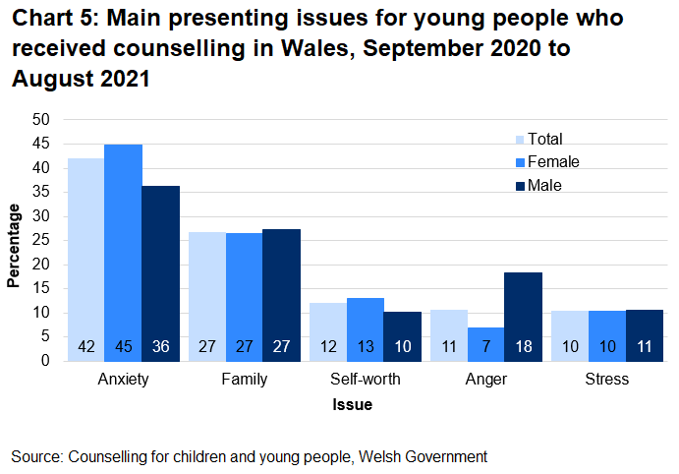

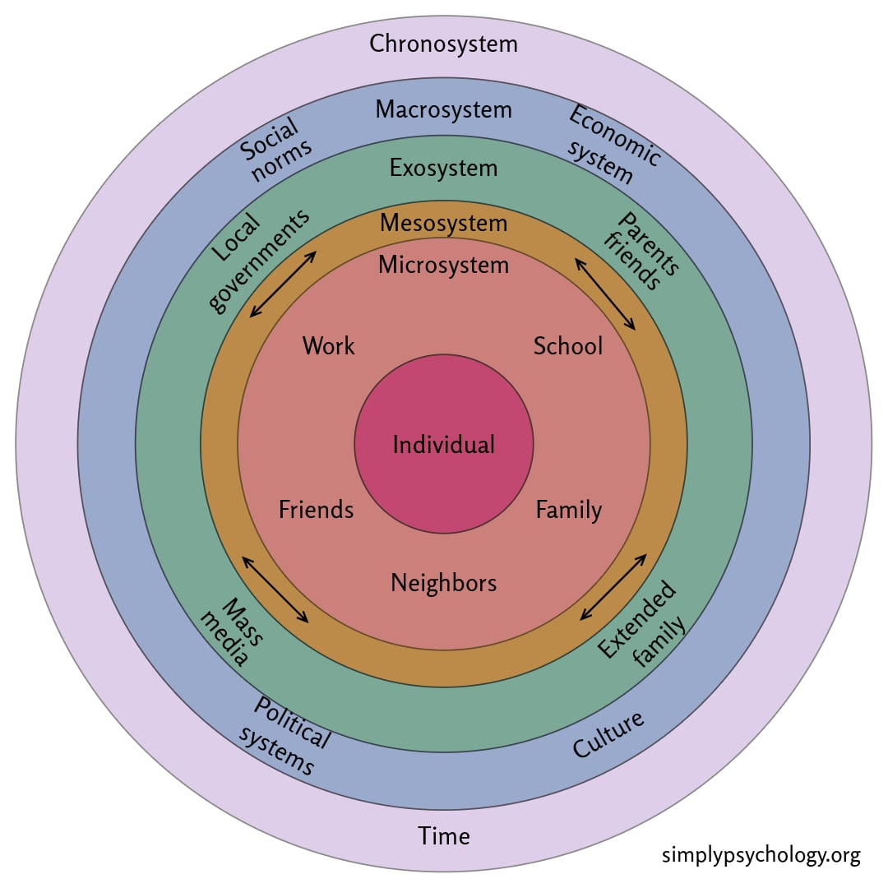

Needs of the Community
Young people of the community need’s that one person to be safe, secure and give a stable relationship, as well as routine according to Bronfenbrenner ‘every child needs at least one adult who is irrationally crazy about him or her’. Through Youth Justice Service working with young people, we try to be that positive role model, giving them clear communication they way they like to communicate, routine to show consistence, as well as doing plans that are child centre. Linking in with other services to support the needs of the child. What services are and not available such as education, mental health, substance misuse, spaces, services, drop-in centres, sign posting. Early intervention is key for young people to be able to thrive in society and fit in. Early intervention with deprived or unstable families is needed to strengthen the support network around them to prevent unnecessary family breakdowns resulting in children being in care.
The young people are the future generations of development and growth of society. It’s key that they have the support to development and flourish with the right education, mental health support and care, including accommodation needs are met to support for the future economic development.
Young people that work with the Youth Justice Service of Llanelli and the wider community, lack in essential needs and services that are required to support the needs of an adolescent child. Many of these young people go under the radar due to not being in education especially with their wellbeing and mental health needs, as many due to lack of understanding of their mental health needs including neuro diversity, neglect and trauma, they seek self-support via substance misuse to manage their emotions and anxiety, as they don’t have that supportive adult to access services such as CAMHS, counselling, referrals for neurological needs, however when able to have access they face long waiting lists due to lack of staffing, sickness, training and support.

As per the graph below there was a spike in off offending around substances, this could have been the result of the covid pandemic, however linking in with the strengths of the Youth Justice Service this reduced by 2022.
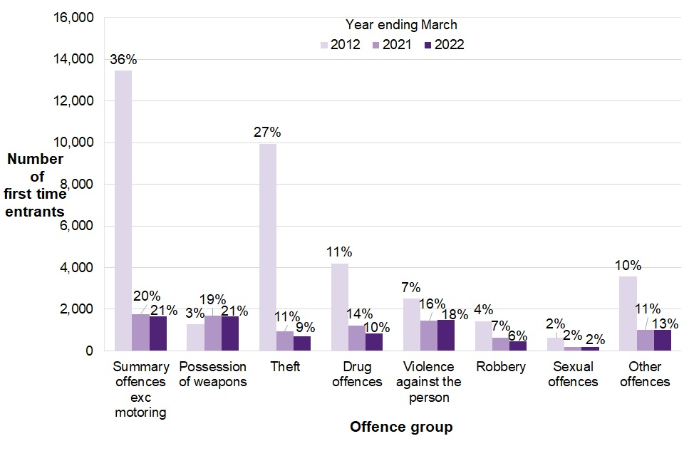

Strengths
The strengths within working with Youth Workers in the Carmarthenshire area helps supports young people’s social and emotional development as well as personal needs such as substance and wellbeing support. These are delivered through many services that are available to the young people within the area such as organisations as us the Youth Justice Service, Carmarthenshire Youth Support Service, Carmarthenshire Youth Project (Dr M’z and Bwlch), Youth Council and CYCA who offer diverse and centred approached work to a young person. This assignment explores the strengths that the Llanelli area of Carmarthen has to offer young people such as job opportunities, community engagement, substance misuse support, wellbeing support, opportunities for progression as well as speech and language support to support their education and employment needs, as well as multi agency work.
Barriers
People living in Carmarthenshire face many barriers when trying to access mental health services. These barriers are linked to Geographical area, service capacity, transport, language and socioeconomic factors. Llanelli is a large rural town making it difficult for people to attend appointments. Many residents live in isolated communities where poor public transport and long travelling distances makes it difficult to attend appointments. According to Carmarthenshire County Council, the lack of public transport is a major barrier to accessing services. This links to Gulliford et al. (2002) whereby services may exist but remain practically inaccessible due to geographical constraints. One young person out of the group stated, ‘I missed one appointment due to no bus available and then I was closed to the service’. This aligns with the Welsh Assembly Government policy ‘Routine referrals will be discharged following one non-attendance. | disagree with this as it can be a symptom of illness, severe depression, anxiety or the ability to organise transport to attend appointments. Discharging young people after missed appointments may affect those in greater need with severe health issues, delaying access to appropriate support.
Needs of the community
Young people of the Llanelli area constantly face social, educational, wellbeing and substance misuse needs. The Hywel Dda University Health Board Llanelli identifies mental health as one of the areas greater health priorities. This demonstrates that mental health is recognised as a major population requiring targeting investment and community-based service. Dahlgren and Whiteheads (1991) Social Determinants of Health model argues that health outcomes are sharped not only by individual factors but also by wider social economics and environmental conditions. High levels of deprivation within Llanelli are likely to increase the need of mental health and the demand for community mental health services. Based on working with young people and what the local authorises have to offer for young people facing the following needs; educational and employment, mental health, substance use support and more safe spaces within the area. At present there are safe spaces within Llanelli and the wider Carmarthenshire area. The Bwlch in Llanelli, Felinfoel Community Resource Centre, Streets in Ammanford and Dr M’z Carmarthen town centre, however thinking of the population of young people within these areas, are these four places enough for the young people of Carmarthen.
Appendix one: - graph of facilities in the Llanelli Area.
Many services operated from these places as they offer a young person a safe place. These young people with regards to wellbeing concerns as per reports from Mind, especially in Tyshia, Llwynhendy, Bigyn and Glanymor are experiencing high levels of anxiety, loneliness and self-harm. Three of my current cases are all reporting their concerns over their wellbeing are from these areas which are all self-mediating with substances which is mainly cannabis who have come through the Youth Justice Service.

Intervention
I delivered an intervention session around substances and sexual health to young people aged between 14-17. It was a small group of five, each of these young people have wellbeing and mental health, speech and language as well as being NEET. One home schooled but a well to do family with more than one supportive adult. During one session I delivered an intervention and informed education around substance through visual aid boxes of different substances including sexual health to empower them with knowledge so they can make more informed choices around substances and their sexual health. Be safe within the community or at home as they have lack of support within the family home as per theorist John Bowbly, “We are only as needy as our unmet needs”.
As per Carl Rogers I offered an intervention that was child focused to cater for their needs by using visual aids, keeping it as an informal setting which was non-judgemental, being empathetic to their needs and actively listening and using motivational interviewing to show that I was listening. As well following the National occupational standards/ Safeguarding and protecting young people by recognising signs of emotional distress with their wellbeing and offering a service through the Youth Justice Service by referring them to CAMHS as I have the power to be able to support these needs. As per theorist John Bowbly offering informed practice makes me consider what are the needs of the child, rather than what is wrong with him. It enabled me to prioritise safety and trust as all five had past trauma.
Reflecting from the session I envaulted that I offered a safe environment using the Bwlch, which helped create a supportive and reassuring environment for the young person. I listened without judgement, allowing them to speak openly and feel heard. I also respected the young person's need for personal space while ensuring they were monitored from a safe distance to maintain their wellbeing.
Reflecting on the experience of the session I offered a laid-back approach however remained professional and follow appropriate procedures. Through following risk assessments if there was an incident, I would recognise the importance of seeking support and participated in a debrief with a senior colleague. This provided an opportunity to reflect on the situation, process my own emotional response, and identify learning points for future practice.
To conclude this community profile has demonstrated that the mental health needs of young people of Llanelli are shaped by socioeconomic depredation, health inequalities and access to services. Although Llanelli benefits from a range of statutory mental health provisions, local evidence suggests that mental health remains a priority within Llanelli. This supports Dahlgren and Whiteheads (1991) model, which recognise that mental problems are determined by social and environmental factors, rather than individual behaviours alone. I believe improving the mental health of young people in Llanelli requires a coordinated multi agency approach. Strengthen communication between health, education, social care and voluntary organisations and continued early intervention and prevention is essential to reduce inequalities and promote positive mental wellbeing. This aligns with the principles of prudent health care and person centred care in Wales and likely to improve both health outcomes and long term community resilience. “People’s health is determined by the conditions in which they’re born, grow, live, work and age”. (Marmot, 2010, p.10).

Opportunities for youth work – personal development plan.

 | Work with Young People in accordance with the five pillars of Principles and Purposes of Youth Work in Wales (YWWRG, 2018) (Educative, Expressive, Participative, Inclusive, Empowering). | Facilitate learning and development of young people through planning and implementing learning activities in youth work. | Actively demonstrate commitment to inclusion, equity and young people’s interests, health, and wellbeing. | Plan and implement strategy and youth work activities for young people | Develop, lead, and manage self and others | 6. Work with communities. Encouraging Young People to actively engage in their communities and work to promote the voice and needs of young people.
What do you need to learn? | Learning through assessments, planning for the young person.  How I embed the five pillars into the needs of the young person by empowering them through participative, self-lead sessions, being able to express their needs, concerns by empowering them by giving them a voice. Educative through planning.  Working with Carmarthenshire Youth Justice Service on how and why working on intervention and prevention young person lead to reduce/stop reoffending. | To facilitate the learning and development of young people, I need to apply communication skills, planning in advice to the needs of the child, safeguarding, inclusion, group facilitations, managing behaviours. During this I need to create safe spaces which is for support personal and social development needs | Learn to promote the needs of the young person through youth justice work to consider inclusion and equality through my practice. Learn through training and embedding inclusion through my practice. | Need to learn to plan, keep the young person informed on their sessions by voicing planned activities with a YP. | Lead on sessions that supports the needs of the YP. Need to learn to work in partnership with other services. | Working with communities, I learn to engage with people from cultures. Help young people have their voices heard. Through activities such as volunteering in community events, and local projects., Develop communication and advocacy skills. These experiences will help me support positive change in my community while promoting the needs and interests of young people.
Activities you will learn from (how will you learn, what will you learn from) | Supporting other services both statutory and non-statutory.  Leading my own workload with the five pillars the forefront of each session with a young person.  Observing and reflecting on my work to supporting the learning and growing of the needs of the child, as well as observing other services and youth workers. | Activities learn from such as preventative work such as the graffiti project, workshops on substance and alcohol prevention to promote personal and educational work on lowering risks and re-offending.  Attending workshops with young people to support development on personal growth like the fairy project at present that the YJS work with young people to give back to the community. Learning that linking in a YP can support them being part of the community. | Learn from supporting young people’s interests, personal centred planning from assessments and their plans. Learn and grow knowledge by attending up to day courses to support the needs of the YP. | Planning and learning on a young person’s learning styles for example visual and practical needs to learn how to engage with a YP. Through this method I will learn to meet the needs of the person. | By working with youth workers, I can develop my communication, leadership, and organisational skills. Activities such as peer mentoring, community projects, leading on planned events, and working as part of a team. Manage responsibilities and become a positive role model for other young people. | Through learning their communicational needs. How they like to communicate. Linking with other services such as CAMHS, Substance misuse, schools.

My aim, following the successful completion of 200 hours of placement within the Youth Justice Team, is to demonstrate competence in engaging effectively with young people involved in the youth justice system. I will apply my knowledge and understanding of key theories and approaches, including reflective practice, social learning theory, strengths-based practice, and trauma-informed practice, to support positive outcomes for young people.
Throughout my placement, I will reflect my development as a youth worker by promoting inclusion, participation, rehabilitation, and empowerment. I will achieve this through regular supervision, training opportunities, and direct interventions with young people, enhancing my ability to assess needs, manage risks, and work collaboratively with partner agencies.
My practice will align with the National Occupational Standards (NOS) for Youth Work, promoting informal learning opportunities and delivering support at times and in ways that best meet the needs of young people. This development plan is underpinned by Kolb’s Experiential Learning Cycle, recognising that effective youth work requires an ongoing process of action, reflection, learning, and improvement.
By focusing on areas such as trauma-informed practice and safeguarding, my goal is to increase my knowledge and adapt my professional practice to the needs of the young person. As a youth worker, I aim to following the five pillars to embed this into my practice achieving positive outcomes. This development plan will enhance my ability to build pro-social relationships, encourage informed decision-making, and support young people to reach their full potential.

Five Pillars of Youth Work and purpose of Youth Work strategy in Wales 2019. Aligning my practice set out in the Youth Strategy Framework for Wales 2019 and National Occupational Standards for Youth Work around supporting young people with mental health and wellbeing.
Participative
Young people within the Youth Justice Service in the Carmarthenshire area are encouraged to engage in their plan from their offences, as it’s essential for them to know they’re in charge of their own plans. To be able to participate and have a voice and that voice is heard for them to able to contribute fully to their community and society as they grow as people to fit in their communities. “Social damage they may do through their behaviours (e.g. in relation to sex drugs and delinquency). (Morrow and Richards 1996:4).
Educative
Within my role, I provide both formal and informal support, considering each young person’s individual needs, including diversity considerations and preferred learning styles. I also ensure that I regularly attend training and professional development opportunities to stay up to date with emerging trends in substance use and mental health. This enables me to deliver an effective, responsive service that meets the needs of young people and empowers them to make positive choices for their future.

Expressive
In my role as a Youth Justice Service Worker, it is essential that I consider each young person’s individual circumstances, including their additional needs, experiences of poverty, and cultural background, as these factors can sometimes create barriers to engagement. To ensure I can effectively support young people, I maintain up-to-date training in trauma-informed practice, substance misuse, and mental health awareness. This enables me to engage confidently with young people who may present with challenging behaviours and to tailor interventions and sessions to their specific needs. By adopting an inclusive and person-centred approach, I help ensure that young people feel valued, understood, and able to participate fully in the support being offered.
Empowering
Through effective engagement, I ensure that interventions are led by the young person wherever possible.
The Youth Justice Service provides a range of restorative and community-based activities designed to promote personal growth and positive social engagement. Examples include graffiti art projects, bench design initiatives for local communities, and the construction of planters for local parks. These activities provide young people with opportunities to make positive contributions to their communities, particularly where offences have involved criminal damage or substance misuse.
Participation in such projects helps young people to develop a greater understanding of the impact that their actions have on victims, local communities, and public resources. By engaging in restorative activities, they are encouraged to take responsibility for their behaviour, make amends, and contribute positively to their local environment. This process can also support the development of social relationships and strengthen connections with their community, reducing feelings of exclusion and promoting a sense of belonging.
In addition to facilitating these opportunities, I act as an advocate for the young people I work with, ensuring that their views, wishes, and feelings are heard and considered. This aligns with the Youth Work National Occupational Standards, which state that youth work seeks to enable young people “to develop their voice, influence and place in society and to reach their full potential.” By promoting participation, advocacy, and restorative practice, I support young people to develop the skills, confidence, and resilience needed to make positive choices and achieve better outcomes in the future. As well as “personal, social and educational development, to enable them to develop their voice, influence and place in society and to reach their full potential.” (NOS)

Summary
To summaries working with the young people within the Llanelli area who are linked with the Youth Justice Service of Carmarthenshire I embedded the five pillars approach when working with the young people as well as mine own learning from the National Occupational Standards for Youth Work (NOS, 2019) to expand my practise and applied during my role within the Carmarthenshire Youth Justice Service. I’ve summarized that if you commit low level crimes, can be beneficial to be able to link in with what services to support their wellbeing and mental health that are related to substance misuse if they have fallen under the ratio from lack of attendance in education and goals for further education and employment. I through practise have to offer links to much needed services for young people to achieve their goals. Hopefully come away from substances that they use through lack of education to manage their wellbeing. I feel through practise and knowledge gained through working with offending young people, that if you come from a non-offending background young people of Llanelli and the wider Carmarthenshire area, fall under the radar and don’t gain the access and support they need to achieve and to contribute to society. As per the Principles and Purpose. “Promote opportunities and access for all young people whatever their race, sex, gender, sexual identity, language, religion, disability, age, background or personal circumstances”, however I feel this is not the case for all of the young generation of Llanelli and wider field as it’s not straight forward easy accessible for the young generation and if you’re not supported or have the right guidance in place to access and have equal opportunities as per the Principles and Purpose unless your pathway crosses with certain services like the Youth Justice Service of Carmarthenshire.

Appendix One: - graph of facilities available to young people in the Llanelli area.
Youth Centre / Service | Location | Activities | Support
Bwlch Youth Centre | Llanelli | Youth club, sports, arts & crafts, DofE, volunteering, ASDAN & Agored Cymru | Ages 11-25
Burry Port Youth Club | Burry Port | Social activities, games, sports, community projects | Ages 11-18
Trimsaran Youth Club | Trimsaran | Youth sessions, recreation, personal development | Ages 11-18
Carmarthenshire Youth Support Service | Across Carmarthenshire | Wellbeing, guidance, mentoring, accredited learning, projects | Ages 11-18 with disabilities
Llanelli Mind | Llanelli | Mental health and wellbeing | Ages 11 plus
Morfa Children's Centre | Llanelli | Family support, youth activities, community programmes | All ages and families.
Llanelli Town Council Community Centres | Llanelli | Community events, youth and family activities. | All ages and their

Appendix Two: - Core Strengths of Youth Work in Carmarthenshire/what’s available for young people. Working with these strengths as per Youth Work Curriculum for Wales, “promote and actively encourage opportunities for all young people in order that they may fulfil their potential as empowered individuals and as members of groups and communities”.

Summary - Core Strengths of the Youth Work in the Carmarthenshire Area including Llanelli which is under Carmarthenshire County Council.
Right- based practice | Right-based practice is where Youth workers actively promote the following with young people:  Participation – being able to participate in education, employment and their community as well as a positive and meaningful experience.  Respect – they have the right to be respect and in return show and give their respect as well as being heard.  Equality- they have a right to be respected as a person and their culture.  Young people’s decision-making power – empowering young people so they can contribute to society.
Skilled Youth Workers | Youth workers in Carmarthenshire are trained to deliver both universal and targeted support. Their strengths include, building trusting relationships, working with young people with restorative approaches. Working with the young person on educational needs as well as supporting their mental health and wellbeing. Providing safeguarding and early intervention projects such as Dr M’z offering a safe, inclusive environment where young people feel safe and valued.
Community-led Projects | Projects that are led by the needs of the young people and the community that they live in.
Youth Voice Structures | Targeted work for 11–21-year-olds to work on strengthening confidence, leadership, and civic engagement.
Skill Development | Working on training to development in many areas to support the needs of the child. Maintaining high levels in knowledge around aces and traumas.
Early Intervention | Youth workers in Carmarthenshire use restorative approaches, early intervention, and prevention strategies—helping reduce anti-social behaviour and supporting young people before issues escalate.
Substance Misue Workers | Supporting their substance use as well as being able to signpost for further support after intervention and prevention to support their needs.
Multi Agency Work | Working together to lower the need for a young person to not be repeating their story and no crossover in works as well as support the needs of the child by working as a collective.
Speech and Language | Support a young person’s development and learning needs in education or employment settings. Agencies are limited on offering this service. Youth Justice Service are lucky to have funding to employ a Speech Therapist to support the needs of young people.
Bilingual Provision | The rights to obtain a service in Welsh or English, as well as access to services for translators.
CAMHS/ wellbeing | Supporting young people around their past and present trauma, self-harm and suicidal ideations.

Appendix three: - Reflective Journal One.

Young person in possession of cocaine.

Situation
Case is not in education or employment since leaving school. Secondary education poor dur to ill health with bowels, suffering with her emotional wellbeing and self-harm. Past trauma is witnessing substance use with the family home with a variety of class B and A drugs.
Took cocaine to increase her emotions as low at the time due to a relationship breakdown. Wanted to mask her feelings however bad reaction, resulting in the young person being taken to hospital and then arrested for possession which mum handed over to staff.
Task
Education to the young person around risks taking class A drugs as well as being vulnerable under the influence of substances and it can impact on her emotional wellbeing.
Young person also needs support gaining further education or employment. Chase progress of referrals for ASD and ADHD to support her employment.

Thoughts and feelings
My thoughts that the young person is vulnerable and what is the reason being taking class A substance and by passing the usual substances young people tend to take to manage their emotions and needed to education her around the risks of being in areas that people can take advantage of her if she has lost consciousness to make more informed decisions going forward and steering away from cocaine.
The feelings that I had for the young person is that I needed to get her support around employment because that is what she wanted and wellbeing support to help her manage her wellbeing better if she was to have another relationship in the future.
Concerns of the risks around where she got the cocaine from as it was a friend of the family (father), which was given at the time.
Evaluation
Reflecting over what was not in place for this young person is that I needed to link in and refer to other services to get the support she needed so she can have purpose and routine in her life.

Reflection
On reflection on working with this young person is that she has struggled with routine and purpose for a long time due to ongoing medical concerns and needed the support of the service as nothing was in place since leaving state education which she was home school for a long period and the impact of covid so I decided due to her using cocaine only twice and no longer using I focused my work on education and her emotional wellbeing and being that voice for her to gain support taking the trauma informed route to support her needs as she was very quiet, looked at mum a lot for support and encouragement or mum would talk on her behalf.
Reflection on myself
On reflection of my work in relation to this case I ensured I used all my links to get the support this young person needed and put my substance misuse work to one side. I also pleased that I could also support the mum around links to volunteer. Please that she worked well with other agencies and got a long time support worker as I was only short term which give me confidence to close her straight after.
Pleased that I could reward the young person with a beauty box with loads of products that the young person would enjoy as a reward for her work and contribution in completing her targeted plan with the Youth Justice Service.
Working with others
I feel that multi agency work is key for this young person as well as others. Building good relations with other services is good for the need of the child as well as minimising the cross over doing the same work.
On closing the young person, I was confident that this young person’s plan was completed so I was happy to close her to the Youth Justice Service.

Analysis
The guidelines that are in place. from the YJ board, building good interaction relationship between worker and young person is child lead, however, are challenging but the need of the child is first served and to lower risks for a young person. The adverse childhood trauma this young person could have experienced cannot be undone for a young person in quick consensus.

Actions
Before closing the young person.
- Check with all other professionals what support is in place to meet the needs of the young person.
- Record all facts what services are going to do for the young person. Take it higher if these areas are not being addressed.
- Give a true reflection on reviewing and closing plan. Update all services that the young person is no longer with the Youth Justice Servies.

What have I learned
What I’ve learned is that it is beneficial that the Police refer a young people to the Youth Justice Service to get the support they need to give them support and purpose as young people can fall under the raider for a number amount of reason.

Appendix four: - Reflective Journal Two.
Situation – YP arrested for criminal damages and assault x3 on family members aged 14.

What
Young person was arrested early hours of the morning for criminal damages within the family home and assault on three members of the family which was all captured on Police body cameras. He had been out all weekend at a festival with family, home Sunday but wanted to go out local which he was allowed, however met with mates drinking Vodka. Highly under the influence of alcohol and cannabis. Mum was trying to get him home with the YP lashing out, hitting mum, finally calmed down, then mum took him for a McDonalds drive through. At home mum was trying to make him stay at home with boundaries in place, however YP wanted to go home with gran where he could possibly go back out into the community as no boundaries are in place there. Difficulties were that mum was struggling to manage YP resulting in mum phoning the Police as he was aggressive, disruptive and trying to leave the home as mum just wanted to keep him safe as he was highly intoxicated.
Situation was that due to how the YP conducted himself in front of the Police, they had a duty of care to arrest YP as he was not calming down as he smashed a TV and hit mum and sister in front of them which was early hours of the morning. I that day was on appropriate adult duty who would be needed to support YP being processed (DNA swops, fingerprints, and interviewed process).
YP did not get interviewed until lunch time either though I was asked to be present at 9am which would result in most of my working day gone which would have impact on my cases that day, which wouldn’t be great, however with good communication with staff and custody, I did not arrive until I know the YP was getting interviewed which allowed me time to speak to his case worker as he was open to the Youth Justice Service which made me feel better about managing my working day.
YP information gathered
YP is very small for his age and could possibly pass for an 8-year-old boy. He’s experienced many past traumas growing up. YP has witnessed domestic violence within the family home from dad to mum, with the understanding that dad is well known within the community for domestic violence. He’s also been present and witnessed a house fire where he saw his pet dying at the scene. YP is also displaying traits of his father within the family home resulting in YP staying at grans for periods of time however no boundaries in place, so the YP does not engage with education or services.
YP has difficulty sleeping and is medicated for ADHD.

So, what?
The implication of the situation is that I do not pass judgement on the young person’s character or physical appearance as I was imagining that this person is small but how small.
Based on all the information gathered before had steered my actions on how best to support the young person present in custody following our policies and procedures that give his guidelines to look after the welfare of the young person.
Listening to my colleagues gathering information on the YP while he was in custody before I met him was key to support his needs during process and interview.
Before interview the Solicitor wanted me present for the ‘before chat’, before the interview starts on how best to approach the interview with his client (the YP), however I was a tad reluctant to be present as if the YP said something during that process and didn’t voice the information during interview I have to speak up. I advised the Solicitor of this to make him aware; however, he wanted me present as he was going to guide the YP into a silent interview due to his ADHD and understanding as the YP can only cope with small and short questions to process what was needed of him. He will present as his witness checked the interview process with the YP with myself present and the details of the incident was not disclosed during the time that I was present which made me feel more comfortable and happier to continue on with supporting the YP as an appropriate adult being mindful of the policies and procedures that we have to follow to conduct our role.
Reflecting over the process I feel that I could not have conducted myself any better and that I was pleased that I informed the Solicitor of the role of an AA person and the experience of the situation tells me that I have confidence within myself on how best to support myself as well as the young person.

The action plan
Now what...
Going forward with AA duty I will try my best to find out as much information and the needs of the young person to best support their needs. My plan would be that I would gather as much information as possible if that person would be sent to the Youth Justice Service or if they were to come through the system again as much information as possible is shared with management/case worker to be support that person.

Appendix Five: - Reflective Journal three.
Situation - Possess a controlled drug of Class B - Cannabis / Cannabis Resin 2 (aged 14)

What
In March, Police have received a call from a Care home in the local area to state that they have confiscated a joint of cannabis from one of their residents. Police then attended the address of the Care Home and interviewed the YP in her room as she did not want a solicitor and had an appropriate adult present, which was a member of staff. Due to the YP moving around, lack of engagement and the YP associating my colleague with the moves and reasons behind the move it has been allocated to myself however due to my colleague working with the YP in the past to save her repeating information that is needed for assessment to support the YP my colleague completed all the relevant paperwork associated to the crime, then allocated to myself to complete the plan around substances and possession, as well as education around cannabis to try and get the YP to engage with the Youth Justice Service. I did a joint visit to introduce myself with my colleague, however due to the YP having a bad weekend with her girlfriend coming down for a visit, then failing to return to the place she was staying, going missing and the YP getting tattoos by her mate. First meeting was not great with the YP refusing to work with “it” (myself), then leaving the room, however returning a few times with no conversation. This was not a great time for her and not a great experience for myself however will try again.

So, what
The implications of the situation
This situation teaches me that a Monday is not possible the right day for the YP to engage as the weekends maybe a little hectic for the YP, so what can I do differently for next time for try and engage with this YP!? different situation may be more suitable for the best engagement, so spoke with staff as they know her and her routine. Get to know her a little better through them, so changed the day to a Wednesday afternoon after school as it’s her most structured day. She loves Starbucks, so will call that morning to see what she would like which is a caramel Frappuccino with no coffee, but will phone first and confirm this.
Refection on my last encounter with the YP I needed to be mindful of the first meeting, as I wasn’t introduced straight away so she learnt who I was by overhearing out conversation while signing in. I will ensure that I’m the person who hands her the Starbucks as a re-engagement with a laid-back attitude to the YP so she can take the lead on how the engagement will take place. My aim to introduce myself properly, however, let her lead the conversation If she does not want to engage.

Now what?
The action plan
Plan of action going forward is to tailor in the factors of possible non engagement and that I need to show perseverance as this YP does not trust well. Too many services involved in the past at a young age as only recently turned 14. Struggles to follow structure and boundaries due to high volumes of change through her life to do better on interaction and now knowing who she is in person as I was unfamiliar with her in person as not met beforehand, this I’m being mindful may already impacted my chances going forward for engagement.
Things that I may need to also consider is the YPs experiences that week/day so plan is to speak to staff first before seeing her (hopefully she is not by the signing in book as again but I’m aware of the surroundings and layout of the care home, so plan is to approach with care.
Make sure that I don’t forget the Starbucks as one staff member may voice this to the YP so don’t want to disappoint from her. Make sure that I’m the one that is giving her the Starbucks so she can see the efforts that I am making an effort to get to know her and hopefully she can see that following the five pillars empowering her with options and choices but trying to engage on her level of participation on how much she wants to engage by allowing her to be expressive.
Going forward after the meeting, countering in factors that this may result in the YP continue to refuse engagement, however working with others to try again to show I’m factoring her needs and working towards building working relations with her to complete her plan.

Appendix Six: - Reflective Journey (four).

Situation - Possess a controlled drug of Class B - Cannabis / Cannabis Resin 2 (aged 14)

What

In March, Police have received a call from a Care home in the local area to state that they have confiscated a joint of cannabis from one of their residents. Police then attended the address of the Care Home and interviewed the YP in her room as she did not want a solicitor and had an appropriate adult present, which was a member of staff. Due to the YP moving around, lack of engagement and the YP associating my colleague with the moves and reasons behind the move it has been allocated to myself however due to my colleague working with the YP in the past to save her repeating information that is needed for assessment to support the YP my colleague completed all the relevant paperwork associated to the crime, then allocated to myself to complete the plan around substances and possession, as well as education around cannabis to try and get the YP to engage with the Youth Justice Service.
I did a previous joint appointment with a colleague, however due to the weekend events, it did not go well the previous week, however working with staff and coming on a different day with Starbucks of her choice worked better for her, and she was looking forward to meeting me (or should I say – waiting on the Starbucks), so that was a positive move going forward. During waiting for the young person, I also learnt from staff that she was keen on netball and cheerleader so I used those two subjects as a form of engagement to support her plan that we are going to work on if she is willing to engage with myself as her Youth Worker in the Justice System.
At present the young person has restriction in place with regards to her going missing and trying to flee from staff at any given time, may that be heading to school, free time or supervised time. With these events the young person has had her smart phone removed. Has been working with staff of late and improved so now in possession of a brick phone however monitored and only for periods of a time.

So, what
The implications of the situation
This situation teaches me that change the day to a more suitable for the YP. Offering a Starbucks is something that she likes and a way in for engagement. Noting her likes around the two sports, we engaged in conservation around those two sports to help me get to know her, as well as touched briefly on the cannabis possessions as a reminder why I’m there and will be working with her going forward which by the end of the hour, the YP was happy to work with me.
Refection on my last encounter with the YP I needed to be mindful of the first meeting, and her past trauma, with her having multiply agencies working with her that just because this engagement went well, situations throughout the weekend and week may impact on our next interaction. During conversations with the YP I tried to allow her to lead on many conversation, so she has the knowledge that our working together is not ridged or restricted to the offence only. Ending the engagement with the YP saying when she wants to see me next and suitable time for her to take the lead on the engagement. Also voiced what we will be doing during that appointment.

Now what?
The action plan
Plan of action going forward is to tailor in the factors of possible non engagement on some occasions due to possible situations that may occur due to the YP being chaotic at times and work on building trust by keeping to my word to show perseverance as this YP does not trust well and struggles to follow structure and boundaries due to high volumes of change in her life. Use her interests for engagement and getting to know her as a person as well as possible combination of doing the netball and substance misuse work to maintain engagement and get the YP interaction with her plan to complete her work around the offences.
Things that I may need to also consider is the YPs experiences that week/day, so plan is to speak to staff first before seeing her to check in on her mood, interaction and how her week has been.
Make sure that I don’t forget the Starbucks as promised the previous week and carry on with the Starbucks to hopefully gaining a good working relationship with her to take her to get her own Starbucks which could be a goal to look forward to. Try to embed the five pillars empowering her with options and choices but trying to engage on her level of participation on how much she wants to engage by allowing her to be expressive.

Going forward for next week the YP took the lead on day and time for the following weeks appointment, then updated staff to unsure she was free, as well as me getting booked in to see her.
Plan is also to take it week by week with her to support her needs.

Appendix Seven: - Reflective Journey (five)
Situation - Possess a controlled drug of Class B - Cannabis / Cannabis Resin 2 (aged 14)

What

In March, Police have received a call from a Care home in the local area to state that they have confiscated a joint of cannabis from one of their residents. Police then attended the address of the Care Home and interviewed the YP in her room as she did not want a solicitor and had an appropriate adult present, which was a member of staff. Due to the YP moving around, lack of engagement and the YP associating my colleague with the moves and reasons behind the move it has been allocated to myself however due to my colleague working with the YP in the past to save her repeating information that is needed for assessment to support the YP my colleague completed all the relevant paperwork associated to the crime, then allocated to myself to complete the plan around substances and possession, as well as education around cannabis to try and get the YP to engage with the Youth Justice Service.

At present the young person has restriction in place with regards to her going missing and trying to flee from staff at any given time, may that be heading to school, free time or supervised time. With these events the young person has had her smart phone removed. In the last week the young person has been following her restriction and not tried to go missing or run from staff. She has a brick phone which is monitored.
On arrival staff voiced that she did not go to sleep until around 3am. She has refused to surface at present, being mindful that it was past 1pm. Staff had tried to get her up and active many of times however she has refused to be giving the impression that the session will not go ahead. I did have the Starbucks for the YP so hopefully she’ll remember that I’m bringing her one.
After chatting with staff, the young person came out of her room, grabbed the drink, was expecting her to grab and return to her bedroom, however sat down opposite me, I carried on chatting to the staff member and said hello, then included her in the conversation by making her included. Checked in on her hobby trial the weekend which she was not a fan of, however praised her for going and giving it a go, still looking forward to starting netball in the new season which again praised her but reminded her to practise skills with staff to give her confidence come September to try and empower her when it comes to her first training session.
With the gentle ice breaker complete, the young person engaged well on the activity planned. Allowed her to take the lead on the session by using visual aids around alcohol misuse (different glasses with fake drinks inside). Used open questions that the YP was thinking around possible risks, keeping safe and allowing her to answer her own questions, also talking about different situations, giving her examples and allow her to take the lead on the session for full participation and her being included and always leading take a laid-back approach, however when voiced possible risky situations ensuring the importance of alcohol risks and awareness.

So, what
The implications of the situation
The situation and my style of working with the young person is working well. Taking that less informal approach however getting the key factors across to the young person and learning her learning styles keep the young person engaged but actively engaged. My engagement style gives the impression that the young person looking is looking forward to seeing me again the following week and each week after that as she voiced “we keep to every Friday at the same time”, which was really good so will take that as a win and good that she will get her plan completed going forward.
Now what?
The action plan
Plan of action going forward is to tailor in the factors of possible non engagement on some occasions due to possible situations that may occur due to the YP being chaotic however work towards us going to get the Starbucks on our last session working together. Carry on using her interests for engagement and getting to know her as a person as well as possible combination of doing the netball and substance misuse work to maintain engagement and get the YP interaction with her plan to complete her work around the offences.
Going forward that I still need to consider, is the YPs experiences that week/day, so plan is to speak to staff first before seeing her to check in on her mood, interaction and how her week has been.
Carry on with the engagement style that is working well with her and keep working towards making sure that her engagement is led by her needs.

Appendix Eight: - Reflective Journey (six).
Situation – work placement – progression and opportunities.

What
I’ve actively been in my role as a Substance Misuse Worker for nearly four years, however during my time with the Youth Justice Service, I as a member of staff have been will to learn and progress as a member of staff within the team but most importantly wanted to process to offer the best service possible to the young people that I as a person can offer those who have come through the Justice Service to empower them and help, where I can to improve their lives as well as educate them around Substance use including alcohol. I completed Youth Justice Certificate, however, couldn’t process on into the next stage unless funded by myself which is not cost effective and restricted without the support of the services. I have actively looked and discussed this area of progression with my supervisor since starting my role.

So, what
The implications of the situation
The situation to date is that due to the council over spending budgets across the board and budgets being cut, I took it upon myself to process my knowledge and qualifications to open up more opportunities within the council as well as being in a better position to best support myself and family, however during the process of starting the Master’s degree I have found it challenging to get the support of the work placement and management to help me achieve my goals which is based on young people within the community, yes it does not cover Youth Justice and the court process however it is young people led and all young people belong to the community, wither they have offended or not. End goal is to support the needs of the child regards of offence related.
Other barriers that have occurred during working with the Youth Justice Service is training is limited, unless it is role related there is no support to process and grow your knowledge in other areas, I feel which to me personal is really restricted and limits possible opportunities if they were to occur makes me feel undervalued.

Now what?
The action plan
The plan going forward is to learn and process as I complete my master’s degree. To keep asking about opportunities and growth within the Youth Justice Service while I work and complete the degree, then once completed look at opportunities elsewhere within the councils to put my degree and what I’ve learned into a role that a young people and I can benefit from my skills and skill sets I have to offer the service and the young person.

References

Bowlby, John (1998), A Secure Base: Parent-Child Attachment and Healthy Human Development. Basic Books.
Bronfenbrenner's Ecological Systems Theory – the five systems.
Community – Youth Work in Wales: Principle and Purpose, Youth work in Wales is intended to: p.7.
Culture – Youth Work in Wales: Principle and Purpose, Youth work in Wales is intended to: p.7.
Dahlgren, G. and Whitehead, M. (1991) Policies and Strategies to Promote Social Equity in Health. Stockholm: Institute for Futures Studies.
Driscoll’s reflective model (Driscoll, J. (2007) Practising clinical supervision: a reflective approach for healthcare professionals. 2nd edn. Bailliere Tindall Elsevier):
Figure 5: Main presenting issues for children and young people who received counselling in Wales, September 2022 to August 2023 – Search Images. Source: Welsh Government.
Graph, Fig_2.4.jpg (960×640) – Youth Justice Board – GOV.UK.
Llanelli Mind Resilience Project.
The Art of Youth Work, Kerry Young, published 1999. Philosophy p.33 – Virginia Morrow and Richards (1996). Transition into Adulthood. York: Joseph Rowntree Foundation.
The Art of Youth Work, Kerry Young, published 1999. Philosophy p.34 – John Coleman and Leo Hendry (1990). The Nature of Adolescence. London: Routledge.
The Art of Youth Work, Kerry Young, published 1999. Philosophy p.34 – Walter Lorenz (1996). “Pedagogical Principles for Anti-racist Strategies”, in Antonella Aluffi-Pentini and Walter Lorenz (Eds.), Anti-racist Work with Young People. Lyme Regis: Russell House Publishing Ltd.
The Vision of Urie Bronfenbrenner: Adults Who Are Crazy About Kids – Larry K. Brendtro.
What is Child First? – Youth Justice Resource Hub.
World Health Organization (2005) Mental Health: Facing the Challenges, Building Solutions. Copenhagen: WHO Regional Office for Europe.
Marmot Reviews and Reports: The Marmot Review: Fair Society, Healthy Lives (2010), which explores social inequalities in health in England.
Youth Work Wales – Working in partnership with young people.
Youth Strategy Framework for Wales 2019 and National Occupational Standards for Youth Work.
Youth Work Curriculum for Wales.
Youth Work National Occupational Standards (UK) (NOS).
Youth Work National Occupational Standards – National Occupational Standards for Youth Work – National Youth Agency quote.

