Name: Meha Limbasiya
Student Number: 2230882
Module Code and Name: BMMB7007 Human Resource Management
Assignment 1

Employee well-being and HRM: A Case of Korn-ferry Organization

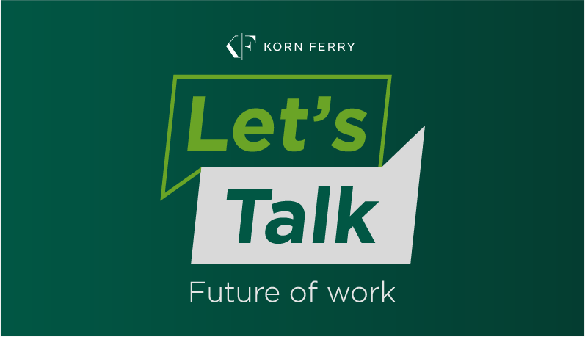

Table of content

Sr# | Content | Pg#
1 | Executive summary | 5-6
2 | Introduction | 6
3 | Employees wellbeing | 6
4 | Employee well-being and HRM | 7
5 | Types of wellbeing | 8-9
6 | Models of well being | 9-11
7 | Benefits of wellbeing at work place | 11-12
8 | Empirical evidence between Employee wellbeing and organization performance | 12
9 | Examples of organization promoting wellbeing. | 13
10 | Negative consequences | 13
11 | Case Example of Korn Ferry | 14-17
12 | Recommendations | 18-19
13 | Conclusion | 19
14 | References | 20-24

List of Figures

Sr# | Figures | Pg#
1 | Model of Employees Wellbeing in Corporate Sector | 7
2 | Types of Wellbeing in Employees | 9
3 | Employee Wellbeing and Engagement Matrix | 10
4 | Korn Ferry Organization Profitability Year Wise | 15

Executive Summary
The modern technological world has adopted the concept of wellbeing for efficiency and better outcome in different of one’s life. One of the major area of discussion is taking into consideration employee’s wellbeing to improve the productivity of organization.
Organizations nowadays, are developing and evolving, understand the importance of employees hold for an organization. For this purpose, employees’ needs and issues should be addresses within the organization. One of the important concepts with regard to employees are building wellbeing in the employees.
Wellbeing is associated with numerous health, social, emotional, job, family and economic benefits. Building wellbeing in employees’ foster good mental health and improved their work-related quality of life. The research conducted within organization has revealed that investing in employee’s wellbeing is associated with resilience, better employee engagement, reduce health related issues, burn out, exhaustion, interpersonal conflict, and stress management.
In the current report, importance of wellbeing is explained with respect to organizational context. The importance of wellbeing is illustrated with the case example of firm Korn ferry. Korn Ferry is a well-respected global consulting firm that specializes in offering a wide range of Human Resource Management (HRM) services to businesses across the world. Their services include talent management services, executive search services, workforce transformation services, and leadership development services.
These services are beneficial for career development, talent assessment, and succession planning finding and recruiting candidates, implementation of compensation packages that attract and retain top talent, workforce transformation, developing effective leadership strategies etc. The company provides innovative and effective HRM solutions that enhance business success and help organizations achieve their goals.
The report provides overview of the strategies the Firm Korn ferry, has adopted for building employee’s wellbeing, areas of improvement in fostering wellbeing. Future recommendation was given to improve the working dynamics in fostering wellbeing.
Introduction
This report will highlight the importance and impact of employee’s well-being in an organization.
Employee well being
In the developed world, technological advancement and competition has become an integral part of an organization. For this purpose, employees with special skill set are the backbone of an organization. It has become increasingly important for organizations to retain the skill full employees. Employee retention has become a challenging task in the fast-paced world, where majority of the people are experiencing high levels of stress. Therefore, to make the employees better functioning the concept of employee’s wellbeing is adapted within the context of work place (De Clercq et al., 2019).
Employee’s well-being is defined as an overall, physical, mental, emotional and economic health of employees, which is influenced by numerous factors such as relationships with coworkers, decision-making, access to resources, job satisfaction and security, work place safety, working hours etc (Dewe & Cooper, 2012).
Lot of emphasis is being given on employee’s well-being as an adult spend one quarter of its life at work place, for pursuit of improving one’s quality of life. Feeling good and functioning well are the key factors in improving well-being of employee’s with an organization, which in turn is important for efficient and smooth functioning of organization (Hone et al., 2015).
Employee well-being and HRM
The growing attention to work place well-being has also encompassed the work place. The new concept has emerged at workplace is “working for healthier tomorrow” . Galvanized interest in well-being is an important area of concern for both employees and organizations. It is reported in HR literature that companies are developing strategies to reduce stress of employees (Kowalski, Loretto, & Redman, 2015). Human capital could provide competitive advantage to the companies, therefore, supporting the work place well-being has become, the fore front of HR strategy in 21st century (Mallett, & Wapshott, 2017).
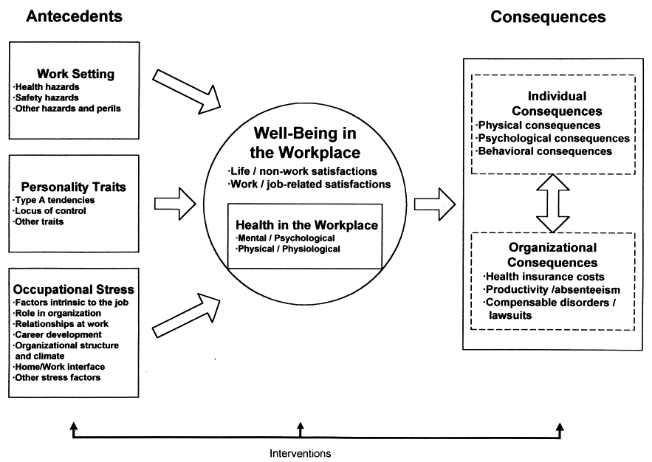
Fig 1: showing model of employees wellbeing in corporate sector

Types of well-being
Literature has postulated different types of well-being to highlight its significance encompassing different aspect of life (Bakker, 2015).
Mental and emotional well-being
Mental health is an important aspect in an employee’s life and well-being. Employees has to work long hours at time away from home in remote areas, bearing tough working condition. Along with that, employees have to interact with colleagues, bosses and maintaining the work life balance. All these aspects of life require to cope up with stress without decreasing the productivity (De Witte et al., 2015).
Physical well-being
Physical well-being encompasses maintaining active physical life style to cope with the fatigue and inactivity that be encountered in work place, to avoid hazards and ensure physical safety of the employee. Therefore, most of the organizations are providing the facilities of Gym, meditation classes, well-being coach, and online fitness training (Devonish, 2016).
Social well being
Social wellbeing is important for daily social interactions. Social distancing and remote working
make employees feel isolated and lonely, eventually effecting the efficiency of employees, increased absenteeism, lower work motivation and effecting productivity of the company. Therefore, companies are arranging team bonding virtual meetings, hosting picnics and outdoor activities to improve social well-being of employees (Jo et al., 2020).
Professional well being
Companies values the professional wellbeing and wellness of employees by encouraging them to develop skills by providing training courses, peer tutoring, arranging workshops and seminars. To reduce turnover and improve employees retention, variety of talent retention techniques, online coaching program have been introduced to enhance learning and professional development (Aked et al., 2009).
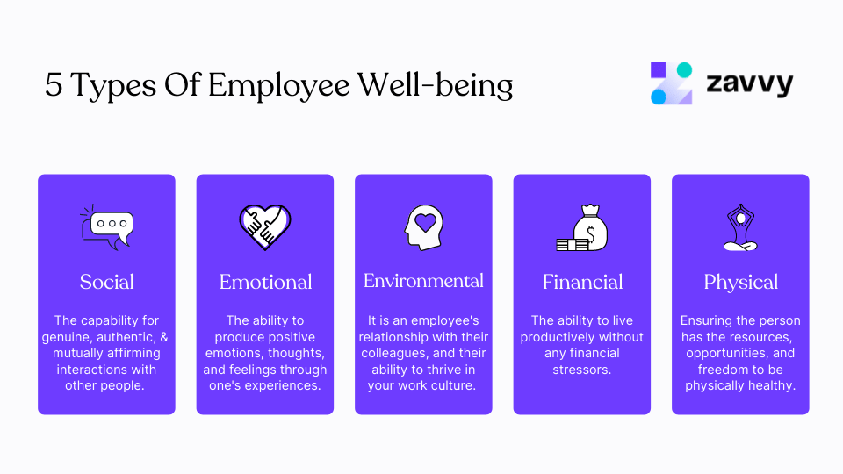
Fig 2: showing types of wellbeing in employees
Models of well being
Two different perspective have defined well-being at work. According to the hedonic perspective, wellbeing is described as happiness. This aspect described the importance of three components i.e. life satisfaction, the presence of positive mood and absence of negative mood. The eudemonic perspective described wellbeing in terms of self-actualization. This perspective proposed that an individual engage in activities that foster growth, autonomy, self-acceptance, purpose of life, mastery, positive relatedness that are the essential elements in increasing well-being at work place (Kaluza et al., 2021).

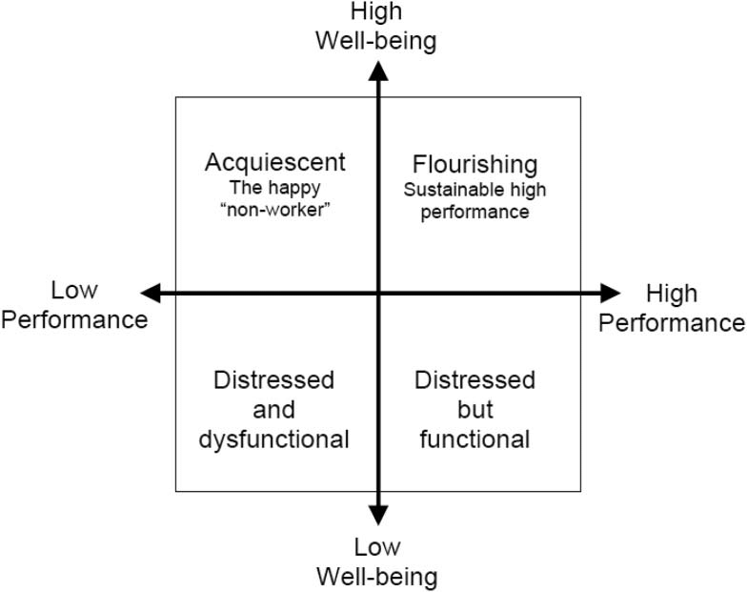
Fig 3: showing employee wellbeing and engagement matrix
One of the framework employee engagement and well- being posited the importance of well-being for an organization. As shown in fig area of distressed but functional believed that this area encompasses high levels of performance and employees engagement, despite of being stressed. These people discuss issues of stress that are more align with the organizational climate such as motivation, time management, staff retention and interpersonal problems (Cavanagh & Buckley, 2014). The second quadrant comprised of area of distressed and dysfunctional. These individuals are both low in performance and wellbeing. For example, crises focused social work agencies might have larger proportion of employees in this quadrant. It could be attributed to the factors burnout, bullying, compensation claims and toxicity. Employees in this quadrant experience higher levels of mental health problems and lower job performance and well-being. Whereas on interpersonal level employees could show passive aggressive behavior and low performance. The Acquiescent “Happy Non worker area encompasses good mental, high well-being and low performance. These workers accept the job objectives but lack commitment in fulfilling them. These employees are physically and emotionally present at work place, with regular attendance, but are not proactively engaged in meeting the goals of an organization. Area of flourishing and high performance encompasses both high performance and high well-being. These individuals are highly engaged in their work, have positive relationship with co-workers. These individuals believed in high quality of work, i.e. to work smarter not harder. These workers are highly required in an organization as they agile, creative, problem solver, and facilitate growth and development (Hebdon & Noh, 2013).
Benefits of wellbeing at work place

Organizations across the globe are realizing the fact the building employees well being is advantageous in many ways:

Reduce abseentism and health care cost

One of the benefits of building wellbeing is building employees wellbeing prevents issues such as burnout, stress, reduce absenteeism and turn over intention. Studies have found that 63% of the employees take sick leaves as a result of exhaustion and burn out.

For example: the company Johson and Johnson estimated that wellness program of their company saved $ 250 million dollar of health care cost.

Increase employee engagement

Well being also enhanced the employees’ engagement in an organization. Those companies who are taking initiatives in recognizing efforts of employees, providing constructive feedback, it holistically enhanced the company’s performance. In a study it was reported that 85% of the employees reported improved engagement in the tasks, feel more connected, has elevated mood, and feel happy, where focus was given on the employees wellness and well-being (Sohiers et al., 2019).
Improved productivity
Well-being enable employees to improve their productivity and performance. Optimizing employees wellbeing is the only way to increase productivity and efficiency within an organization (Richa & Deepika, 2017).
Improved morale of employees.
The companies who have introduced well –being initiatives such as mental health workshops, fitness programs were better able to boast the morale of the employees.
Attractive employer branding
To retain the competitive, highly qualified, talented employees that provide benefits to the company such as revenue, credibility and increased productivity of the organization. Studies have shown that 78% of the companies are offering employees wellness programs to attract talented employees (Fisher, 2014).
Empirical evidence between Employee wellbeing and organization performance
A plethora of research studies have highlighted that wellness program in the work place reduces health care costs and increases productivity of an organization (Shuck & Reio, 2014) . The studies have shown that the results indirectly correlated to monetary values, and generating revenues. The studies concluded that employee engagement, wellbeing and business outcomes are directly correlated with each other (William et al., 2019). The employee’s wellbeing is related to increase productivity and tangible benefits for the company. Similarly, studies have find out that there was a positive correlation between engagement of workers, employee performance, employee’s loyalty, and negative correlation with employee’s turnover (Ward & Neve, 2019).
Examples of organization promoting wellbeing.
A recent study conducted by Korn ferry consulting firm, it was found that 89% of the employees are suffering from burnout and exhaustion, making it difficult to utilize their potential, causing lower engagement and lower productivity.
For this purpose after 2020 companies are taking employee wellbeing in perspective and devising strategies to improve it. For example: a company Johnson and Johnson’s offices have wellbeing standard built in with sit/ stand desks, exercise, and relaxation spaces, nutrition guidance in the staff restaurant. They are providing holistic wellbeing program to make long lasting impact on an individual. Similarly, in New Zealand several companies like Unilever are trailing four –day work week. The company are showing empathy through various communication channels i.e. video calls or zoom meeting, for employees for remote working employees, remote employees are also encouraged to take walking breaks, opportunities for social interaction. Furthermore, the company is designing wellbeing initiatives which helps in reducing compensation claim for physical and mental health problems.
Negative consequences for organization
The negative consequences of poor wellbeing for organization could be increased stress level and mental health problems of employees that could effect their physical and interpersonal relationships with coworkers. All these factors have adverse effect for organization in terms of decline in productivity, meeting required goals of the company, increasing health care cost, higher turnover rate, ultimately, increases financial cost for the company (Warr & Nielsen. 2018)

Case Example of Korn Ferry
Korn ferry is a global consulting agency, specializing in HRM known for its services in leadership development and succession planning. The company was established in 1969, by Richard Ferry and was expended to 50 countries worldwide. The main objective of the company was to help organizations to retain employees and providing effective business solution.
The company provides consultation on the following areas: talent management, executive search, compensation and benefits, workforce transformation, and leadership development. One of the critical areas in which they excel is talent management. The company has a team of experts that use a data-driven approach to assess and identify top talent, enabling organizations to make informed hiring decisions. Korn Ferry is highly regarded is leadership development, to help organizations create effective leadership strategies that drive business success (Nigel, 2016). Additionally, executive search services are also in high demand, with the company helping organizations find and recruit the best candidates for senior leadership positions, using a rigorous search process. Compensation and benefits consulting is another area in which Korn Ferry provides services, to the organizations. In 2021 the company’s revenue was increased to 24% , and the stock price reached to $84.17 per share (Joann, 2015).
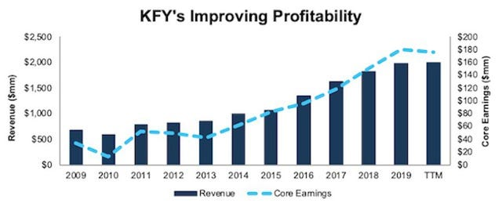
Fig 4: showing Korn ferry organization profitability year wise
One of the major success factors in the company is the deep understanding of latest trends, particularly enhancing employee’s wellbeing.
Meeting motivational needs
Korn Ferry company may work with an organization to develop a purpose-driven mission statement or to create opportunities for employee development and training. The enterprise's approach to meeting employee motivational needs is focused on creating a work environment that is supportive, engaging, and empowering. The company helps organizations create a workplace culture that is conducive to employee satisfaction, productivity, and success.
Meeting needs of the employees
Korn Ferry has included Maslow hierarchy of need into its people management strategy, to enhance employee’s wellbeing (Neal, 2007).
- Physiological Needs: Korn Ferry makes sure that its employees have access to basic comforts like clean water and wholesome food options as well as a safe and comfortable working environment.
- Safety requirements: At Korn Ferry, safety needs are covered through a broad spectrum of employee benefits, including health insurance, retirement programmes, and paid time off.
- Social Needs: Korn Ferry promotes a culture of cooperation and teamwork and acknowledges the importance that society demands. The workplace promotes open communication and gives staff members chances to get to know one another through social gatherings, team-building exercises, and voluntary work.
- Esteem needs: Korn Ferry values rewards and recognition of employee’s performance. The business values the input of its employees and regularly recognizes their accomplishments through performance evaluations, bonuses, incentives and perks.
- Self-Actualization Korn Ferry gives its employees chances to grow and develop. This includes having access to mentorship opportunities, career pathways that are clear, and training & development.
The company offers training and development programs under the Growth and Development pillar to aid employees in developing their abilities and advancing their careers. To promote employee well-being and engagement, the organization offers flexible work schedules and supports a positive work-life balance. The organization has developed an atmosphere where people feel respected, encouraged, and inspired to perform at their best.
Weaknesses of Korn ferry organization
Despite of its ongoing research and emphasis on developing wellness program in the company, it still lack proper implementation to reduce stress in employees.
The company offers virtual wellness program, but employees were not satisfied as it was not good fit with the company’s culture and values. Studies have shown that many wellness program within the company was considered lack luster, desired results were not obtained. It mainly attributed to the reason that company is not taking into account the needs of their employees. Spending less expenditure on research to understand employee needs, stressors, high job stress, lack of organizational commitment, misalignment of organizational leadership style are effecting employees mental, physical and emotional wellbeing, which has adverse on the employees and indirectly on the productivity of the company (Marescaux et al., 2018).
The survey has shown in the organization that ignoring different facets of wellness in employees has become costly for the company. According to survey, it was found that mental health issues cause 200 million lost workdays, resulting in annual cost of $17 billion to $44 billion to employers. The above-mentioned factors are causing high turnover rate, absenteeism, and reduced employees morale and efficiency. It is directly effecting by increased health care cost, lower growth and development, and difficulty in retaining qualified/ skilled workers (Lauren, 2014).
Recommendations
Experts and analysts at Korn ferry believed that following areas could be improved to enhance employee’s performance in future:
- Team leaders should understand the needs of the employees. Many employees are caregivers of children, elderly parents, maintaining work life balance becomes difficult and stressful for them. For this purpose organization provide flexible work timings, to prevent exhaustion and burnout in the employees.
- It is important for the company to understand the multifaceted nature of wellbeing i.e. physical, emotional, social, psychological and spiritual that should be developed in employee.
- To build physical wellbeing company must recruit more and more staff to divide workload equally among employees. Excessive workload could cause physical and mental health problems causing abseentism and in efficiency.
- To build social wellbeing interactive activities, trips, dinners, office trivia parties, celebrating occasions within organization to improve interpersonal relationships among employees.
- To build psychological wellbeing, the company should hire wellness coach, or mental counsellor to effectively deal with the mental health problems.
- Company must allocate areas for employees for rest, walk or take some time out of the hectic schedule to have a break for a while.
- The culture of group meetings and peer mentoring should be established, within an organization. To resolve interpersonal conflict, within work place.
- Bosses and executives should provide workshops, seminars, for continuous professional development, skill building to help those employee that difficulty in achieving targets and goals of the company.
- Stress management, time management, self-esteem and wellbeing building training should be provided within organization.
- The company should develop corporate wellness program for better engagement of employees.
- To boast morale and self-esteem of the employees by providing constructive feedback, employee of the quarter or year ceremonies should be arranged to reinforce employees for better performance.
- Incentive, perks, rewards, performance appreciation benefits, allowances should be given to employees for boosting the morale, employee involvement in meeting corporate goals.
Conclusion
Workplace wellbeing is an important multi-faceted construct that encompasses different aspect of an employee’s life, from the physical security to feelings about the work environment, commitment to the work and organization. Understanding and implementing the wellbeing is key determinant in an organization long-term effectiveness

References

Aked, J. Marks, N. Cordon, C. and Thompson, S. (2009) Five Ways to Wellbeing: A Report Presented to the Foresight Project on Communicating the Evidence Base for Improving People's Well-Being. London: Nef. https://neweconomics.org/2008/10/five-ways-to-wellbeing [Accessed 9 March 2023].

Bakker, A. B. (2015) Towards a multilevel approach of employee well-being. Eur. J. Work Organ. Psychol, 24, pp. 839–843. https:/ /www. tandfonline. com / doi/abs/10.1080/1359432X.2015.1071423?journalCode=pewo20[Accessed 10 March 2023].

Cavanagh, M. and Buckley, A. (2014) Coaching and mental health. In E. Cox, T. Bachkirova, & D. Clutterbuck (Eds.), The complete handbook of coaching. London, UK: Sage. http://dx.doi.org/10.1057/9781137304483_3 [Accessed 5 March 2023]
De Clercq, D., Haq, I.U. and Azeem, M.U. (2019) Perceived contract violation and job satisfaction: buffering roles of emotion regulation skills and work-related self-efficacy. International Journal of OrganizationalAnalysis, 28 (2),pp. 383-398.https://www.emerald.com /insight/content/doi/10.1108/IJOA-05-2020-2204/full/html[Accessed 13 March 2023].
Devonish, D. (2016) Emotional intelligence and job performance: the role of psychological well-being. International Journal of Workplace Health Management, 9 (4), pp. 428-442. https://www.emerald.com/insight/content/doi/10.1108/IJOA-05-2020-2204/full/html[Accessed 12 March 2023].
De Witte, H. Vander Elst, T. and De Cuyper, N. (2015) Job insecurity, health and well-being, Sustainable Working Lives. https://www.emerald.com/insight/content/doi/10.1108/IJOA-05-2020-2204/full/html[Accessed 10 March 2023].

Dewe, P. and Cooper, C. (2012) Well-being and Work: Towards a Balanced Agenda. Basingstoke: Palgrave MacMillan. ww.research.lancs.ac.uk/portal/en/publications/wellbeing-and-work-towards-a-balanced-agenda(fa97509d-6ad2-4244-9897-390d25bce442)/export.html[Accessed 10 March 2023].

Fisher, C. D. (2014) Conceptualizing and measuring wellbeing at work, in Wellbeing: A Complete Reference Guide, Work and Wellbeing. Wiley. https://w ww.rese archgat e.ne t/publication/ 3008 8987 4_Conceptualizing_and_Measuring_Wellbeing_at_Work [Accessed 11 March 2023]

Hebdon, R. and Noh, S. C. (2013) A theory of workplace conflict development: From grievances to strikes. In G. Gall (Ed.), New forms and expressions of conflict at work. London, England: Palgrave Macmillan UK. http://dx .doi.org/ 10.1057/9 7811373 04483 _3 [Accessed 5 March 2023].

Hone, L. C. Jarden, A. Duncan, S. and Schofield, G. M. (2015) Flourishing in New Zealand workers associations with lifestyle behaviors, physical health, psychosocial, and work-related indicators. J. Occup. Environ. Med, 57, pp.973–983. http:/ /10.1 097/ JOM .000 00 00 000000508[Accessed 5 March 2023].
Joann S. L. (2015) Suit Alleges Korn/Ferry Fired Official In Retaliation. Wall Street Journal. New York, N.Y., United States. https://en.wikipedia.org/wiki/Korn_Ferry [Accessed 13 March 2023].
Jo, H. Aryee, S. Hsiung, H.-H. and Guest, D. (2020) Fostering mutual gains: explaining the influence of high-performance work systems and leadership on psychological health and service performance. Hum. Resour. Manag. J. 30, 198–225. doi: 10.1111/1748-8583.12256 [Accessed 11 March 2023].
Kaluza, A. J. Weber, F. van Dick, R. and Junker, N. M. (2021) When and how health-oriented leadership relates to employee well-being—the role of expectations, self-care, and LMX. J. Appl. Soc. Psychol. 51, 404–424. doi: 10.1111/jasp.12744[Accessed 6 March 2023].
Kowalski, T. H. P. Loretto, W. and Redman, T. (2015) Call for papers: Special issue of international journal of human resource management: Well-being and HRM in the changing workplace. The International Journal of Human Resource Management , 26, pp.123–126. https://www.tandfonline.com/doi/full/10.1080/09585192.2017.1345205[Accessed 12 March 2023]
Lauren, W (2014). Here's What Boards Want in Executives. Wall Street Journal. New York, N.Y https://en.wikipedia.org/wiki/Korn_Ferry [Accessed 13 March 2023].

Mallett, O. and Wapshott, R. (2017) Small business revivalism: Employment relations in small and medium sized enterprises. Work, Employment and Society , pp. 1-8. https://doi.org/10.1177/0950017017690503 [Accessed 8 March 2023].
Marescaux, E. de Winne, S. and Forrier, A. (2018) Developmental HRM, employee well-being and performance: the moderating role of developing leadership. Eur. Manag. Rev. 16, 317–331. doi: 10.1111/emre.12168[Accessed 9 March 2023].
Neal, S.A (2007) Korn/Ferry International to acquire Leader Source; The purchase, in addition to one last year of Lominger International, broadens Korn/Ferry's areas of business. Star Tribune (Minneapolis, MN). https://en.wikipedia.org/wiki/Korn_Ferry [Accessed 13 March 2023].
Nigel, S. M. (2016). Court Ruling Could Make Sharing Netflix and Spotify Passwords a Federal crime. The Guardian. London. Guardian News and Media Limited [Accessed 12 March 2023].
Richa, A. and Deepika, K. (2017) Psychological wellbeing at workplace: An analytical study on it
sector. International Journals of Advanced Research in Computer Science and Software Engineering, 7(6), 223-228. https:// www.rsearc hgate .net/ publication/ 356001595 _IMPACT _OF _EMPLOYEE_WELL_BEING_ON_ORGANIZATIONAL_PERFORMANCE_IN_WORKPLACE [Accessed 15 March 2023].
Shuck, B. and Reio Jr, T. G. (2014) Employee engagement and well-being: A moderation model and implications for practice. Journal of Leadership & Organizational Studies, 21(1), 43-58. https://www.researchgate.net/publication/356001595_IMPACT_OF_EMPLOYEE_WELL_BEING_ON_ORGANIZATIONAL_PERFORMANCE_IN_WORKPLACE [Accessed 14 March 2023].
Sohiers, L. Van Ootegem, L. and Verhofstadt, E. (2019) Well-Being During The Transition From Work
To Retirement (No. 19/957). Journal of Leadership & Organizational Studies, 21(1), 43-58. https://www.researchgate.net/publication/356001595_IMPACT_OF_EMPLOYEE_WELL_BEING_ON_ORGANIZATIONAL_PERFORMANCE_IN_WORKPLACE [Accessed 13 March 2023].
Ward, G. and De Neve, J. E. (2019) Employee Wellbeing, Productivity and Firm Performance Christian Krek Ward, Employee Wellbeing, Productivity and Firm Performance Christian Krekel. https:// www.re searchgate.net/publication/356001595_IMPACT_OF_EMPLOYEE _WELL _BEING _ON_ ORGANIZATIONAL_PERFORMANCE_IN_WORKPLACE [Accessed 10 March 2023].
Warr, P. and Nielsen, K. A. R. I. N. A. (2018) Wellbeing and work performance. Handbook of well-being. Salt Lake City, UT: DEF Publishers. https:// www.researchgate.net/pu blication/356001595_IMPACT_OF_EMPLOYEE_WELL_BEING_ON_ORGANIZATIONAL_PERFORMANCE_IN_WORKPLACE [Accessed 10 March 2023].
Williams, D. F. Chen-Bowers, N. Lankford, T. and Wolff, M. B. (2019) Designing an Organizational Profile to Inform Leadership of Employee Well-being. Handbook of well-being Salt Lake City, UT: DEF Publishers. https:// www.re searchga te.net/pu blication/356001595_IMPACT_OF_EMPLOYEE_WELL_BEING_ON_ORGANIZATIONAL_PERFORMANCE_IN_WORKPLACE [Accessed 10 March 2023].
Williams, D. F., Chen-Bowers, N., Lankford, T., & Wolff, M. B. (2019). Designing an Organizational
Profile to Inform Leadership of Employee Well-being.

Shuck, B., &Reio Jr, T. G. (2014). Employee engagement and well-being: A moderation model and
implications for practice. Journal of Leadership & Organizational Studies, 21(1), 43-58.
• Sohiers, L., Van Ootegem, L., &Verhofstadt, E. (2019). Well-Being During The Transition From Work
To Retirement (No. 19/957). Ghent University, Faculty of Economics and Business Administration

Williams, D. F., Chen-Bowers, N., Lankford, T., & Wolff, M. B. (2019). Designing an Organizational
Profile to Inform Leadership of Employee Well-being.

