

Student Name: PRATIK MUKESHBHAI PRAJAPATI
Student ID:2428117

Module Name: Marketing Management
Module Code: LCMB7024
Word Count: 2570
Lecturer’s Name: Dr LAILA MAAZOUZ
Assessment Component 1

Table of Contents
Introduction 3
1. The advantages of being a pioneer and follower company 3
2. Role of product life cycle strategies on increasing growth and maintaining a strong competitive advantage within successful pioneer and follower companies with examples 6
Conclusion 8
References 10
Appendices 14
Appendix 1: Product life cycle 14
Appendix 2: Apple iPhone brand profile in the U.S 14
Appendix 3: Increasing net sales revenue of Amazon 14
Appendix 4: Tesla dominated American EVs sales over three years 15
Appendix 5: Comparison between pioneer and follower smartphone companies based on global market share 15

Introduction
Business leaders go through several experiences and situations while driving the business towards its success. The timing of market entry is the most critical strategic decision that a company needs to make in case of launching new technology or new products in different market (Chen et al. 2023). The market entry strategy is the most complicated task as the advantage of market entry relies highly on the market profitability that is often uncertain.
Pioneer and Follower are two concepts that a company follow before making its position stronger in a market. Both the pioneer and follower approaches provide unique risks and benefits to a company. The purpose of this study is to focus on the advantages of being a pioneer and a follower for a company. Further, the study will also evaluate the product life cycle strategies introduced by a successful pioneer and follower company to enhance growth while maintaining a strong competitive advantage. Examples of successful pioneers and followers will be included to support the statement strongly. Through this study, the difference between pioneer and follower of a company will be understood along with opportunities of being a pioneer or follower of a company in the long run.

1. The advantages of being a pioneer and follower company
Managing a business involves making various decisions on a regular basis. Some are routine decisions, whereas some are vital for the business. Selecting the right strategy is the most important decision the organisation needs to make and introduce adequately in the market. The organisation can focus on various strategies, but in the case of innovations, the company can focus on being either a follower or a pioneer. If the company is capable of facing challenges and is not afraid of taking risks, then it can focus on pioneer strategy over follower strategy(Gómez et al. 2022)..
Being a pioneer, company is more concerned about refining its strategy, ensuring to create new services, a market, or a product. Being the first mover, the pioneer company tend to set the standard for the industry, develop strong brand recognition and gain market share. For instance companies like Keloggs,Apple , Amazon etc are some of the famous first mover advantage companies One of the key advantages of being a pioneer company is the first-mover advantage (Gómez et al. 2022). The first mover advantage company are the ones that are first to market and that provides them competituve edge over the others. Since pioneer company is the first to integrate an innovation, it has the opportunity to attract early adopters, shape customers' preferences and build brand loyalty. Customers usually associate pioneering brands with leadership and innovation, resulting in long-term consumer retention (Wei et al. 2021). Another advantage is that the pioneer company has a greater opportunity to enjoy market leadership by establishing new trends and developing industry standards. Early entrance into a new market enables the pioneer company to establish itself as innovators, which in turn makes the situation highly difficult for the rival companies to stand against them (Peter et al. 2024). The strong brand image of the pioneer companies enables them to stay ahead in the market as businesses and customers prefer leading brands with positive track records. For instance companies like Nike, Coca Cola, Toms Shoes etc has made their brand image strong in the global market by following Pionerer Startegy.
A study has revealed that Pioneer strategy is highly advantageous to a company due to its ability to server a temporary monopoly position in the competitive market (Giachetti and Pira, 2022). As a result, the pioneer companies have the benefits of setting premium pricing for their services and products. Due to limited or no competition in the early phase, the company can charge premium prices from the customers and gain higher profit margins in the long run. Customers are likely to pay high for innovative services or products offering unique value. As a result, it allows the pioneer company to boost their revenue before their rival companies. For instance, Apple is well known for its innovative, pioneering products in the tech industry. It was the first company to bring touchscreen smartphones successfully in 2007 (Woggon, 2022). This innovation was new in the industry, due to which it has become highly popular worldwide. In the same year, the company sold nearly 1.4 million smartphones globally, and this increased to 11.6 million in 2008. The company has experienced constant growth in the global market for years, reaching its sales dramatically to 231.3 million in 2023 (Statista, 2024).
In addition, to this following a pioneer strategy enables the company to develop strong relationships with the retailers, distributors, and suppliers. Securing adequate terms and strong partners, they tend to make it highly difficult for the followers to enter any market. (Karkali et al. 2023).
Despite higher advantages experienced by pioneers over followers, follower companies also experience many advantages. One of the key advantages experienced by a follower company is that those companies can avoid the possibility of high costs and risks linked with innovation. They have the opportunity to study the failures and successes of the pioneers (Wang and Jiang, 2025). This, in turn, allows them to make investments of their products strategically without making any risky experiments that may affect their performance in the long run. Thereby, the pioneer company can minimise research & development costs and invest more effectively in other essential tasks (Wambsganss et al. 2023). The follower company has the opportunity to study the challenges experienced by the pioneer company while launching new products and services, analyse the customers’ feedback, technological shortcomings and pricing strategies and formulate their strategies accordingly. Pioneer strategy allows the companies to create updated versions of the existing products and offer a better experience to the customers without an expensive trial-and-error procedure (Yazdanpanah et al. 2023). For instance companies Netflix, Amazon , American Express follows Pioneer Strategy for makin their service quality better ( Ludwig and Fallon-O’Leary, .,2020.).
Following the pioneer strategy, companies have the opportunity to improve and adopt the existing technologies. They are able to increase the quality of the product, include cost-effective alternatives and new features that seek better attention of the customers. For instance, Samsung has followed the follower strategy. It has focused highly on studying what rival companies are doing. They intended to evaluate the customers’ demand and needs in the competitive companies and develop their products accordingly to the global market (Wambsganss et al. 2023). After the launch of Apple’s product, Samsung entered the smartphone market with their own unique version of the smartphone (London Business School, 2016). The company has easily succeeded in grabbing the attention of the customers and selling its products effectively in the competitive market. The sales made by Apple inc from the year 2023-2024 is somewhat around 382.29 US billion dollars to 391 US billion dollars whereas for the case of Samsung has sold nearly 60 million smartphones just in the Q1 of 2024.
Companies following pioneer strategy used to experience challenge to educate customers about their products or services and convince them to buy new products (Chen and Wang, 2024). In this case, companies with follower strategies tend to experience higher benefits as the company has entered a market where customers are widely familiar with the service or product. As a result, the follower company does not need to invest largely in educating customers regarding the product or service, which in turn lessens the time required to develop customers’ trust (Wiest, 2024). In addition, followers have a better opportunity to scale their business quicker than pioneers as they do not need to build a market from scratch. They have the opportunity to see existing supplier networks, manufacturing processes and distribution channels to deliver services and products effectively to the customers (Wambsganss et al. 2023). They allow them to stand against the pioneer company strongly with any delays. Thereby, it has been understood both pioneers and follower provide unique advantages to the business in the long run (Wambsganss et al. 2023).

2. Role of product life cycle strategies on increasing growth and maintaining a strong competitive advantage within successful pioneer and follower companies with examples
Concept of product life cycle and its phases
According to Stark (2022), “Product Lifecycle Management (PLM)” presents the company’s products in all the pathways across their lifecycles, from the first idea making to its departure. The main objective of this PLM is to reduce product related costs, increase product revenue and enhance the value of current and future products for customers and shareholders. The product life cycle has several phases such as development (pre-launch and launch), introduction, growth, maturity and decline (Hooley et al. 2020). [Refers to appendix 1]

Development:
During the pre-launch phase, organisations mainly focus on research and development which is needed for preparing the production capacity. The lunch phase is considered as a major opportunity for companies as the aim of this stage is to show the value to customers through innovative product launching. Rusch, Schöggl and Baumgartner (2023) noted that information of the actual design of the products is useful to facilitate R strategies like repair, recycle and recycling.

Introduction:
The next phase is introduction which is valuable for new products. When sales are increased, the company gets a high market position and competitors closely monitor this success.
Growth:
The growth stage represents that when products achieve market acceptanc,e then the sales and profitability of the companies increase and risks decrease (Hooley et al. 2020).
Majority:
The majority phase highlights that when competitor companies launch the same type of products and prices are frequent.
Decline:
After majority phase the market growth slows down and profit margin shrinks. As per this cycle concept, it understands that all of these phases are playing an important role in increasing growth and getting competitive advantage for both pioneer and followers companies.

Impacts of product life cycle strategies on increasing growth and competitive advantage within pioneer companies
As per the product life cycle phases, pioneer companies efficiently focus on the pre-launch phase (research and development) as they introduce new products in the market (Giachetti, and Pira, 2022). On the other hand, Followers companies focus less on this research and development phase as they follow similar products of pioneer companies. Based on this product life cycle, it identifies that pioneer companies focused on creating awareness and market development in the introduction phase. The main aim of this stage is to gain brand recognition and customer loyalty. For example, Apple with the launch of the iPhone was not the first example of creating a smartphone but it pioneered the touchscreen in 2007 (a new category of smartphone) (Woggon, 2022). Customers are attracted by this premium quality of Apple smartphone so it examines that new product launch or this brand increases their brand popularity, brand awareness, and customer loyalty. Based on an online survey with 1187 U.S smartphone owners, 93% of participants agreed that they were aware of the Apple iPhone and 42% of participants showed brand loyalty towards this brand (Statista, 2025). [Refers to appendix 2]
In the growth stage, pioneer companies mainly focus on innovation and creativity to maintain the market growth. According to Surya et al. (2021), innovation has increased the productivity of organisations that positively impacts their economic growth. For instance, Tesla is a pioneer company who innovate electric vehicles that differentiate them from other automotive companies (Persson, 2024). Product differentiation creates opportunities for companies to achieve market growth in a competitive market (Sudirjo, 2023). Products like Model S, model X, model 3 and model Y are creating a differentiation of the Tesla brand into a competitive brand. Based on a survey in 2021, it found that Tesla dominated American EVs sales over three years with 296392 unit sales by Model 3 and 67335 units by Model S (McCarthy, 2021). Tesla invested in R&D for introducing the Autopilot feature, lithium-ion battery cells and over the air software updates (Persson, 2024). These unique features have differentiated Tesla from others and give them a competitive advantage. [Refers to appendix 3]

Based on the maturity stage, it recognises that production by focusing on a rapidly growing market helps to capture more customers' attention and increase sales. For example, Amazon is the initial book seller in online platforms but this brand has expanded their product categories to enhance their customers’ base and increase sales. The net sales revenue of Amazon increased from 169.96 billion U.S dollars in Q4 of 2023 to 187.79 billion U.S dollars in Q4 of 2024 (Coppola, 2025). Based on all of these examples of pioneer companies, it understands that investment on R&D for new product making, innovation, maintaining differentiation, quality enhancement and adopting market needs are important for increasing market growth and getting competitive advantage. [Refers to appendix 4]
Effectiveness of product life cycle strategies on increasing growth and competitive advantage under follower companies
Followers enter the market after pioneer companies with improved versions of initial products. These companies invest in research and development to enhance the quality of products but in lesser amounts in comparison to pioneer companies (Kamp, and Ruiz de Apodaca, 2023). Although Samsung is the follower of Apple, it's better camera technology (world’s first dual pixel sensor), larger screen (AMOLED display), analog touch to digital devices, trusted mobile bodyguard, dust and water protection, and affordable prices cause more customer engagement and increase growth (Samsung, 2022). In the introduction stage, Samsung used these improvements for capturing a significant market share especially in the android segment. Based on product life cycle, it examines follower companies that are benefited due to a lesser amount of investment on production cost as they can learn from the mistakes of pioneers. For example, Xiaomi is a follower of the smartphone market who offers high quality products at lower cost compared to Apple as they adopt cost-efficient manufacturing and smart pricing strategies. Zandt (2024) reported that Samsung gained 19% global market share and Xiaomi gained 14.7% market share whereas Apple had 15.8% market share in April and June 2024. Based on these market reports, it found that follower companies gain more market share compared to pioneer companies. In these ways, follower companies get competitive advantage and continue to grow in the market. [Refers to appendix 5]

Conclusion
As per question one, it concludes strong brand recognition, shaping customers' preferences, enjoying market leadership and building brand loyalty are some advantages that pioneer companies gain in the market. Limited competition, setting premium prices and strong relationships with suppliers are also some advantages of pioneer companies. On the other hand, follower companies get advantages due to lower cost on research and development, creating an updated version, and offering better customer experience. Based on the second question, it has been summarised that high investment on R&D for introducing new products, creating innovation, making differentiation, controlling quality and adopting market trends are valuable to increase market growth and get competitive advantage under pioneer companies. Followers face less risk in product experiments as they follow pioneer companies. The follower companies make better quality products based on mistakes of pioneer companies that help them to attract more customers.

References
Chen, C.H., Ishida, J. and Mukherjee, A., (2023). Pioneer, early follower or late entrant: Entry dynamics with learning and market competition. European Economic Review, 152, p.104360. https://papers.ssrn.com/sol3/Delivery.cfm?abstractid=3831735
Chen, X. and Wang, Y., (2024). Pioneer advantage or late-mover advantage? An examination of the interplay between policy diffusion sequence and policy outcomes. Policy Sciences, pp.1-23. https://link.springer.com/content/pdf/10.1007/s11077-024-09560-7.pdf
Coppola, D., (2025). Amazon quarterly net sales revenue 2007-2024. statista. [online]. Available at: https://www.statista.com/statistics/273963/quarterly-revenue-of-amazoncom/ [Accessed on 4th March 2025]
Giachetti, C. and Pira, S.L., (2022). Catching up with the market leader: Does it pay to rapidly imitate its innovations?. Research Policy, 51(5), p.104505. https://cris.unibo.it/bitstream/11585/952829/4/Giachetti-LiPira-2022_RESPOL-D-21-00205_R3.pdf
Giachetti, C. and Pira, S.L., (2022). Catching up with the market leader: Does it pay to rapidly imitate its innovations?. Research Policy, 51(5), p.104505.https://www.sciencedirect.com/science/article/pii/S0048733322000336
Gómez, J., Perez-Aradros, B. and Salazar, I., (2022). How to beat early movers: The role of competitive strategy and industry dynamism on followers’ performance in the telecommunications industry. Long Range Planning, 55(5), p.102244. https://www.sciencedirect.com/science/article/pii/S0024630122000632
Hooley, G. J., Nicoulaud, B., Rudd, J. M., and Lee, N. (2020) Marketing strategy and competitive positioning. Seventh edition. Harlow, England ; Pearson.
Kamp, B. and Ruiz de Apodaca, I., (2023). Leveraging (in) formal early-mover and diligent-follower advantage mechanisms to attain international niche market leadership: insights from Basque “hidden champions”. Competitiveness Review: An International Business Journal, 33(6), pp.1013-1045.https://www.emerald.com/insight/content/doi/10.1108/cr-10-2022-0158/full/html
Karkali, K., Saunders, T.E., Panayotou, G. and Martín-Blanco, E., (2023). JNK signaling in pioneer neurons organizes ventral nerve cord architecture in Drosophila embryos. Nature Communications, 14(1), p.675. https://www.nature.com/articles/s41467-023-36388-1.pdf
London Business School, (2016). Lessons from the world's best-known fast-follower: Samsung [online] Available at: https://www.london.edu/think/diie-innovation-icons-samsung [Accessed on 4th March 2025]
McCarthy, N., 2021. Tesla Dominated American EV Sales Over The Past 3 Years. Statista. [online]. Available at:https://www.statista.com/chart/24908/electric-vehicle-sales-by-model-in-the-us-over-the-past-three-years/ [Accessed on 4th March 2025]
Persson, E., (2024). Tesla: Leading the EV Revolution. Quarter. [online]. Available at: https://quartr.com/insights/company-research/tesla-leading-the-ev-revolution [Accessed on 4th March 2025]
Peter, M.K., Wuersch, L., Wong, A. and Neher, A., (2024). Digital transformation of work: Swiss MSEs working from home behaviour during COVID-19–pioneers leading the pack. European Business Review, 36(2), pp.249-270. https://www.emerald.com/insight/content/doi/10.1108/ebr-01-2023-0008/full/pdf
Rusch, M., Schöggl, J.P. and Baumgartner, R.J., (2023). Application of digital technologies for sustainable product management in a circular economy: A review. Business strategy and the environment, 32(3), pp.1159-1174. https://onlinelibrary.wiley.com/doi/abs/10.1002/bse.3099
Samsung, (2022). How Samsung Galaxy Has Rewritten Smartphone History in 10 Innovative Technologies. Samsung Newsroom. [online]. Available at: https://news.samsung.com/global/how-samsung-galaxy-has-rewritten-smartphone-history-in-10-innovative-technologies [Accessed on 4th March 2025]
Stark, J., (2022). Product lifecycle management (PLM). In Product lifecycle management (volume 1) 21st Century paradigm for product realisation (pp. 1-32). Cham: Springer International Publishing.https://link.springer.com/chapter/10.1007/978-3-030-98578-3_1
Statista, (2024). Unit sales of the Apple iPhone worldwide from 2007 to 2023 [online] Available at: https://www.statista.com/statistics/276306/global-apple-iphone-sales-since-fiscal-year-2007/ [Accessed on 4th March 2025]
Statista, (2025). Apple iPhone brand profile in the U.S. statista. [online]. Available at: https://www.statista.com/insights/consumer/brand-profiles/3/38/apple-iphone/united-states/#contentBox1 [Accessed on 4th March 2025]
Sudirjo, F., (2023). Marketing strategy in improving product competitiveness in the global market. Journal of Contemporary Administration and Management (ADMAN), 1(2), pp.63-69. https://journal.literasisainsnusantara.com/index.php/adman/article/view/24
Surya, B., Menne, F., Sabhan, H., Suriani, S., Abubakar, H. and Idris, M., (2021). Economic growth, increasing productivity of SMEs, and open innovation. Journal of Open Innovation: Technology, Market, and Complexity, 7(1), p.20.https://www.mdpi.com/2199-8531/7/1/20
Wambsganss, A., Bröring, S., Salomo, S. and Sick, N., (2023). Technology strategies in converging technology systems: Evidence from printed electronics. Journal of Product Innovation Management, 40(5), pp.705-732. https://onlinelibrary.wiley.com/doi/pdfdirect/10.1111/jpim.12693
Wang, L. and Jiang, Y., (2025), February. A Study on the Group Mechanism of the Demonstration Effect of Pioneer Enterprises on the Digital Transformation of Small and Medium-Sized Manufacturing Enterprises in Industrial Clusters. In 2024 4th International Conference on Public Management and Big Data Analysis (PMBDA 2024) (pp. 369-381). Atlantis Press. https://www.atlantis-press.com/article/126008784.pdf
Wei, S.J., Wei, Z. and Xu, J., (2021). On the market failure of “missing pioneers”. Journal of Development Economics, 152, p.102705. https://ink.library.smu.edu.sg/cgi/viewcontent.cgi?article=3483&context=soe_research
Wiest, J.K., (2024). Characteristics of Effective Pioneer Leaders: A Research Project. Asbury Theological Seminary. https://place.asburyseminary.edu/cgi/viewcontent.cgi?article=2690&context=ecommonsatsdissertations

Woggon. M., (2022). A Brief History Of Touchscreen Technology: From The IPhone To Multi-User Videowalls [online] Available at: https://www.forbes.com/councils/forbestechcouncil/2022/07/20/a-brief-history-of-touchscreen-technology-from-the-iphone-to-multi-user-videowalls/ [Accessed on 4th March 2025]
Yazdanpanah, M., Zobeidi, T., Mirzaei, A., Löhr, K., Warner, L.A., Lamm, A., Rouzaneh, D. and Sieber, S., (2023). Comparison of different modern irrigation system adopters through socio-economic, innovation characteristics and social capital values. Regional Environmental Change, 23(4), p.152. https://link.springer.com/content/pdf/10.1007/s10113-023-02147-7.pdf
Zandt, F., (2024). Samsung, Apple and Xiaomi Command Half of the Global Smartphone Market in Q2 2024. Statista. [online]. Available at: https://www.statista.com/chart/32252/global-quarterly-market-share-of-the-top-5-smartphone-vendors-by-shipped-devices/ [Accessed on 4th March 2025]
Ludwig, S. and Fallon-O’Leary, D. (2020). 10 Hugely Successful Companies that Reinvented Their Business. [online] https://www.uschamber.com/co. Available at: https://www.uschamber.com/co/good-company/growth-studio/successful-companies-that-reinvented-their-business.

Appendices

Appendix 1: Product life cycle
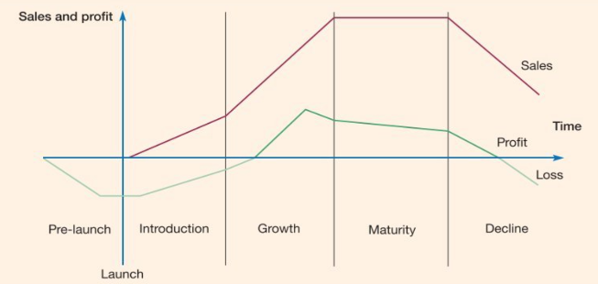
(Source: Hooley et al. 2020)

Appendix 2: Apple iPhone brand profile in the U.S
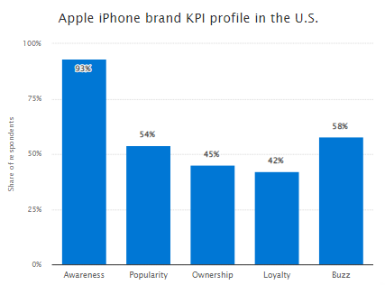
(Source: Statista, 2025)

Appendix 3: Increasing net sales revenue of Amazon
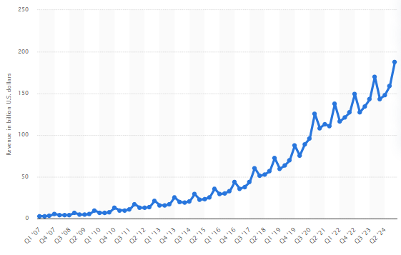
(Source: Coppola, 2025)

Appendix 4: Tesla dominated American EVs sales over three years
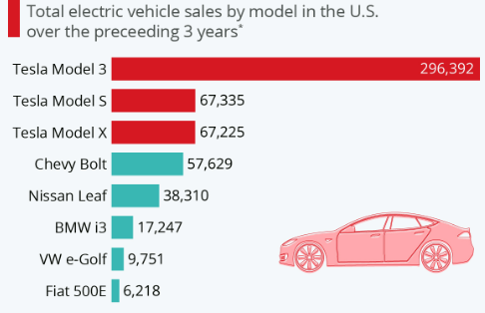
(Source: McCarthy, 2021)

Appendix 5: Comparison between pioneer and follower smartphone companies based on global market share
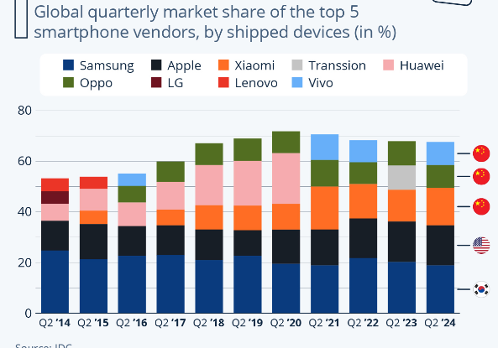
(Source: Zandt, 2024)

