Module Name: Human Resource Management
Task: 2
Module number: LCMB7000
Format: Report
Title: Human Resource Management Task
Student Name: Suraj kumar
Student Code: 2126818
Course Name : Gernal Management
Lecturer Name: Dr. Gladius Kulothothangan

Content
1. Introduction……………………………………………………………………….……….……1
2. Company’s Background………………………………………………………….……….…….1
Change Management………………………………………………………………..……………..2
* Change Management Model……………………………………….……………...…….3
* Relevance and Applicable……………………………………………….…….………...5
HR effective measurement……………………………………………………………...….….…..7
Metrics for measuring HR effectiveness …………………………………………………..7
Relevance and significant in the context of Intel…….………………………………….…8
Compensation………………………………………………………………………………….….9
Compensation Theory …………………………………………………………………...9
Application and Relevance…………………………………………………….…….…..10
Conclusion…………………………………………………………………..…………….…….11
Recommendation………………………………………………………………………….…….12
References…………………………………………………………………….…………..……..13

Introduction
As far as income, Intel is the world's greatest semiconductor chip creator and one of the most conspicuous American worldwide innovation organizations. It is the maker of the x86 line of chip, and its processors can today be tracked down in an assortment of PC gadgets. Coordinated Electronics Corporation was framed in 1968 and is settled in Santa Clara, California, USA. Intel additionally delivers motherboard chipsets, incorporated circuits, illustrations chips, network interface regulators, and other correspondence and figuring utility gadgets. The firm was framed by Robert Noyce and Gordon Moore, who worked intimately with Andrew Grove's senior initiative. As the firm advanced, it started to coordinate creative chip plan with top abilities support creation. During the 1990s, the business started its well known publicizing exertion with Intel's "Intel Inside" and laid out its Pentium image names as the home-utilized CPU (Nadji and Boudour, 2022).
Background
Intel was notable for being an early trailblazer in creating memory chips, for example, SRAM and DRAM, which were its essential business until 1981. During the 1990s, Intel burned through truckload of cash on creative microchip designs, which assisted the PC business with creating dangerously fast. During this time, Intel turned into the predominant provider of PC chip, and was subsequently known for uncovering forcefully questionable promoting methodologies with regards to its item market position, especially against its two fundamental rivals, AMD and Microsoft, for controlling across the PC business' headings (Noyce and Hoff, 1981).
Toward the finish of the 1980s, the firm had really repositioned itself as a main player in semiconductors in the wake of changing fundamental parts of its business methodology and moving its market accentuation to microchips. Intel started a 10-year period of uncommon extension as the significant equipment supplier to the PC business, energized by its special situation as a CPU provider to IBM and its opponents in the growingly beneficial PC market (Noye and Hoff, 1981).

Change Management
Barrett's upgrades included entering new businesses like the assembling of data and correspondence apparatuses and the manufacture of organization servers and switches, however he pulled out when he understood he would contend with chip clients like as Cisco and Dell. Another distinction is that during his initial three years as CEO of Intel, Barrett shut down ICat, a web based business area for private ventures. Moreover, he laid out a remote unit and the Architecture Group in his second and third years; he rearranged the Architecture Group much further by joining Intel's correspondences and systems administration divisions (Manary et al., 2019).
Reuters, May 16 - According to an administrative recording on Monday, Intel Corp (INTC.O) investors dismissed remuneration bundles for senior leaders, including an installment of up to $178.6 million to Chief Executive Officer Pat Gelsinger.
As indicated by Intel, around 1.78 billion votes were projected against CEO compensation at the yearly gathering, but the vote is non-restricting. There were around 921.2 million votes cast in favor.
As indicated by Reuters, Intel said, "We view our financial backers' feedback very in a serious way, and we are committed to drawing in with them and settling their interests."
Change Management Model
Change the executives is characterized as the methodologies and techniques utilized by an enterprise to portray and execute change in both inside and outside tasks. Getting ready and supporting individuals, fostering the fundamental systems for change, and assessing pre-and present change exercises on ensure compelling execution are all essential for this.
Critical hierarchical change might be troublesome. It frequently requires many layers of cooperation and may incorporate different independent gatherings inside an association. Thinking up an arranged system to change is pivotal for guaranteeing a smooth progress while limiting interference.
Changes regularly fizzle for human reasons: the allies of the change didn't consider the typical individuals' sound, veritable, and unsurprising reactions to disturbances in their schedules. One of the most fundamental achievement standards for good change the executives is brilliant correspondence. All work force connected with should grasp the movement through the various stages and witness results as the change overflows (Manary et al., 2019).
Fig 1
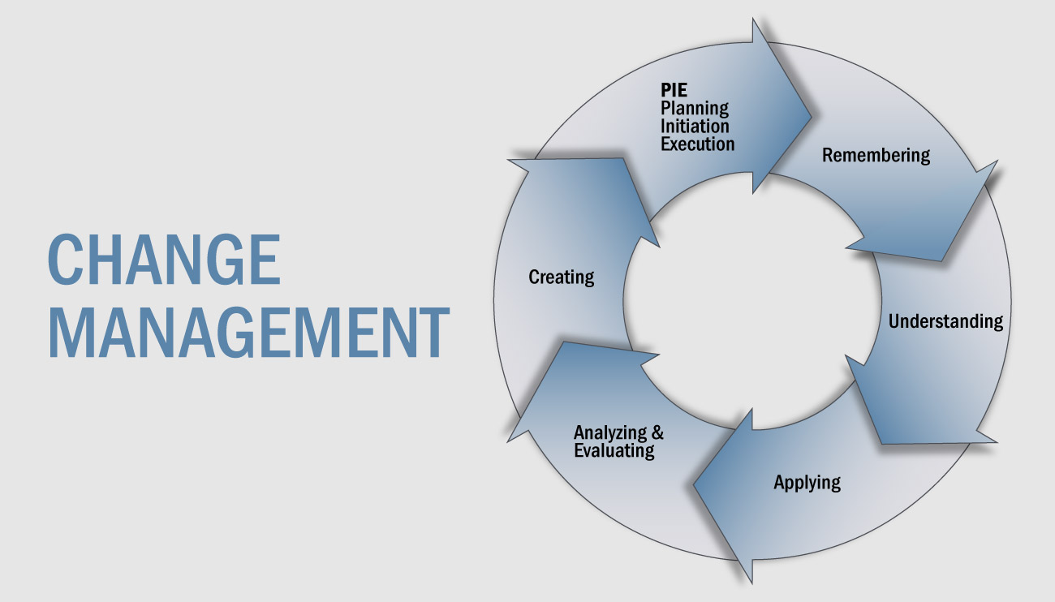
“Source: Strategyassociates.com”

Awareness
Workers should be instructed on the need of progress.
The primary structure block tends to what is maybe the most fundamental inquiry: why is change required and wanted? Staff will make some intense memories embracing the change and supporting the development except if there is an unmistakable reaction to this issue, including inspiration.
To bring issues to light, it is essential to convey these thoughts from numerous perspectives successfully. In a perfect world, the message would give substantial instances of why laborers will find the proposed endeavors significant and how they will improve their work (Cragg and Chraibi, 2020).
Desire

Employees should be anxious to draw in and energetic about the change. Employee inspiration is the focal point of the subsequent structure block. Organizations can't advise their laborers how to feel about specific issues, yet they might motivate them. There are different justifications for why people are impervious to change.

As per research, a few laborers could invite change in the event that they feel appreciated and treated deferentially in the meantime. A normal mistake is to welcome specialists to a conversation on change and afterward not organize anything. Employees frequently find it ineffectual to write down ideas that they don't catch wind of later. Arranging successive contact and input opportunities is thusly basic. In this methodology, cooperation is supported, which helps with the acknowledgment of progress (Cragg and Chraibi, 2020).

Knowledge

Workers will comprehend the (last) point of the change as they gain data about the change cycle. Learning doesn't happen in a restricted setting. Anything data laborers have, it is important that they share and mirror that information in a coordinated educational experience. They give significance to what they've gained and help each other benefit from newly procured data thusly. This is frequently alluded to as friendly learning. Social learning is the way to normally sharing data. Associations ought to effectively permit their staff to adapt to new data instead of simply sending them on a course (Cragg and Chraibi, 2020).

Ability
Change is accepted because of the capacity to acquire new skills and manage behavior. What is it that keeps workers from contributing to change? Sometimes it's because they don't feel like they're a part of the solution. Companies may discover and eliminate obstacles by listening to their staff. Inquire about how things are going and how they feel about their situation.
Encourage individuals to believe in their own talents by recognising them. Even if they fail, since they are more likely to learn from their errors. Employees find it difficult to admit their flaws at work, so tell them that there is no shame in seeking assistance (Cragg and Chraibi, 2020).

Reinforcement
Reinforcement to maintain the change communicates to all workers that there is no going back. To support the transformation, a business must encourage workers and management to continue discussing the projects' progress, to celebrate milestones, and to share success stories.
Give workers a place to readily share their experiences (Cragg and Chraibi, 2020).
Relevance and application in HR practice and policy
Fashion was one of the difficulties Intel faced as a result of consumers' need for rapid modem connections rather than the speed of computer processors, which was Intel's specialty.
Another source of change at Intel was hypercompetition from Advanced Micro Devices and other chip makers, which necessitated change in order to guarantee Intel's profitability and relevance.
Due to the weak economic business scenario, another change pressure at Intel was the shrinking market. The imminent conflict with Iraq created geopolitical pressure for change at Intel, necessitating adjustments within the company. The mandate was also another change pressure in which Intel sought to maximise profits by overpricing rather than enhancing customer experience in order to build a solid reputation with customers and maintain customer loyalty. As previously said, technology roadmapping is more than simply a procedure; the people participating in the process are also critical to its success.
Cosner et al. (2007) discuss the significance of building a cross functional team by incorporating individuals from many departments in the process. Those in the marketing and new product development departments, for example, may have a larger role in designing a roadmap, while people in the operations and support departments may concentrate on aligning their resources and day-to day activities with a roadmap. Participants in TRM seminars are a primary source of information (McCarthy 2003). According to Brown and O'Hare (2001), the effectiveness of a roadmap is tid to the quality of information gathered.

HR effective change management
Worker inspiration has become more significant as contest in the innovation area has expanded. Innovation firms are moreover doing combating for the top staff in the field. Organizations are giving higher pay, workplaces, and advantages to their employees and chiefs to motivate and keep them. These qualities are basic for worker maintenance and inspiration. Intel has focused on these models, and because of its endeavors, whether as far as compensation or advantages and different advantages, it has procured overall standing as a business of decision.
Beside serious compensation, the firm gives expansive based stock awards and rewards, a famous Employee Stock Purchase Plan, medical care and retirement benefits, took care of time, adaptable plans for getting work done, holidays, fruitfulness support, and on location administrations to its laborers. The organization puts stock in being liberal to its laborers regarding wages and advantages. For over 10 years, the company has led a pay concentrate on in the United States to guarantee pay equality by orientation and race. It extended its examination to the overall labor force in 2018, and it recently asserted that it had accomplished worldwide orientation pay decency (Chyhryn et al., 2019).
Fig 2
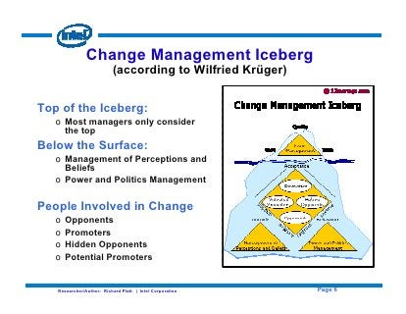
“Source: Slideshare.net”
Employees at Intel are given the apparatuses and preparing they need to reveal new opportunities for progression. It spends a lot of in ability improvement to keep them cutthroat and imaginative. Beside yearly preparation, the association furnishes its workers with pivoting task opportunities to get ability in different areas. Drawing in specialists with new methodologies assists with spurring them and raises the standard for dependability. In 2017 and 2018, the organization conveyed consideration preparing to its administration. In the past five years, the organization's turnover rate has diminished. During this time, its unfortunate deliberate turnover rate was under 5%.
Relevant and significant in the context
Communication is a fundamental part of viable human asset the executives. It advances staff commitment and inspiration while lessening misery and resolve. Besides, it has a huge impact in bringing down the steady loss rate. An organization's still up in the air by how successfully its laborers comprehend their obligations and how they add to the association's presentation and efficiency. Intel conveys and connects with its laborers utilizing different correspondence and commitment stages. Intel has different courses for immediate and straightforward correspondence. There are open leader discussions as well as quarterly Organizational Health Polls. Intel likewise draws in workers by means of in excess of 30 particular employee asset associations, like the Women at Intel Network, the Network of Intel African American Employees, the Intel Latino Network, and others.

Compensation
Compensation Management, as it is right now called, has been a basic wellspring of enrolling, keeping up with, and persuading the important HR for each firm. Albeit most specialists, especially those at the center and senior levels, accept that cash plays no impact in their decision to leave or stay in an organization, as a matter of fact, cash spurs most of individuals (Lagarde et al., 2019).
Worker appraisal frameworks have been created to connect employee execution with proper compensation, despite the fact that without all out progress.
Expectancy and Reinforcement theory of compensation

Victor Vroom, along with Edward Lawler and Lyman Porter, recommended that the connection between individuals' work conduct and their targets was not quite as direct as past researchers had accepted. Vroom perceived that a worker's not entirely set in stone by human attributes like character, abilities, information, experience, and gifts (Andeyo, 2021).

Valence

Valence alludes to individuals' personal directions toward results [rewards]. The power of a employee's longing for extraneous [money, advancement, downtime, perks] or natural [satisfaction] motivators. The executives should realize what their kin esteem (Andeyo, 2021).

Expectancy
Workers have different assumptions and levels of trust in their capacities. The board should figure out which assets, preparing, or oversight are expected by laborers (Andeyo, 2021).

Instrumentality
Employees' impression of whether they will get what they need, regardless of whether it has been guaranteed by a chief. The executives should ensure that reward responsibilities are kept and that laborers know about this.
As per Vroom, a employee's thoughts regarding Expectancy, Instrumentality, and Valence join mentally to shape a propelling variable that makes the worker act in manners that offer joy while abstaining from misery (Andeyo, 2021)..
Fig 3
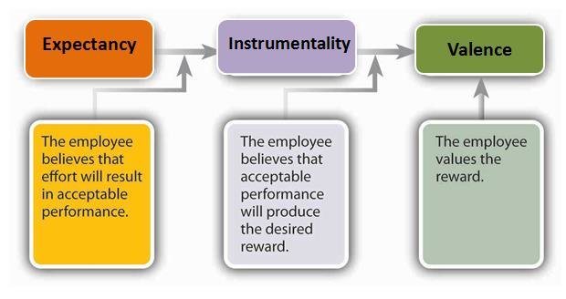
“Source: researchgate.net”
Application of the relevance theory
Intel imagines that to obtain results from their laborers, they should give them the expected devices. As per the speculation, there is an unmistakable connection among exertion and execution; on the off chance that a representative feels that their endeavors won't be compensated, they are less inclined to perform (NerdySeal, 2022). As per the idea, it is basic to understand a representative's level of capacity; Intel perceives this, as well as the way that laborers work in a dynamic and quickly evolving climate. Thus, Intel made an interior college that offers a full improvement educational plan, including new representative onboarding and preparing programs for existing specialists hoping to progress and profit from a lifelong advancement. Workers may upskill at the college during their visit with the firm, whether they wish to fortify their administration capacities, increment their IT abilities, or gain particular information about the association. The University's web-based data set remembers the latest scholastic data for subjects going from initiative to innovation.
Conclusion
As per the accompanying review, Vrooms Expectancy Model, which was created in 1964, is as yet significant in the present culture. It is a broadly famous cycle hypothesis of inspiration that is utilized by numerous global organizations across the world, including Intel, which is examined in extraordinary profundity above. In any case, no hypothesis is truly perfect. Each hypothesis will continually be studied and, in certain conditions, worked on by different scholars. Vroom's underlying assumption model has various adversaries, and a few scholars have looked to expand it throughout the long term, as demonstrated in the basic study above. Vrooms Theory has generally had a significant impact in administration practice, and it will keep on doing as such in the twenty-first hundred years.

Recommendation
An idea is to reinforce Intel's situation in the semiconductor market by zeroing in additional on creating cutthroat and rewarding CPUs for cell phones. It is additionally proposed that the enterprise structure new connections to decrease its dependence on Microsoft. Another idea is for Intel to expand its organization, for example, by means of new acquisitions in different areas, to decrease market chances and the conceivable impact of reducing PC deals.

Reference
Andeyo Okutu, J., 2021. Effect of organizational compensation and reward system on employee performance at Kenya Revenue Authority (Doctoral dissertation, Moi University).
Brown, R. and S. O’Hare. 2001. The use of technology roadmapping as an enabler of knowledge management. Paper presented at the IEE Seminar on Managing Knowledge for Competitive Advantage (Ref. No. 2001/047), 7 February.
Chyhryn, O.Y., Karintseva, O.I., Kozlova, D.D. and Kovaleva, A.V., 2019. HR management in the digital age: The main trends assessment and stakeholders.
Cosner, R.R., E.J. Hynds, A.R. Fusfeld, C.V. Loweth, C. Scouten, and R. Albright. 2007. Integrating roadmapping into technical planning. Research Technology Management 50, no. 6: 31.
Cragg, T. and Chraibi, S., 2020. Reviewing procurement: a change management model based on action research. International Journal of Procurement Management, 13(6), pp.737-755.
https://strategyassociates.cc/change-management-model/
https://www.researchgate.net/figure/Vrooms-Expectancy-Theory-Expectancy-Expectancy-is-the-belief-ones-effort-E-will_fig53_323695129
https://www.reuters.com/technology/intel-shareholders-reject-compensation-packages-top-executives-2022-05-16/
https://www.slideshare.net/rplatt/intel-corporate-change-agent-presentation
Lagarde, J.J.S., Mateo, J.G., Torrejos, A.J.O., Tolentino, G.A.S. and Concepcion, E.P., 2019. BANKING MANAGEMENT SYSTEM: Human Resource 4 (Core Human Capital, Compensation Planning, HR Analytics and Payroll). Ascendens Asia Singapore–Bestlink College of the Philippines Journal of Multidisciplinary Research, 1(1).
Manary, M.P., Wieland, B., Willems, S.P. and Kempf, K.G., 2019. Analytics makes inventory planning a lights-out activity at Intel Corporation. INFORMS Journal on Applied Analytics, 49(1), pp.52-63.
McCarthy, R.C. 2003. Linking technological change to business needs. Research Technology Management 46, no. 2: 47–58.
Nadji, A.Z. and Boudour, R., 2022. ‘Intel Acat’Assistive Platform for Arabic Speaking Disabled People: a Complete Integration. Medical Archives, 76(2), p.140.
NerdySeal. (2022) 'Vrooms expectancy theory of motivation team members management essay'. 31 January. (Accessed: 28 August 2022).
Noyce, R. and Hoff, M., 1981. A history of microprocessor development at Intel. IEEE Micro, 1(01), pp.8-21.

