8/15/2020
HUMAN RESOURCE MANAGEMENT
Human Resource Management 2 1604693
Annmarie Francis Lecturer: Mary March

Executive Summary
Within this report, there will be a demonstration of a holistic understanding of the reward practices of the Hanoi hat company. For example, having a clear understanding of how the organization will take on a new reward strategy for improvement as well as is a clear insight into how the organizational behaviors affect the corporate culture of the business.
The analysis requires considering how the General Manager can persuade the line managers that the introduction of these reward practices can add value to the business.
The report will display the practices of human resource systems, which will continuously link to the appropriate principles of the organization with chosen human resource theories, models, and concepts to back the report up.

Contents
Executive Summary 1
Introduction 2
Part one 3
Organizational Behavior 3
Approach 4
Organizational Commitment 6
Part Two 8
Reward Strategy 8
Conclusion 11

Introduction
The Hanoi Hat Company is a hat and cap business founded in Vietnam; at the start, the organization concentrated on creating a limited variety of essential models. By this stage of the organizational strategy, the company ran a straightforward organizational structure, which meant that the CEO's and the managers handled issues concerning the company.
Because the organizational structure was simple, the managers decided that Human resource management would not help at this stage of the company's system. Employee's where paid on a piece-rate basis, and this means the workers had an excellent opportunity to earn good money on the number of hats they produced individually as well as developing skills to provide unlimited quantities of these models.
The Hanoi Hat company became a very profitable organization, which opened up the organization to new short term contracts with an international sportswear company. The hat company did exclusive models for specific events. The deal meant significant profits, although each one of the unique models is designs differently, so this required the employees had to develop various skills to produce each order.
Retraining the workers to produce these unique models for the sportswear company would affect on reducing the organization's production rate. Consequently, the workers earned less because of this. This issue caused the workers to have frustrations even though the external labor market offered few equal opportunities. So this means the principles that men and women should be compensated equally for work requiring comparable skills, responsibilities, and effort were not a fundamental approach within the organization.
The Hanoi Hat Company is the case study that one will use to identify the organization's contemporary reward practices as well as how there will be an introduction of the methods into the organization, also the target of increasing employee engagement.
There will also be an appraisal of how the general managers will motivate the line managers to understand and embody the introduction of the reward practices on how they may add value to the organization.

Part one

Organizational Behavior
Having a clear understanding of how the organization will take on a new reward strategy for improvement is imperative; here is a clear insight into how the organizational behaviors affect the corporate culture of the business. The people of Vietnam are very spiritual, so there cultural and social beliefs affect their organizational culture.
For instance, the people of Vietnam, especially the woman, has lived by the four virtues, hard-working, refined speech, and behavior, three essential Confucian ideas manage the traditional Vietnamese lady. The woman submits to her dad. Also, the woman should submit to her husband, and if the woman is widowed, she ought to comply with her oldest son.
The many challenges the Vietnamese woman face is social and cultural. For example, their social environment centers around the family, which is very important to Vietnamese culture as well as the five main principles of Confucianism, as shown below.
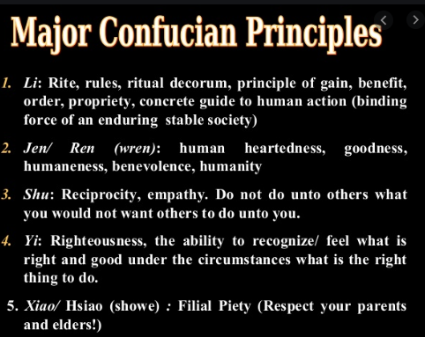
According to a study conducted by the International Labour Organization, Vietnamese women have faced extensive gender pay gaps. In 2016, there was a variation in income amongst male and female untrained employees was 8.1 percent, while for graduate degree holders, it was 19.7. The payment of women in managerial positions was about 12 percent lower than their male counterparts. (Organization, 2008)

Approach
Reward strategy is an approach that the Hanoi Hat Company needs to adapt to make the organization up to date in its strategic human resource strategy. One of the ways Reward strategy is beneficial to the business is that it can pave the way for growth and development at the same time as keeping the workforce happy and satisfied.
At present, the Hanoi Hat Company's approach is simple, Issues of recruitment, pay, and the administration office only handles dismissal. The line managers and employees carry out any other personal problems. There is the issue of time, as well as the short term contract with the international sportswear company that Hanoi Hat Company has taken on, to produce short runs of exclusive models for special events
Starting with the organizational strategy finding out the methods of the Hanoi Hat Company is essential to the reward strategy. For example, the company has adopted the paying system, which they know is required to keep the countless workers alert on the job to generate the maximum results and raise the organization to the next level.
The method of Strategic human resource management, a way to control that encompasses the human resource strategy created to enhance business execution and practices the effect of these procedures on organizational performance. A prevalent meaning of strategic human resource management communicated to the degree that a sequence of arranged human resource management and operations planned to accomplish organization objective. (Robin, 2013)
The Hanoi Hat Company will need to look at issues such as wages and salary. Not all workers will benefit from piece work, and some will work faster than others, which means the employee is free to take as much time as the individual thinks they need to complete the job. Because of this, workers pay much more attention to quantity and not quality.
Identifying and replicating the workforce teams, understanding the work, and the skills applied from the Hanoi Hat Company cutters, which individuals or groups have the skills to be retrained to develop the exclusive models for special events, including making vital policy decisions to support these issues.
Perhaps introducing a membership-based reward system at this stage that an organization gives to their workers may be centered on both the individual's performance or membership principles. The Performance-based reward characterizes with the use of tasks, piecework payment plans, incentive programs, team bonuses, skill pay, or other forms of compensation for performance-based systems.
Performance-centered systems suggest to workers that the effects of an individual's behaviors and required incentives that pull out a suitable answer. Even when training is standardized, being consistent, the appropriate response suggested, offering clarity to the situation may, on the other hand, be a weak one if incentives are deficient in the beginning. (Jorgensen, 2018)

Organizational Commitment
The theory of organizational commitment is a process that will excellently fit the Hanoi Hat Company. In light of the model, there are three stands out factors of organizational commitment. 1. Affective commitment. For instance, the emotional attachment the workers have to the organization, understanding that the workforce has a high degree of active engagement, this supports the chance of the Hanoi workers residing with the business.
In this case, the high degree of engagement where the workforce believes leaving is costly to the company. 2. Continuance commitment. In this instance, the workers of the Hanoi organization will be continuance in their commitment level. Workers have devoted an adequate amount of time and feel attached to the organization. The individual will want to stay in the organization for a more extended period because of this issue.
There is a high degree of engagement where the worker feels obligated to stay. 3. Normative commitment. The Hanoi worker believes staying within the business is the correct thing to do, having a moral obligation to the organization where the individual will choose to remain because the upper above believe in them.
Organizational commitment shapes the core of a vast narrative that determined both on the prototypes of dedication and its ramifications for labor conduct, for example, work turnover, job performance, and worker's wellbeing. Meta-systematic research of literature indicates that organizational commitment is powered by work experience as opposed to the recruitment or option of workers and features the significance of corporate assistance in this system. (Rayton, 2007)
There are many vital advantages of organizational commitment. For example, there will be less absence within the workplace due to Hanoi workers not being overworked due to piece work, along with committed workers looking forward to going to work, fulfilling their task, aiding out projects, and contributing toward organizational goals.
The organization is focusing on the teams and the team players, the actively engaged employees to the organization who willingly invest in the business success who are excellent in collaborating with working teams. So in this instance, it means investing in a group of workers who specialized in the exclusive models for other short term contracts alongside the line managers who want to contribute significantly to boosting the team's productivity.
The Hanoi Hat Company is producing a high level of organizational commitments, which will relate to increased business performance. An increase in profitability, employee retention, customer satisfaction amongst all improving the workplace culture, so enhancing engagement can come in the light of communicating clear goals and expectations to the workers. Employees seem to feel a sense of the need of the organization, so the workers tend to stay longer in the company.
The Hanoi organization forms an influential teamwork culture, and it is imperative to improve organizational commitment. They will have a healthy work environment where any two managers have different ideas, among the diverse backgrounds of the Hanoi people, in light of their religion and beliefs, which surround five main principles of Confucianism.
The definition of organizational commitment may interpret in a variety of ways. However, a few examples, as far as the approach adopted is prominent. The social methodology, for instance, shows that organizational commitment is behavior that surpasses conventional or normative needs. Also, in the attitudinal method, organizational commitment is characterized as a personality of the worker connected to the organization. The evaluation of the degree an organizational commitment regarding the acceptability of corporate objectives by a worker. (Gupta, 2017)
The Hanoi organization's engagement between employer and worker needs to be transparent for the employee to be loyal and also trust the organization, allow the workers to contribute to the company, including the way they can participate more in developing the business.
If the Hanoi Hat Company is transparent, for instance, being open with numbers and figures with the workers, there is a significant chance that the worker will feel valued and increased sense of belonging. They are consequently enhancing the performance of workers through transparency.
Another approach to increase employee engagement is by adopting a positive organizational work culture, having happy workers who enjoy being a part of the group, helps make them feel encouraged and motivated to be able to share innovative ideas and make accessible communication with line management, with no concerns of being misunderstood, which allows the worker to align a personal fit with the organizational culture
The development of employee engagement and commitment has, by tradition, has always been the plan of human resources. The analysis demonstrates that having an engaged and committed staff can prompt many favorable findings, for example, lower turnover aims and higher organizational performance. (P. Matthijs Bal, 2013)

Part Two

Reward Strategy

An essential step in the development of a reward strategy system is to retain the high-level staff the line managers and to motivate the average level staff the cutters to work harder, so maximizing the Hanoi's organization's financial and non-financial resources. Competitors are looking for opportunities to scout the high-level workers at all times. On the flip side, competitors are always exploring for an effective reward strategy plan that can be a good reason for senior employees to leave for the competitors.
Individuals work to obtain an income to look after themselves and their family's need. Most people's needs are vital to there life. According to Maslow's hierarchy of needs, the primary physiological needs at the base and rising through safety, social conditions, and conclude in need for self-fulfillment. Consequently, individuals value rewards in terms of how well it satisfies their needs for security, social esteem, fulfillment, and independence. Unsurprisingly people benefit from different factors differently, which suggests the reward must include many variations.
Maslow distinguished that while an individual's needs are varied, it was significant for the progression in the area of psychology to recognize, teams, and categorize the individual in terms of demand. Every single one of the essential needs he identified characterized, and by a common element and by a degree of importance, is the reason physiological conditions are simply the most significant, and that self-actualization the least. (Stoyanov, 2017)
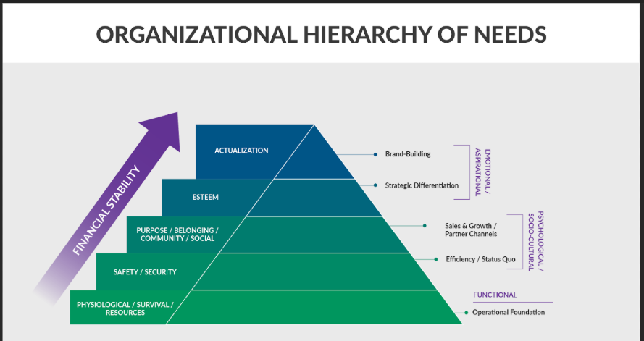
Financial reward is essential because this increases the probability of workers staying within the Hanoi organization, and this helps the business to retain talent. Alternatively, not everybody is concerned with pay, and other reasons could be just as important or more valuable to the individual than money, in terms of the average level staff, the consciousness of being fairly treated in light of there Knowledge, effort and skills is a vital factor
The Self-fulfilment of the ordinary level workers, being acknowledged for what they do as well as inspired to reach their full potential with active learning and development systems, with feedback given on the individual's performance, also organizational culture is a significant factor understanding there are clear roles amongst management and that their values align and workers fit in and enjoy their jobs
When implementing a reward strategy, there has to be an alignment between the reward strategy and human resource strategy. The Hanoi hat company having effective human resource management is the maximum deployment of the capacity of the workers within-group by suitable assigning of workforces and sufficient motivation for all different types of employees.
The goal of implementation initially is to make reward strategies a functioning reality with developing the scope of the company to incorporate the proposition worked out in the development phase. As Armstrong and Brown (2006) focused, 'It is consistently fundamental to plan considering implementation.' (Armstrong, 2014)
The Hanoi hat company's senior manager's intention should be to convince the line managers that the implementation of the reward strategy alongside its practices adds value to the business. Ultimately, this is an essential operation of the organization. The human resource department alongside, the senior staff who are directly involved with an organizational strategy, should be the ones to construct the reward strategy, amongst the support and a consistent review in conjunction with the line managers.
Having an incremental approach to implementing the reward strategy will best fit with the Hanoi company. The managers Allowing the workers to soak up and adapt to the new practices. Due to the organizational culture of the business, the factors of the reward strategy will stage the introduction of the different elements. Continually communicating with all staff throughout this process is fundamental for this strategy to be a success.
Implementing a reward strategy and the way its executed is significant in understanding the Hanoi company's sustainability. Change management should be the approach to implement the reward system. To form a clear vision of what the Hanoi hat organization can achieve by way of when and what advantages and then communicating the change effectively to the workers. The organization must have a meaningful discussion with all organizational stakeholders, and this will not only add value to the proposals but also provide a sense of ownership and buy-in, minimizing resistance to change.
Change management gives a chance to incorporate numerous management themes; for example, the job of learning inside the organization, the need to grow excellent correspondence, group development, and successful human resource management. Specifically, the abilities of the operations managers alongside the project managers, require the implementation of change. The effects of change upon you as an employee or manager and how you can contribute to decisions about the organization's response all play a full role in the successful implementation of change management. (Learning, 2005)
The next steps for the Hanoi hat company are to evaluate and monitor the progress of the reward strategy, so this can mean the organizational performance insight of the organization's profit, productivity, and market position. Ultimately, this also can include individual performance and behaviors. For example, skill development and targets and objectives achieved alongside recruitment, retention, and conflict.
The achievement of the new reward structure and the total reward principles underlining it may see through some necessary measurements. Recruitment costs come down, individuals that leave within a year of service are down, and measuring increased annual survey of employee engagement will increase. The human resource stand fulfilled that the systems they have made are valuable

Conclusion
This report Outlines contemporary reward practices of the Hanoi hat company, for example, having a clear understanding of how the organization will take on a new reward strategy for improvement as well as is a clear insight into how the organizational behaviors affect the corporate culture of the business. In this instance, the people of Vietnam, especially the woman, has lived by the four virtues, hard-working, refined speech, and behavior, three essential Confucian ideas manage the traditional Vietnamese lady.
The organizational culture implies that the many challenges the Vietnamese woman face is social and cultural. For example, the corporate culture centers around the family, which is very important to Vietnamese culture as well as the five main principles of Confucianism.
The reward strategy approach that the Hanoi Hat Company needs to adapt to make the organization up to date in its strategic human resource strategy. Starting with the organizational process finding out the methods of the Hanoi Hat Company is essential to the reward strategy. For example, the company has adopted the paying system, which they know is required to keep the countless workers alert on the job to generate the maximum results and raise the organization to the next level.
The Hanoi hat company's way of Increasing employee engagement is through organizational commitment. There are many vital advantages of organizational commitment. For example, there will be less absence within the workplace due to Hanoi workers not being overworked due to piece work, along with committed workers looking forward to going to work, fulfilling their task, aiding out projects, and contributing toward organizational goals.
Considering how the General Manager can persuade the line managers that the introduction of these reward practices can add value to the business is through reward strategy. An essential step in the development of a reward strategy system is to retain the high-level staff the line managers and to motivate the average level staff the cutters to work harder, so maximizing the Hanoi's organization's financial and non-financial resources is imperative.
Competitors are looking for opportunities to scout the high-level workers at all times. On the flip side, competitors are always exploring for an effective reward strategy plan that can be a good reason for senior employees to leave for the competitors. Also, the Hanoi hat company's senior manager's intention should be to convince the line managers that the implementation of the reward strategy alongside its practices adds value to the business.
Ultimately, this is an essential operation of the organization. The human resource department alongside, the senior staff who are directly involved with an organizational strategy, should be the ones to construct the reward strategy, amongst the support and a consistent review in conjunction with the line managers.

References
Armstrong, M., 2014. Armstrong's handbook of human resource management practice. 13 ed. England: Kogan Page.
Gupta, M., 2017. Corporate Social Responsibility, Employee-Company Identification, and Organizational Commitment: Mediation by Employee Engagement. Current Psychology, 36(1), pp. 101-109.
Jorgensen, K. S. F., 2018. Performance-based rewards and innovative behaviors. Human Resource Management, 57(6), pp. 1455-1468.
Learning, E. L. P. F., 2005. Change management. Britain: Management Extra. Taylor & Francis Routledge.
Organization, I. L., 2008. Work, Income, and Gender Equality in East Asia: Bangkok: Nelien Haspels Eva Majurin Subregional Office for East Asia.
P. Matthijs Bal, D. T. A. M. K., 2013. How Do Developmental and Accommodative HRM Enhance Employee Engagement and Commitment? The Role of Psychological Contract and SOC Strategies. Journal of Management Studies, 50(4), pp. 545-572.
Rayton, A. M. B., 2007. The contribution of corporate social responsibility to organizational commitment. The International Journal of Human Resource Management, 18(10), pp. 1701-1719.
Robin, K., 2013. Beyond strategic human resource management: is sustainable human resource management, the next approach?. The International Journal of Human Resource Management, 25(8), pp. 1069-1089.
Stoyanov, S., 2017. An Analysis of Abraham H. Maslow's Theory of Human Motivation. 1 ed. England: Macat International Limited.

