Graveyard Survey: Saint Peter’s Church, Lampeter

This report presents a detailed survey of the graveyard at Saint Peter’s Church, Lampeter, with a specific focus on iconography and symbols used throughout the site. It explores the historical significance, artistic expressions, and cultural meanings behind gravestone motifs. The study employs systematic data collection methods, including photographic documentation, mapping, and analysis of symbolic representations. The findings reveal patterns in the use of religious, secular, and nature-inspired symbols, shedding light on evolving attitudes toward death and remembrance. The discussion integrates background research with field observations, highlighting the graveyard's role as a historical and cultural record.

Keywords: Graveyard, Iconography, Symbols, Memorials, Inscriptions

Introduction
Graveyards serve as valuable historical archives, reflecting social structures, religious beliefs, and artistic expressions. One of the most significant aspects of memorialization is the use of iconography and symbols, which communicate messages about faith, mortality, and personal identity. The study of burial symbols provides insights into changing attitudes toward death, the afterlife, and cultural influences over time. Saint Peter’s Church graveyard, Lampeter, features a diverse range of iconography that offers a glimpse into past commemorative practices. This survey examines the meanings and significance of these symbols, contributing to the broader understanding of burial traditions in Wales.

Methods
To ensure a comprehensive survey, data collection was conducted through the following methods:
- Photographic Documentation: High-resolution images were taken to record gravestone carvings, symbols, and inscriptions.
- Iconographic Analysis: Symbols were categorized based on religious, secular, and nature-inspired themes to determine their frequency and significance.
- Environmental Assessment: Observations were made regarding the preservation of symbols and the effects of weathering on their visibility.

Evidence
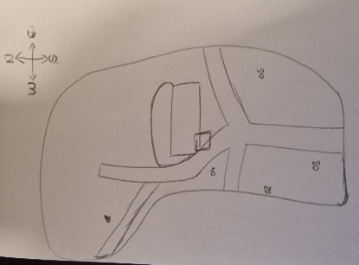
00. Map of Saint Peter’s Church

G1: Mary Anne & Hartley Seldon Luckman

- Description of the Grave
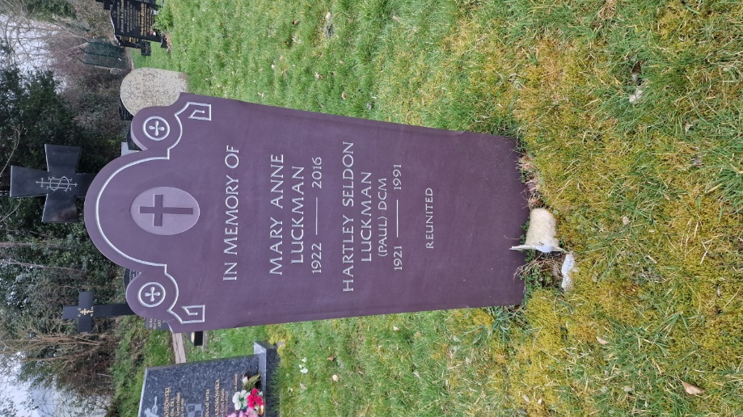
  - Material & Condition: The gravestone is made of polished dark stone, possibly granite, which is well-preserved with clear inscriptions.
I
  - Shape & Style: The headstone has an arched top with two symmetrical side flourishes, incorporating religious iconography.
  - Inscription Details: The epitaph is deeply engraved, commemorating Mary Anne Luckman (1922–2016) and Hartley Seldon Luckman (1921–1991), with the phrase “Reunited” at the bottom, emphasizing a connection even in death.

- Iconography & Symbolism
  - Cross in a Circle (Top Centre):
The central cross, enclosed within a circular frame, is a Christian symbol representing faith and eternal life. The circle around the cross may symbolize unity and eternity, reinforcing the belief in resurrection.
  - Small Crosses and Scroll-Like Flourishes (Sides):
The decorative elements surrounding the central cross echo traditional memorial designs, suggesting continuity, faith, and remembrance. The scroll-like design could symbolize the unfolding of life’s story.
  - “Reunited” Inscription:
This word conveys the belief in an afterlife where loved ones will meet again, a common theme in Christian memorials emphasizing eternal bonds.

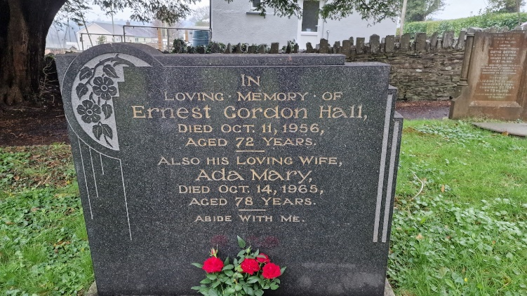
G2: Ernest Gordon Hall & Ada Mary
II
1. Description of the Grave
- Material & Condition: The gravestone is made of polished dark granite, which is highly durable and resistant to weathering. The inscriptions are engraved in gold lettering, which contrasts well against the dark background and remains clearly legible.
- Shape & Style: The headstone has a stepped, asymmetrical design with a curved floral motif carved into the upper left corner, adding an artistic touch to the memorial.
- Inscription Details: The epitaph honours both Ernest Gordon Hall (died 1956, aged 72) and Ada Mary (died 1965, aged 78). The phrase “Abide With Me” at the bottom references a well-known Christian hymn, often associated with faith, comfort, and the presence of God in life and death.
2. Iconography & Symbolism
- Floral Engraving (Upper Left Corner):
  - The floral design, featuring leaves and flowers, likely represents the fragility of life and the beauty of nature.
  - Flowers, particularly roses, often symbolize love and remembrance, reinforcing the connection between the deceased and their loved ones.
- Gold Lettering:
  - The choice of gold lettering signifies reverence and respect, often associated with wealth or a desire for a lasting tribute.
- Biblical Reference – “Abide With Me”:
  - This phrase comes from the Christian hymn written by Henry Francis Lyte in 1847, often sung at funerals. The words express a plea for divine comfort and presence during life’s final moments, reinforcing the family’s faith and hope in eternal life.

G3. Gwenllian Jones & Evan Jones
1.Description of the Grave
- Material and Condition: The Gravestone is made of dark stone, possibly granite or slate. The Gravestone is well preserved with clear inscriptions and decorations.
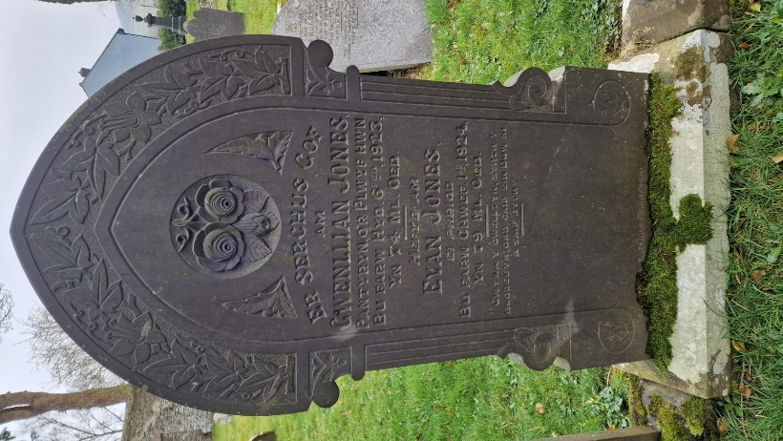
- Shape and Style: The headstone has a symmetrical arch design engraved with an ivy pattern with decorated pillars going down each side. There is a central carving of flowers at the base of the arch.
- Inscription Details: The epitaph honours both Gwenllian Jones (died 1923, aged 74) and Evan Jones (died 1924, aged 79). The inscription reads Gwyway y Gwelltyn, syrth y blodeuyn ond cair ein Duw ni a saif byth which translated to The Grass withers, the flower falls but the word of our God will stand forever
III

2. Iconography and Symbolism
  - Floral Engraving (Centre): The two roses attached at the stem symbolize everlasting love between a couple, the dead hanging rose underneath the two blooming petals likely indicate a deceased child.

  - Floral Engraving (Around arch): Ivy carved into a tombstone is said to represent friendship, fidelity, and immortality. The hardy, evergreen lead of the ivy denotes immortality and rebirth or regeneration.

  - Biblical Reference: 40:8 – The Grass withers, the flower falls but the word of God will stand forever.

G4: Elizabeth Thomas, Evan Thomas & Ellen Anne
- Description of the Grave
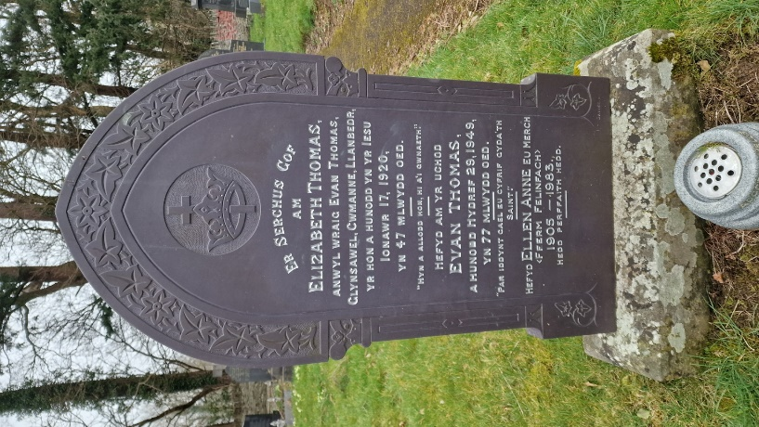
- Material and Condition: The Gravestone is made of a dark stone, possibly slate or granite. The Gravestone is very well preserved with clear engravings and carvings.
IV
- Shape and Style: The Gravestone has a symmetrical arch engraved with a floral design with decorative pillars going up each side. It is sat on top of a base stone.
- Inscription Details: The epitaph is fully in Welsh, engraved with silver and honours Elizabeth Thomas (died 1920, aged 47), with the engraving “Hyn a allodd hon, hi a’I gwnaeth”, Evan Thomas (died 1949, aged 77) with the engraving “Par iddynt cael eu cyfrif cyda’th saint” and Ellen Anne (died 1983, aged 78) with the engraving “Hedd perffaith hedd”

- Iconography and Symbolism
- Floral Engraving (Around arch): Ivy carved into a tombstone is said to represent friendship, fidelity, and immortality. The hardy, evergreen lead of the ivy denotes immortality and rebirth or regeneration
- Central Engraving: The Crown with a cross through it symbolizes the reward in heaven that comes after the difficulty of life.
- Biblical Reference 1: Engraving “Hyn a allodd hon, hi a’I gwnaeth” meaning “She hath done what she could” [Mark 14:8]
- Biblical Reference 2: Engraving “Par iddynt cael eu cyfrif cyda’th saint” meaning "May they be numbered with your saints" is a prayer or a wish for someone to be included among the blessed and holy.
- Biblical Reference 3: Engraving “Hedd perffaith hedd” meaning Peace, perfect peace

G5: D.Sturdy
- Description of the Grave
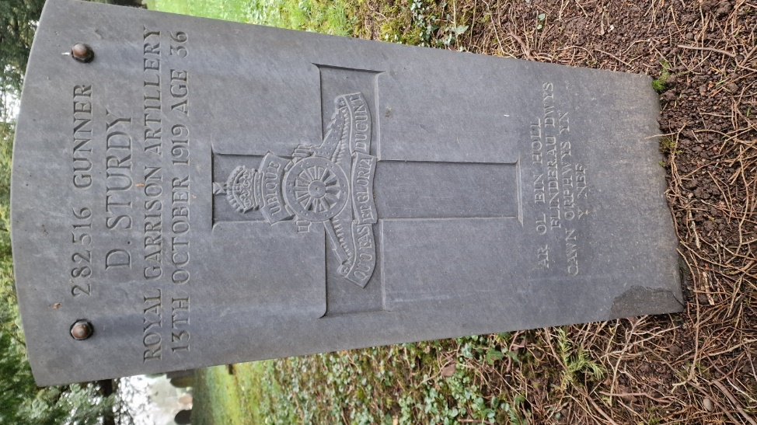
  - Material and Condition: The gravestone is made of a light stone, most likely a limestone. The grave is in very good condition with easily read inscriptions.
V
  - Shape and Style: The gravestone has a very shallow round top with straight sides.
  - Inscription Details: The epitaph honours Gunner D.Sturdy (died 1919, aged 36), Royal Garrison Artillery with the engraving “ar ol ein holl flinderau dwys cawn orphwys yn y nef”. His serial number 282516 is written at the top of the grave.

- Iconography and Symbolism
- Central Engraving: The Centre of the gravestone features a large cross containing the symbol of the Royal Artillery badge with their own motto: QUO FAS ET GLORIA DUCUNT (Where fate and glory lead) with the scroll above stating UBIQUE (Everywhere)
- Reference: Engraving “ar ol ein holl flinderau dwys cawn orphwys yn y nef” meaning “After all our intense fatigues we find rest in heaven”.

Conclusion

This study of five graves at Saint Peter’s Church, Lampeter, highlights the importance of symbols and inscriptions in memorials. The use of crosses, floral engravings and religious phrases shows a strong connection to Christian faith and beliefs about the afterlife. Each gravestone reflects not only the individuals buried there but also the traditions and values of their time.
Common themes, such as family bonds and remembrance, were evident in phrases like “Reunited” and “Peace, Perfect Peace” shows the comfort that faith and memory bring to loved ones. The choice of materials, such as polished granite and gold lettering, suggests a desire for lasting tributes.
Overall, this survey shows that gravestones are more than just markers—they tell stories about people, their beliefs, and how they are remembered. Future research could explore changes in gravestone design over time or compare symbols in different cemeteries.

