ASSESSMENT 1
STUDENT NAME: SADAF HEERA RASHID
STUDENT ID : 1814941
MOUDLE : CHANGEMAKERS: BUILDING YOUR PERSONAL BRAND FOR SUSTAINABLE EMPLOYMENT
MOUDLE CODE: BMHP5015
LECTURER : Dr MARK GALLAGHER-READ

COVER LETTER FOR SOCIAL WORKER

09/02/2022

Sadaf Heera Rashid
07913609338
Hirasrashid@hotmail.co.uk
Linked/in/ Sadaf
@sadaf97407797

Senior Social Worker, Birmingham’s Children Trust, Sandwell

Dear Recruitment officer and Head:

I am very please to be applying for the opening position of a social worker on your website. I have got primary experience in social work and a degree in BSC in Health and Social care. And a postgraduate in social work. I am very excited for this position and pretty confident I would be suitable for this job. I do believe I have the right skills, and ability for this role. I always wanted to be a children social worker and I do believe I got very good understanding in children’s development topics and with future experience it will give me more knowledge.
I have got ability to give support and care to children and their families in difficult circumstances. My DBS (Disclosure of Barring Service) is clear.
And please note as Urdu/English interpreter in past I have got good communication skills in different languages. And very good IT and computer skills. These skills in future will contribute to my success goal.
I have got some experience in children with mental health who needs extra care and love. “Mental health problem in UK affects around one in six children. Which will include depression, anxiety and behaviour problem”. (August 12, 2021)
Further this position will give me the perfect opportunity to work with children and their problems and issues.
I would be very honoured and and happy to work in such a good environment and with other co social workers.
In my studies I have learn a lot of skills about social work in my BSC Health and Social work.
. Flexible working hours (available at any time)
. DBS clear
. BSC(Hons) Health and social care
. Good communications and social skill
. Experience in children needs
. Worked with children with Mental Health

I am sure I have got patience and ability to work in challenging situations. And work in groups or individually to support children and vulnerable families. I am ready to work in any situation, to make decisions on my own to protect children and provide the best shelter and education for their wellbeing.
In addition to my degree and experience I am fully capable of working with children with mental health issues and problems. Social worker role is quite demanding and challenging sometime but I am ready to tackle that role.
I would love to have that opportunity to work in one of the best social worker agency in city. I look forward to hearing from you soon.

Thank you for your time and consideration.
Your sincerely
Sadaf Heera Rashid

PROFESSIONAL HEALTH AND SOCIAL CARE CV

Health Care Assistant CV Sample
Health Care Assistant/ City Nursing Home/Hospital Birmingham
(Sadaf Heera Rashid/ Aubrey Road/ Birmingham/Midlands/ B10 9DG/ 07913609338/ Hirasrashid@hotmail.co.uk)

My Professional Summary:
I am mother of three and have got experience in health care field and very keen to get this job, caring for patients in hospital or care homes (health care assistant) is my passion and this is the area I wanted to work in. I have got the perfect skills and experience for this job. Including very good practice. I have got some experience for the Eardley and disable patients as well when I was working in city nursing home as voluntary basis. After my education I always wanted to go into this field to work in care home, nursing home, hospital, or school with special needs. Always had passion for this role. I have got IT skills which will be very help full in this job. I am flexible working in day or night shift as my children are grown up and independent. I am very responsible person and will not compromise on any patient or fellow workers privacy matter.

Qualifications:
Had previous qualifications from Pakistan
School/collage (Pakistan)
1986-1996/ Model school
1996-1998/ public secondary school
1998-2001/ Mirpur girl’s collage

Education in UK
Certificate of Higher Education in Skills for Workplace / August 2020 (University of Wales Trinity Saint David)
BSc (Hons) Health and Social Care / September 2023/ University of Wales Trinity Saint David

Key Skills:

. Good IT Skills
. Good Communication Skills
. Got a car
. Clear DBS
. Can read and write Urdu/Punjabi/English
. first Aid pass
. Good team worker
. Very friendly
. Good experience in care work
. Available in day and night shift
. Respect patients Privacy
. punctual /Time management
. Can work with elderly young / Special needs
. Good Team Worker

Key Achievements:

. After my graduation I attended patients in care homes and hospitals and some patients with mental illness and disabilities, so I have got a lot of experience in this area.
. I know how to look after patients physical and emotional wellbeing.
. I have experience of taking patient health check, blood pressure/ blood check/ monitor heart rate/ oxygen rate/ weight / pulse including dressing management.
. I can take care home patients out on shopping trips or physiotherapy appointments.

Experience:
2017- 2020

Ideal Care Home, Small Heath

Looked after elderly disable patients/ about 12 patients i use to look after in 1 year time a done there.
City Care Home (2018-2020)
Worked there for 2 years and care for patient and residence of all ages (10-90) Tasks like feeding medications making notes, health checks, taking out from bed to all their chores, and taking them for walks and personal care.
In-between My education and jobs I have worked and gain a lot of positive experience from voluntary work with local charities and Care homes.

Providing high standards of care and time will be my main motto. And I will love this job because it is rewarding. I will be looking forward to hearing from you and hoping to get this position, Thanks

Sadaf Heera Rashid

Create a “pitch” to convince a company to accept your proposal for a TV series, radio show, documentary, or a book, on a topic relating to your professional area of interest within Health and/or Social Care.
COVID 19

For this Task I will be creating a “pitch” a company or organisation to accept my proposal for Documentary I want to make about “Covid 19” one of the biggest pandemic of our time. 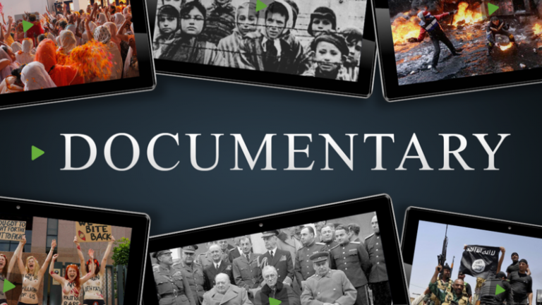
This Photo by Unknown Author is licensed under CC BY-SA-NC

In this part of my pitch, I will be making a Documentary about “covid” 19 (Coronavirus) which has change life’s all around the world. We going to document about the aftereffects and impact of covid 19 in our lives and all around the how has lives have changed since and for some probably forever. Daily lives have changed in relation to daily activities, social life, hygiene, and day to day normal life is change. “Gulnaz M”.
. What is Covid 19 and what is its origin?
Covid 19 (Coronavirus) first case was detect in Wuhan, in China. According to “The Guardian” Coronavirus first case came from Wuhan Animal Market and not in Chinese Lab, “Martin P/ 2022”. But there are some theories that it started in a Chinese Lab and was an experiment which was gone wrong.
Covid 19 is an acute respiratory disease(illness) in humans, coronavirus can produce severe breathing difficulty in some cases death, it can attack lungs straight away and like pneumonia attack. For most people it’s like cold/flu symptoms. Older people and people with underlying condition are at very high risk. It started in 2019 and WHO (World Health Organisation) declared Covid 19 pandemic to whole world.

. How dangerous and deadly “Covid 19” is and the total Death rate?

Coronavirus is a respiratory disease and very deadly for people for age 60 and people with under lying Medical Health Conditions. “According to WHO (World Health Organisation) 60% people was over 60 who had covid 19”. Coronavirus is worst hit pandemic of recent years.

Up until now There are 442M (million) people had Covid 19 and 5.97M (million) Death recorded so far. This is not exact figures, but the people had tested positive in test Centres hospitals or local facilities.
Covid 19 is like flu symptoms though (fever, body aces, cough, and loss of taste and smell which was new) but for some people it attacks their lungs and they needed care in hospitals. If you test positive with it, you have to self-isolate for 14 day (from March 2020) then 10 days in 2021 and in 2022 5-7 days but now these restrictions have coming to end in UK and some parts in other countries.
WHO (World Health Organisation) did say in start of pandemic to the whole World “Our key message to the world is test, test and more test” BBC/March 16,2020”?
So covid testing was key to know how many people Positive are, in this disease some people do not show any symptoms and can actually spread the virus(coronavirus)
Coronavirus is very contagious and dangerous and deadly for some people.

. How Covid 19 has change the world and change, lifestyle, travelling, eating day to day activities have not going to be same.

“We are living in different World”

The year 2020 was a hard difficult year when worse hit Pandemic name Coronavirus hit the world. This is worst Pandemic in 100 years, this illness has affected nearly everyday activities from work, school even getting groceries hard. Life has change since “Rachael R/ Dec 2020”
I remember in start of March 2020 whole UK went in Lockdown yes Lockdown (shops got close, schools close, business close everything in Lock down) this was something no one had experienced in their life before. Whole world went to lock down in 2020. People cannot go out anywhere unless it was a medical emergency or just one adult from house can go shop for groceries, kids have to stay home no school no playtime in parks or anywhere. Families cannot travel to see their loved ones. Masks was new normal and still is, all the important procedure and operations was cancelled. Many cancer and other patient died waiting for their opts. Then Covid testing was introduced in June 2020 for public which is free.

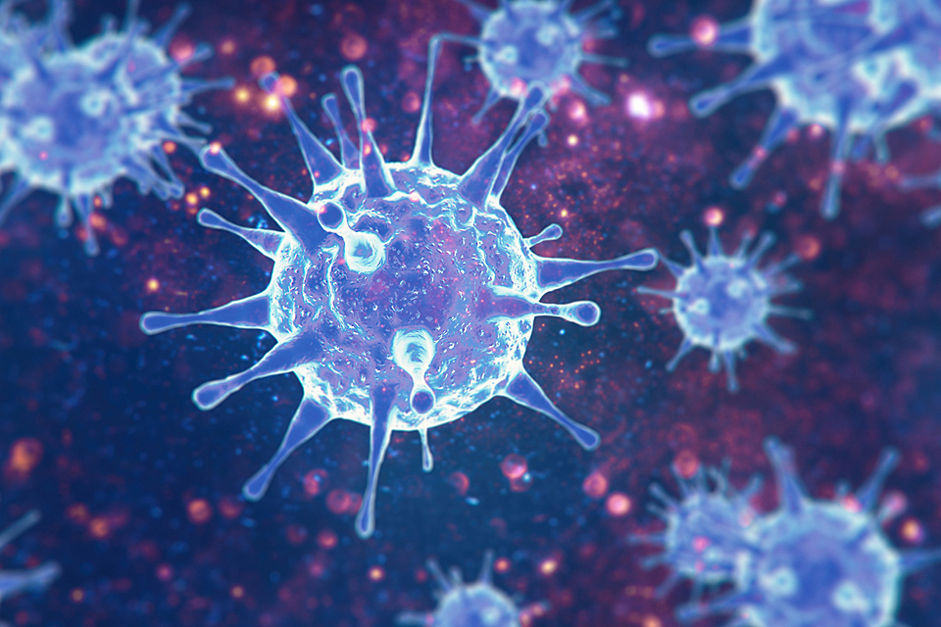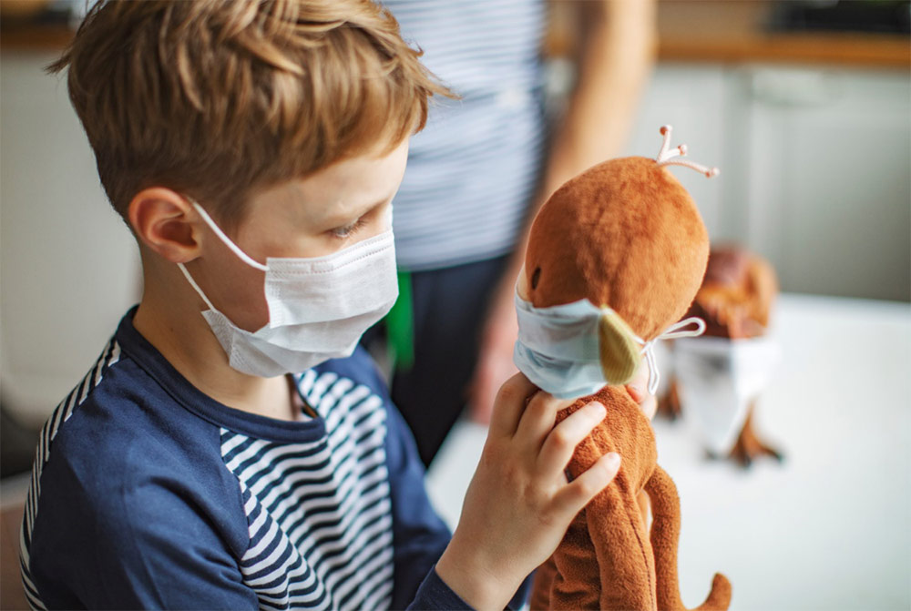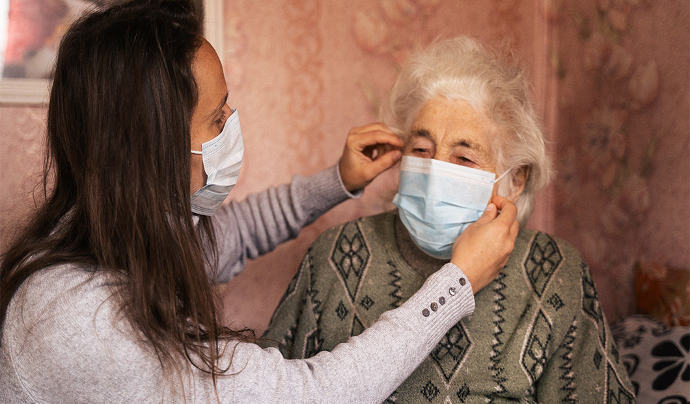

https://post.healthline.com/wp-content/uploads/2020/04/Female_Face_Mask_Elderly_1200x628-facebook-1200x628.jpg

https://thedacarecovid19.org/wp-content/uploads/2020/07/child-wearing-mask-plays-with-stuffed-animal-also-wearing-mask.jpg

https://th.bing.com/th/id/OIP.PyC2GZtQNUMjUSW3ExgpeAHaE8?pid=ImgDet&rs=1

“Lock Down Life”

. Working from Home”
. Schools closed
. leisure/ Gyms/ Restaurant/ Hair salon Closed
. International Traveling was Ban
. only one person per Household allowed in essentials shops
. Over 60 not allowed to even meet with their loved ones
. family friends can not meet under no circumstances
. weddings cancel
. Businesses closed

“Mental Health in Lock Down”

Due to Covid millions of people couldn’t meet their loved ones, due to travelling ban they can not even meet their dying parents or family or friends which has affect a lot of people and their Mental Health. It was very difficult time and lock down could not help in that time. Older people were alone no one to talk to them and family and friends was not allowed to visit them. “According to WHO 130 Countries across the World show more demand in Mental Health Services than ever before, because of isolation and loneliness and loss of loved ones that trigger increased level of drug use, alcohol use, insomnia, and anxiety.” “October 5/2020”
People in UK and all around the world went in depression with the fear of Covid 19 and people loss their business and income. Millions of people loss their jobs and left them with no income.
Due to lockdown with schools, nurseries and collages was shut, that had effect children mentally and physically. Thousands of children in deprived areas got ignored in lockdown. Children living on flats with no garden (nowhere to play) get effected mentally in pandemic.

Overall Covid 19 has affect us all very bad all around the world. Getting vaccinated is now the only cure and way out from this nasty diseases which killed million of people all around the world.

REFRENCES:

.10 ways Covid 19 changed the world.
By/ Racheal Rettner December 31/2020

. Children and young people / August 12
https://www.mentalhealth.org.uk/a-to-z/c/children-and-young-people

. Shorter Documentaries “The impact of Covid-19”
https://www.essity.com/company/essentials-initiative/stories-and-videos/covid-documentries/

. The Guardian
Martin Pengelly/ 26 February 2022
https://www.theguardian.com/world/2022/feb/26/coronavirus-wuhan-market-chinese-lab-studies

. World Health Organisation
Coronavirus diseases
https://www.who.int/westrenpacific/health-topic/cronavirus

