Megan Roles
1701337

Illustration

Contextual Studies

Ways of Perceiving
ADAD4010

Mr Scott Smith/ Martin Bush

Total word count without bibliography: 1,484

Total word count with bibliography : 1,971

The art of murder, or art murderers make, why do people commercialise crime?

In this exhibition I am going to look at the commercialisation of crime whether that be of a serial killer or gangsters or other forms of crime with not only the commercial side being explored but also the art of the individuals mentioned from the art of Charles Manson to the Kray twins.

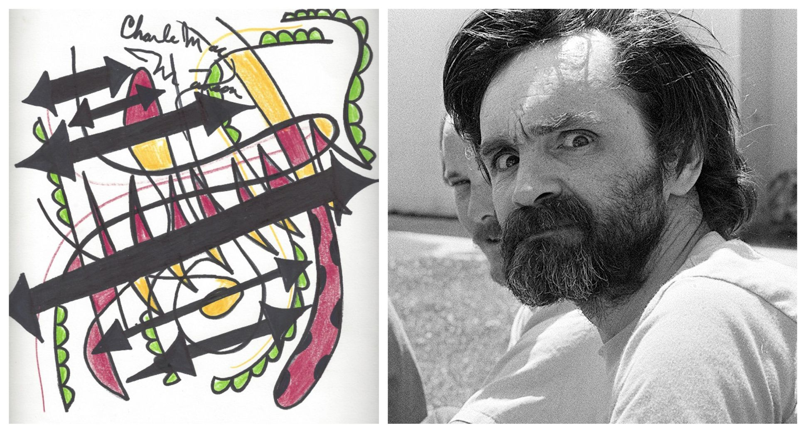
Commercialisation can be seen as a greed or selfishness that is involved when certain marketing forces are let loose on society. The danger of commercialisation is not the process itself but us as individuals using it as a constant form of identification for inner and outer manifestations. In physiological terms there is very little understanding needed as we can not entirely comprehend something that is in its self a dictionary definition. The oldest understanding of commerce is simple buying and selling which has almost been lost to us from a certain perspective as different marketing avenues have been explored and therefore become the norm to many people with us all coming under the umbrella of commercialisation. That in some cases can be a disease to places such as small businesses and high streets it is in it self its own killer disease. There is however no problem with the exchange of goods and services within our society this is how we trade international. However things such as a knife can be used to cut vegetables or have a more sinister application, so there can be two sides to commercialism one that prospers and one that kills.
Charles Manson(Pablo Picasso period)

Commercialisation itself does have its share of concerns, as some see it as a misleading tool to their creativity with the added hitch of not allowing them to fulfil this creativity along with simple needs that we all have as individuals. The fear is that it can also skew our motives and create a mindless pursuit of things such as profit and promote endless consumption on our part. So why do we allow our selves to fall into the commercialisation of crime. Whether it be a book, film, tv programme or game we have all fallen into this trap and have become consumed by others greed to become profitable and allowed them to do so. And with illegal intentions being the main profitable scheme here, the felons themselves may have these notions themselves to gain money through crime or simply become a depraved individual that believes murder is the way to life.

The most common option of the commercialisation of serial killers people could recognise is the production of movies depicting the killers themselves in the middle of their deprived acts. Some are more prolific than others for example Ted Bundy who became the master at psychopathic seduction in order to kill his assumed at leas thirty female victims. This glorified killer has been put on a pedestal by the film industry with at least six films being based off of this specific murderer. The charisma of the man made him more of an opportunity to commercialise and highlights the lengths that industry will go too, to sate their greed.

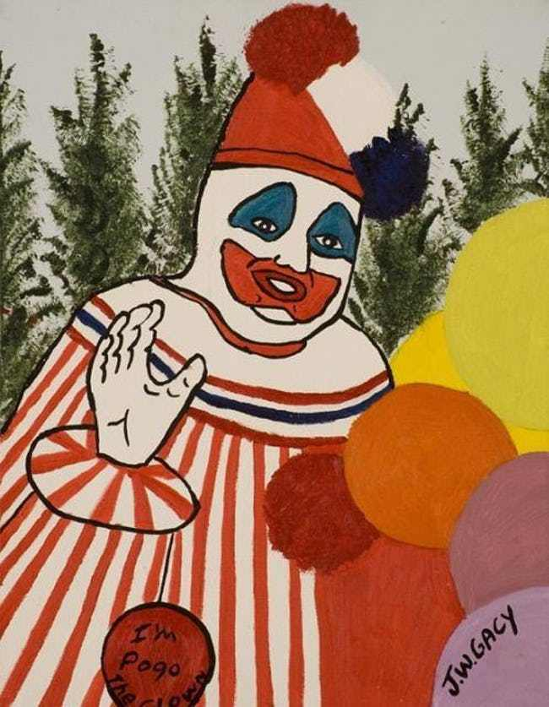
Not all people however are after money, London based artist Nicola White is the founder of ArtReach. Which is a program that commissions and sells the work of death row inmates
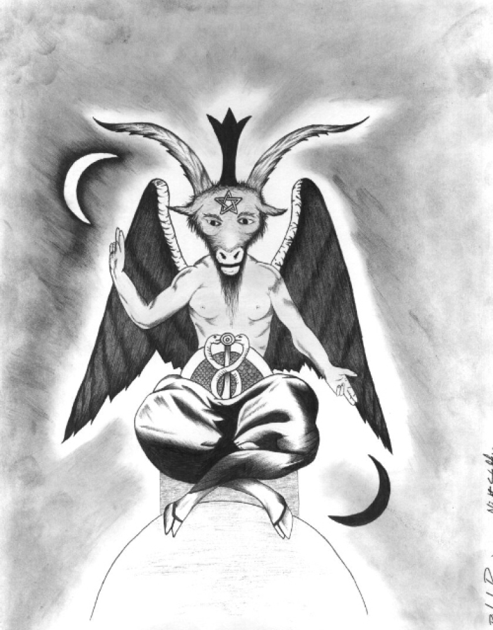
In San Quentin prison in the state of California. She herself says that her interest in their work lies with their artistic impressions of the convicted murderers on death row and in this practice has nothing to do with the profit from each commission. With the ideal of “putting a little bit of light in every dark place”. The ArtReach work is sold online or at exhibitions in the UK and USA, the artists featured are forty inmates represented by Nicola White. The paintings price at between $20 and $300 with all the proceeds going towards art supplies or to charities. White herself says that not one of the inmates are trying to make money from their crimes. This however is not just a understanding between white and the forty inmates it is also a law in some US states, New York being one of the first states to introduce the Son of Sam Law in 1977 so named after the serial killer David Berkowitz or the Son of Sam killer. The change in law meant that murderers were prevented from cashing in on their despicable endeavours. Forty one states drafted similar laws to the one drafted in New York and although these laws are challenged regularly by criminals, the laws were not only challenged by the criminals themselves but also the US Supreme Court, who 1991 unanimously voted amongst themselves that the Son of Sam laws violated the first amendment( first amendment protects against several basic freedoms such as freedom of religion, speech, press, the right to assemble and the right to potion the government). The laws are there for killers to prevent the creation of money although this money sometimes may not be made by the killer. William Harder who runs Murder Auction since 2005, has developed many personal relationships with numerous killers and has listed up to ninety of them in prison including The Night Stalker Richard Ramirez. Harder himself sells memorabilia but claims to have never sold anything that the killers themselves gift him as it would be a break in trust within the relationships that he develops and he has to much respect for them as people to do that to them and sell on a personal gift. The only items he claims to sell on is anything acquired from other sellers as these are not a dissolution of trust just a means to an end. Although this cannot be said for some dealers who in an effort to make a quick buck will pose as women in letters to the killers and develop a relationship with them to acquire items to sell. This situation happened to John E.Robinson (a rapist and serial killer of at least eight women) he went on to express his hate for “bottom feeders” who prey on the people in prison for their own monetary gain. Crime however can be such a lucrative business that not only do killers themselves sometimes receive a large amount but people will go to the extremes and forge a painting such a painting done by John Wayne Gacy( notorious serial killer and children birthday clown who tortured and murdered at least thirty three men and boys) the paining itself was a “lazy fake” with the date and signature being written as two years after his execution. He himself created thousands of painting both before incarceration and during, the original selling price in the 90s of some of his work was as much as $250 and with the same painting years later selling for up to $50,000, so crime no matter where you are is still a lucrative business whether that be for the killers or the merchants who make a living selling the art of some of the most despicable individuals living or dead today. And although so dealers may have a lucrative business in the trade of this murder memorabilia, William Harder states that any typical dealer who manages to sell a few paintings a month can likely only see at best up to $800 a month if they are lucky.
John Wayne Gacy(pogo the clown)
Richard Ramirez

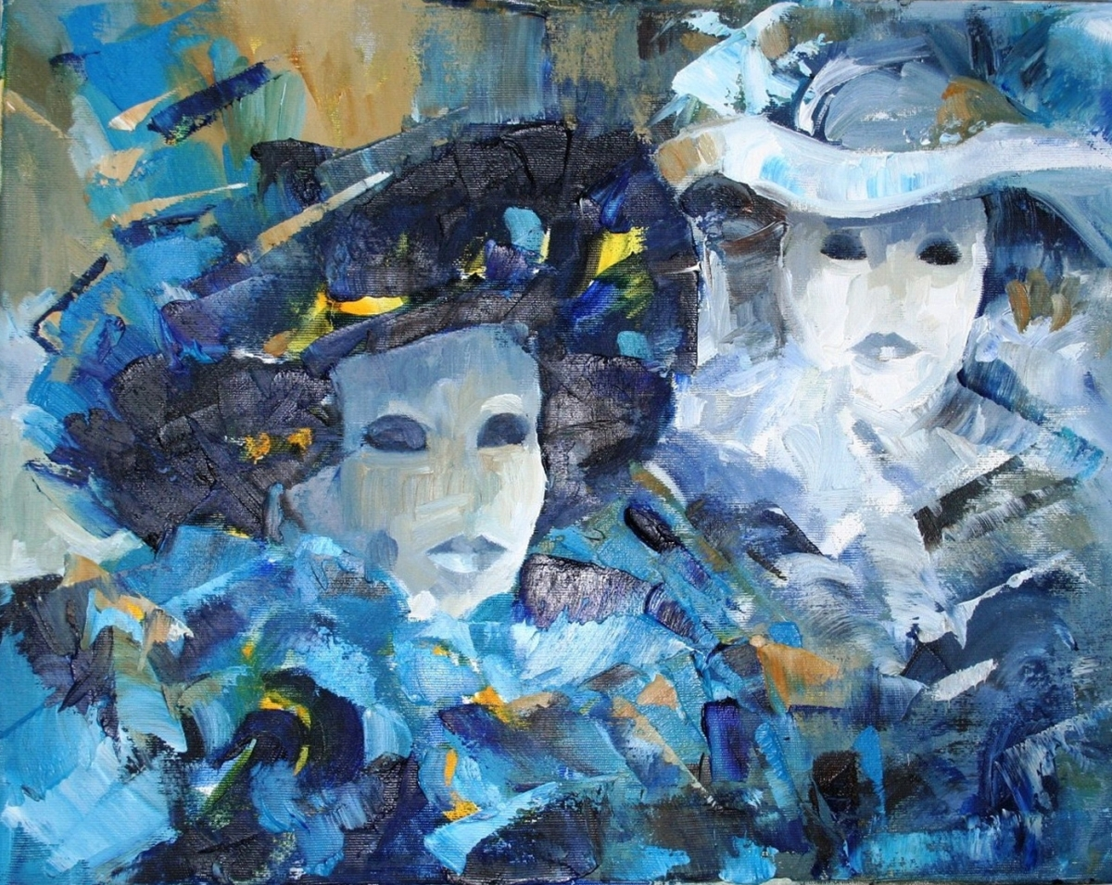
Memorabilia itself in many ways is a contradiction as dealers and even the murderers who have created the piece themselves want to separate themselves from the art. Their own individual expressions that come out inlet these pieces are in no way an extinction of their crimes and don’t wish fo their work to be seen as this. This is due to people being so prejudice that they would have a hatred for the individual responsible for the artwork purely because of who they are and what they have done. They are incapable of appreciating the art for what it is. This is true to some extent but without the notoriety of the killer themselves their art would not necessarily be selling for thousands of dollars at a time if they weren’t acknowledged in the first place as the killers work. Without context most art is unmemorable to those who happen upon it. The dealers themselves sometimes are no better than the criminals themselves they are in reality sometimes grooming the killers to do there bidding and created a source of income from those incarcerated. The criminals can also make a difference much like the Kray twins did with theirs which went to auction for charity and although juvenile it was the notoriety that allowed for the sale and collect that would help charity. So although the commercialisation of crime can leads to bottom feeding of the masses it also can be benefited especially when certain notable criminals use the attention to help a worthy cause no matter what depraved thinned they did in there lives.
The Kray twins
Bibliography

Taryn Simon : The Innocents august 2nd - October 1st, 2005, Hugh M Hefner Foundation, John Simon Guggenheim Foundation Fellowship in the Photography ,http://www.mocp.org/exhibitions/2000/5/taryn-simon-the-innocents.php

Is it a crime to take pictures?, Victoria Bone, BBC news, Monday 16th February 2009, http://news.bbc.co.uk/1/hi/uk/7888301.stm

The Top 10 Crime Scenes in art, the Guardian, Jonathan Jones, Wednesday April 23rd 2014, https://www.theguardian.com/artanddesign/jonathanjonesblog/2014/apr/23/top-10-crime-scenes-in-art

True crime: the women making art out of murder, the Guardian, Emine Saner, Tuesday 24th February 2015, https://www.theguardian.com/artanddesign/2015/feb/24/forensics-the-anatomy-of-crime-wellcome-collection-female-artists

2 images used from website/Criminal art: paintings by famous killers and criminals, huffington post, Sam Parker, 21/08/2012, https://www.huffingtonpost.co.uk/2012/06/21/criminal-art-famous-killers-paintings_n_1615653.html?guccounter=1&guce_referrer=aHR0cHM6Ly93d3cuZ29vZ2xlLmNvLnVrLw&guce_referrer_sig=AQAAAIAkzf2BU9EPwFPcNxQABUbsHrecHnkkj5va5ZlNK2z8-QOBQi8EirsiEpitQCxWwymq1oPi5mRtmhRiqkauyfM5qFJTYGOlPd2EGwtwaK6aEr70XV00uLLVEs9FetEarfmO9NGFlrZ87EuCRe69tEraF6tZior3eTf-HNRNbueH

The Krays: The Prison Years, David Meikle and Kate Beal Blyth, arrow books

Kray painting sold at Woking auction, BBC news, 21st September 2012, https://www.bbc.co.uk/news/uk-england-surrey-19678674

Invaluable (the worlds premiere auctions and galleries), https://www.invaluable.com/artist/kray-ronnie-379zytg0i8/sold-at-auction-prices/

Image of John Wayne Gacy’s work: 20 extremely creepy and disturbing artworks by serial killers, Jacob Shelton, https://www.ranker.com/list/serial-killer-art/jacob-shelton?page=4

Inside the creepy underground world of serial killer art, where Manson means money, Observer, Eric Spitzangel, 10/29/18, https://observer.com/2018/10/serial-killer-art-lucrative-charles-manson-richard-ramirez/. (1 image of Manson’s art)

Art sheep, 10 brutal serial killers and the creepy artworks they created, unknown author, https://art-sheep.com/10-brutal-serial-killers-and-the-creepy-artworks-they-created/

4 spine chilling unsolved occult murders that will scare you senseless, crime wire, Ed Smith, august 12th 2015, https://www.instantcheckmate.com/crimewire/post/occult-murders/

Morality prevents crime, university of Cambridge, published 25th June 2012, https://www.cam.ac.uk/research/news/morality-prevents-crime

Knife crime: assault data can help forecast fatal stabbings, university of Cambridge, Cambridge journal of evidence-based policing, 15th April 2019, https://www.cam.ac.uk/knifehomicide?ucam-ref=read-this-next

10 most deranged serial killers of all time, online psychology degree guide, https://www.onlinepsychologydegree.info/worst-serial-killers-of-all-time/

How many un-captured serial killers are out there?, Live Science, April 28th 2018, Stephanie Pappas, live science contributor, https://www.livescience.com/62431-how-many-serial-killers-free.html

9 serial killer movies based on true stories, serial killer shop, July 07 2017, Daniel Lukacs, https://serialkillershop.com/blogs/true-crime/9-serial-killer-movies-based-on-true-stories

