ACDA5001
Electrical Engineering
(2415170)
Conner Kinsey



Table of contents
1. Introduction 3
2.Circuit modelling and analysis 4
2.1 Circuit modelling 4
2.2 Voltage and current waveforms 5
2.2.1 Power factor v Capacitance 8
2.2.2 Power factor v Phase angle 9
2.2.3 Energy Stored in the Inductor and Capacitor 10
2.3 Phase angle calculations 11
2.4 Power Factor Calculation 12
2.5 RMS values and power calculations. 12
2.6 Target Power factor 13
3 Phasor diagrams 13
3.1 Phasor diagram at 50Hz 13
3.2 Calculations for △OAC 14
3.3 Calculations for △OAB 15
3.4 Complete Phasor diagram 16
4 Capacitor values 17
TASK 2 18
5 RLC circuit with Power factor correction (PFC) 18
5.1 Resonance Frequency 19
5.1.2 Resonance frequency waveform measurements 19
20
5.1.3 Resonance PFC Calculations 21
5.1 4 50Hz Waveform measurements 23
5.1.5 50Hz PFC Calculations 25
5.1.6 +25Hz PFC Waveform measurements 26
5.1.7 +25Hz PFC Calculations 28
5.1.8 -25Hz Waveform measurements 29
Figure 28: Voltage max measurement. 30
5.1.9 -25Hz PFC Calculations 31
5.1.10 PFC circuit Phasor diagrams 32
5.1.10.1 Resonance phasor diagram 32
5.1.10.2 +25Hz phasor diagram 33
5.1.10.3 50Hz phasor diagram 34
5.1.10.4 -2Hz phasor diagram 34
Task 3 35
5.2 Resonance in the circuit 35
5.3 Achieving maximum power transfer 36
5.4 Energy efficiency 36
Task 4 36
5.5 Why three-phase transmission is used 36
Task 5 36
5.6 Power factor and power factor correction 36
5.7 Discussion 36
5.8 Conclusion 37
6. References 37

Introduction

In AC power systems, reactive components such as inductors and capacitors cause the current and voltage to become out of phase, reducing power factor and increasing energy losses. Power factor correction (PFC) is used to restore the phases closer, improving efficiency and reducing supply current.
This report shows a RLC load using Proteus simulation. The circuit is analysed at 50 Hz and 300 Vrms using component values from our student number which is 2415170:
- Source resistor: 2.4 Ω
- Load resistor: 70 Ω
- Inductor: 151 mH
- Capacitor: 16 µF
Tasks include modelling the circuit, calculating power, correcting the power factor, analysing phasors, and explaining PFC in electrical systems.

2.Circuit modelling and analysis

2.1 Circuit modelling
An RLC circuit, shown below in figure 1, was modelled in Proteus using component values from our individual student number. The circuit consists of a 2.4 Ω source resistance, a 70Ω load resistance, an 151 mH inductor. Then a capacitor value was calculated to be used later for power factor correction. The circuit was supplied with a 300 V RMS, 50 Hz AC source.

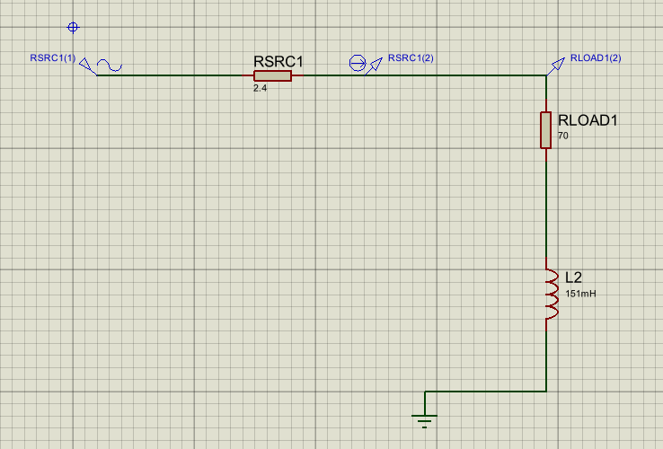
Figure 1: RLC circuit.

Voltage and current waveforms
Figures 2 and 3 show the simulated source voltage and load current waveforms at a supply frequency of 50 Hz. The voltage waveform is shown in red and the current waveform in green. It can be observed that the current waveform lags the voltage waveform, indicating that the load is inductive in nature.
In addition, a time delay of 1.9 ms was measured, shown in figures 2 and 3, between corresponding points on the voltage 220ms and current 221.9ms waveforms.
This time shift was later used to calculate the phase angle between voltage and current, as well as the period of 20ms. This is shown in figures 4 and 5. In which in turn was used to determine the power factor of the circuit.

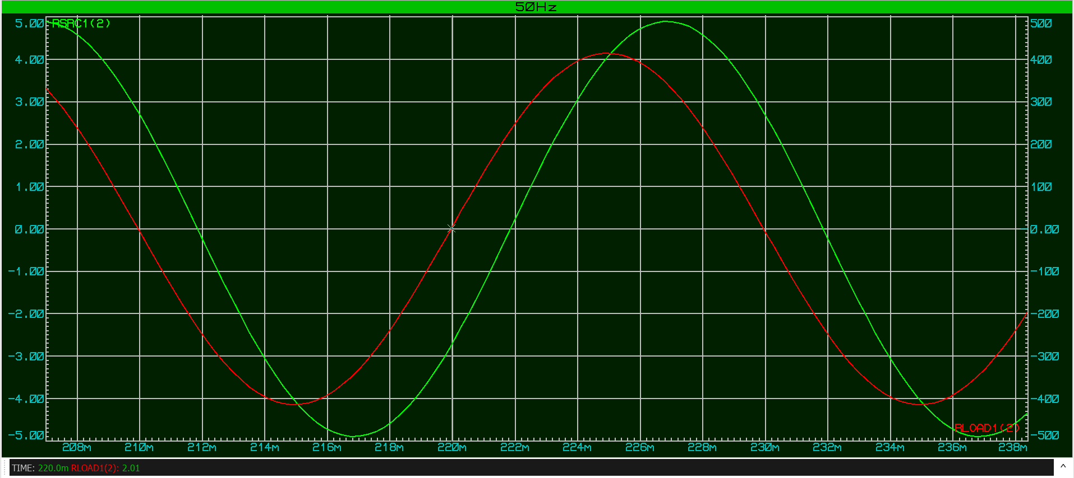
Figure 2: Voltage time measurement.
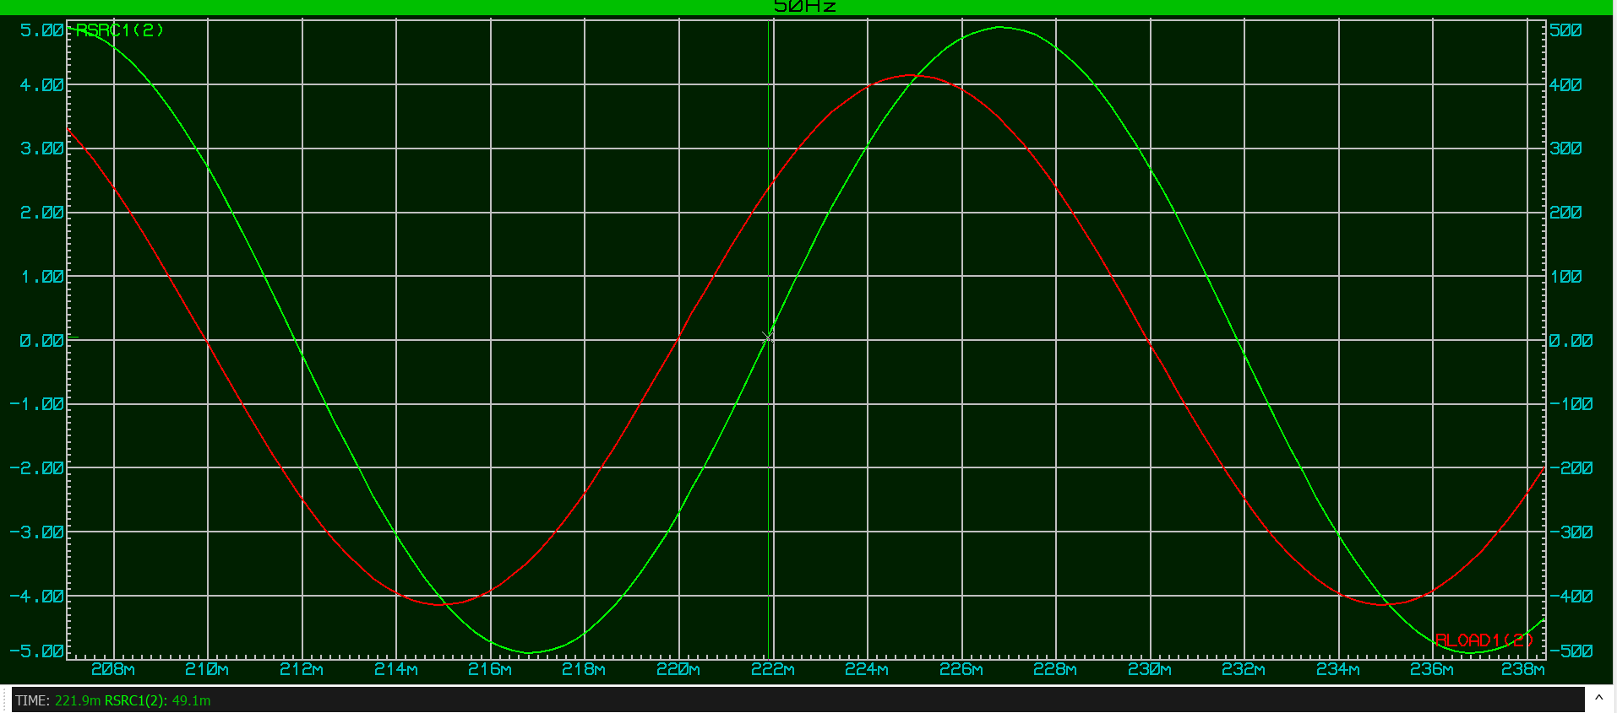
Figure 3: Current time measurement.
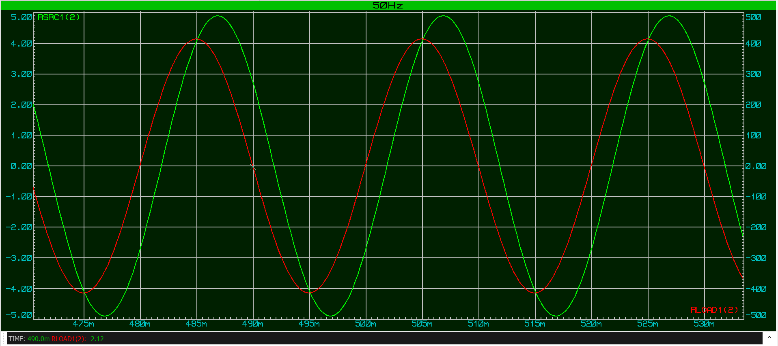
Figure 4: Period time measurement minimum value.
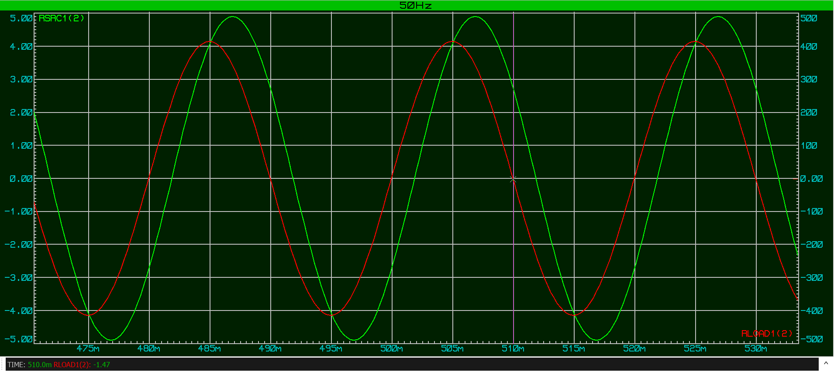
Figure 5: Period time measurement maximum value.
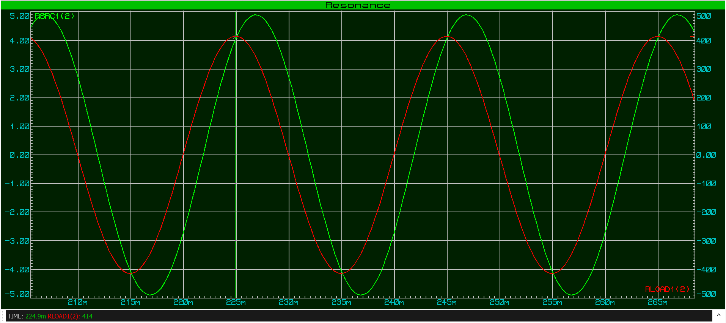
Figure 6: Voltage maximum value.
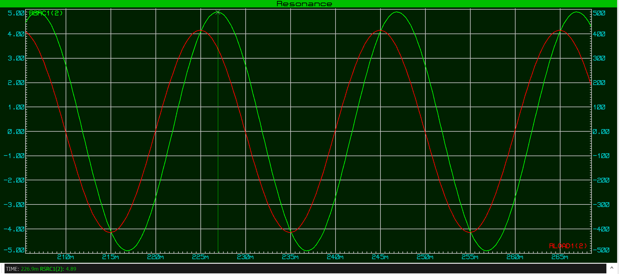
Figure 7: Current max value.

Power factor v Capacitance
As shown in graph and table 1, the power factor against capacitor value shows that increasing the capacitance improves the power factor of the circuit. With no capacitor connected, the power factor is low due to the inductive load. As the capacitor value increases, it provides leading reactive current, which cancels part of the inductive reactive current. This causes the voltage and current to become more closely aligned, increasing the power factor. The graph shows that the power factor rises rapidly at first and then begins to level of. This explains why a target value of 0.95 is chosen instead of correcting fully to a power factor of 1.

Capacitor | PF
0 | 82
5 | 89
10 | 94
15 | 98
20 | 99
Table 1: Capacitor values v Power factor values.

Graph 1: Capacitor values v Power factor values.

Power factor v Phase angle
As shown in table and graph 2, the phase angle versus capacitor value shows the opposite trend to the power factor graph. When there is no capacitor connected, the phase angle is quite large, which shows that the current is lagging the voltage. As the capacitor value is increased, the phase angle gets smaller as the capacitor helps cancel some of the reactive current in the circuit. This makes the current move closer to being in phase with the voltage. At higher capacitor values, the phase angle is close to zero, meaning the circuit behaves more like a resistive load. This reduction in phase angle explains why the power factor improves as the capacitor value increases.
Capacitor | phase angle
0 | 34.56
5 | 27
10 | 19.8
15 | 10.8
20 | 1.8
Table 2: Power factor values v Phase angle.

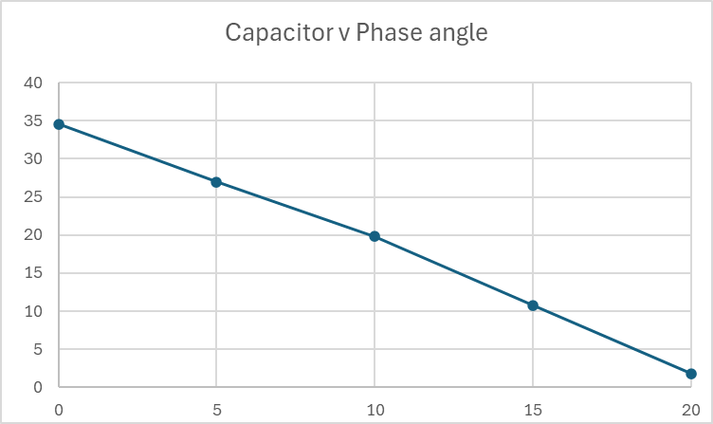
Graph 2: Power factor v phase angle values.

Energy Stored in the Inductor and Capacitor
As the power factor of the circuit gets closer to 1, the energy stored in the inductor and the capacitor starts to balance out. The inductor stores energy in its magnetic field, which causes the current to lag behind the voltage and increases reactive power. When a capacitor is added, it stores energy in its electric field and produces a leading current. As the capacitor value is increased, this leading current cancels out more induction. This means the supply does not need to provide as much reactive power [1].
When the power factor is close to 1, the energy stored in the inductor and capacitor is almost equal and opposite during each phase. Because of this, less energy is being stored and then used by the reactive components. More of the supplied energy is then used to do useful work in the resistive part of the circuit. This reduces losses and improves efficiency. Correcting the power factor exactly to 1 isn’t done, as it can cause over compensation and resonance issues [2].

Phase angle calculations
The phase angle between the voltage and current was calculated using the measured time delay, which is 1.9ms, as mentioned previously. Also, the period of the waveform is measured to be 20ms.
Formula:
$$Ø=\frac{time}{Period} x 360$$
Formula with values added:
$$Ø=\frac{1.9x{10}^{-3}}{20x{10}^{-3}} x 360=34.56$$
This confirms a phase difference between voltage and current, with the current lagging the voltage.

Power Factor Calculation
The power factor of the circuit before correction is given by using the formula:
$$Q1=34.56$$
$$PF=Cos\left(34.56\right)=0.82$$
A power factor of 0.82 means that only 82% of the apparent power supplied to the circuit is converted into useful real power.

RMS values and power calculations.
As shown in Figures 6 and 7, the voltage maximum value was measured to be 414V, whilst the currents maximum value to be 4.89A. These can be used to calculate the Vrms and Irms of the circuit using the formula:
$$Vrms=\frac{Vmax}{ 2}$$
$$Irms=\frac{Imax}{ 2}$$
Formula with values added:
$$Vrms=\frac{414V}{ 2}=292.7V$$
$$Irms=\frac{4.89A}{ 2}=3.4A$$
The power values of the circuit were calculated using RMS quantities. From the waveform measurements, the RMS voltage was 300 V and the RMS current was 3.44A. Using the measured phase angle of 34.56°, the apparent, real and reactive power were calculated.

Real power formula:
$$P=Vrms x Irms x CosQ1$$
$$P=300 x 3.44 x Cos\left(34.56\right)$$
$$P=849.8 W$$
The real power is the useful power converted into work.
Reactive power formula:
$$Q=Vrms x Irms x SinQ1$$
$$Q=300 x 3.44 x Sin\left(34.56\right)$$
$$Q=585.4 VAR$$
The reactive power represents the power associated with energy stored in inductors and capacitors.

Apparent power formula:
$$S=Vrms x Irms$$
$$S=300 x 3.44$$
$$S=1032 VA$$

The apparent power represents the total power supplied to the circuit.

Target Power factor
The assignment specification requires the power factor of the load to be corrected to at least 0.95.
The phase angle corresponding to a power factor of 0.95 is:
$$ϕ_{2}={cos⁡}^{-1}(0.95)={18.2}^{∘}$$

Phasor diagrams

3.1 Phasor diagram at 50Hz
Figure 8 shows the phasor diagram of the circuit at 50 Hz. The supply voltage is taken as the reference at 300 V RMS. Before power factor correction, the load current lags the voltage by 34.56°, indicating inductive behaviour. After the addition of a capacitor, it reduces the phase angle to 18.2°. This reduction in phase angle demonstrates the improvement in power factor from 0.82 to 0.95.

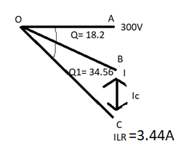
Figure 8: Phasor diagram for power factors.

Calculations for △OAC
Triangle, Figure 9, OAC represents the original load current before power factor correction. The hypotenuse OC corresponds to the magnitude of the load current $I_{LR}=3.344\text{A}$, while the angle at point O is the initial phase angle of 34.56°, from the waveform analysis. The vertical side AC represents the reactive component of the current and is calculated below.

AC:
$$SinØ=\frac{AC}{OC}$$
$$Sin\left(34.56\right)=\frac{AC}{ILR}$$
$$Sin\left(34.56\right)=\frac{AC}{3.44}$$
$$AC=3.44 x Sin\left(34.56\right)$$
$$AC=1.95A$$

OA:
$$CosØ=0A/0C$$
$$CosØ=\frac{OA}{ILR}$$
$$OA=ILR x CosØ$$
$$OA=3.44 x Cos\left(34.56\right)=2.83A$$
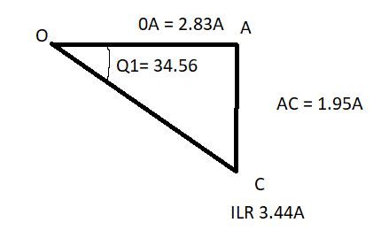
Figure 9: Phasor diagram for OAC.

Calculations for △OAB
Triangle, Figure 10, OAB represents the phasor after power factor correction has been applied. In this case, the corrected phase angle is 18.2°, corresponding to a target power factor of 0.95. The hypotenuse OB represents the new supply current, while the vertical side AB represents the remaining reactive current after correction.

OB:
$$CosØ=\frac{OA}{OB}$$
$$Cos\left(18.2\right)=\frac{IR}{I}$$
$$I=IR x Cos\left(18.2\right)$$
$$I=2.83 x Cos\left(18.2\right)$$
$$I=2.69A$$

AB:
$$SinØ=\frac{AB}{OB}$$
$$Sin\left(18.2\right)=\frac{AB}{I}$$
$$AB=I x Sin\left(18.2\right)$$
$$AB=2.69 x Sin\left(18.2\right)$$
$$AB=0.84A$$

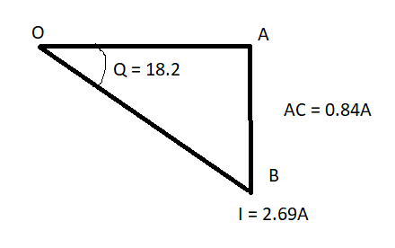
Figure 10: Phasor diagram for OAB.

Complete Phasor diagram
Figure 11 shows how the total current in the circuit is made up of different parts. OA represents the part of the current that is in line with the voltage and does useful work. AC represents the extra current caused by the inductor, which does not do useful work and makes the current lag behind the voltage. Together, these form the line OC, which shows the total current before power factor correction. After a capacitor is added, part of this extra current is cancelled, which is shown by the shorter line AB. This reduces the overall current to OB and moves it closer to the voltage line. As a result, the phase angle becomes smaller and the power factor of the circuit improves.

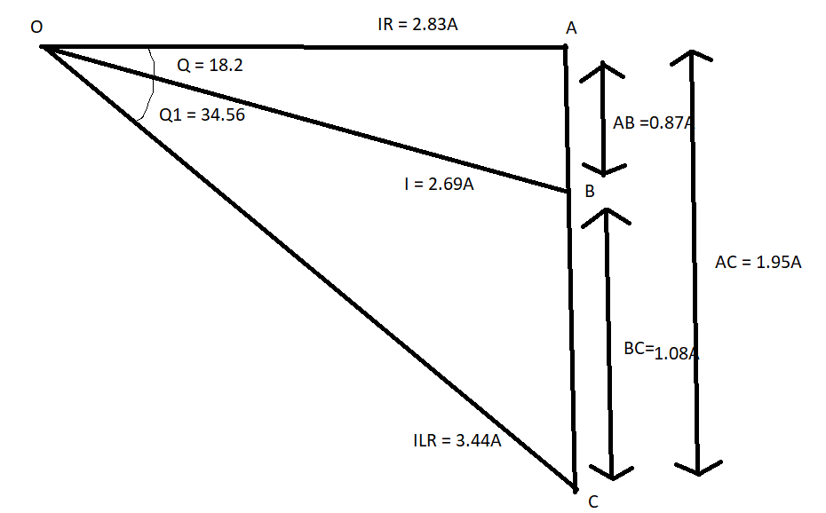

Figure 11: A complete Phasor diagram containing all values

Capacitor values
To improve the power factor of the circuit, from 0.82 to the target of 0.95, a capacitor would need to be installed, to improve the power factor to the required level, shown using the formula below:
$$Ic=\frac{Vc}{Xc}$$
$$Xc=\frac{Vc}{Ic}$$
$$Xc=\frac{292.74}{1.08}$$
$$Xc=271.05Ω$$
Subtracting the formula:
$$Xc=\frac{1}{2ℼXfXC}$$
$$C=\frac{1}{2ℼX5OX271.05}$$
$$C=11.74uF$$
From this calculation, a capacitor value of approximately 11.74 µF is required to improve the power factor to 0.95.

TASK 2

RLC circuit with Power factor correction (PFC)
As the capacitor value that was needed was now calculated, the PFC of four circuits was selected to create phasor diagrams showing the component voltages and current. The circuit frequencies that were selected were 50Hz, resonance, as shown in 5.1 below and -25Hz below resonance and +25Hz above.

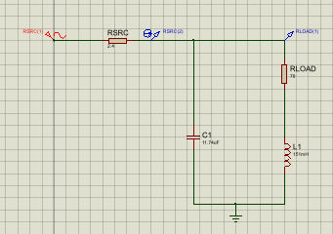
Figure 12: RLC with PFC capacitor installed.

Resonance Frequency
$$fr=\frac{1}{2ℼ} \frac{1}{LC}-\frac{R^{2}}{L^{2}}$$
$$fr=\frac{1}{2ℼ} \frac{1}{\begin{aligned}151 X {10}^{-3}X 16X {10}^{-6} \\ \\ \end{aligned}}-\frac{{70}^{2}}{{(151X{10}^{-3})}^{2}}$$

$$fr=\frac{1}{2ℼ} \frac{1}{0.000002416}-\frac{{70}^{2}}{{0.151}^{2}}$$
$$fr=98.29Hz$$

5.1.2 Resonance frequency waveform measurements

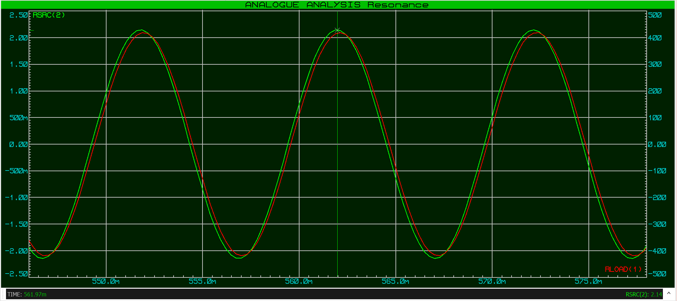
Figure 13: Current max for resonance waveform.

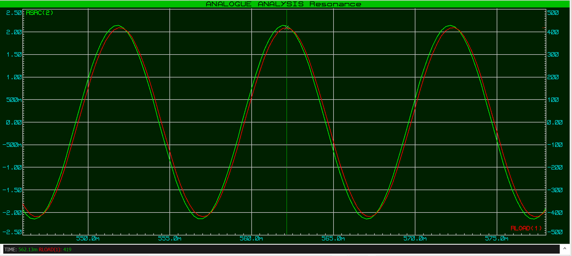
Figure 14: Voltage max for resonance waveform.
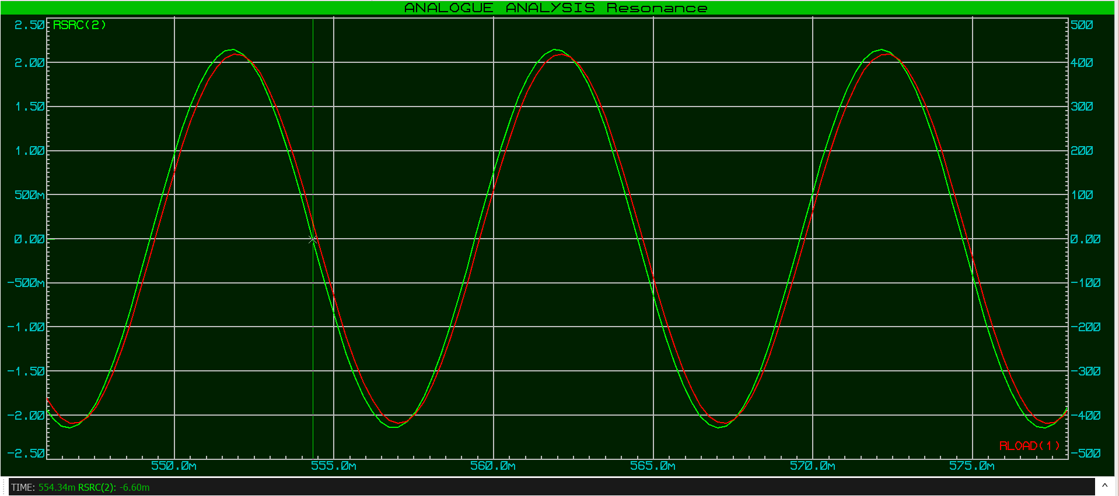
Figure 15: Current time measurement.
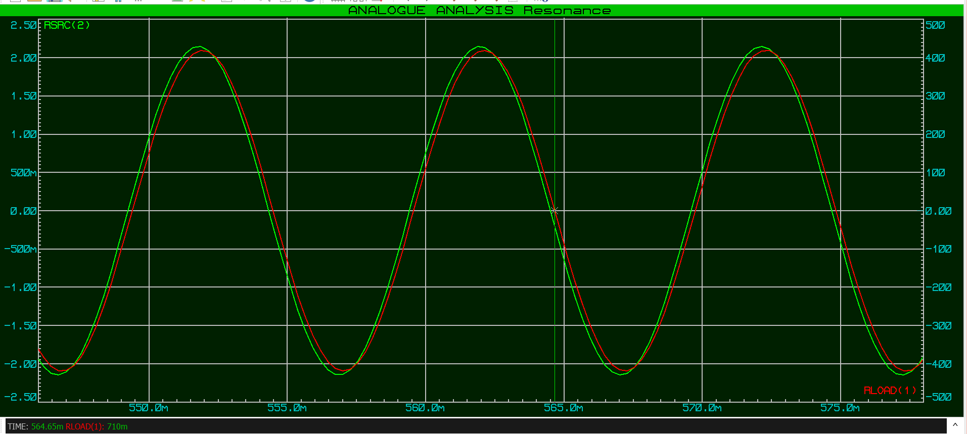
Figure 16: Max period measurement and Voltage time measurement
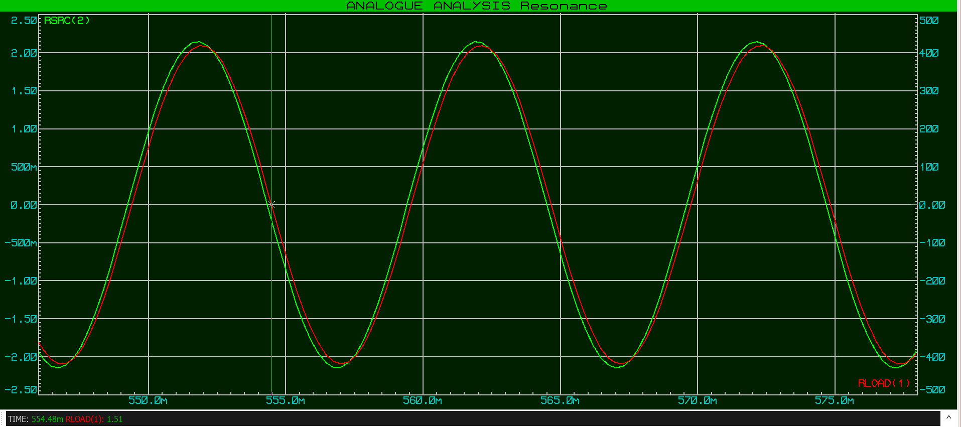Figure 17: Min period measurement.

5.1.3 Resonance PFC Calculations
From the waveforms shown above:
Vmax: 419V
Imax: 2.14A

Time: 554.48 – 554.34 = 0.14ms
Period: 564.65 – 554.48 = 10.17ms
Formula 1:
$$Ø=\frac{time}{period } x 360$$
$$Ø=0.14 x\frac{{10}^{-3}}{\begin{aligned}10.17x {10}^{-3} \\ \end{aligned}} x 360=4.95$$
Formula 2:
$$PF=CosØ$$
$$PF=Cos\left(4.95\right)$$
$$PF=0.99 99\% efficient$$

Formula 3:
$$Xc=\frac{1}{2ℼxfxc}$$
$$Xc=\frac{1}{\begin{aligned}2ℼx98.29x11.74x{10}^{-3} \\ \end{aligned}}=137.9Ω$$
Formula 4:
$$Xl=2ℼxfxL$$
$$Xl=2ℼx98.29x151x{10}^{-3}=93.25Ω$$
Formula 5:
$$ZLR=\frac{Vmax}{2}$$
$$ZLR=\frac{419}{2}=296.27V$$

Formula 6:
$$ILR=\frac{VLR}{ZLR}$$
$$ILR=\frac{296.27}{93.25}=2.54A$$
Formula 7:
$$Ic=\frac{Vc}{\begin{aligned}Xc \\ \end{aligned}}$$
$$Ic=\frac{296.27}{137.9}=2.14A$$
Formula 8:
$$ØLR= \tan^{-1\left(\frac{Xl}{R}\right)}{}$$

$$ØLR= \begin{aligned}\tan^{-1\left(\frac{93.25}{70}\right)}=53.1 \\ \\ \end{aligned}{}$$
Formula 9:

$$Ø=\tan^{-1}{}\left(\frac{ILRxSINØLR-Ic}{ILRxCosØLR}\right)$$
$$Ø=\tan^{-1}{}\left(\frac{2.54xSIN\left(53.1\right)-2.14}{2.54xCos\left(53.1\right)}\right)= -4$$
Formula 10:
$$ILRxSinØLR$$
$$2.54 x Sin\left(53.1\right)=2.03A$$

Formula 11:
$$I= {\left(ILRxCosØLR\right)}^{2}+{\left(ILRxSinØLR-IC\right)}^{2}$$
$$I= {\left(2.54xCos(53.1)\right)}^{2}+{\left(2.54xSin(53.1)-2.14\right)}^{2}$$
$$I=1.52A$$

5.1 4 50Hz Waveform measurements
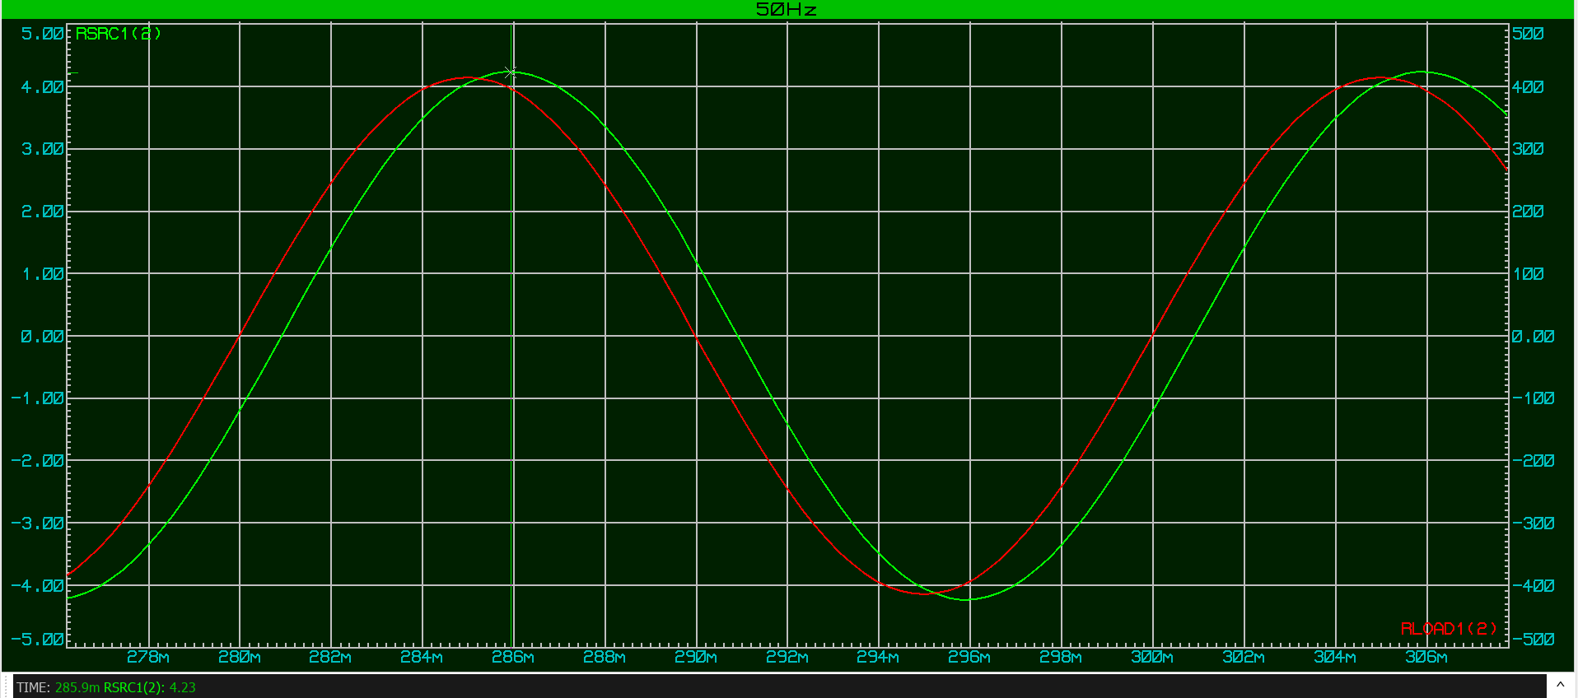
Figure 17: Current max for 50Hz.
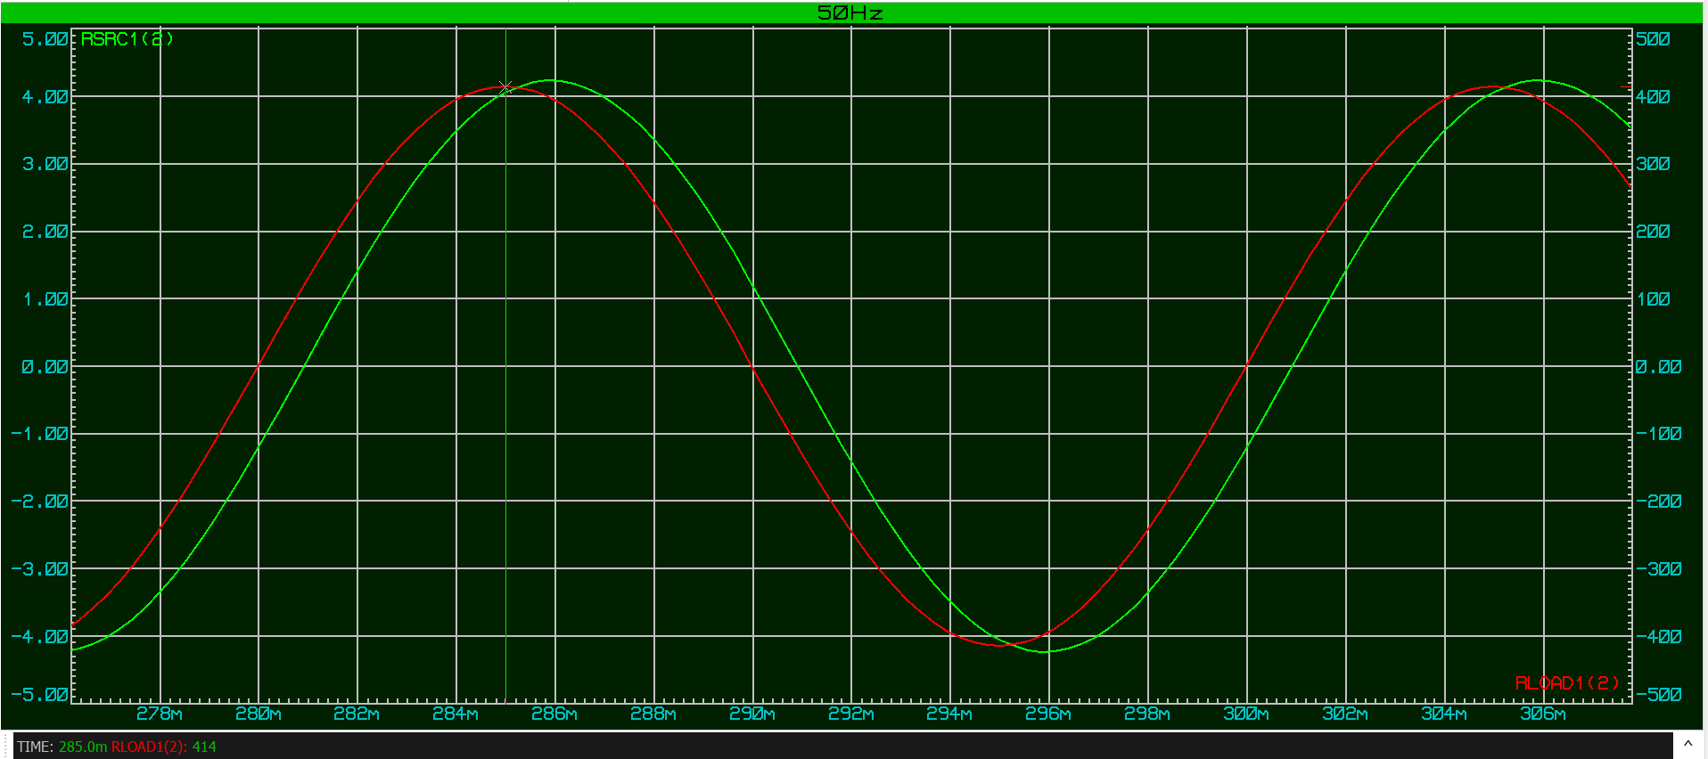Figure 18: Voltage max for 50Hz.
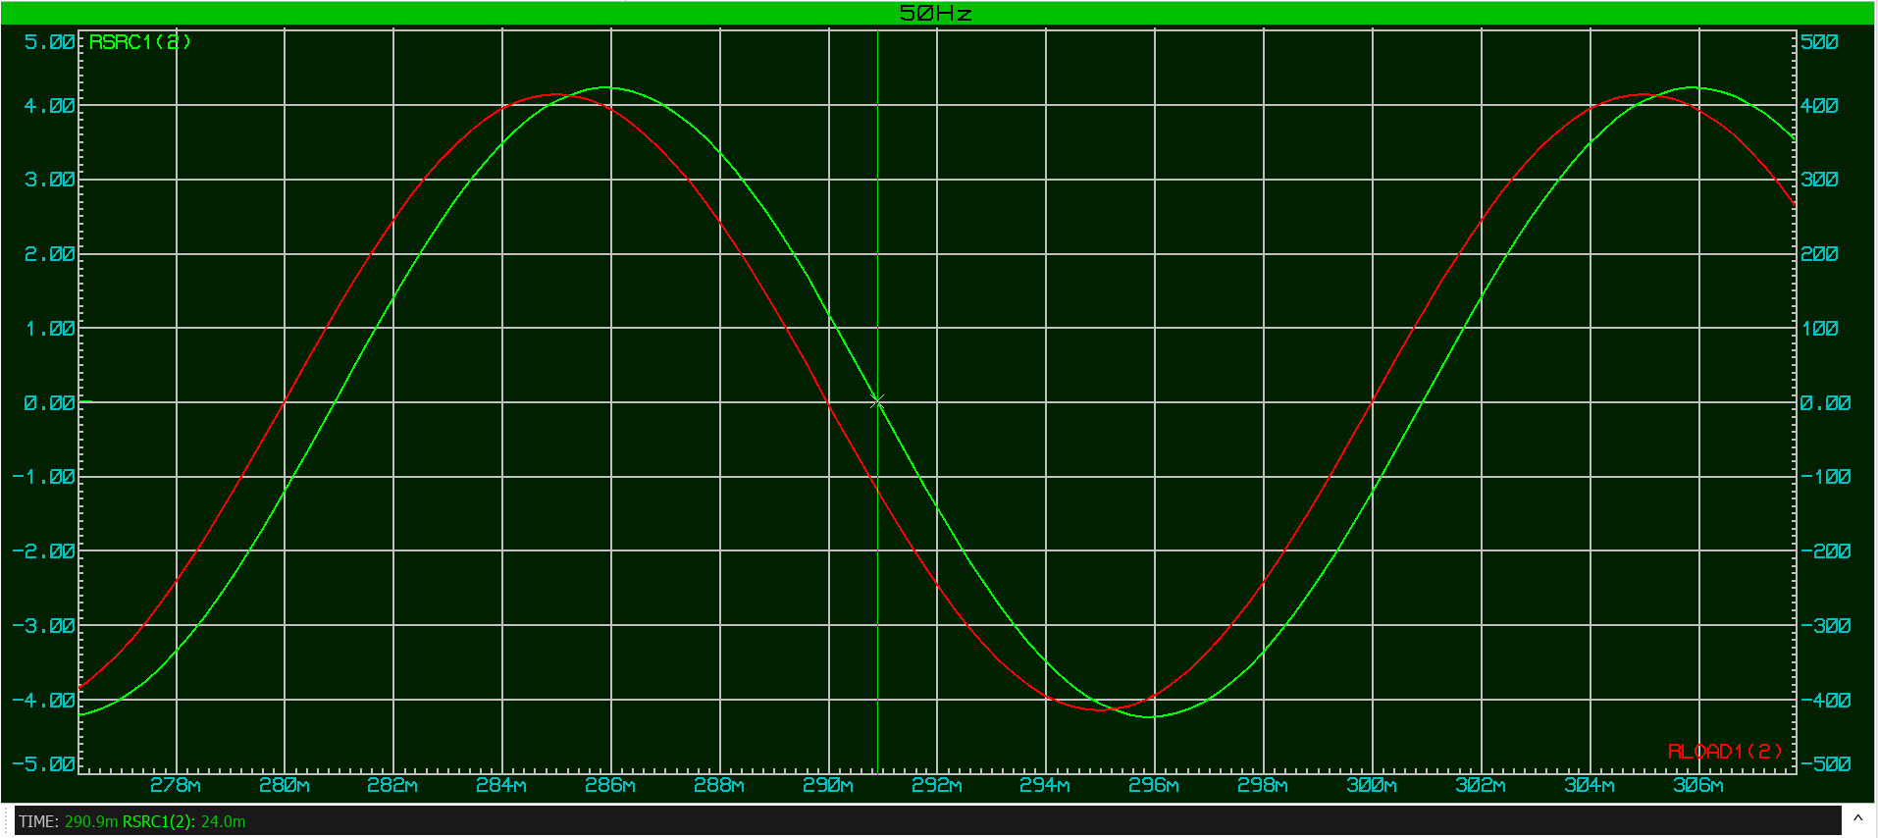
Figure 19: Current time measurement.

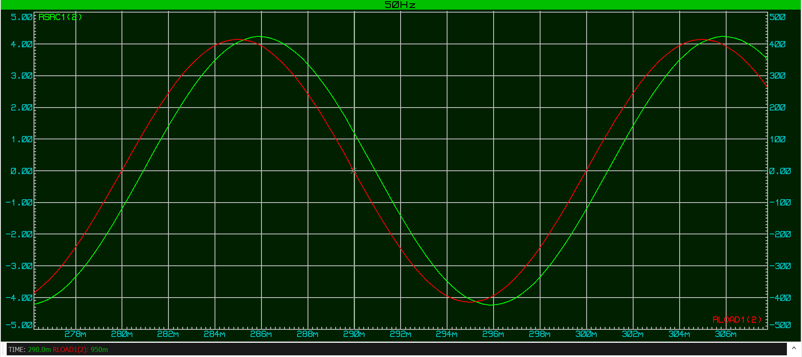
Figure 20: Voltage time measurement and period measurement.
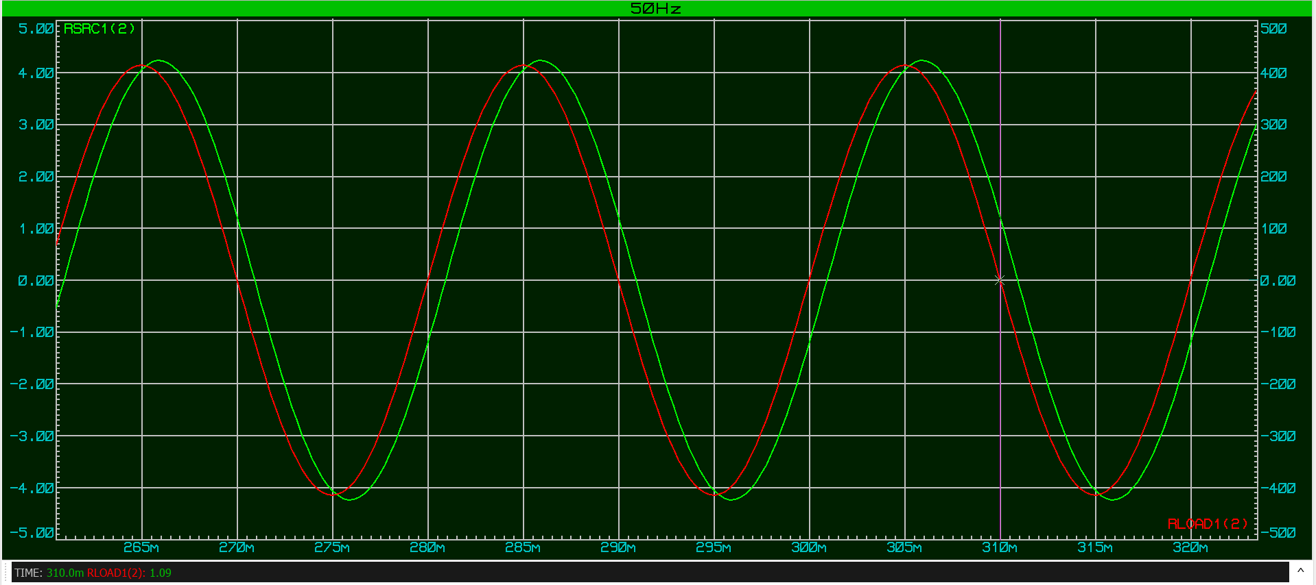
Figure 21: Voltage period measurement.

5.1.5 50Hz PFC Calculations

Vmax = 414V
Imax = 4.23A
Time = 0.9ms
Period = 20ms
Ø = 16.2°
PF = 0.96 96% efficient
Xc = 271.1Ω
Xl = 47.4Ω
ZLR = 84.5Ω
VLR = 292.74V
ILR = 3.46A
Ic = 1.07A
ØLR = 34.1°
Ø = 16.88° (Leading)
ILRSinØLR = 1.93A
I = 2.99A

5.1.6 +25Hz PFC Waveform measurements

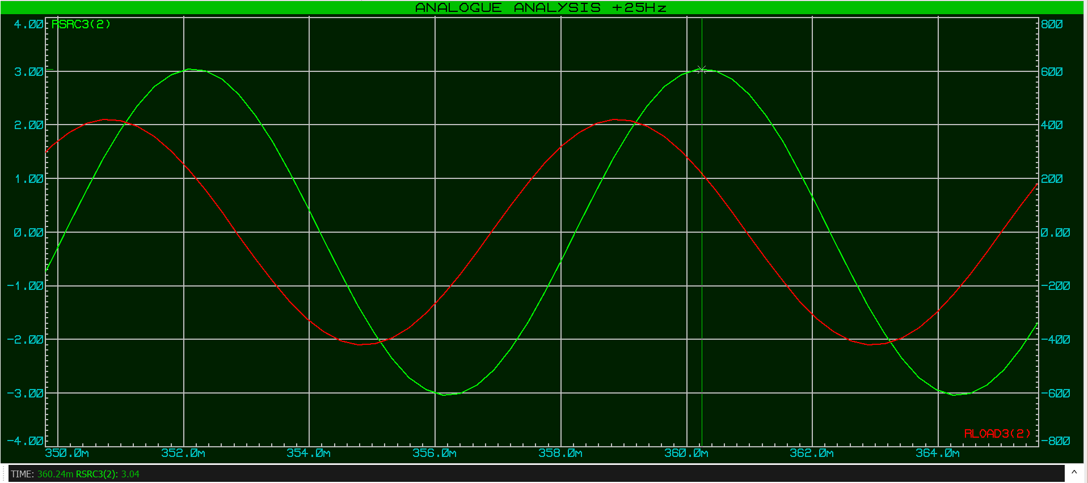
Figure 22: Current max measurement.
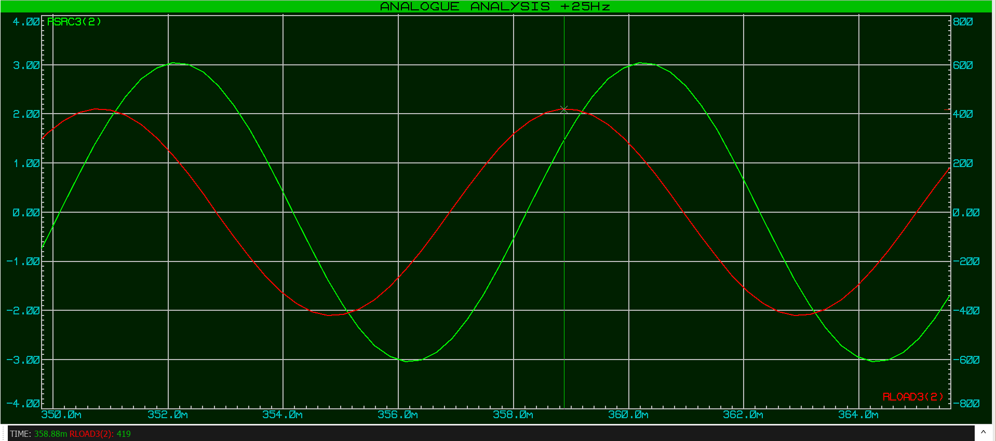
Figure 23: Voltage max measurement.
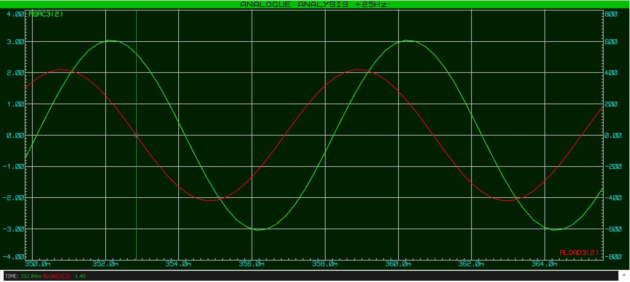
Figure 24: Voltage time measurement and minimum period measurement.
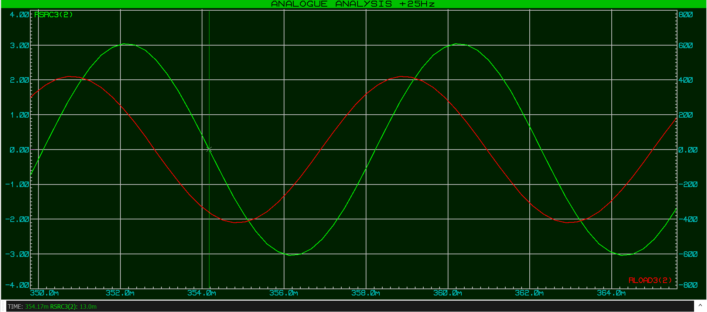
Figure 25: Current time measurement.
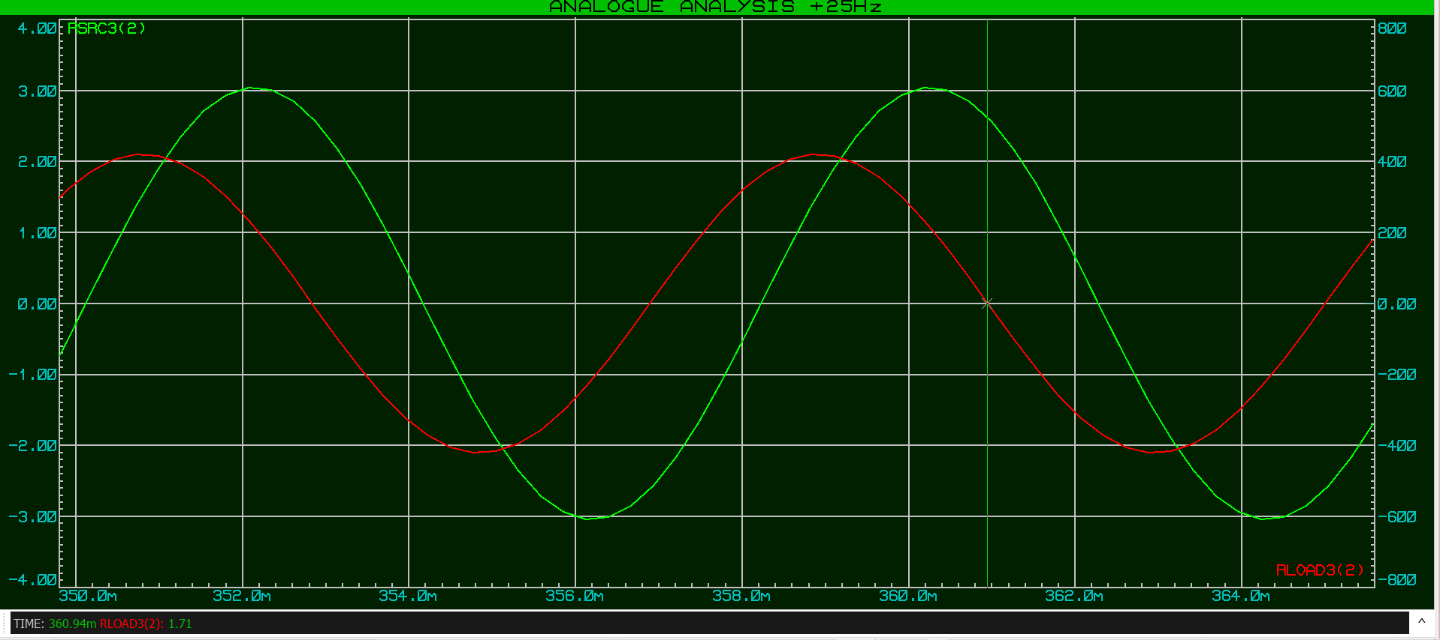
Figure 26: Voltage period max measurement.

5.1.7 +25Hz PFC Calculations

Vmax = 419V
Imax = 3.04A
Time = 1,33ms
Period = 8.1ms
Ø = 59.1°
PF = 0.51 51% efficient
Xc = 109.95Ω
Xl = 116.97Ω
ZLR = 136.31Ω
VLR = 296.27V
ILR = 2.17A
Ic = 2.69A
ØLR = 59.1°
Ø = -36.6° (Lagging)
ILRSinØLR = 1.86A
I = 1.03A

5.1.8 -25Hz Waveform measurements
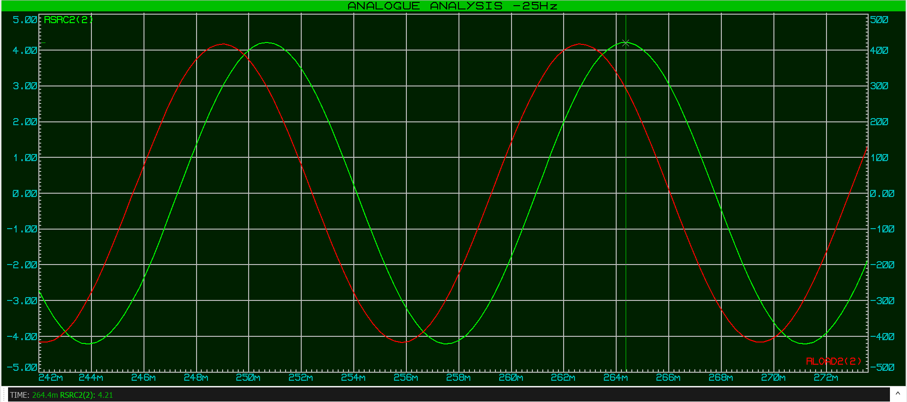Figure 27: Current max measurement.
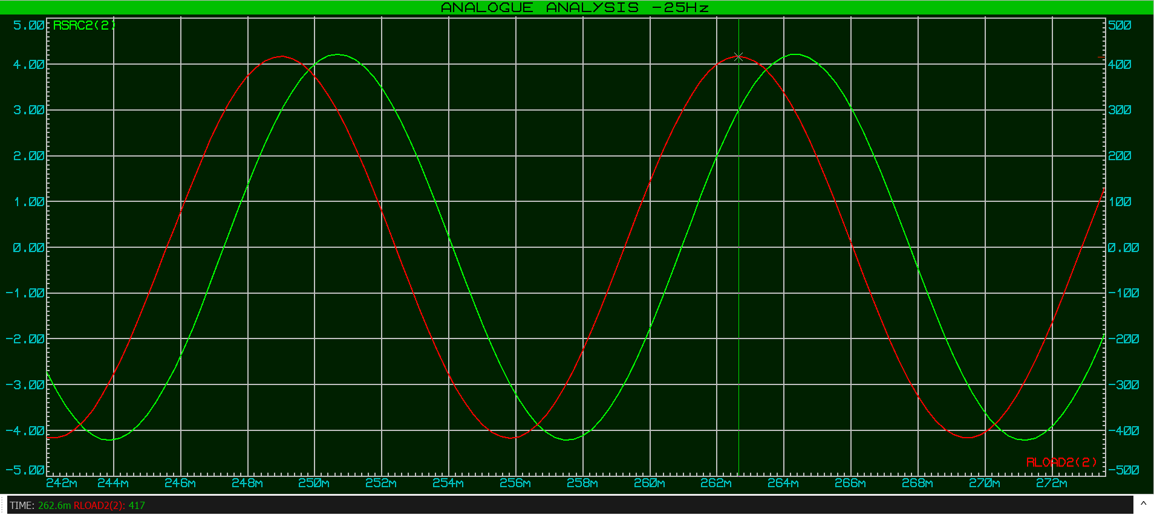

Figure 28: Voltage max measurement.
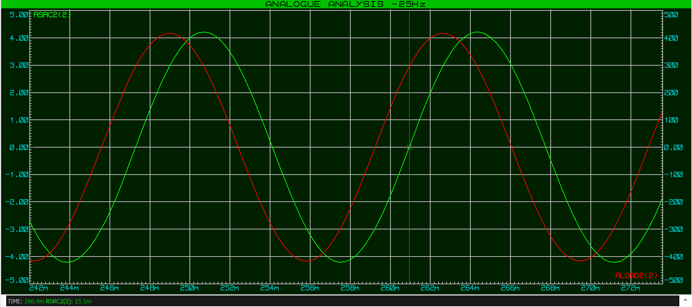
Figure 29: Current time measurement.
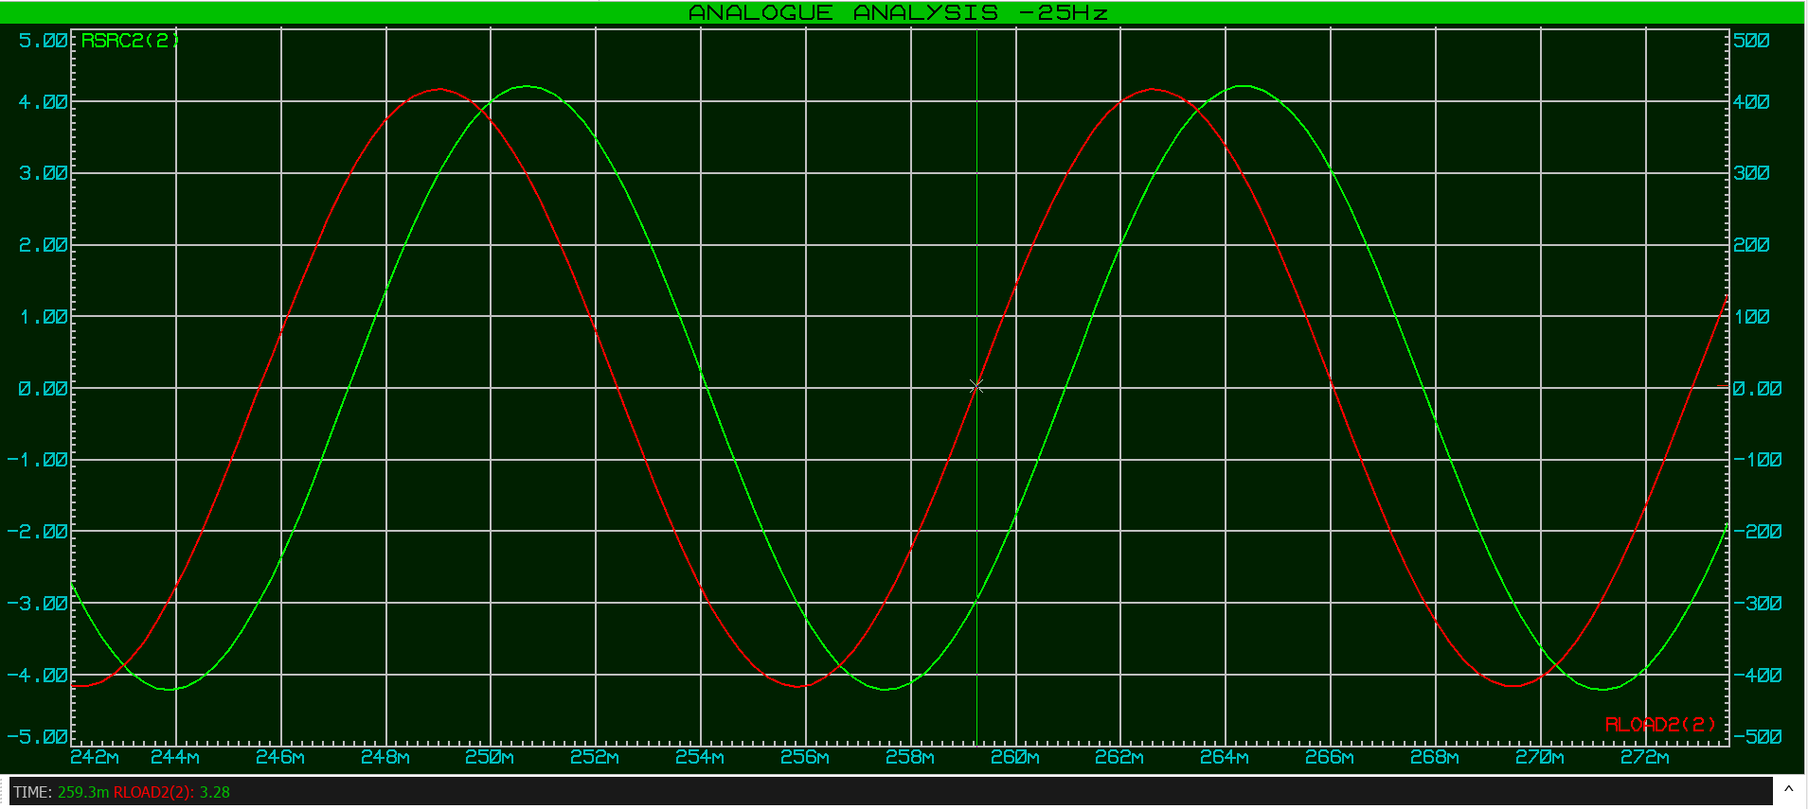
Figure 30: Voltage time and minimum period measurement.
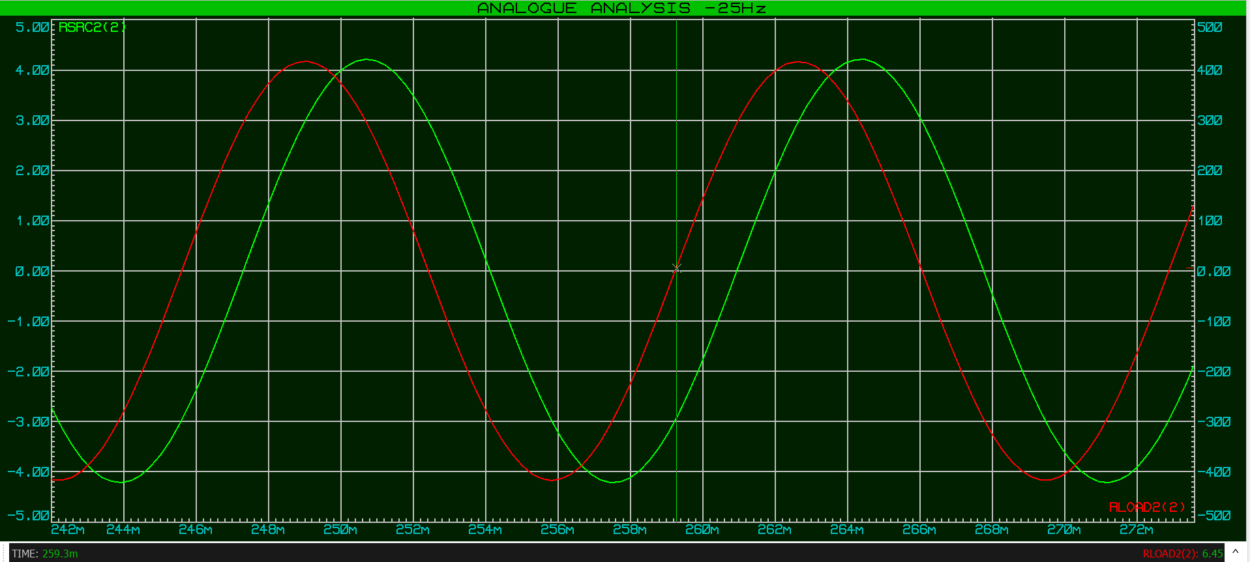
Figure 31: Voltage max period measurement.

5.1.9 -25Hz PFC Calculations

Vmax = 417V
Imax = 4.21A
Time = 1.6ms
Period = 13.7ms
Ø = 42°
PF = 0.76 76% efficient
Xc = 184.9Ω
Xl = 69.53Ω
ZLR = 98.66Ω
VLR = 294.86V
ILR = 2.98A
Ic = 1.59A
ØLR = 44.8°
Ø = 13.55° (Leading)
ILRSinØLR = 2.09A
I = 2.17A

5.1.10 PFC circuit Phasor diagrams

5.1.10.1 Resonance phasor diagram
At resonance, the inductive and capacitive reactance largely cancel each other out. The load current ILR is 2.54 A and lags the voltage by 53.1°, while the capacitor supplies a leading current of 2.14 A. This causes the total supply current to reduce to 1.52 A, with a very small inductive phase angle of approximately −4° lagging, showing that the current is almost in phase with the voltage. This indicates that reactive current is minimised and the power factor is close to unity at resonance.
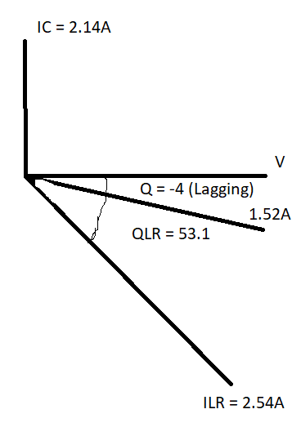
Figure 32: Resonance phasor diagram.

5.1.10.2 +25Hz phasor diagram
At 25 Hz above resonance, the circuit again shows predominantly inductive behaviour. The load current ILR is 2.17 A and lags the voltage by 59.1°, indicating a large phase difference. Although the capacitor supplies a leading current of 2.69 A, the total supply current is reduced to 1.03 A and still lags the voltage by 36.6°, showing that significant reactive current remains at this frequency.
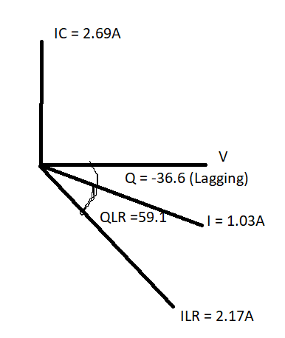
Figure 33 : +25HZ phasor diagram.

5.1.10.3 50Hz phasor diagram
At 50 Hz, the load current ILR is 3.64 A and lags the supply voltage by 34.1°, showing inductive behaviour. The capacitor supplies a leading current of 1.07 A, which reduces the overall reactive current. As a result, the total supply current is 2.99 A and leads the voltage by 16.88°, indicating that the circuit is slightly capacitive at this frequency and that power factor correction has a significant effect.
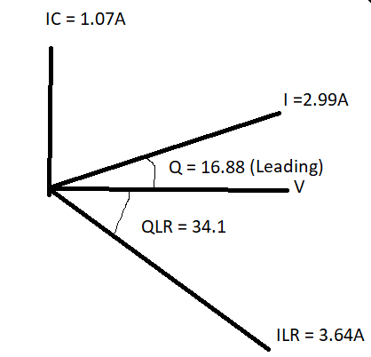
Figure 34: 50Hz phasor diagram.

5.1.10.4 -25Hz phasor diagram
At 25 Hz below resonance, the circuit behaves mainly as a capacitive load. The load current ILR is 2.98 A and lags the voltage by 44.8°. The capacitor supplies a leading current of 1.59 A giving a total supply current is 2.17A leading by 13.55 ° and still shows that reactive current is present at this frequency.
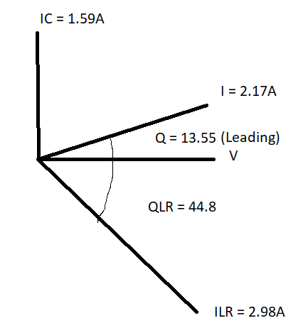
Figure 35 : -25Hz phasor diagram.

Task 3

Resonance in the circuit
Power factor correction improves the circuit by reducing the phase difference between voltage and current. Adding a capacitor helps cancel the inductive reactance, moving the circuit closer to resonance at the operating frequency. This reduces reactive current and improves the power factor [3].

Achieving maximum power transfer
Maximum power transfer occurs when the circuit behaves mainly resistive. Improving the power factor reduces reactive current, allowing more of the supplied power to be converted into useful real power instead of being stored and released by reactive components [4].

Energy efficiency
A low power factor, below 0.90, implies energy waste. This will factor into costing more money to run and potential equipment strain. This resulting in increases in current and causes higher losses due to overheating. Power factor correction reduces supply current, lowers losses and improves overall efficiency by reducing unnecessary power loss [5].

Task 4

5.5 Why three-phase transmission is used
Three-phase transmission is used in the UK because it is more efficient for delivering large amounts of power. It provides a more constant power output and allows smaller currents per conductor, reducing transmission losses. Systems with more than three phases are not commonly used because they increase cost and add little benefit [6].

Task 5

5.6 Power factor and power factor correction
Power factor describes how effectively electrical power is used and is formulated as:
$$PF=cos⁡(ϕ)$$
where $ϕ$is the phase angle the between voltage and current. A low power factor means more current is required for the same real power, increasing losses in the system. Power factor correction uses capacitors to reduce the phase angle, improve efficiency, lower losses, and reduce stress on electrical equipment. A power factor of 0.95 or higher is commonly targeted as a practical and safe operating value.

5.7 Discussion
The results from this investigation show a relationship between frequency, reactive components and power factor in an RLC circuit. The waveform analysis confirmed that the load was inductive, as the current consistently lagged the voltage before correction. This phase difference resulted in a low power factor and higher reactive current which would reduce efficiency.
The power factor versus capacitance results showed that increasing the capacitor value reduced the phase angle and improved the power factor. Initially, small increases in capacitance produced large improvements. After, the curve then began to level off, justifying the choice of a target power factor of 0.95 rather than full correction. This avoids overcompensating and potential resonance issues.
Also, the phasor diagrams further supported these findings. At frequencies below and above resonance, the circuit showed large phase angles and reactive current. At resonance, the PFC cancelled out the inductive side more, resulting in a small phase angle and reduced supply current. At 50 Hz with power factor correction applied, the capacitor provided leading current that cancelled most of the inductive current, bringing the total current close to being in phase with the voltage. Overall, the results confirm that power factor correction effectively reduces reactive current and improves efficiency.

5.8 Conclusion
This assignment investigated how a RLC circuit behaves and the effects of power factor correction using proteus and phasor analysis. The results showed that inductive loads cause the current to lag the voltage, reducing power factor and increasing reactive current. By adding a suitably sized capacitor, the phase difference was significantly reduced and the power factor improved to the target value of 0.95.
Analysis of waveforms, calculations and phasor diagrams showed that operating near resonance or applying power factor correction reduces supply current and improves efficiency. The findings show that power factor correction is suitable for improving the performance of AC electrical systems.

References
[1] C. K. Alexander and M. N. O. Sadiku, “Fundamentals of Electric Circuits,” 6th ed. New York, NY, USA: McGraw-Hill Education, 2017, pp. 272–279.
[2] A. R. Hambley, “Electrical Engineering: Principles and Applications,” 6th ed. Boston, MA, USA: Pearson Education, 2018, pp. 356–362.
[3] “Power factor correction,” Electronics Tutorials. https://www.electronics-tutorials.ws/accircuits/power-factor-correction.html (accessed Jan. 01, 2026).
[4] Allen, “Maximum power transfer theorem,” Nov. 19, 2024. https://allen.in/jee/physics/maximum-power-transfer-theorem
[5] Skipper, “Power Factor explained: A guide to efficiency, calculation, and cost savings.” https://skippertrans.org/blog/power-factor-explanation-calculator-understanding/
[6] Electrical Engineering Planet, “Why is Three-Phase power used instead of Single-Phase?,” Electrical Engineering Planet, Aug. 05, 2025. https://electricalengineeringplanet.com/why-is-three-phase-power-used-instead-of-single-phase/

