Effective team working and communication
Name: Winnie Nzaramba
Student ID: 2014619
Module Code: BMSW4002

Lecturer: Diya Ganguly.

Table of Contents
1.0 Introduction 3
2.0 Main Body 4
2.1 Shannon and Weaver model 4
2.2 Schramm’s model 6
2.3 Barlo’s model 7
3.0 Communication skills 9
3.1 Poor communication example 9
4.0 Conclusion 11
5.0 References 12

1.0 Introduction

This report is based on effective communication where the field of study will justify various issues incorporated with the communication. Communication consider as one of the most important element for the business that can boost performance of a team unimaginably as well as it is responsible to ensure high productivity (Duck and Mcmahan., 2020). When it comes to the definition of communication; it refers to imparting and replacing of data via speaking, writing and other types of medium. It is also an effective process that individual adopt to exchange information through sign, behavior, posture and symbol. The reason why communication is important is, it leads team to a develop a goal and work to achieve it until then get success. Apart from that, regular effective communication might support all the team members to build a sense of belongings that in turn strengthen relationships (Adair., 2009). This report will discuss various aspects of communication from different theorist and researcher’s viewpoint such as different models e. g. Shannon and weaver’s communication model, Schramm’s communication model and Berlo’s communication model. Along with these model the field of study will demonstrate poor communication within workplace via real life example and different type of communication will be discussed to get richer understanding about the domain. All the information gathered within this report will be referenced correctly to avoid collusion and plagiarism.

2.0 Main Body

Due to technological advancement business whether any scale or from any industry taken communication into consideration with high importance as well as it has now become very easy for business to carry out communication through various medium in compare to last few decade. Therefore, business with any process, scales or expertise now use different mode of communication to connect with different internal and external stakeholders (Griffith and Dunha., 2015). Thus, implementing right communication tactics within the process of business would help health care setting to maximize their prospects immensely. Some major and earliest model of communication are discussed below;

2.1 Shannon and Weaver model

Shannon and weaver’s communication was developed in 1948 and its one of the earliest model of communication which consider as father of all communication model. The foundation of the communication model was developed by this and its designed effective communication between receiver and sender. Apart from sender and receiver this model also identified an affecting factor known as noise. At the beginning, the model was developed to maximize the potentiality of the technical communication but later it has been widely accepted and applied within the field for communication (Communicationtheory.org., 2020). The illustration of Shannon and weaver model is given below;


Source: Communicationtheory.org., 2021.
From the above illustration, Shannon-Weaver model of communication took place with various concept like channel, noise, receiver, message, decode, encode and destination.

Sender: sender is the originator of the message and the source s of information who chooses desire message to deliver (Communicationtheory.org., 2020).

Encoder: after the sender’s message convert into signal via encoder through binary data or waves (Communicationtheory.org., 2020).

Decoder: decoder is the reception signal place which converts signal into message which is also a reverse process of encode (Communicationtheory.org., 2020).

Receiver: it refers to the destination of the message sent from the receiver (Communicationtheory.org., 2020).

Noise: noise is the factor that impact or distract the process such as crown, thunder, sounds within the channel of communication and due to that receiver failed to accept correct message (Communicationtheory.org., 2020).

Here the example of Maria and Pedro’s can be drawn where communication get disrupted by various aspects reason being countless interaction took place in a classroom between students and teacher where teacher should have high level of control. Here, teacher deliver the message and students receives it through their level of understanding. But due to noise or barriers factors teacher practices developed good process of communication where Maria ensure effective communication through avoiding orders, getting student involve, valuing autonomy of student, focusing on their practices, comforting student with difficulties. Due to her collaborative approach of communication her ability to question herself turned more visible. Via ensuring all these aspects Maria as a teacher have developed and effective communication channel between her and the students (Maria and Pedro., 2009).

2.2 Schramm’s model

Schramm’s communication model was first developed in 1954 where he highlighted both sender and receiver plays role of the encoder and decoder during communication (QS study., 2021). The communication model of Schramm’s is given below;

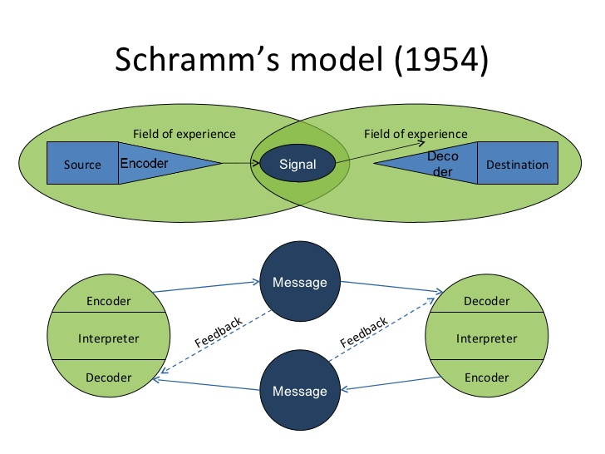
Source: Schramm W.1954.

The Schramm’s model of communication is cyclical I nature and in incorporated effective element of the communication process which is following;

Sender: sender is the person who send the message.
Encoder: encoder is the person who turn on the message to be sent into the codes.
Decoder: decoder is the person, who receive the encoded message that was sent via encoder as well as it converts into an understandable language by the person. To understand this message individual, need to have listening and reading skills.
Interpreter: interpreter is sort of person who work to analyze and understand the messages. The receiver and interpreter are the same individual. One individual might interpret the message in different way to different way or they might not have same understanding as encoder which indicate they have misinterpreted the message.
Receiver: receiver is the person who receive the message and interprets and decodes it.
Message: the message here is the information which was sent via the sender and the data that received by the receiver.
Feedback: it’s a sort of process that acknowledge the message received via the receiver.
Media: media is the medium or channel that one uses to send the messages.
Noise: noise is interruptions caused via during the communication process. this is also created while intend meaning of message sent via sender as well as meaning interpreted via the receiver is totally different which refers as semantic noise (QS study., 2021).

2.3 Barlo’s model

David Barlo’s mode of communication anther famous communication model where Berlo has developed relation between the sender and receiver. According to this model, messages required to be effectively encoded or decoded while communication between both sources ought to be great (MSG., 2021). Following chart is to demonstrate the Barlo’s model of communication.



Source: Helpfulprofessor.com., 2020

This communication often considers as persuasive if individual in both point are skilled. The model incorporates four factors such as sources, message, channel and receiver which is discussed below;

Sources:

Sender of the messages are the sources and responsible to deliver the message to the receiver. Sources are also incorporated some features which is following;

Attitude: the overall attitude of the sender and the receiver improves the message impact and its changes the overall meaning of the delivered message (MSG., 2021).

Communication skills: communication skills play crucial role as it has huge impact over the process of communication model. if a sender have good level of communication skills then message will be delivered and received more efficiently (MSG., 2021).

Knowledge: knowledge enhance the familiarity of the delivered message that turned communicator to deliver message more profoundly (MSG., 2021).

Message:

message includes content, element, treatment, structure and cos and it is something send by the sender and accepted by receiver in the form of voice, text, audio and video (MSG., 2021).

Channel:

as far as channel is concern it is a mode of communication that one can use to send the message and it includes elements like, hearing, smelling, seeing, testing and touching (MSG., 2021).

Receiver: receiver is individual who receive the sent message through communication mode. Receiver also incorporates factors like culture, knowledge, attitude and communication skills (MSG., 2021).

3.0 Communication skills

Communication skills is act that develop the meaning among groups and the entities via mutually understood symbol, sign and semiotic conventions (Kelly and Shawn., 2020). Three popular mode of communication is following;

Verbal: verbal communication is spoken, oral or face to face conversation which can also be done through phone or video call (Kelly and Shawn., 2020).

Non-verbal: nonverbal communication can be processed via convening the message without using any sort of written or spoken work such as sign, posture, tone, signals etc (Kelly and Shawn., 2020).

Listening: listening is offering attention to a sound and it can in a form of active listening or empathetic listening. Active listening is a technique where one can put careful observation while empathetic listening develop relationship with the understating of what being said (Kelly and Shawn., 2020).

3.1 Poor communication example

Poor communication is sort of factor that delay and create problem of effective work deliver and create result of poor productivity. I am currently working in a hospital where the management become shattered due to the pandemic. On the first wave of the pandemic it was horrendous situation for all my team members. Our supervisor was completely failed to offer us with adequate instruction regarding the task we do. We run out of PPE which was dangerous for our life. While asked supervisor indicated he does not have instruction from top management. In that situation, I saw many of my team members left the work due to bad managing style. My supervisor decision also failed to allocate us with enough break which force us to work with low motivation. Due to this following problem was encountered;

- Employee stress was so high and staff did not have what task to do.
- Waste huge amount of time due to poor instruction as we encountered doing repeat work.
- Staff turnover was at peak and existing teammates had heavy workload.
- Many product was wasted due to misunderstanding and lack of knowledge.
- We put patients and colleague life at risks (Giffith and Dunha., 2015).

In that scenario, effective communication need to be implemented to avoid such situation and we as a team report it to the senior management and replaced the supervisor with another skilled one; upon joining she ensured following;

- Use effective communication tools, highlight key issues.
- Had one to one conversation with all the employees.
- Implement distinctive strategy and change management.
- Reward colleagues who works hard.
- Engaged team members with decision making process, carry out employee performance review and observation (Duck and Mcmahan., 2020).

By doing and implementing all these aspects discussed above our new supervisor has ensured the improvement of poor communication channel within the hospital.

4.0 Conclusion

Finally, it’s evident that communication plays crucial role to that can maximize the overall potentially of the business whether its small, large or multinational (Adair., 2009). This report was based on effective communication where the field of study has justified various issues incorporated with the communication. Communication consider as one of the most important element for the business that can boost performance of a team unimaginably as well as it is responsible to ensure high productivity. By undertaking various issues regarding communication this report will discussed insight of different communication models like Shannon and weaver’s communication model, Schramm’s communication model and Berlo’s communication model. Along with these model the field of study also has demonstrate poor communication within workplace via real life example and different type of communication has also been discussed to get richer understanding about the domain.

5.0 References

Adair J. 2009. How to grow leaders: the seven-key principle of effective leadership development. London: Kogan Page.

Barlo’s model of communication. 2021. Retrived from https://www.managementstudyguide.com/berlo-model-of-communication.htm. Accessed 29th April. 2020.

Duck S. and Mcmahan D. 2020. Communication in everyday life: a survey of communication. 4th ed. Thousand Oaks. Calif: Sage Publications.

Griffith B and Dunha, E. 2015. Working in teams: moving from high potential to high performance. LA: Sage publications.

Kelly M and Shawn W. 2020. Business and professional communication: Keys for workplace excellence. LA: Sage publications.

Maria H and Pedro J. 2009. Communication in the classroom: Practice and reflection of a mathematics teacher. Retrieved from https://www.researchgate.net/publication/261215685_Communication_in_the_classroom_Practice_and_reflection_of_a_mathematics_teacher. Accessed 27th April. 2020.

Shannon and Weaver model of communication. 2020. Retrieved from https://www.communicationtheory.org/shannon-and-weaver-model-of-communication/. Accessed 27th April. 2020.

Schramm’s model of communication. 2021. Retrieved from https://qsstudy.com/business-studies/schramms-model-communication. Accessed 28th April. 2020.

