Destination Management: Mount Everest

Student name: Atikuz Zaman
Module Title: Sustainable Hospitality & Tourism Management
Module Number : BMIH5006
Lecturer Name: Dr. Huw Thomas

Contents
Introduction 3
Three Pillars of sustainable development at Mount Everest 4
Butler’s Life Cycle Model 6
Doxey’s Irridex Model 9
Recommendations 11
Conclusion 11
References 12

Introduction
An attractive tourism destination keeps the high potentiality of bringing huge number of tourists. Maximum cases, the destination management works to make a tourism destination desirable to as much as number of tourists. A tourism destination has much impacts on the life of local communities, national economy, and other related stakeholders. The world’s highest mountain Mount Everest is attracting huge number of tourist every year (Jacquemet, 2017). But, the concern has arisen due to the uncontrolled pollution in the tourist destination in Nepal. Due to lack of awareness among the tourist, the number of dumping is increasing and the rubbish management system in Mount Everest is not yet quietly effective. The report will make analysis of Mount Everest to demonstrate the sustainable development of a tourism destination. Based on the principles of sustainable development, the analysis will be made. By applying different models, the life cycle of Mount Everest as a tourism destination will be demonstrated.

Three Pillars of sustainable development at Mount Everest
Environmental degradation across the world has made the life of habitat in the world endangered to vanish. There is a call for sustainable tourism destination management to prevent environmental pollution from tourism. Sustainable development of a tourism destination refers to the activities that are taken in present by considering the future where it tries to ensure social and environmental protection and contribute to economic development (Rosen, 2017). Sustainable practices refer to the steps that are taken for greater economic development while preserving the future needs of the next generations. The need for sustainable products and services across the world has risen (Geum and Park, 2011). Overconsumption in the tourism industry is making stress on the natural environment. The heavy consumption in the tourism industry is making pollution, soil erosion, and loss of natural habitat. This is affecting the endangering species. Mount Everest is facing the negative impacts of heavy tourism. To protect the tourism destination, there needs a practice of sustainable development.
To ensure the preservation of natural resources, there need sustainable practices in all areas of tourism (Chindarkar and Thampapillai, 2018). The authority of Mount Everest should focus on the sustainable development of the tourism destination by using sustainable principles. The three pillars of sustainable principles are economic development, social, and environmental consideration protection. There needs balancing of these elements of these three factors in managing sustainable development. Socio-cultural factors will be considered in managing a tourism destination. The life of the local communities is related to tourism destination development (Halisçelik and Soytas, 2019). The 17 SDGs proposed by the United Nations have focused on sustainable development (Smale, 2018). The tourism industry can relate its sustainable development practice with the SDGs and can ensure a sustainable tourism industry. As a nature-based tourism industry, Mount Everest is under threat of high environmental degradation. Saving this tourist destination for saving nature is necessary. The three pillars of sustainability state that environmental sustainability must be ensured along with ensuring economic viability and social equality (Kozak and Kozak, 2016). Preserving the planet is the sole responsibility of the world’s population. The eradication of biodiversity due to the stress of heavy tourism is affecting the earth negatively. For natural environment preservation, increasing awareness among tourist is the most critical step toward the destination’s sustainable development. Climate change and economic development are two major parts of any sustainable development (MacNeill and Wozniak, 2018). In ensuring economic development, there needs proper concentration on environmental sustainability. There is also a need for a concentration on social progress. Among the three pillars of sustainability, the social pillar is also important for protecting the rights of all stakeholders related to the tourism destination. Creating scope for the employment of the local people, taking steps to increase the standard of living of the local people, preserving local heritage, etc. should be considered in sustainable tourism management. Mount Everest faces much environmental degradation due to the heavy plastic and other wastage. The authority of the tourism destination has taken some steps for rubbish management. But increasing social awareness programs is a precondition for any environmental sustainability. By ensuring the proper focus on the three pillars of sustainability, tourism destination management will enable to ensure sustainable tourism development.
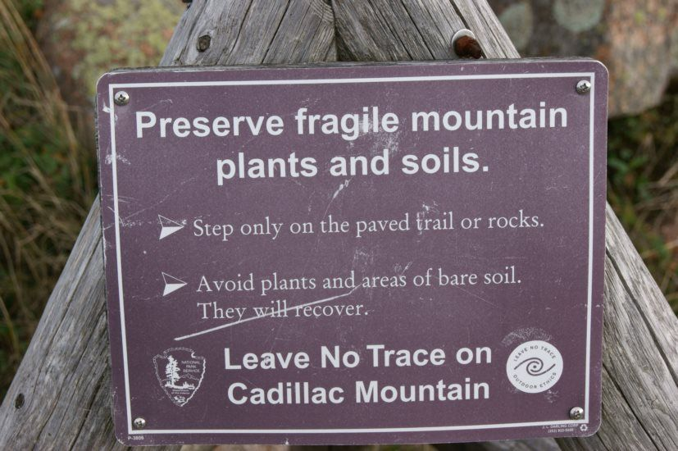
Figure 1: The awareness campaign for protecting Mount Everest. Source: (National Geographic Society, 2019)
Nepal’s Tourism Ministry is acting on protecting the tourism destination from excessive pollution (BBC, 2021). Nepali authorities of Mount Everest had taken different steps at different times especially focusing on the climbing season (Brändlin, 2014). The clean-up rules for the climbers of Mount Everest is one of the biggest steps that is taken by the Nepali Authority. The new rule requires every climber of Mount Everest to bring back their trash. The destination is facing heavy dumping due to the boom of alpine tourism. The authority of Nepal has made regulations for the climbers to bring back all the trash. But, the authority was not able to properly implement the new rule. Due to the huge number of inexperienced climbers who usually left their garbage to save their energy. One of the world’s most famous climbers Reinhold Messner has stated that the tourist destination should be closed for a certain time for recovering the destination. The Tourism Ministry of Nepal encourages the highest number of climbers and it had already taken the step of reducing the fee for the climbers as well as working to make the climbers aware of the pollution at the destination. The number of tourists at Mount Everest is increasing. There need extensive and collaborative efforts to ensure sustainable development of the destination. The government alone may not proceed much on its steps toward sustainable tourism development. As sustainable development requires the tourism industry to focus on three main pillars such as economic, social, and environmental factors, the authority of Mount Everest should blend all of these three areas in developing and implementing the sustainable practice. During the pandemic time, the tourism destination also suffered a lot as many climbers had become Covid-19 positive (BBC, 2021a). In the Everest Base Camp, there was a spread of the Covid-19 pandemic. The situation has been recovered. But, tourist destination is vulnerable to any type of critical situation.

Butler’s Life Cycle Model
A well-known model in the tourism industry is Butler’s Life Cycle Model which is widely used for measuring the life cycle of a tourism destination (Šulc, 2015). Mount Everest is one of the best places for adventure travellers to travel. But, the destination due to inexperienced climbers and unawareness among the climbers is getting polluted day by day which is a major concern for the environmentalists, destination management authority, etc. Bulter’s model is illustrated below for understanding the life cycle of Mount Everest and to guide the proper suggestions for the sustainable management of the destination.
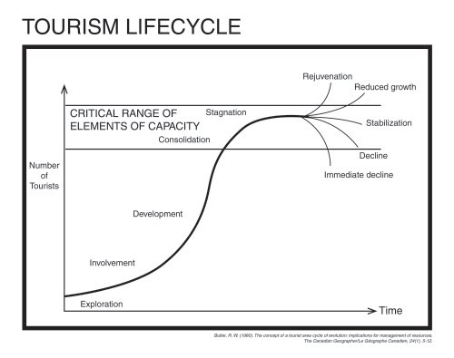
Figure 2: Butler's Life Cycle Model. Source: (Stainton, 2020)
Stage one: Exploration stage
There involve six stages in this Butler’s life cycle model. The first stage is exploration. In this stage, very few travellers are attracted by a tourism destination and visit the stage. It is the stage where a tourism destination starts exposing its attractiveness to tourists. The first expedition to the peak of Mount Everest happen in 1953. From then the destination has got people’s attention. In this stage, the tourist may not find enough facilities like modern hotels, development transportation, etc.
Stage two: Involvement stage
In this stage, local people become aware of the attractiveness of the tourist destination. The facilities of the tourist destination are developed to attract potential tourists. Government investment in the destination increased in this stage and promotional activities could be taken.
Stage three: Development stage
In this stage, extensive efforts from the government and the related authority are taken to make the tourism destination one of the well-organised tourism destinations. For example, the Nepal Tourism authority cut the fee of the climbers of Mount Everest to encourage more tourists to travel to the destination at different times (Times of India, 2020).
Stage four: Consolidation stage
This is the stage where the local communities of a tourism destination become bothered because of the activities of the tourists. Some unwise decision hampers local people’s life and environmental degradation happens. This is the stage where Mount Everest as a tourist destination belongs.
Stage five: Stagnation stage
This stage refers to the situation where the number of tourists in the destination reached its highest peak and keeps affecting the society and economy negatively (Serdane, 2019). Authorities may want to revive the destination attractiveness in this stage.
Stage six: Decline stage
In this stage, the number of tourists would decrease by huge numbers. This can be referred to as the end of the attractiveness of a tourism destination.
Or Stage six: Rejuvenation stage
The authority of a tourism destination may ignore the decline stage and ensure the rejuvenation of the stage. There need for well-planned initiatives for the rejuvenation of the destination.
The analysis of Butler’s model state that Mount Everest stays at the consolidation stage where the tourism destination is experiencing a huge number of tourists. This huge number of tourists is hampering the natural environment by dumping huge number of trash. The authority of Mount Everest management had taken initiatives to reduce the dumping on Everest which does not help much in the reduction of environmental pollution. So, there need more focus steps and awareness campaigns to save the tourism destination.

Doxey’s Irridex Model
Doxey’s Model defines the 4 stages of a tourism destination. The model is illustrated below.
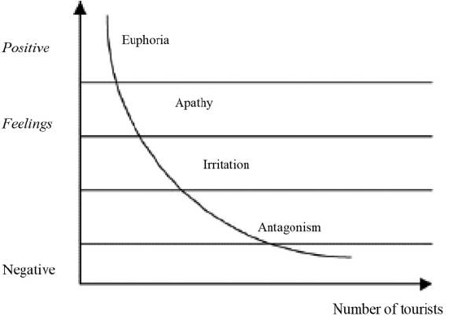
Figure 3: Doxey's Irridex Model. Source: (Beeton, 2006)
Euphoria
In this primary stage of tourism destination development, local people actively cooperate with the tourists and try to become economically independent based on tourism development. The local people welcome tourists and work on attracting potential tourists.
Apathy
In this stage, a formal relationship between the tourists and local people prevails. The tourism destination gives focus to marketing. This is the stage where different initiatives are taken for making the destination a well-defined tourism market.
Irritation
The irritation stage says that an excessive number of tourists hamper the usual life of the local people. The local communities become irritated by the activities of the tourist. Local protests may be observed at this stage. Mount Everest is going through this stage where the environmentalists suggest keeping the destination for a time period to recover it from excessive pollution.
Antagonism
In this stage, excessive pollution happens and the destination loses its natural beauty. The negative impacts of heavy tourism on the local communities are observed in this stage.
The above analysis demonstrated that Mount Everest belongs to the Irritation stage of Doxey’s model. This is the stage where the action by the tourist negatively affects the normal life of the local people and people, and environmental activists protest against this excessive tourism practice.

Recommendations
The tourism industry across the world is booming since earlier times. But, the different inconsiderate decision in the tourism industry has made it one of the biggest contributors to the world’s natural environment deterioration. Mount Everest in Nepal keeps the high potential of tourist attraction across the world. Among adventure travellers, Mount Everest is a desirable tourism destination. The huge number of tourists is contributing to the pollution of the destination. There need proper steps to save the environment from this excessive pollution. For sustainable development of Mount Everest needs proper planning and collaborative action. Nepal’s Tourism Ministry handles the destination where they make rules for decreasing dumping in the destination. The first recommendation to the authority is to make a plan by following environmental standards. Second, the authority can align with the SDGs declared by United Nations. Balancing the three pillars of sustainable principles could be effective for the sustainable development of the destination.

Conclusion
The report has analysed two models for understanding the life cycle of Mount Everest as a tourism destination. The tourism destination stays in the consolidation stage where it is facing excessive pollution due to the dumping of plastic and other trash waste. The situation requires destination management to take proper steps. Only by the collaborative efforts from the tourist, authorities, government, local communities, and other stakeholders can reduce pollution and ensure a sustainable tourism destination.

References
BBC (2021a). Covid cases at Everest base camp raise fears of serious outbreak. BBC News. [online] 4 May. Available at: https://www.bbc.com/news/world-asia-56984320 [Accessed 11 Nov. 2022].
BBC (2021b). Everest: China to set up ‘separation line’ at summit. BBC News. [online] 10 May. Available at: https://www.bbc.com/news/world-asia-china-57053982.
Beeton, S. (2006). Community development through tourism. Collingwood, Vic: Land Links.
Brändlin, A.-S. (2014). Taking control of Everest climbers’ environmental impact | DW | 19.03.2014. [online] DW.COM. Available at: https://www.dw.com/en/taking-control-of-everest-climbers-environmental-impact/a-17502443 [Accessed 24 Oct. 2019].
Chindarkar, N. and Thampapillai, D. (2018). Rethinking Teaching of Basic Principles of Economics from a Sustainability Perspective. Sustainability, 10(5), p.1486. doi:10.3390/su10051486.
Geum, Y. and Park, Y. (2011). Designing the sustainable product-service integration: a product-service blueprint approach. Journal of Cleaner Production, 19(14), pp.1601–1614. doi:10.1016/j.jclepro.2011.05.017.
Halisçelik, E. and Soytas, M.A. (2019). Sustainable development from millennium 2015 to Sustainable Development Goals 2030. Sustainable Development. doi:10.1002/sd.1921.
Jacquemet, E. (2017). Why Do People Come to See Mount Everest? Collective Representations and Tourism Practices in the Khumbu Region. Revue de géographie alpine, (105-3). doi:10.4000/rga.3844.
Kozak, M. and Kozak, N. (2016). Tourism and hospitality management. United Kingdom ; North America: Emerald.
MacNeill, T. and Wozniak, D. (2018). The economic, social, and environmental impacts of cruise tourism. Tourism Management, 66(1), pp.387–404. doi:10.1016/j.tourman.2017.11.002.
National Geographic Society (2019). Protecting Mount Everest: The Rights of the Mountain. [online] National Geographic Society. Available at: https://www.nationalgeographic.org/activity/protecting-mount-everest-rights-mountain/.
Rosen, M.A. (2017). The Future of Sustainable Development: Welcome to the European Journal of Sustainable Development Research. European Journal of Sustainable Development Research, 1(1). doi:10.20897/ejosdr.201701.
Serdane, Z. (2019). Slow Philosophy in Tourism Development in Latvia: The Supply Side Perspective. Tourism Planning & Development, pp.1–18. doi:10.1080/21568316.2019.1650103.
Smale, A. (2018). What the SDGs mean. UN Chronicle, 55(2), pp.6–7. doi:10.18356/ca912345-en.
Stainton, H. (2020). Butler’s Tourism Area Life Cycle Model: A simple explanation. [online] Tourism Teacher. Available at: https://tourismteacher.com/butlers-tourism-area-life-cycle-model/.
Šulc, I. (2015). Tourism Development and Stagnation of Korčula Island in the Model of the Tourism Area Life Cycle. Hrvatski geografski glasnik/Croatian Geographical Bulletin, 76(2), pp.61–84. doi:10.21861/hgg.2014.76.02.04.
Times of India (2020). Mount Everest reopened by Nepal to boost tourism. [online] Times of India Travel. Available at: https://timesofindia.indiatimes.com/travel/travel-news/mount-everest-reopened-by-nepal-to-boost-tourism/articleshow/77296225.cms [Accessed 11 Nov. 2022].

