TITLE: Individual report- Learning and development report


STUDENT NAME: RALUCA IOANA SERBAN
STUDENT ID: 2213917
MODULE CODE: LCBB5012
LECTURER NAME: LIYANAGE RODRIGO
COMPONENT 2
2000 WORDS

Table of Contents
INTRODUCTION 3
Impact of Internal and External Forces on L&D Design and Implementation 3
Learning and Development Supporting Adaptation to Environmental Factors 5
L&D as a Tool for Maintaining Competitive Advantage 5
Supporting Employees from Diverse Backgrounds 6
Application of a Relevant L&D Model 7
Challenges and Recommendations 9
Conclusion 10
References (Harvard Style) 11

INTRODUCTION


HRM training and development the planned learning process, leading to the acquisition of attitude, knowledge and skill through experience or instruction, for the purpose of improving individual performance in an organisational setting. It consists of organized learning, professional development and ongoing learning that allows employees to adjust to the changing workplace. Organizations need productive L&D strategies to meet the challenges of technological innovation, global competition and social transformation in nurturing a value system that is inclusive and unbiased (Swanson & Holton, 2018). Moreover, L&D interventions allow organizations to facilitate diversity by allowing every member of an organization the opportunity of developing the skills and progressing in the career (Noe et al., 2021).
The Kirkpatrick’s Evaluation Model, an established training evaluation model, measures result at four different levels: Reaction, Learning, Behaviour and Results (Kirkpatrick & Kirkpatrick, 2016). This model helps organizations take a holistic view to measure the impact, and value of learning interventions.
The British Red Cross, one arm of the International Red Cross and Red Crescent Movement, is among those proving the value of L&D to charitable operations. It equips its staff and volunteers with essential technical skills to effectively respond to emergencies, promote resilience, and assist in the recovery of disaster-affected populations worldwide.

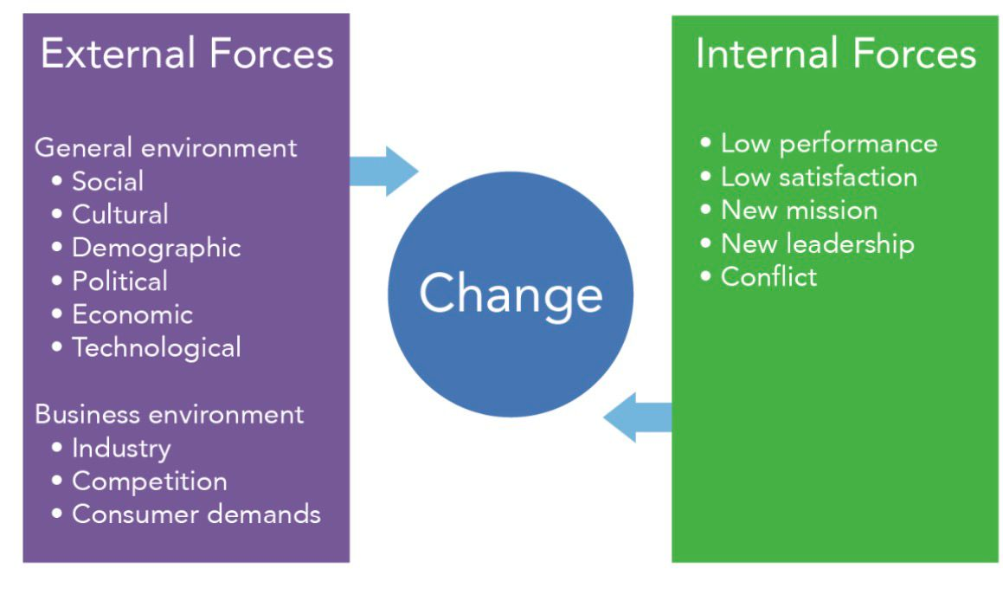
Impact of Internal and External Forces on L&D Design and Implementation

Internal organization dynamics and external environment pressures drive the development and implementation of learning and development (L&D) initiatives. “Internally, it comes down to culture, leadership support, staff competencies gaps and the technology infrastructure to determine L&D’s effectiveness as a part of operations. The leadership-enabled learning culture encourages professional development and innovation over time throughout the organization (Schein, 2017). At the British Red Cross, experience and leadership commitment to humanitarian values ensure that training programs cultivate a range of expertise in both technical skills and empathetic competencies essential to mobilize in a crisis.
At the macro-level, externally, the PESTEL framework (Political, Economic, Social, Technological, Environmental and Legal) can help explain how macro-environmental forces influence L&D priorities (Johnson et al., 2020). Politically, the NGO must adhere to international humanitarian law and government tie-ins with an impetus toward compliance and ethical training. Economic forces, funding changes as an example, are precipitate the requirement for affordable digital learning tools. Given social considerations such as diversity and community needs, training that promotes cultural competence is imperative (Noe et al., 2021). The training provision for dispersed teams within the British Red Cross has been revolutionised by technological advances, namely e-learning and virtual working (Salas et al., 2015). There is therefore a need to create special training in anticipation and resilience related to environmental hazards (such as disasters related to the climate). Finally, health safety and data protection legal regulations mould the way in which training is designed and delivered.
In general terms, a combination of internal and PESTEL-driven external forces make it necessary for the BRC to develop adaptive, technology-mediated and ethically justified L&D strategies. These programs are designed to equip staff and volunteers with the competencies, and awareness to effectively respond to international humanitarian needs in a manner consistent with organization and regulatory expectations.

Learning and Development Supporting Adaptation to Environmental Factors
Organizational development Learning and development (L&D) is a key enabler of organizational adaption to environmental changes, such as digitalization, globalization and changing workforce trends. As a highly dynamic and technology-oriented workplace increasingly becomes the norm, lifelong learning serves to maintain employees’ competent response to ongoing challenges in everchanging work environments (Noe et al., 2021). Adapting We need to adapt if we are still going to deliver humanitarian help in a world of crisis, technological and social change.
How training is designed and delivered has been drastically impacted by digital transformation. The utilization of e-learning, virtual simulations and digital collaboration facilitates the accessing of training by staff and volunteers at a distance enabling both flexible and inclusive learning to be provided within geographically dispersed teams (Salas et al., 2015). Remote working patterns have also inspired the British Red Cross to develop digital and communication skills, enhancing employees’ engagement and performance in virtual settings.
The adoption of lifelong learning programmes is part and parcel of such an adaptive strategy. Workshops, online modules and scenario-based learning keep staff and volunteers up to date in specific areas such as crisis management, safeguarding and mental health awareness. Such interventions not only enhance operational readiness, but they strengthen organisational resilience and creativity (Garavan et al., 2019).
By incorporating continuous L&D into its culture, the British Red Cross is able to keep their workforce flexible and ready to respond rapidly and efficiently to external changes - upholding their humanitarian mission in a volatile international landscape.

L&D as a Tool for Maintaining Competitive Advantage
L&D as a strategy is the primary way through which businesses continue to provide long-term value by developing the skills and engagement of its people. In today's ever‐changing world of work where demographics define talent mobility, effective L&D bodes well for organizations that seek to attract and retain talented employees and support a motivated, high‐performing workforce (Saks & Haccoun, 2019). Workforce development programs. L&D intervention that strive to provide for continuous professional development enhance employee engagement by developing a sense of worth and meaning, which in turn develop job satisfaction and organization commitment (Noe et al., 2021).
Running leadership development programs is specifically critical for sustainability, as they develop the quality leaders who will drive complexity, innovation and change (Garavan et al., 2019). Also at the British Red Cross, leadership and management development is part of its wider talent strategy. The management trainee and volunteer programmes provide the next generation of leaders with the opportunity to learn through shadowing, reflective practice and real-life experience. Through its internal capacity building of leadership, the organization can maintain continuity as well as strategic convergent with its humanitarian objective.
Second, L&D improve productivity by enhancing the technical competency of employees and decision-making capacity, as well as effectiveness to be responsive in crisis. For British Red Cross this could mean greater impact of humanitarian intervention, operational effectiveness and increased confidence in its stakeholders. In this way, through focused L&D and leadership development, the organization ensures not only continued internal capability but also its international reputation and competitive position within the broader humanitarian sector.

Supporting Employees from Diverse Backgrounds


( Figure 1: Learner )
Programmes of inclusive L&D are the cornerstone to guaranteeing that all people, no matter their backgrounds, cultures or identity, have access on a level playing field to learn and grow in ways which will enable contribution to success. Organizations in today's globalised and multi-cultural workplace must have L&D strategies of equity, respect and understanding across diverse groups of employees (Noe et al., 2021). An L&D strategy that is inclusive helps promote belonging, increase engagement and aid in the development of innovative, collaborative work environments (Shore et al., 2018).
At the British Red Cross, as we have such a varied staff and volunteer base, we understand that learning is most beneficial when it’s inclusive. It also includes sensitivity training to help staff and XXXX workers liaise productively with a society in which the cultural and language barriers are involved. These efforts not only enhance teamwork and service delivery but are in line with the organisations' value of humanitarian principle including impartiality and respect for diversity. Language skills programs and open e-learning course further guaranteed that also employees with different information level and language capabilities had the opportunity to participate on equal terms in the professional development of their careers.
Recognising different learning styles is also a key part of inclusive L&D. Learning style-based strategies such as visual, aural and kinesthetics learning can be adopted on the supply side to develop training which caters to individual preferences for learning by employees within an organization (Honey & Mumford, 1992). Furthermore, mentoring schemes aiming to draw in underrepresented groups, like ethnic minorities or people with disabilities, offer tailored advice and support professional development (Clutterbuck 2019).
With its unified approach to L&D, the British Red Cross develops people’s skills and knowledge and therefore their competence, confidence and commitment while promoting a unified workforce that embraces society too. Finally, diversity-based learning initiatives enable the organization to walk its talk of humanitarianism at a time when the full potential of each employee matters more than ever.

Application of a Relevant L&D Model

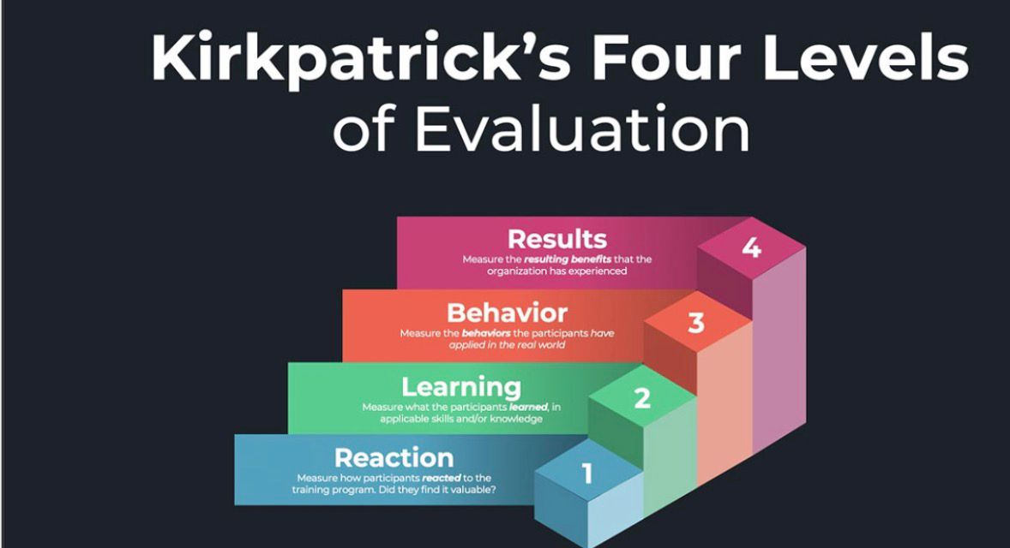
( Figure 2: Learner )
Kirkpatrick’s Evaluation Model stands as one of the most widely used models for evaluating L&D programmes. Originally established by Donald Kirkpatrick (1959) and subsequently revised, the model assesses training effectiveness at four sequential levels: Reaction, Learning, Behaviour, and Results (Kirkpatrick & Kirkpatrick, 2016). The first level looks on how satisfied and engaged are the participants in learning; second looks on what knowledge or skills has been acquired; third relates to the transfer of learning to the job (workplace behaviour) and fourth deals with the overall impact of learning to organization, for example, a performance improvement or strategic direction.
An example of how we identify outcomes using Kirkpatrick’s model can be found in the case study below, which shows how we have applied it at the British Red Cross to ensure that training all our way from crisis response through to leadership and inclusion programmes, deliver effective learning and are directly linked into humanitarian outcomes. For example, the organization after providing emergency response training takes participant feedback (Reaction), assesses retention of knowledge through evaluating their assessment scores (Learning), sees the practice of new skills in the field operations (Behaviour) and checks whether there are operational outcomes resulting out of it like increased efficiency or community impact (Results). This disciplined review mechanism enables the organization to hone its learning design and promote on-going improvement.
The merits of Kirkpatrick’s model are clarity, flexibility and being comprehensive: it allows organizations to assess learning at both individual- and organizational levels (Salas et al., 2015). However, its shortcomings can be exposed in global, pluralistic cultures such as British Red Cross. Variability in context, cultural differences and varying perspectives on what constitutes behavioural change can lead to inconsistencies in the evaluation among international teams (Bates, 2004). And it can be difficult to separate the effects of training from other factors. Nevertheless, it has a place within mission- and purpose-driven organizations seeking to align their learning strategy with evidence-based, greater impact-led practice.

Challenges and Recommendations
Effective L&D strategies face significant obstacles, even in large, global and resource rich organizations such as the British Red Cross. One of the major obstacles is resistance to change (Dekko et al, 2016), with staff or volunteers not always wanting to embrace new learning technologies or styles, particularly when moving from traditional face-to-face training to anything digital-based-models (Kotter, 2012). Budget constraints are also a challenge, for humanitarian agencies often depend on contributions and limited funding, which prohibits investment in sophisticated learning systems. Differences in technology availability between international branches and volunteers may also act as a barrier to equal participation in online learning resources. Addressing inclusion and access in a global perspective that spans multiple languages, culture, and geography also presents implementation challenges (Noe et al., 2021).
There are a range of forward-thinking approaches that the British Red Cross can take to meet these challenges. First, the use of AI and analytics can enable personalized learning paths for employees and volunteers that will allow them to receive training based on their specific roles, as well as according to their unique ways of learning (Jarrahi, 2018). Secondly, resources should be directed towards the mobile learning and microlearning platforms to improve access, retention and engagement for field-based personnel working in remote locations. Leadership endorsement and reward structures which can also decrease resistance and promote participation, and uptake of a culture of continuous learning. Lastly, promoting mutual cross-cultural mentoring and peer-to-peer learning efforts can also help to achieve inclusivity and enhance regional cooperation.
Through combining these creative and inclusive methods, the BRC will become able to maximise the effectiveness, reach, and continuity of its L&D practices into a shifting humanitarian sphere.

Conclusion

Summary L&D is a strategic driver in HRM that provides organisations like the BRC with the capability to be agile, inclusive and competitive in a continually evolving environment. By means of on-going learning, leadership development and inclusive training the organisation sustains employee engagement, agility and international mobility. "Measuring What You're Doing with Kirkpatrick’s Four Levels of Training Evaluation" also helps connect L&D efforts with the organization. Despite the limitations of budget and human inertia, including resistant faculty members as the unwilling participants, an ideal balance can evolve based on integrating new technology and AI-based personalization with user-friendly e-learning modules. And by putting what it does best, inclusive, adaptive and evidence-based L&D at the heart of all its work in this way, the British Red Cross workforce can remain in charge of delivering strong humanitarian outcomes in a variety of complex global contexts.

References (Harvard Style)

- Bates, R. (2004) ‘A critical analysis of evaluation practice: The Kirkpatrick model and the principle of beneficence’, Evaluation and Program Planning, 27(3), pp. 341–347.
- Clutterbuck, D. (2019) Everyone Needs a Mentor: Fostering Talent in Your Organisation. 5th edn. London: Chartered Institute of Personnel and Development (CIPD).
- Garavan, T., Carbery, R. and Rock, A. (2019) Strategic Human Resource Development. London: Routledge.
- Honey, P. and Mumford, A. (1992) The Manual of Learning Styles. Maidenhead: Peter Honey Publications.
- Jarrahi, M.H. (2018) ‘Artificial intelligence and the future of work: Human–AI symbiosis in organizational decision making’, Business Horizons, 61(4), pp. 577–586.
- Johnson, G., Whittington, R., Scholes, K., Angwin, D. and Regner, P. (2020) Exploring Strategy: Text and Cases. 12th edn. Harlow: Pearson Education.
- Kirkpatrick, D.L. and Kirkpatrick, J.D. (2016) Kirkpatrick’s Four Levels of Training Evaluation. Alexandria, VA: ATD Press.
- Kotter, J.P. (2012) Leading Change. Boston, MA: Harvard Business Review Press.
- Noe, R.A., Clarke, A.D.M. and Klein, H.J. (2021) ‘Learning in the twenty-first-century workplace’, Annual Review of Organizational Psychology and Organizational Behavior, 8(1), pp. 245–269.
- Saks, A.M. and Hacon, R.R. (2019) Managing Performance Through Training and Development. 8th edn. Toronto: Nelson Education.
- Salas, E., Tannenbaum, S.I., Kreiger, K. and Smith-Jentsch, K.A. (2015) ‘The science of training and development in organizations: What matters in practice’, Psychological Science in the Public Interest, 13(2), pp. 74–101.
- Schein, E.H. (2017) Organizational Culture and Leadership. 5th edn. Hoboken, NJ: John Wiley & Sons.
- Shore, L.M., Cleveland, J.N. and Sanchez, D. (2018) ‘Inclusive workplaces: A review and model’, Human Resource Management Review, 28(2), pp. 176–189.
- Swanson, R.A. and Holton, E.F. (2018) Foundations of Human Resource Development. 3rd edn. San Francisco, CA: Berrett-Koehler Publishers.
- Tannenbaum, S.I. and Yukl, G. (1992) ‘Training and development in work organizations’, Annual Review of Psychology, 43(1), pp. 399–441.

