

Name: Harrison Davies

Student Number: 2114726

Course: HND Quantity Surveying (Higher Apprenticeship)

Module: Work Based Project

Assignment Title: Learning Contract

Lecturer: Deborah Hughes

Contents
1 Proposed Research Title 2
2 Abstract 2
3 Introduction & Background 2
4 Aims and Objectives 3
5 Research Methodology(ies) and Justification 3
6 Literature Review 4
6.1 Sustainability in Construction 4
6.2 Traditional Energy Methods 6
6.3 Net Zero Carbon 7
7 Primary Research 8
7.1 Solar Energy 8
7.1.1 Benefits of Solar Energy in Local Authority Homes 9
7.1.2 Drawbacks of Solar Energy 9
8 Data Analysis 10
9 Conclusion 10
10 Bibliography 12

Proposed Research Title

Should Solar Energy be used on Local Authority Developments?

Abstract
The purpose of the research is to learn more about the uprise in solar energy being implemented into local authority homes.

Introduction & Background
The Researcher has been involved in the installation of Solar Panels on Council properties as an Assistant Quantity Surveyor. The Researcher works for a main contractor who are working with many Local Authorities. The researcher seeks to find out the advantages of this renewable energy source whilst comparing against traditional methods used within the construction industry.
The findings from the research will be of great interest to Housing Associations, councils and other Local Authorities who are undertaking the works and ultimately contribute to their decision in whether to implement a strategy to create a works programme that’s sole purpose is to increase the number of properties within their current housing stock which have solar panels/pv installed.
An article by Giles Parkinson (Parkinson, 2015) he supports his strong opinion with reasons and statistics that the benefits of solar do outweigh the costs of installation. Conversely a recent article from Graham Sawrey (Sawrey, 2022) discusses that the high costs take a long time to break even, therefore not even reap the savings until multiple years down the line.

Aims and Objectives
The three main aims of this research project are outlined below:
- What are solar panels / PV?
- What are the benefits and drawbacks of solar panels and their introduction to social housing / council properties?
- How does the installation/performance of solar panels compare against traditional methods that have been historically used in social housing stock?
The aim of this research is to provide a greater understanding of solar energy. What is it? Why has it revolutionised the industry, how it has been integrated into council properties in today’s construction world and the benefits of doing so. This research intents to give a non-biased perspective which shows the advantages and disadvantages of solar energy. The cost efficiency, to evaluate the feasibility and does it make financial sense for the local authorities to implement solar panels onto homes? Will it offer long term savings? Next, the effects on the community and how it empowers the local communities by showcasing renewable energy and encouraging further use. Furthermore, this research aims to describe the long term environmental impact of solar energy and how it contributes to reducing the carbon footprint and reliance on non-renewable energy sources by transferring council properties to cleaner and renewable energy alternatives. (Crail, 2023)
The hypothesis would be that “The cost for local authorities to install solar energy onto homes outweigh the benefits” The objective of this research is therefore to review the pros and cons of solar energy to see if the cost of installation outweighs it. This research will collate data from housing associations and councils for several opinions on PV panels and if they should increase the quantity of homes with renewable energy sources.

Research Methodology(ies) and Justification

This research will explore the different factors which go in to using a renewable energy source such as solar and how it can be advantageous to local authorities in the UK in order to battle climate change, reducing carbon emissions while making savings financially. This research will be exploratory. Therefore, it opens the door to more and more questions and further research. Conclusive research will also be used to obtain final findings to answer the aimed questions for this project. (Dudovskiy, 2018)
Due to the vast amount of information on solar energy, the research will predominantly be from secondary date such as online journals and articles. In order to understand fully the benefits of solar panels, the primary data will be collected from interviews from Local Authorities with experience on solar developments. Once the data has been collected, it will be analysed and described with thorough reasoning as to why the results from the research are what they are. Choosing the appropriate audience to target is crucial. As a result, careful sampling will be done. Project managers, cost managers, contract managers, and clients possess the necessary comprehension to make judgements about the use of solar panels on homes.
There will be a sequential mixed-method approach to the investigation. Both quantitative and qualitative data are accumulated using mixed approaches in order to better comprehend the research difficulty. This research will be important to the construction industry as it will give a better understanding of why solar energy is used on social housing projects. It builds onto the current knowledge and can help towards big decisions from the hierarchy in the local authorities as to whether it may be a better idea to introduce more homes to a renewable energy source like solar.

Literature Review

Sustainability in Construction
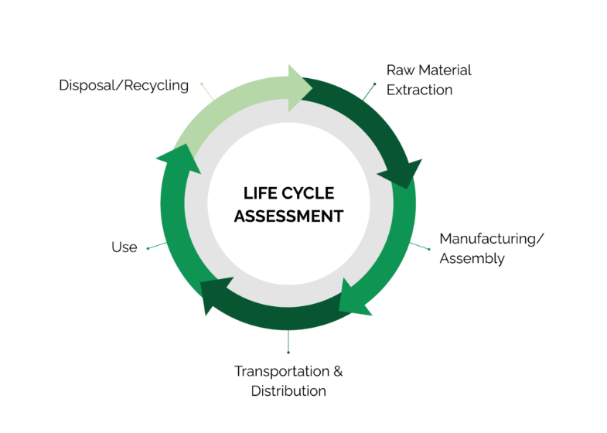
In recent years, the global focus on sustainability has increased as renewable energy sources have become central to the fight against climate change. The construction industry has a colossal impact on the world eco system as it is one of the largest users of global resources and contributors to pollution comes with a responsibility to build a future that will improve lives for generations to come. (GO Construct, 2020) Sustainability in construction is the process of developing, building, maintaining, and dismantling infrastructure and buildings in a way that reduces its negative effects on the environment, preserves natural resources, promotes equity in society, and assures its long-term and short-term financial viability. It entails a structure's complete life cycle, from the extraction of building materials and construction to their usage, upkeep, and eventual disposal or reuse. (Jones, 2020) To achieve sustainability in the construction industry, eco-friendly techniques must be incorporated into all phases of the process, from planning and material selection through building, maintenance, and eventual demolition or reuse. Start by giving the greatest attention to sustainable design concepts that maximise environmental performance, water conservation, and energy efficiency. To save energy and improve occupant comfort, consider elements like building orientation, passive solar architecture, natural ventilation, and daylighting. It is also essential to analyse the effects of building materials and methods on the environment, society, and the economy across the building's whole life cycle. When making design and construction selections, take into account aspects like longevity, upkeep requirements, operating energy consumption, and end-of-life disposal or reuse. A life cycle assessment (LCA) is a thorough process that is used to assess how a product's life cycle—from the extraction of raw materials through manufacture, usage, and disposal or recycling—affects the environment. It is a methodical and comprehensive approach that considers a product or process's environmental inputs and outputs over the course of its whole life. (Sphera, 2020)
With that in mind, It is important to employ building materials that, from extraction and manufacturing to transportation and disposal, have the least negative effects on the environment. Seek for materials with low embodied energy, renewable resources, and recycled content. Think about using sustainable insulation, recycled concrete, and recovered wood as substitutes for conventional materials. (Tunley Environmental, 2024)

Housing developers can reduce energy consumption and greenhouse gas emissions by implementing energy-efficient building systems and technology. This could entail setting up energy-saving lighting, sophisticated building controls, high-efficiency HVAC systems, and renewable energy sources like windmills or solar panels. Another way of doing this is using a ‘SMART’ home. A smart home refers to a convenient home setup with technology to control house appliances from anywhere by use of an internet connection. It allows adjustable settings such has heat, light, energy and security to the occupants preference. An example of how a smart home can save energy would be thermostats automatically lowering temperature when the occupants are away or asleep, and then raise it when present or awake. (Hayes, 2024)
Prior studies have demonstrated that a building's energy consumption can exceed expectations by 40%. (Yu, 2011) This can be due to many of factors such as the occupant forgetting to turn down the heating, leaving windows open or heating empty rooms. With the use of smart homes, that can significantly reduce these factors, ensuring that the energy usage is as efficient as possible.
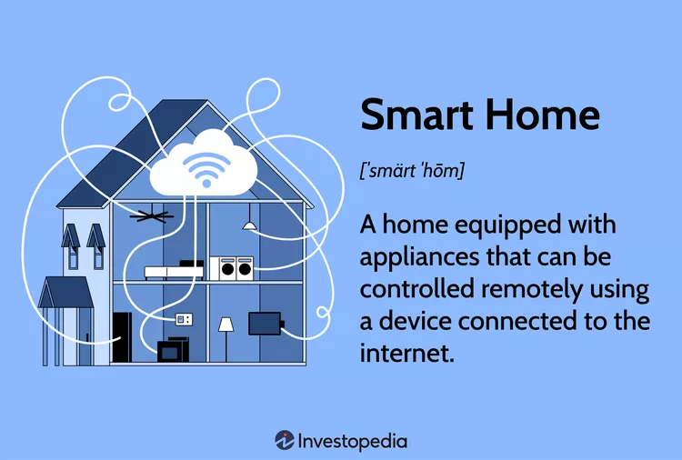
(Hayes, 2024)
Furthermore, accreditation is an aspect of sustainability in construction that must be followed. Environmental monitoring in the construction industry is the measurement and analysis of the surroundings and on-site environment. Construction and infrastructure projects can assure compliance with environmental plans, permits and other regulations while minimising their negative effects on the environment by using environmental monitoring. Monitoring and managing environmental conditions also helps to protect against future lawsuits; on some construction sites, it may even be required by law and clients frequently favour responsible contractors. It is becoming more crucial than ever to be able to show that you care about the environment and how the construction site can affect the area.
BREEAM is a method for assessing a project's sustainability and environmental impact. The Building Research Establishment Environmental Assessment Method is known as BREEAM. This tool is used to help a project achieve its sustainability requirements. BREEAM can be achieved at many levels. Pass, Good, Very Good, Excellent, and Outstanding are the possible grades. Local planning authorities set the minimal standard for a project as "Excellent." Nine different criteria are used to evaluate the rating. It assesses a building's performance in nine areas related to sustainability: energy, water, materials, pollution, land use, health and well-being, innovation, management, and ecology. It is assessed during the planning stage, design, construction, post construction and certification stages. The project is evaluated twice for BREEAM. stage 1, a design evaluation, is when the interim certificate is given out. Stage 2 is the post-construction evaluation, during which the final certificate and outcome are issued. A building's BREEAM accreditation assures all parties involved—clients, tenants, and occupants—that it complies with strict environmental regulations and promotes a sustainable built environment. (Build Energy, 2024) Solar energy can contribute massively to the BREEAM accreditation which gives an added incentive for local authorities to implement the use of solar energy into homes. Solar energy developer Footprint Zero mentioned that “In the BREEAM certification process, solar energy significantly impacts the Energy category, which constitutes 19% of the total score. By reducing dependence on non-renewable energy sources, buildings incorporating solar panels can achieve higher scores. Moreover, they can sell surplus energy back to the grid, cutting down energy expenses and generating additional revenue.” (Footprint Zero, 2024). This is relevant as BREEAM is used in a plethora of construction projects today, it is something that is sort after because it affects the reputation of the stakeholders involved. (BREAAM, 2024). The company ‘Footprint Zero’ are a credible source as they are highly experienced developers who also provide consulting services to companies looking to join the movement of reducing carbon emissions. They justify their information with the fact that they already have established relationships with suppliers and other companies.

.

Traditional Energy Methods
Over the years the sources of energy for homes have significantly widened, due to the implementation of renewable energy. Incorporating renewable energy technologies into their facilities has become a more proactive approach for social housing developments. This includes biomass boilers, heat pumps, solar panels, and wind turbines. These innovations support sustainability objectives, lower energy costs for renters, and cut carbon emissions. However, coal and gas is still predominantly used in the UK as its main energy source. Traditionally, in local authority developments, coal, oil and gas have been utilised for cooking and heating, especially in places where these energy sources are easily accessible and reasonably priced.
Fossil fuels are commonly used to provide energy to homes worldwide. These are natural resources that died millions of years ago and now used to power everything from gas ovens to cars to aeroplanes. (BBC Bitesize, n.d.)
One of the most popular fuels for home heating is natural gas. To provide warmth throughout the winter, natural gas furnaces heat air and then distribute it throughout the house via ductwork. Natural gas is a frequently used cooking fuel in residential kitchens. (Gaertner, 2015) Because they provide precise temperature control and instantaneous heat, gas cookers and cookers are widely used in homes. Oil-fired furnaces are also used to heat homes in places without access to natural gas. A byproduct of natural gas processing and oil refining, gas is used as a cooking fuel in homes without access to natural gas pipelines. Ovens and stoves powered by propane operate similarly to those powered by natural gas. Although they run on heating oil rather than natural gas, oil furnaces function similarly to gas furnaces. Although and coal stoves are becoming less frequent as a result of environmental concerns and the advent of cleaner heating alternatives. However, because of environmental concerns and the introduction of cleaner heating alternatives, coal burners are becoming less common.
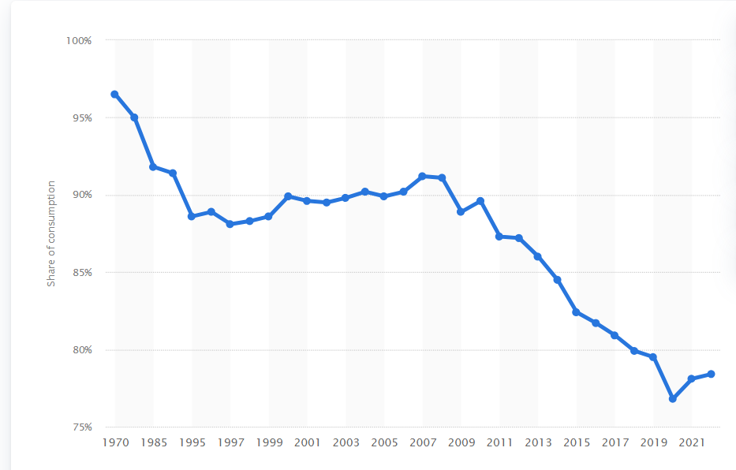
(Statista Research Department, 2024)

The above graph shows the depreciation of percentage dependency on fossil fuels in inland energy consumption in the United Kingdom (UK) from 1970 to 2022.
Even though there is a push for renewable energy in homes, there is still a 78.4% dependency on fossil fuels which is a greatest contributor to pollution. Burning of fossil fuels produces Carbon Dioxide (CO2) (Ritche, 2022)

Net Zero Carbon
Many governments have passed laws and incentives aimed at encouraging the use of renewable energy in social housing. These could include tax breaks and grants which would increase the financial viability of renewable energy investments for housing providers. Namely, the UK government has set out plans to achieve ‘Net Zero Carbon’ by the year 2050. The term "net zero carbon" describes the state of balance reached between the amount of greenhouse gases released into the atmosphere and the quantity extracted from it. To put it another way, it refers to bringing greenhouse gas emissions as close to zero as feasible and compensating for any leftover emissions by processes like carbon capture and storage or reforestation that remove carbon dioxide from the atmosphere.

Because it helps stabilise Earth's climate by avoiding additional accumulation of greenhouse gases, which are principally responsible for global warming, achieving net zero carbon is essential for tackling climate change. Usually, this objective is stated in terms of emissions of carbon dioxide (CO2), but it can also include other greenhouse gases, such as nitrous oxide and methane. (Wood, 2021)
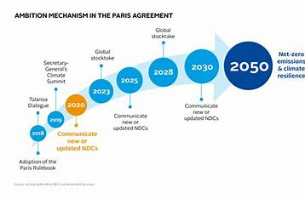

(PRI, 2018)

Primary Research

Solar Energy

Solar Energy is energy created from a nuclear fusion that takes place in the sun. In the sun's core, fusion happens when the protons of hydrogen atoms clash forcefully and combine to form helium atoms. (National Geographic, 2024) This energy can be harnessed to power everything fossil fuels can do in an ecofriendly way. Solar Energy is used through various technologies but primarily photovoltaic (PV) and solar thermal systems.
Photovoltaic systems, commonly referred to as Solar panels, is a form of active solar technology that was discovered in 1839 by 19-year-old French physicist Alexandre-Edmond Becquerel (National Geographic, 2024). use semiconductor materials like silicon to directly convert sunlight into electricity. A solar panel produces electricity when photons, or tiny particles of sunlight, displace electrons from atoms and start them moving. Solar panels are made to capture this electron flow and convert it into a useful electric current. This flow of electrons is known as electricity. The majority of solar technology is based on this fundamental chemical and physical mechanism, known as the ‘photovoltaic effect’. (Aggarwal, 2023) Solar thermal systems generate heat energy by heating a fluid (like water or air) with the help of sunshine. Numerous uses for this heat exist, such as industrial activities, water heating, and space heating. Solar thermal collectors gather solar radiation and transmit heat to a fluid that circulates through the device. Examples of these collectors include flat-plate collectors and concentrating solar collectors. Afterwards, a heat exchanger or storage tank is used to supply hot water or heat the space. (Fields, 2023)
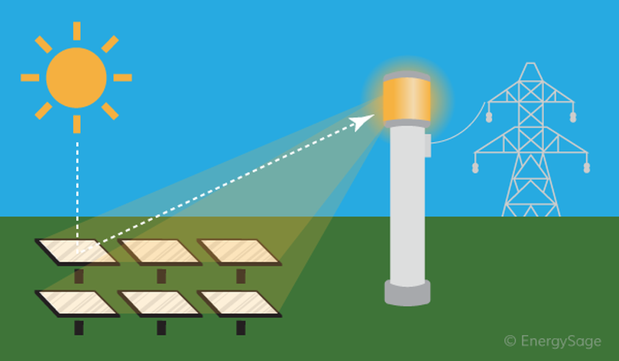

(Fields, 2023)

Solar energy is becoming more and more appealing to homeowners and have chosen renewable energy as there have been 283,000 solar panel installations since February 2022, which has grown the proportion of UK households with solar panels from 3.5% to 4.5%. This equates to 1.28 million households in the UK with solar panels. (Jackson, 2024)
In 2021 the UK Government revealed its much-anticipated ‘Heat in buildings strategy’ which involves plans for decarbonisation works to houses all across the UK. Decarbonisation works includes retrofitting of heating and gas systems delivered through local authorities and social housing. There is said to be £800 million funding (over 3 years) is for energy-efficient social housing upgrades, while the Home Upgrade Grant (£950 million) will help low-income families make energy-efficient upgrades. Both will be managed by local authorities. This is where solar PV enters into the equation. Replacing gas heating with electric heating will result in higher energy costs because electricity is more expensive than gas, unless the initial levels of thermal insulation are particularly low and can be greatly increased. (Elmes, 2021)

Benefits of Solar Energy in Local Authority Homes

The environmental advantages of solar energy are endless, by harnessing sunlight as a renewable energy source, social housing developments can significantly diminish their carbon footprint and prevent the harsh effects of fossil fuel dependency on climate change and air pollution. (McCabe, 2018) As societies strive for equitable development, combining solar electricity and social housing is a compelling solution that meets both environmental and social challenges. Safe and affordable housing are often provided through local authorities, which is typically designed to cater to impoverished or disadvantaged communities. Since solar energy is the most plentiful energy source on Earth, we have been able to develop cutting-edge technology over time that may one day allow us to rely only on it for our energy needs. However, these communities are disproportionately affected by rising energy costs and environmental degradation. Incorporating solar energy systems into social housing not only reduces energy costs for residents, but also contributes to environmental protection and community resilience. Residents of social housing can feel more empowered through solar energy projects that involve them in the development, execution, and administration of renewable energy programmes. Participation in solar projects and community involvement can increase citizens' sense of pride and ownership, enhancing social cohesiveness and bolstering community resilience. (IGINI, 2023)
Looking from another perspective, lowering energy expenses can help social housing residents—many of whom may have fixed or low incomes—free up money for other necessities like healthcare, education, or food security. The benefits of solar energy would be seen greatly by the residents as the installation of the PV panels would be covered by social housing. As mentioned previously, the government are even providing funding and grants for the works to be completed. Employment opportunities are generated by the use of air source heat pumps and solar energy in a number of industries, including production, installation, maintenance, and support services. By providing incentives for the expansion of renewable energy enterprises in their areas, local governments can assist these companies. This employment generation boosts the local workforce's skill level, draws in investments, and encourages economic growth. (Project Heating Solutions, 2023)

Drawbacks of Solar Energy

However, there are obstacles in the way of promoting the use of solar energy in social housing constructions. Installation may encounter challenges due to upfront expenses, technical difficulties, and regulatory restrictions. It also takes careful planning and policy assistance to meet the needs of disadvantaged people and guarantee fair access to solar benefits. A dependable and safe source of electricity is provided by solar energy, particularly in regions where power disruptions or outages are common. Having constant access to power can improve quality of life and guarantee basic needs are addressed for people living in social housing, especially those with limited financial resources.
Furthermore the time it takes for the return on investment (ROI) of solar energy systems in social housing developments to materialise may deter developers or investors looking for quick profits from making the investment. Another disadvantage is the cost of projects will likely increase if expensive renovations or alterations are needed to older buildings to make room for solar systems. Solar energy system maintenance and repair may prove difficult, especially in buildings with little technical know-how or funding for continuous maintenance. (IGINI, 2023)
The UK is renowned for its bad weather. One of the biggest arguments against solar energy in the UK is getting your bang for your buck due to lack of sunlight throughout the year. The amount of sunshine and cloud cover, which can change throughout the day and seasonally, are two factors that affect the production of solar energy.
Batteries and other energy storage technologies can lessen the effects of solar variability, but they also raise the cost and complexity of system design and execution.
Social housing developments may still need to rely on grid electricity during times of poor solar generation if they lack adequate storage capacity or backup power sources, which would reduce the projected cost savings and energy independence. (Dubuis-Welch, 2023)

“The Greenage” adds that solar panels need the right amount of space for installation “With a panel therefore being approximately 1.44m2 in total, to get 14 panels on a roof you need a space of about 20m2” (The Greenage, 2014)

Data Analysis
The following summary of the interviews has been collected from a medium size local authority, with 2 interviewees giving their opinions on “Should solar energy be introduced into Local Authority developments?”

Technical Manager - Of course, including solar energy into social housing buildings is an important step in addressing energy cost and resilience for vulnerable groups, in addition to being an ethical choice for sustainability. Our government is aware of the enormous potential that solar power holds to revolutionise the way that we provide housing and electricity, especially to people who are struggling financially.
There are challenges that must be overcome such as upfront expenses, technological issues, and legal restrictions. These challenges are not impossible to overcome, though, and our "Local Authority" is dedicated to collaborating with housing developers, energy specialists, and community members to create creative solutions and encourage the wider use of solar energy in social housing.

Project Manager - "Although it may initially appear like a good idea to include solar energy into social housing complexes, there are a number of reasons why we should exercise caution. Since a local authority's first priority is the welfare and best interests of its citizens, we must carefully consider the possible advantages of deploying solar energy solutions in this particular context against their practical problems and constraints. The possible social ramifications of integrating solar energy into social housing constructions need to be taken into account. Residents stand to gain from lower energy expenses, but there's a chance that low-income households will bear a disproportionate share of the cost of solar systems, escalating already-existing disparities. Any solar energy projects in social housing must be carried out in a fair and equitable way, taking into account each resident's affordability and accessibility.”

Conclusion

In conclusion, there are strong reasons in favour of solar energy integration in social housing constructions as well as valid concerns that need to be taken into account when debating this complicated topic. One method that solar energy can help achieve sustainability, affordability, and resilience is by increasing energy independence, lowering greenhouse gas emissions, and mitigating climate change. Social housing buildings might potentially alleviate financial pressures, lower energy costs for tenants, and improve overall quality of life by utilising solar electricity. However, there are several difficulties and restrictions associated with the use of solar energy in social housing developments. To guarantee that solar energy programmes are efficient, equitable, and durable, it is necessary to carefully manage upfront costs, technical viability, regulatory obstacles, and equity issues. To overcome obstacles and optimise the advantages of solar energy integration, legislators, housing developers, community organisations, and inhabitants must work together to address these issues.
From the data and research I have collected, I have been able to get a much greater understanding of solar energy and sustainability as a whole. It has broadened my construction knowledge which as an Assistant Quantity Surveyor, can help me in my professional endeavours. Going forward, I will keep in mind renewable energy and hope for a greener future in construction.
This research has very mixed opinions, especially in the industry. In my opnion this is mainly due to the upfront costs of solar panels. If these were to be reduced, there is potential for a significant increase in green homes in the UK.
The choice to incorporate solar energy into social housing constructions should ultimately be made based on a thorough analysis of the needs, priorities, and local context. Though it is a sustainable and eco-friendly solution, solar energy installation must be done carefully, considering the particular opportunities and difficulties that each community presents. Solar energy may contribute significantly to the creation of more inclusive, affordable, and resilient social housing developments for all residents with careful design, creative solutions, and a dedication to equity and sustainability.
If I were to do this project again, I wouldn’t change the approach I have taken as I feel I have adhered to both perspectives of the argument and come from an unbiased opinion. It has however strengthened my feelings towards sustainability and introducing solar energy into Local Authority developments.

Bibliography
Aggarwal, V., 2023. Energy Sage. [Online]
Available at: https://www.energysage.com/solar/solar-panels-work/
[Accessed 16 04 2024].
BBC Bitesize, n.d. BBC. [Online]
Available at: https://www.bbc.co.uk/bitesize/topics/ztv4q6f/articles/zc69r2p#zt8bdnb
[Accessed 15 04 2024].
BREAAM, 2024. BREEAM. [Online]
Available at: https://breeam.com/en/about/how-breeam-works#:~:text=A%20BREEAM%20certified%20rating%20reflects%20the%20performance%20achieved,on%20performance%2C%20quality%20and%20value%20of%20the%20asset.
[Accessed 15 04 2024].
Build Energy, 2024. [Online]
Available at: https://www.buildenergy.co.uk/services/breeam/what-is-breeam/
[Accessed 12 04 2024].
Crail, C., 2023. Forbes. [Online]
Available at: https://www.forbes.com/home-improvement/solar/solar-energy-pros-and-cons/#:~:text=Pros%20and%20Cons%20of%20Solar%20Energy%20%20,impact%20of%20manufacturing%20%205%20more%20rows%20
[Accessed 26 11 2023].
Dubuis-Welch, C., 2023. Independant Advisor. [Online]
Available at: https://www.independent.co.uk/advisor/solar-panels/solar-panel-pros-and-cons
[Accessed 29 04 2024].
Dudovskiy, J., 2018. Exploratory Research. [Online]
Available at: https://research-methodology.net/research-methodology/research-design/exploratory-research/
[Accessed 27 11 2023].
Elmes, S., 2021. Solar Energy UK. [Online]
Available at: https://solarenergyuk.org/the-social-housing-decarbonisation-fund-a-role-for-solar-pv/
[Accessed 29 04 2024].
Fields, S., 2023. Energy Sage. [Online]
Available at: https://www.energysage.com/about-clean-energy/solar/solar-thermal-what-you-need-to-know/
[Accessed 16 04 2024].
Footprint Zero, 2024. Footprint Zero. [Online]
Available at: https://footprintzero.co.uk/solars-impact-on-breeam-scores/#:~:text=In%20the%20BREEAM%20certification%20process%2C%20solar%20energy%20significantly,buildings%20incorporating%20solar%20panels%20can%20achieve%20higher%20scores.
[Accessed 15 04 2024].
Gaertner, R., 2015. Large.Stanford. [Online]
Available at: http://large.stanford.edu/courses/2015/ph240/gaertner1/#:~:text=Most%20energy%20for%20homes%20comes%20from%20traditional%20sources,required%20to%20burn%20fuels%20to%20actually%20produce.%20
[Accessed 16 04 2024].
GO Construct, 2020. Go Construct. [Online]
Available at: https://www.goconstruct.org/why-choose-construction/whats-happening-in-construction/sustainability-in-construction-1/
[Accessed 02 04 2024].
Hayes, A., 2024. Investopedia. [Online]
Available at: https://www.investopedia.com/terms/s/smart-home.asp#:~:text=A%20smart%20home%20allows%20homeowners%20to%20control%20appliances%2C,technology%20provides%20homeowners%20with%20convenience%20and%20cost%20savings.
[Accessed 12 04 2024].
IGINI, M., 2023. Earth.Org. [Online]
Available at: https://earth.org/what-are-the-advantages-and-disadvantages-of-solar-energy/
[Accessed 29 04 2024].
Jackson, J., 2024. Sunsave. [Online]
Available at: https://www.sunsave.energy/solar-panels-advice/cities-and-regions/homes-with-solar
[Accessed 16 04 2024].
Jones, S., 2020. Autodesk. [Online]
Available at: https://www.autodesk.com/design-make/articles/sustainable-construction#!
[Accessed 02 04 2024].
McCabe, A., 2018. Science Direct. [Online]
Available at: https://www.sciencedirect.com/science/article/abs/pii/S030142151730856X
[Accessed 16 03 2024].
National Geographic, 2024. National Geographic. [Online]
Available at: https://education.nationalgeographic.org/resource/solar-energy/
[Accessed 16 04 2024].
Parkinson, G., 2015. The Guardian. [Online]
Available at: https://www.theguardian.com/commentisfree/2015/may/25/the-benefits-of-solar-do-outweigh-its-costs-some-have-a-hard-time-accepting-it
[Accessed 26 11 2023].
PRI, 2018. PRI. [Online]
Available at: https://www.unpri.org/news-and-press/paris-agreement-cop24-update-everything-you-need-to-know/3853.article
[Accessed 02 04 2024].
Project Heating Solutions, 2023. Project Heating Solutions. [Online]
Available at: https://www.projectheatingsolutions.co.uk/the-benefits-of-renewable-energy-to-social-housing-a-breakdown-for-local-authorities/#:~:text=The%20Benefits%20of%20Renewable%20Energy%20to%20Social%20Housing%3A,...%203%20Social%20Benefits%20...%204%20Conclusion%
[Accessed 29 04 2024].
Ritche, H., 2022. Our World In Data. [Online]
Available at: https://ourworldindata.org/fossil-fuels#:~:text=When%20burned%2C%20they%20produce%20carbon%20dioxide%20%28CO%202%29,linked%20to%20millions%20of%20premature%20deaths%20each%20year.
[Accessed 16 04 2024].
Sawrey, G., 2022. ECAVO. [Online]
Available at: https://ecavo.com/solar-energy-disadvantages/#cost
[Accessed 26 11 2023].
Sphera, 2020. Sphera. [Online]
Available at: https://sphera.com/glossary/what-is-a-life-cycle-assessment-lca/
[Accessed 03 04 2024].
Statista Research Department, 2024. Statista. [Online]
Available at: https://www.statista.com/statistics/418202/fossil-fuel-dependence-united-kingdom/#:~:text=The%20United%20Kingdom%27s%20fossil%20fuel%20dependence%20stood%20at,source%20of%20energy%20consumption%20has%20decreased%20since%201970.
[Accessed 15 04 2024].
The Greenage, 2014. The Greenage. [Online]
Available at: https://www.thegreenage.co.uk/how-many-solar-panels-can-i-fit-on-my-roof/
[Accessed 29 04 2024].
Tunley Environmental, 2024. Tunley Environmental. [Online]
Available at: https://www.tunley-environmental.com/life-cycle-assessment?utm_term=Life%20Cycle%20Assessment%20Sustainability&utm_campaign=GUD+-+Carbon+-+UK&utm_source=bing&utm_medium=ppc&hsa_acc=4168009927&hsa_cam=20545322347&hsa_grp=1232553544251687&hsa_ad=&hsa_src=o&
[Accessed 12 04 2024].
Wood, J., 2021. World Economic Forum. [Online]
Available at: https://www.weforum.org/agenda/2021/11/net-zero-emissions-cop26-climate-change/
[Accessed 02 04 2024].
Yu, Z., 2011. Science Direct. [Online]
Available at: https://www.sciencedirect.com/science/article/abs/pii/S0378778811000466
[Accessed 12 04 2024].

