Using a Research Approach in Human Resources

Report Title: Using a Research Approach in Human Resources

Name: Paul Bennett

CIPD Membership Number: 55439410

Date: 22.06.2020

Word count (maximum of 2250 words)

By signing below, I confirm that the work/evidence presented is my own, unaided work. I understand the regulations pertaining to candidate malpractice and the action that may be taken as a result.

Signed: P.Bennett
Date: 22.06.2020

Executive summary
This research report will provide a snapshot of how our employees at Castle leisure feel after the restructure of the companies pay scheme and benefits in September 2019. The changes came from a stagnation in economic growth from 2018/2019. The changes were extensive but were required for the company to continue in the current format and retain the current staffing levels.
The changes made were:
- Removal of sickness incentive.
- A change to our skill level pay rates (still exceeding NLW).
- Removal of Christmas bonus.
- Removal of the discretionary commission payments for supervisors and club management.
- Wellbeing initiatives removed and replaced with an annual health screening with an option of low cost private medical insurance.
During the variation to contract consultation, the changes were seen only as a negative by the staff representatives. At close of consultation the variations were agreed with small alterations.

It was decided in November 2019 that the usual staff survey needed to be completed. I asked to change it to gauge current opinion of the company after the changes.
This was agreed and the first week of December I sent out the quantitative survey to all 698 employees. This questionnaire had 13 categories of questions and a box at the bottom for any other comments. The questionnaire was anonymous.
The methodology for this report is mainly primary data that was captured from the 401 responses I received.
- Firstly, from the results this survey had a 3% increase in response since the last survey of 2017.
- Surprisingly, health and wellbeing had a 3% increase since last survey.
- Staff motivation decreased by 15% since last survey.
- Good place to work increased by 1%
- Job security increased by 3%
- Reward and elements of reward decreased by 3%
- Recognition increased by 1%
- Career development linked to training and development increased by 2%
- Castle leisure trust in leadership decreased by 2%
Recommendations from this survey are based on the 15% decrease in motivation. From the comments box the main demotivator was the loss of the Christmas bonus. The Christmas bonus was not a large sum of money, but it did help with Christmas food shopping. The bonus was £50 of Asda vouchers, these were issued 1 week before Christmas. This bonus equates to an annual cost of £34,900. I suggest we reintroduce this bonus but in a different manner. After discussing this with our food supplier Castell Howell, they have agreed prior to our boards agreement to produce and deliver to each club Christmas hampers, including everything needed for a Christmas dinner for four at a cost of £22 per head, this equates to £15,356 annually. This cost will be reclaimed from the health shield private medical insurance. We only have 31 policies in effect out of 698 on offer, we pay £21,999 contribution to this scheme. I suggest that we stop the scheme and use the money saved to pay for the Christmas hampers. This would leave £6000 for a subsidised Gym membership for the staff at each site reducing the cost to them by 30%. We would also pay them for 1 hour spent at the gym.

Contents
1. Introduction. 4
1.1 Research focus. 4
1.2 Research Aims. 4
2. Literature Review 5
3. Methodology 6
4. Findings/Discussion 6
5. Conclusions 6
6. Recommendations for change 7
Limitations 7
References 7
Appendices 7

1. Introduction.

This research report is a critical evaluation of the motivation of the workforce of Castle Leisure. The Company decided in September 2019 to restructure their pay schemes and benefit and reward packages to stabilise the lack of economic growth for the previous 2 financial years. The reduction of benefits was used to reduce the need for redundancies and a change in our business model. This reasoning was made very clear to the employees. Resulting in a generally smooth variation to contract consultation. The reasoning behind this research is to find what level has the restructure effected staff morale and motivation.

Research focus.
The research is based on a quantitative survey questionnaire sent out to all 698 employees. Consequently, I received 401 responses. A similar survey was used 2 years ago. I want to compare both surveys, so I did not rewrite it. I carefully reworded some of the questions to meet my research parameters. These parameters were:
- Motivation
- Staff morale
- Loyalty to the company
- Benefits and rewards.
- Paid fairly for the job role.
Previous survey of 2017 is attached with the 2019 survey results.

Research Aims.

The research aims to critically review motivation and morale levels post changes to my organisation, with the scope to offer quick fixes whilst still making a saving to the organisation. Any suggestions made via this report will go before the board for approval.

2. Literature Review
Whilst researching motivation in the workplace I have found that one report stood out to me (Latham & Ernst, 2006) This report looks at the five needs of workers to achieve motivation:
- Physiological
- Security
- Affiliation
- Esteem
- Self-actualisation
He looks in depth into (Maslow, 1943) paper which has no data supporting it and researches his theory. Through a survey in 2004 conducted by Latham, and the theories of Maslow’s 1943 paper suggests that people in lower level jobs craved only two things to motivate them, job security and remuneration. Whilst the people in the higher paid higher-level jobs already have achieved the first two so look for self-esteem through achievement and self-actualisation in maximizing their knowledge and skills. (Latham & Ernst, 2006) Also suggests that need 3 Affiliation, is required by both types of workers at different times. For the lower level jobs money and security come first then their own wellbeing, Safety and social needs are looked at once the money is taken care of. For the higher-level workers Affiliation come between Esteem and self-actualisation. Once the respect and admiration phase of their jobs are on track then they require the wellbeing, safety, and social needs before moving on to expanding their skills and knowledge. This report from (Latham & Ernst, 2006) I believe is key when looking at my organisation’s workforce. For the general member of staff which makes up 90% of the organisation, Job security and regular pay are in the forefront of their minds. When we re structured our pay and benefits package, it was the hourly rate that most staff were concerned about. Then the loss of benefits they had always had. Once the workforce was informed that the perks and bonuses were ceasing enabling the company to not make redundancies, the change was accepted. This report uses the same key themes throughout regarding the five needs and let’s not forget that (Latham & Ernst, 2006) found through solid surveys and data analysis of workers from different sectors the same conclusions as (Maslow, 1943) almost 70 years ago. Things clearly have not changed much in the modern workforce.
I also read at length numerous CIPD fact sheets on motivation and the workforce. This is a more UpToDate (CIPD, 2019)look at how we motivate our workforce. This fact sheet was written by Jonnie Gifford who is a senior advisor to the CIPD on organisational behaviour. He states that according to the MacLeod review (MacLeod, 2009) in 2009 there are four enablers of motivation in the workplace:
- Leadership that gives a ‘strong strategic narrative about the organisation’.
- Line managers who motivate, empower, and support their employees.
- Employee voice throughout the organisation, to involve employees in decision making.
- Organisational integrity that stated values are reflected in the actual organisational culture; what we say is what we do.
Although all the points from the Macleod review are certainly valid, there are major issues with this review for me. The survey was undertaken in Canary Wharf London. The average wage for the 220 respondents was £286,000 a year. This review is focused on the highest earners of major international banking organisations. This review is not relevant in my sector and would have very little in common with the average NLW employee.
In summary the (Latham & Ernst, 2006) paper looks at many different research papers that all lead to a similar conclusion. Normal employees are still focused on financial gain and stability from an employer and the higher level of employees are focused on self-development and how they are seen within the organisation’s hierarchy. This rational dates back to (Maslow, 1943) paper and has changed very little.
I also used (Anderson, 2013) as a route map of the research process as well as how to write the report.

3. Methodology

This research report was instigated to critically review the motivation of Castle Leisure’s employees after major changes were made to the pay scheme and benefits packages that all employees receive. September 2019 saw major changes to our pay and benefits packages. I will critically look at the data from the 2017 survey and compare and contrast against the differently worded survey of 2019. Hopefully, I will see a patten from the surveys that will give us an insight to the motivation and morale of the employees and also if changes are needed to increase motivation and morale.
I looked at any secondary data that was available, The (Glint, 2019) report had some very well researched theories about engagement but it was focused on millennials in the tech industry in Silicon valley again it would be difficult to draw comparisons with our employees. I decided to use our own source of data. The 2017 Castle leisure staff survey. This questionnaire would give me direct data and comparisons to my research if I created a similar survey.
My primary data then was created from my secondary data. I reworded the questions that would give me the most useful return of data I required. The rest of the questions I left the same as the secondary data. The questionnaire is a positivist approach and with quantitative questions. I asked a question and the answers were listed from strongly agree to strongly disagree. There were 13 categories in total but really the only useful data for this research came from 4 questions.
From an ethical approach I decided to leave the questionnaires anonymous, I felt that if did it this way then the staff could be honest in their answers.
When It came to choosing my sample size, I wanted to select 20 anonymous questionnaires from each club giving me a data set of 220 questionnaires. When discussing this with the director of people she felt that the results would be more beneficial to the company if I asked every employee to take part. This gave me a sample size of 698. In previous surveys there has been a response rate of around 40% so I would be looking at a sample of 300 surveys. I received 329 surveys completed in total. Due to the quantitative nature of the survey I felt that the reliability of the results would be affected by non-responses to some of the questions with the answer of neither agree nor disagree. Another issue to the reliability of this survey was the company wanted it completed in a short time frame. I was given 1 month from sending the surveys to presenting the results.
The analysis of the data sample was manually collated into an excel spread sheet for ease of presentation. I would use graphs to present to the board and excel would make this easier.

4. Findings/Discussion
The results as far as this report is concerned will look at only the motivation and morale questions of the survey. The survey generated a response rate of 43% which is a 3% increase over the 2017 survey.
Question 1:
This question focused on if our employees felt safe in work. Safety is an important part of a motivated work force. This question does not have much secondary data as it was a new question. I thought that it was important to include in this report as safety would be high up on the motivation and morale of the work force.
- 66% of our employees feel that our annual health screening is important 28% disagreeing and 6 % no response.
- Mental health in the workplace has seen a rise in the media and I wanted to see if the employees felt we were doing enough to support them. 64% believed we are with 31% disagreeing and 5% not responding.
- The company providing training to keep the workforce safe had a 90% agree rate but of those 90%, 86% agreed that they felt safe in work.
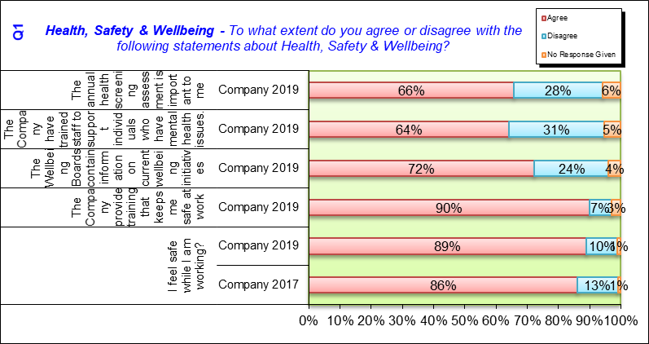

Question 2:
This question was to gauge the overall motivation level. There is a 15% drop from the previous survey of 2017. This is the key question for the whole report. Why has the workforce’s motivation dropped so dramatically in 2 years? This question was linked to the comments box. 89% felt demotivated as we had removed the Christmas bonus. 6% felt the unsociable hours were to blame with 5% no response.
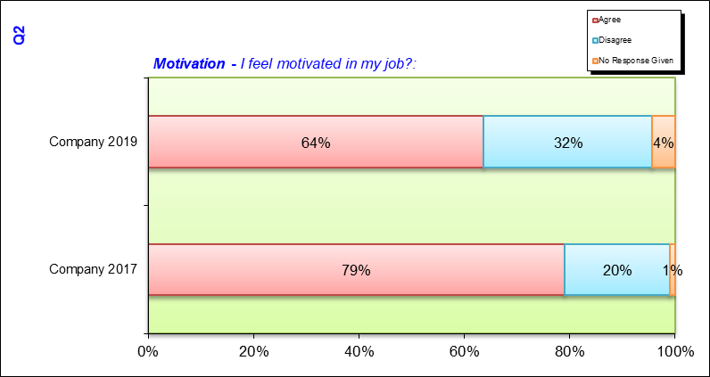

Question 3:
This question looked at the rewards element for the workforce. There is 40% decrease in the use of the health plan from 71% in 2017 to 31% in 2019. The subsidised meals are comparative with the 2017 survey with an increase of 2%. Also, the provision of uniform with no change. The free life insurance has seen a decrease since 2017 this is due to starting the policy after 2 years’ service in 2019 when in 2017 it was from day 1. The Christmas bonus importance has increased by 20% since 2017. The bonus had been removed before the survey, but I wanted to see if this was an issue for the workforce, so I left the question in. Looking at the key results of this question (Maslow, 1943) and (Latham & Ernst, 2006) seem to be accurate with their research as the workforce sampled from my survey are the lower paid end of the scale, they require the financial aspects of reward. The free uniform, Reduced cost food and drink and of course the very sensitive topic of the christmas bonus.
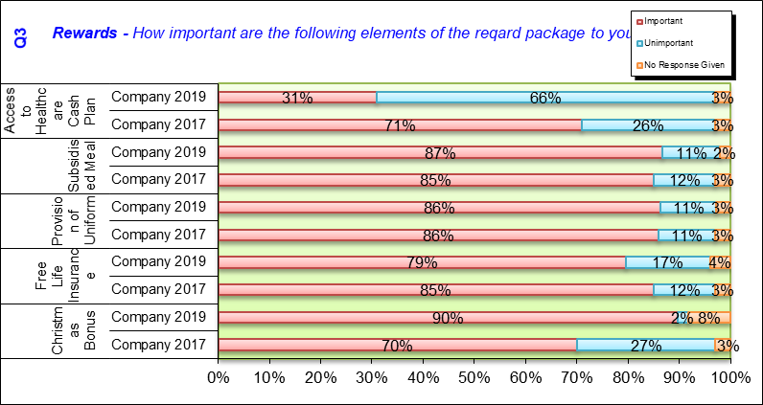
Question 4:
This question was regarding pay. The new policy on pay scales was reduced from 8 levels to 2. No employee had a pay reduction but the levels were frozen so the lower paid staff would catch up with the higher paid staff as the NLW increased. The eventual plan here is to have one standard pay rate for all employees. There has been a small decrease in both questions 3% decrease in industry pay and a 4% decrease in fairly paid for their contribution. Currently we pay an extra 5p an hour compared to our industry counterparts. A lot has changed over the last two years for the workforce. Later evening shifts mandatory weekend day. So, I would put the decrease in paid down to the changes.
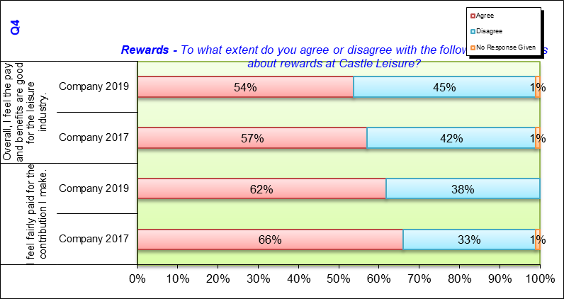

Conclusions
The aim of this research was to critically review the impact of the changes made to pay and benefits in September 2019 regarding motivation of the workforce of Castle Leisure.
Motivation has decreased 15% against the benchmark secondary data of 2017 (Castle Leisure, 2017). I believe that this decrease is linked to the benefits package. The main issue from the 329 surveys received was the removal of the Christmas bonus food shopping vouchers that the company previously issued prior to September 2019. I do not believe the pay restructure has had such a negative impact as we first thought. During consultation for the variation of contract, I t was made clear that the company had to make changes and if they were not made, a change of ethos would be made which would probably lead to redundancies. The consultation was generally smooth with just a few alterations.
The second point the research has highlighted for me is the need for the health plan the company contributes to. The importance of this has decreased by 40% against the benchmark figures of 2017. This is a large cost point for the company which I believe is no longer required and the cost of this could be utilised for a benefit and reward scheme that would be largely accepted by the workforce.
It is also worth noting that the workforce feel safe whilst at work (Mariani, 2015) suggests that this is secondary to remuneration but always at the forefront of any employees minds. 89% of Castle Leisure workforce feel safe at work. This is a 3% increase against the benchmark data of 2017, and I believe if 89% of your work force feel safe at work then that battle is won.

6. Recommendations for change

The Castle Christmas bonus has been around since I started with the company almost 20 years ago. It was not a large sum of money, it was £50 of Asda vouchers, these were issued 1 week before Christmas. This bonus equates to an annual cost of £34,900.
I suggest we reintroduce this bonus but in a different manner. Castell Howell who have partnered with us for many years, have agreed to produce and deliver to all 11 clubs Christmas hampers, including everything needed for a Christmas dinner and a bottle of wine for four at a cost of £22 per head, this will incur a cost of £15,356 annually at our current numbers. To pay for this we would use our contribution to the health shield private medical insurance. We only have 31 policies in effect out of 698 on offer, we pay £21,999 contribution to this scheme. The research shows that 40% of our work force find the medical insurance unimportant, so I suggest that we stop the scheme and use the that we contribute to the plan ( last year £21,999 ) to cover the extra cost for the Christmas hampers. This would leave a balance of £6000 for a subsidised Gym membership for the staff at each site reducing the cost to them by 30%. The Company GYM has agreed to a cooperate plan for our staff and with our contribution of £6000, our staff could use any of their facilities for £6 a month a saving of 30% to their normal corporate membership.

Limitations
The limitations to this survey and report are twofold. Firstly only 43% return on the survey does not speak for the whole workforce, alongside the limitations of a quantitative closed question survey which are:
- They can suggest ideas that the respondent would not otherwise have
- Respondents with no opinion or no knowledge can answer anyway
- Respondents can be frustrated because their desired answer is not a choice
- Misinterpretation of a question can go unnoticed
- Clerical mistakes or marking the wrong response is possible
The second Limitation was the time frame. I was rushed into getting the survey prepared and delivered. The respondents had only 1 week to complete and return to me, leaving me just over a week to collate all the data and generate the reports and graphs. I received a further 132 surveys after the closing date but could not include them in my findings as the data had already been collated and presented to the board. With these extra surveys I would have had a return of 67%.

References
Anderson, V., 2013. Research methods in human resource management. 3 ed. London: CIPD.
Castle Leisure, 2017. Staff survey 2017. Cardiff: Castle Leisure.
CIPD, 2019. Employee engagement and motivation. [Online]
Available at: https://www.cipd.co.uk/knowledge/fundamentals/relations/engagement/factsheet
[Accessed 21 April 2020].
Glint, 2019. The state of employee engagement, los angeles : HR research institute.
Latham, G. P. & Ernst, C. T., 2006. Keys to Motivating tomorrows workforce, Toronto: Human Resource Management review Science direct.
MacLeod, D., 2009. Engaging for success: enhancing performance through employee engagement. , London: CIPD .
Mariani, M. G., 2015. Employee Safety and Motivation, Bologna: University of Bologna.
Maslow, A. H., 1943. A theory of human motivation, Rouledge: Martino Fine Books.

Appendices

