

Developing relationships and workplace achievement

Executive Summary
Akbor Ali 1709535
April 17, 2019

BMSK5002

The purpose of this report is to analyse……..

Table of Contents

Executive Summary 0
Introduction 3
1.0 Development Methods in a Workplace 4
1.0.1Training 4
1.0.2 Employee Engagement 5
1.0.3 Performance Management 6
1.0.4 Development Methods in Action 6
1.0.5 Theories that Promote Development-Organisation & Individual 7
2.0 Benefits of Development Methods to an Organisation & Individuals in the Workplace 7
Conclusion 9
References/Bibliography 11
Appendix 13

Introduction

Development Methods in a Workplace

What are development methods, Cornerstone, (2019) defines employee development methods as, a process where the employee with support from the employer undertakes various training programs to enhance skills and acquire new knowledge. Most business leaders know that development of individuals within their organisation is essential for success and understands that it is the only way to ensure that their employees have the skills and knowledge necessary to perform and meet their objectives. According to Wood, (2018), employee retention in today’s work environment has stabilized especially among millennials due to high performance development methods, such as training, performance management and very importantly employee engagement programs.
Why are these methods important to an individual, Lipman, (2013) understands that, young employees want training, mentoring and coaching and have the desire to gain skills, they want to become more versatile and valuable to an organisation. Jones, (2018) writes that, identifying employee learning and development needs is a crucial element to organisations, and link directly to their desired business outcome and a very important part of an organisation's overall strategy and its business policies. Woods, (2018) says that,” employee development methods mean nothing if they don’t align with an organisations goals”, so in short, identify the skills required to fill talent gaps. Change in skill and knowledge can be developed using several employee development methods.

Training

A clear training strategy helps workers align their work to your business goals. Knowing that the employees are one of the most valuable assets to an organisation, they should be given adequate training in order to improve and develop their functioning in the workplace. McNamara, (2019) writes, that training can be initiated for a variety of reasons, whether it be for development needs or for performance enhancements, it is vital that the management recognises this and provides the correct training to its employees. Half, (2018) explains that, an employer needs to plan a training programme to ensure value is gained not just financially but in terms of developing employee skills.

1.0.2 Employee Engagement

Why is employee engagement an important development method, according to Engagement Multiplier, (2018), the importance of employee engagement should not be overlooked, and that, employee engagement strategies have been proven to improve productivity, efficiency, retain customers at very high rates and most of all reduce employee turnover. This approach creates the right environment where employees are able and willing to make the best of their skills and abilities for their benefit and of their employer, also conditions individuals to thrive knowing that the employer cares and wants the best for its workforce.
Some may say that employee engagement is the same as employee satisfaction, but they are completely different methods, as Custominsight, (2019) states, employee engagement is not the same method as employee satisfaction, but in fact they are opposites, the evidence they provide is that, employee satisfaction only indicates how content or happy an employee might be, and does not address levels of motivation, involvement or the measurement of commitment emotionally or otherwise, but rather just satisfied employees, that are happy to do as little work as possible for a salary. The understanding according to Custominsight, (2019) is that, although employee satisfaction is important to development, it won’t necessarily lead to increased performance.
Employee engagement on the other hand focuses on an engaged workforce, and this point is supported by, CMI, (2015) who references David MacLeod’s report of 2009 on employee engagement, where he defines employee engagement as, a workplace approach developed to ensure an organisations workforce are committed to their organisation’s values and goals, and are motivated to contribute to its success, along with a sense of personal well-being. Referring to Custominsight, (2019) there are two primary factors that drive employee engagement-
- Engagement with the Organisation-This measures how engaged an employee is with the organisation.
- Engagement with Managers-A more specific measure of how an employee can relate with their line managers.

1.0.3 Performance Management

Performance management, “is it an important method”, Gilfford, (2018) describes performance management as, a set of processes to help improve employee performance and aims to maintain performance in line with an organisations goals and to ensure employees contribute positively to business objectives. Gilfford, (2018) also states that, there is no clear definition of performance management, but that of a range of tools and activities that help establish objectives, improve individual performance and to hold individuals to account. Gilfford states, there is no clear definition of performance management, but further research enables Hearn, (2017) to give a more distinct definition referencing a quote from Michael Armstrong who is the creator of the Armstrong performance management cycle, as saying “Performance management is the continuous process of improving performance by setting individual and team goals which are aligned to the strategic goals of the organisation, planning performance to achieve the goals, reviewing and assessing progress, and developing the knowledge, skills and abilities of people.”
Many mistake performance management and performance appraisal as the same method but, they are completely different. As Pawar, (2017) explains, performance management and performance appraisal can be, and is used interchangeably, they also share similarities, but they are not the same. His explanation to this is that performance management is a more comprehensive approach that involves maximum dialogue among all within the organisation, and performance appraisal is primarily a top down assessment in terms of rating or grading employees’ performance periodically. It is a fare point to raise the question of performance appraisal as this method in conjunction with performance management can be combined to create a more comprehensive process, as evidenced by Pawar, (2017) who says” Many forward looking organisations have made performance appraisal a part of their performance management process and It has helped take corrective action and assign further targets by combining the two”.

1.0.4 Development Methods in Action

People often ask how Richard Branson has sustained the success of his company the Virgin group, for over 40 years. In a recent blog, he reveals the secrets. According to Virgin.com, (2019) he Richard Branson says, “It was the people I surrounded myself with who made the difference: If you treat your employees right, they will treat your customers right, and sustained profits will follow.” In close inspection to how this company sets its self-up there is clear evidence as to the use of development methods. According to Virgin Atlantic, (2019) they state that, You will have a clear and precise path of development, where you will have the support of your manager to enable you to be successful, this indicates the use of the employee engagement methods, also they state that, everyone has the chance to learn and develop ensuring that you progress to be your best, these claims show that they have the performance management method in place.
Employees form an integral part of Virgin Atlantics business policy and is committed to serve its employees better. A case study by Rodrigo, (2017) explains that, Good work is recognised through its recognition program and Virgin Atlantic provides world class training to all its employees. Training is given great emphasis as it’s a core value to the company. Organisations such as Virgin Atlantic prove that development methods, not just for Virgin but for the majority should be looked at, not as a hindrance but as an investment to an organisation’s success.

1.0.5 Theories that Promote Development-Organisation & Individual

Development methods work when there is an organisational structure that allows this process to happen. Popular theories and models are also a big element to an organisation and its structure, it in many ways determines the approach an organisation might take and how it goes about its business.

2.0 Benefits of Development Methods to an Organisation & Individuals in the Workplace

Haydon, (2018) states that, clear and systematic identification of learning and development needs is a key aspect to an organisations process of ensuring effective learning across each level of an organisation, he also expresses that, if used correctly, it can provide new data and insight for identifying the learning needs of individuals and organisations.

2.0.1 Benefits to an Organisation

For organisations to utilise these methods, the management needs to be effective, in other words the relationships between the individuals working together and their overall effect are dependent on the leadership and management from the hierarchy, on this point, Entrepreneur, (2005) expresses their opinion, and writes that, the primary reason training is overlooked by so many organisations is because it's considered more as an expense than an investment. Now contrast that opinion to that of one where training is viewed as an investment rather than an expense.
According to Business.com, (2017), the willingness to invest in the development of employees through vehicles such as employee engagement, performance management and training will likewise inspire them to invest their hard work, effort and are more likely to be loyal to the organisation. Key benefits for an organisation can be-
- More profits & revenue
- More efficient
- Enhanced reputation
- More competitive
- Increased innovation
- Increased employee retention
- Promote from within
- Augmented Abilities

2.0.2 Benefits to an Individual

According to Staff training solutions, (2017), ambitious employees, look for quality training programs that can aid in their career development, because they no as an employee training and development provides an opportunity to progress. Key benefits for an individual can be-
- Motivation
- Job satisfaction
- Higher morale
- Self esteem
- More productivity
- Promotion
- Competitiveness
- Job Awareness

3.0 PDP Plan

Conclusion

References/Bibliography

Haydon, D. (2018) ‘Identifying learning and development needs’ [Online]. Available: https://www.cipd.co.uk/knowledge/fundamentals/people/development/learning-needs-factsheet, Accessed: [ 4th, April, 2019]

Cornerstone, (2019) ‘Employee Development’ [Online]. Available: https://www.cornerstoneondemand.com/glossary/employee-development, Accessed: [ 4TH, April, 2019]

Entrepreneur, (2005) ‘The Importance of employee Development’ [Online]. Available: https://www.entrepreneur.com/article/77678, Accessed: [ 4th, April, 2019]

Business.com, (2017) ‘Why Business Should invest in Employee Training’ [Online]. Available: https://www.business.com/articles/why-businesses-should-invest-in-employee-training/, Accessed: [ 4th, April, 2019]

Lipman, V. (2013) ‘Why Employee Development is Important, Neglected and can Cost You Money’ [Online]. Available: https://www.forbes.com/sites/victorlipman/2013/01/29/why-development-planning-is-important-neglected-and-can-cost-you-young-talent/, Accessed: [ 4th, April, 2019]

Jones, M. (2018)’How To identify training and development needs’ [Online]. Available: https://www.breathehr.com/blog/how-to-identify-employee-training-and-development-needs, Accessed: [ 4th, April, 2019]

Wood, S. (2018)’ 5 Steps to Help Improve Your Employee Development Methods’ [Online]. Available: https://www.greatmanagers.com.au/improve-employee-development-methods/, Accessed: [8th, April, 2019]

CMI, (2015)’Employee Engagement’ [Online]. Available: https://www.managers.org.uk/knowledge-bank/employee-engagement, Accessed: [9th, April, 2019]

Engagement Multiplier, (2018)’Why is Employee Engagement So Important’ [Online]. Available: https://www.engagementmultiplier.com/blog/why-is-employee-engagement-so-important/, Accessed: [8th, April, 2019]

Gilfford, J. (2018)’Performance management: an introduction’ [Online]. Available: https://www.cipd.co.uk/knowledge/fundamentals/people/performance/factsheet, Accessed: [8th, April, 2019]

Pawar, Y. (2017)’ How to differentiate performance appraisal from performance management?’ [Online]. Available: https://upraise.io/blog/performance-appraisal-management/, Accessed: [8th, April, 2019]

Hearn, S. (2017)’ What is an Effective Performance Management System?’ [Online]. Available: https://www.clearreview.com/resources/guides/what-is-effective-performance-management/, Accessed: [8th, April, 2019]

Custominsight, (2019)’What is Employee Engagement’ [Online]. Available: https://www.custominsight.com/employee-engagement-survey/what-is-employee-engagement.asp, Accessed: [9th, April, 2019]

Virgin.com, (2019)’ Richard Branson secrets for success’ [Online]. Available: https://www.virgin.com/entrepreneur/richard-bransons-secrets-success, Accessed: [9th, April, 2019]
Virgin Atlantic, (2019)’Learning and Development’ [Online]. Available: https://careersuk.virgin-atlantic.com/life-at-virgin-atlantic/learning-and-development, Accessed: [9th, April, 2019]

Rodrigo, (2017)’Virgin Atlantic Airlines’ [Online]. Available: https://writepass.com/journal/2017/01/virgin-atlantic-airlines/, Accessed: [9th, April, 2019]
McNamara, C. (2019)’Development Reasons and Benefits’ [Online]. Available: https://managementhelp.org/training/basics/reasons-for-training.htm, Accessed: [9th, April, 2019]

Staff Training Solutions, (2017)’benefits of Training to Employees and Employers’ [Online]. Available: https://www.stafftrainingsolutions.co.uk/sts-blog/benefits-of-training-to-employees, Accessed: [9th, April, 2019]
Half, R. (2018)’The Benefits of employee training’ [Online]. Available: https://www.roberthalf.ae/advice/people-management/benefits-employee-training, Accessed: [9th, April, 2019]

Appendix

. 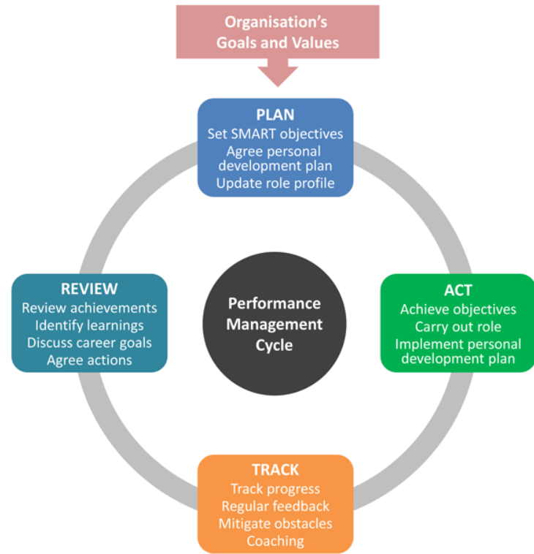Armstrong Performance management Cycle
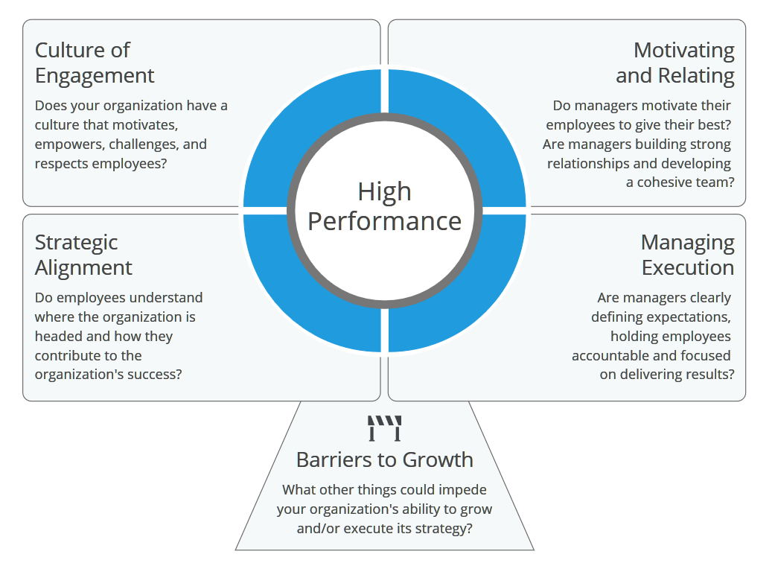Custominsight, (2019)

