Welsh Air Ambulance Charity Awareness Campaign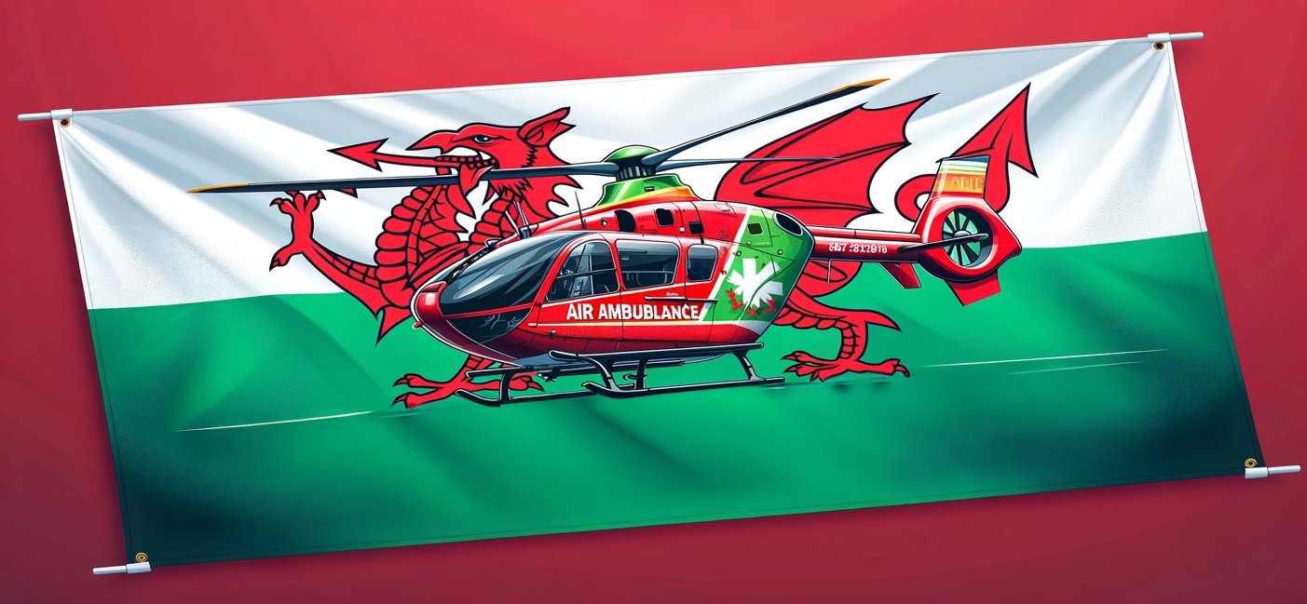
After we know our roles, we are delegated tasks according to individual strengths, fostering accountability and efficiency.
“The Quad Chart includes defining the project scope, stakeholders, desired outcomes, and measures of success.” Minwir Al-Shammari (2013), Project Management. Available at: https://www.slideshare.net/slideshow/project-management-1-16207030/16207030
(Accessed: 21 May 2024).
We use a quad chart to outline key aspects of our project. This visual tool helps us summarise information in a way that's easy for people to understand. It shows the rooms, objectives, stakeholders, critical success factors, and how we will measure our success. It helps us focus on our deliverables. According to Heffernan (2024), some may argue that this approach needs to be more complex because it only involves categorising information into four boxes. Excessive information can lead to confusion and misleading if not organised accurately.
Feedback and review sessions reinforce our commitment to maintaining high standards. These sessions and problem-solving meetings foster an environment of innovation and continuous improvement. Effective collaboration is the backbone of our project, and we ensure its continuity through regular meetings and project management tools. Celebrating milestones is a formality and a way to keep our team motivated and focused on our shared goals. Our collective journey is driven by a shared passion to support the Welsh Air Ambulance Charity. We are not just a team but a force that strives to make a significant impact through our unwavering dedication and collective teamwork. Our goal is to ensure the continuity of this critical service, saving lives across Wales. Our work directly demonstrates the impact on the charity's mission, underscoring the importance of our collective efforts.

Appendices

Quad Chart

Welsh Air Ambulance Awareness
Purpose  Raise funds for the Welsh Air Ambulance Charity.  Engage sponsors, team members, and the public in the fundraising effort.  Develop a comprehensive fundraising plan that urgently addresses the charity's immediate and long-term financial needs, underlining the importance of your support.  Produce marketing materials to increase awareness and donations. | Stakeholders  Hannah – Air Ambulance representative  The public, including community members and social media followers.  Team members and volunteers were supporting the event.  Corner Shop (sponsor)  Brecon Beacons people (first aid people)
Desired result  Achieve or exceed the fundraising target set for the Welsh Air Ambulance Charity (at least £2000).  Effective marketing and promotion significantly increase public awareness of the charity's mission and impact.  Foster strong engagement from sponsors, team members, and the public in supporting the fundraising activities.  Establish a sustainable model for future fundraising events to ensure ongoing support for the charity. | Measures of success  Achieve or exceed the fundraising target for the Welsh Air Ambulance Charity.  Increase public awareness of the charity's mission and impact.  Enhance team collaboration and leverage individual strengths effectively.  Establish a sustainable fundraising model for future events and ongoing support for the charity.  Getting at least 80 people engaging

References
Maria Heffernan (2024), Managing Projects in Organisations. Available at:
projects-20240513_113040-Meeting Recording.mp4 (Accessed: 18 May 2024).

Minwir Al-Shammari (2013), Project Management. Available at: https://www.slideshare.net/slideshow/project-management-1-16207030/16207030
(Accessed: 21 May 2024).

