Data has become one of the priorities for businesses of all sizes. Data can be referred to as the information collected by the organisations like Tesco, Sainsburys and so on regarding trends in the market, consumer satisfaction and move (Ramanathan et al., 2017). These data and then translated into a form which is efficient for movement of processing. As assessed by Yabsley and Coleman (2019), the two most important tools used by the companies for collecting the data are the internet of things and artificial intelligence. For instance, to collect customer data on metrics from demographic data to behavioural data, the companies are using cornucopia of sources. For this purpose, an organisation good idea which to the customers directly or may track the customers or may even use some other appending sources.
Example of data, information and knowledge includes the following.
- The organisation has enrolled 1200 employees this year.
In this case, the number of employees is referred to as the data. Thus, 1200 is the data of the organisation. On the other hand, the relation of 1200 is with the employees. Therefore, 1200 employees are the information. This information can then be used to extract the knowledge that the organisation has been facing employee turnover. Thus, to meet the needs of the organisational operations, the organisation has recruited 1200 employees.
- The profit earned by the company if 500 million euros
The data available here is 500 million euros. With the help of this, the extracted information is that the company has achieved a profit of that much amount. With the aid of the above-mentioned information, the knowledge that can be gained is that the company has been able to meet the needs of the consumers. Because of this, the company has strengthened its position in the market and achieved competitive advantage. Moreover, the hard work of the employees has enabled the company to achieve higher profitability rates.
However, the same set of data collected is often useful to a particular group and useless to some other group. For instance, organisations tend to collect feedback in the form data from the consumers so that the product could be upgraded as per the requirement. This will further help the consumers to receive a better product. However, based on the target market of the product, the data collected will be useful for that particular group not for other groups of consumers. For instance, if a product is launched that has a premium pricing than the data related to that particular product will be crucial for those groups who prefer purchasing products with premium tags. On the contrary, people who prefer products with moderate pricing tag will not benefit from that data collection. Therefore, the usefulness of data depends on the relationship that is being shared by the diverse factors. As in this case, the factors are consumers that go for premium purchasing and the product.
Similarly, it is true for the hospitality industry. As mentioned in the study of Mariani et al., (2018), with respect to geographical regions, the taste and the preferences of the consumer changes significantly. This is because of the change in culture. For instance, if a hotel like Holiday Inn is interested in expanding its market into a European country and an Arabian country than the data associated with the customer choices and preferences must be collected separately. The data received from the European country will be the reflection of the prevailing trends of that particular country. On the other hand, data retrieved from Arabian country will be the indicative content of the preferences prevailing among that particular country. Thus, in this case, the data collected from one geographical area would be useless for the other geographical region (Nguyen et al., 2018). Further, the data collected by the hospitality industry will not be useful for other industries.
Collection of the raw data logically and sequentially is termed as information. This information along with its content becomes knowledge. Henceforth, the study conducted by Shaw et al. (2017), revealed that the information obtained by collecting the data forms the basis of knowledge for the group for which it is useful. This is because it will help the people in the management to take strategic decisions as mentioned by Alwan et al., (2017). This, in the end, will help the organisation. For instance, the survey collected by Tesco related to customer satisfaction had been an important piece of information for the organisation. The knowledge gained from this information had helped Tesco to improve its products and services significantly (tescoviews.com, 2019).

The terms data, information and data are often used as synonyms. However, a thin line of difference exists between these terms. Data is defined as the raw of facts. As put forward by DeMauro et al. (2016), it can be a group either of symbols, writings or numbers. Data itself does not convey any meaning. Rather it can be considered as the description of the facts. Generally, the data are used as the input for a system. On the other hand, as evinced from the study of Webb, (2017), information is the processed version of the information. For instance, when an organisation like Tesco collects the feedback from the consumers, at that time the writings of the consumers are the data. Thereafter, when the diverse answers for the same question are processed then it is referred to as the information. These two stages ultimately lead to knowledge. Therefore, knowledge is referred to as the real content that the information conveys about a particular thing. Therefore, a sequential process starts from data and ends up in providing the realistic knowledge that will help the entire organisation to achieve their objectives.

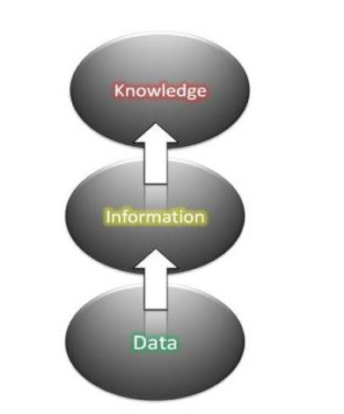
Figure 1: levels of data, information and knowledge
(Source: Created by learner)
The diagram indicates that knowledge is at the topmost level. Therefore, to gain the knowledge, it is very essential to pass through the phase of collection of data and then convert it into an information which ultimately give rise to information. Therefore, as argued by Snaders (2016), knowledge is not the symbolic representation that had been derived in a model from a received piece of information. Rather, the emitted response can be either spoken or written. Thus, knowledge implies the persistence and viability in contrast to data and information. It is ultimately considered the product of the process. Further, the author revealed that information is a flow that can be modified by the effect of various interactions taking place within the components. This flow of information, for instance from the consumers, results in a spatial representation based on it. This representation is organised symbolically under the influence of a strong mind. This is referred to as the data that exists only in the presence of a modelling agent. This agent is capable of manipulating static components to build a representation. Further, as argued by Webb, (2017), with the aid of decoding the encoded form of information, it is possible to retrieve the underlying processes. Thus, it is crucial from the perspective of the organisations. This is referred to as the information that is thereafter used for drawing valuable knowledge. This is essential as it helps an organisation to take important and strategic decisions. It is the knowledge that is gathered from the data that leads to build the success story of the organisation. Henceforth, knowledge is at the highest stake in the process of decision-making.

A card game player uses tacit knowledge. This is because card playing is a game in which the player uses his intuitions, along with insights and hunches for analysing the state of the card game. This, in turn, helps in the formulation of the strategies that leads the card player to achieve success. Moreover, as tacit knowledge comes under the category of experiential learning (Addis, 2016). Therefore, a card player learns the vital moves to be played during the game in the course of his or her experience. Further, the understanding developed by the individual regarding card playing card will be helpful that person. It is very difficult to share the knowledge with other person or teach the other individual the significant steps to be followed to win the game.
Definitions
Tacit Knowledge: This form of knowledge reflects the experiential knowledge that is gained during the process of activities. In addition to this, it reflects the unconscious cognitive work of the individual. Tacit knowledge is very personal and difficult to formalise (Jaleel and Verghis, 2015). Therefore, it makes it very difficult to communicate tactic knowledge. This category is the combination of the hunches, insights as well as intuitions. In addition to this, tacit knowledge finds its roots deep inside an individual’s actions and experiences. This can be further extended into the ideas, emotions as well as values being embraced by the individual. Therefore, it can be stated that tacit knowledge plays a crucial role in enabling an individual to perform the duties and responsibilities in a skilful manner (Aboagye-Nimoet al., 2015). Examples of tacit knowledge include riding a bike, hitting a nail with the hammer.
Explicit Knowledge: As argued by Addis (2016), this form of knowledge can be expressed either in a natural or in a symbolic language. Thereafter, the knowledge is transferred into verbal or written communication. Further, explicit knowledge is the range of formalised skills that is well described as well as known to the organisation (Park et al., 2015). Examples of explicit knowledge involve manuals, documents, and procedures.

Explicit knowledge | Tacit (implicit) Knowledge
The knowledge entrusted under this category is objective, technical and rational | The knowledge under this category is Subjective, experiential and cognitive
the knowledge is well structured | The knowledge is personal and varies from individual to individual
the content of the knowledge is fixed | the content of the knowledge is sensitive and specific concerning the person possessing
it is characterized by independent context | the knowledge is created dynamically
the knowledge comes to an individual some external sources | the knowledge is gained by an individual due to his personal experiences and hence is internalized
it is very easy to document explicit knowledge | it is very difficult to capture and document tacit knowledge
it is very easy to codify explicit knowledge | The codification of tacit knowledge is very difficult.
The sharing of explicit knowledge is very easy | it is very difficult to share tacit knowledge
it becomes very easy to transfer and teach explicit knowledge to others | it is very difficult to teach experiential learning to others. therefore, making tacit knowledge individual-specific
Explicit knowledge is present in high volumes | implicit knowledge has a high value.

Table 1: Difference between explicit and implicit knowledge.
(Source: Brătianu, 2016)

The five decisions that had been made along with their classification as data, information and knowledge are the following:
- Taking a turn while driving to university
Data: 2
Information: 2 turns
Knowledge: 2 turns on the way to university
- Choosing a cold drink at a convenience store
Data: 6
Information: 6 flavours
Knowledge: 6 different flavours of cold drinks are available in the convenient store
- Climbing the stairs in the building
Data: 14
Information: 14 stairs in the building
Knowledge: no need to use the lift, it is possible to climb the stairs.
- Reading a book
Data: 2
Information: 2 books are available to be chosen
Knowledge: Selection of the book of the favourite author
- Visiting a friend in the cafe
Data; 4 pm
Information: At 4 pm need to meet a friend
Knowledge: The meeting will be done at a cafe.

Decision 1: In the absence of the data, information and knowledge, it would be difficult to reach the university in time.
Decision 2: It would be very difficult to get the flavour if the pre-existing information, data or knowledge would not be available.
Decision 3: Lift would be preferred instead of the steps due to lack of data, information and knowledge.
Decision 4: the lack of pre-existing data, information, or knowledge would lead reading of a book that is less interesting
Decision 5: It would be very difficult to meet the friend at the right time and place.

The product that is to be launched into the market for the first time after its invention is a face cream rich in hyaluronic acid.

The demographic data are as follows:
- Preference for the product

Options | Number of participants | Total number of participants
Male | 2 | 50
Female | 42 | 50
Others | 6 | 50
Table 2

Information
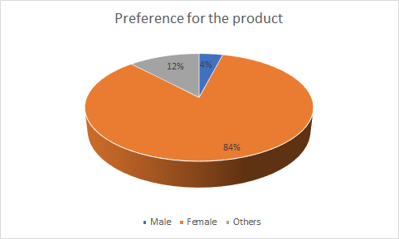
Figure 2

Among the 50 participants, 84% were females who showed preference for the product.
- Age group of the participant that want the product

Options (in years) | Number of participants | Total number of participants
16 to 25 | 3 | 50
26 to 35 | 10 | 50
36 and above | 37 | 50
Table 3
Information
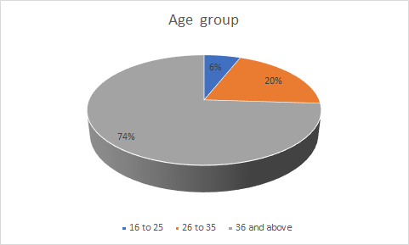
Figure 3
Among all the female participants, 74% belonging to the age group 36 and above showed a preference for the product
- Income status of the individuals who want the product

Annual income in pounds | Number of participants | Total number of participants
10000-20000 | 5 | 50
21000-30000 | 7 | 50
31000 and above | 38 | 50
Table: 4
Information
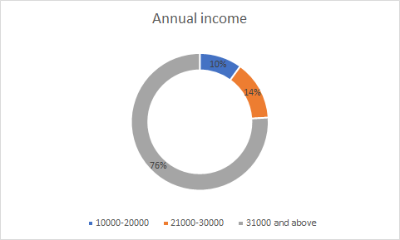
Figure 4
People with income more than 31000 showed an interest in the product followed by the group having an income between 21000 to 30000
Knowledge: The promoting strategies should be for the middle-aged women with higher annual income. Therefore, it would be preferable to go for celebrity endorsement for the promotion of the product.
- Select the location
Location | Number of participants | Total number of participants
City | 30 | 50
Town | 19 | 50
Village | 1 | 50
Table: 5
Information

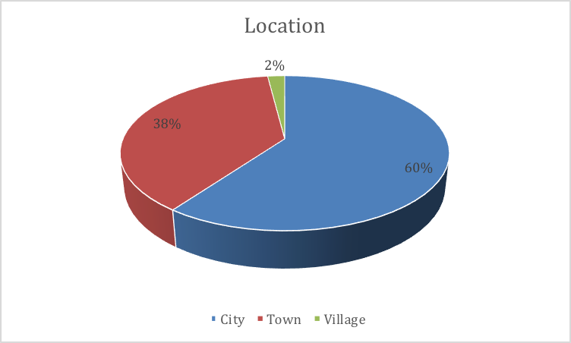
Figure 5
Knowledge: The information obtained from the collected data signifies that the preference of the face cream rich in hyaluronic acid is more among the women residing in city as compared to town and village. Therefore, the target market would be the women residing in cities.

Reference list
Aboagye-Nimo, E., Raiden, A., King, A. and Tietze, S., 2015. Using tacit knowledge in training and accident prevention. Proceedings of Institution of Civil Engineers: Management, Procurement and Law, 168(5), pp.232-240.
Addis, M., 2016. Tacit and explicit knowledge in construction management. Construction management and economics, 34(7-8), pp.439-445.
Alwan, Z., Jones, P. and Holgate, P., 2017. Strategic sustainable development in the UK construction industry, through the framework for strategic sustainable development, using Building Information Modelling. Journal of Cleaner Production, 140, pp.349-358.
Brătianu, C., 2016. Knowledge dynamics. Management Dynamics in the Knowledge Economy, 4(3), pp.323-337.
De Mauro, A., Greco, M. and Grimaldi, M., 2016. A formal definition of Big Data based on its essential features. Library Review, 65(3), pp.122-135.
Jaleel, S. and Verghis, A.M., 2015. Knowledge creation in constructivist learning. Universal Journal of Educational Research, 3(1), pp.8-12.
Mariani, M., Di Fatta, G. and Di Felice, M., 2018. Understanding customer satisfaction with services by leveraging big data: the role of services attributes and consumers’ cultural background. IEEE Access, 7, pp.8195-8208.
Nguyen, Q., Nisar, T.M., Knox, D. and Prabhakar, G.P., 2018. Understanding customer satisfaction in the UK quick-service restaurant industry: The influence of the tangible attributes of perceived service quality. British Food Journal, 120(6), pp.1207-1222.
Park, C., Vertinsky, I. and Becerra, M., 2015. Transfers of tacit vs. explicit knowledge and performance in international joint ventures: The role of age. International Business Review, 24(1), pp.89-101.
Ramanathan, U., Subramanian, N. and Parrott, G., 2017. Role of social media in retail network operations and marketing to enhance customer satisfaction. International Journal of Operations & Production Management, 37(1), pp.105-123.
Sanders, J., 2016. Defining Terms: Data, Information and Knowledge. 10.1109/SAI.2016.7555986.
Shaw, D.R., Grainger, A. and Achuthan, K., 2017. Multi-level port resilience planning in the UK: How can information sharing be made easier?. Technological Forecasting and Social Change, 121, pp.126-138.
tescoviews.com, 2019. [online] Available at: https://www.tescoviews.com/websurvey/2/execute#!/1 [Accessed 9 Oct. 2019].
Webb, S.P., 2017. Knowledge management: Linchpin of change. Routledge.
Yabsley, W. and Coleman, S., 2019. Using data analytics for business decisions in the UK energy sector: a case study integrating gas demand with weather data. International Journal of Oil, Gas and Coal Technology, 21(1), pp.109-129.

Part 1- Case study
The American Airlines and IBM came up with the concept of Semi-Automatic Business Research Environment or SABRE and the idea was in motion by 2000. The basic aim was to replace the hand-written system with computer-based technology. American Airlines incorporated Porter’s competitive strategy, which includes both cost leadership and product differentiation. A company can gain two types of market advantage, which are low cost and product differentiation. Cost leadership, product differentiation and focus are the general strategies used to earn advantage in the market (Ifm.eng.cam.ac.uk, 2019).
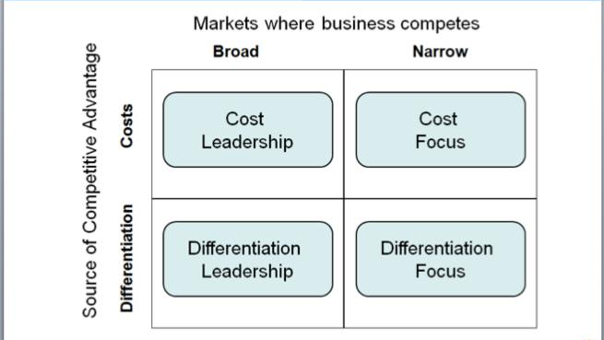
Figure 1: Porter’s competitive strategies
(Source: tutor2u, 2019)
1.1 cost leadership
SABRE started operating with the aim of making the process of reservation easy for the customers and the company. However, this system helped American Airlines to gain cost leadership. Cost leadership is a business strategy, used by a company to achieve the lowest cost of operation. A company is enabled to produce products with high quality at the lowest cost by applying cost leadership strategy (Muasa, 2014). Moreover, an organization can increase the profit and market share by reducing the production cost and charging less. American Airlines was able to take up cost leadership with the innovation of SABRE as it helped the company to reduce the cost of production or in this case the ticketing and reservation. Information management became easier with this automatic system. The process became less time-consuming. More importantly, the whole process could have been done with small stuff. The company was able to get the job done with a smaller number of staff. Therefore, the company could reduce the stuff, which earned a big profit for the company. American Airlines saved approximately 30% of the stuff costing after setting SABRE in motion (Sabre.com, 2019). The system provided the option of Bargain Finder, which allowed the company to compare its prices with its competitors. Thus, the airline was able to give the passengers lower rates in the market.
1.2 Product differentiation
Product differentiation is a marketing strategy, which allows a company to differentiate its products or services with its competitors. This strategy makes a company or its products distinguished by shedding light on its unique qualities. The successful application of this strategy will result in a market advantage. SABRE was the perfect alternative for the existing reservation system with was manual. This automatic system provided the customer with speed and efficiency. Before SABRE, an agent would book a ticket after checking availability and inform the passenger via telephone on message. The cancellation was done manually as well, which made the whole process time-consuming. In addition, it had more chances of errors. SABRE could do the whole process in 3 seconds, whereas the manual system took 45 minutes (Ethw.org, 2019). This new speed in the process made the reservation of American airlines different from others. The passengers adopted quickly with the new less-time consuming technology. The company gained market advantage as its service proved unique.

Comparative advantage: Comparative advantage allows a company to give better products or services to the customers by comparing themselves with their rivals. The company can provide the target audience better products at a lower cost compared to its competitors. American Airlines realised that time was a key factor in the business. Customers would definitely be attracted to an airline, which was less time-consuming. The innovation of SABRE made the ticket booking and reservation system less time consuming and easier for the passengers (Berisha-Shaqiri, 2015).
Cost-competitive advantage: SABRE allowed American Airlines to provide better service at a lower price, which resulted in cost-competitive advantage. The automatic system replaced the manual structure of the company, which means the company needed less labour. The company reduced the stuff, therefore, is had to spend less money on the process. The decrease in production allowed the company to offer lower prices to its passengers. The cost-leadership strategy helped to increase the customer base and the profit of the company.
Differential advantage: The Semi-Automatic Business Research Environment system made the service of American Airlines unique. A company can increase sales and profit by promising something new and innovative to its target audience. Research and innovation are needed for understanding the target audience and the market. A company needs to change itself according to the change in the target sector. Moreover, a company sometimes needs to initiate change to make itself better than others. American Airline realised that a system like SABRE could bring a change. The uniqueness earned differential advantage for the company.
Entry barrier in terms of new entrance: Porter’s five forces model establishes the threats of new entrants as one of the macro-environmental factors, which influence a business. SABRE worked as a perfect entry barrier for new entrants in the market. American Airline has a system which was different from the manual structures of other service providers. The airline has invented a new technology that its competitors did not have. In that scenario, a start-up airline would have to come up with a similar or better system to make a profit in the market. American Airline made the market more competitive for the entrants. Thus, it can be said that American Airline had created a proper entry barrier which helped it to hold its strong market place.
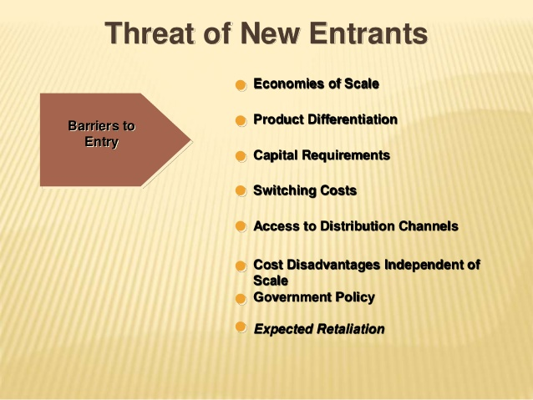
Figure 2: Entry barriers
(Source: Gul, 2016)
Increasing customer loyalty: Competitive advantage earns customers’ trust and loyalty for a particular brand. These advantages are some qualities, which makes a company better for a customer than other market-holders. American Airlines took less time, yet provided more efficiency than other air services available in the market. This factor gave American Airlines advantage, as the passengers were willing to choose it over others (Ethw.org, 2019).

Weak economy: As per the findings of Kaplan and Schulhofer-Wohl (2017), people are travelling less because of cutbacks, unemployment. It has been tough for American Airlines to gain back its profit and position in this weak economy, where the GDP is low.
Numbers of low cost carrier-competitions: American Airlines was able to gain cost leadership in the market after the innovation of SABRE. However, in today’s market, there are many airlines, proving low cost to customers. Southwest Airlines Company’s business strategy allows them to operate at a low cost. Therefore, the company can provide their services at low cost. JetBlue airways provide point-to-point flights, which are cheap for both company and passengers (Kellogg.northwestern.edu, 2019). American Airlines is struggling to compete with these low-cost carrier-competitions.
Increasing fuel cost: The increasing rates in crude oil had a huge effect on the business of American oil. The price of WTI crude oil as of October 08, 2019 is $52.63 per barrel. The highest rate for WTI crude oil was $66.30, in April. The increasing fuel cost is adding to the flight charges.
Unsatisfying service: The customers’ reviews for American Airlines are not good and the ignorance in the management has made the situation worse. Their on-time performance has faced many criticisms over the years (Economics-files.pomona.edu, 2019). The company used to take pride in their low cost and efficiency after the SABRE initiative, however, that scenario has changed. Many passengers have accused American Airlines of inefficiency; nonetheless, the company is not ready to take the blame.
3.1 The company’s reaction
- The merger between American Airlines Group and AMR Corporation was a marketing strategy to regain market position. The high media coverage on the issue aided in implementing the strategy. The merger seemed to be a comeback for the struggling airline (American Airlines. 2019)
- The company is adding new aircraft in the line, which will help in cost control by providing superior fuel efficiency. This new foot is promising comfort and the feedback from the audience is positive so far (Economics-files.pomona.edu, 2019).
- However, the findings of Economics-files.pomona.edu (2019) indicate ignorance in the management of the company. The company is trying to blame the severe weather conditions for their inefficiency.
Henceforth, on evaluating the business and marketing strategies of American Airlines in recent years along with the strategies taken by the company like cost leadership and product differentiation with SABRE in background various results had been deduced. Along with this, analysis of the competitive advantage of American Airlines provided by SABRE followed by outlining of the factors, which play an important part in the company's erosion was done. The results found had helped in the identification of various facts. SABRE helped the company in gaining cost leadership and product differentiation in the market. The new automatic system helped in reducing the time, production cost and flight rates, which earned brand loyalty for the company. However, this study established some reasons behind the erosion of the company in the market. The reasons include week economy, growing competition and ignorance in the company’s attitude.

Part 2- Information System
The information system is a combination of components, which collects stores and process data and provides information. Organizations use information system to keep records and to interact with its external and internal people. IS includes a wide range of information technologies such as computers, databases, internet, telecommunication, communication models and so on (Sci.brooklyn.cuny.edu, 2019). The information system is an operating tool for many companies, whereas some organizations operate entirely based on IS. The main objective of an information system is to combine all the data related to a business and give them a structural form, which creates a smooth information flow inside and outside of an organization (Laudon and Laudon, 2016). Furthermore, the information system helps a company in operational activities and decision-making process.
Other than this, the role of the information system can be categorised as general and specialised. In the general form of information system, there occurs a combination of the software and data. This is referred to as the database management system (DBMS). However, the organisations do not use this, rather takes into consideration the specialised information system. In this form of system, the process is designed such that it can aid in the process of carrying out specified analysis task in the organisation. the interpretation done with the help of the analysis aids an organisation to be aware of the situation that will be facilitating success to the organisation. One such information system is the enterprise resource planning (ERP). This helps in the integration of the management process of all the internal and external information across the organisation.

In a computer-based information system, computer plays an important part. Its opponents are hardware, software, data and procedures. People are often considered as components in CBIS, as they operate the machines. The computer-based information system can be categorized in following parts
2.1 Management information system: Management information system can be considered as the backbone of an organization’s operation. It helps in the smooth running of the business by providing information to every level of management. Examples of management information systems are reservation management, customer support centre, research management etc.
2.2 Expert system: Expert system uses artificial technology to influence or help the decision-making process of an individual or organization. In this system, the computer stores information of an expert on any particular subject. XCON is an example of Expert system, which can select specific software to generate a users’ desired computer system.
2.3 Transaction processing system: This system keeps records of all kind of business transaction. A transaction of any kind, such as hiring employees, billing, cheque clearance etc, affects the business. Transaction processing system collects stores and circulates all the data related to the transaction.
2.4 Office Automation systems: The main objective of the office automation system is to increase the productivity of the workplace. A company tries to increase the work speed and efficiency of its workers, managers, assistants, secretariats and so on. It includes Word-processing equipment, electronic mail and so on.
2.5 Decision support system: This system provides data, which helps in the decision, making the process. This system may use data from both internal and external sources to help reach a decision. This system does not include regular management reports. Sales report and financial data are internal sources. On the other hand, interest rates and lifestyle trends are external sources.
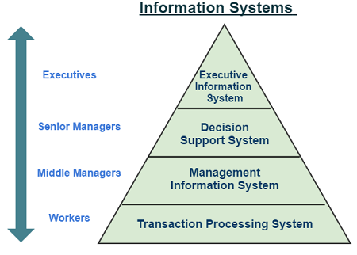
Figure 3: Information systems
(Source: Petrovic et al., 2017)
- Management information system gives overall information regarding any business, which gives a manager or a decision-maker a proper outline of the company. The data provided by this system helps in taking short term and long-term decision for business growth.
- Expert information system handles complex and intricate information. This kind of information helps in diagnosing an issue and finding proper strategies or solutions. In modern times, managers often work in dynamic situations. In order to make the right decision, managers need to seek information from experts.
- The transaction processing system keeps provides all data related to the transaction. For example, a lower-level supervisor will check the financial background of a customer before granting a loan.
- The office Automation system is used as per the requirements of any workplace. For example, an administrative manager will analyze the present work speed and efficiency in order to decide, whether the place needs some technological upgrades or not.
- Decision support system helps a manager in making situation-based decisions. Decisions based on this information system are rapid, frequent and unique.
Thus, on carrying out detailed analysis of the definition and types of information system along with categorization of the information system the expansion of the knowledge was immense. It was possible to explore various business examples. Furthermore, the support given by different information systems to the managers on each level of an organization and enabled in extension of the knowledge. It had aided in understanding yhe significance of the information technology in decision-making process.

Reference list

American Airlines. 2019. AMR Corporation And US Airways Announce Approval From European Commission For Pending Merger | American Airlines. [online] Available at: https://americanairlines.gcs-web.com/news-releases/news-release-details/amr-corporation-and-us-airways-announce-approval-european [Accessed 9 Oct. 2019].
Berisha-Shaqiri, A., 2015. BUSINESS INITIATIVE FOR CREATING COMPETITIVE ADVANTAGE THROUGH INFORMATION TECHNOLOGY. Romanian Review of Social Sciences, (8).

Economics-files.pomona.edu. 2019. [online] Available at: http://economics-files.pomona.edu/jlikens/SeniorSeminars/Likens2014/reports/americanairlines.pdf [Accessed 9 Oct. 2019].

Ethw.org. 2019. SABRE Airline Reservation System - Engineering and Technology History Wiki. [online] Available at: https://ethw.org/SABRE_Airline_Reservation_System [Accessed 9 Oct. 2019].

Gul 2016. Marketing Management - Porter's Five Forces. [online] Slideshare.net. Available at: https://www.slideshare.net/SaroshGul/marketing-management-porters-five-forces [Accessed 9 Oct. 2019].

Ifm.eng.cam.ac.uk. 2019. Porter's Generic Competitive Strategies (ways of competing). [online] Available at: https://www.ifm.eng.cam.ac.uk/research/dstools/porters-generic-competitive-strategies/ [Accessed 9 Oct. 2019].
Kaplan, G. and Schulhofer‐Wohl, S., 2017. Understanding the long‐run decline in interstate migration. International Economic Review, 58(1), pp.57-94.

Kellogg.northwestern.edu. 2019. [online] Available at: https://www.kellogg.northwestern.edu/faculty/mazzeo/htm/airline_ontime.pdf [Accessed 9 Oct. 2019].
Krotov, V., 2015. Bridging the CIO-CEO gap: It takes two to tango. Business Horizons, 58(3), pp.275-283.
Laudon, K.C. and Laudon, J.P., 2016. Management information system. Pearson Education India.
Muasa, S.M., 2014. Cost leadership strategy and sustainable competitive advantage of Naivas supermarket limited in Kenya. Unpublished MBA thesis university of Nairobi.
Petrovic, R., Tehranchi, B., Jemili, K., Winograd, J.M. and Angelico, D., Verance Corp, 2017. Media monitoring, management and information system. U.S. Patent 9,648,282.

Sabre.com. 2019. [online] Available at: https://www.sabre.com/files/Sabre-History.pdf [Accessed 9 Oct. 2019].

Sci.brooklyn.cuny.edu. 2019. [online] Available at: http://www.sci.brooklyn.cuny.edu/~sklar/teaching/s08/cis20.2/notes/lecII.1-notes.pdf [Accessed 9 Oct. 2019].

tutor2u. 2019. Porter's Model of Generic Strategies for Competitive Advantage | Business | tutor2u. [online] Available at: https://www.tutor2u.net/business/reference/porters-generic-strategies-for-competitive-advantage [Accessed 9 Oct. 2019].

