LEVEL 4

SEMESTER 2

MODULE CODE: SHSS4066
INTRODUCTION TO HEALTH AND EXERCISE PSYCHOLOGY
aSSESSMENT TYPE: REPORT
Assessment/Component: 1

COMPONENT WEIGHTING: 50%

WORD COUNT: 1500 WORDS

MODULE TUTOR: ALISON CONNAUGHTON

School of Sport, Health & Outdoor Education

Assessment Feedback Sheet

Student No./Name: Nigel Balfour/ 1808471.
Module: Introduction to Health and Exercise Psychology
Module Code: SHSS4066

Personal Evaluation – to support your academic progress please complete the section below BEFORE submitting your work.
What do you consider to be the best aspects of this work? |  |  | Research.
Which aspects do you consider could have been improved in this piece of work? |  |  | Timing, Timing, Timing, (Also IT)!
What have you found most satisfying whilst undertaking this submission? |  |  | Research.
ASSESSMENT CRITERIA | Learning  Outcomes |  | GRADE
ASSESSMENT CRITERIA |  |  | Poor  < 20% | Weak  20-29% | Unsatisfactory  30-39% |  | Satisfactory  40 – 49% | Good  50 – 59% | Very Good  60 – 69% | Excellent  70 – 84% |  | Exceptional  85– 100% | %
1. Introduction:  Review of appropriate literature relating to mood state and exercise / physical activity.  (approx. 500 words) | 1,2,3 |  |  |  |  |  |  |  |  |  |  |  | 30%
2. Results:  Descriptive statistics, use of tables, figures and associated narrative (approx. 250 words) | 1,3 |  |  |  |  |  |  |  |  |  |  |  | 25%
3. Discussion:  Discussion of your findings in light of previous research & practical implications.  Use of appropriate resources (approx. 550 words) | 2,3,4 |  |  |  |  |  |  |  |  |  |  |  | 30%
It is expected that students will present work that is proof read, correctly referenced and adheres to the Assessment Checklist. Therefore a range of 0 – 10 marks will be deducted for non-completion of any of the points on the checklist below.
TUTOR COMMENTS:
Submission date: 5/4/19 via Turnitin |  | Return date:  (at least within 4 weeks) |  |  |  | Tutor: Alison Connaughton |  |  |  |  | Mark:

The Effect of Exercise on Mood State.
Introduction.
It can be said that physical exercise is a key part of a healthy life, and the benefits have been well documented. However the link with mental health and wellbeing is a more recent topic. The effect of exercise on mood state has been under discussion for several years now, and therefore has a large body of literature available for it. This has revealed that the relationship between mind and exercise is far more complex, and a scientific argument still exists. It is hard to quantify feelings, and more research needs to be done.
In a paper published in the Journal of Psychosomatic Research, the results of a review of literature from 1977 to 1995 were reported. The outcome suggests that clinical and nonclinical subjects can get a positive benefit from even a single exercise session (Yeung, 1996). Reed and Ones conducted a meta – analysis on one hundred and fifty eight studies of the effect of aerobic exercise from between 1979 and 2005. The results showed that the effects were consistently positive (Reed and Ones, 2006). Berger and Owen looked at college joggers at different intensities and found that the effect of intensity was insignificant (Berger and Owen 1998). Previously they had looked at the effect of different types of exercise on mood. The conclusion was that the exercise mode and practice needs can lesson the benefits (Berger and Owen, 1987). At the Huron University College a study was conducted on the effects of three different exercise modes on mood; weight training, yoga, and aerobics. There was found to be an improvement in mood, but no difference in mood change across the three modes of exercise. This was considered contrary to previous research (Green, 2010). In Oman a study looked at a group of female children between 10 and 13 years of age. It was concluded that physical activity on a regular basis created higher self-esteem, reducing negative emotions (Zayed, Kilani and Alkitani, 2013). This reduced or prevented the symptoms of depression.
Method.
Participants.
The participants in this study were a diverse age group of 18 individuals (Mean age = 35.44 years, SD = 13.66) and consisted of 5 males (Mean age = 39.8 years, SD = 13.99), 11 females (Mean age = 33 years, SD = 13.88) and 2 unknown gender (Mean age = 38 years, SD = 16.97). The participants were aware of the purpose of the study prior to taking part. All information was collected anonymously.
Procedure.
All participants were asked to pick an exercise of their choice, which they would take part in for a minimum of twenty minutes. Before commencing the exercise they were given two copies of two different questionnaires to fill out. One copy of each questionnaire was filled in before starting the chosen exercise and the second copy of each was filled in after the exercise was over.
Materials.
Two questionnaires were used, one being the Brunel Mood Scale (BRUMS: Terry et al., 1999), which is a development of the Profile of Mood States (POMS: McNair et al. 1971). This takes one to two minutes to complete. The other was the Exercise Induced Feeling Inventory (EFI: Gauvin and Rejeski, 1993). This also can be completed in a couple of minutes.
BRUMS consists of twenty four items in six subsets:
Anger – annoyed, bitter, angry, bad-tempered;
Confusion – confused, muddled, mixed-up, uncertain;
Depression – depressed, downhearted, unhappy, miserable;
Fatigue – worn out, exhausted, sleepy, tired;
Tension – panicky, anxious, worried, nervous;
Vigour – lively, energetic, active, alert.
Using a ‘how do you feel’ response set, the participant gives each item a rating from zero to four, where zero is not at all and four is extremely. The sum of each subset gives a score from zero to sixteen which can then be analysed.
EFI lists twelve adjectives which the participant rates from zero to four (zero being do not feel, four being feel very strongly). The twelve words are in four subsets; Revitalisation, Tranquillity, Positive Engagement and Physical Exhaustion. These are broken down from the score sheet to give a picture of the participant’s mood state.
Results.
For the Brunel mood scale the results seem to agree with the bulk of the research. Anger, confusion, depression, and tension have all dropped fairly significantly, while fatigue has risen slightly, and vigour has risen significantly. Standard deviation is quite small for anger, confusion and tension, showing a small spread across the group. Fatigue had a slightly larger spread. Anger dropped from a mean of 3.44 to 0.72. Confusion went from 3.13 to 1.11. Depression fell from 4,74 to 1.94, while tension dropped from 3.96 to 1.29. Fatigue rose from 5.85 to5.88 and vigour also went up from 3.08 to 6.04. As can be seen in figures one and two, there is a noticeable change.
For the Exercise Induced Feeling Inventory all results showed an increase. Positive engagement rose from a mean of 4.72 to 7.72. Revitalisation went from 3.61 to 7.56. Tranquillity went from 4.17 to 7.33 and physical exhaustion rose from 5.72. In figures three and four it can be seen that there has been an effect.
Figure 1.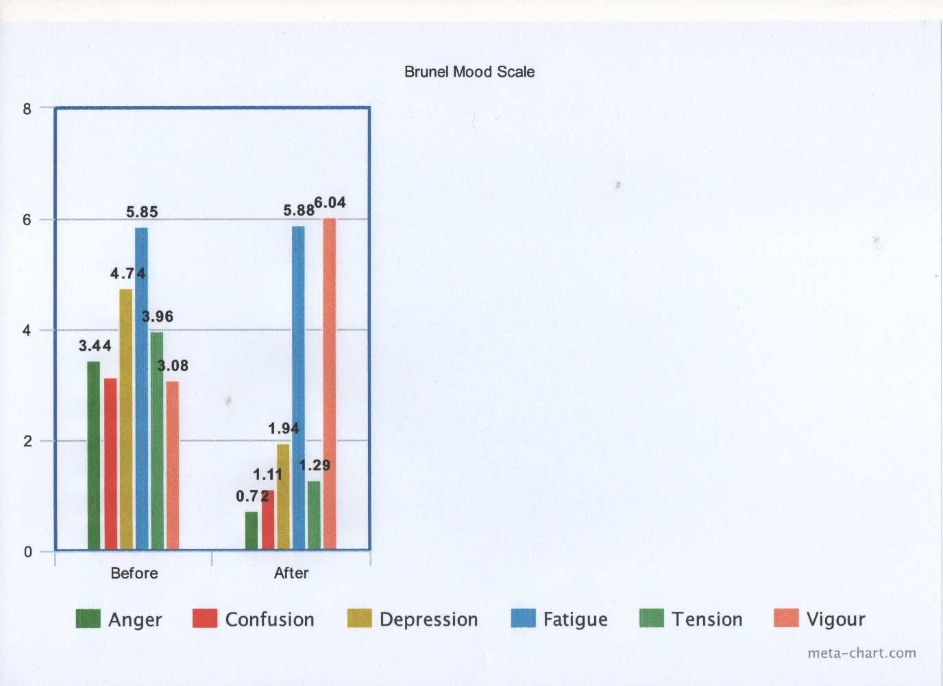
Figure 2.
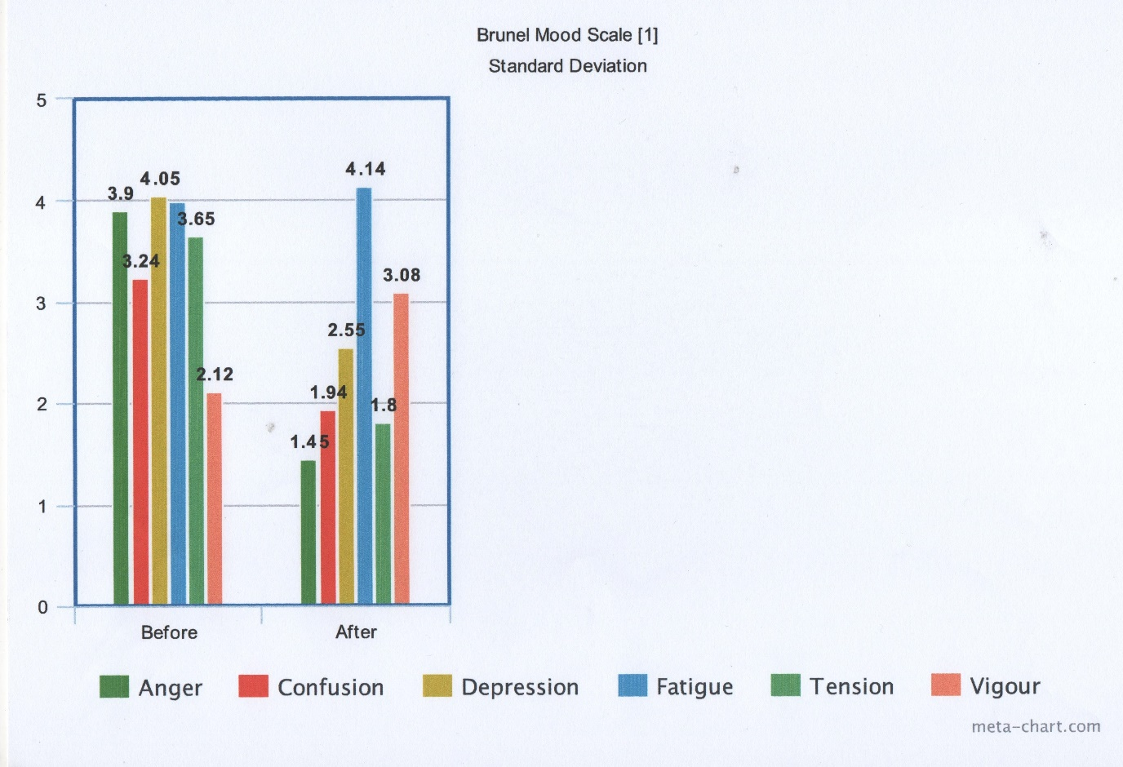
Figure 3.
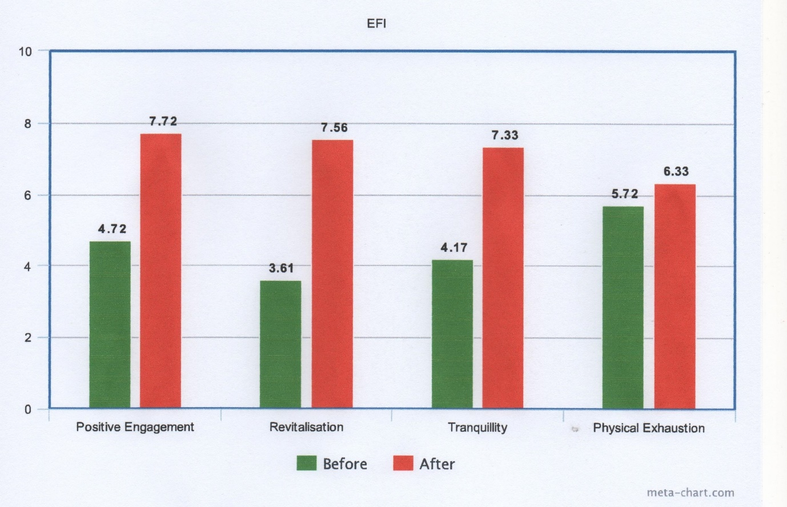
Figure 4.
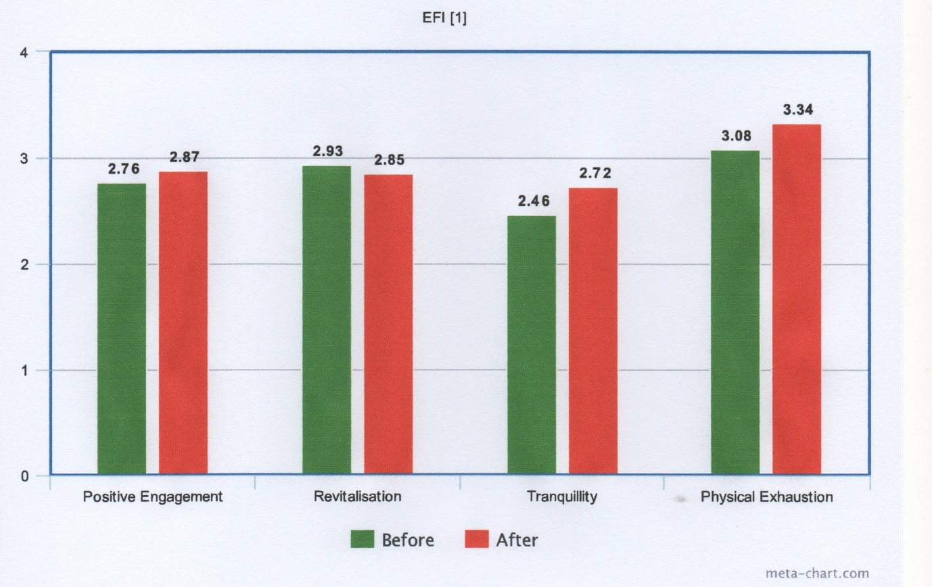
Discussion.
Looking at these outcomes they tend to agree with the majority of the evidence. However it is a very small sample and the selection criteria was not exhaustive or thorough. This may have impacted on the results in ways in which it impossible to measure. There were no controls put in place for pre exercise levels of fitness in affect or self-reported exercise intensity. The two modes of measurement are very subjective and depend on the subject’s perception of themselves and how they feel. An optimist is likely to report differently than a pessimist, for example. This is bound to introduce errors into the results.
In conclusion it can be said that while the hypothesis that exercise has a beneficial effect on mood has been broadly affirmed, this study is not strong evidence for it.
Word Count: 1006.

Reference List.
American Psychological Association (2011) ‘The exercise effect’, 42(11),
Anderson, R.J. and Brice, S. (2011) ‘The mood enhancing benefits of exercise: Memory biases augment the effect’. Psychology of Sport and Exercise, 12(2), pp79-82.
Berger, B.G. and Owen, D.R. (1987) ‘Stress reduction and mood enhancement in four exercise modes: swimming, body conditioning, hatha yoga, and fencing’. Research Quarterly for Exercise and Sport. 59(2), pp.148-159.
Berger, B.G. and Owen, D.R. (1998). ‘Relationship of low and moderate intensity exercise with acute mood changes in college joggers’. Perceptual and Motor Skills. 87(2), pp.611-621.
Gauvin, L. and Rejeski, W.J. (1993). ‘The exercise induced feeling inventory: development and initial validation’. Journal of Sport and Exercise Psychology. 15, pp.403-423.
Green, K. (2010). ‘The effects of three different exercise modes on mood’. The Huron University College Journal of Learning and Motivation. 48(1).
McNair, D.M. et al. (1971). Manual for the profile of mood states. San Diego: Educational and Industrial Testing Service.
Reed, J. and Buck, S. (2009) ‘The effect of regular aerobic exercise on positive activated affect: A meta-analysis’. Psychology of Sport and Exercise. 10(6), pp.581-594.
Reed, J. and Ones, D.S. (2006). ‘The effect of acute aerobic exercise on positive activated affect: A meta-analysis. Psychology of Sport and Exercise. 7(5), pp. 477-514.
Skully, D. et al. (1998) ‘Physical exercise and psychological wellbeing: A critical review’. British Journal of Sports Medicine. 32, pp111-120.
Terry, P.C. et al. (1999). ‘Development and validation of a mood measure for adolescents’. Journal of Sports Sciences. 17, pp.861-872.
Yeung, R.R. (1996) ‘The acute effects of exercise on mood state’. Journal of Psychosomatic Research. 40(2), pp.123-141.
Zayed, K., Kilani, H., and Alkitani, M.S., (2013) The 5th International Council for Health, Physical Education, Sport, and Dance Conference, ICHPER.SD, Middle East. Dubai, UAE. ‘Physical activity is associated with depression and self-esteem levels among Omani female children’. Canadian Journal of Clinical Nutrition (2014), 2(1), pp.15-28.

