

A report focussing on:

Solutions to different construction elements and the procedure of construction

Prepared for:

Juan A Ferriz-Papi

Created by:

Rhydian Preece

Date Completed:
April 27th, 2020
Table of Contents
Page Number
- Executive Summary

- Terms of reference

- Procedure

- Findings

- Conclusion

- References

8.0 Appendices

- Executive Summary
This report aims to explain all the elements that I have been asked to draw (AutoCAD format). I have given a step-by-step procedure of how the element would be constructed and used building regulations throughout this assignment where relevant.

- Terms of Reference
  - The principal focus is:
    - To solve different elements via drawings.
    - To give a step-by-step procedure of how the element is constructed. Show building regulations throughout the procedure.

- Procedure
This section identifies the research sources used.
  - The research included secondary sources on the subject construction technology and textbooks set out in the references and bibliography.
  - University notes also provided background to the research.

- Findings

  - Building Regulations - Throughout the descriptions, building regulations will be listed and why each element must conform to them. The three main parts that will be listed in this report are Part A, B and C. Design Building Wiki (2020) has provided this report with descriptions of the three main parts. Part A “requires buildings to be designed, constructed, or altered to be structurally safe and robust, and so as not to impair the structural stability of other buildings”. Part B “covers all precautionary measures necessary to provide safety from fires for building occupants, persons in the vicinity of buildings, and firefighters”. Part C “Includes the weather-tightness and water-tightness of buildings, subsoil drainage, site preparation, and measures to deal with contaminated land, radon, methane, and all other site related hazardous and dangerous substances.

  - Suspended timber flooring - Flynn (2013) has provided me with some information on suspended timber flooring. To construct this type of flooring, concrete must first be laid over a foundation to have a flat surface. The layer of concrete poured must have a ventilated gap of 150mm between the timbers and concrete to prevent moisture gathering. The sleeper walls will have air gaps that are created through a honeycomb bond. A wall plate is attached to the top of the sleeper wall, on which the floor joists will rest on. A DPC will be put in between the wall plates and the sleeper walls to prevent decay from rising moisture. Suspended timber flooring must conform to Building Regulations part C under section 4.13 (Gov.uk 2013) where it states that the ground must be covered to resist moisture, a ventilated air space between the ground covering and timber and there must be damp-proof courses between the timber and any material which can carry moisture from the ground. An air brick will also be implemented to allow ventilation, which will keep the timber dry. The air brick will be placed through the brickwork and blockwork. Workers must ensure a gap is left in the blockwork to implement the air brick. The floor joists indicated in Appendix C are raised above the floor using sleeper walls and will also use noggins to ensure they don’t twist. These joists will be fitted into the blockwork and will be levelled and cemented to the blockwork. After the joists have been placed, insulation can be put down to keep the floor thermally insulated. Then the flooring can be placed on top of the insulation. Weep vents will be used in conjunction with a cavity tray to allow water to drain away from the cavity preventing it from transferring to the inner leaf and causing damp. A section drawing of the suspended timber flooring can be found in Appendix A.

  - First floor - To install the first floor, the builder must ensure enough gaps have been left in the blockwork to install the first-floor joists. The number of floor joists will be determined on the area of the floor. Once the joists have been placed in, they will be levelled and cemented to the blockwork. The joists must also have noggins installed to prevent them from twisting. The floorboard (tongue and groove) will be placed on top of the joists and will be fixed using nails. A drawing for the tongue and groove flooring can be found in Appendix D. To create the ceiling effect, the builder would then need to implement plasterboard underneath the wooden joists. The plasterboards will have a foiled back to prevent heat loss from each floor. The solid timber flooring can be found in Appendix B. The code of practices for timber floors are stated under BS 8103-3:2009 (Part A) (Gov.uk 2013). Eurocode 5 sets out requirements for the design of structures and requires that timber structures be fit for their intended use. All timber components should comply with Eurocode 5.

  - Openings - When laying the bricks and blockwork, the builders must ensure that a sufficient opening has been left to install the window. Section 5.30 (Part C) states that damp-proof courses should be provided to direct moisture towards the outside (Gov.uk 2013). I have however used flashing in the window assembly which will ensure that moisture will enter the building. Both inside and outside precast lintels must be installed ensuring flashing are on both. Under section 5.29 (Part C) the joint between the walls and door and window frames should resist the penetration of precipitation to the inside of the building and not be damaged by precipitation (Gov.uk 2013). Jambs and the head of the window can then be installed; this is the window assembly. Having installed the assembly, you should then install the flashing and place the sill above it. The flashing will prevent water from getting into the structure. The last step is to then install the double-glazed window unit and ensure that it has been sealed. Double-glazed windows provide better insulation and in turn make the house eco-friendly. A drawing to show the sill and lintel is in Appendix E. A front view of the window can be found in Appendix F.

  - Eaves detailing and roof covering - Once brickwork, blockwork, and rafters have been installed, the builders can start to install the soffit and fascia. Under section 4.1, All materials used to cover roofs should be capable of safely withstanding the concentrated imposed loads upon roofs specified in BS EN 1991-1-1:2002 (Part A) (Gov.uk 2013). Depending on what size soffit the client has asked for, the worker must cut the rafters to suit the size of the soffit. Once this has been done, the soffit can be fixed to the rafter and brickwork. An L shaped fascia will then be installed insuring that it lips under the soffit. After the soffit and fascia have been installed, the guttering can be fixed to the fascia. The battens that have been placed on the rafter will be used to fix the slates too. The slates will be single lapped and will be fixed to each batten on the rafter. Insulation will be installed between the rafters which will keep warmth in the living space below. Roof insulation will lower the houses’ heating bills and reduce the home’s carbon footprint. A section view of the closed eave can be found in Appendix G. With all covering in place, the roofing should resist the penetration of precipitation to the inside building under section 6.2 of the building regulations (Part C) (Gov.uk 2013).

  - The main roof structure - A roof layout drawing can be found in Appendix H. (Gov.uk 2013) state that BSI PD 6693-1:2012 (Part A) give recommendations for the design of timber structures. So, all roof structures of this house must conform to this standard. Myrooff (2019) has provided me with information on the installation of trusses. When installing the roof trusses, it is very important to use some sort of crane to place them on the top of the house. Principle rafters will also be used and secured using purlins and purlin cleats. Metal gusset plates must be used for joining truss joints and the builder must nail each point. The number of trusses used will be determined on the span of the building. Each truss will be secured using battens. The drawing for the 1st roof is in Appendix I. The 2nd and 3rd roof will not require trusses as the span of the roof is not as big as the 1st roof. For the 2nd and 3rd roof, rafters will be simply put up and secured together with a ridge board. Tie beams will be used and held together with binders. The drawing for the 2nd and 3rd roof can be found in Appendix J. All roofs of this house must conform to part B of the building regulations (Gov.uk 2020) under the section where the roof should resist the spread of fire from one property to another.

- Conclusion

  - To conclude, this report includes elements of a house where different solutions have been put in place to avoid humidity because of rain, thermal bridging, and condensation. Extra graphical details have been included to illustrate materials and methods for construction. Alongside the drawings, building regulations have been included to ensure each drawing conforms to the different regulations and standards. I faced no limitations for this assignment, and I believe I have solved each element with good solutions. AutoCAD has been very helpful to create much neater and annotated sketches. In my opinion, using AutoCAD is much easier and accurate than hand-drawing as you can store data and easily access CAD drawings. CAD also offers pixel-perfect CAD drafting accuracy making drawings easier to read and higher-quality designs.

6.0 References

Design Buildings wiki (2020) – Building Regulations. Designbuildings.co.uk
Flynn, C. (2013) – Suspended Timber Flooring. Construction Studies Q1.
Gov.uk (2013) – Section 4.13: Available at: https://www.gov.uk/government/collections/approved-documents (Accessed: 27 April 2020).
Gov.uk (2013) - BS 8103-3:2009: BSI. Available at: https://www.gov.uk/government/collections/approved-documents (Accessed: 27 April 2020).
Gov.uk (2013) – Section 5.3: Available at: https://www.gov.uk/government/collections/approved-documents (Accessed: 27 April 2020).
Gov.uk (2013) – Section 5.29: Available at: https://www.gov.uk/government/collections/approved-documents (Accessed: 27 April 2020).
Gov.uk (2013) - BS EN 1991-1-1:2002: BSI. Available at: https://www.gov.uk/government/collections/approved-documents (Accessed: 27 April 2020).
Gov.uk (2013) – Section 6.2: Available at: https://www.gov.uk/government/collections/approved-documents (Accessed: 27 April 2020).
Gov.uk (2013) - BSI PD 6693-1:2012: BSI. Available at: https://www.gov.uk/government/collections/approved-documents (Accessed: 27 April 2020).
Gov.uk (2020) – (Part B) fire safety: Available at: https://www.gov.uk/government/collections/approved-documents (Accessed: 27 April 2020).
Myrooff (2019) – Installing roof trusses. Myrooff.com

- Bibliography
Anon (2020) - Building Regulations: Flooring. Planning Portal.
Anon – Different types of ground floor suspended flooring. Practicaldiy
Anon – Suspended Timber Floor Insulation Cost & Benefits. Home advice guide.
Jul (2016) – In construction, what are lintels? Quora.
Lindsay, C. (2018) – Construction Test 2 Terms. Study blue.
Shahpurwala, S. – Section Drawings of Doors & Windows. Pinterest.

8.0 Appendices

Appendix A – Suspended timber flooring

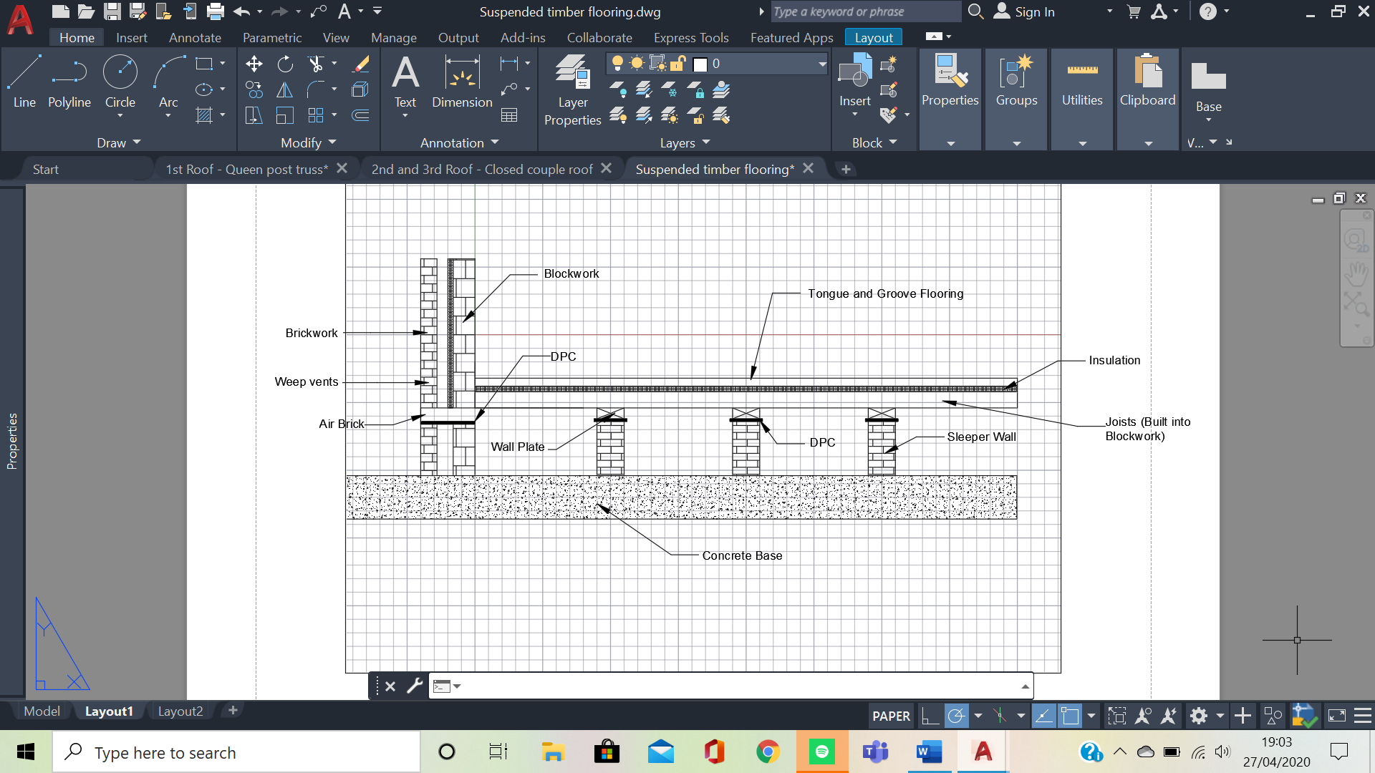

Appendix B – Solid timber flooring

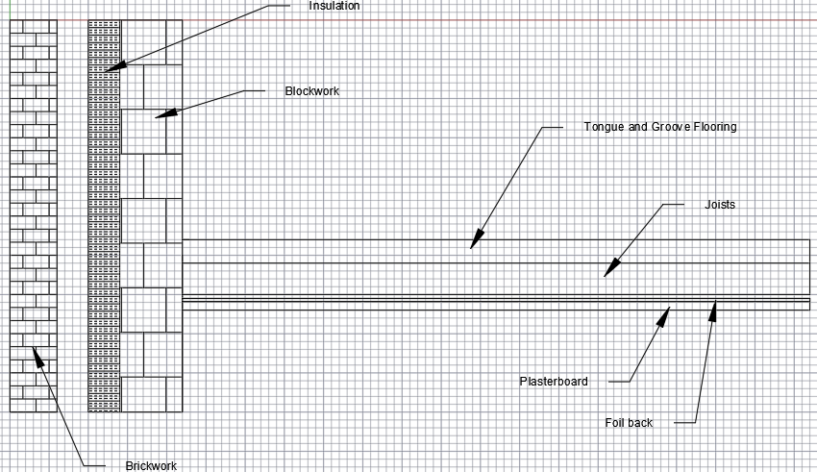

Appendix C – Drawing of joists
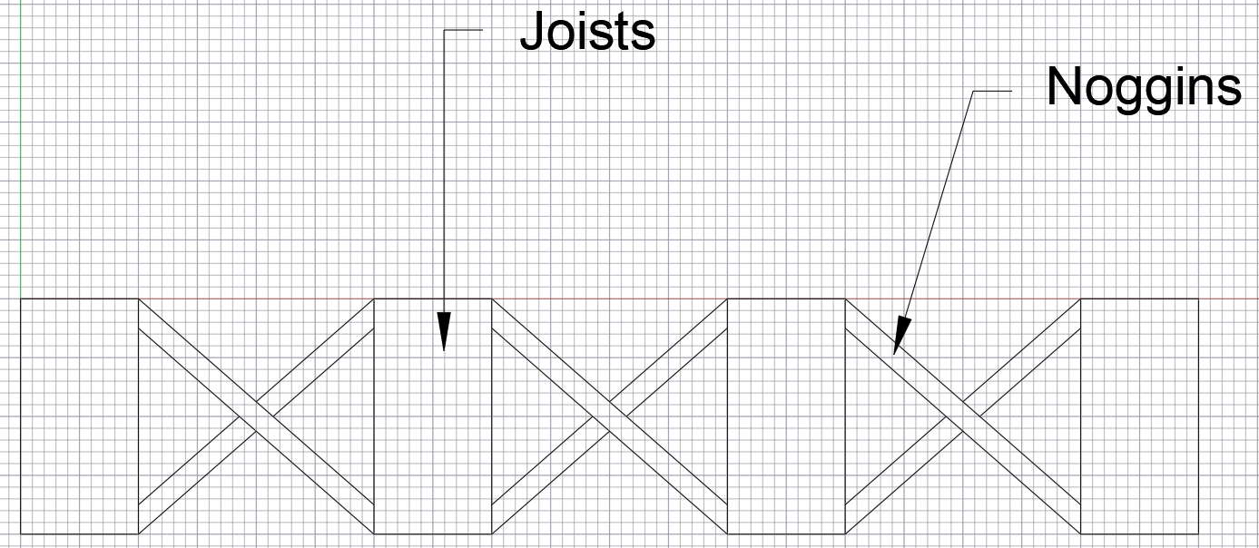

Appendix D – Tongue and Groove
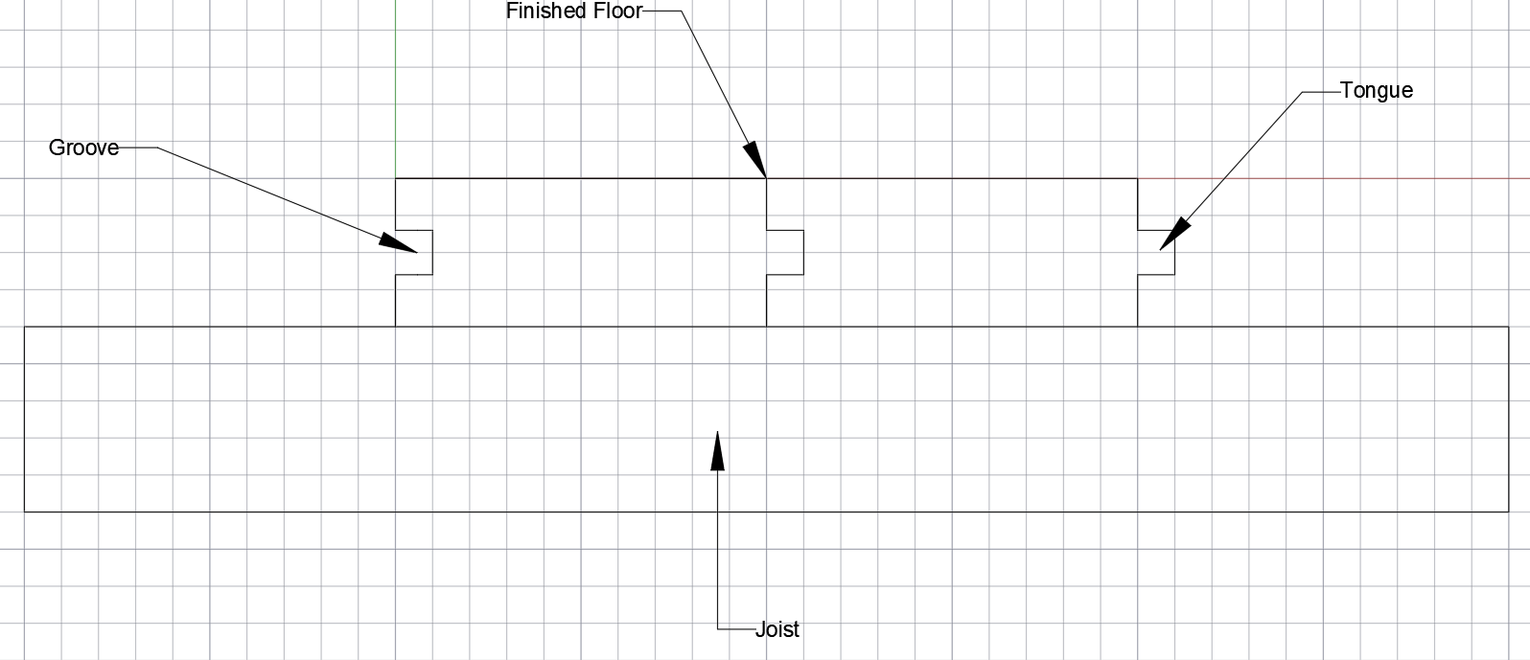

Appendix E – Section drawing of a window
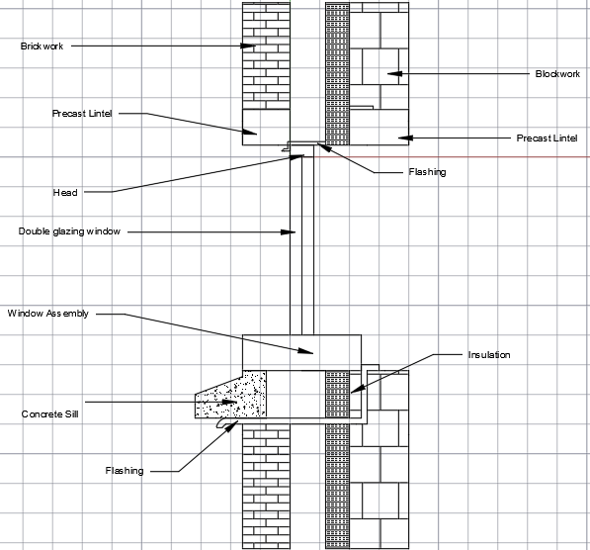
Appendix F – Front drawing of window
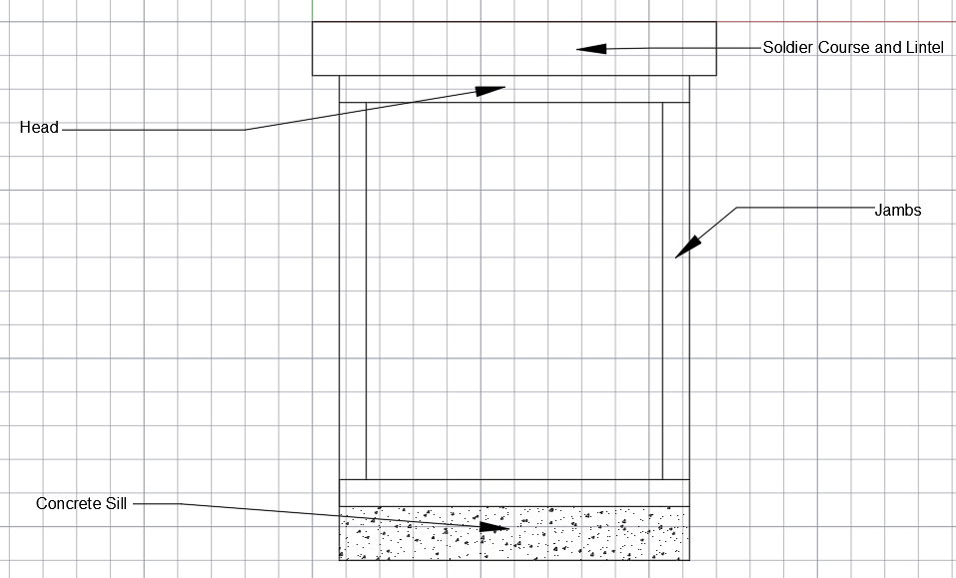

Appendix G – Closed eave with showing fixings and slates
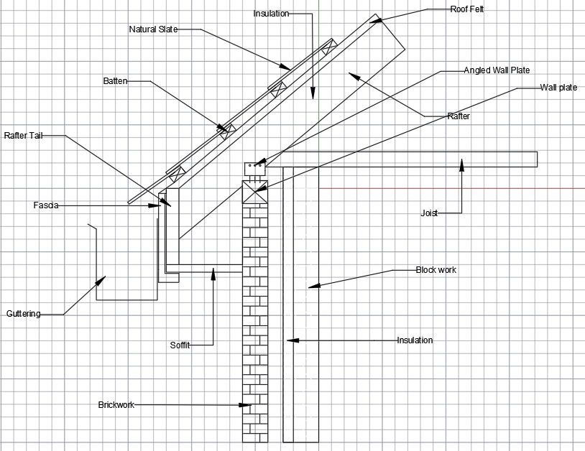
Appendix H – The roof layout
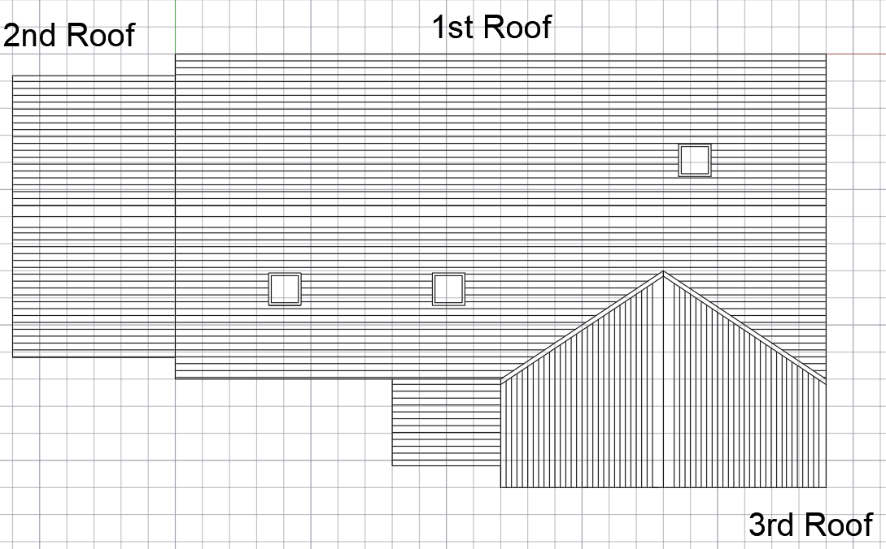

Appendix I – The queen post truss (1st roof)
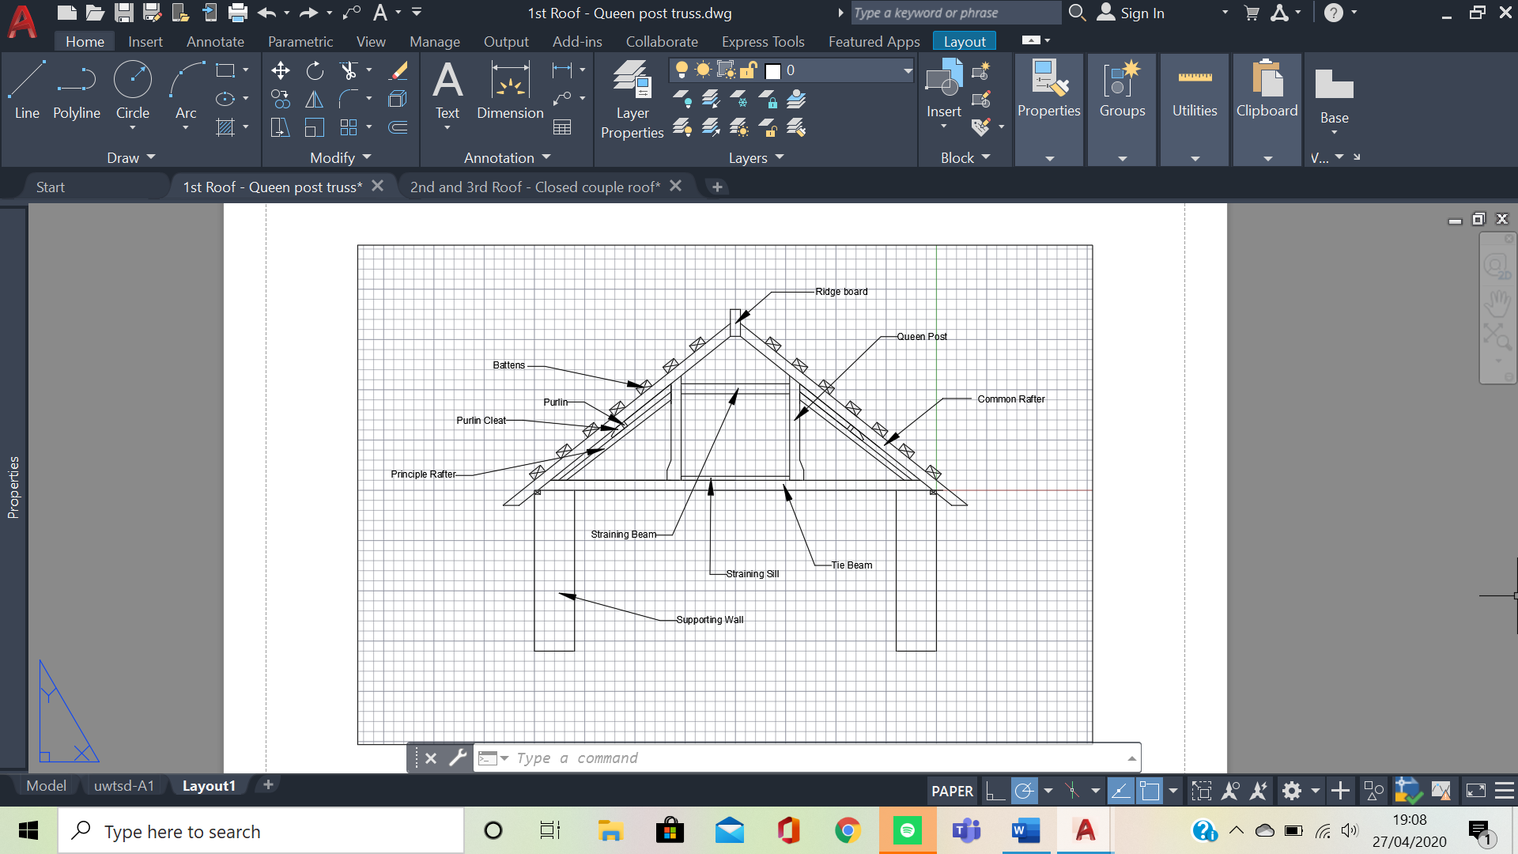

Appendix J – Closed couple roof (2nd and 3rd roof)


