

BMIH6003
Hotel Placement- Managing Guest Service Operations

Student Name: Mihai Diaconu
Student ID: 2131599
Module Lead: Giulia Chifari

Table of Contents
Introduction 3
Section 1: Reflection on Experience and Personal Development 4
Section 2: Critical Analysis of Work-Based Skills and Technical Knowledge 5
Section 3: Reflection on Organisational Issues 6
Conclusion and Action Plan 8
References 9

Introduction
The guest service operations of Ty Newport Hotel are about ensuring that the hotel is easily enjoyable for every client. As this area of the hotel is visible to the guest, it should comprise check-in formalities, bookings, requests, and complaints handling among others. All these tasks ensure that both technical and people skills are incorporated to achieve high standards of the hotel’s services.
Learning Objectives for Placement in Front Office:
- Observe and understand the supervisory role in managing guest service expectations.
- Develop communication, task management, and problem-solving skills.
- Gain practical knowledge of front-office systems and service standards.
- Enhance adaptability in high-pressure guest service situations.

Section 1: Reflection on Experience and Personal Development
Kolb’s model of reflection outlined below is a theoretical model that presents how one gains experience. The analysis covers four stages which were developed by David Kolb in 1984 and these are the stages of learning that continue in a cycle (Fewster-Thuente & Batteson, 2018). It includes stages of Concrete Experience, Reflective Observation, Abstract Conceptualisation, and Active Experimentation.
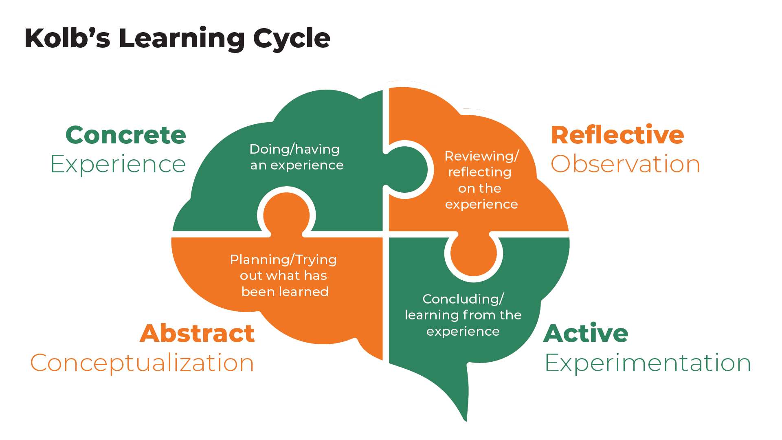
Figure 1: Stages of Kolb's Learning Cycle (Fewster-Thuente & Batteson, 2018)
Concrete Experience
I learnt the difficulties of guest service management while on a placement at the Ty Newport when observing a front office supervisor. I realised how the supervisor engages in all organisational routine tasks, such as check-in, change of reservation, and handling of questions and complaints from the guests. This job involves a significant amount of interaction with customers this position requires relatively heavy multitasking and fast decision-making skills to address the client’s needs (Fallon & Rutherford, 2010). For instance, I observed that once when one group was checking in while at the peak busy time, their bookings were not indicated at the reception. My supervisor politely greeted the group and other employees in a relaxed manner.

Reflective Observation
This gave me an understanding of how communication is an important industry for managing guests and also an eye opener to the aspect of teamwork (Cousins & Weekes, 2020). This is evident when the supervisor makes calls to make contact with departments such as housekeeping to find out whether they are prepared for reception helping to explain how Hotel functions are integrated (Johnston et al., 2012). These interactions have been discussed academically and this aided me further in the course of my work to appreciate how each team operates to enhance the aspect of guest satisfaction. I realised that one has to manage tasks as well as how people interface them to be productive, especially during load.
Abstract Conceptualisation
I thought this was a point of learning because front office jobs require technical experience to handle bookings in the hotel and also Emotional intelligence to handle clients (Walker, 2021). Reflecting on academic and placement time, I have analysed how these times have formed me into what I am today and how these times have formed the set of skills that I possess today such as communication and Problem Solving. When doing the shadowing, it becomes easier for me to relate these skills in real-life practice.
Active Experimentation
In my future placements, I would like to improve on how I manage pressure when making decisions and in interpersonal communication and listening. I think that the integration of these skills will assist in enhancing an area of performance that involves high guest contact and service delivery.

Section 2: Critical Analysis of Work-Based Skills and Technical Knowledge
Concrete Experience
While in the front office for my placement I came to understand the various work-based competencies and know-how to meet guests’ service needs. Some core competencies were serving in PMS, invoice and payment processing and collaborating with other departments to serve the guests Vallen & Vallen, 2014). For example, once a guest requested to switch his/her room type to another during the night. My supervisor handled this by using fast access on the PMS to coordinate with the housekeeping division for availability of area and then go forward with the changes of technical ability over the guests.
Reflective Observation
As for the interaction with the supervisor, I had the idea that what kind of behaviours occur in real-life situations in a front office environment are not only technical abilities used. The technical skills of the professional such as listening skills, courtesy and time management skills are as valuable as technical skills (Fanthorne, 2004). For example, once a billing dispute occurred between the guest and the supervisor. It required solving the disagreement appropriately by demonstrating a good attitude by presenting company value to the guest. From this experience, I learned that technical and behavioural skills are required to sustain the guest (Martin, 2020).
Abstract Conceptualisation
While assessing such scenarios, I realised that it is imperative to apply technical competency in handling the different digital systems together with the personal skills to meet the service expectancies. These skills relate to knowledge that is expounded in services marketing; for instance, the SERVQUAL Model classifies reliability, responsiveness, and assurance as operational factors which influence guests’ satisfaction (Wood, 2013). The handling of PMS and the delicate and complex demands of the guests or clients requires skill “know-how” to handle these processes to ensure the satisfaction of guests. Proper communication and empathy are required for the service providers in a dynamic environment.

Active Experimentation
In future positions, I would like to enhance my technical knowledge regarding PMS and practice listening and empathy. It will also help in normal operations and cases of crisis, while the concept is aimed at achieving guests’ expectations and ensuring high quality of service.

Section 3: Reflection on Organisational Issues
Concrete Experience
During my placement, I encountered a situation whereby one guest complained of delayed check-in due to the check-out of the existing guest. This created a negative impression of the hotel at the front office by the guest. The supervisor who had to deal with it apologised for the delay and offered the guest some vouchers that allowed him to get a free drink. This was an attempt to bring some calm to the frustration of the guest but also raised the question of periods of demand pressure.
Reflective Observation
This experience made it clear that there is a need to work on the planning part by coming up with a good strategy on how to handle the front office during the busy period. This made me realise the fact that although a small move may eliminate a portion of dissatisfaction, there is an issue with staffing and resource distribution at the workplace (ASET, 2017). I noticed that during peak moments organisational limitations are seen by the customers and the employees who receive many tasks that they cannot complete before additional equipment.
Abstract Conceptualisation
For this case, service management theories such as the Service Gap Model showed that there was a ‘gap’ between the services offered by the hotel, and the customer's expectations because of staff shortages. One of the elements proposed to prevent problems in the supply of proactivity services, such as scheduling during high-demand hours, could lead to such adverse effects (Hagg, 2013). The front office could either adjust the working schedule of the staff or introduce an electronic queuing system that would enhance guests’ satisfaction and staff efficiency simultaneously.
Active Experimentation
In other related guest service jobs I would wish to take in the future, to ensure that I do not experience the above bottleneck I should always plan especially during the peak season. Such options as before check-in or any other during the high demand can be also fulfilled to manage guests’ expectations and to reduce pressure upon the staff, all parties involved meeting more satisfaction and having more positive experience.

Conclusion and Action Plan
The placement at The Ty Newport helped me see how important technical skills and personal skills are to guests’ expectations. I was able to relate to the different hospitality theories that I learned in class with real-life exposure especially when it comes to guest service during periods of high occupancy. I have had a good experience managing guest services and this has been a good grounding for the development of my career in the hospitality arena.
Here is my SMART-based action plan for furthering my skills:
Objective | Specific Action | Measurable | Achievable | Relevant | Time-bound
Enhance Technical Proficiency | Complete PMS training and practice daily | Track progress with supervisor feedback | Yes, through training | Essential for guest service | Within 2 months
Improve Interpersonal Skills | Attend customer service workshop | Measure through guest feedback scores | Yes, via workshops | Critical for guest relations | Within 1 month

References
ASET (2017). Good Practice Guide for Work-based and Placement Learning in Higher Education. Sheffield: ASET.
Cousins, J. & Weekes, S. (2020). Food and Beverage Service. 10th ed. London: Hodder Education.
Fallon, M. & Rutherford, D. (2010). Hotel Management and Operations. London: Wiley.
Fanthorne, C. (2004). Work Placements – Survival Guide for Students. Basingstoke: Macmillan.
Fewster-Thuente, L. and Batteson, T.J. (2018). Kolb's experiential learning theory as a theoretical underpinning for interprofessional education. Journal of allied health, 47(1), pp.3-8.
Hagg, E. (2013). Internship Guide: Work Placements Step by Step. 5th ed. The Hague: Eleven International Publishing.
Johnston, R., Clark, G. & Shulver, M. (2012). Service Operations Management: Improving Service Delivery. 5th ed. London: Pearson.
Martin, A. (2020). The Practical Guide to Understanding and Raising Hotel Profitability. Abingdon: Routledge.
Vallen, G.K. & Vallen, J.J. (2014). Check-In Check-Out: Managing Hotel Operations. 9th ed. Harlow: Pearson Education Limited.
Walker, J.C. (2021). Introduction to Hospitality. 8th ed. Harlow: Pearson Education Limited.
Wood, R.C. (2013). Key Concepts in Hospitality Management. London: SAGE Publications Ltd.

