CFD - Ahmed Body

  - Investigation of a 3D simulation of the external aerodynamics of a simplified vehicle

  - Oliver Duane

  - Advanced Computational Methods
  - Motorsports Engineering BEng
  - School of Engineering
  - University of Wales Trinity St. David
  - 2020

Contents
1. Contents i
2. Figures ii
3. Tables iii
4. Abstract 1
5. Introduction 1
6. Aim 1
7. Purpose 1
8. Background research 2
Pressure 2
The general CFD process 2
The governing equations solved by the CFD method 2
Measuring aerodynamic effects 2
Modelling aerodynamic effects 3
Model verification 3
The Ahmed body 3
The Ahmed body’s dimensions 4
Wind tunnel dimensions 4
Test specifications 4
9. The software: Ansys WorkBench 5
10. The Fluid Domain Geometry 5
11. Creating the mesh 5
Mesh strategy 5
Density Boxes 5
Shape and alignment of the cells 8
Appraising mesh quality 8
12. Solving 8
13. Post processing 9
Pressure 9
Streamlines 10
Turbulent energy 12
Velocity 12
Vortices 14
14. Analysing the results 17
Pressure plots 17
15. Conclusion 18
16. Further work 19
17. Bibliography 19
18. Appendices 19
Drag and lift data 19

Figures
Figure 1. Ahmed body dimensions 4
Figure 2. Density boxes 6
Figure 3. Octree mesh 6
Figure 4. Delaunay mesh 7
Figure 5. Prism layers 7
Figure 6. Lower-front prism layers 7
Figure 7. 8
Figure 10. Pressure contours of the Ahmed 25 9
Figure 11. Pressure contours of Ahmed 35 (unrefined mesh) 9
Figure 12. Streamlines over Ahmed 25 10
Figure 13. Streamlines over Ahmed 35 (unrefined mesh) 10
Figure 14. Streamlines over Ahmed 35 (vortex) 10
Figure 15. Streamlines showing trapped airflow (refined mesh) 11
Figure 16. Streamlines showing trapped airflow (rear – refined mesh) 11
Figure 17. Streamlines showing trapped airflow (front – refined mesh) 11
Figure 18. Turbulent energy of Ahmed 25 12
Figure 19. Turbulent energy of Ahmed 25 (side view) 12
Figure 20. Air velocity over Ahmed 25 12
Figure 21. Air velocity over Ahmed 35 (1) 13
Figure 22. Air velocity over Ahmed 35 (2) 13
Figure 23. Air velocity over Ahmed 35 (3) 13
Figure 24. Vortices and streamlines around Ahmed 25 14
Figure 27. Vortices and streamlines with unrefined mesh from Ahmed 35 14
Figure 25. Vortices with refined mesh from Ahmed 35 15
Figure 26. Vortices with refined mesh from Ahmed 35 (lower view) 15
Figure 28. Pressures around the vortices of Ahmed 35 with refined mesh 16
Figure 29. Pressure behind Ahmed 35 with refined mesh 17
Figure 36. Pressure plots for Ahmed 35 (unrefined mesh) 18
Figure 37. Pressure plots for Ahmed 35 (refined mesh) 18
Figure 30. Drag data for Ahmed 25 19
Figure 31. Lift data for Ahmed 25 20
Figure 32. Drag data for Ahmed 35 (unrefined mesh) 20
Figure 33. Lift data for Ahmed 35 (unrefined mesh) 20
Figure 34. Drag data for Ahmed 35 (refined mesh) 20
Figure 35. Lift data for Ahmed 35 (refined mesh) 20

Tables

Table 1. Drag and lift results 0

Abstract
The air around us can be both a help and a hinderance to the car designer, understanding how it moves can help to maximise the pros, while minimising the cons.
To begin to understand this complex motion an attempt was made to simulate several scenarios (with known results) using CFD software. Simulated drag and lift were then compared with measured results from the scenarios tested.

Introduction
When an object passes through air it squashes the air in front of it and leaves a wake of turbulence behind it. Millions of particles interact with each other creating almost infinitely complex three-dimensional movement around the object. Changes of pressure on the surfaces of the object create forces, affecting the objects’ motion. Surface pressure control can be achieved by controlling airflow and airspeed around the object, because faster flowing air has reduced pressure.
To save the effort and expense of prototyping and testing shapes, simulations are increasingly being used.
Due to the complexity of modelling millions of particles swirling arounds, simplifications and generalisations must be made. What these simplifications and generalisations are and to what degree they are simplified and generalised is up to the modeller; the validity of the model being testament to their ability.
Using Ansys CFD software, two bluff (non-streamlined) Ahmed body vehicle shapes were tested. The test process involves many stages, with many options for each stage.

Aim
This report aims to produce a simulation model that conforms to the experimental data from two standard test shapes: the Ahmed body with 25 and 35 degree angle end sections. This is a common technique for evaluating the aerodynamic performance of a shape without testing it in a wind tunnel.
The aim of this exercise is to develop a simulation model that produces the same results as the actual experimental empirical measured data. This involved:
- Analysis and investigation of CFD methodologies
- Gathering all relevant information about the real-life tests
- Implementing a suitable strategy
- Testing various models against real-life data
- Calibrating the most suitable model with real-life data

Purpose
The reason for developing a simulation model that produces the same results as those that were obtained by empirical observation, is to verify the simulation model. This can then be used with different shapes, sizes, velocities, air densities etc. to predict the aerodynamic characteristics of the object under various conditions.

Background research
Computational fluid dynamics is the attempt to predict the behaviour of fluid with the use of computers. It has many areas, with many different methods of prediction (governing equations), of which, depend on the conditions of the test. This report focuses on sub-sonic, sea-level motion of a ground vehicle through air.
Air is generally assumed to be a Newtonian fluid in that shear stress increases linearly with the rate of strain, the proportions of which determine the viscosity of the fluid.

Pressure
Static air relative to an object creates forces normal to the entire surface due to the air pressure. These negate and result in zero aerodynamic force.
When there is a difference in velocity between the air and the object, air pressure around the object changes and results in drag and lift.

The general CFD process
CFD analyses an area in space, the fluid domain, and how fluid flows through it. The general processes are as follows:
- A shape is selected for investigation
- The size and position (relative to the shape) of the fluid domain is specified
- Boundary conditions are specified for the domain, and the surfaces of any objects in it.
- The fluid domain is split into cells called a mesh.
- The force on each cell face is calculated, resulting in a three-dimensional network of values for variables such as pressure, air velocity, etc.
- The data can then be visualised in numerous ways, this is termed post-processing.

The governing equations solved by the CFD method
For all models, air was considered compressible.
The main equations used in CFD are based around conservation laws:
- Conservation of mass – The rate that air mass enters the control volume must be the same as exits it.
- Conservation of momentum - Navier-Stokes equations and Newtons second law of motion.
- Conservation of energy – The first and second laws of thermodynamics

Measuring aerodynamic effects
The many techniques of measuring / visualising aerodynamic effects include:
- Flow-visualisation paint
- Particle Image Velocimetry
- Coast-down testing
- Surface mounted pressure sensors
- Force balances
- Strings attached to bodywork
- Hot-wire systems
- Smoke trails

Modelling aerodynamic effects
Numerical modelling attempts to predict the aerodynamic effects by using empirical mathematical formulas (Ansys, 2009). Just a glance at the long list of software comprising Ansys shows the daunting variety of tools available to approach the problem with. The lack of integration between them unfortunately reduces usability.

Model verification
The mathematical model can be verified by comparing results with real-life testing, although achieving adequate test conditions can be expensive or impossible.
Due to the complexity of aerodynamics, the need to verify aerodynamic prediction models is common. This has led to a standard test shape, the Ahmed body, along with real-life results being adopted. This enables the modeller to compare their work with actual findings, without the need to do physical testing.

The Ahmed body
The Ahmed body is a generic form of a road car. It has only one variable: the angle of the rearmost upper surface. The angles used in this report are 25 and 35 degrees of slope. The reason these angles are chosen is because they are either side of 30 degrees, the angle at which flow separates (Lienhart, et al., n.d.).
This has been tested in a wind tunnel and is used as an educational tool to teach about calibrating predictions to actual data.
Verification of the mathematical model was done with the Ahmed body, a simple shape designed to study the wake in airflow. In 1984, S.R. Ahmed published results of experiments using the Ahmed body (Ahmed, et al., 1984).

The Ahmed body’s dimensions
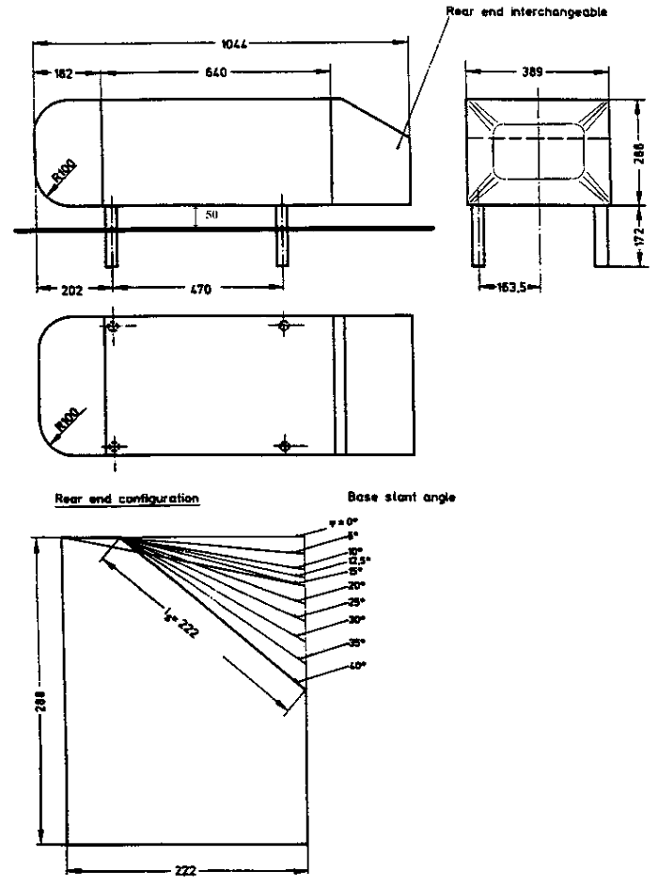
Figure 1. Ahmed body dimensions

Wind tunnel dimensions
The wind tunnel dimensions are 1.87 wide and 1.4m high, a cross section area of 2.618m² . It has an open ¾ test section. Using the suggestion of Lamfritz, three car lengths in front, 5 behind were used.

Test specifications
- Air flow speed: 40m/s
- Kinematic viscosity of air: 15 × 10⁻⁶ m²/s
- Bulk velocity: U_{b} = 40 m/s
- Height of body: h = 288 mm
- Reynolds number based on height of body: Re = 768,000

The software: Ansys WorkBench
The software used for this investigation was Ansys WorkBench. It is a collection of tools used in the simulation of fluid flow.
For the task in this report, there were seven different stages of the process:
- Import solid model
- Specify domain dimensions
- Specify domain properties: inlet, outlet, density boxes, etc.
- Mesh the fluid area
- Run the simulation
- Post-processing: displaying the data
- Data analysis: examining the graphic data

The Fluid Domain Geometry
The size and shape of the fluid domain (or area of study that contains the fluid), are vital factors in obtaining useful results. There should be enough space around the vehicle body to not restrict flow or cause a Venturi effect between the upper vehicle surface and the tunnel ceiling, and it should be long enough for turbulence to have subsided by the time the air exits the fluid domain.
Using the wind tunnel dimensions, a domain geometry was made in Design Modeller.
For these tests, the car and air flow were considered symmetrical and so only half of the model was used. This halved the number of calculations necessary for each run.
The boundary conditions were set to simulate the vehicle travelling straight ahead at 40m/s (144km/h).

Creating the mesh
FEA breaks down a large problem into many small problems. The large problem of the domain is split into the many small problems, the cells of the mesh. Due to the limited speed of computers, calculating the large number of cells can take long periods of time and, therefore, cells should be used wisely, and their number kept to a minimum. If there are too few, i.e. the cells are too large, there is not enough detail for accurate results.

Mesh strategy
The main cell size of the fluid domain was 0.3m. This was a relatively large cell size as it is not expected to see large or sudden changes in velocity or pressure.

Density Boxes
Three density boxes were created. The first, with a maximum cell size of 0.1m began one meter from the front, extended halfway to the side and top, and trailed to the end of the domain.
The second density box had a maximum cell size of 0.06m and extended halfway to the first density box, but also trailed to the end of the domain.
The third density box only trailed three meters behind the Ahmed body and did not extend outward in any other direction. This was intended to capture detail of the vortex from the upper edge and had a maximum cell size of 0.03m. This was later refined for the Ahmed 35 to 0.01m.
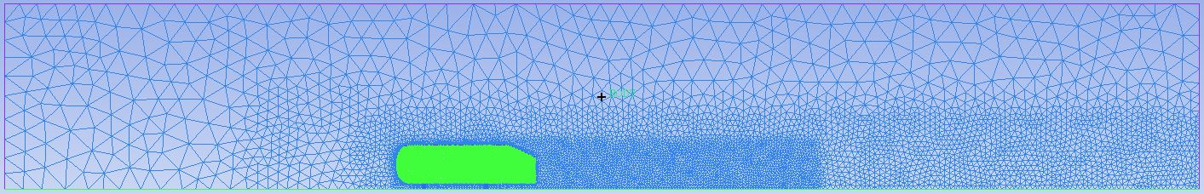
Figure 2. Density boxes

An Octree mesh was initially generated. This method produces a very uniform cell structure, see Figure 2.
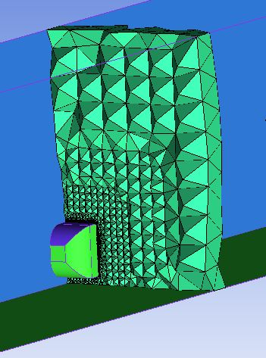
Figure 3. Octree mesh
It was decided to use a Delaunay mesh due to the more random cell structure, see Figure 3.
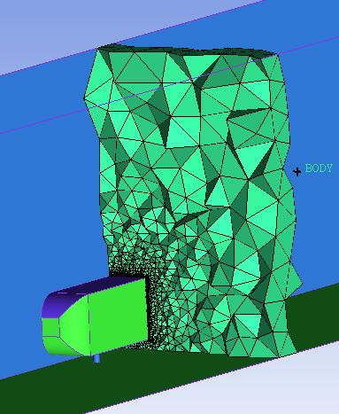
Figure 4. Delaunay mesh
Prism layers were used for surfaces where laminar airflow was expected, shown in Figure 4.
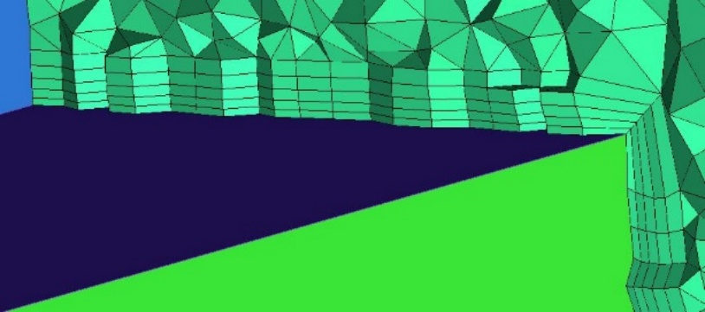
Figure 5. Prism layers
Surfaces where turbulence was expected, such as the underside and rear end of the Ahmed body, did not have prism layers added as the air flow would be less likely to be laminar (Figure 5.).
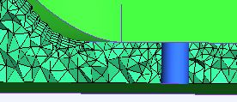
Figure 6. Lower-front prism layers

Shape and alignment of the cells
The cell faces were as equilateral as possible, as acute angles can cause inaccuracies. The alignment was random as possible to try and replicate the chaotic element of airflow.

Appraising mesh quality
The mesh quality was assessed by examining:
- Skew
- Orthogonality
- Aspect ratio
- Node point distribution
- Smoothness
(Ansys, 2009).

Solving
The study ran for 200 iterations and a solution was found.
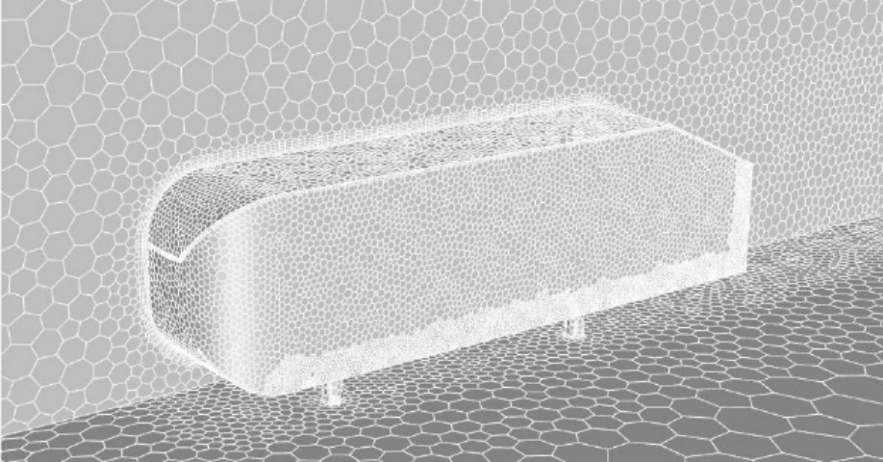
Figure 7.

Post processing

Pressure
The visual results for surface pressure were as expected, with the main characteristic being the high pressure on the front surface.
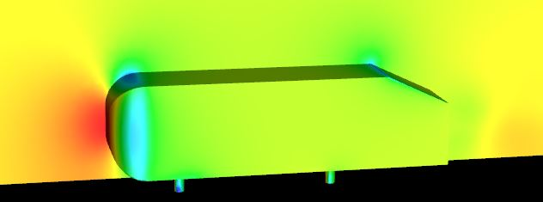
Figure 10. Pressure contours of the Ahmed 25

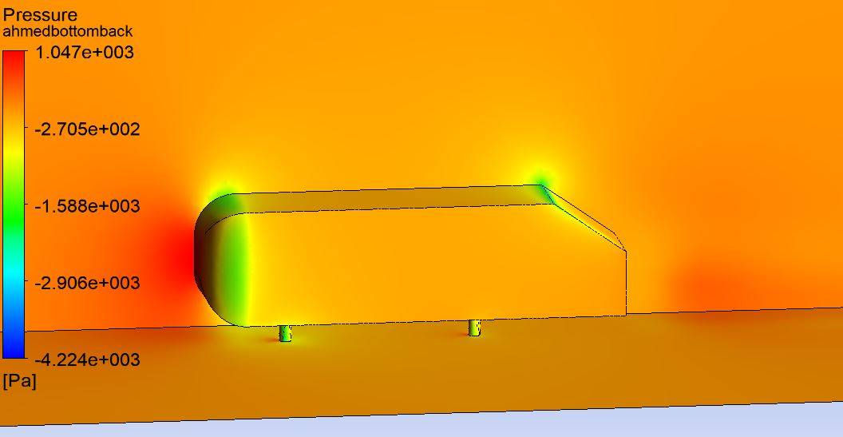
Figure 11. Pressure contours of Ahmed 35 (unrefined mesh)

Streamlines
Looking side-on at the streamlines of the Ahmed 25, the trapped air behind the body was visible (Figure 12.).
Another noticeable feature was the streamlines going down appear to pull the side streamlines up, creating the vortex (Figure 12.).
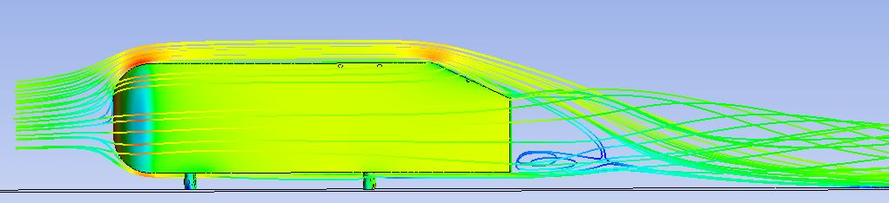
Figure 12. Streamlines over Ahmed 25
When this was viewed on the Ahmed 35, the streamlines did not appear to separate from the angled rear surface as was expected (Figure 13. and Figure 14.), but with the refined mesh they did (Figure 15.).
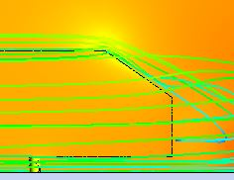
Figure 13. Streamlines over Ahmed 35 (unrefined mesh)

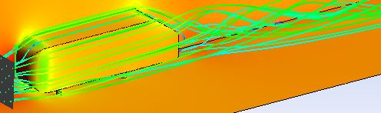.
Figure 14. Streamlines over Ahmed 35 (vortex)

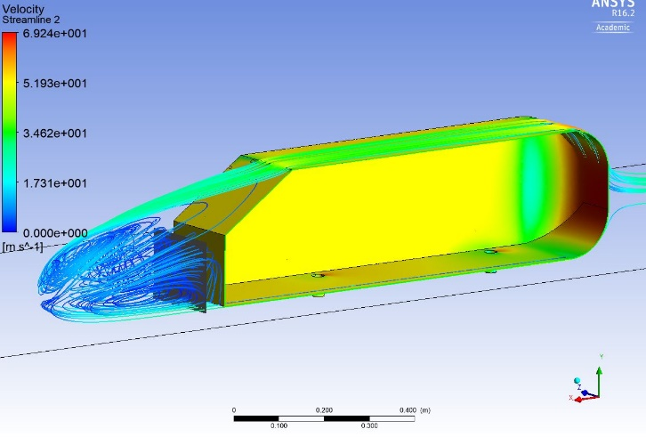
Figure 15. Streamlines showing trapped airflow (refined mesh)
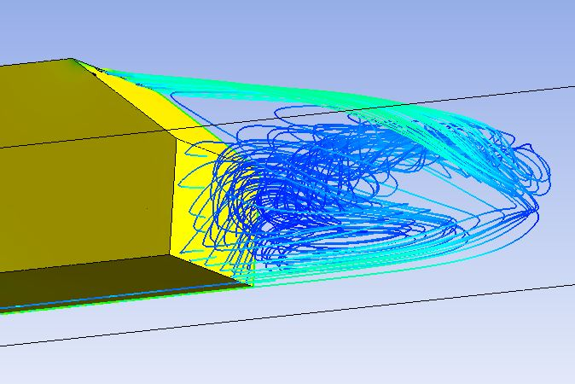
Figure 16. Streamlines showing trapped airflow (rear – refined mesh)
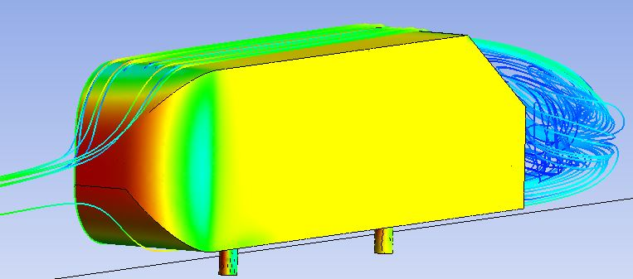
Figure 17. Streamlines showing trapped airflow (front – refined mesh)
The streamlines passing close to the rear surface of the body were visualised to see where they came from. They were almost always from the upper surface.
The complex path of this slow speed airflow was displayed as turbulent energy, Figure 18.

Turbulent energy

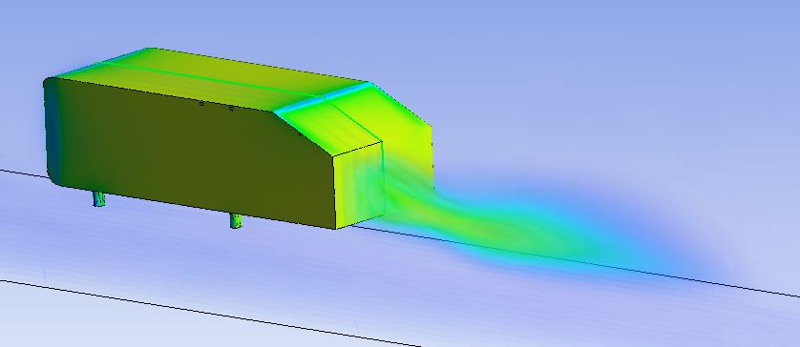
Figure 18. Turbulent energy of Ahmed 25

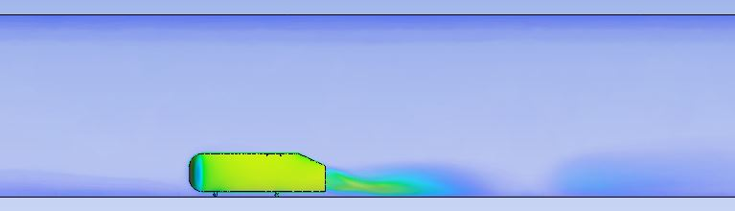
Figure 19. Turbulent energy of Ahmed 25 (side view)
The shape of the turbulent energy was similar to the visualised velocity, Figure 20.

Velocity

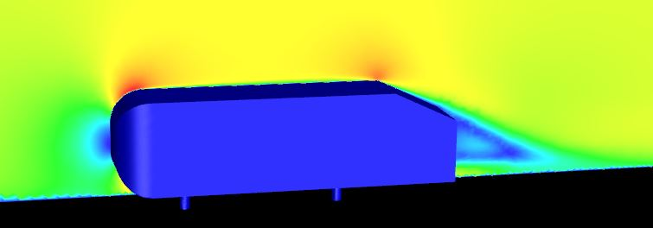
Figure 20. Air velocity over Ahmed 25

The velocity of the airflow past the Ahmed 35 (refined mesh) appears to show completely different behaviour, with full separation from the rear surface.
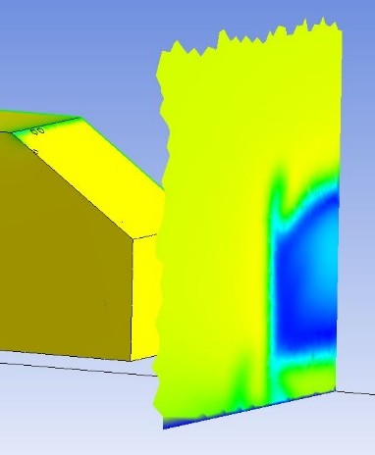
Figure 21. Air velocity over Ahmed 35 (1)
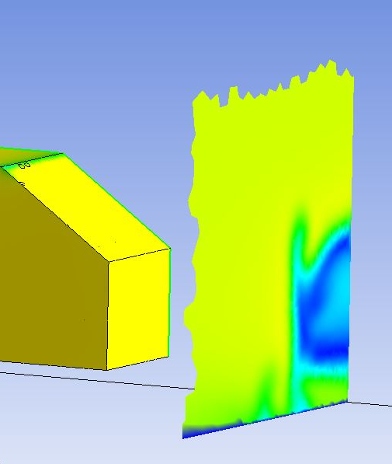
Figure 22. Air velocity over Ahmed 35 (2)
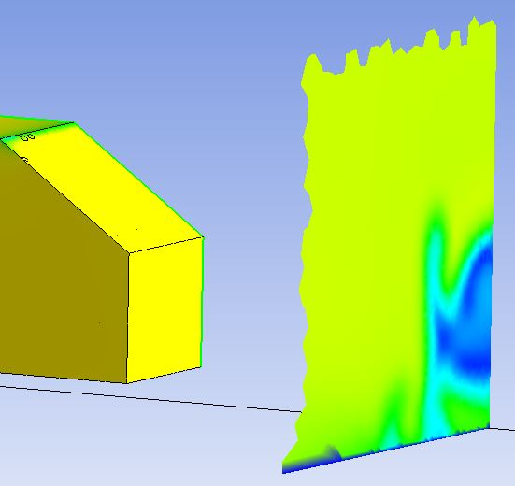
Figure 23. Air velocity over Ahmed 35 (3)

Vortices
The Ahmed 25 and 35 that used the basic mesh both show a basic vortex, with the steeper angled Ahmed 35 creating a slightly stronger rotation, see Figure 24. and Figure 27.
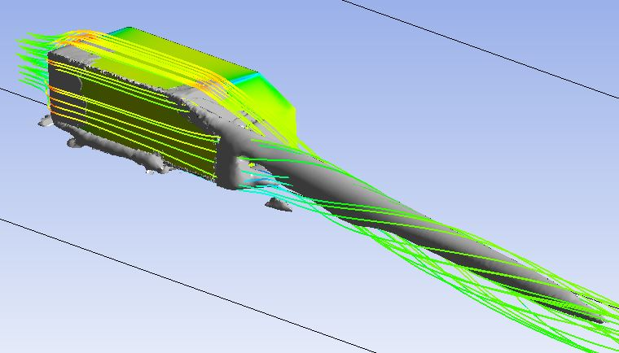
Figure 24. Vortices and streamlines around Ahmed 25
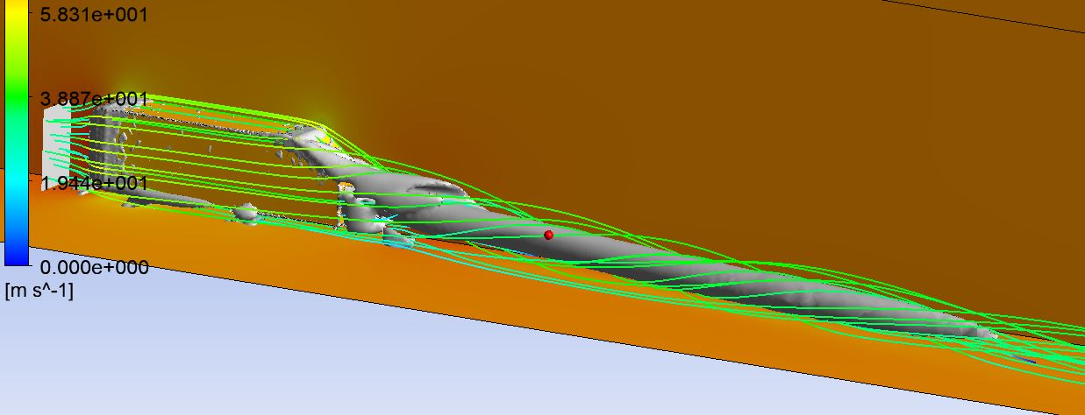
Figure 27. Vortices and streamlines with unrefined mesh from Ahmed 35

When the mesh was refined to a maximum cell size of 0.01m in the smallest density box the vortices became far more intricate.
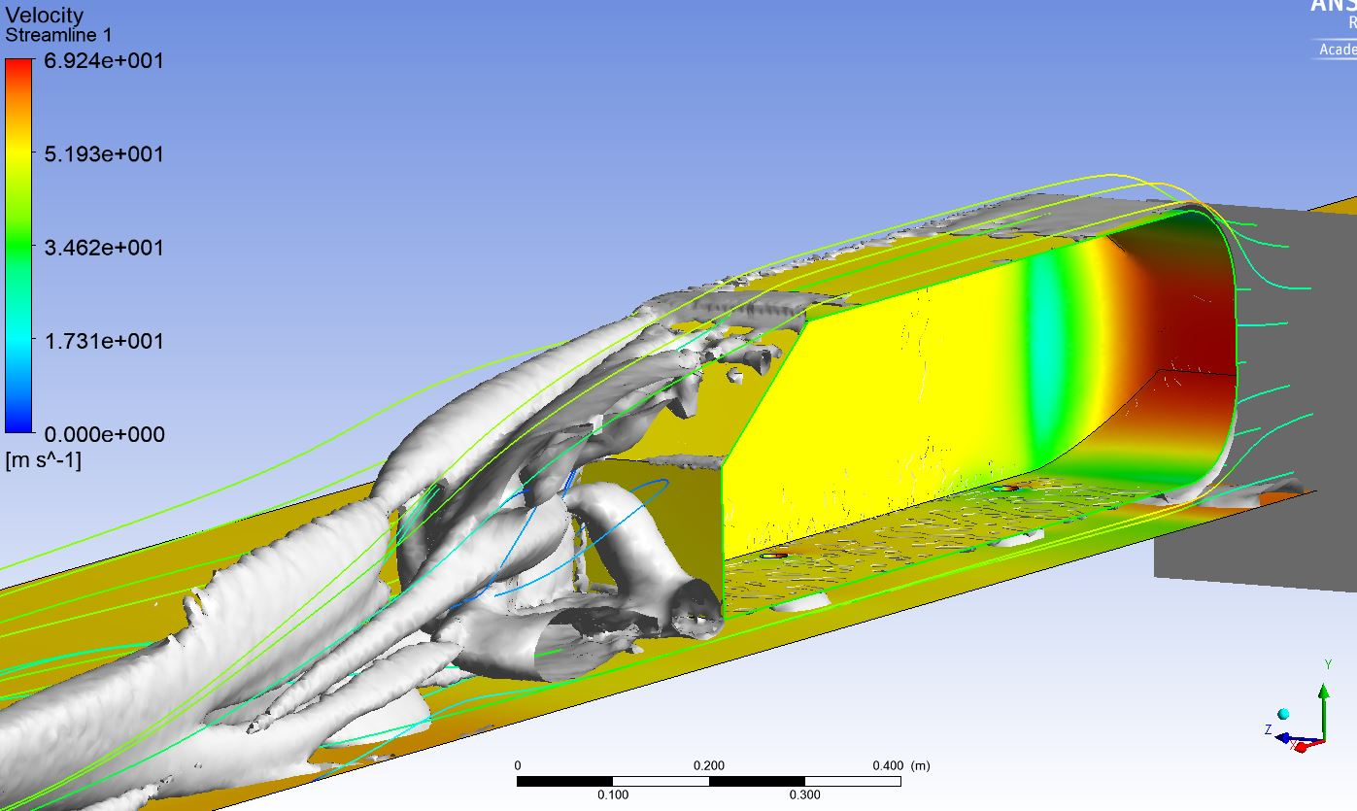
Figure 25. Vortices with refined mesh from Ahmed 35

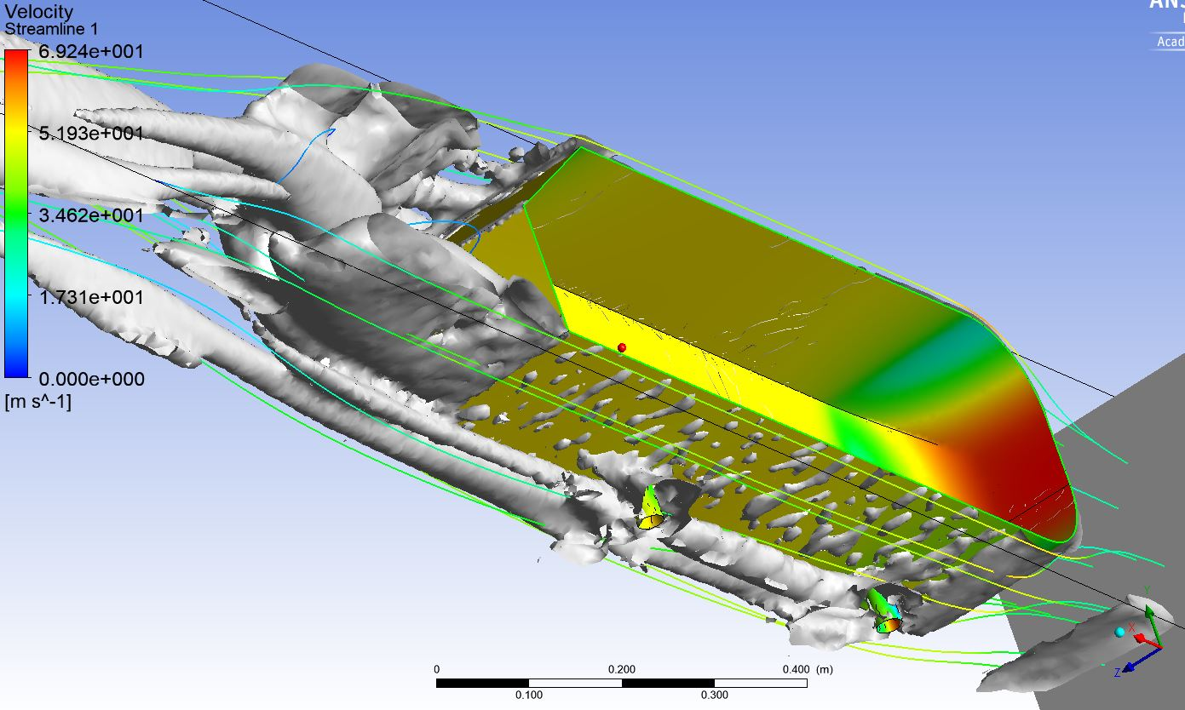
Figure 26. Vortices with refined mesh from Ahmed 35 (lower view)

Figure 28. shows air pressure around the vortices. Interestingly, the higher velocity areas are higher pressure, while the lower velocity areas are lower pressure. This could indicate that vortices contribute to the low pressure in the wake that increases drag.
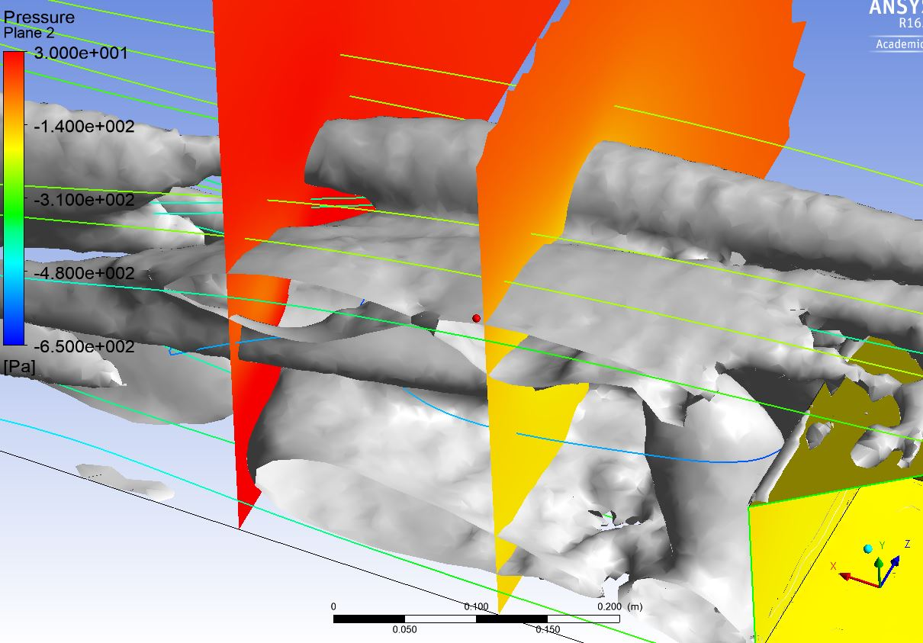
Figure 28. Pressures around the vortices of Ahmed 35 with refined mesh

Figure 29. shows the lower pressure directly behind the Ahmed body.
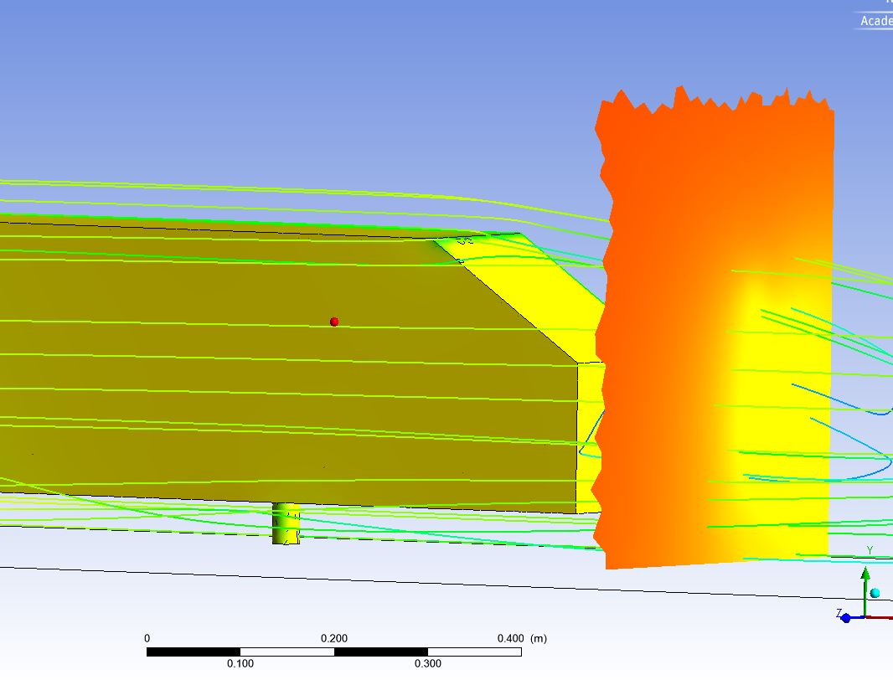
Figure 29. Pressure behind Ahmed 35 with refined mesh

Analysing the results

Table 1. Drag and lift results
 | Ahmed 25 | Ahmed 35 (unrefined mesh) | Ahmed 35 (refined mesh)
Drag Cd | 0.330 | 0.398 | 0.276
Drag Force | 18.6 | 22.4 | 15.5
Lift Cl | 0.422 | 0.587 | 0.0208
Lift Force | 23.7 | 33.0 | 1.17

Pressure plots
The pressure plot for the unrefined mesh of the Ahmed 35 shows a large drop in pressure at the rearmost end of the body, whereas the refined mesh has a figure of less than half for the same place. This is probably due to the flow staying attached in the unrefined mesh, creating a large amount of lift, or negative pressure. The refined mesh simulates the detachment better, resulting in a wide discrepancy.
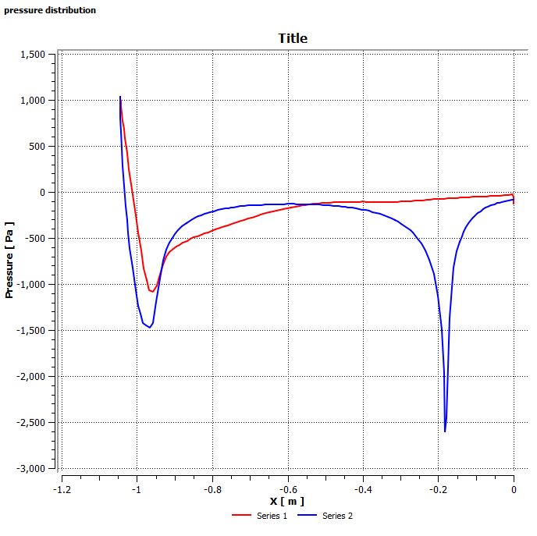
Figure 36. Pressure plots for Ahmed 35 (unrefined mesh)
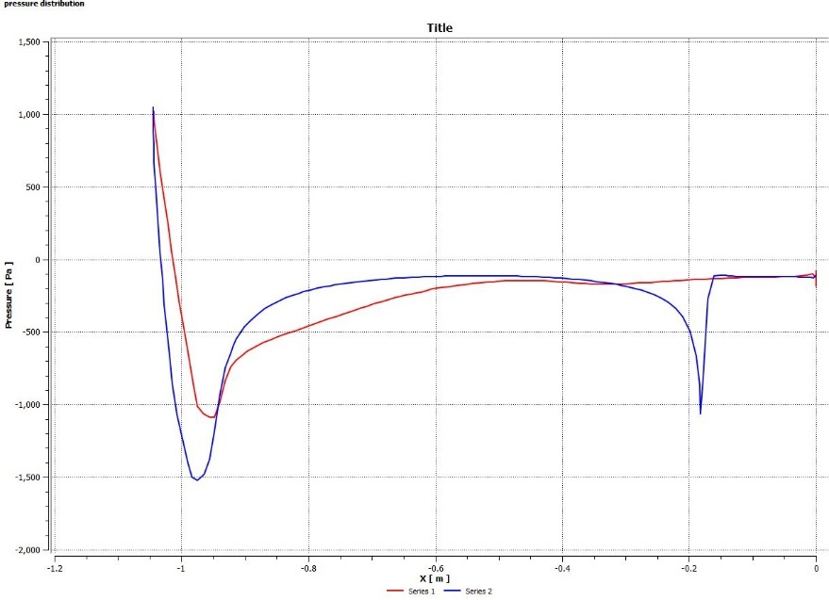
Figure 37. Pressure plots for Ahmed 35 (refined mesh)

Conclusion
The importance of small enough cells was highlighted, as there was a large margin of error for the mesh with cells no smaller than 0.03m.
Efficient use of density boxes showed that significant benefits to the detail of results were possible while keeping run times to a minimum.
As there are so many variables available, great care needed to be taken to ensure different tests were comparable, i.e. all the settings the same, while changing specific variables.

Further work
Further work necessary is to verify the pressure plots with actual data from tests. The model can then be further refined.

Bibliography
Ahmed, S. R., Ramm, G. & Faltin, G., 1984. Some Salient Features Of The Time-Averaged Ground Vehicle Wake. [Online]
Available at: https://saemobilus.sae.org/content/840300
[Accessed 28th January 2020].
Ahmed, S. R., Ramm, G. & Faltin, G., 1985. Some Salient Features of the Time Averaged Ground Vehicle Wake. SAE Transactions, Volume 93, pp. 473-503.
Ansys, 2009. 6.2.2 Mesh Quality. [Online]
Available at: https://www.afs.enea.it/project/neptunius/docs/fluent/html/ug/node167.htm
[Accessed 27th January 2020].
Lienhart, H., Becker, S. & Stoots, C., n.d. Flow Around a Simplified Car Body (Ahmed Body). [Online]
Available at: http://cfd.mace.manchester.ac.uk/cgi-bin/cfddb/prcase.cgi?82&EXP&database/cases/case82/Case_data&database/cases/case82&cas82_head.html&cas82_desc.html&cas82_meth.html&cas82_data.html&cas82_refs.html&cas82_rsol.html
[Accessed 28th January 2020].
Phillips, L., 2018. Turbulence, the oldest unsolved problem in physics. [Online]
Available at: https://arstechnica.com/science/2018/10/turbulence-the-oldest-unsolved-problem-in-physics/
[Accessed 27th January 2020].

Appendices

Drag and lift data
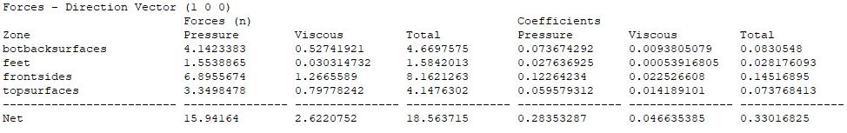
Figure 30. Drag data for Ahmed 25

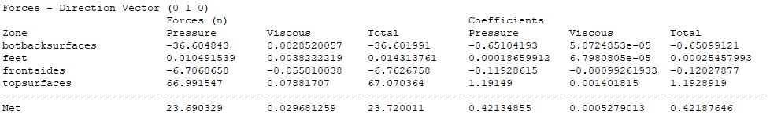
Figure 31. Lift data for Ahmed 25

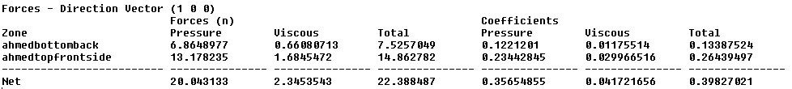
Figure 32. Drag data for Ahmed 35 (unrefined mesh)

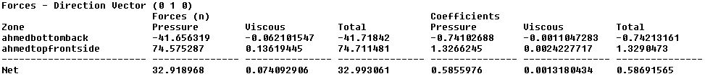
Figure 33. Lift data for Ahmed 35 (unrefined mesh)

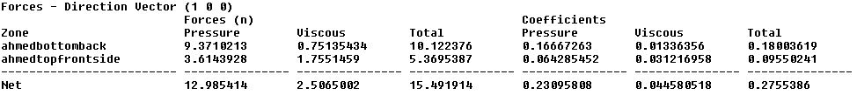
Figure 34. Drag data for Ahmed 35 (refined mesh)

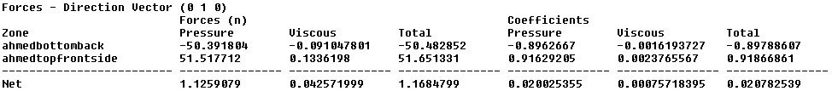
Figure 35. Lift data for Ahmed 35 (refined mesh)

