Zaha Matthews
Managing Director
Quantity Surveyor
Ecoguard Innovations
16 Jan. 24

Chief Executive
Neath Port Talbot County Council
Port Talbot

Subject: Proposal for Implementing BIM Maturity in Ysgol Yr Afan

Dear Sir/Madam,
I hope you receive this letter in good health. We are honoured to work with the Neath Port Talbot County Council on the prospective Ysgol Yr Afan. We are enthusiastic regarding the potential of this endeavour and are fully dedicated to producing a triumphant result that is per your overarching vision and goals. Recognising the critical importance of Building Information Modelling (BIM) in contemporary construction endeavours, we have conducted a thorough examination of the school's particular BIM maturity requirements. We are committed to maintaining effective information sharing, coordination, and administration throughout the entire project lifecycle, including the operational phase, in accordance with international standards and best practices.
Our approach to BIM Maturity Assessment entails conducting an exhaustive analysis of the project's unique characteristics and requirements. The assessment will conform to globally acknowledged standards, including ISO 19650, which provides a framework for efficiently supervising data throughout the undertaking. The primary aim is to evaluate the current state of development and determine the essential steps required to achieve the desired level for the infant school. The process of Information Sharing and Coordination entails the arrangement and interchange of data. The successful conclusion of a project is contingent upon the efficient distribution of information. To streamline this procedure, we propose the implementation of a robust Common Data Environment (CDE) that adheres to the ISO 19650 benchmarks. By serving as a centralised repository for all project-related data, the CDE will facilitate stakeholder collaboration. Consistently scheduled meetings, utilisation of online collaboration tools, and provision of timely updates will ensure that every member of the team possesses a mutual comprehension, thereby fostering a collaborative and effective workflow.
An essential element of our approach entails the creation and execution of a comprehensive BIM Execution Plan (BEP). The Building Execution Plan (BEP) will determine the specific standards, methods, roles, and responsibilities required for each project to effectively apply Building Information Modelling (BIM). During the project, we will make sure that the Building Execution Plan (BEP) aligns with ISO 19650 and other applicable international standards. This will provide a clear path for the integration of Building Information Modelling (BIM) in a transparent manner. Our dedication to a smooth transition from construction to operation is shown by our inclusion of the Implementation into the Execution Phase in our BIM plan, which extends into the operational stage. We will form an effective partnership with your operations and maintenance teams to ensure a seamless transfer of the BIM data generated during the project, specifically for facility management purposes. By using this approach, the asset's long-term value will be enhanced, enabling more efficient operations and maintenance. Educational and support services: We suggest implementing a thorough training plan for your project team to guarantee the effective adoption of BIM methods. This course will address the principles of efficient cooperation in the BIM environment, strict adherence to industry standards, and the effective use of BIM technologies. We will provide continuous support to overcome any challenges and ensure the continuous improvement of BIM processes.
Therefore, we are dedicated to providing a BIM-enabled project that not only fulfils but is beyond your expectations. Our methodology, based on internationally recognised standards and reinforced by a BIM Execution Plan, will guarantee efficient dissemination, coordination, and administration of information throughout the project's entire duration, including the operational phase. We eagerly anticipate the chance to delve into our recommended BIM approach more and resolve any inquiries or apprehensions you may possess.
We appreciate your consideration of our proposal and are enthusiastic about the opportunity to make a valuable contribution to the development of Ysgol Yr Afan, your infant school.

Sincerely,
Zaha Matthews
Managing Director
+44 079369301
Ecoguard Innovations

BIM Execution Plan (BEP)

  - Project Number: 5010
  - Project Title: Ysgol Yr Afan
  - Description: 1 form entry infant school for 90 pupils, with 48 PT Nursery provision.

16 January 2024
Executive Summary
This executive summary outlines the key steps that will assess the project team's competence in meeting the Building Information Modelling (BIM) maturity requirements for the new infant school project in Port Talbot. Neath Port Talbot County Council manages the programme in collaboration with the Sustainable Communities for Learning Programme of the Welsh Government. During the various stages of the RIBA process, it is required that the project team provide a Level of Development (LOD) and Level of Information (LOI) in a certain format. It highlights the need of continuous monitoring over the whole lifespan using a CAFM system.
Essential guidelines that must be adhered to include:
- Evaluation of BIM Competency: Perform a thorough evaluation of the project team's BIM expertise, including their level of experience and skill in the relevant software.
- The BIM Execution Plan (BEP) was carefully prepared to guarantee adherence to both project and regulatory requirements. Clearly outline the individual roles and responsibilities within the Building Execution Plan (BEP), highlighting the importance of Building Information Modelling (BIM) in achieving project goals.
- Criteria Compliance Control: Ensure strict compliance with national and international BIM standards, including ISO 19650.
- Periodic audits and evaluations are to be conducted to guarantee compliance with BIM standards.
- Incorporate a Computer-Aided Facility Management (CAFM) system into the Building Information Modelling (BIM) process to provide comprehensive monitoring during the whole lifespan of the facility. The essential CAFM data comprises asset particulars and maintenance schedules.
- The format used for the AIR/LOD LOI was designed to guarantee that the project goals are following the RIBA stages. This was achieved by creating a tailored LOD LOI matrix in cooperation with the client and stakeholders.
- Creating a mechanism for receiving and incorporating feedback is crucial to consistently enhance performance. Regularly review and modify the BEP (Business Execution Plan) and LOD (Level of Detail) LOI (List of Items) matrix to adapt to changing project needs and incorporate lessons learned.
BIM Objectives
- Obtain a pre-established level of Building Information Modelling (BIM) development that corresponds to international standards to enhance collaboration, productivity, and data administration across the entire duration of the project.
- Construct an efficient Computer-Aided Facility Management (CAFM) system that integrates Building Information Modelling (BIM) to facilitate comprehensive asset monitoring throughout its complete life cycle. This will ensure effective facility maintenance and administration after the construction phase concludes.
- Develop and adhere to a comprehensive Level of Development (LOD) and Level of Information (LOI) matrix that conforms to the RIBA phases and represents the project's specific information needs and client preferences with precision.
- The overarching objective is to ensure customer satisfaction through the delivery of a high-quality infant school facility that adheres to the Sustainable Communities for Learning Programme and exceeds expectations related to BIM.
- To facilitate the transfer of ownership, furnish appropriate data, and oversee the operation, maintenance, and assessment of the transferred asset's performance.

Content
1.0 Project Information 8
1.1 Project Details 8
1.2 Project description 8
1.4 Information Exchange 8
2.0 Data requirements 10
2.1 EIR 10
2.2 Construction Operations Building Information Exchange 11
3.0 Standards 11
3.1 File Naming Conventions 11
3.2 BIM Object/Asset Naming 11
3.2 Project Specific Naming Conventions 11
3.3 Status Codes and Revisions 12
3.4 Project Information Model Delivery Strategy 12
4.0 Handover 12
5.0 Appendices 12
5.1 Appendix 1 12
Stage 2: Concept 13
Stage 3: Spatial 14
Stage 4: Technical 14
Stage 5: Manufacturing and Construction 15
Stage 6: Handover 16
5.2 Appendix 2 17
References 20

1.0 Project Information

1.1 Project Details
Project Title: Ysgol Yr Afan
Project Number: 5010
Employer Name: Neath Port Talbot County Council
Issue Date: 16 January 2024

1.2 Project description
Illustrate innovative and adaptable planning, creation, implementation, and oversight of educational institutions that could have a beneficial impact on the environment and the local environment.

1.3 Information Exchange
A considerable quantity of information will be disseminated among the members of the project team at each stage. This serves a dual purpose. At the beginning, the data presented at the end of one stage must function as the fundamental basis for the following stage. They must therefore be informed of the details that will be implemented in the subsequent stage. Moreover, the data produced following a stage incorporates a wide range of choices, instigated by the client, that will influence the advancement of the subsequent phase.

 | FORMATS
 | IFC | DWG | PDF | XLSX | DOC | RVT | ETC
Project Brief
Feasibility Study
Health and Safety
Project Budget
Responsibility matrix
Drawings (file)
Reports
ED Models

The following dates have been designated as the Data Drops for the official Information Exchange:
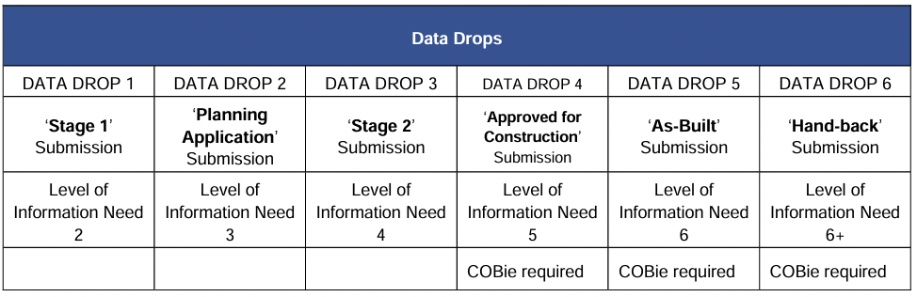

2.0 Data requirements

2.1 EIR
In BIM, an employer's information requirement (EIR) is commonly categorised into three distinct groups: technical, management, and commercial.

- The management section encompasses details concerning the subsequent facets: Standards; predetermined criteria or guidelines implemented to guarantee uniformity and excellence. Roles and responsibilities of stakeholders: precise duties and obligations of individuals or collectives participating in the project. Security: precautionary measures implemented to thwart unauthorised access or violations. Collaboration process: a methodology or strategy employed to foster cooperation and collaboration; - Compliance plan: a strategic approach designed to guarantee adherence to pertinent legislation, policies, or regulations System performance constraints refer to limitations or restrictions that impact the capabilities or operation of the system. Meetings to evaluate models, Strategies for the management of asset information delivery, health and safety, planning, data segregation (model management, nomenclature standards, etc.), and construction design.

- The commercial component shall comprise information concerning: A data delivery schedule pertains to the predetermined period during which the customer will receive data obtained from the building information model during critical stages. The purpose of this data is to support the strategic objective of the client. Defined the objectives of the BIM initiative and performed an exhaustive assessment of BIM-related competencies.

- The technical section offers extensive information regarding: The software platforms that the client prefers for the project comprise Data Exchange Formats, Training Requirements, and Level of Detail.

2.2 Construction Operations Building Information Exchange
Throughout the duration of this project, COBIE-compliant information deliverables for facilities management purposes will be produced at the designated Information Exchange stages.

3.0 Standards

3.1 File Naming Conventions
The naming convention for files shall adhere to the ISO 19650-1 standard. Accepting the specified character limits is imperative for complete compliance. Codes can be found in Appendix 2.
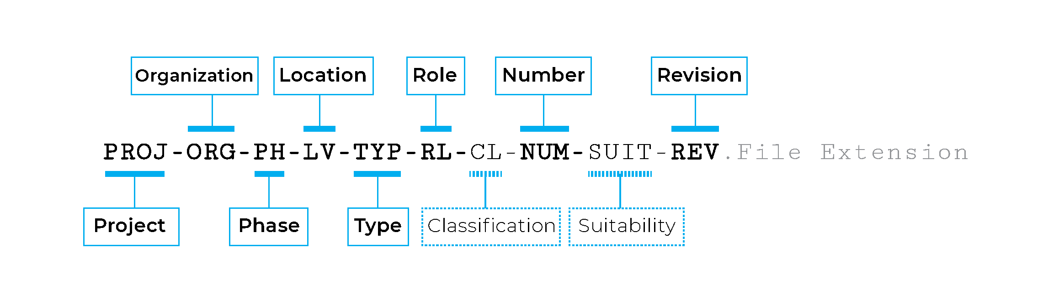
Figure 1: Example of Naming convention to be followed based on standards.

3.2 BIM Object/Asset Naming
It is mandatory to name each component in adherence to BS8541-1.

3.3 Project Specific Naming Conventions
Project naming conventions must be observed by all suppliers to align with the CAFM system.

3.4 Status Codes and Revisions
Status codes are required for this project.

3.5 Project Information Model Delivery Strategy
To ensure effective coordination, it is essential to consider the individual needs of each stakeholder. To ensure universal access to information, please follow the procedures indicated below. Prior to diverging from this table, the consent of the Information Manager is necessary.
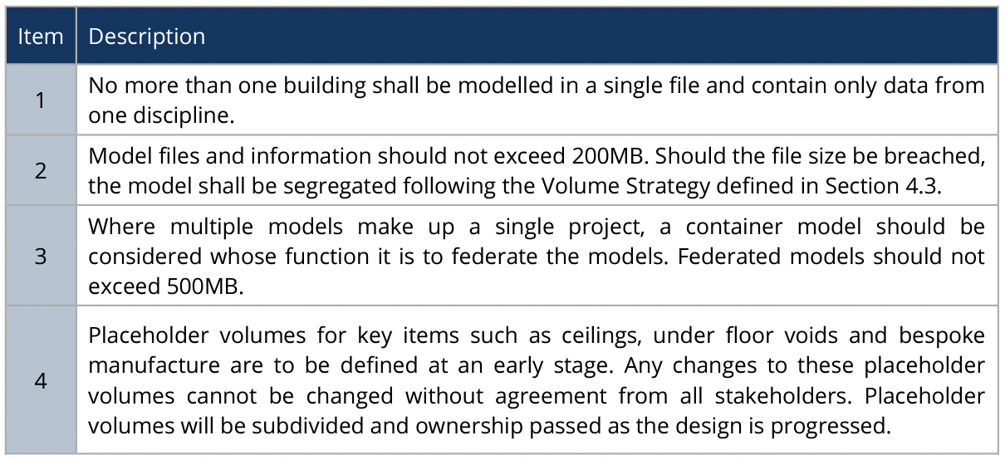

4.0 Handover
A comprehensive documentation of the project in its initial condition during the transfer, including all essential information for operation and maintenance. Record the final financial report of the project's cost.

5.0 Appendices

5.1 Appendix 1
Responsibility Matrix Identifies the: - Level of Information and/ or Level of Model Detail
The term "Level of Definition" (LOD) is used in combination with "Level of Information" to indicate the level of geometric accuracy and complexity of model objects and components related to model outputs. The phrase "level of information" refers to the accuracy of the information associated with model objects, components, and other sources of information. To provide an adequate illustration, I will provide the Level of Detail (LOD) and Level of Information (LOI) for a component in the next section. This will help you understand how it may be integrated into the overall project.

Fireproof door:

Stage 2: Concept
Description: At this stage, the model is in basic development, during which it attempts to demonstrate variables including height, area, and orientation. The frame is devoid of any embellishments or decorations, contributing to its minimalist design. The data provided at this stage is considered a preliminary assessment that assists professionals in understanding spatial requirements.
Visual: 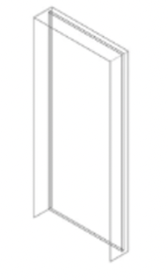
Model Information: height – 1981mm
width – 838mm
thickness – 45mm

Stage 3: Spatial
Description: The objective of Stage 3 is to coordinate the spatial arrangement of the design before shifting attention towards generating the specific information necessary for the production and construction of the structure. This level uses an approximate framework of the model, which is then used for the creation of building documents, rather than a solid model.
Visual: 
Model Information: A model that is dimensionally accurate, coordinated, and effectively conveys the response to the brief while also contributing to its aesthetic purpose.

Stage 4: Technical
Description: An accurately coordinated and dimensioned model that may be employed to validate adherence to regulatory standards. The integration of design models developed by specialised contractors serves as the initial point of reference. Data that is relevant for prefabrication, estimation, and reaching an agreement on a target price or guaranteed maximum price may be included in the model. Production-related particulars for the operation Assemblies, objects, and systems that exhibit precision concerning the placement of specifications, identification of crucial interfaces, methodology for determining energy consumption, and methodical design. While the information acquired at this stage is comparable to that of stage 3, its applicability to other building components is also established at this stage. This stage focuses on acquiring the necessary expertise in the installation of different construction components and their integration with other building systems.
Visual: 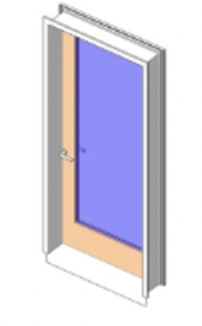
Model Information: This model will contain Architectural components and Structural details.

Stage 5: Manufacturing and Construction
Description: The model is manufactured and assembled during Stage 5. The level may also include non-visual components. It is feasible to analyse the different construction parameters without relying on non-modelled components. The data obtained at this stage of progress may be directly sent to the suppliers of construction components.
Visual: 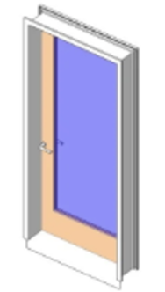
Model Information: At this level, clients have access to installation information, fixings, and interface details for usage.

Stage 6: Handover
Description: Upon reaching Stage 6, the structure will be entirely operational, and the project team's attention will be directed towards rectifying any defects and achieving the necessary tasks to fulfil the Building Contract. Project managers may utilise this model for operation, maintenance, and lifecycle management purposes during this stage. Further, it comprises equipment specifications, maintenance records, and geometric data, in addition to the general structure information.
Visual: 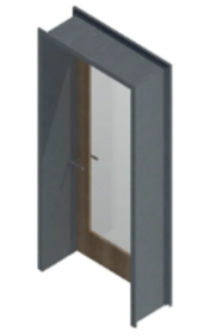
Model Information: A detailed inventory of the asset in its original state at the time of transfer, encompassing all pertinent data necessary for functioning and maintenance.

5.2 Appendix 2
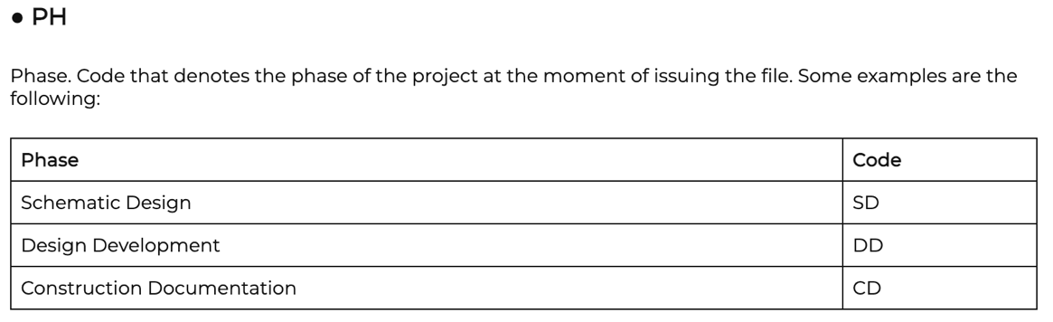
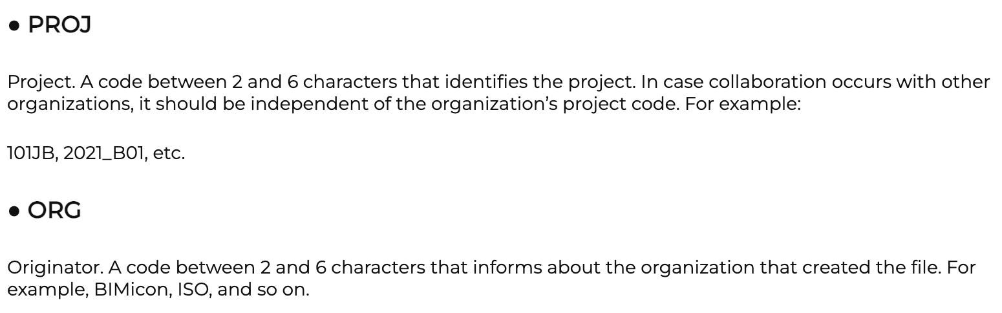
Code Naming conventions
Provided by (Anon, 2021)
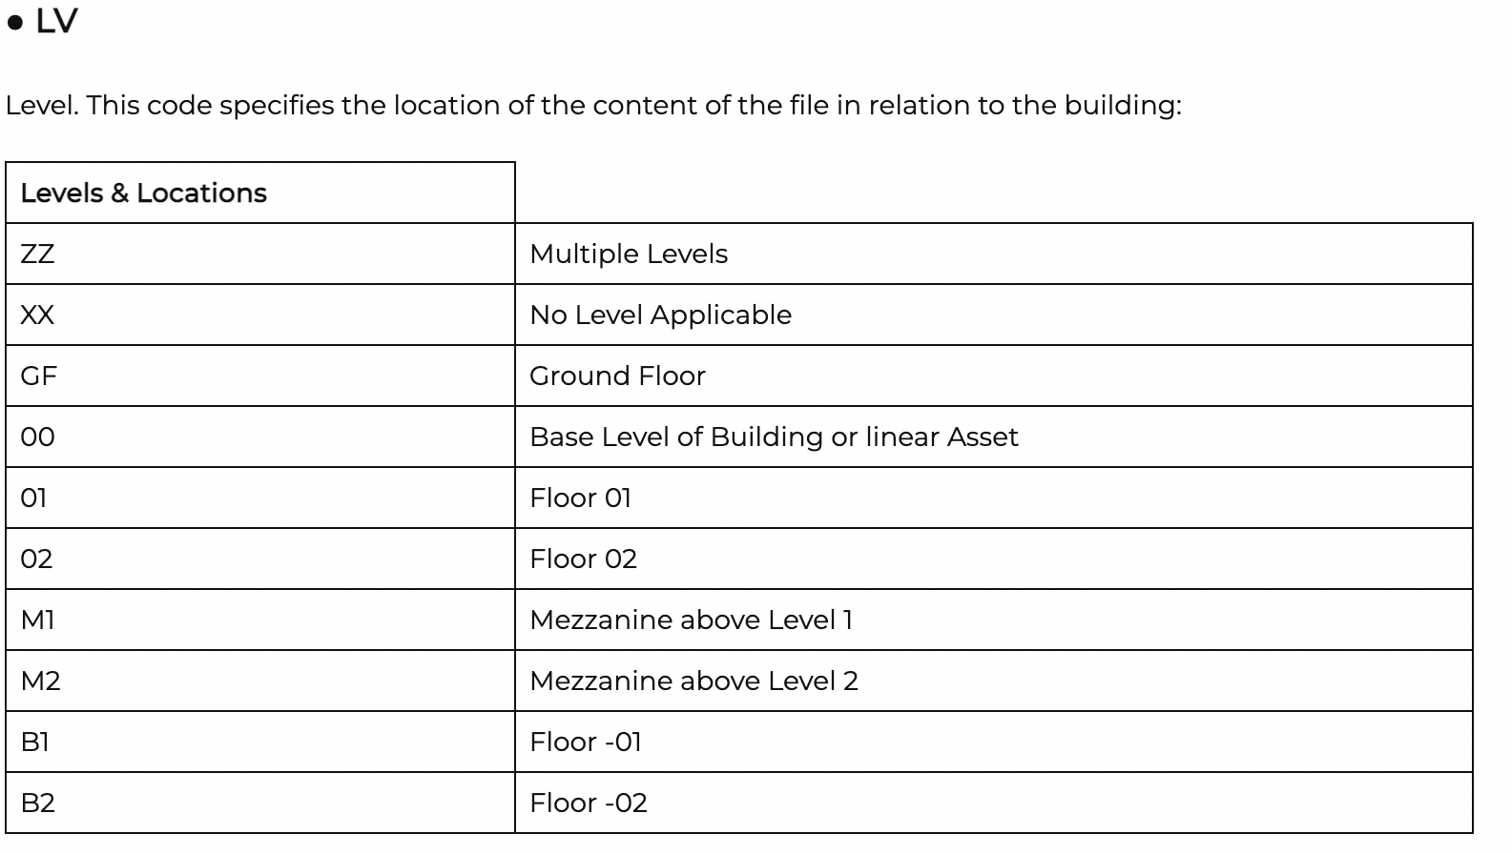
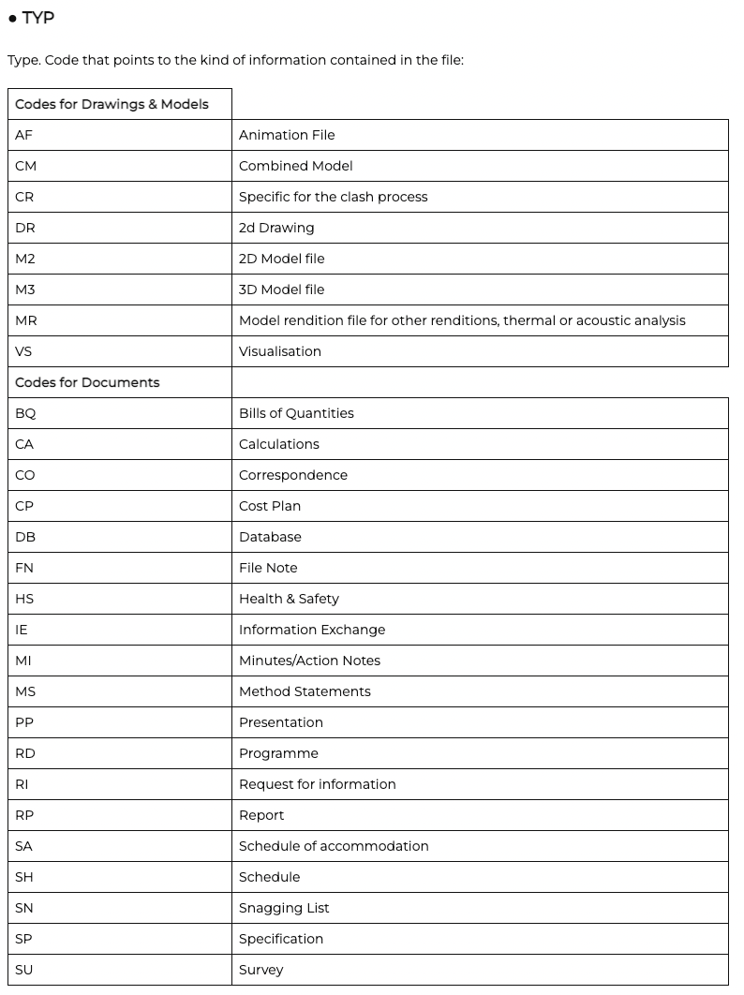
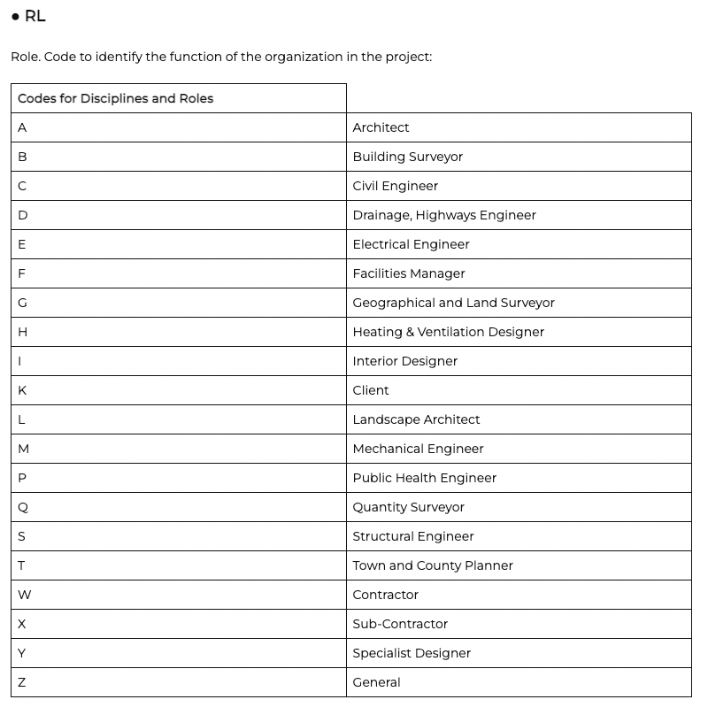
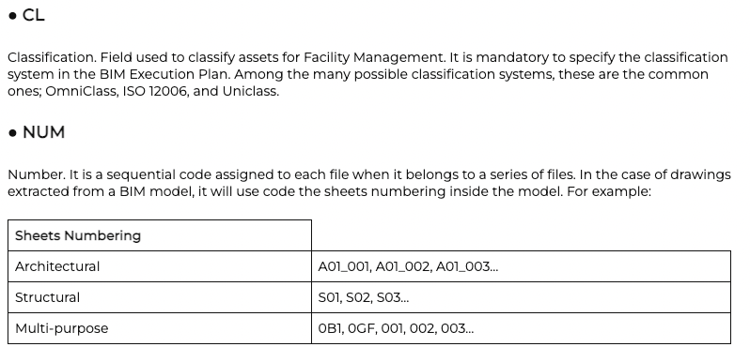
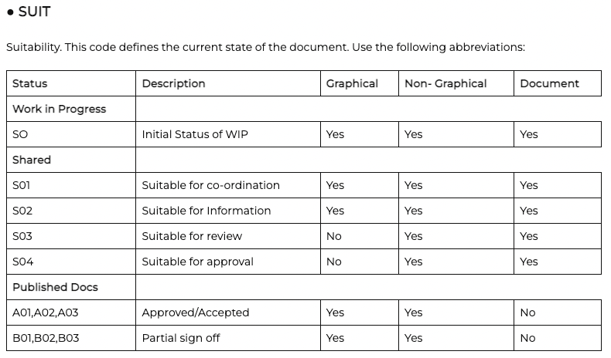
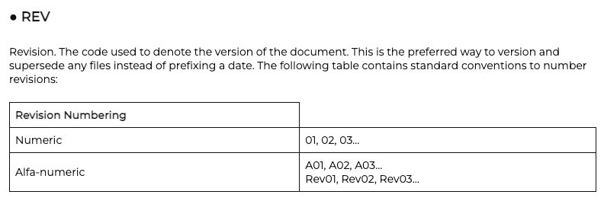

References
Anon, (2021). A Simple BIM Naming Convention Based on ISO 19650 Part 1 - BIMicon. [online] Available at: https://www.bimicon.com/bim-naming-convention-based-on-iso19650-part1/.
Anon, (2023). BIM Level of Development (LOD) 100, 200, 300, 350, 400, 500. [online] Available at: https://www.virtualbuildingstudio.com/bim-level-of-development-an-overview/.
BIM Protocol Schedule 30 of the Template MIM Education Project Agreement (WEP Strategic Partnering Delivery Model) Building Information Modelling Protocol CONTENTS. (n.d.).
Catenda. (n.d.). Employer’s Information Requirements (EIR). [online] Available at: https://catenda.com/glossary/bim-eir/#:~:text=EIR%20(Employer [Accessed 16 Jan. 2024].
RIBA Plan of Work 2020 Overview RIBA Plan of Work. (n.d.).
Sustainable Schools’ Challenge Challenging Innovation through Collaboration. (n.d.).
Uk, W. (2019). BIM Execution Plan (BEP) Digital Construction Competition.

Safiya Nanton (2114630) ACBA5010 Lecturer: Gavin Taylor

