

BA (Hons) Leadership and Management in The Workplace

Student Name: Okwala Ibengina
Student Number: 2409441
Course Name: Project Management LCLM5003
Lecturer Name: Dr Xavier Matieni
Session: February 2026 Term 2

Table of Contents
- Poster --------------------------------------------------------------------------------------3
- Reflective Essay ------------------------------------------------------------------------4-5
- Report: Project Management Plan: Reopening of the Highway after
the July 2025 West Midlands Floods ---------------------------------------------5
- Introduction ----------------------------------------------------------------------6
- Project Description ------------------------------------------------------------6
- Scope -------------------------------------------------------------------------------7
- Work Breakdown Structure (WBS) ---------------------------------------8
- Quad Chart -----------------------------------------------------------------------9
- Gantt Chart -----------------------------------------------------------------------9-11
- Stakeholder Involvement ----------------------------------------------------12
- Allocation of Resources -----------------------------------------------------13
- Risk Analysis --------------------------------------------------------------------14
- Conclusion -----------------------------------------------------------------------14
- References------------------------------------------------------------------------15

- POSTER
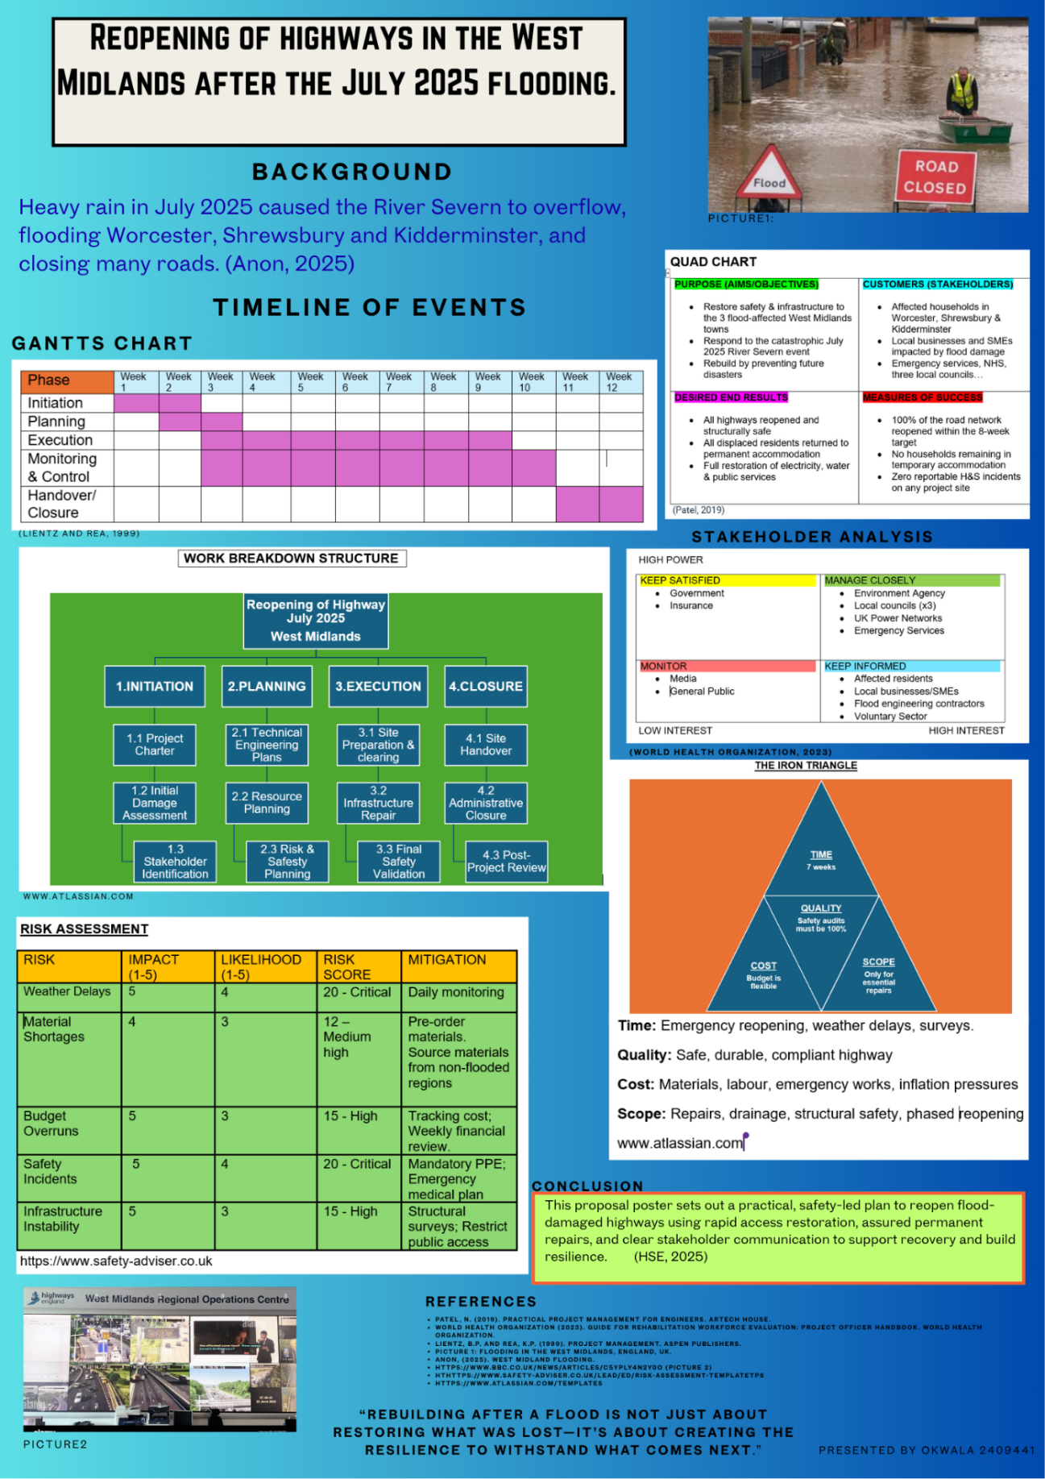

- Reflective Essay

Description

The poster presentation covered the impact of the July 2025 floodings in the West Midlands, the damage to the highway, and the project management approach used to reopen it. It included the project scope, the work breakdown structure, the quad chart, the Gantt chart, stakeholder analysis, and risk management. The aim was to show the planning for the highway's recovery and how different agencies worked together to restore transport links. The audience consisted of students, and the lecturer, and I had around 10 minutes to present the poster.
First, I started working on a Word document, and as I struggled, I decided to try Canva. I found a template that helped me to start. The Word document helped me design the project management, and I took screenshots using the Snipping Tool before uploading them to Canva.

Feelings

Before presenting, I felt a mixture of confidence and nervousness. The topic was familiar, as I had spent quite some time preparing it, but I still had some concerns about how to explain it clearly to other students. During the presentation, I felt more at ease as I was following the structure. After finishing, I felt relieved, not because I was not feeling well, but because I knew I communicated the main points to the audience and they understood.
Overall, my feelings are positive, as I have proven I can succeed and am ready for the next presentation.

Evaluation

To be honest, on evaluating my progress, I can say that the presentation went well. I like the way I defined and explained each project management tool, such as the quad chart, the Gantt chart, stakeholder analysis, and scope, to help the audience understand. I made a calculation mistake on the risk management grid, the lecturer told me, and I corrected it right away. The screenshots I took from the Word document and uploaded to Canva were very colourful, making the poster stand out.

Analysis

Looking back, all I can say is that preparation played a major role in the strength of a presentation. I needed a strong understanding of the flooding structure and the project management tools for the presentation. All the experience has strengthened my communication and presentation skills, as I have been able to translate information into clear messages that my audience can understand.

Conclusion

Overall, the presentation was successful, but there is room for improvement. The content was good; the poster was well organised, with not too much writing, simple and colourful, and easy to read and understand. The time and confidence were perfectly managed, but I still need to improve my confidence. I feel very proud of what I have achieved in my presentation skills.

Action plan

For future presentations, I should practice more to avoid reading my notes and just look at the visuals and talk. I should ask for more feedback from my peers and the lecturer so I can improve myself. By doing so, I would like to become a better public speaker and presenter with more confidence, engagement and presence.

- Report

- Introduction

In July 2025, the West Midlands experienced one of the most severe floods. Weeks of intense rainfall, driven by an unusual Atlantic weather system, caused the River Severn to exceed its capacity and breach flood defences across Worcester, Shrewsbury, Kidderminster, and surrounding towns. Streets were submerged within hours, electricity networks failed, and hundreds of homes and businesses were inundated. Local councils, emergency services, and community organisations were overwhelmed by the scale and speed of the disaster. Although the Environment Agency issued “severe Flood Warnings – Danger to Life”, many residents underestimated the
severity of the rising water.

The flooding caused extensive damage to the region’s transport infrastructure, particularly the highway network. Roads were submerged, embankments eroded, drainage systems blocked, and bridges compromised. The disruption significantly affected emergency response, supply chains, and community mobility. Reopening the highway network became a critical priority for regional recovery.

This project management plan outlines the structured approach needed to safely and efficiently restore and reopen the affected highways. It provides a comprehensive framework for planning, executing, monitoring, and closing the project, ensuring alignment with recognised project management methodologies.

Highways are essential for economic continuity, emergency response, and community resilience. Their rapid restoration is vital for enabling recovery efforts, supporting local businesses, and reconnecting isolated communities. The project management plan ensures that the reopening process is systematic, risk-aware, and aligned with stakeholder expectations. (Turner, 2018)

- Project Description

The July 2025 floods created a complex, multi-layered infrastructure emergency across the West Midlands. The scale of the rainfall, combined with the unusual Atlantic weather system, resulted in conditions that exceeded the capacity of many regional flood defences. As the River Severn overtopped its banks, the resulting inundation caused widespread structural, environmental and operational disruption. Highways, already vulnerable due to ageing infrastructure and increased climate-related pressures, were among the most severely affected assets.

The project aims to address these challenges through a structured, evidence-based, and collaborative approach. It recognises that post-disaster environments require rapid decision-making, flexible resource allocation, and strong inter-agency coordination. The project adopts a management approach that supports accountability and documentation, both of which are essential in dynamic disaster-recovery environments (Turner, 2020).
This approach allows for the management of scope, risk, and resources, and agile elements enable the project team to respond quickly to emerging issues, such as unexpected structural failures or weather-related delays.

The project’s objectives reflect the need for both immediate action and long-term resilience. While the primary focus is on reopening the highway network safely and efficiently, the project also seeks to integrate resilience measures that reduce future vulnerability. This includes improving drainage capacity, reinforcing embankments, and ensuring that repairs meet modern climate-adaptation standards. The project, therefore, contributes not only to short-term recovery but also to the region’s long-term infrastructure resilience strategy.

- Scope

The scope of this project is to restore and reopen the sections of the West Midlands highway network that were damaged during the July 2025 floods. The project includes all activities necessary to assess, repair, and certify the affected transport infrastructure to ensure it is safe, functional, and compliant with current UK highway standards.

Key in-scope activities include conducting structural and safety assessments of roads, bridges, pipes, and embankments; clearing and restoring drainage systems to reinstate hydraulic capacity; and removing flood-related debris and hazardous materials to enable safe access for repair teams. (Zhang et al., 2022)

The project also covers the repair and reinstatement of damaged road surfaces, embankments, bridges, pipes, signage, and lighting, followed by safety testing, load assessments, and formal certification prior to reopening. Stakeholder coordination with local authorities, emergency services, utility providers, and the public is included to ensure effective communication and operational alignment throughout the recovery. (Osei-Kyei et al., 2021)

Out-of-scope activities include long-term flood defence construction, repairs to private property, restoration of non-transport infrastructure, and environmental rehabilitation beyond the immediate highway corridor. The project will deliver structural assessment reports, restored drainage systems, repaired and certified highways, resilience recommendations, and final handover documentation. The defined scope ensures that the project remains focused, deliverable, and aligned with the urgent requirements of regional recovery. (Hossain and Ng, 2022)

- Work Breakdown Structure

The Work Breakdown Structure (WBS) decomposes the project into manageable components, ensuring clarity of responsibilities and deliverables.

Figure 1 (Canva template, 2026)

- Quad Chart

Objectives  - Conduct rapid structural and safety assessments of flood-damaged roads, bridges, pipes, and embankments.  - Restore drainage systems to full hydraulic capacity to prevent further surface flooding.  - Remove debris and hazards to enable safe access for repair teams and road users.  - Repair and reinstate damaged road surfaces, embankments, signage, and lighting.  - Achieve staged reopening of priority routes within the planned 12-week programme.  - Ensure all reopened routes meet UK highway safety and certification standards.  - Integrate resilience measures to reduce vulnerability to future flooding events. | Stakeholders  - Local councils  - Environment Agency  - Emergency services (police, fire, ambulance)  - Contractors  - Utility companies (water, electricity, telecoms)  - Residents  - Contractors and engineering firms  - West Midlands Combined Authority  - Local communities, businesses, and road users  - Transport for West Midlands (TfWM)
Desired end results  - Fully restored and certified highways that are safe for public use.  - Reinstated drainage systems capable of managing heavy rainfall and runoff.  - Improved resilience of transport corridors against future flood events  - Reduced disruption to emergency services, supply chains, and daily travel.  - Clear documentation, including assessment reports, repair records, and handover files.  - Strengthened stakeholder coordination and communication processes for future incidents. | Risks & Mitigations  - Risk: Recurring severe weather delaying works.  Mitigation: Contingency scheduling, flexible work sequencing, and real-time coordination with the Environment Agency.  - Risk: Structural instability in bridges, pipes, or embankments.  Mitigation: Specialist inspections, geotechnical monitoring, and staged load testing.  - Risk: Supply chain delays for materials and equipment.  Mitigation: Multi-supplier procurement strategy and early ordering of critical materials.  - Risk: Contractor or labour shortages.  Mitigation: Framework agreements with multiple contractors and redeployment of regional crews.  - Risk: Public safety incidents near work zones.  Mitigation: Enhanced traffic management, clear signage, and strict site safety protocols.
(Transport for West Midlands, 2025)

- Gantt chart (12-week schedule)

The reopening of the highway following the July 2025 floods is structured into five major phases aligned with recognised project management methodologies. The following 12-week schedule outlines the sequencing of activities within each phase, demonstrating clear dependencies, logical progression, and alignment with the

Phase | Wk  1 | Wk  2 | Wk  3 | Wk  4 | Wk  5 | Wk  6 | Wk  7 | Wk  8 | Wk 9 | Wk 10 | Wk 11 | Wk 12
Initiation
Planning
Execution
Monitoring & Control
Handover Closure
Figure 2 (leandatapoint.com,2026)

Phase 1: Initiation (Weeks 1-2)

- Appointment of Project Manager and project team
- Establishment of governance structure, reporting lines
- Initial stakeholder briefing with local councils, the Environmental Agency, emergency services, and contractors.
- Development of the project and confirmation of project objectives
- Mobilisation of site teams, equipment, and temporary welfare facilities
- Development of Health & Safety Plan and Environmental Management Plan
- Full structural inspections of highways, bridges, and embankments
- Surveys to identify erosion, voids, and subsurface instability
- Drainage system evaluations to determine blockages and capacity
- Safety audits to identify immediate hazards
- Prioritisation of routes based on emergency access needs

Phase 2: Planning (Week 3-4)

- Compilation of structural assessment reports
- Categorisation of roads into priority tiers (critical, high, medium, low)
- Agreement of repair strategy with stakeholders
- Procurement of specialist contactors and materials
- Establishment of temporary traffic management systems

Phase 3: Execution (Week 5-9)

- Removal of debris (trees, vehicles, damaged infrastructure)
- Clearance of blocked drainage
- Pumping of residual standing water from low-lying areas
- Hazardous material identification and safe disposal
- Installation of temporary barriers and signage
- Deep cleaning of drainage systems to restore hydraulic function
- Patching of potholes and cracks caused by water damage
- Resurfacing of severely degraded road sections
- Repair of damaged kerbs and verges
- Installation of erosion-resistant materials to improve resilience
- Replacement of damaged lighting columns and electrical systems
- Repair of traffic signals and control systems
- Reinstatement of road markings and signage

Phase 4: Monitoring & Control (Week 5-10)

- Load testing of bridges
- Safety inspections of repaired road sections
- Environmental compliance checks
- Certification of completed works by qualified engineers
- Reopening of critical corridors for emergency services and essential transport
- Monitoring of traffic flow and structural performance
- Completion of remaining minor repairs
- Removal of temporary traffic management systems
- Final inspections of secondary roads
- Coordination with utility companies to ensure no outstanding conflicts

Phase 5: Handover/ Closure (Week 11-12)

- Compilation of final project report, including cost summary and lessons learned
- Handover of documentation to local councils and transport authorities
- Final stakeholder review meeting
- Demobilisation of site teams and equipment
- Post-project evaluation and resilience recommendations

- Stakeholder Involvement

Effective stakeholder involvement is essential for the successful delivery of the highway reopening project. Flood recovery projects involve a diverse range of stakeholders, each with distinct interests, responsibilities, and expectations. Managing these relationships requires a structured and transparent engagement strategy that promotes collaboration, reduces conflict, and ensures that decisions are informed by accurate, timely information. (Hossain and Ng, 2022)

Stakeholders include public authorities, emergency responders, technical specialists, private contractors, utility providers, local businesses, and residents. Local councils, such as those in Worcester, Shrewsbury, and Kidderminster, play a central role in coordinating recovery efforts, approving funding allocations, and communicating with the public. Their involvement ensures that the project aligns with local priorities and regulatory requirements. The Environment Agency provides essential data, flood risk assessments, and environmental guidance. Their expertise is critical for ensuring that repair works do not inadvertently increase future flood risk or violate environmental regulations. (Bourne,2015)

Emergency services, including fire, police, and ambulance teams, require early access to priority routes. Their operational needs influence the sequencing of repairs and the identification of critical corridors.
Highway contractors and engineering firms are responsible for delivering the technical aspects of the project, including inspections, repairs, and safety testing. Their expertise ensures that the restored infrastructure meets required standards and is safe for public use.

Utility companies represent another key stakeholder group. Flooding often damages underground and overhead infrastructure, such as water mains, gas pipelines, and electrical systems. Coordination with these providers is essential to avoid accidental damage during excavation and repair works. Residents and businesses, although not directly involved in technical decision-making, are significantly affected by road closures and disruptions. Their feedback helps identify access needs, safety concerns, and community priorities.

The stakeholder engagement strategy includes daily briefings during the initial assessment phase, weekly progress meetings, and regular public updates through council websites, social media, and local radio. This multi-channel communication approach helps ensure and manage expectations. Collaborative decision-making is encouraged through joint planning sessions, particularly when prioritising routes for reopening. This approach aligns with best practice guidance, which emphasises the importance of stakeholder collaboration in post-disaster infrastructure recovery (Bourne, 2015)

- Allocation Resources

Resource allocation is a critical component of the project, as the effectiveness of the recovery effort depends on the availability and efficient use of human, material, financial, and temporal resources. The project requires a multidisciplinary team with expertise in structural engineering, drainage systems, environmental management, health and safety, and project coordination. Structural engineers are responsible for assessing the integrity of bridges and road surfaces, identifying areas requiring immediate intervention. Drainage specialists evaluate and restore water management systems, ensuring that the repaired infrastructure can withstand future rainfall events.

Road maintenance crews carry out the physical repairs, including resurfacing, embankment stabilisation, and debris removal. Health and safety officers ensure that all activities comply with regulatory requirements and that risks to workers and the public are minimised. Environmental consultants provide guidance on ecological impacts, waste disposal, and compliance with environmental legislation. Communications officers manage stakeholder engagement and public information dissemination.

Material resources include heavy machinery such as loaders, pumps, and resurfacing equipment. These assets must be deployed strategically to ensure that priority routes are addressed first. Consumable materials and safety barriers must be procured in sufficient quantities and delivered on schedule. Supply chain disruptions are common in post-disaster environments, making early procurement and supplier diversification essential.

Financial resources are allocated across labour, equipment hire, materials, traffic management, environmental compliance, and contingency funds. The contingency budget (typically 10-15%) accounts for unforeseen issues such as additional structural failures or adverse weather conditions. Time is also a critical resource. The project’s 12-week timeline requires careful scheduling to ensure that tasks are sequenced efficiently and that dependencies are managed effectively. The use of a Gantt chart supports this process by providing a visual representation of task durations, overlaps, and critical paths.
(Rahman and Karim, 2023; Li and Chen, 2024).

- Risk Analysis

Risk analysis is a central component of the project management process, particularly in post-disaster environments where uncertainty is high and conditions can change rapidly. The project adopts a structured risk management framework which includes risk identification, qualitative assessment, prioritisation, mitigation planning, and continuous monitoring.

Flood recovery projects face a range of risks, including environmental, technical, financial, and operational challenges. Continued rainfall poses a significant threat, as it can delay work, cause additional damage, and compromise worker safety. Structural failures represent another high-impact risk, particularly for bridges and embankments that may have been weakened by floodwater. These risks require specialist inspections and, where necessary, temporary closures or load restrictions.

Financial risks include delays in funding approval or cost overruns due to unforeseen repairs. Contractor shortages may arise due to high regional demand for skilled labour following the floods. Public safety risks must also be considered, as unauthorised access to work zones or unstable infrastructure can lead to accidents. Environmental risks include contamination from floodwater, improper disposal of debris, or damage to sensitive habitats.

The risk register provides a structured overview of these risks, their likelihood, impact, and mitigation strategies. Mitigation measures include contingency scheduling, early procurement, multi-supplier contracting, strict health and safety protocols, and environmental monitoring. Risk monitoring is conducted through weekly review meetings, site inspections, and real-time reporting from field teams. This proactive approach ensures that emerging risks are identified early and addressed promptly, reducing the likelihood of project delays or safety incidents.

10. Conclusion

The July 2025 floods created a complex and urgent infrastructure challenge across the West Midlands. The reopening of the highway network is essential for restoring mobility, supporting emergency services, and enabling economic recovery. This project management plan provides a structured, evidence-based approach to delivering the project efficiently and safely. The plan ensures that the project remains adaptable while maintaining strong control mechanisms. The detailed scope, Gantt chart, quad chart, WBS, stakeholder strategy, resource allocation, and risk analysis collectively form a robust framework for successful delivery.

10. References

Bourne, L. (2015). Stakeholder Relationship Management. Gower.
Hossain, M. and Ng, S. (2022) ‘Post-flood infrastructure recovery: prioritisation and scope definition in transport projects’, International Journal of Disaster Resilience in the Built Environment, 13(4), pp. 512–528.
Li, Y. and Chen, X. (2024) ‘Transport network restoration strategies following extreme weather events’, Journal of Infrastructure Systems, 30(1), pp. 1–12.
Osei-Kyei, R., Chan, A.P.C. and Ameyaw, E. (2021) ‘Quality assurance frameworks for post-disaster reconstruction projects’, International Journal of Project Management, 39(6), pp. 673–685.
Rahman, M. and Karim, R. (2023) ‘Hydraulic capacity restoration in flood-damaged drainage systems: a resilience-based approach’, Water Science and Engineering, 16(2), pp. 145–158.
Turner, J.R. (2018). Handbook of Project-Based Management. McGraw-Hill.
Zhang, L., Wu, H. and Li, J. (2022) ‘Rapid structural assessment methods for flood-affected transport infrastructure’, Engineering Structures, 266, pp. 1–14.
Transport for West Midlands (2025) Highway Maintenance Funding: Network North.
https://www.canva.com/graphs/work-breakdown-structure (Figure 1)

Gantt Chart: What Is a Gantt Chart? Gantt Charts Explained

What is a Quad Chart: Definition, Templates & Use Cases (Figure 2)

