Tai Tarian (Office Building Project)
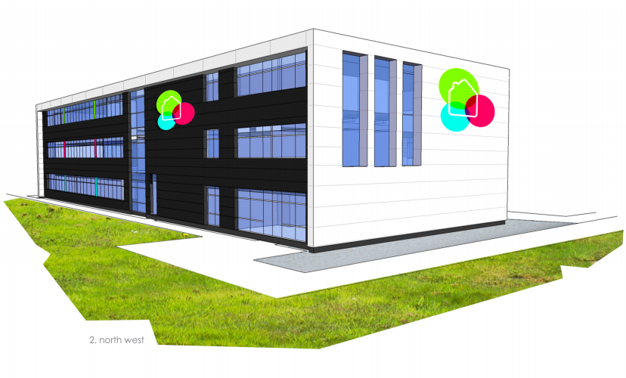

Project Name: Tai Tarian

Site Address: Baglan Energy Park, Briton Ferry, Neath, SA11 2HZ
Prepared By: SPG Constructions
Date Prepared: April 2021
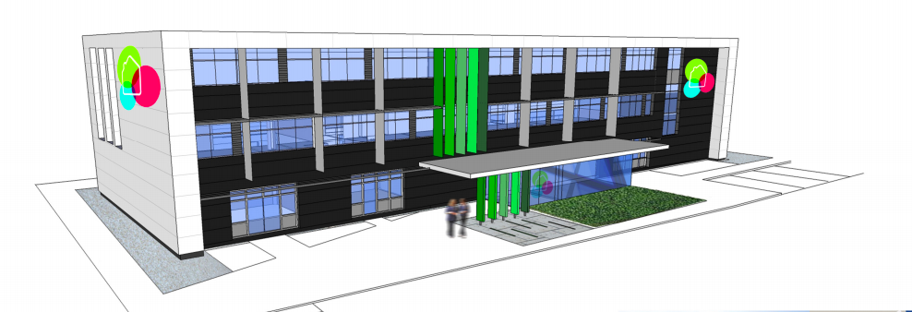

Appendix

Work Breakdown Structure (page 3)

Method Statements (page 4 - 22)

- Continuous flight Auger Piling (page 5-9)

- Steel Structure (page 10-17)

- Aluminium cladding (page 18-22)

Site Specific Report (page 23-32)

- Workforce Capacity (page 23-24)
- Cost (page 25-
Individual cost of tasks (page 25-26)
Total Price of job (page 27)
Resource cost overview (page 28- 29)
- Time (page 30-31
- Summary of the project (page 32)

Specification / Materials key
- Polyurethane coating or single ply membrane
- Kingspan Composite panel system (Pearl white / Jet black)
- Aluminium Window System
- Horizontal / Vertical Aluminium Sunshade system (Dark Grey)
- Vertical Fin System
- Aluminium frame glazing system – Entrance lobby
- Black masonry plinth brick work
- Windows Louvered Actuators
- Window Glazing system (panels dark grey)
- Intake & Exhaust Louvre system
- Aluminium square exposed RWP system
- Cedar Cladding System
M&E Commissioning
Work Breakdown Structure
Completion / Handover
Client needs have been met. Ensure operators understand systems installed. Reviews & check-ups of the project.
1.Inception & Briefing
2.Design Development & review
3.Pre- Handover
4.Initial aftercare
5.(POE) Extended aftercare & post- occupancy evaluation
Client Inspection/ Familiarisation / inductions
Building control final inspections
Air / Acoustic testing
Issue O&M manuals/ handover documentation
Snagging
Remove existing waste, vegetation
Necessary. To remove this layer of soil, as it is unsuitable to build on.

Remove top soil & clear site
Materials to begin project… cement
Reinforcement steel
MEP
Partitions
Lift Shaft
Joinery
Tape & Joint
Decorate
Ceilings
Floor Finishes

Information on previous use of site... previous services & foundation, soil characteristics.
Planning & Management of the project.

Pre- construction Information (CDM 2015 REG)
New office building in Baglan Energy Park
- Offices
- Entrance lobby
- WC/ ACC WC
- Lift
- Combined Enclosure
- Flat Roof
- Roof Access
- PV Panels
Client Brief
Material delivery
Pre- contract meeting
Place sub-contracts
Site accommodation
Mobilisation
Drainage / Service Ducts
Garden, Tree’s
Grass
Plants
Soft Landscape
Public Pathway
Plant Room
Cycle Store
Combined enclosure
Construct footpaths
Construct external ramps & steps
Tarmac
Road car parking markings
Complete access road
Road
Gas main
BT from boundary
Ground sprinkler main
Electrical supply
DCWW provided meter
Brickwork
Cladding
RWP System
Windows / Curtain Walling
Entrance lobby
Sunshade system
NPT Homes logo
CFA Piles
Reinforce concrete
Pile caps
Internal Fitout
Building envelope
Single ply covering
Roof access hatch
Fall arrest system
PV panels
Flat Roof
Steel Frame
Formwork, reinforce concrete slab
Metal decking
Superstructure
Substructure
External works
Build
Closing Out
Design
Site Set Up
Tai Tarian

Method Statement for Tai Tarian
by S Pryce-Griffiths

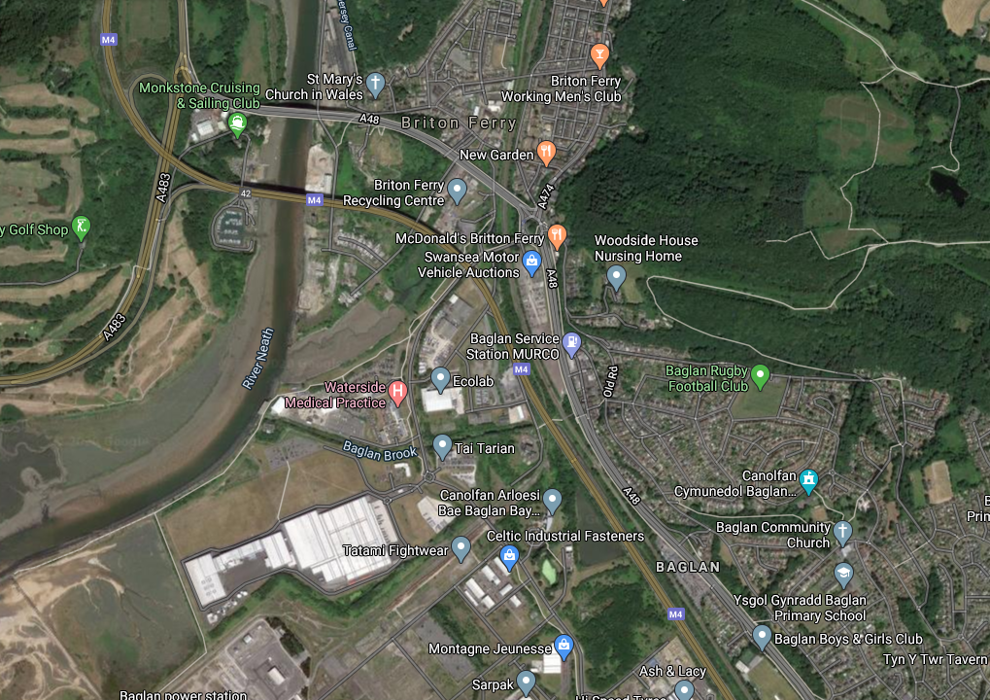

Project Name: Tai Tarian

Site Address: Baglan Energy Park, Briton Ferry, Neath, SA11 2HZ
Prepared By: SPG Constructions
Date Prepared: April 2021

Method Statement for Tai Tarian New Office Building
by S Pryce-Griffiths

1,Description of the Task/Activity: |  | Construction Continuous Flight Auger Piling (By Ikete Piling)
2,Project Name: |  | Tai Tarian New Office Building |  |  |  |  | Project Ref: |  |  |  | Tai Tarian 01
3,Site Address/ Location: |  | Baglan Energy Park, Briton Ferry, Neath, SA11 2HZ |  |  |  |  | Start Date/Time: |  |  |  | 26th May 2021
 |  |  |  |  |  |  | Finish Date/Time: |  |  |  | 5 weeks
4,Personnel involved: |  | Name |  |  |  |  | Role/Trade
 |  | Nigel Watts |  |  |  |  | CSCS/ Piling Rig Operator
 |  | Terry Thomas |  |  |  |  | CSCS/ Concrete Pump Operator
 |  | Steve Little |  |  |  |  | CSCS/ Banksman
 |  | David Ikete |  |  |  |  | CSCS / Triple STS supervisor
5,Works Supervisor: |  | TBC |  |  | Role: |  | Contracts Manager |  |  | Tel: |  | TBA
6,Key Plant and Tools Required: |  | CFA Hydraulic Piling Rig Concrete Holding drum  / agitator Trailer mounted concrete pump Compressor.  Fuel bowser  Foreman’s van  Appropriate Certificates of Test and Inspection to be held on site for all relevant plant, equipment and lifting appliances.
7,Key Materials Required: |  | Readymix Concretre (UKAS certified)  Reinforcement Steel (CARES certified)
8,Other Essential Equipment: |  | (ie: access platforms/winches/ladders etc)
9,Special Considerations |  | - Manual Handling of Worktops (refer to Manual Handling assessment)  - All incidents/ accident to be reported to the Site Agent immediately.  - Main Contractors site rules to be adhered to at all times.  - Deliveries to be conducted to site entrance and directed to offloading area by representative. All Deliveries to be pre booked in with site with Construction managers  - All tools and equipment to be logged into register before works commence on site  - SMSTS/SSSTS supervisor will be on site at all times and also to attend daily briefing, Construction company to advise times for this meeting.  - All risks to incorporate our trades and others.  - Site SSSTS/SMSTS to communicate with fitters on assessments and Method statement  - Assessments to be reviewed by site fitters, supervisor to approve or change if needed.
10,Specific Staff Training Requirements: |  | (ie: Confined Spaces/Abrasive Wheels/Working at Height/Plant Operators etc)  PILING RIG OPERATOR  SLINGER/SIGNALLER  CONCRETE PUMP OPERATOR  - Once on-site operatives will receive site specific CDM Induction illustrating CDM & Working areas, Hazards, Key Personnel, welfare facilities, etc.  - When required specific perimetry will be used these will be issued by SPG Constructions Central Site Management, no work will take place until the relevant permits are in place, if in doubt ASK  - All operatives will work under the direction of their own site supervisor, all operatives and supervision will take direction from SPG Constructions Central Site Supervision on Safety matters.  - All operatives will, prior to commencing any works on site have read and have fully understood this Method Statement, all operatives will sign a declaration sheet confirming they have read and fully understood the method statement.  - All operatives will be fully qualified and competent, copies of all certification, documentation will be provided, and all operatives will present their CSCS CARDS and any relevant CPCS or IPAF certification before beginning work on site. Copy of certificates etc. available upon request for all operators Copies of specific certificates e.g. Working at Height, Manual Handling etc. also available.  - Telehandler driver will be CPCS trained.  - All operatives will be as a minimum requirement prior to being allowed on site have taken and passed their CSCS card, not withstanding, all operative are trained to recognised CITB standards.
11,Sequence of Operations:  (Specifying methods of working, tools, materials and equipment utilised) |  | Set Up and Boring  - Foreman checks drawings and design before inputting the pile data into the pile monitoring computer.  - Auger will be set up over pile pin position by rig operator, guided by a banksman, who checks the front and side of the rig.  - Reference pins are set up in two directions at right angles using spacing bar to assist in maintaining position.  - Concrete discharge flap at auger tip closed by following methods:  Using short length of tying wire or similar material. Banksman stands clear and signals rig driver to lower the tip of the auger to ground level, then proceeds to signal the rig driver to proceed with drilling.  Held closed using a rod longer than 1m in length by banksman. Banksman must remain within clear view of the dig driver. Signals the rig driver to lower auger until flap is held closed by the ground.  Sacrificial bung is used to close the tip of the auger.  - Augering will commence to required depth if the foreman is satisfised all is in order.  - Gates to the rig are kept in the closed position during boring until the auger advances into the natural ground or a minimum of 3.0m depth. Offset markers are used to check pile position before gates are opened.  - A Ikete Pilling banksman is to be on duty in front of the rig at all times to ensure that all is in order and other personnel are kept clear of the moving auger.  - After target depth is achieved, the auger is rotated to allow spoil to rise and the auger is lifted a maximum of 150mm to allow concrete to exit.  - Rig instrumentation used during pile construction to monitor constant rate of the auger lift.  - Concrete pressure flow rate and overbreak percentage is monitored throughout the construction.  - Operators manoeuvres the mechanical auger cleaner to clear away spoil held on the auger.  - Unauthorised personnel will be kept clear of work area by the pilling team.  - In some instances, the pilling gang may be required to manually clear the auger flight of all spoil to prevent this going above head height.  - This will be controlled under the foreman/banksman who ensure that the auger is not rotated when it is being lifted.
12,Method of Access and Egress to the work area: |  | Vehicle will be unloaded to safe storage area so that the vehicle can be released from site to save congestion
13,Required Personnel Protective Equip.: |  | Safety Ankle Boots BS EN345 | Hard Hats BS EN 397 | Safety Gloves BS EN 388;1994 |  | Ear Plugs BS EN 352-2;2002 |  |  | Dust Mask  Task specific AS Above  FFP3 | Light Eye Protection  Task Specific BS EN 166 |  |  | Other:  1. Hi-Viz Top  2.Overalls  3.
 |  | Yes | Yes | Yes |  | Yes |  |  | NO | Yes |  |  | Other:  1. Hi-Viz Top  2.Overalls  3.
14, Hazardous Substances  Applicable:
  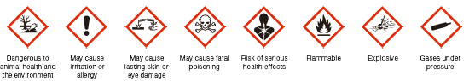
  NO YES. NO NO NO YES. NO.
15,Security and Emergency Procedures: |  | Small plant must be taken off site at the end of the working day.  Emergency procedures - As main contractor’s induction.
 | 16,First Aid Facilities: | Name of On-Site First Aider: |  |  |  |  |  | SPG Constructions- Steffan Pryce-Griffiths
 | 16,First Aid Facilities: | First Aid Box Location: |  |  |  |  |  | SITE VAN/Site Cabins with SPG Constructions
 | 16,First Aid Facilities: | Location of Nearest Hospital: |  |  |  |  |  | Neath Port Talbot Hospital, Baglan Way, Port Talbot SA12 7BX
17. Other information |  | Site hours Monday to Friday 8:00am ~ 6pm (No noise before 8am or after 6:30). All vehicle movements to be as directed by SPG Constructions Central site management. Any posted speed limits or restricted access areas to be adhered to. Access to the construction site area will be under the control of SPG Constructions Central personnel, all deliveries need to be scheduled and signed in.  A competent operative will supervise vehicle and plant movements on site, to and from their places of work and allotted lay down areas for storage of materials.  All plant and tools to be recorded in the SPG Constructions site register on arrival, and also weekly inspections.  Welfare Facilities:  SPG Constructions to provide adequate welfare facilities: - suitable and sufficient sanitary conveniences and washing facilities should be provided at readily accessible places. They and the rooms containing them should be kept clean and be adequately ventilated and lit. Washing facilities should have running hot and cold or warm water, soap and clean towels or other means of cleaning or drying.  Pedestrian Access:  Pedestrians must wear the correct High Visibility clothing and keep to any identified pedestrian walking routes as identified in their induction or as directed SPG Construction.  Lighting:  Lighting of access and egress routes to the work area will be by natural light during daylight working  Work Boundaries:  All work will take place within the site CDM area.  The boundaries will be set out in accordance with the agreed work location and site control procedures.  The boundaries of the CDM and associated work area are to be strictly adhered to at all times.

All work will be undertaken by qualified competent persons with experience of the type of work described above, and in all cases in full accordance with safety procedures specified in the company’s Health and Safety Policy.

Prepared by: Steffan Pryce-Griffiths Mobile tel: 07944592636

Position: Construction Manager Date: 22-04-2021

Method Statement for Tai Tarian New Office Building

by S Pryce-Griffiths

1,Description of the Task/Activity: |  | Installation of steel structure for Tai Tarian office building (CF Fabrications)
2,Project Name: |  | Tai Tarian New Office Building |  |  |  |  | Project Ref: |  |  |  | Tai Tarian 01
3,Site Address/ Location: |  | Baglan Energy Park, Briton Ferry, Neath, SA11 2HZ |  |  |  |  | Start Date/Time: |  |  |  | 28th June 2021
 |  |  |  |  |  |  | Finish Date/Time: |  |  |  | 24th September 2020
4,Personnel involved: |  | Name |  |  |  |  | Role/Trade
 |  | Rhys Thomas |  |  |  |  | CSCS/ structural steelwork erector
 |  | Alex Williams |  |  |  |  | CSCS/ structural steelwork erector
 |  | Talfan Allcock |  |  |  |  | CSCS/ structural steelwork erector
 |  | Colin Fuentes |  |  |  |  | CSCS / Triple STS supervisor
5,Works Supervisor: |  | TBC |  |  | Role: |  | Contracts Manager |  |  | Tel: |  | TBA
6. Sequence of work |  | - Operatives to be booked in prior to the works taking place  - Delivery arrives at the main entrance via HIAB lorry  - Materials to be offloaded using the HIAB and lifted using the site crane if feasible on to the slab  - Alternatively, the steel will be boomed up using a sufficient HIAB  - A cordoned area will be set up around the slab whilst erection is taking place  - The works will be carried out in normal working hours
7. Description of Method statement |  | - Operatives will attend a site briefing with the CF fabrications Manager to receive the SPG Constructions induction, a Method Statement briefing and a daily safe start to highlight the risks surrounding the work areas.  - The delivery will arrive at the main entrance and will be off loaded and materials and tools will be taken to the work area.  - The operatives will cordon off the immediate work area when lifting is taking place and a CF Fabrications operative will patrol this exclusion zone.  - Lifting will take place using a mobile spider crane, which will be lifted in to position using the SPG Constructions site crane. This will be used to erect the remainder of the steelwork.  - The positions and loads applied by the outriggers of the crane will be marked up on a drawing and then transferred to site using a spray mark. This will then denote the position of the back propping by others. In order to establish the capacity of the slab will require information from SPG Constructions  - Roof steels will be delivered to site and craned up on to slab. These sections will then be manoeuvred on the slab to the appropriate lifting site for the erection. Once positioned the crane will be tracked into position and the steel will be slung by the banks man ready for lifting.
8,Key Plant and Tools Required: |  | - Welders  - MEWP x2  - UNIC spider crane  - Tools  - Leads  Appropriate Certificates of Test and Inspection to be held on site for all relevant plant, equipment and lifting appliances.
9,Key Materials Required: |  | - Structural steel beams and columns  - Rib deck sections
10,Special Considerations |  | Manual Handling of Worktops (refer to Manual Handling assessment)  All incidents/ accident to be reported to the Site Agent immediately.  Main Contractors site rules to be adhered to at all times.  Deliveries to be conducted to site entrance and directed to offloading area by representative. All Deliveries to be pre booked in with site with Construction managers  All tools and equipment to be logged into register before works commence on site  SMSTS/SSSTS supervisor will be on site at all times and also to attend daily briefing, Construction company to advise times for this meeting.  All risks to incorporate our trades and others .  Site SSSTS/SMSTS to communicate with fitters on assessments and Method statement  Assesments to be reviewed by site fitters , supervisor to approve or change if needed .
11,Specific Staff Training Requirements: |  | - Once on-site operatives will receive site specific CDM Induction illustrating CDM & Working areas, Hazards, Key Personnel, welfare facilities, etc.  - When required specific perimetry will be used these will be issued by SPG Constructions Central Site Management, no work will take place until the relevant permits are in place, if in doubt ASK  - All operatives will work under the direction of their own site supervisor, all operatives and supervision will take direction from SPG Constructions Central Site Supervision on Safety matters.  - All operatives will, prior to commencing any works on site have read and have fully understood this Method Statement, all operatives will sign a declaration sheet confirming they have read and fully understood the method statement.  - All operatives will be fully qualified and competent, copies of all certification, documentation will be provided, and all operatives will present their CSCS CARDS and any relevant CPCS or IPAF certification before beginning work on site. Copy of certificates etc. available upon request for all operators Copies of specific certificates e.g. Working at Height, Manual Handling etc. also available.  - Telehandler driver will be CPCS trained.  - All operatives will be as a minimum requirement prior to being allowed on site have taken and passed their CSCS card, not withstanding, all operative are trained to recognised CITB standards.
12.Preparation for the job |  | Steelframe Superstructure  Job Site Planning & Preparation  - Space and a firmed pathway for truck delivery/ crane truck erection operation. Capacity suitable for truck & crane must be clarified.  - Unloading of materials and storage should be in a suitable and dry location on site. Material stored in designated areas providing installing quicker and safer in clearly identified location.  Receiving Of material at Site  - All delivery materials to the site shall be informed to the site manager to have the plan for unloading. Upon arrival of materials at the storage yard, the materials controller will match delivery notes and shall verify the consignment.  - Unloading can be done manually by term with using 25-tonnes cranes. A spreader should be used for long steel components. Lifting nylon or cloth belts with suitable SWL shall be used for unloading the materials to minimize the damage. Be sure to hook belts to component with the right number of points and position so that the load of the component itself do not damaged or broken especially the coating/discolour.  - All materials receipt at the site shall be visually inspected by site supervisor/engineer for any damage after unloading. Any damage shall be taken immediately, if possible, to avoid any delay of erection.  Sequence of Erection  The structural portal frames and other parts that related of the building structural can be erected in various ways which will depend on the following key factor:  - The availability of equipment  - The site conditions  - The experience level of the erectors  - The individual job conditions.
13,Sequence of Operations:  (Specifying methods of working, tools, materials and equipment utilised) |  | METHOD  Transportation of fabricated portal frame.  - I-beam columns, rafter and truss are transported to the site by the mean of lorry, The steel materials should be arranged properly on the lorry.  Unloading, arrangement, storage and protect materials  - Cranes will be used to unload fabricated portal frames.  - Access road need to be prepared properly before any trucks or cranes are used by term safety load.  5.2.2 Arrangement  - Materials shall be stacked in location according to the building/areas, near to the lifting position to be erected to minimise unexpected damages of paint or discolour and shapes.  5.2.3 Storage and Protect Material  - Dry area and stored above ground level with timber packing and ventilated.  - Steel component or materials shall be stored separately for difference sizes and types.  - The materials should be placed in minimum 5% slope to avoid water pond.  - The materials shall be kept free from the dirt, dust, grease and other foreign materials.  Installation of Steel Column  - Repeat procedures of erection columns and portal frames to complete.  Preparation  - Columns distributed along in designated positions, materials need to be cleaned and assembled ready before erection.  - Checks will be made on level and positions of nuts and anchor, lifting weight and position of crane.  - The crane is set up in a suitable position to lift columns into position. All slings are inspected by riggers before major lifts.  - Lifting area will be barricaded to prevent anu unauthorised personnel/work into the area.  - The nuts will be tightened upon installation of column base plate into anchor bolts in right position.  Erection of Portal Frame  Preparation  - Scaffolding prepared for workers to perform rafter to rafter, rafter to column connection.  - Temporary anchor points should be fixed to avoid hanging materials.  Erection  STEP 1  - Fabricated sections joined together at the site along the grid lines.  STEP 2  - Connected frame will be lifted by two cranes into position and bolts tightened.  - Mobile scaffold platforms will be used to the joint height to do the nuts tightened.  - On the ground workers will fix the fabricated steel/rafter to the correct position in coordination with the crane. Crane will only be released when all connection bolts and nuts are the adequate tighten.  Erection Sequence  - Brace bay will be erected in priority. Bracing bay frames after completion, all components such as brace rod, flange brace, etc shall be completed and followed with according drawing.  - Temporarily braced nay frame will be aligned before installation of purlins and bracing to avoid any difficulties.  Remaining Frames Erection  - Erection of the remaining frames and additional bays should be carried out. Eave struts and peak purlins will be installed immediately bay between braced bays to stabilize frames
14,Method of Access and Egress to the work area: |  | Vehicle will be unloaded to safe storage area so that the vehicle can be released from site to save congestion
15,Fall Protection Measures:  (Where work at height cannot be eliminated - consider both Personnel & Materials) |  | Harness / MEWP
16,Exposure to Noise and Vibration and Dust |  | All tools and equipment to be assessed for noise and vibration levels.  All tools used have been assessed for vibration exposure and have been identified as a low risk.  PPE shall be worn at all times when on site this comprises Helmet, Glasses, Hi-Viz Gloves and Safety Boots and ear protection for operatives and other persons to be advised via warning signs of the noise levels  Dust masks to be used for specific task related duties and the correct mask as per face fit test to be used, Face fit test for the Force 8 Press to Check Masks have been carried out, this is only to reduce the dust and not to eliminate it therefore always required when cutting, disposable masks must NOT be used at any time.  All cutting machinery will be fitted with local extract with Class M filters fitted.
17,SWL's: |  | (Detail any limits on the loadings applicable to temporary plant/equipment or fixed elements of the structure where the work is taking place.)
18,Required Personnel Protective Equip.: |  | Safety Ankle Boots BS EN345 | Hard Hats BS EN 397 | Safety Gloves BS EN 388;1994 |  | Ear Plugs BS EN 352-2;2002 |  |  | Dust Mask  Task specific AS Above  FFP3 | Light Eye Protection  Task Specific BS EN 166 |  |  | Other:  1. Hi-Viz Top  2.  3.
 |  | Yes | Yes | Yes |  | Yes |  |  | Yes | Yes |  |  | Other:  1. Hi-Viz Top  2.  3.
19,Security and Emergency Procedures: |  | Small plant must be taken off site at the end of the working day.  Emergency procedures - As main contractor’s induction.
 | 20,First Aid Facilities: | Name of On-Site First Aider: |  |  |  |  |  | Construction Firm- TBC
 | 20,First Aid Facilities: | First Aid Box Location: |  |  |  |  |  | SITE VAN/Site Cabins
 | 20,First Aid Facilities: | Location of Nearest Hospital: |  |  |  |  |  | Neath Port Talbot Hospital, Baglan Way, Port Talbot SA12 7BX
21. Other information |  | Site hours Monday to Friday 8:00am ~ 6pm (No noise before 8am or after 6:30). All vehicle movements to be as directed by SPG Constructions Central site management. Any posted speed limits or restricted access areas to be adhered to. Access to the construction site area will be under the control of SPG Constructions Central personnel, all deliveries need to be scheduled and signed in.  A competent operative will supervise vehicle and plant movements on site, to and from their places of work and allotted lay down areas for storage of materials.  All plant and tools to be recorded in the SPG Constructions site register on arrival, and also weekly inspections.  Welfare Facilities:  SPG Constructions to provide adequate welfare facilities: - suitable and sufficient sanitary conveniences and washing facilities should be provided at readily accessible places. They and the rooms containing them should be kept clean and be adequately ventilated and lit. Washing facilities should have running hot and cold or warm water, soap and clean towels or other means of cleaning or drying.  Pedestrian Access:  Pedestrians must wear the correct High Visibility clothing and keep to any identified pedestrian walking routes as identified in their induction or as directed by SPG Construction.  Lighting:  Lighting of access and egress routes to the work area will be by natural light during daylight working  Work Boundaries:  All work will take place within the site CDM area.  The boundaries will be set out in accordance with the agreed work location and site control procedures.  The boundaries of the CDM and associated work area are to be strictly adhered to at all times.

All work will be undertaken by qualified competent persons with experience of the type of work described above, and in all cases in full accordance with safety procedures specified in the companies Health and Safety Policy.

Prepared by: Steffan Pryce-Griffiths Mobile tel: 07944592636

Position: Construction Manager Date: 01-05-2021

Method Statement for Tai Tarian New Office Building

by S Pryce-Griffiths

1,Description of the Task/Activity: |  | Installation of aluminium cladding
2,Project Name: |  | Tai Tarian New Office Building |  |  |  |  | Project Ref: |  |  |  | Tai Tarian 01
3,Site Address/ Location: |  | Baglan Energy Park, Briton Ferry, Neath, SA11 2HZ |  |  |  |  | Start Date/Time: |  |  |  | 10th January 2022
 |  |  |  |  |  |  | Finish Date/Time: |  |  |  | 25th February 2022
4,Personnel involved: |  |  |  |  |  |  | Role/Trade
 |  | Dean Howells |  |  |  |  | CSCS
 |  | Matthew Davies |  |  |  |  | CSCS
 |  | Steff Davies |  |  |  |  | CSCS
 |  | Phillip Thomas |  |  |  |  | CSCS / Triple STS supervisor
5,Works Supervisor: |  | TBC |  |  | Role: |  | Contracts Manager |  |  | Tel: |  | TBA
6,Key Plant and Tools Required: |  | - MEWP’s  - Safety Harnesses as required.  - Mobile Crane  - Generator  - Telehandler  - Hand Tools to include screw guns and sabre saws.  - Clad-Boy.  Appropriate Certificates of Test and Inspection to be held on site for all relevant plant, equipment and lifting appliances.
7,Special Considerations |  | - Manual Handling of Worktops (refer to Manual Handling assessment)  - All incidents/ accident to be reported to the Site Agent immediately.  - Main Contractors site rules to be adhered to at all times.  - Deliveries to be conducted to site entrance and directed to offloading area by representative. All Deliveries to be pre booked in with site with Construction managers  - All tools and equipment to be logged into register before works commence on site  - SMSTS/SSSTS supervisor will be on site at all times and also to attend daily briefing, Construction company to advise times for this meeting.  - All risks to incorporate our trades and others .  - Site SSSTS/SMSTS to communicate with fitters on assessments and Method statement  - Assesments to be reviewed by site fitters , supervisor to approve or change if needed .
8,Specific Staff Training Requirements: |  | - Once on-site operatives will receive site specific CDM Induction illustrating CDM & Working areas, Hazards, Key Personnel, welfare facilities, etc.  - When required specific perimetry will be used these will be issued by SPG Constructions Central Site Management, no work will take place until the relevant permits are in place, if in doubt ASK  - All operatives will work under the direction of their own site supervisor, all operatives and supervision will take direction from SPG Constructions Central Site Supervision on Safety matters.  - All operatives will, prior to commencing any works on site have read and have fully understood this Method Statement, all operatives will sign a declaration sheet confirming they have read and fully understood the method statement.  - All operatives will be fully qualified and competent, copies of all certification, documentation will be provided, and all operatives will present their CSCS CARDS and any relevant CPCS or IPAF certification before beginning work on site. Copy of certificates etc. available upon request for all operators Copies of specific certificates e.g. Working at Height, Manual Handling etc. also available.  - Telehandler driver will be CPCS trained.  - All operatives will be as a minimum requirement prior to being allowed on site have taken and passed their CSCS card, not withstanding, all operative are trained to recognised CITB standards.
9,Sequence of Operations:  (Specifying methods of working, tools, materials and equipment utilised) |  | KINGSPAN OPTIMO COMPOSITE PANEL SYSTEM (FLAT PANEL PEARL WHITE/ JET BLACK)  Line setting  Fix the skeleton and bounce the position of the skeleton onto the base. The skeleton is fixed on the main structure. And the quality of the main structure should be checked before the lining.  Have the skeleton connection fixed  Weld the fitting frame on the column of the main skeleton.  Fix the skeleton  The skeleton should be embalmed in advance. Make sure the installation skeleton position is accurate and the combination is firm. Inspect the centre line, surface elevation and so on. In order to ensure the accuracy of the aluminium composite panel installation, it is appropriate to use the transit to connect the beam vertically. Properly handle the deformation joints, settlement joints, and variable sections to meet the requirements of use.  Installation of aluminium composite panel  The installation of aluminium composite panel should be firm and reliable.  The clearance between two aluminium composite panel shall be handled internally to make it flat and bare.  Cover the part which prones to contamination with plastic film or other material after finishing the installation.  SQAURE PROFLIE ALUMINIUM EXPOSED RAIN WATER SYSTEM  Supply and fix 1.2mm Aluminium gutter complete with 1.2mm PVC membrane 100mm outlets PPC aluminium downpipe, fixing brackets.
10,Method of Access and Egress to the work area: |  | Vehicle will be unloaded to safe storage area so that the vehicle can be released from site to save congestion; Furniture will then be distributed to the allocated rooms.
11,Fall Protection Measures:  (Where work at height cannot be eliminated - consider both Personnel & Materials) |  | - Perimeter guard rails, netting to roof area & access to be supplied Safe Edge Ltd prior to commencement of cladding works.
12,Exposure to Noise and Vibration and Dust |  | All tools and equipment to be assessed for noise and vibration levels.  All tools used have been assessed for vibration exposure and have been identified as a low risk.  PPE shall be worn at all times when on site this comprises Helmet, Glasses, Hi-Viz Gloves and Safety Boots and ear protection for operatives and other persons to be advised via warning signs of the noise levels  Dust masks to be used for specific task related duties and the correct mask as per face fit test to be used, Face fit test for the Force 8 Press to Check Masks have been carried out, this is only to reduce the dust and not to eliminate it therefore always required when cutting, disposable masks must NOT be used at any time.  All cutting machinery will be fitted with local extract with Class M filters fitted.
13,SWL's: |  | (Detail any limits on the loadings applicable to temporary plant/equipment or fixed elements of the structure where the work is taking place.)
14,Required Personnel Protective Equip.: |  | Safety Ankle Boots BS EN345 | Hard Hats BS EN 397 | Safety Gloves BS EN 388;1994 |  | Ear Plugs BS EN 352-2;2002 |  |  | Dust Mask  Task specific AS Above  FFP3 | Light Eye Protection  Task Specific BS EN 166 |  |  | Other:  1. Hi-Viz Top  2.  3.
 |  | Yes | Yes | Yes |  | NO |  |  | NO | Yes |  |  | Other:  1. Hi-Viz Top  2.  3.
15,Security and Emergency Procedures: |  | Small plant must be taken off site at the end of the working day.  Emergency procedures - As main contractor’s induction.
 | 16,First Aid Facilities: | Name of On-Site First Aider: |  |  |  |  |  | SPG Constructions- Steffan Pryce-Griffiths
 | 16,First Aid Facilities: | First Aid Box Location: |  |  |  |  |  | SITE VAN/Site Cabins
 | 16,First Aid Facilities: | Location of Nearest Hospital: |  |  |  |  |  | Neath Port Talbot Hospital, Baglan Way, Port Talbot SA12 7BX
17. Other information |  | Site hours Monday to Friday 8:00am ~ 6pm (No noise before 8am or after 6:30). All vehicle movements to be as directed by SPG Constructions Central site management. Any posted speed limits or restricted access areas to be adhered to. Access to the construction site area will be under the control of SPG Constructions Central personnel, all deliveries need to be scheduled and signed in.  A competent operative will supervise vehicle and plant movements on site, to and from their places of work and allotted lay down areas for storage of materials.  All plant and tools to be recorded in the SPG Constructions site register on arrival, and also weekly inspections.  Welfare Facilities:  SPG Constructions to provide adequate welfare facilities: - suitable and sufficient sanitary conveniences and washing facilities should be provided at readily accessible places. They and the rooms containing them should be kept clean and be adequately ventilated and lit. Washing facilities should have running hot and cold or warm water, soap and clean towels or other means of cleaning or drying.  Pedestrian Access:  Pedestrians must wear the correct High Visibility clothing and keep to any identified pedestrian walking routes as identified in their induction or as directed by SPG Construction.  Lighting:  Lighting of access and egress routes to the work area will be by natural light during daylight working  Work Boundaries:  All work will take place within the site CDM area.  The boundaries will be set out in accordance with the agreed work location and site control procedures.  The boundaries of the CDM and associated work area are to be strictly adhered to at all times.

All work will be undertaken by qualified competent persons with experience of the type of work described above, and in all cases in full accordance with safety procedures specified in the companies Health and Safety Policy.

Prepared by: Steffan Pryce-Griffiths Mobile tel: 07944592636

Position: Construction Manager Date: 22-04-2021

Site Specific Report

This report will evaluate particular activities from the Gantt chart of the Tai Tarian project to inform the clients the specific requirements to fulfil the project needs. The time and critical paths needed to meet the completion date, resources of equipment used and cost estimation of using them and the capacity of work force necessary to deliver the tasks without interference.

Workforce capacity

Red people on the left show a clash in the amount of people working in M&E. Which will affect the completion of the activities unless changes are made.
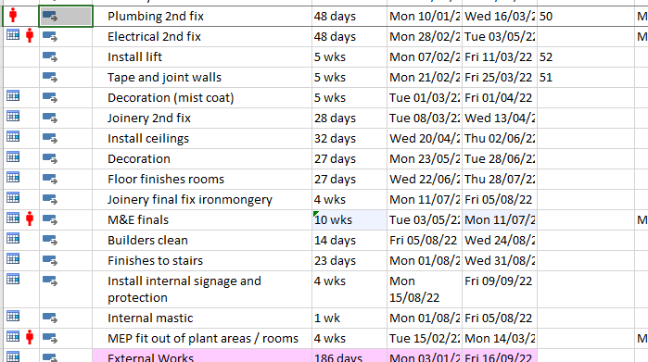

Added workforce
M&E clash has disappeared from the increase in workforce from 12 to 14 people
Evenly spreading out the workforce which shows on the image. 100% = 1 person.
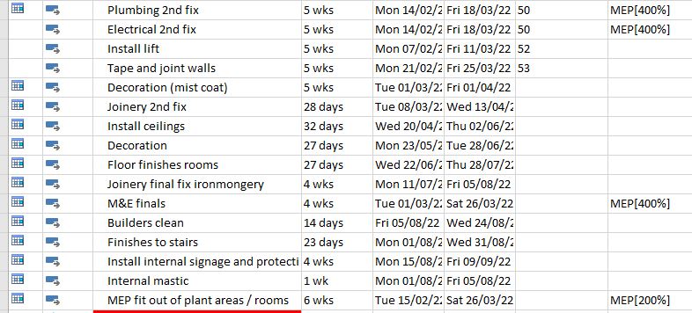
Allocated correct amount
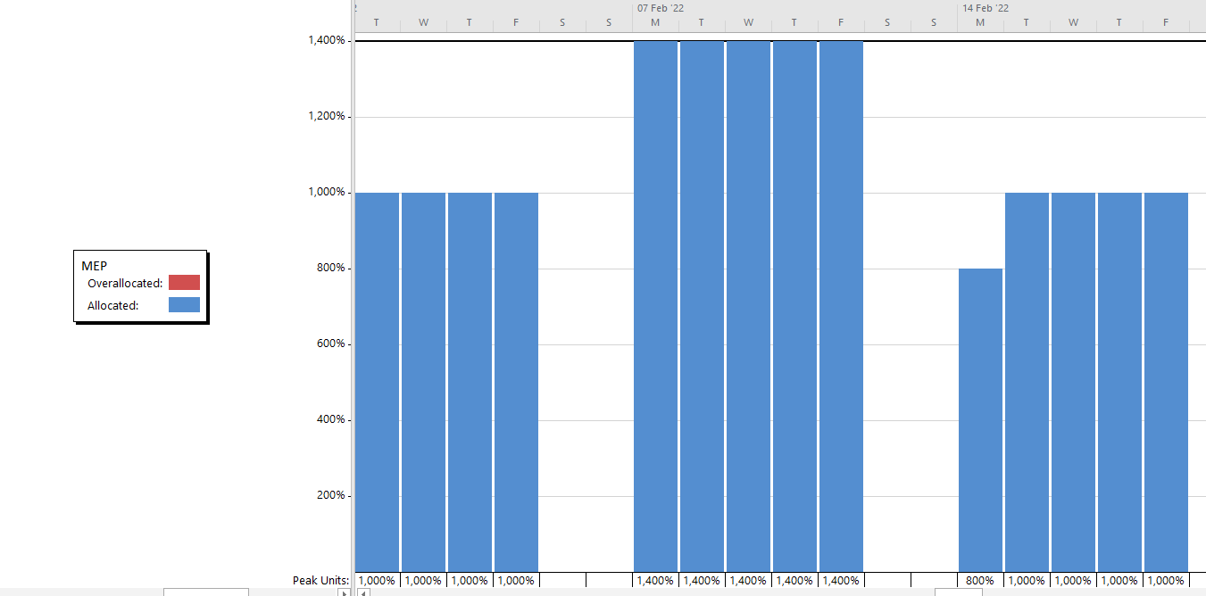
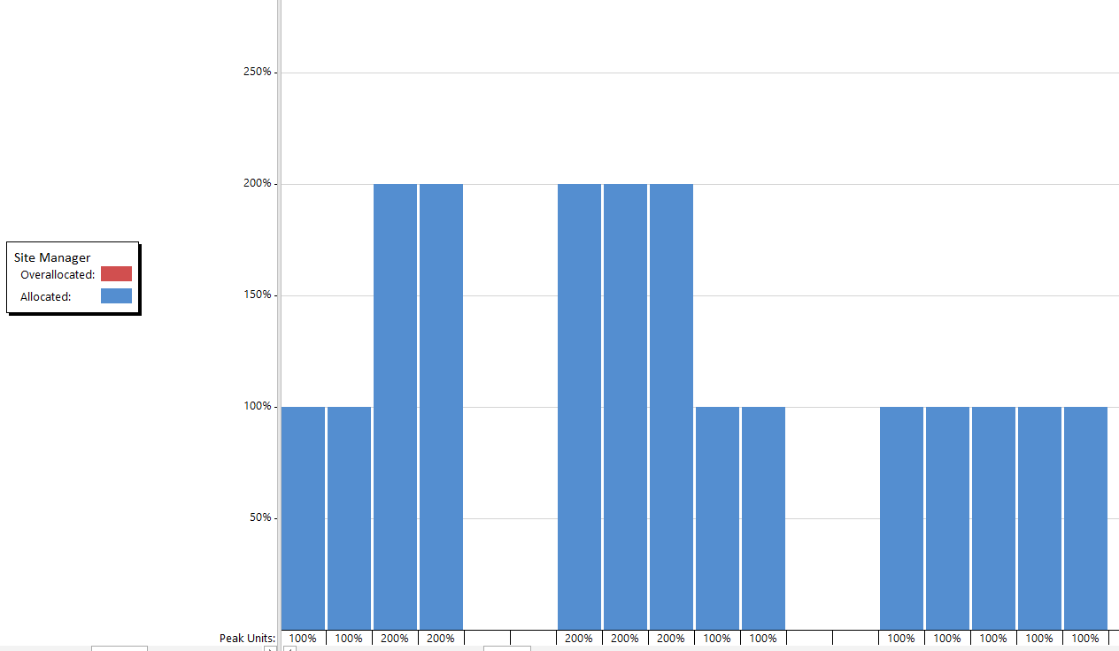
Resource graph shows M&E is evenly allocated throughout the whole project.

Allocated sufficient supervision to allow the project to flow safely and to the best of quality.

Cost

Individual tasks cost

Microsoft project allows us to pick individual tasks and shows the number of workers and the pricing of using them. Images below show the duration and price for these contractors / workers. 100% = 1 worker.
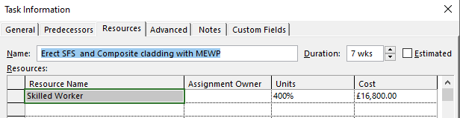
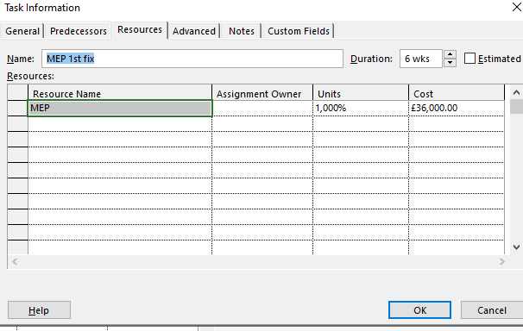
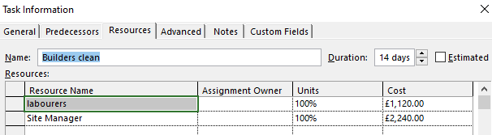

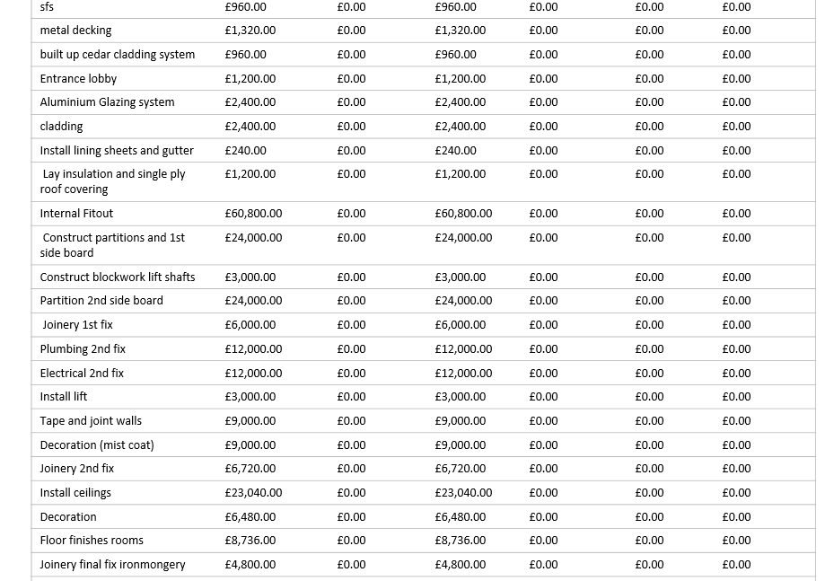
List of particular individuals’ tasks on the project with the price of the installation.

Total price of the job

Cost overview of the whole project from start until completion. £455,476 the final cost overview. This is supported by the cost overview from Microsoft project.

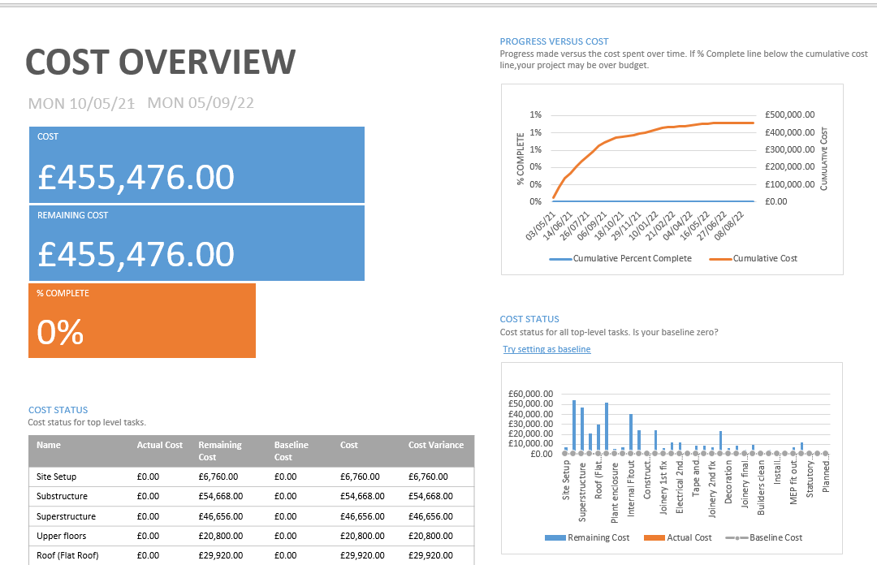

Cost Status
The cost of top-level tasks of the project. Substructure, superstructure, building envelope and internal fitout being the most expensive. Substructure being the highest at over £50,000.

Resource Cost overview

Overview of the cost, breaking down the total price in to the different work resources required for this projects and materials needed, £400,976.00 being spent on work and £54,500.00 on material. Skilled worker being the most expensive £250,000 from the graph.
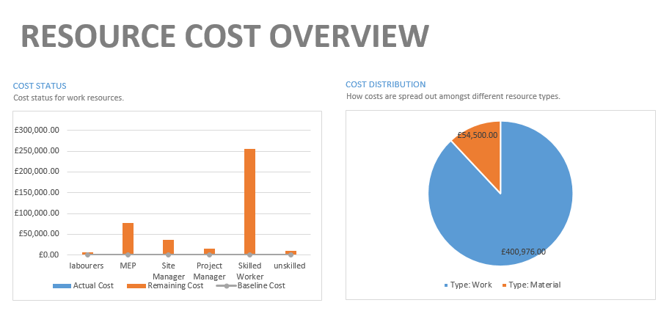

Cost overruns of the whole project
Similar example to the cost status, this allows us to indicate roughly the amount of money is required to complete tasks.

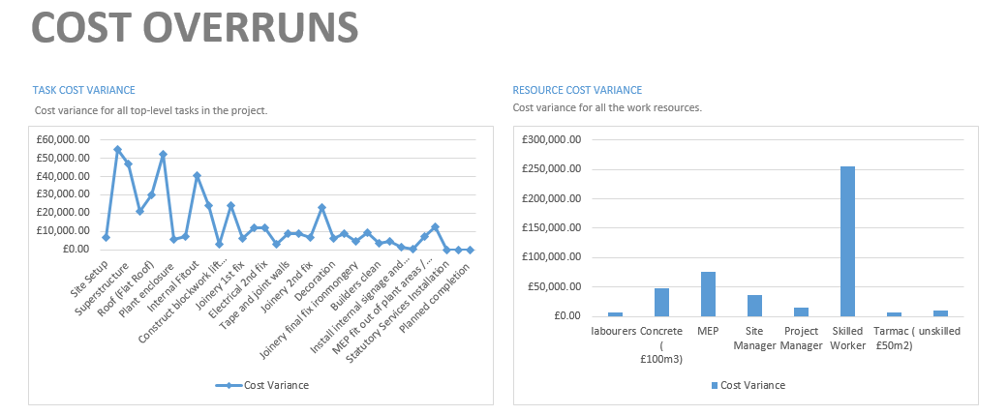

Comparison between materials needed to the work resources for the project. Skilled worker over £250,000, just under £50,000 needed of cement.

Task cost overview
Alternative bar chart, shows the task cost overview of the project. It’s been shown that substructure and superstructure are the most expensive, although this bar chart reveals the least expensive tasks. Decoration, joinery and builders are just some examples with a price under £10,000.
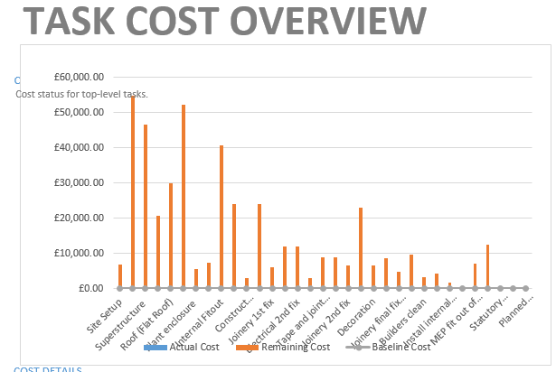
Time
Total working hours required
26,444 working hours required to complete the project.
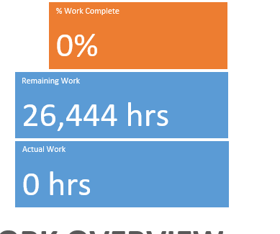

Work hours breakdown
Breakdown of the total hours required in the individual’s tasks. Internal fitout requiring the most with just under 6,000 work hours and building envelope required 3,500 work hours to complete
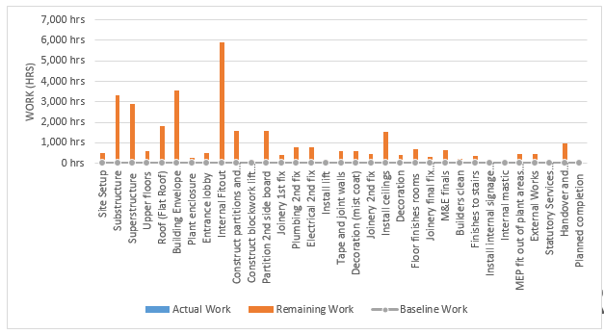
Number of hours required out of trades and professionals
Skilled worker required around 17,000 hours to complete the project. M&E at 5,000, project managers, site manager, labourers and unskilled under 5,000 work hours needed.

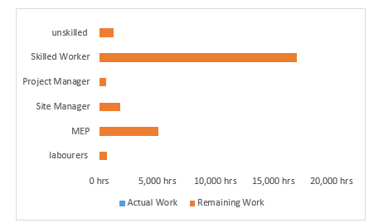

Critical Tasks

The project duration is 400 days, the tasks below are critical to the duration of the project. If these tasks start late or overrun the project completion date will be delayed. The completion of the project will be the Friday the 18th of November 2022.
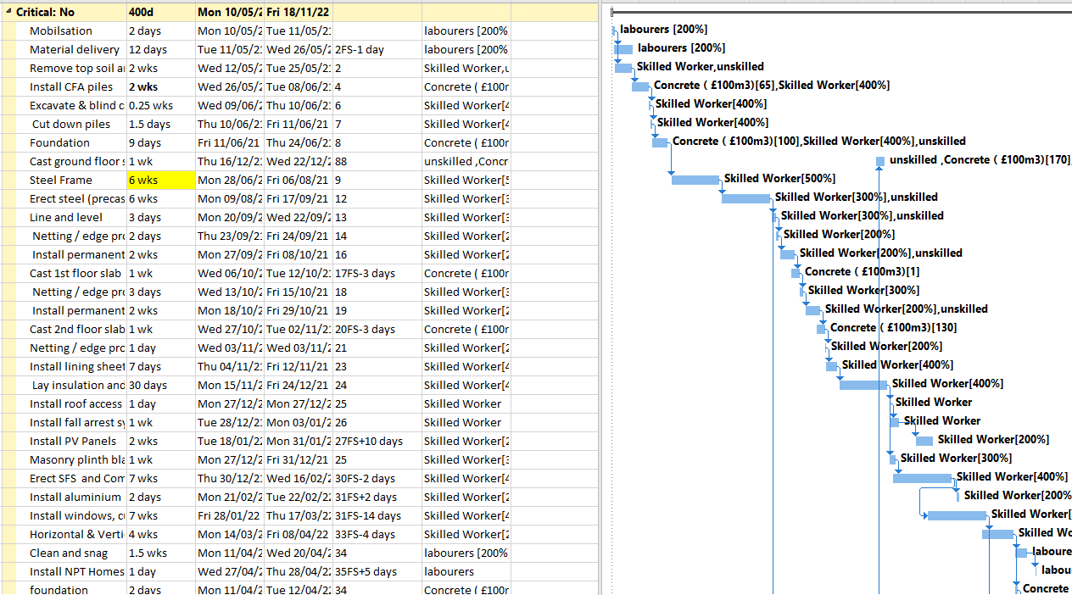

Summary of the project
Type of Task | Duration
Site set up | 2 weeks
Substructure | 151 days
Superstructure | 13 weeks
Roof | 67 days
Building envelop | 88.5 days
Plant enclosure | 14 days
Entrance lobby | 31 days
Internal fitout | 31 weeks
External works | 10 weeks
Statutory services installation | 54 days
Handover and commissioning | 10 weeks

The Site report, has reported the workforce, cost and duration required to the client.
SPG Construction are able to complete this project to the best of quality and to the completion date from the resources on Microsoft project and the support of the Gantt chart.

