BMSW5106
Student name: Aleksandar Mihaylov
Student ID: 2029754
Submission date: 05/05/2023

Knowledge and Information Management Skills for the Workplace

Task 1 - Individual Report

Role & extent of Knowledge & Information Management in Contemporary organisations

Table of Contents
Introduction 3
Overview of Amazon Inc. 3
Participants in contribution and collection of knowledge 5
Evaluation of the KM approaches of Amazon in their success 8
Participation in KM approaches and requirement of Amazon to invest on the project 10
Potential benefits and challenges related with KM activities 11
How the new source of knowledge would be distributed among the business partners 14
Operating cost and legal requirements 14
Promotion of KM system and helping employees to be aware in attaining future use 16
Conclusion 16
Reference List 17

Introduction
Knowledge Management has been considered to be the approach related with creating, relating, using and managing with the knowledge and information for the organisation’s development (Chopra et al., 2021). It is one of the key aspects which has been undertaken within an organisation which helps them to grow in a much significant manner and help in achieving greater goals for the firm. Knowledge Management programmes currently are of wide range as the working approach and ethics have changed in a much wider manner. It is key to understand that the companies have been undergoing a much more positive approach in order to conduct this process, as it has been helping them to improve on a much larger scale (Rana et al., 2022). Considering this report, which has been based on Amazon Inc. which has been one of the top organisations within the E-commerce and retail sector. The company has their own Knowledge management policy implemented over a long period of time. This provides them with a competitive advantage over the years and along with that success as well. The report would basically evaluate the approaches of Knowledge management which has been implemented by Amazon Inc. management. Along with that evaluation of the KM approach, participants' roles and their understanding of the KM approach. Benefits associated with it, source of knowledge would influence the employees, legislative factors with operational cost and promotional activities undertaken by the Amazon management in order to conduct the KM process.

Overview of Amazon Inc.
Amazon inc. has been one of the well-known E-commerce organisations to exist within the globe currently. The company has been set up within Seattle, Washington at the garage of Jeffry Bezos the founder and owner of Amazon Inc. At first it was an online book-selling organisation for people across the United States. Over the time being the business started to improve for Amazon Inc. The company with the flow of the internet within the globe started to establish new and innovative business ideas which helped them to achieve greater knowledge from the retail and Information technology market as well (Kodiyan, 2019). The flow of knowledge management within Amazon Inc has been quite innovative. In late 90'sE-commerce was not that much popular to be adopted for an organisation who has been trying to establish themselves within the market. Amazon Inc. under the strong leadership of Bezos, understood a very simple thing, if the company does not innovate with something new it would be very difficult for them to be successful in the modern millennium.
Amazon knows that the knowledge which they need to update has to be valid for their customers and their employees. This would have provided a competitive advantage within the market The company undertook with Flywheel technique within the company which has been a new AI based technology. This helps to easily understand the basic demands of a customer as per their generic search about products on the internet (Brevini and Swiatek, 2020).
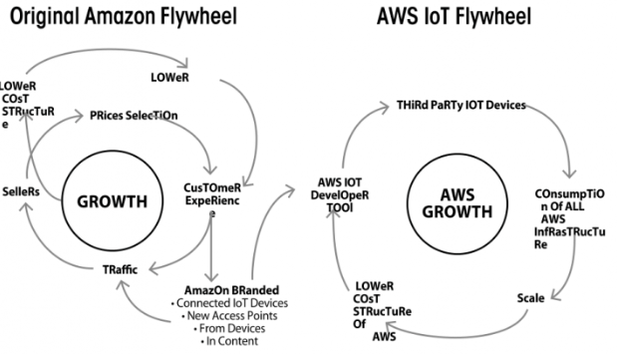
Fig 1: Transformation of the Amazon Flywheel, with the incorporation of advanced technologies
(Source: Watanabe et al., 2021)
Amazon created a one single interface for their users which would help them to be recognised as a brand across the USA and also in the global context which is currently observed. It is key to note that Amazon management always tries to conduct something innovative in their approach which would help them to attract a larger set of customers by their side and the rise of the internet provided with that opportunity. Amazon Inc. started with Macro-management within their workforce in the early 2000s, through the help of Kaizen.
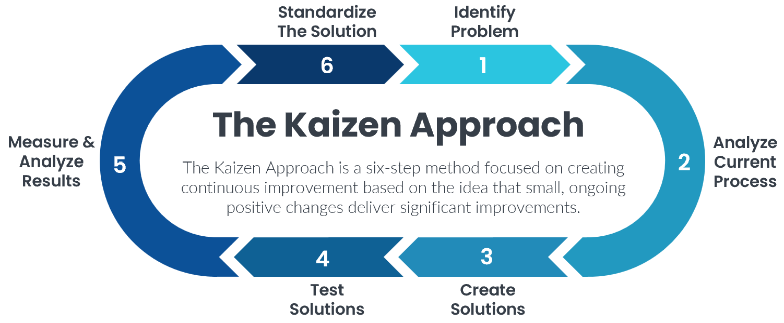
Fig 2: Kaizen Approach at Amazon
(Source: Helmold, 2020)
Amazon was facing an enforcement issue which required it to be overtaken in a significant manner, this was the reason the leader Jeff Bezos implemented the kaizen approach within the workforce, which provided with a wide range of opportunities in order to improve across the market. This was being done through training the existing employees and along with that the senior management involved within the organisation. This accomplishment helped Amazon to achieve greater success within the market and helped to improve their approach for the future as well. This improved the working efficiency factors of Amazon as well. This was the early stage of Knowledge management implication within Amazon and helping the employees to acknowledge the importance of it in growth for them as also for the organisation (Aversa et al., 2021). Around 1541000 employees currently working under the direct payroll of Amazon Inc. in the globe. The company has been conducting constant training for these employees and helping them to understand about the new knowledge management approach within the organisation’s workforce. This has helped the organisation to achieve a revenue of $502.19 billion in 2022. Thus, it could be easily understandable that the company has managed to conduct a knowledge management programme in a very suitable way which has been providing them positive results and sustainability.

Participants in contribution and collection of knowledge
Amazon Inc has a definitive role in conducting their knowledge management programme within their organisation, it has been observed that the company has been constantly trying to improve, innovate and improvise with the situation in order to increase productivity within the organisation in a very significant manner. Generally, there are different groups of people within which the participants are being divided within Amazon Inc. generally there has been a knowledge Leader, who generally promotes the process of KM within Amazon (Ganguly et al., 2019). Knowledge Managers of Amazon conduct with the process of acquisition and along with that management of internal and along with that external knowledge which has been gained by them in order to make these people successful. Amazon has implemented Knowledge Navigators as well, whose role has to locate the knowledge and try to improve them within the organisation.
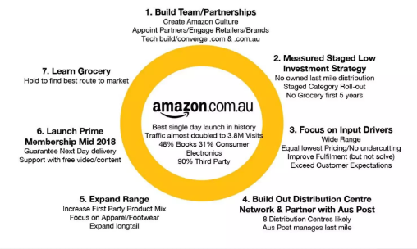
Fig 3: Knowledge Management approaches at Amazon
(Source: Schein, 2020)
Knowledge Synthesisers generally record the significant knowledge which is required for the growth of the organisation and place them properly within the memory of the organisation. Content editors are those who have been implemented within the team of KM who are those people who basically conduct with capturing and along with that documenting of knowledge which has been gained. All this collected knowledge by these people are being properly transferred for the people involved within the organisation. Those are the employees who are considered to be Group B participants. These people are to be acknowledged about the Knowledge Management programme which has been undertaken within the management and how those factors would provide the company like Amazon with a competitive advantage and wide range of benefit in order to grow across the market.
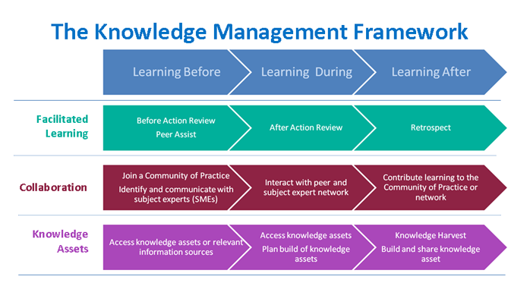
Fig 4: Knowledge Management Framework at Amazon
(Source: Delfanti, 2021)
These employees are being trained by Amazon management in a very significant manner which would help them to easily understand the process and work on the basis of it as per the surrounding factors which are related with the whole process. It is key to note that Amazon has implemented various innovative approaches from time to time, so this programme of Knowledge management has been quite common in the basic growth of the company in order to help them in achieving long-term benefits for their sustainable and profitable future. Their recent implementation of Intelligent Automation through improvising with AWS solutions helped them to achieve significant success within the organisation and along with that helped them to reach the pivotal goal associated with the growth of the company (Hoseini et al., 2019).
Through collection of knowledge, it has been clearly observed that the Amazon employees have been trying to conduct with a proper approach which helps them to achieve greater productivity. Employees have been considered to be Group A, participants in the KM process of Amazon. The company has been much inclined towards providing the best opportunities for the employees. It has been found that the employees are provided with the basic knowledge which are associated with the KM process and along with that helps them to easily understand how the process which the company has undertaken works in general (Veeravalli et al., 2020). These factors specifically help the company like Amazon to achieve a good and strong customer base and manages them to achieve a good amount of prodigy across the market.

Evaluation of the KM approaches of Amazon in their success
It has been observed that Amazon often uses a quite innovative strategy when it comes to conducting with Knowledge Management approach within their organisation. Introduction of the brick-motor service which has been adopted by the Amazon management has been providing the company with a competitive advantage within the market. It has also provided the customers with a new range of online shopping experience for their customers as well. Along with that the innovation includes handling acknowledgement which provides a wide range of promotional experience when it comes to online shopping (Zhou et al., 2020). Free and Fast delivery service which Amazon provides their customers helps them with a competitive advantage and growing option as well within the market. There has been another factor with Amazon in maintaining proper knowledge management approaches within the integrated methods associated with communication. The company generally provides instant feedback for their customers which helps them to easily get suggestions as per the online shopping process which the company has been planning to undergo.
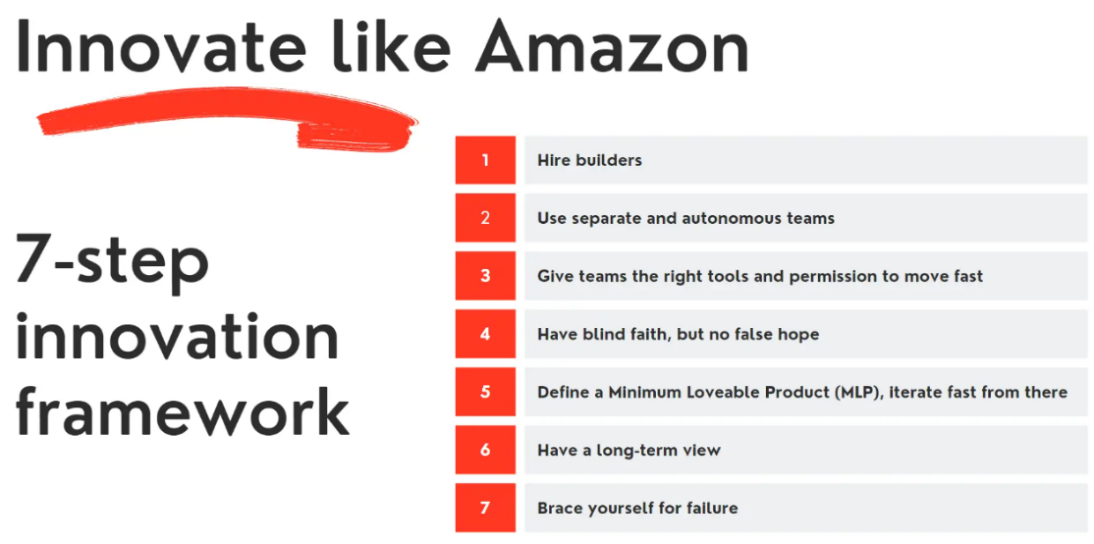
Fig 5: Innovation Management at Amazon
(Source: Gupta et al., 2020)
The innovation of strategy as per knowledge management programme has helped the company to attract a wider range of customers by their side. This has been a daily basis factor which is continued for the organisation. In essence it is important to note that Amazon is an established company which has been applying strategic approaches of innovation which is helping them with advanced operations within the market where they have been existing. The failure in employing proper and indicative strategy by an organisation might have a determinant effort of managing with the well-being related with the firm of Amazon's stature (Thomas and Chopra, 2020). Amazon further uses the social media platforms in a large scale which helps them conduct advanced communication with their employees and again gain the required knowledge as well on the basis of the demands which are linked with the customers.
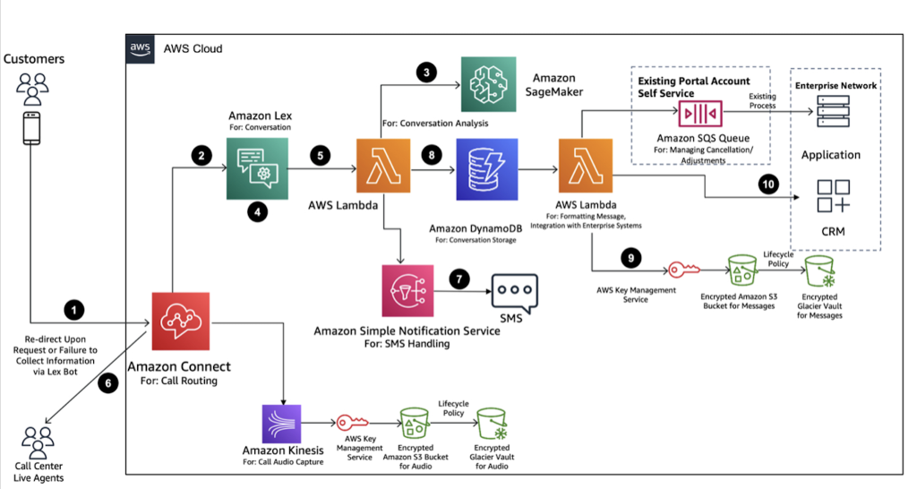
Fig 6: AWS Architecture driven by Artificial Intelligence, at Amazon
(Source: Gupta et al., 2020)
Amazon with their knowledge management programme further attracts a wider range of players from different industries within the society. Technical advancements through various AI related technologies which Amazon have undertaken has provided them with an advantage and opportunity within the retail sector. The company further conducted with a significant strategic approach as well within the company. This has helped them to reduce the cost related with physical retail stores within the market. Online shopping provides the customers with a much more convenient approach and along with that provides them with greater and larger options to easily engage with the products which the company is trying to sell. The convenience and efficiency programme which has been conducted by Amazon has been providing a wide range of opportunities for the customers and for themselves as well. This provides Amazon with a strong upper hand within the community. Amazon further considered proper strategic arrangements within their workplace. This has helped them with suppliers and customers in a bid to enhance trust and improve on the working relationship. The way the knowledge management programme of Amazon has been conducted that the gaunt tech companies have been conducting with several suppliers who sell their products directly within the E-commerce platform.

Participation in KM approaches and requirement of Amazon to invest on the project
Amazon's implications of Knowledge Management states that why a top company or a company which is trying to reach the top or acquire success needs to have this programme within their workforce. The main reason has been that it has been constantly sharing data and information across every other user within a business organisation. Along with that it emphasises the importance related to learning and clearly understanding the approaches which are required to be undertaken. Sharing information and along with that data is being considered to be the primary task related to Knowledge Management (Sills et al., 2020). It enables innovation and along with that company culture as well. The knowledge and expertise which are important to assess for the management creates a positive and conducive environment to work into.
Effective knowledge management approaches are created with proper support and creation along with that dissemination and proper utilisation if knowledge would definitely help in achieving the goals and objectives which the company has been planning to achieve over the period of time. It helps in providing a wide range of information for the management. Amazon received a lot of information through knowledge management. It further facilitates informed decisions and helps in undergoing leadership approaches within the different sectors (Elias et al., 2021). Along with that company share with proper information and along with that experience as well to learn and reveal the strengths related with the company. Allowing the process of organic evaluation through focused knowledge and along with that learning process through self-management. It further empowers the workers to conduct with individual performance and improve the company for the business success.
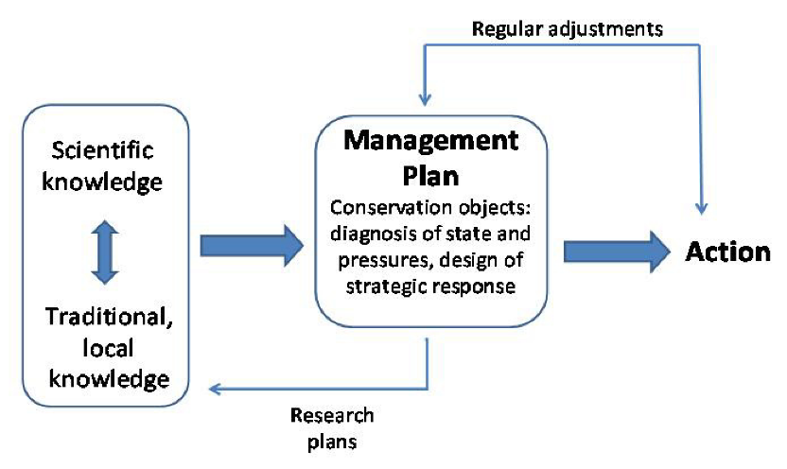
Fig 7: Knowledge Management System at Amazon
(Source: Dimitrakaki, 2022)
Knowledge management programme within Amazon has been largely providing a wide range of information and creating easier ways to access with the experienced employees and reference of knowledge as well. They feel quite recognised and along with that motivated in order to successfully guide others in sharing the required experience. Along with that there has been a wide range of organic transfer and transition of data as well. This provides the employees with opportunities within a little cost. Additional knowledge on individual strengths have been quite unique as well. This provides a wide range of satisfaction to perform for the company (Pereira, 2021). Along with that it encourages and enables proper team work as well within Amazon. The shared activity which is quite common and being undertaken within the process provides with relevant dialogue and shared experiences which reflects in the learning. This provides proper ideas to stimulate a significant change in the culture as per the society and improve the workplace as well.

Potential benefits and challenges related with KM activities
Knowledge Management has been one of the significant approaches which provides a wide range of opportunities for the organisation in general to attain greater goals. Following are the advantages related with the Knowledge Management programme undertaken within the Amazon Inc.
Improves efficiency of the organisation
Through effective sharing of various crucial information organisations helps in increasing the productivity of employees and overall productivity of the company.
Creates with effective solving of problems
By focusing on relying on information it has been observed that the overall Objectives and goals are more effectively solved through the searching of information and attachments of effective tools.
Focuses on developing the employees
Focuses on providing the information which they need to show them with the value of time and input. They are basically valued for proper contribution and allowed to attain opportunities to sharpen their skills and share proper information.
Sharing expertise
Experienced employees are given a voice of help to others. This is therefore vested interest in order to achieve greater success for the organisation. Through being regarded to be experts within the industry they develop with proper relationships and meaningful mentorship where the knowledge is being shared in a critical manner. This provides the employees to feel their importance within the company.
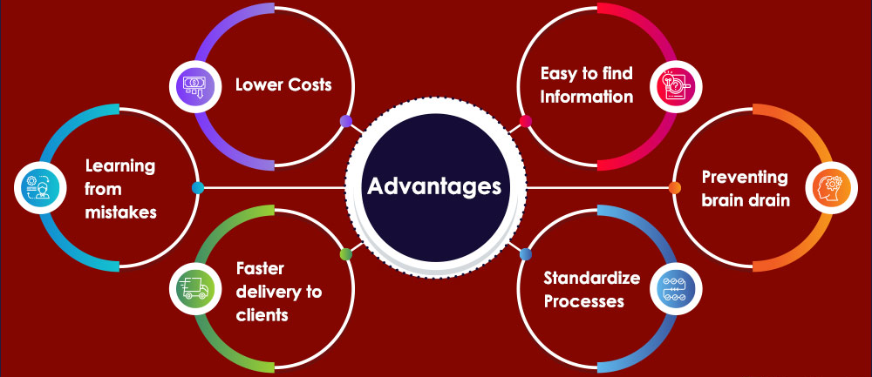
Fig 8: Advantages of Knowledge Management approaches
(Source: Dimitrakaki, 2022)
Increase of employee morale
Through recognising the overall success, it also helps in increasing the morale of the employees through motivation and knowledge exchange. It aligns with the professional goals of the individuals and creates a corporate culture where knowledge has been shared freely among the employees and the management alike.
Even though there has been a wide range of benefits surrounding Knowledge Management it is key to notice that there have been certain challenges as well which are related with the process. As per Amazon also there has been certain issue regarding KM, which are as follows;
Lack of Awareness
Often the management of companies fail to understand the basic factors which are associated with the market trends as per the one in which they have been existing. This results in significant issues within the long-term benefit of the company. They fail to assert with proper inclusion which directly results in a problem.
Lack of resources
It is often observed that there has been a lack of technical resources within the organisation which often results in the company to suffer poorly in order to attain Knowledge Management in a very successful manner.

How the new source of knowledge would be distributed among the business partners
It is key to note that when Amazon is generally launching with a new product or approach which they have been planning to launch with the use of proper innovation, it has been observed that the management often informs their business partner on the usage of the new approach as per Knowledge management. The acknowledgement has been generally done in a much significant and prudent manner which helps the business partners to easily understand the approach which the company has been willing to undertake in order to attain better results for them profitably and strategically in the future. Along with that, a strategic approach is often undertaken to make the business partners understand the approach which has been planned to undergo within the organisation. It is key to note that on launching a new product through KM, the employees are often trained from before in order to make them properly aware on how these approaches are to be significantly undertaken to ensure the best interest of the company and achieve better benefits for themselves in the future.

Operating cost and legal requirements
Amazon by implementing a robust Knowledge Management System has successfully increased company revenue, minimised operational costs and enhanced employee productivity. The company allowed its knowledgeable employees to regain their workdays, put back their skills in practice and spend less time helping out the peers. The Knowledge Management system helped reduce employee churn thereby saving service expenses. As argued by Harward (2021), losing a team member is both challenging from the financial and productivity view point. An employee replacement costs 33% of the person’s annual salary. However, the use of AI and ML as information systems to manage algorithms and share knowledge can reduce the chances of employee burnout and thus reduce business costs. Additionally, KMS helps prevent recreating the resources that already exist. Thus, help the team members to create new resources and up selling that will generate more business revenue (Manesh et al., 2020). From customer service to quality assurance, there are many such areas that are prone to errors. However, Amazon avoids such costly errors through the application of efficient Knowledge management systems featuring step-by-step guides and walkthroughs from the people using them.
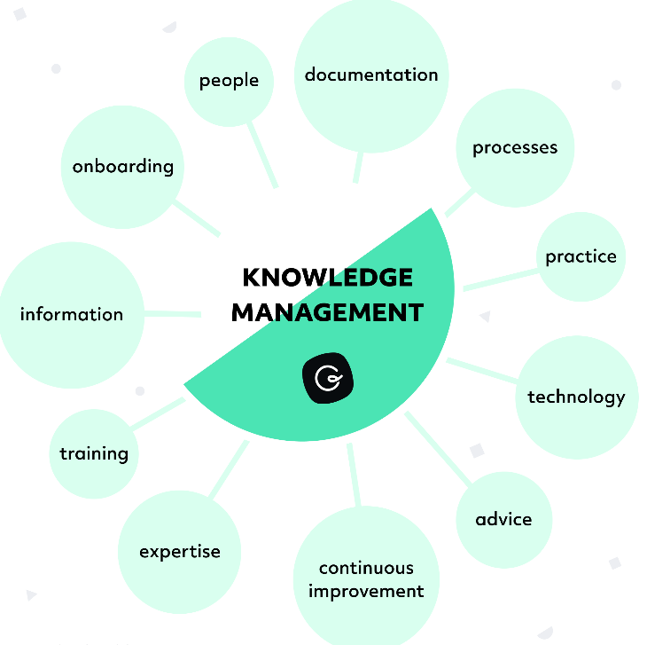
Fig 9: Knowledge Management System of Amazon
(Source: Pereira and Terrenas, 2022)
Apart from just maintaining the operating costs, Amazon also manages the legal requirements of the company with the application of the KMS (Knowledge Management Systems). This helps the firm attract more business by streamlining their operations and offering better value for money to the clients. The systems created in a structured and legal manner helps reduce the time that employees spend on finding information across different departments (Wen, 2022). Moreover, employees quickly and inclusively getting hold of the information they need, serves to improve the financial health of the company. In addition to this, another legal requirement of Amazon involves eradicating stereotypes. Free sharing of knowledge among teams and departments helps build effective team players and is not a hindrance to the company's success. The responsiveness and transparency help to create stronger relationships among the company and the people.

Promotion of KM system and helping employees to be aware in attaining future use
Instead of reinventing the entire knowledge management system, the company can keep things simple. This will allow the organisation to better train the employees quickly, along with making the KM system a lot more accessible to everyone on board. In addition to this, letting the employees have a say in the implementation process will also be a good initiative to promote these systems effectively (Debara, 2019). As employees are the ones who will be using the KM systems, they should be made comfortable with the processes and allowed to suggest ideas. Collecting feedback from the employees can help improve decision-making processes in Amazon and reduce employee resistance to the knowledge management systems chosen for the company. Moreover, by creating an environment of knowledge sharing the company can ensure employees can make the best use of these systems. The knowledge sharing culture will encourage different departments and teams to work together and promote free exchange of knowledge.

Conclusion
The report especially discussed Knowledge Management and the approaches which are required to be undertaken within the organisation in order to achieve greater results and better goals for themselves. It is key to understand that the company which was selected has been Amazon Inc. who have been trying to improvise the situation through clearly undergoing specific actions from time to time. These actions are based on the competitive advantages which are to be undertaken in order to achieve a significant result in a very suitable manner. The benefits associated with it are being discussed and along with that the realm of the participants as well. The operation cost in attaining it with the legislative factors which are being considered by Amazon has been the area of discussion as well.

Reference List
Aversa, P., Haefliger, S., Hueller, F. and Reza, D.G., (2021). Customer complementarity in the digital space: Exploring Amazon’s business model diversification. Long Range Planning, 54(5), p.101985.
Brevini, B. and Swiatek, L., (2020). Amazon: Understanding a global communication giant. Routledge.
Casey Harward, (2021). 5 Ways Knowledge Management Improves Efficiency. Available at: https://www.kminstitute.org/blog/5-ways-knowledge-management-improves-efficiency [Accessed on: 21 April 2023]
Chopra, M., Saini, N., Kumar, S., Varma, A., Mangla, S.K. and Lim, W.M., (2021). Past, present, and future of knowledge management for business sustainability. Journal of Cleaner Production, 328, p.129592.
Deanna Debara, (2019). Level up your team’s knowledge management system in 5 steps. Available at: https://slack.com/intl/en-in/blog/productivity/level-up-team-knowledge-management-system [Accessed on: 21 April 2023]
Delfanti, A., (2021). Machinic dispossession and augmented despotism: Digital work in an Amazon warehouse. New Media & Society, 23(1), pp.39-55.
Dimitrakaki, I., 2022. Organizational Knowledge as a Source of Competitive Advantage-Amazon Case Study.
Elias, A.A., Donadelli, F., Paiva, E.L. and Bacic Araujo, P.P., (2021). Analysing the complexities of sustainable wood supply chain in the Amazon: a systems thinking approach. The International Journal of Logistics Management, 32(4), pp.1481-1505.
Ganguly, A., Talukdar, A. and Chatterjee, D., (2019). Evaluating the role of social capital, tacit knowledge sharing, knowledge quality and reciprocity in determining innovation capability of an organization. Journal of knowledge management.
Gupta, B., Mittal, P. and Mufti, T., (2021, March). A review on Amazon web service (AWS), Microsoft azure & Google cloud platform (GCP) services. In Proceedings of the 2nd International Conference on ICT for Digital, Smart, and Sustainable Development, ICIDSSD 2020, 27-28 February 2020, Jamia Hamdard, New Delhi, India.
Hoseini, M., Saghafi, F. and Aghayi, E., (2019). A multidimensional model of knowledge sharing behavior in mobile social networks. Kybernetes, 48(5), pp.906-929.
Kara Wen, (2022). Your guide to legal knowledge management. Available at: https://www.simplelegal.com/blog/legal-knowledge-management-guide [Accessed on: 21 April 2023]
Kodiyan, A.A., (2019). An overview of ethical issues in using AI systems in hiring with a case study of Amazon’s AI based hiring tool. Researchgate Preprint, pp.1-19.
Manesh, M.F., Pellegrini, M.M., Marzi, G. and Dabic, M., (2020). Knowledge management in the fourth industrial revolution: Mapping the literature and scoping future avenues. IEEE Transactions on Engineering Management, 68(1), pp.289-300.
Morgan, B., (2018). How Amazon Has Reorganized Around Artificial Intelligence And Machine Learning. Available at: https://www.forbes.com/sites/blakemorgan/2018/07/16/how-amazon-has-re-organized-around-artificial-intelligence-and-machine-learning/?sh=34dd30237361
Pereira, J.C. and Terrenas, J., (2022). Towards a transformative governance of the Amazon. Global Policy, 13, pp.60-75.
Pereira, R., (2021). Public participation, indigenous peoples’ land rights and major infrastructure projects in the Amazon: The case for a human rights assessment framework. Review of European, Comparative & International Environmental Law, 30(2), pp.184-196.
Rana, J., Gaur, L. and Santosh, K.C., (2022), November. Classifying Customers’ Journey from Online Reviews of Amazon Fresh via Sentiment Analysis and Topic Modelling. In 2022 3rd International Conference on Computation, Automation and Knowledge Management (ICCAKM) (pp. 1-6). IEEE.
Schein, A., (2020). Organisational ambidexterity, hard power management and smart power management at Amazon, a case study. Global Business and Economics Review, 22(1-2), pp.27-40.
Sills, E., Pfaff, A., Andrade, L., Kirkpatrick, J. and Dickson, R., (2020). Investing in local capacity to respond to a federal environmental mandate: Forest & economic impacts of the Green Municipality Program in the Brazilian Amazon. World Development, 129, p.104891.
Thomas, A. and Chopra, M., (2020). On how big data revolutionizes knowledge management. Digital transformation in business and society: Theory and cases, pp.39-60.
Veeravalli, S., Venkatraman, V. and Hariharan, M., (2020). Why do people seek knowledge? Tracing factors that affect knowledge seeking intention. VINE Journal of Information and Knowledge Management Systems, 50(2), pp.271-290.
Watanabe, C., Akhtar, W., Tou, Y. and Neittaanmäki, P., (2021). Amazon's initiative transforming a non-contact society-Digital disruptionleads the way to stakeholder capitalization. Technology in Society, 65, p.101596.
Zhou, F., Ayoub, J., Xu, Q. and Jessie Yang, X., (2020). A machine learning approach to customer needs analysis for product ecosystems. Journal of mechanical design, 142(1).

