Reflection on “Deep Dive Team” Work Based Group Project

Work Based Group project

Module code ACDB5021/22

Alex Clarke
2309711@student.uwtsd.ac.uk
Level 4 OME Course
November 2025


Table of Contents
1 Introduction 3
2 Design project management 3
2.1 Initial approach 3
2.2 Final approach 3
2.3 Project team interaction 3
3 My role in the team 4
3.1 Allocated role. 4
3.1.1 Overall structural integrity of the munitions 4
3.1.2 If the munitions casing has been breached 5
3.1.3 Overall integrity of the explosive compositions in the munitions 5
3.2 Supporting roles 6
4 Presentation 6
5 Feedback from presentation 6
6 Response to feedback 8
7 Conclusions 9
8 References 9
9 Appendix A 10
9.1 Systems engineering workbook and supporting documents 10
10 Appendix B 12
10.1 Slide pack 12

Figure 1 Shared OneDrive folder structure 4
Figure 2 Presentation summary feedback screenshot 7
Figure 3 Dave’s feedback screenshot 7
Figure 4 Jenni's feedback screenshot 8

Introduction
This report aims to reflect on the learner’s journey taken through the group-based project unit and cover the steps taken by the learner to deliver the “Deep Dive Team” presentation. It will cover reflections on how the learner felt the project was managed, the learner’s role within the team (including referencing to supporting research), the presentation itself, including feedback and any potential design/ method changes or alternatives that could be applied to the process.

Design project management

Initial approach
As stated in the presentation the initial approach taken by the learner and the team was a “scatter gun” approach. This approach provided defined roles for the learner and the rest of the team but with no structure of how to progress this project forwards in a defined and logical manner. The initial defined roles of the learner and fellow team members were as follows:
- Alex Clarke (learner) – Assessment of munitions and render munitions safe.
- Simon Shepherdson – Safety and risk assessment, determination of AO and determination of quantities of munitions.
- Dan Cowen – Raising of munitions from lakebed.
- Stephen Dean – Cataloguing of munitions and assessment of level of disruption to environment and ecology.
- Daani NAYYAR – Transport, storage and disposal of munitions.

Each of these roles was allocated following a team discussion on what each team member believed their strengths laid and what applied most appropriately to their day jobs.
Initially a project management role was not allocated to any of the team members but as the project started to progress, this role was jointly taken by the learner and Simon Shepherdson.

Final approach
Following on from initial role allocation of the team members and the summer break the team returned to University of Wales Trinity St David (UWTSD) for a new academic year and quickly concluded that application of a systems engineering approach would provide the most structure and direction on the project. This approach applied multiple tools the learner had been taught during the systems engineering unit, specifically the systems engineering workbook used for that assignment as seen in Appendix A.

Project team interaction
Initial interaction for allocation of roles and responsibilities demonstrated a good level of teamwork but sadly this was short lived. Whilst carrying out the initial stages of the systems engineering workbook some of the team members input was lacking due to minimal interaction and availability. Thankfully as the workbook progressed, input from all team members increased which the learner felt greatly improved the speed at which the project moved forwards. By the point of delivery of the presentation the whole team was fully interacting with each other and providing any support where required.
As the team was comprised of a mix of AWE and QinetiQ apprentices, communication was a potential issue. This was rectified using a WhatsApp group chat, weekly catch-up meetings over Microsoft Teams, and use of library facilities during block release weeks at the UWTSD campus to ensure full group participation and discussions. To have a single repository for any research and supporting documents (e.g. the presentation PowerPoint Slide pack), the learner set up access to their university OneDrive for the other team members and created a folder structure. Having shared folder access allowed the team to update and maintain single document created for each stage of the project. A screenshot of this can be see below in figure 1.
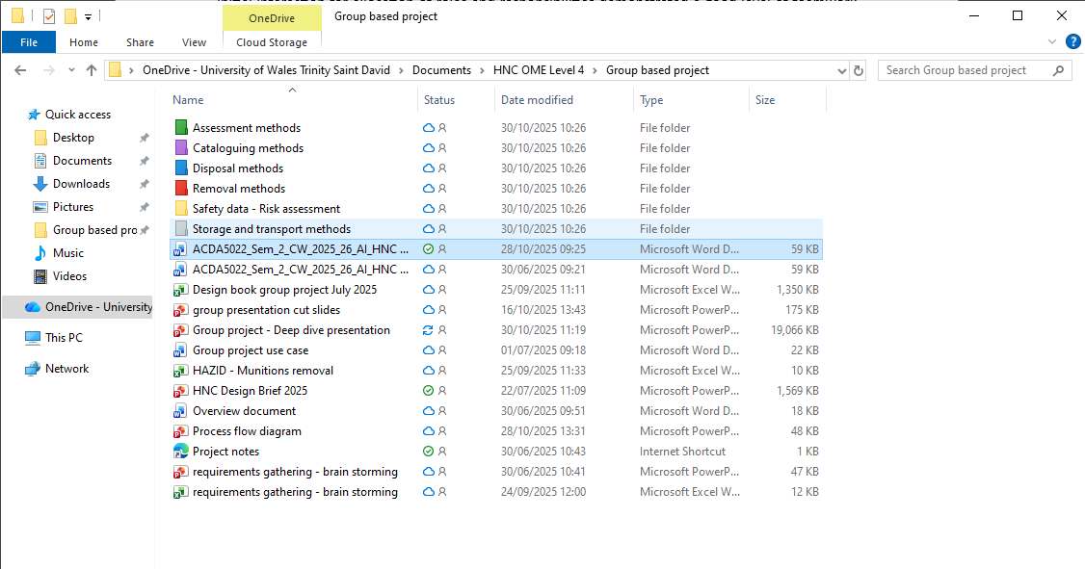
Figure 1 Shared OneDrive folder structure

My role in the team

Allocated role.
The initial allocated role of the learner for this project was for “Assessment of munitions” and “Render safe munitions”. As the project progressed it was agreed by the group that the “Render safe” role, specifically relating to any fuzes present on the munitions would be covered as the assumption was agreed that any munitions with a fuze attached would not be a candidate for removal and to remain within the lake.
The learner offered to take the “assessment of munitions” role as this would partially relate to their role within the Explosives Physical Characterisation (XPC) team at AWE, which covers powder hazard testing, mechanical property tests and physical characterisation (including particle size distribution and specific surface area analysis)
To be able to fully assess the munitions the learner broke this requirement down into three subsections below.

Overall structural integrity of the munitions
This subsection was further broken down into visually inspection and metallurgy assessment.
Visual inspection would be carried out using Remote operated vehicles (ROVs) and underwater automated vehicles (UAVs) but would depend greatly on the visibility available at the depths with factors viability based on availability of light and level of sedimentation present. The next part of visual inspection would be via in-situ X-ray ^{[1]} and CT scans ^{[2]} via technologies used by gas and oil industries for assessment of underwater assets.

Metallurgy assessment of the munition’s housings would be carried out on unaged and aged modern day equivalent materials (assumed Steel) via mechanical property testing to the following tests standards:
• ISO 13314 2011: Mechanical testing of metals – Ductility testing- compression test.
• ISO 6892-1 2016: Metallic materials – Tensile testing. Method A: controlled by the speed of the machine’s crosshead. Properties measured include Yield strength, tensile strength and strain at break.
• ISO 7438: Bend test on metals. 3-point bend test measuring properties including flexural strength and flexural modulus.
• ISO 12135 2021: Metallic materials — Unified method of test for the determination of quasistatic fracture toughness

Arrhenius kinetics would need to be applied for the accelerated aging (ASTM F190 2016: Accelerated aging). To provide aging data for an estimated 70 years (25550 days) of the munitions being submerged in the lakes at an assumed temperature of 2°C, the aged samples would need to undergo a time aging experiment in the lake water at 75°C for 162.1 days.^{[3]}
Comparison between the aged and unaged data would then be conducted to determine if any reduction in structural integrity of the munitions has occurred whilst being submerged in the lakes. The main changes the learner would be looking for would be a deduction in yield strength or fracture toughness (going from ductile to brittle).

If the munitions casing has been breached
To determine if the munition casing had been breached the learner determined that chemical analysis would be the most suitable method. For chemical analysis to be viable, water samples would need to be taken from multiple sites in the lake where munitions have been determined to be present. These samples could be take using the same ROV and UAV used for the proposed visual inspection methods.
Multiple methods of separation and reconcentration methods including Gas Chromatography (GC), High Pressure liquid chromatography (HPLC), ^{[4]} can be used to detect traces of explosive materials.
Multiple methods of spectroscopy can be used to detect traces of explosive materials including Raman spectroscopy, and UV-spectroscopy.^{[4]}

Overall integrity of the explosive compositions in the munitions
This subsection was further broken down into hazard property testing and thermal analysis to determine stability.
Explosive Materials Testing Assessment Policy Manual of tests 1-6 (EMTAP) would be carried out on representative explosive materials for comparison purposes between unaged and aged samples to determine the hazard properties. Tests 1-6 are comprised of the following methods:
• Test 1: Rotter test – Impact test that defines the materials figure on inventiveness.
• Test 2: Mallet friction test – Friction test that determines the materials response to a friction insult on multiple mallet/anvil combinations.
• Test 3: Ease of ignition test – Thermal test.
• Test 4: Temperature of ignition test – Thermal test.
• Test 5: Train test – Thermal test.
• Test 6: Electrical Spark test – Electrical test that determines the materials response to an Electrostatic Discharge (ESD) insult.

Accelerated aging of the samples would be carried out to the same method stated in section 3.1.1.
Comparison between the aged and unaged results would then be conducted to determine if any change in response to insult stimuli thus changing the sensitivity of the explosives.
Thermal analysis can be used to determine the stability of explosive materials. These methods include Differential Scanning calorimetry (DSC) and Thermogravimetric analysis (TGA) ^{[5]}. Both methods would be carried out to STANAG 4515 ED 2
Accelerated aging of the samples would be carried out to the same method stated in section 3.1.1.
Comparison between the aged and unaged data would then be conducted to determine if any change in the thermal stability of the munitions has occurred whilst being submerged in the lakes.

Supporting roles
As stated in section 2, the learn undertook addition roles for this project. This included project management, undertaking the systems engineering approach for method/ process development and providing support to other team members.

Presentation
The “Deep Dive Team” presentation was delivered by the learner and fellow team members on the 30th of October 2025 at the Swansea UWTSD campus, IQ building room 310. It was presented to representatives of the OME course along with invited attendees from both AWE and QinetiQ. The presentation had a run time of around 42 minutes which sat well within the requested delivery time of between 40 and 45 minutes defined in the assignment brief.
Screen grabs of the slides presented by the learner can be found in Appendix B of this report with the full slide pack available for review upon request.
The slides delivered by the learner included the following topics:
- Project brief (Slide 2)
- Background to systems engineering approach taken. (Slides 6-9)
- Assessment of integrity of munitions (slides 18-23)

Feedback from presentation
Following on from the presentation the learner received feedback from the unit’s lecturers Dave Holly and Jenni Steen. The feedback was separated into a presentation summary, Dave’s feedback and Jenni’s feedback. Screen shots of the feedback can be seen in figure 2, 3 and 4 below.

Figure 2 Presentation summary feedback screenshot

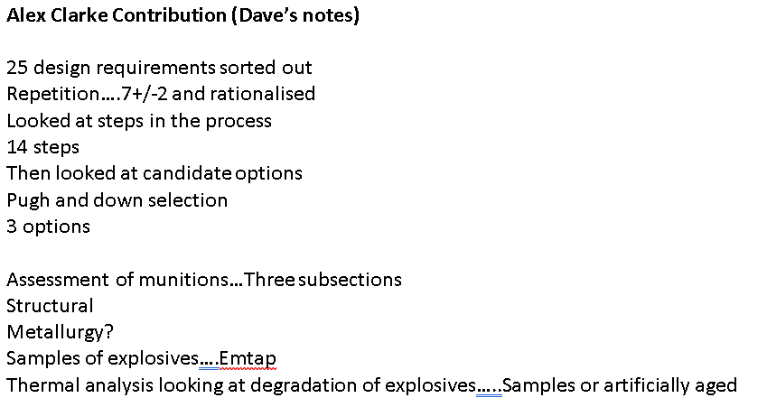
Figure 3 Dave’s feedback screenshot
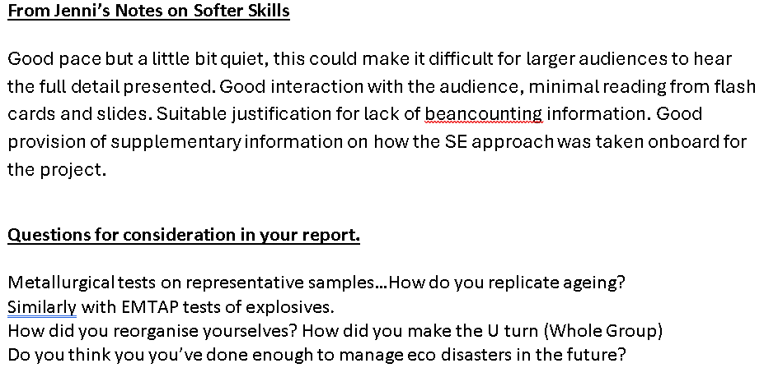
Figure 4 Jenni's feedback screenshot

Response to feedback
The learner was happy with the feedback from the lecturers and took on board the comments made with the following responses to a few sections made below:
“Presentation was good in content but perhaps lacked the slick, suited rehearsed appearance of the competition. Regrettably this sounds in the view of our seniors.”
The apprentice believes that what was worn by the “Deep Dive Team” should not have really come into the discussion relating to feedback and that the team concentrated on the content provided in the presentation rather than the aesthetic look. If the presentation had been presented in a more formal setting, say a conference, then the learner would have dressed accordingly for that in a smart attire.
“Good pace but a little bit quiet, this could make it difficult for larger audiences to hear the full presentation”
The learner was expecting this comment as public speaking is something that they are not accustomed to and are normally very nervous about doing, to which sadly manifested as being a little bit quiet. This is however a learning experience for the learner to improve upon in future presentations.
In relation to the questions to consider for the report, the learner believes the information provided in sections 2 and 3 of this report answer most questions. For the question relating to if the team had done enough to manage eco disasters in the future, this was a very difficult question to answer. Mechanisms can be put in place with the aim of managing eco disaster (monitoring etc), but without full adherence to procedures and processes to be put in place to monitoring and managing eco disaster it has the potential to get worse over time. With the solution the Deep Dive Team presented the apprentice believe it would be enough to rectify the munitions dumping and ecological and environmental impact.

Conclusions
The learner believes that a defined and robust method has been devised to adequately remove said munitions from the multiple lakebed locations with minimal disruption to the environment and ecology in a safe manner.
Option one (leave it all there and do nothing) would have been the most viable and realistic method to follow as this is what the Swiss government has done, but it would have been a very dull project for the learner to research and present.

References
- "Underwater radiography." Theengineer.co.uk. Accessed: October 2025 [Online]. Available: https://www.theengineer.co.uk/content/news/underwater-radiography
- “Sub-sea CT scanning to assess pipeline corrosion.” Epcmholdings.com. Accessed: October 2025 [Online] Available: https://epcmholdings.com/sub-sea-ct-scanning-to-assess-pipeline-corrosion/
- “Calculations of accelerated aging according to ASTM F 1980.” Innoform-testservice.de. Accessed: October 2025 [Online] Available: https://www.innoform-testservice.de/accelerated-aging?action=process&temperature_real=2&duration=25550&temperature_test=75
- B. Raupers, J. Passig, C. Gehm et al "In situ detection of munition compounds in coastal waters – section 3" Trends in Analytical Chemistry ,163, May 2023.
- P. Folly, "Thermal stability of explosives" CHIMIA, 58, no 6, pages 394-400, 2004.

Appendix A

Systems engineering workbook and supporting documents
The screen shots below are from the systems engineering workbook and supporting documents produced by the learner and fellow team members. It documents multiple tools used during the project.
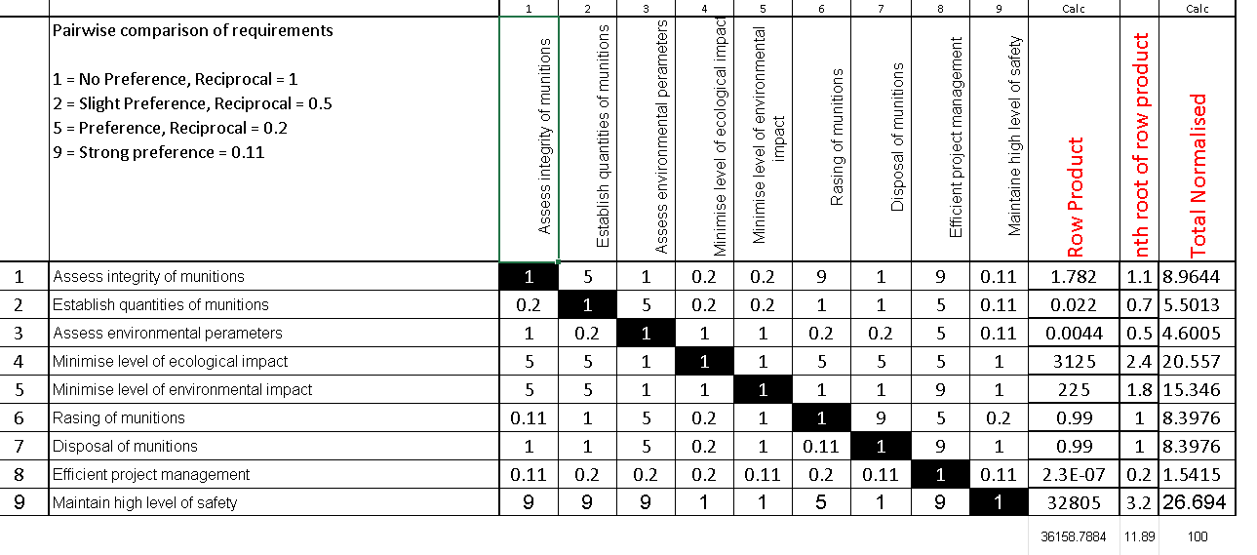
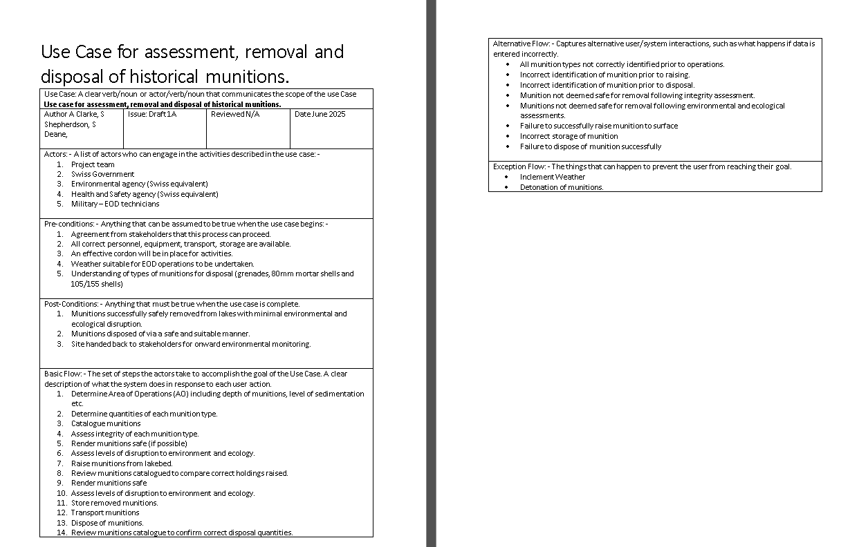

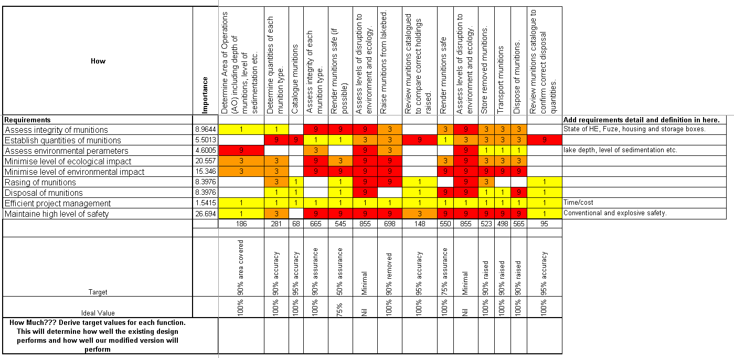
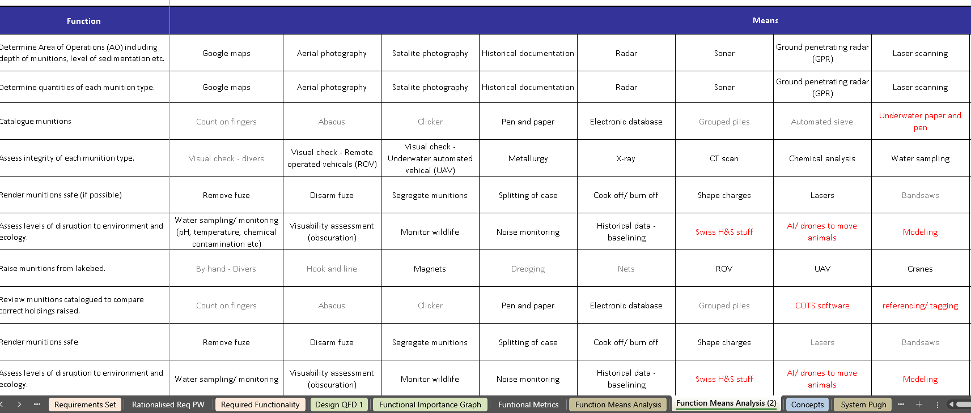

Appendix B

Slide pack
The screen shots below are of the slides the learner presented during the presentation. These are comprised of the brief, the systems engineering approach taken and summaries of the proposed steps to be taken for the assessment of the munitions.


