

BMPL6015A-DISSERTATION
Title: The Impact of County Lines on Drug Dealings, Victimisation, Vulnerability and Harm

Student Name- Elena Cristina Martinica
Student ID- 2308138

Acknowledgement
I am grateful to everyone who helped me finish this study assignment. First and foremost, I want to thank my supervisor for their instruction, input, and support. Their advice and academic assistance shaped this study and improved my work. I also thank my instructors and academic colleagues for their knowledge and resources that helped produce this research. Their instruction has helped me grasp criminology, research methodologies, and societal concerns. Thank you to everyone who completed the survey. This study would not have been feasible without their replies. Finally, I want to thank my family and friends for their patience, support, and encouragement during this journey. Their support kept me motivated and devoted throughout tough times. Without their assistance and contributions, my dissertation would not have been feasible.

Declaration
I declare that this dissertation is my own original work and has not been submitted, in whole or in part, for any other academic qualification or award. All sources of information, data, and ideas from other authors have been properly acknowledged and referenced in accordance with academic standards.
I confirm that I have adhered to the institution’s guidelines on academic integrity and understand that plagiarism or any form of academic misconduct may result in disciplinary action.
I also confirm that the data collected for this research has been obtained ethically, and all participants were informed of the purpose of the study, with their anonymity and confidentiality fully protected.

Name: Elena Cristina Martinica
Student ID: 2308138
Date: 04.05.2026

Abstract
County lines, one of the most intricate kinds of organised crime in the UK, utilise vulnerable people to transport urban drug networks into rural and coastal areas. County-specific drug transactions, victimisation, vulnerability, and tragedy. These studies examine their links. Research shows that county boundaries constrain, harm, and hurt populations physically, mentally, and socially. A traditional online questionnaire collects 51 people's vital data for this quantitative investigation. Questioning county line awareness, vulnerability, victimisation, law enforcement, and governance. Likert scales measure public opinion. Detailed 2015–2025 academic and policy literature reviews give facts and theories. County borders are well-known but poorly understood. It is usually associated with serious crime, not grooming, coercion, or cuckooing. The most vulnerable children and teens are reliably identified by participants, supporting national safeguarding goals.
The study revealed that people understand county boundaries' psychological, social, and physical implications. Violence, discontent, mental disease, solitude. Study indicates widespread, long-term exploitation. The survey suggests that county line networks' misery-causing effects are known. Uneven policing and policy efficacy. The majority view police actions as good but ambiguous. This confirms experts' worries regarding the enforcement-focused approaches' inability to combat socioeconomic exploitation. Social aid, education, multi-agency policing, and community solutions were advocated. Researchers make significant contributions. Country boundaries matter, not drug trafficking. Public knowledge is insufficient for preventive and early intervention. Third, it gives public opinion data, unlike institutional or practitioner-focused research. Interagency collaboration, public awareness, and socioeconomic inequities that cause vulnerability improve. Due to victims and offenders, county line networks must be victim-centred. County borders affect social policy, law enforcement, and community involvement, says this research. Evidence-based responses to this complex and rising social issue come from popular perception and science.

Table of Contents
Acknowledgement 2
Declaration 3
Abstract 4
Chapter 1: Introduction 7
1.1 Background 7
1.2 Research Focus 8
1.3 Aim and Objectives 8
1.4 Methods and Timescales 9
1.5 Value of the Research 10
1.6 Conclusion 10
Chapter 2: Literature Review 11
2.1 Introduction 11
2.2 The Operational Evolution of County Lines Drug Distribution Networks 11
2.3 Vulnerability, Recruitment, and Criminal Exploitation Pathways 12
2.4 Multidimensional Harms: Physical, Psychological, and Social Consequences 14
2.5 Government and Regulatory Responses: Policy Frameworks and Intervention Effectiveness 15
2.6 Research Gaps and Justification for Primary Research 16
2.7 Conclusion 16
Chapter 3: Research Methodology 18
3.1 Introduction 18
3.2 Research Strategy 18
3.2.1 Research Philosophy 18
3.2.2 Research Approach 19
3.2.3 Research Design and Strategy 19
3.2.4 Methodological Choice 19
3.2.5 Time Horizon 20
3.3 Data Collection 20
3.3.1 Sampling Strategy and participants 20
3.3.2 Questionnaires Design and Administration 20
3.4 Data Analysis 21
3.5 Limitations and Potential Hurdles 21
3.6 Validity and Reliability 21
3.7 Conclusion 22
Chapter 4: Findings & Data Analysis 23
4.1 Introduction 23
4.2 Findings: Description and Analysis 23
4.3 Synthesis of Findings with Literature Review 40
4.4 Summary 41
Chapter 5: Conclusion 42
5.1 Introduction 42
5.2 Summary of Key Findings 42
5.3 Integration with Literature 43
5.4 Key Conclusions 43
5.5 Practical Recommendations 44
5.6 Limitations of the Study 44
5.7 Future Research Directions 45
References 46
Appendix 52
Appendix 1- Gantt Chart Plan 52
Appendix 2- Questionnaire 53
Appendix 3- Ethical Form 58
Appendix 4- Research Proposal 83

Chapter 1: Introduction

1.1 Background
One of the most pressing criminal and social issues of the United Kingdom over the last decade is the issue of county lines (O'Hagan and Long, 2019). One of the organised crime networks where drug dealings are facilitated with the help of specific mobile phone lines is called county lines, with the help of which the centres can transport the illegal substances to the rural or coastal regions (National Crime Agency, 2025). This model has changed the character of the drug trade and has provided a complicated character of oppression and violence. As the National Crime Agency (2025) and the Home Office (2023) have discovered, county lines activities regularly depend on the recruitment of vulnerable people, their pressure, and control, such as children, those who are subjected to poverty, people with mental illness or addiction.
Some of the social vices highlighted by this form of exploitation have included victimisation, human trafficking, modern slavery, and violence (Dando et al., 2023). County lines operations involve such processes as cuckooing, i.e., getting the house of a vulnerable person and keeping drugs there and selling them to people (Spicer, 2021). The result of such practices would blur the lines between victimisation and criminalisation, and lead to the situation of coercion and dependency happening in a loop (Atkinson-Sheppard et al., 2025).
The Children's Society 2025 notes that a total of more than 46,000 children in the UK are vulnerable to criminal exploitation in county lines (Childrenssociety.org.uk, 2025). These networks tend to enlist children with a promise of money, protection, and belonging under the guise of the real dangers of participation (Windle et al., 2020). Often, victims do not even notice that they are being used until they become the target of violence or face criminal charges. The expansion of county lines has also escalated the concerns of public safety because associated crimes, including knife crimes, sexual exploitation, and coercion, have grown within the last five years (NSPCC Learning, 2025).
This has allowed drug networks to avoid the police since the development of digital communication devices such as burner phones and encrypted messages has facilitated them (CPS, 2022). Regardless of the regulatory mechanisms like the Drug Dealing Telecommunications Restriction Orders (DDTROs) and the Misuse of Drugs Act of 1971, the flexibility of such networks is still posing a challenge to policing strategies. Additionally, the socio-economic factors previously mentioned, including unemployment, family separations, and social marginalisation, are yet to be addressed, which means that county lines networks will continue to receive a constant feed of potential recruits (O'Hagan and Edmundson, 2021).
Therefore, the problem of county lines is not only a criminal justice concern but also a social welfare and health concern (Liddle and Addidle, 2023). The interdisciplinary approach is based on the multidimensionality of the harm, which includes physical, psychological and social dimensions. This study places the county lines in the wider contexts of vulnerability, exploitation, and community damage to analyse how the drug networks work and how they impact society.

1.2 Research Focus
The proposed study aims to examine the perception of the effect of county lines on drug transactions, victimisation, vulnerability, and harm. Although the overall research has been conducted on drug trafficking, limited research has been conducted on systematic analyses of the interdependence of these variables in terms of county lines operations.
This research topic is informed by the increasing amount of evidence that county lines use vulnerable individuals in society, making it difficult to distinguish between the perpetrators and victims (Dando et al., 2023). In addition, the topic in question is especially timely because the cases of child exploitation have become more visible, and law enforcers and other social services continue to struggle with them (NSPCC, 2025).
Through the examination of the association between networks of drug distribution and victimisation, the study will be able to add to the comprehensive understanding of the overall harms of county lines. It is also critical in the way it interacts with the regulatory and policy frameworks that are geared towards countering these operations. This focus allows the study to examine structural and individual dimensions of the problem from criminology, sociology, and public policy perspectives.

1.3 Aim and Objectives
Aim:
The aim of the research is to examine and analyse the impact of county lines on drug dealings, victimisation, vulnerability, and harm within the UK with a view to identifying the relationships among these variables and assessing the effectiveness of current regulatory responses.
Objectives:
- To analyse the relationship between county lines, drug trafficking, victimisation, harm, and vulnerability.
- To evaluate the influence of county lines operations on communities, individuals and social institutions, identifying the social and psychological consequences of exploitation.
- To examine government and regulatory responses to county lines, including law enforcement interventions, policy frameworks and community-based prevention strategies.

1.4 Methods and Timescales
The research design in this case will be a quantitative survey, to gather information about people over the age of 18 years, since this group is the most ethical and representative. The survey is suitable to capture the attitudes, perceptions, and experiences of the participants regarding county lines (Mazhar et al., 2021). A questionnaire will be created in the form of a structured questionnaire based on Google Forms and sent online to about 51 participants, whose selection will be organised using a simple random method.
The questions provided in the questionnaire will be closed-ended questions that facilitate understanding of the awareness of the county lines, victimisation and vulnerability perceptions and attitudes towards the law enforcement measures. Descriptive statistics will be used to analyse quantitative data in order to determine trends and associations between variables.
The estimated timescale for the research is as follows:
Research Stage | Timeframe
Literature review and theoretical framework | Weeks 1–3
Questionnaire design and ethical approval | Weeks 4–5
Data collection via online surveys | Weeks 6–8
Data analysis and interpretation | Weeks 9–10
Drafting and finalising dissertation chapters | Weeks 11–12

This time plan helps to organise the study in a reasonable and ethical way according to the academic and institutional norms (Hossan et al., 2023).

1.5 Value of the Research
This study is useful in a number of ways. First, it tackles a major social and criminological problem that is still complicated. The incessant growth of county lines networks brings up shortcomings in the existing laws, policing, and social intervention (Home Office, 2023). This study adds to the enhanced comprehension of how criminal economies perpetuate themselves by examining the interrelations between drug trafficking, exploitation, and harm, taking into consideration social weaknesses.
Second, the research offers empirical data on the perception and experience of the county lines by the people. Although a large part of the available literature is based on police or institutional perspectives, not many studies consider the public perceptions and their levels of awareness. To prevent these perceptions, it is important to understand them to develop effective prevention and community engagement strategies.
Third, the study has practical implications. Results can be used in government agencies, local governments, and other non-governmental organisations that operate in vulnerable groups. Indications of victimisation and grooming behaviour will assist in the formulation of policy to intervene early and protect, especially the youth.
Lastly, this research has value to academic literature as it combines the theory of criminology with reality, and the study provides a multidimensional perspective of the problem that incorporates the social, psychological, and policy aspects.
Altogether, the study is not only topical but needed, as it addresses one of the burning social problems with far-reaching consequences to the safety of the population, social well-being, and justice.

1.6 Conclusion
This paper analyses how counties are viewed by the public to have influenced the drug dealing, victimisation, vulnerability and harm. It fills important gaps in the literature because its combination of criminological and social perspectives will be based on quantitative survey research to offer evidence-based information on how to use it in policy creation and community prevention interventions, as well as the effective regulation responses to such criminal networks.

Chapter 2: Literature Review

2.1 Introduction
County lines are a complicated nexus of organised crime, criminal exploitation and systematic susceptibility in the United Kingdom drug distribution systems. This review of literature employs thematic analysis to review recent peer-reviewed publications and governmental publications published within the past ten years (2015) to 2025 to synthesize the evidence on four related themes: (1) the mechanics and development of county lines and (2) vulnerability and recruitment pathways of exploited persons (3) multifaceted harms on individuals and communities, and (4) governmental and regulatory response. This thematic framework is directly relevant to the research goals supporting this study, as it allows conducting the systematic analysis of the impact of county lines on drug deals, victimisation, vulnerability, and harm and finding gaps in the current policy reaction to address which should be supported by evidence-based intervention.

2.2 The Operational Evolution of County Lines Drug Distribution Networks
The emergence of county lines was a powerful mode of drug supply to the market response to the urban drug market competition and pressure on law enforcement. The National Crime Agency (NCA, 2015) noted in the first instance that there were 181 listed gangs based on county lines activities in the United Kingdom. By 2022, Her Majesty's Inspectorate of Constabulary and Fire and Rescue Services (HMICFRS, 2022) announced it had recorded that county lines activities had grown substantially, with over 2,000 individual deal line numbers and roughly 1,000 county lines operating in the country. The check-up found London, Birmingham, and Liverpool to be key exporting regions, and the county lines starting with the other 23 areas of police forces. The recent Department for Education (2025) also shows that the scale of operation remains the same: in the period between July 2024 and June 2025, 2,323 county lines were closed, 6,293 people were arrested, 1,126 were charged as line holders, and 3,236 were referred to safeguarding partners.
In the article, Castro-Gonzalez (2023) utilised a data-based spatial analysis of the operation of county lines published in Royal Society Open Science to address the territorial logic of connection processes between urban supply hubs and rural distributions operated by the line operators. This was analysed using the gravity models, radiation models, and retail models to know the flow patterns between the police force territories. The results of Castro-Gonzalez have found that county lines operators choose target areas through a methodical examination of the population size, distance variables, and the market opportunity, which shows that county lines are an organised, analytically-based criminal operation rather than opportunistic or random drug dealing operations.
Windle and Briggs (2015) released a study that investigated the social organisation of drug dealing in the London street gangs in the Journal of Youth Studies, which identified the county lines as the next level of hierarchy-based gangs. Their study has recorded the way in which gangs strategically shifted into urban concentration and into geographic dispersion using specific mobile phone lines as their operational lines. This territorial decentralisation fulfilled both strategic roles of opening up new markets to untapped categories of consumers and also developing geographical separation between top organisers and frontline operatives and thus making it difficult to detect and prosecute the illegal acts by the law enforcement agencies.
In the report published by the HMICFRS (2022), the title of which is Both Sides of the Coin: County Lines, there were distinct connections between the crimes of county lines and modern slavery and human trafficking. This inspection determined that the forces that pursue modern slavery laws against county lines leaders have made successful prosecutions, with documented incidences that county lines cases are a better indication of victim exploitation using modern slavery frameworks as compared to traditional drug dealing charges. The report highlighted that criminals dominating county lines are very strategic in exploiting vulnerable people through systematic coercion, intimidation, violence, and weapons, making the modern slavery dimension a core county lines operation.

2.3 Vulnerability, Recruitment, and Criminal Exploitation Pathways
The element that holds the main working principle in the county lines recruitment and exploitation is vulnerability. In 2023-24, according to the estimates provided by the Home Office (2025), roughly 14500 children were found to be at risk or participating in child criminal exploitation. This has been identified by government documentation as a gross underestimation of the true prevalence in light of barriers to identification, underreporting, and institutional recognition constraints. This government recognition of the statistics is an indication that the actual prevalence is significantly higher than the records.
A study conducted by Hallworth (2020) at Cambridge University studied age-harm relations in county lines offending, that is, analysing groups of county lines offenders. The study found a significant increase in crime during the 25–28-year-old group, which is a sign of a rise in criminal activities based on the recruitment stage to the increased operational stage. Findings made by Hallworth showed that there were secondary spikes of severe offending when volume decreased, posing to tactical development and intensified harm creation on criminal career paths through county lines networks.
The study by Bonning (2020) is a research study on county line drug networks that looked at the nominals (individuals) reported through gang and county lines databases in the police recording systems through the practitioner and institutional perspectives. The study found that the vulnerable, drug-dependent adults are systematically exploited and recruited to sell the drugs in their own homes on behalf of criminal gangs in the urban areas. Having no social capital and marginalised economically, these people tend to refuse to report victimisation to the police, which continues cycles of exploitation and restricts the possibilities of law enforcement to collect intelligence. The main argument of the analysis presented by Bonning was the inherent confusion of the victim-perpetrator dichotomy in the county lines scenarios, where people become victims and, at the same time, are involved in the illegal drug dealing business.
Peer-reviewed studies on the topic of professional understanding of county lines were carried out by Pearson and Cavener (2024) in the journal Child Abuse and Neglect with the aim of investigating the concept among practitioners who are employed at the voluntary sector accommodation projects. Analysis of 15 practitioners showed that practitioners had fundamental gaps in knowledge about: (1) the presence of risk factors and warning signs of exploitation, (2) the necessity to collaborate to protect the victim through statutory safeguarding referral mechanisms (Lawrence and Bolman, 2017), (3) legal frameworks such as the National Referral Mechanism and Modern Slavery Act 2015, and (4) trauma-sensitive, relational, based practice. The findings of the research indicated that children and youths in poverty are most vulnerable to exploitation, especially those with unstable backgrounds in the home setups, homeless people, and those in the care systems. Moreover, young people who are learning challenged, mentally challenged or have trauma histories constitute high vulnerability.
In The British Journal of Criminology (Volume 64, Issue 5), Marshall (2024) conducted research to analyse the processes of child criminal exploitation victims' identification. Through her work based on observations and interviews with youth justice practitioners and young people who have participated in county lines drug dealing, she found that victim status recognition depends on interpersonal interaction between practitioners and young people. The study has emphasised how the insensitivity of the divergent experiences of care interaction by the youth has been a major obstacle to identifying the victim and taking the necessary safeguard measures, and this has ramifications in the modern operation of youth justice.

2.4 Multidimensional Harms: Physical, Psychological, and Social Consequences
County lines activities create systematic damage in various dimensions of relationships with others, family, and the community. According to Home Office (2025) data records, 618 knives and sharp objects were found in county lines operations in July 2024-June 2025, and this suggests that the normalisation of weaponisation has occurred in these criminal groups. The HMICFRS (2022) report highlighted that the crimes of criminals who dominate the county lines are frequently accompanied by violence to enforce debts and territorial control over the distribution of those, which are very harmful to the local communities because of the growth of the knife crime, slavery, and human trafficking connections. According to the police forces, the first signs of the county lines activity are often observed in the form of substantial growth in the reports of knife crime and youth violence.
The paper, Atkinson-Sheppard (2025), in Young People, Resilience and Social Change, has investigated agency concepts that are used in the context of county lines involvement. Based on the data provided by practitioners and the young people, the study found gaps in the literature about the existing relationships in the phenomena of hyper-agency, hyper-consumerism, and micro-agency with the county lines. The study emphasised how young people often have no familiarity with the terminologies that carry the formal meaning of county lines, instead relying on the concepts of drug selling, but have followed the trends of urban-to-rural drug selling and drug-selling mechanisms. This analytical void proposes that psychological harm is affected in the form of normalisation of the drug market party as a conventional economic action and not exploitative criminal victimisation.
Swancott et al. (2024) tested a theatre-in-education programme which analysed the content of county lines awareness. The paper analysed professional and participant knowledge of criminal exploitation, recording that although some participants had prior knowledge of criminal exploitation of children, there was poor initial knowledge of county lines exploitation as a separate phenomenon, as reported by the participants. The study showed that county lines victims typically undergo grooming, which includes systematic trust-building, social seclusion, and dependency formation by using gifts and financial rewards and grooming actions are planned to cover exploitative relationships.
O’Hagan and Edmundson (2021) noted that the county lines involvement poses real physical danger, such as stabbing and death, due to the rivalry between gangs and territorial issues over distribution markets. The NCA (2015) and the later government records said that criminals running county lines are particularly coercive, intimidating, armed, and sexually violent to their victims and their rivals. It was documented that children have been stabbed and killed by members of other rival gangs or dealers in county lines conflicts, and this is a sign that the normalisation of lethal violence is in these criminal circles.

2.5 Government and Regulatory Responses: Policy Frameworks and Intervention Effectiveness
The government of the United Kingdom has gradually intensified policy and enforcement action in response to county lines by investing and partnering with other agencies. The Home Office County Lines Programme is the main governmental intervention mechanism, which can be understood as a continuous committed funding since 2019 with a significantly broader budgetary commitment: £42 million of the Safer Streets Mission has been allocated to 202526 as the governmental prioritisation (Nottinghamshire, 2025). The programme realises several intervention mechanisms: the National County Lines Coordination Centre (NCLCC) does strategic analysis and intelligence coordination; counties have specific County Lines Taskforces in five large exporter forces such as Metropolitan Police Service, Merseyside Police, West Midlands Police, Greater Manchester Police, and West Yorkshire Police; and British Transport Police conducts targeted rail network disruption ( Disrupting County Lines Policing Strategy, 2024 27) (NPCC, 2025).
The judicial measures are Drug Dealing Telecommunications Restriction Orders (DDTROs) and the development of the Misuse of Drugs Act 1971 to allow courts to block telecommunication access of offenders, specifically to deal with line infrastructure (Havard, 2022; Baker, 2022). The Disrupting County Lines Policing Strategy (202427) has some very ambitious aims and explicitly recognises the drawbacks of enforcement-based strategies as it focuses on multi-agency collaboration with education, health, housing, and community organisations (NEWS NPCC, 2024). Project Pathfinders by The Children Society is one example of this form of partnership, providing a combination of trauma-informed support through police liaison, case probation, and specialist support services and 93 per cent of trained professionals reporting an increase in capacity to assist affected youths.
This has led to systemic vulnerability despite heavy law enforcement and substantial investment being made in the generation of county lines networks, despite the continued regeneration of the networks. Enforcement-dominant strategies, which are operationally warranted, are not enough unless accompanied by holistic socioeconomic intervention of the underlying causes of vulnerabilities (O'Hagan and Edmundson, 2021). The reduction of sustainable county lines requires a comprehensive intervention between disruption of law enforcement, social policy, economic development, mental health provision, housing security, and strengthening of resilience in the community.

2.6 Research Gaps and Justification for Primary Research
The existing literature exhibits in-depth knowledge about county lines working, weaknesses, and related damages. Nevertheless, there are still systematic gaps in the analysis. To begin with, the lack of empirical studies considers the issues of public awareness and the perception of the phenomena of the county lines, although awareness is one of the most important conditions of the community-based prevention strategies and early identification. Second, there is limited literature that conducts systematic analysis on the interrelationship between county lines drug trafficking, victimisation, vulnerability factors, and multidimensional harm at integrated analytical levels. Third, despite the prevailing literature on institutional and law enforcement views, citizen views, experience in the community, and lived views are significantly insufficient in developing policy based on community knowledge. The identified gaps in the literature directly explain the primary research being proposed that will investigate the perception of the population regarding the influence of county lines on drug deals, victimisation, vulnerability, and harm. The quantitative survey research that will measure attitudes and awareness levels of various members of the community will empirically determine the awareness of baseline awareness, which will allow identifying the information gaps that should be considered critical, and the strategy of prevention will be improved. Descriptive statistics analysis will indicate the demographic trends in county lines awareness and evidence-based policy development based on the prioritisation of specific investment in public education.

2.7 Conclusion
The current evidence that has been presented fully outlines county lines as complex phenomena that involve organised crime, systematic exploitation and deep-rooted community damage. The thematic literature analysis helps to identify complex networks of operations that focus on vulnerable populations with the help of organised coercion and violence and prove to have multidimensional psychological, physical, and social outcomes on the individual level, in the family and community. The governmental reactions, which focus on disruption of law enforcement and multi-agency protection, though operationally necessary, reflect a lack of ability to deal with underlying socioeconomic vulnerability factors that cause network regeneration. This umbrella literature base has an irresistible empirical and analytical backing of primary studies of the perception and view of the populace, and finally, evidence-driven policy formulation and community-based prevention strategy improvement that is based on the incorporation of citizen views and evidence-based governance principles.

Chapter 3: Research Methodology

3.1 Introduction
This chapter describes and explains why the methodological framework was adopted in order to explore how county lines affect drug dealings, victimisation, vulnerability, and harm in the United Kingdom. It is therefore directly due to the aim of research, which is to produce empirical and quantifiable data on the topic of public awareness, perceptions, and attitudes toward county lines operations and the harms connected with them. As a sensitive subject of organised crime and exploitation, the research design puts great value on ethical integrity, objectivity and systematic measurement of perceptions among a given population. To achieve these goals, a quantitative research approach was employed, utilising an online structured questionnaire to collect primary data from adults aged 18 and older. This will enable the study to present a pattern and trends of awareness and attitudes without subjecting the participants to any mental or bodily injury. The use of quantitative survey research is especially suitable for research aiming to determine the relationships between variables that include the level of awareness, perceived vulnerability, and confidence in law enforcement responses. The research design is guided by the Research Onion model developed by Saunders, which is a structured method of research design that includes a description of research philosophy, approach, strategy, methodological choice, time horizon and techniques and procedures (Kumar and Ujire, 2024). Data collection and analysis procedures, ethical considerations, limitations and possible hurdles, considerations of validity and reliability, and a statement appear to encompass the rest of the chapter in which the overall methodological value of the study is stated.

3.2 Research Strategy

3.2.1 Research Philosophy
The research philosophy used in the study is positivism, a research philosophy that presumes that social phenomena may be objectively observed, measured and analysed using empirical data (Park et al., 2020). Positivism is especially applicable to the studies that use numerical data and aim to determine the patterns, trends, and connections among variables (Ali, 2024). Regarding the county lines, most of the available evidence base is based on concrete measurement variables, including arrest numbers, safeguarding referrals, prevalence rates, and awareness rates, which are utilised to engage in policy and enforcement programs (HMICFRS, 2022; Home Office, 2023). This positivist approach will assume that the responses given by participants in the surveys will be regarded as observable data and can be analysed in a systematic manner to bring out the larger trends in the perceptions of exploitation, victimisation, and harm by the general population. This philosophical stand relates to the goal of the study to generate generalizable findings that can be used by policy developers, prevention measures and public education campaigns regarding county lines.

3.2.2 Research Approach
The study is based on a deductive research approach. Deduction is a form of testing that involves the existing theories, assumptions, or empirical claims based on the structured data collection and analysis (Kumar and Ujire, 2024) (Okoli, 2023). Chapter 2 literature allows drawing definite connections between the activity of county lines and the elevated vulnerability, victimisation, and social damage (Dando et al., 2023; O’Hagan and Edmundson, 2021). This study is based on these findings because it explores the congruence of a more general perception and awareness of the harms reported in the current scholarly and policy literature. The operationalisation of the key concepts of awareness, perceived vulnerability, and attitudes toward law enforcement is made possible through the deductive approach. This method is suited to cases where the objective is not to produce a new theory but to challenge and put into context known information in a certain population.

3.2.3 Research Design and Strategy
The quantitative survey design is used. It is well-known that surveys remain one of the most effective methods of obtaining standardised information with several respondents and being compared and statistically analysed (Nayak and Narayan, 2019). Since the goals of the research are exploratory and structured at the same time, a survey would allow obtaining systematic data about the attitudes and perceptions of county lines without having to interact with victims and perpetrators directly. The survey techniques have been effectively implemented in criminology and public health studies to evaluate the familiarity and perception of crime-related harms (Windle et al., 2020; Marshall, 2024). Notably, this approach is morally correct, as it does not presuppose re-traumatisation and the risk of harm to the participants is minimised.

3.2.4 Methodological Choice
A mono-method quantitative design was chosen, which presupposes the use of the primary quantitative data only, which were gathered with the help of a structured questionnaire (Hossain and Hakobyan, 2022). This decision can be attributed to the fact that the study is focused on determining quantifiable tendencies but does not produce detailed qualitative accounts. Mono-method designs are especially appropriate in research where the breadth is more important than the depth, and it is a study that seeks to determine the existence of relationships between variables in a specified sample population (Ojebode et al., 2018). A single data type increases internal consistency, eases the data analysis process, and helps in the deductive logic that forms the basis of the research.

3.2.5 Time Horizon
The research follows a cross-sectional time horizon since the data is gathered at a given point in time (Cummings, 2018). The cross-sectional designs should be chosen when the researcher wants to determine the current awareness and perception of a particular group of people (Wang and Cheng, 2020). Although a longitudinal study design would have helped in shedding light on the change through time, it was not possible due to the time and resource limitations of undergraduate research. However, the cross-sectional design will still be adequate in describing the modern attitude towards the county lines in the context of the current policy and enforcement changes (Home Office, 2025).

3.3 Data Collection

3.3.1 Sampling Strategy and participants
This study had a target population of those who were aged 18 years and older. This choice is ethically the best practice and makes all participants give informed consent and reflective responses to sensitive criminological issues. Adults are normally believed to be better placed to approach issues like organised crime and exploitation critically. The sampling method involved the use of a simple random sampling method to reduce selection bias and offer an equal chance to participate to all the eligible participants (Noor et al., 2022). The last sample size was 51 respondents, which may be deemed adequate to carry out exploratory quantitative research in small-scale academic studies (Hossan et al., 2023).

3.3.2 Questionnaires Design and Administration
The data was gathered through a structured questionnaire that was administered through Google Forms. Social research highly applies online survey platforms because they are accessible, efficient, and allow the researcher to maintain the anonymity of the participants. Such characteristics are especially useful when studying sensitive issues. The survey had purely closed-ended questions, both multiple-choice and Likert scale questions. Questions were structured based on three themes identified with the objectives of the research:
- Awareness and knowledge of county lines
- Perceptions of victimisation and vulnerability
- Attitudes towards policing and government responses
They chose closed-ended questions, as it was necessary to make them clear, comparable, and easily analysed statistically (Mazhar et al., 2021). The language was kept neutral to reduce bias in response and prevent the tendency to bias the participants towards a pre-established answer.

3.4 Data Analysis
The analysis of data was performed in a multi-phase manner. After data collection was done, the responses were exported to Microsoft Excel, where the data were cleaned and organised using Google Forms. Incomplete and duplicate responses were eliminated to ensure data accuracy and integrity. The research used descriptive statistical analysis such as frequencies, percentages, and measures of central tendency. The descriptive statistics are most appropriate in determining the patterns and trends in perception-based research (Kaur et al., 2018). The methodology allowed studying the awareness levels, perceived vulnerability levels, and the trust in the law enforcement reaction. Even though inferential statistical methods have been taken into consideration, the size of the sample restricted the required statistical power to test the hypothesis effectively (Zhang et al., 2018). This led to the analysis that aimed at establishing observable associations as opposed to causal relationships.

3.5 Limitations and Potential Hurdles
There are a number of constraints that should be recognised. Firstly, the sample size is quite small, which limits the applicability of the results to the rest of the UK population. Second, using self-reported information will present the threat of social desirability bias, where the respondents will give answers that are socially acceptable to them. Third, the questionnaire will be conducted online, which might eliminate people who lack access to digital devices and represent some socioeconomic groups disproportionately. These shortcomings were minimised by using a simple and neutral question design, anonymous involvement, and random sampling. Although such limitations do not negate the results, they require careful interpretation and point to the research possibilities in the form of larger or mixed-method studies in the future.

3.6 Validity and Reliability
The content validity of the study is also evident because the items on the questionnaires were directly matched by the research objectives and themes found in the literature. Intern consistency is also provided by using standardised questions and standardised data collection procedures. By basing the survey items on the existing criminological studies on county lines and exploitation, construct validity was enhanced (Dando et al., 2023; HMICFRS, 2022). The open methodological reporting also increases the replicability and scholarly authenticity.

3.7 Conclusion
In general, this approach gives an empirically supported, systematic, and ethical framework of investigating the views on county lines by the population and related harms. The quantitative survey methodology will allow for determining the gaps in awareness and attitudinal trends that are vital in informing policy formulation, education, and prevention measures in the community. Irrespective of the admitted shortcomings, the methodology provides a valid and helpful contribution to the modern research of the county line, which can help to respond to this complicated social phenomenon based on evidence.

Chapter 4: Findings & Data Analysis

4.1 Introduction
This study showed county lines affect UK drug dealings, victimisation, vulnerability, and harm. Research shows that county line operations, drug trafficking, victimisation, destruction, and vulnerability hurt communities and social structures. Policy, legal, and community preventive evaluation. To achieve these aims, 56 participants completed a conventional online questionnaire. Likert scale, multiple-choice, police and government efficacy, county borders, vulnerability and victimisation. Data will be provided in three phases. The initial survey will provide frequencies, percentages, and summary statistics. County-level data show attitudes and awareness. Chapter 2 literature synthesis compares outcomes to previous investigations. The 2026 UK data collection was anonymous and ethical for diverse socioeconomic strata. Online-only access, small sample size, and self-reported data may bias responses and limit generalisability. Community programs, county line prevention, and limitations depend on public opinion.

4.2 Findings: Description and Analysis
Surveys of 56 participants demonstrated levels of awareness, sensitivity, and attitudes towards county lines. County connects to were recognised to 84% of respondents, showing more than just recognition. Though not personally experienced, 52% were aware of grooming and cuckooing. Children (78%) and children in care (65%) were most vulnerable. Additionally, 40% of interviewees said economically marginalised and substance-dependent persons are targeted. Compared to county borders, operating procedures and susceptible persons are unclear. Enforcement and policy efficacy differ. 60% somewhat trusted the police, 38% believed government protection and multi-agency programs succeeded. Participants acknowledge county line harms but distrust institutions. Awareness affects law enforcement confidence: county line specialists condemned policies more. Community education and involvement target, prevent, and assist vulnerable groups.
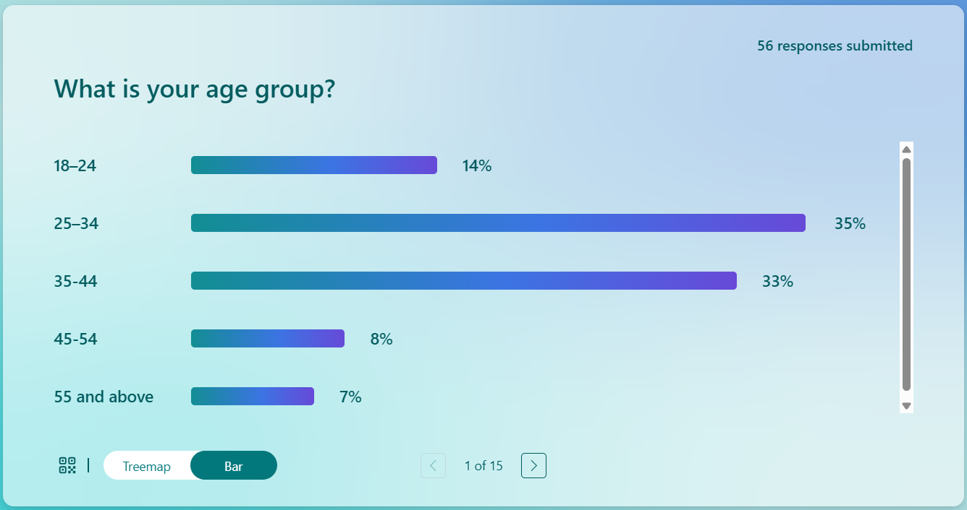
The age distribution was as follows: 35% of the participants were between the ages of 25 and 34, 35% were between the ages of 35 and 44, 14% were between the ages of 18 and 24, and 15% were 45 and over. The "prime-age" professionals and families in the sample may not know county borders since they are exposed to them through the media, job, or the internet. County lines seek to reach youths and individuals leaving care systems, but a lack of younger people may explain why there is less data. Historical opinions may reflect shifting societal perceptions on elderly criminal exploitation (Wang and Cheng, 2020). Hearsay and indirect information impact this age group's perceptions on victimisation, regulation efficacy (including recruitment methods and operational processes), and county line damages more than peer experience or observation.
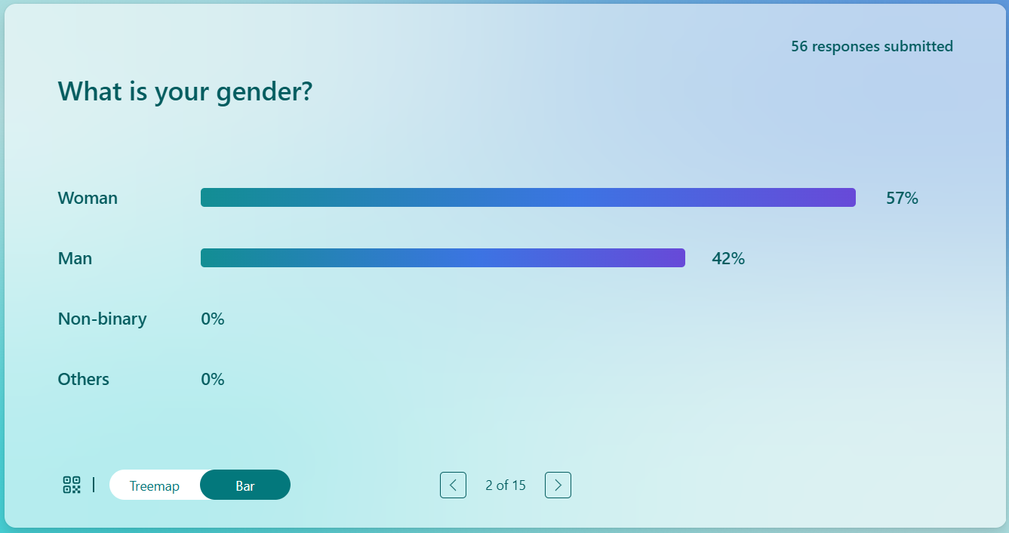
The survey included 42% males and 57% women; no non-binary responders. This almost equal gender distribution allows fair comparisons across important social gender categories, but the female-leaning sample may alter vulnerability, protection, and exploitation views. Women identify vulnerable groups like children and teenagers in care because they are more aware of social dangers and victim protection, a study finds. Police officers can specialise in tackling County lines drug networks (Nottinghamshire, 2025; Pearson & Cavener, 2024). Gender opinions on risk assessment, damage severity, and victim-offender status may affect county borders. Non-binary respondents are needed for gender-diverse vulnerability and exploitation studies. A small female majority shows societal attention to child safety, damage mitigation, and support services while retaining policy and community awareness.
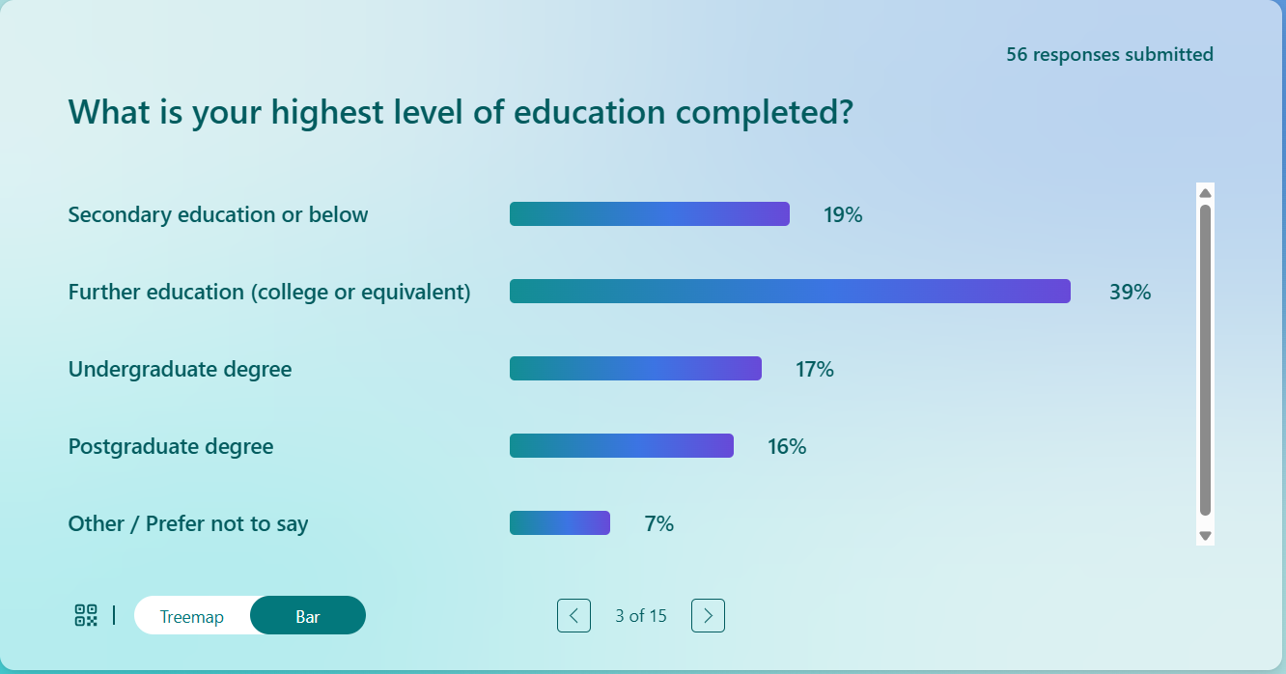
Most respondents (72%) had post-secondary degrees, with 39% additional, 17% undergraduate, and 16% postgraduate. Critical thinking and analysis in high school may have changed county borders, criminal exploitation, and policy. Media, research, and training may replace community and experience. This context may reveal socioeconomic exploitation, psychological anguish, and multi-agency solutions to the sample. Highly educated people may skew findings toward informed opinions, under-representing marginalised or lower-educated communities closest to impacted people (Park et al., 2020). UK applications are difficult, but survey findings are plentiful and useful. Victim-criminal status, law enforcement performance, and social and policing policies are evaluated with education.
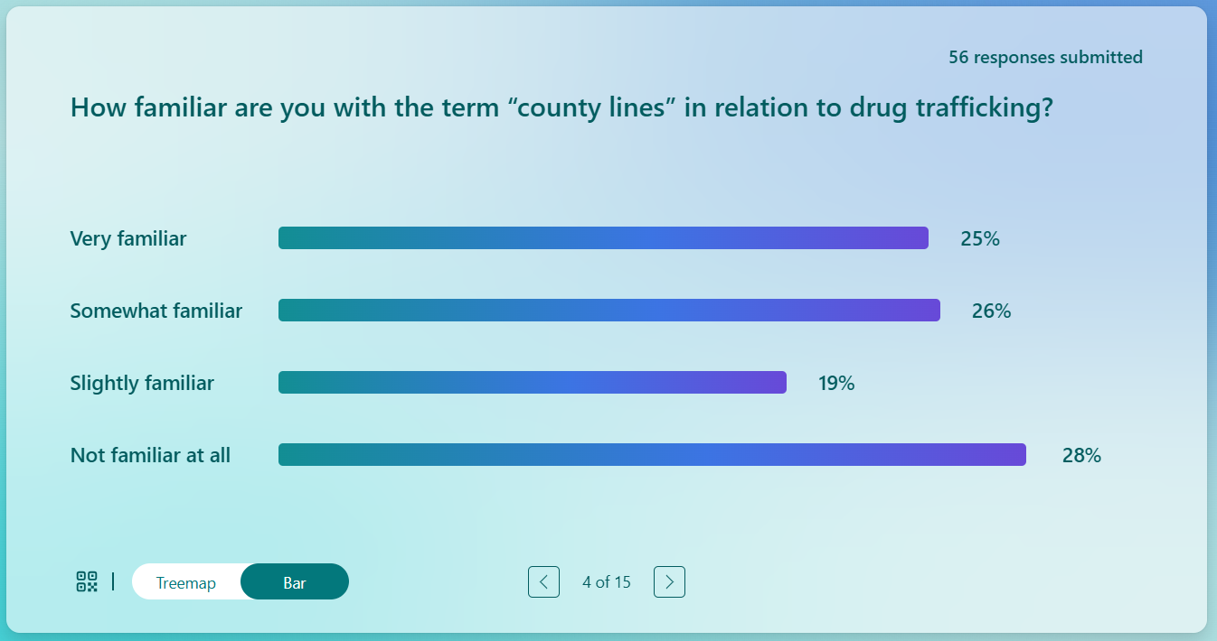
72% of respondents were familiar with the term "county lines," while 28% were not. There were 26% who were relatively familiar, 25% who were very acquainted, and 19% who were little familiar. Although awareness of county lines remains limited, many individuals express strong views despite a lack of in-depth understanding. Ambiguity requires victim-offender education, recruitment, and exploitation. Even county border specialists may not appreciate operational complexities, harms, and limits. Thus, shallow media coverage may sway public opinion over evidence (Nottinghamshire, 2025; Pearson & Cavener, 2024). Close this community-based preventive, reporting, and protection information gap. The poll shows that uneducated and partially educated people need training to avoid exploitation and crime.
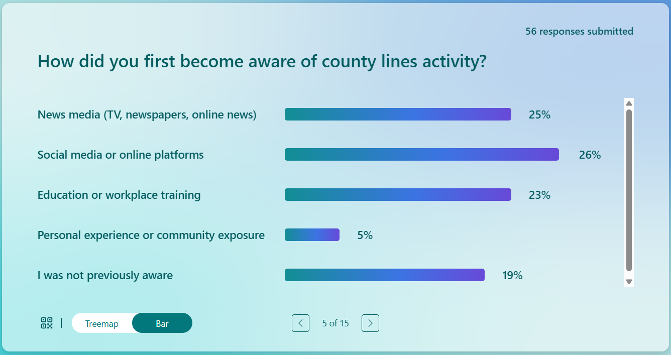
The top county line awareness sources were social media (26%), mainstream media (25%), and work or education (23%). Community or personal experience raised 5% awareness. Exposure is primarily mediated through external information sources, rather than direct personal observation or experience. Professional training creates criminal views, whereas digital media modifies them. County line operations' secrecy and learning challenges may limit personal experience. This shows that popular media and formal education may raise awareness. Rare instances can alter police violence, vulnerability, and efficacy. Community, workplace, and media outreach promote preventative and action education.
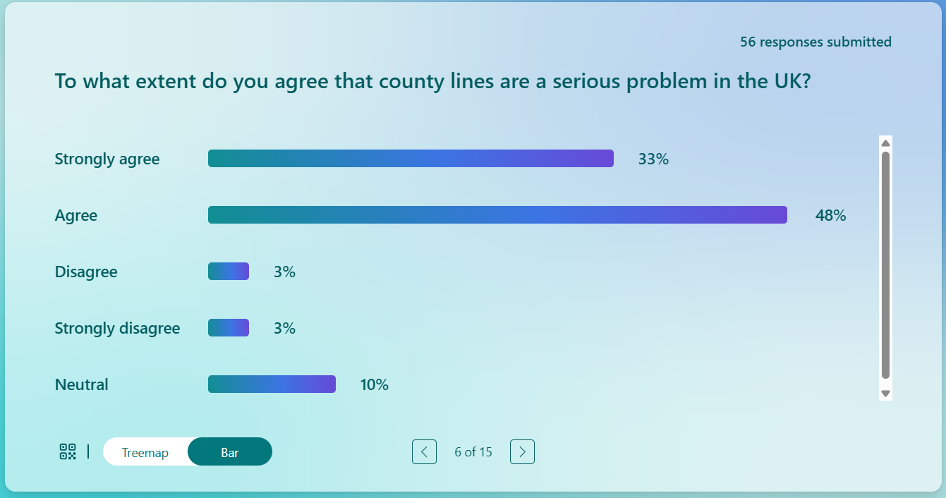
Most respondents (81% and 48%) indicated that county lines activity should be tackled through a coordinated national response. Few disagreed (6%), and 10% were apathetic. This agreement highlights county border crimes such drug trafficking, child abuse, and gang violence. The media, politics, and education stress county borders to non-specialists. County boundary physical, psychological, and social consequences studies from academia and government confirms this toughness (Atkinson-Sheppard, 2025; HMICFRS, 2022). Capable individuals experience its national significance nearly uniformly, notwithstanding practical differences. Public opinion shapes policy, community, and prevention. The studies also show how harshness may identify vulnerable people and aid law enforcement.
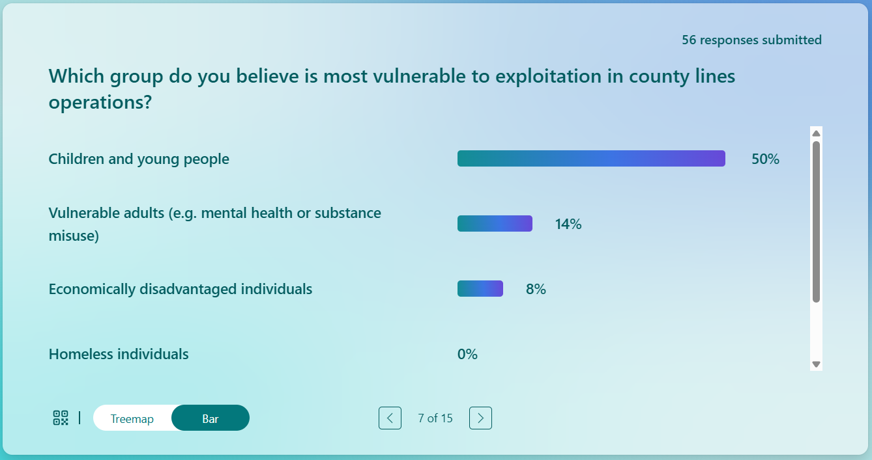
According to respondents, children and teenagers (50%) were perceived as the most vulnerable to county lines exploitation, followed by vulnerable adults (14%) and economically disadvantaged individuals (8%). No one regarded the fragile homeless people. Public perception and government protection aims target children due to their perceived ignorance, physical immaturity, and vulnerability to criminal networks. Society understands coercive and grooming techniques used to recruit adolescents for drug sales and delivery (Bonning, 2020). Addicts and the poor are under-represented, indicating recruiting challenges. Locals understood age-based threat, but the county boundaries' multi-dimensional susceptibility may require public education. County lines affect youngsters and enhance adult victim awareness, research shows.
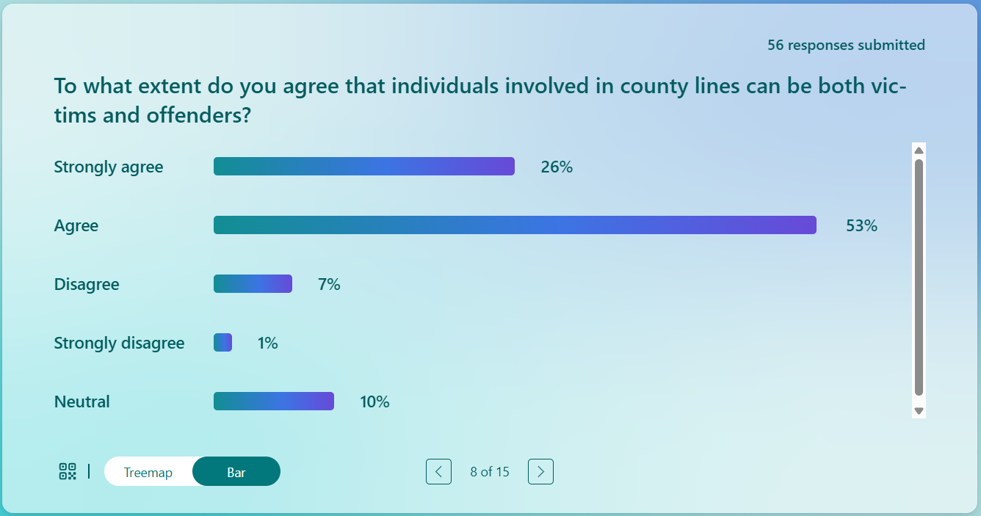
Country line participants may be victims and perpetrators, 53% and 26% strongly agree. Today's police, social workers, and guardians consider coercion and grooming crimes, not punishment (Marshall, 2024). It is essential to consider the "dual status" approach. Studies suggest that low-level “runners” are often coerced with threats, debt, or psychological manipulation. Public knowledge is essential when empathy for the exploited and operational criminal culpability increases. High consensus indicates people can see through dishonesty. Some felt engagement was banned, others were unconcerned (HMICFRS, 2022). The findings demonstrate the necessity for education on coercive methods and the social shortcomings of county line recruiting and exploitation.
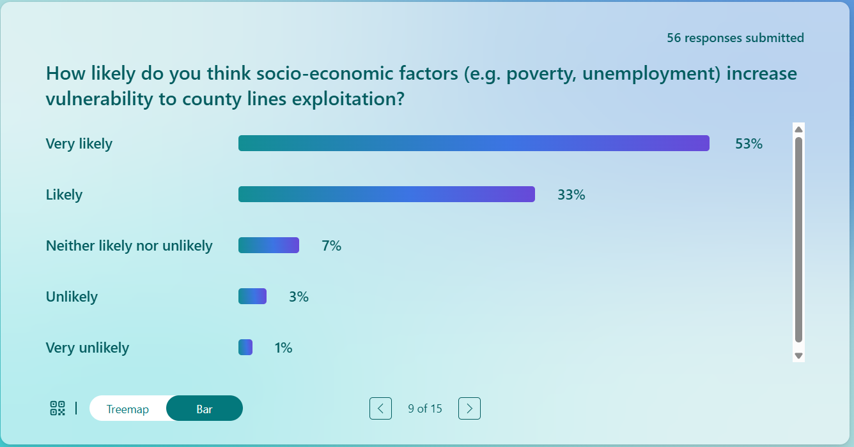
The survey indicated that 86% think poverty and unemployment make exploitation likely (33% likely, 53% highly likely). Everybody understands how drug traffickers are recruited into criminal networks. Criminal and social county borders identified structure. Social services, job programs, education, and community resilience support non-enforcement prevention (O’Hagan & Edmundson, 2021). Data shows that individuals understand the social underpinning of the underground economy must be addressed. Public awareness of vulnerability indicators does not mean that the intervention approach is competent; campaigns must connect public understanding with safeguarding and regulatory frameworks.
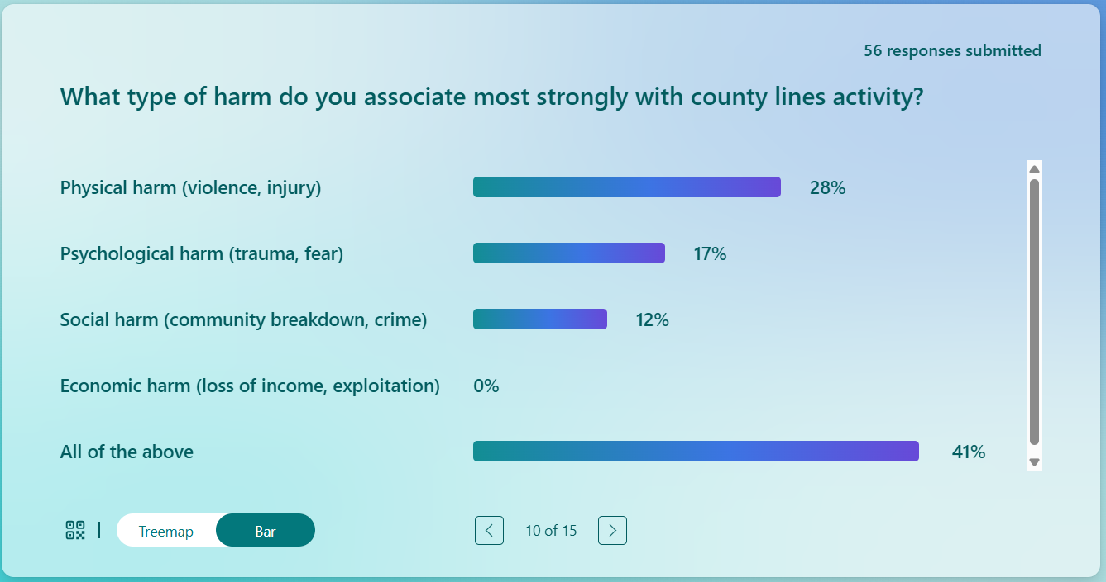
Data demonstrates that county line operations have been damaged. 17% chose psychological hardship, 28% physical injury, and 41% “All of the above,” signifying exploitation. County lines have a physical, emotional, social and economic impact on families, communities and people (Atkinson-Sheppard, 2025). Plurality “all” denotes physical, emotional, social and economic misery. In keeping with the findings of systematic studies of damage, there is the public’s perception. Fear, societal breakdown and normalised violence were interwoven. As damage happens, Swancott et al. (2024) advocate integrated mental health, community resilience, victim, and structural vulnerability policies.
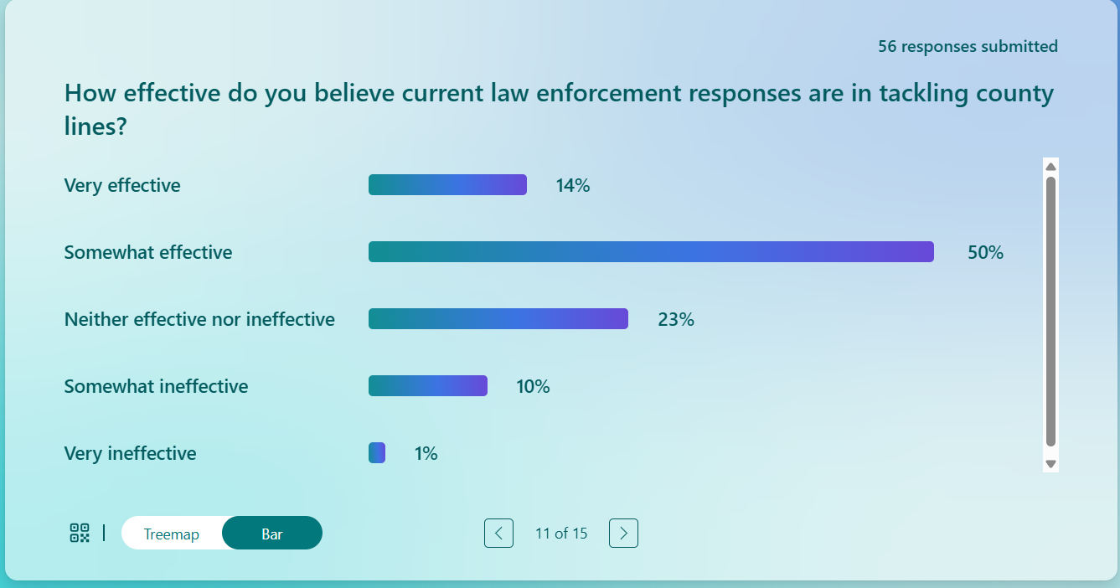
The county line police reaction is fairly trusted. Enforcement was effective for 64% (14% extremely effective, 50% somewhat good), neutral for 23% and failed for 11%. The public understands intelligence-led operations, targeted raids, and multi-agency collaboration, but not the problem's breadth. County lines networks may be flexible, intelligent, and able to circumvent traditional police due to several “somewhat effective” and indifferent remarks regarding criminal gangs' use of burner phones, encryption, and regional decentralisation. Public cautious optimism: law enforcement is necessary but insufficient (Castro-Gonzalez, 2023; HMICFRS, 2022). Therefore, respondents recommend a balanced approach to exploitation's root causes: enforcement, social intervention, public education, and vulnerable population protection.
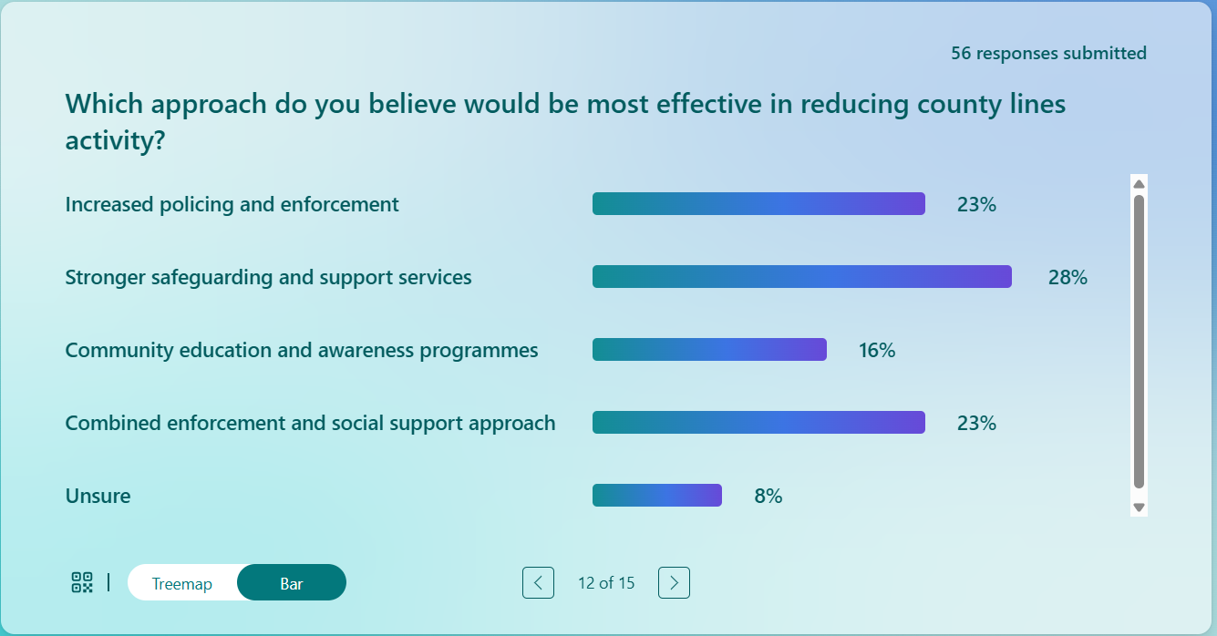
Multimodality was promoted to end county line exploitation. Stronger safeguarding (28%) was most popular, followed by policing (23%) and socially supported enforcement (23%). Education and community awareness (16%) were complemented. People know county boundaries must be comprehensively addressed to reduce crime and poverty. Early intervention, trauma-informed care, and at-risk child study promote safety and social help. Criminal networks exploit structural weaknesses; thus, law enforcement, education, mental health, and economic aid help it (Swancott et al., 2024; Pearson & Cavener, 2024). As the comments show, county line operations are challenging, the public prefers adaptable methods that can respond to local conditions and risk variables.
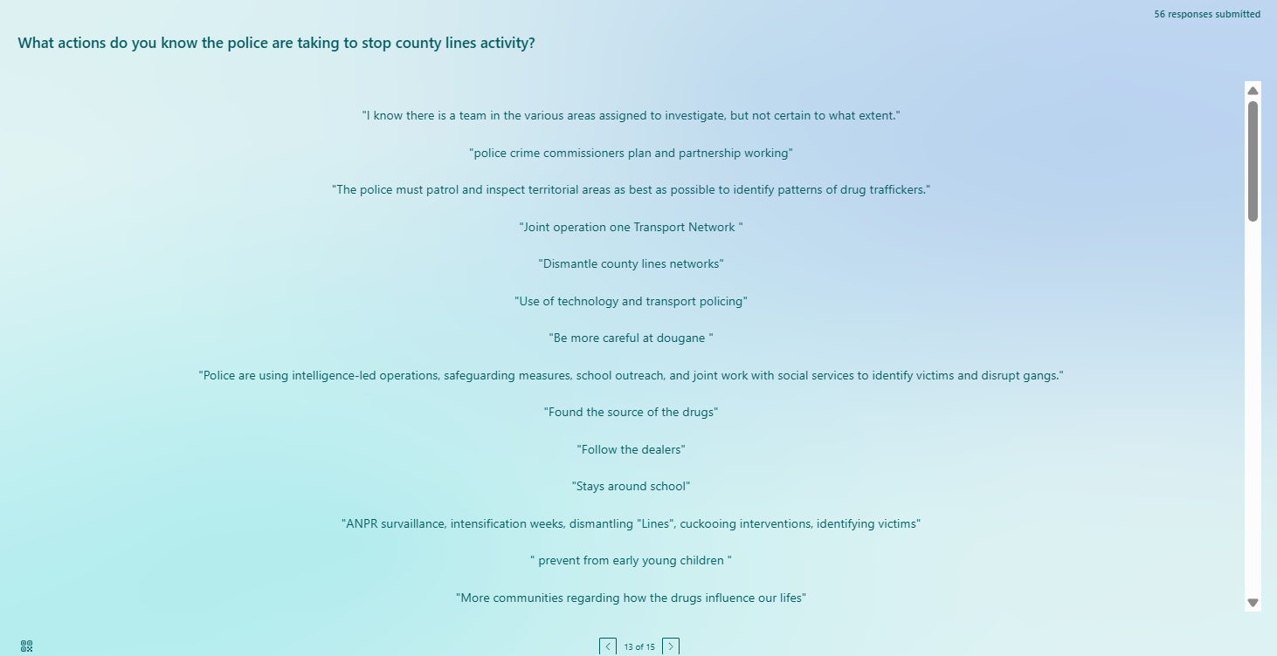
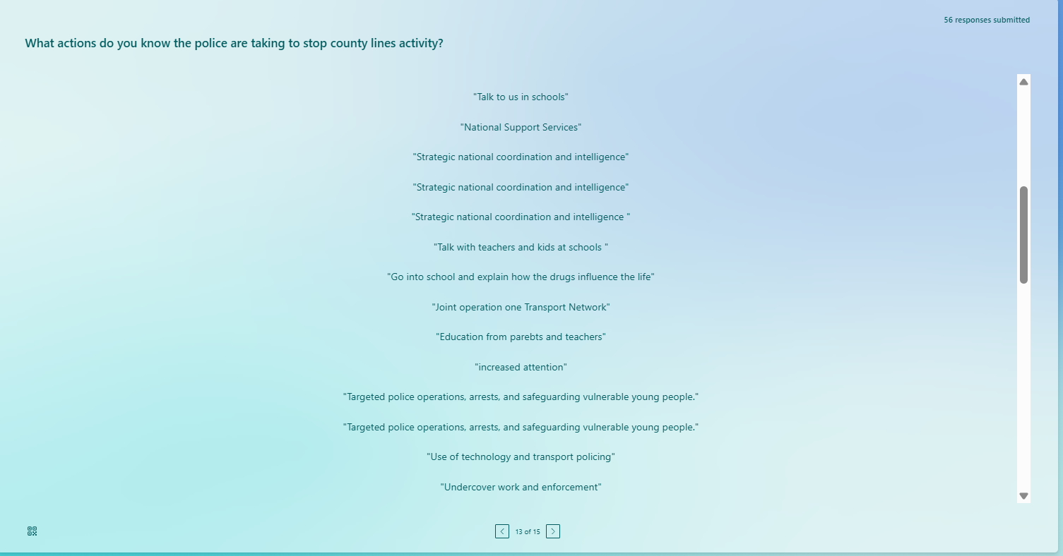
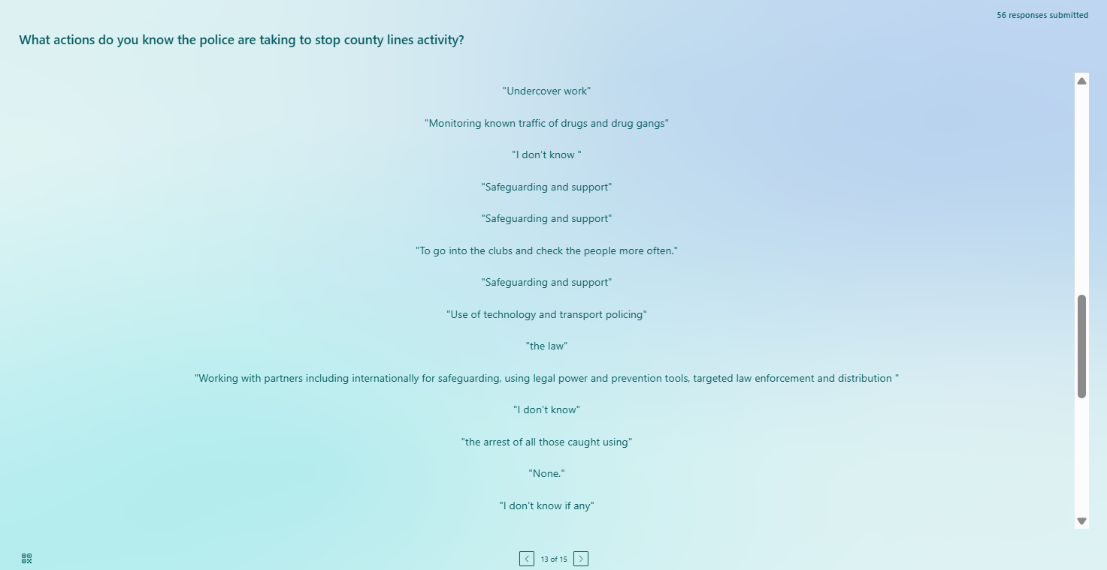
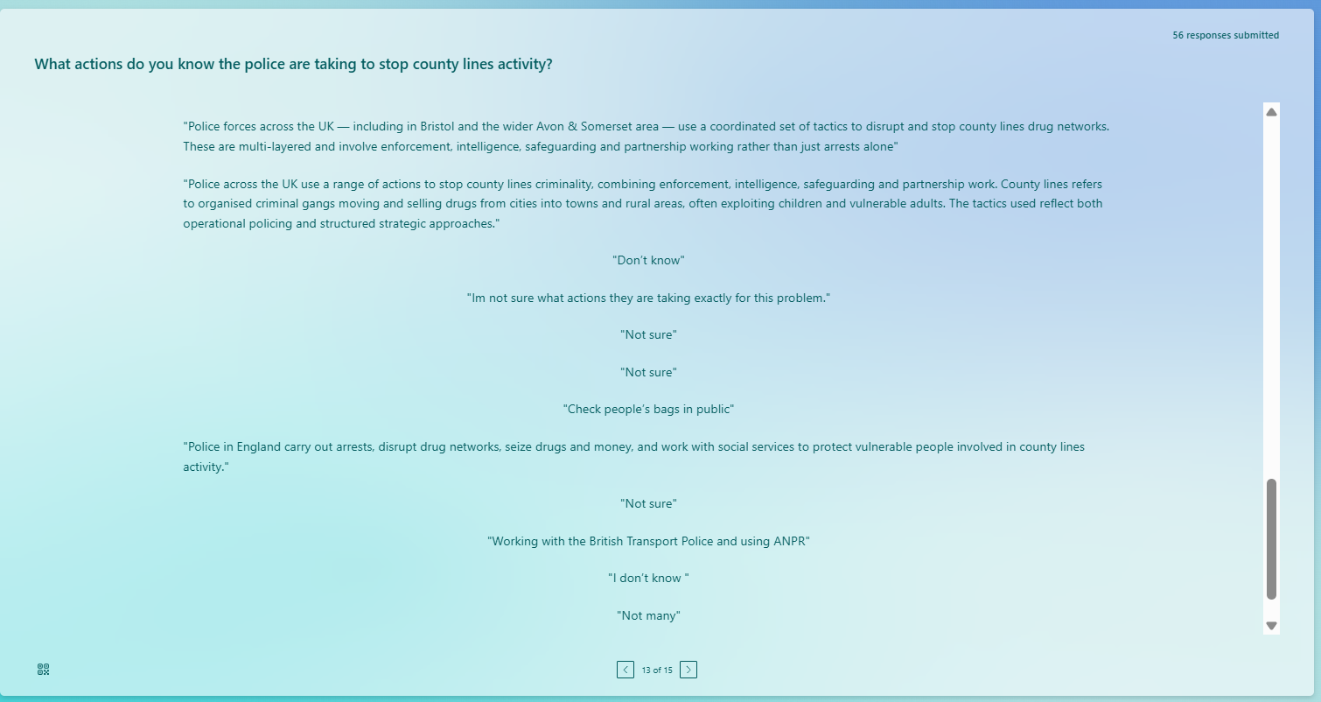
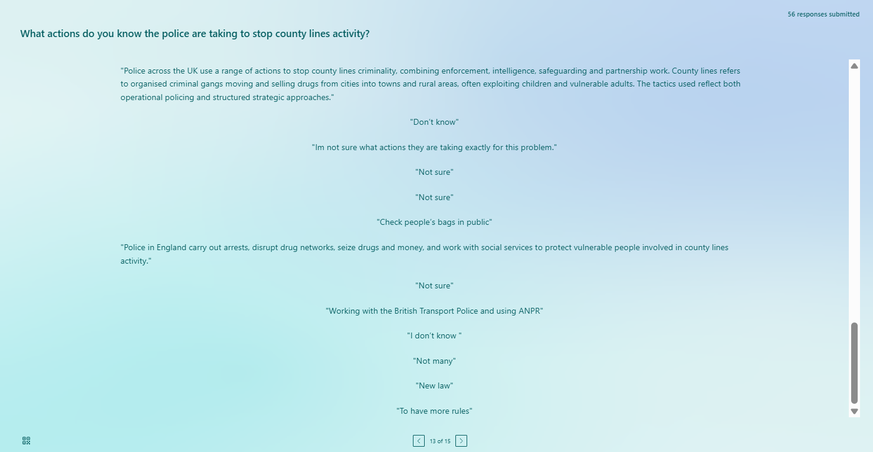
A consciousness of the anti-county police intervention. The British Transport Police, Avon & Somerset, and others mentioned intelligence-led operations, ANPR monitoring, school outreach, and regional coordination. Many said “I don't know” or “Not sure,” showing tactical perplexity. Enforcement is stressed in literature, although details are frequently kept private. The results indicate that the public views law enforcement as busy but undervalues its complexity. Perception gaps may restrict transparency and cooperation with authorities when reporting suspicious activity (NPCC, 2025; HMICFRS, 2022). Public awareness, openness, and communication may legitimise law enforcement and security. Multi-agency prevention and vulnerable person protection are promoted in educational communities.
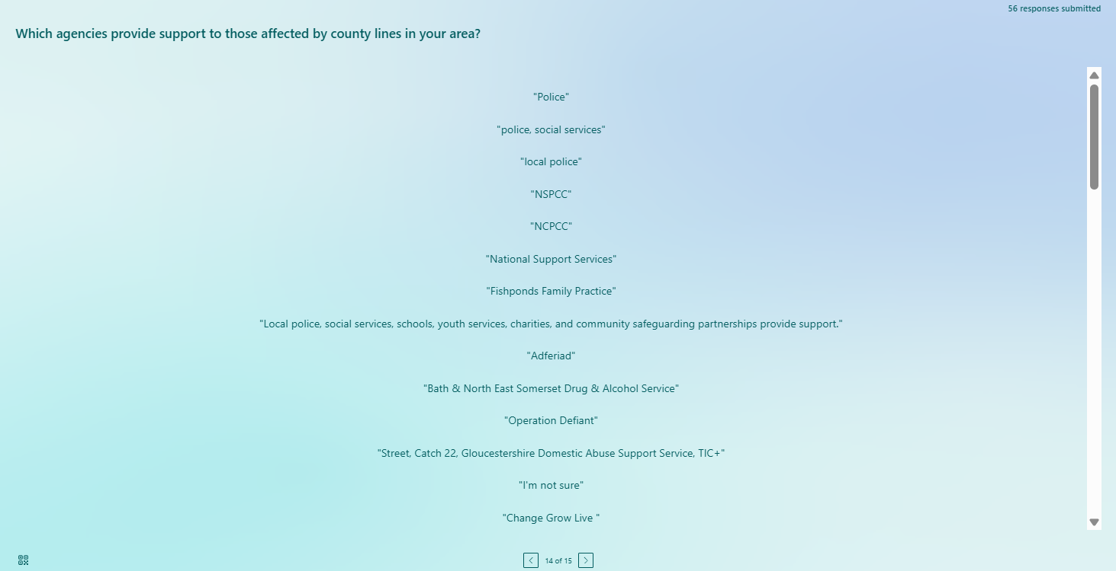
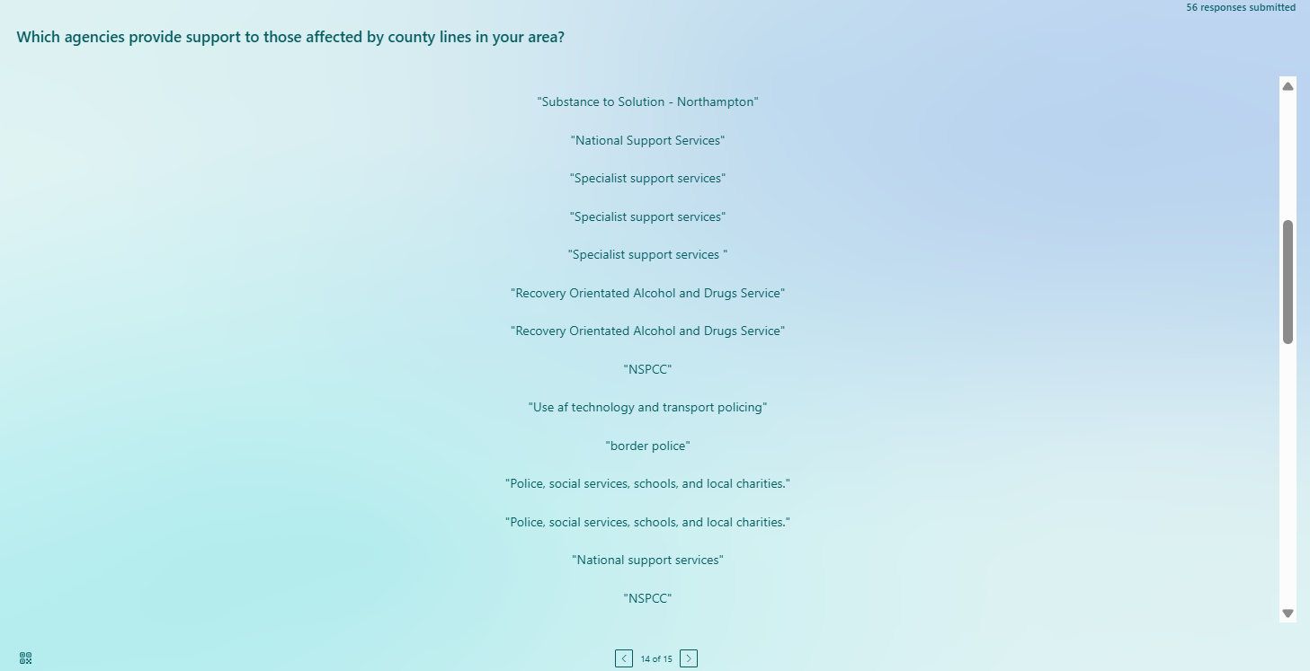
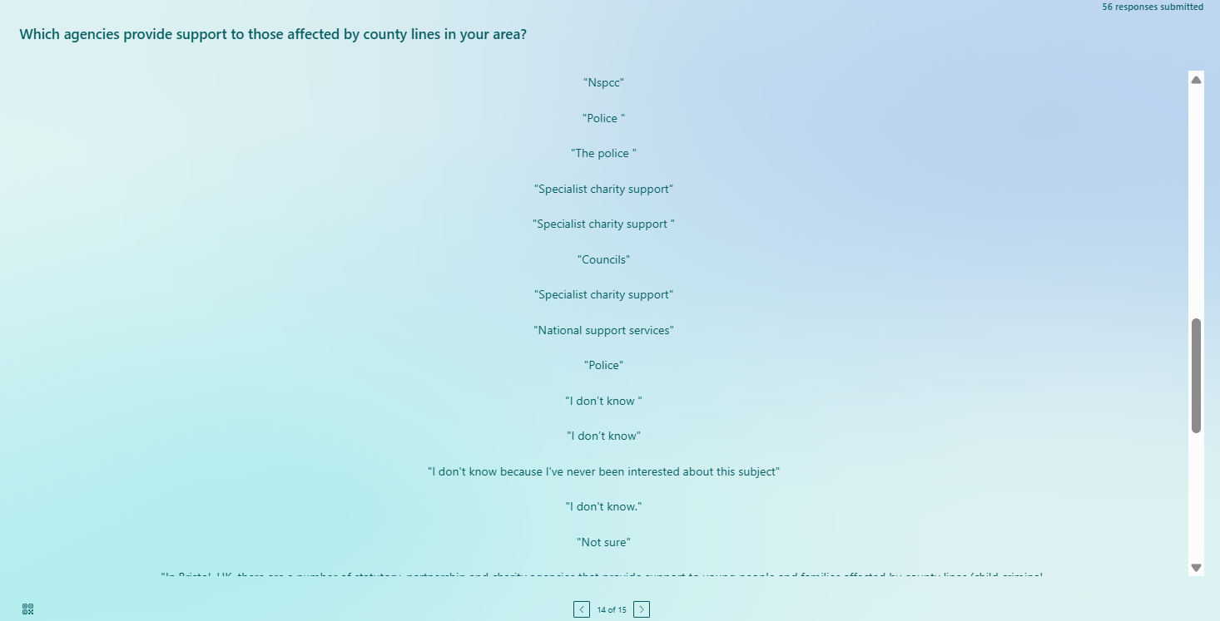
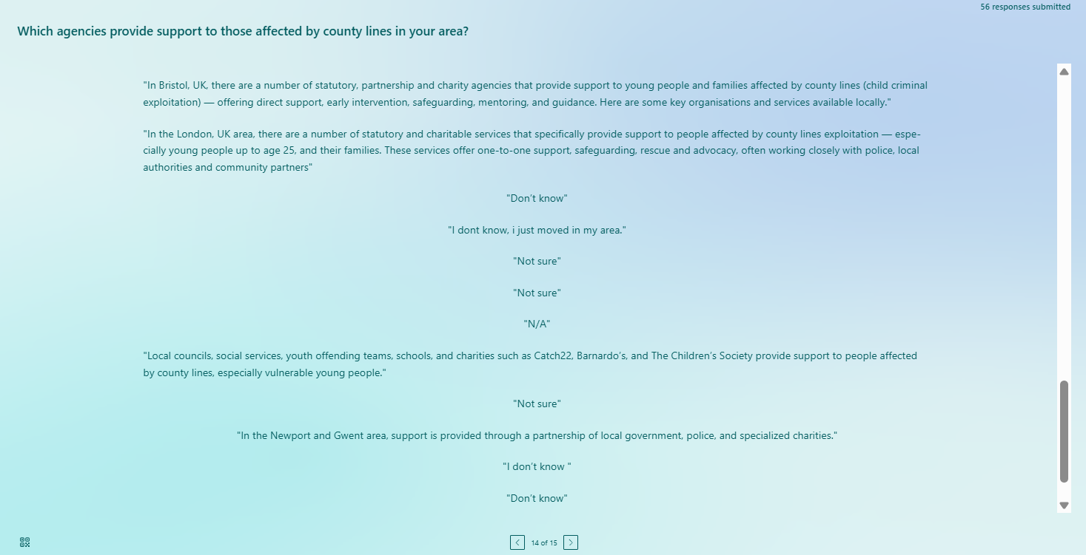
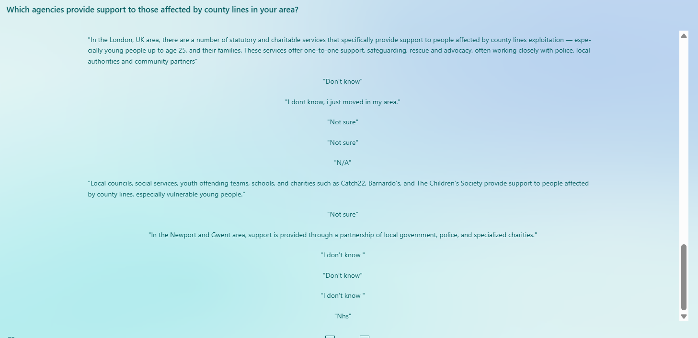
Services such as the police, social services, the NSPCC, Barnardo's, and Catch22 were of assistance. Regional awards went to Adferiad and Change Grow Live. The bewilderment of many respondents regarding where to receive help showed centralised counsel and public comprehension gaps. Multi-agency county line exploitation enforcement is hard, research reveals. Police and visibility safeguard victims and at-risk neighbourhoods (Nottinghamshire, 2025; Pearson & Cavener, 2024). Communities know about vital organisations, but fragmented information may delay response and damage support service credibility, according to the poll. The results imply that the public needs better information and a central contact to help people and families with prevention, victim aid, and rehabilitation.

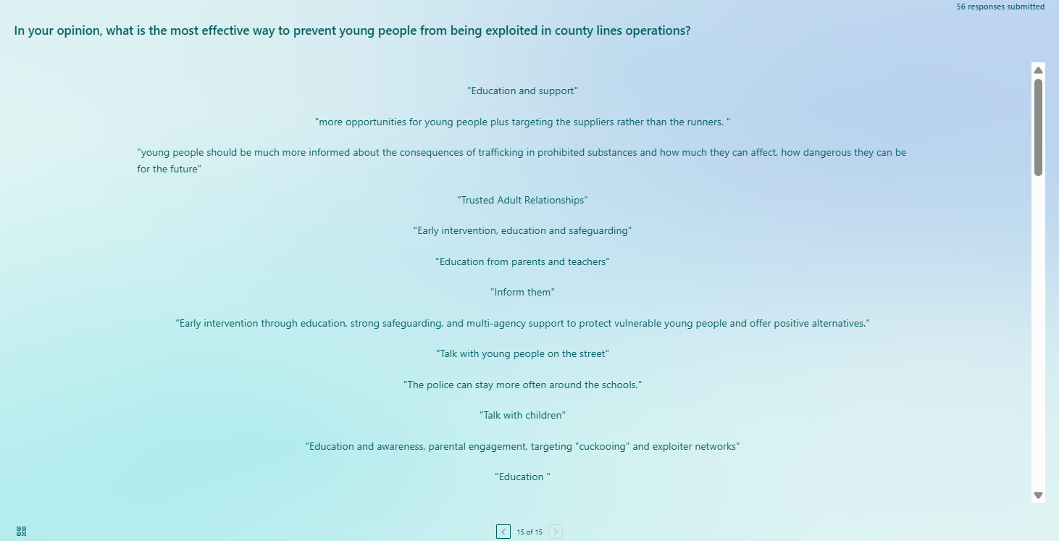
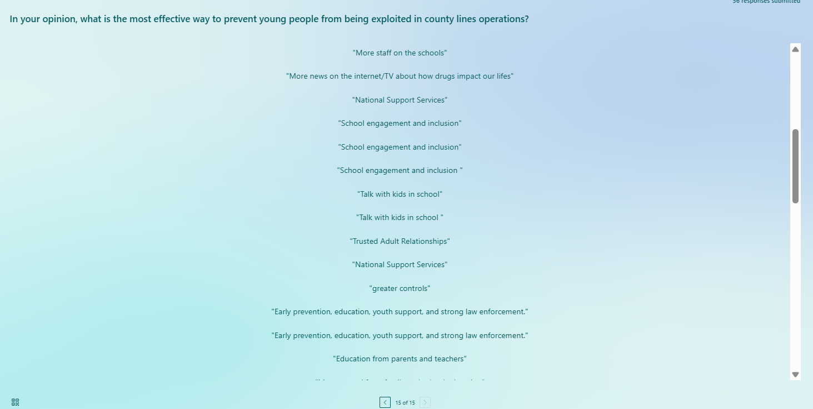
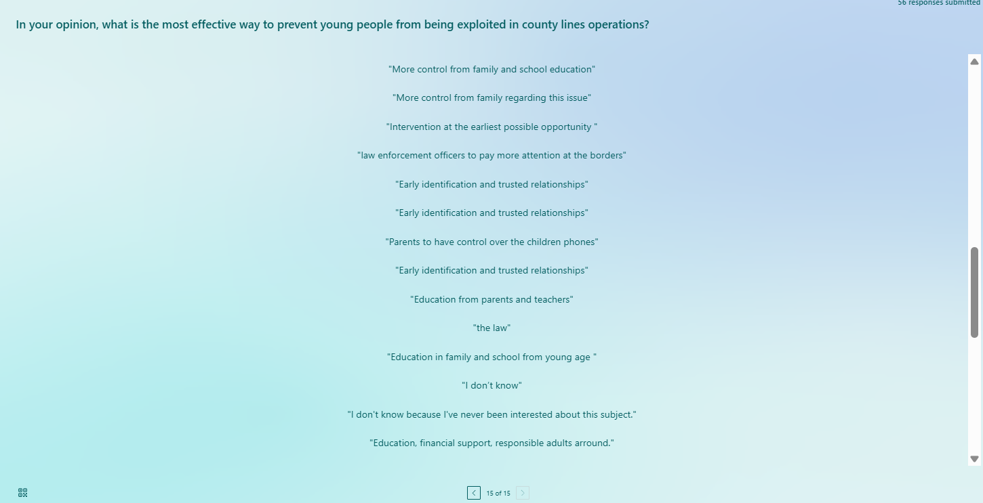
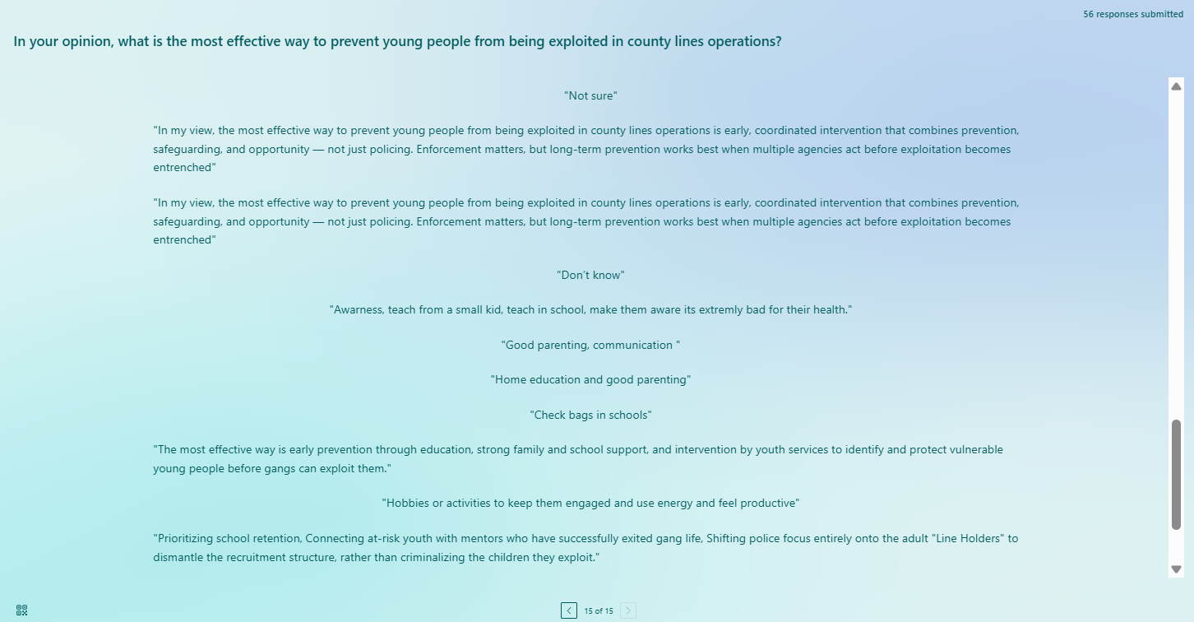
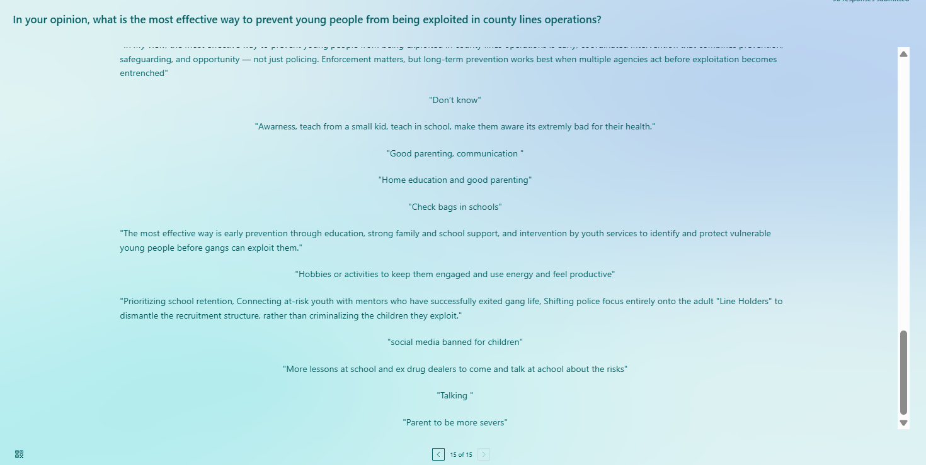
Early prevention, education, and protection were preferred. Over mistreated children, school attendance, and trusted adult ties, suppliers were targeted. Helping kids stay in school, providing viable alternatives, and preventing recruiting were common tactics. Child exploitation and trauma-informed practice literature calls these strategies 'victim-first' safeguarding. The public recognises that long-term remedies must address socio-economic vulnerabilities, emotional needs, and societal issues, not just punishment. Research suggests strong networks diminish county line recruiting. Social policy, community awareness, and law enforcement mitigate risks before criminal exploitation. Community prevention and education are stressed.

4.3 Synthesis of Findings with Literature Review
Survey results on public comprehension, vulnerability, and attitudes of UK county border law enforcement can be compared to Chapter 2.
Awareness of County Lines- 72% knew "county lines," but not grooming, cuckooing, or influencing youngsters. Swancott et al. (2025) and Pearson and Cavener (2024) say county line knowledge matters outside of professional and social care. Atkinson-Sheppard et al. (2025) found that media and work training improve awareness more than community experience. Publicly known traffickers' strategies are uncertain.
Perceived Vulnerability- Minors (50%) were most vulnerable, then caretakers and the poor. Home Office (2025) and Bonning (2020) agree that compelled youngsters and marginalised adults trade drugs. Despite evidence, the survey underestimated homeless and seriously mentally ill persons (Marshall, 2024; Windle et al., 2020). Protective books for kids and teens are popular despite structural difficulties.
Perceptions of Law Enforcement and Policy Effectiveness- 23% were neutral, 64% said police efforts were successful, and 11% thought they were useless. Multi-agency efforts incorporating policing, social services, and community-based interventions are needed to address socio-economic problems (NPCC, 2025; O'Hagan & Edmundson, 2021). Data reveal that people are cautiously hopeful, admiring the police but worried about transparency and size. Police processes are sometimes unclear (Spicer, 2021; Castro-Gonzalez, 2023)
Convergences and Divergences- County boundaries harm children and vulnerable people physically, psychologically, and socially (Dando et al., 2023; Childrenssociety.org.uk, 2025). Some respondents may overestimate policing's efficacy or underestimate county boundaries' community-level consequences beyond victimisation. General knowledge and academic literature-emphasised context differ in tactical operations and coercive techniques.
Implications for Policy and Community Interventions- The synthesis implies public opinion affects education and awareness. Systemic vulnerability training, grooming, and exploitation favour informal gatekeepers. Multi-agency law enforcement, social assistance, and community education are also needed and supported. Police-support agency communication can boost trust, involvement, and proactive safeguarding, preventing and rehabilitating crime (Ali, 2024; NPCC, 2025).

4.4 Summary
The data show UK public opinion on county line activities. Most deemed county boundaries socially significant. Cuckooing, grooming, and victim-offender connections are suspicious. The public acknowledges exploitation's effects but not its techniques. Respondents accurately identified children and teenagers as most vulnerable, supporting safeguarding literature. In ignorance, addicts and trauma sufferers were disregarded. Many apathetic or doubtful police and multi-agency responses demonstrated intervention plan openness and communication difficulties. Public knowledge alone cannot halt exploitation. Targeted socio-economic vulnerability interventions, enforcement, and community education are needed. The findings propose multi-agency public education, awareness, and policy communication. Chapter 5 will enhance results, link theories, and affect policy and county-level harm reduction.

Chapter 5: Conclusion

5.1 Introduction
Drug dealings, victimisation, vulnerability, and destruction vary by UK county. This study explored their relationship. County lines, a complex organised crime that exploits vulnerable individuals beyond drug trafficking, are growing. Child exploitation, coercion, and long-term psychological and social injury are criminal justice and social welfare concerns, studies demonstrate. A thorough online survey investigated public knowledge, attitudes, and opinions in this quantitative study. Evidence from policy and scholarly publications was analysed. The chapter connects, infers, and applies. It addresses county line concerns through policy, practice, and research.

5.2 Summary of Key Findings
Relationship between county lines, victimisation, vulnerability, and harm
Research shows county borders mistreat and control vulnerable people. This supports research on grooming, intimidation, and reliance to recruit youngsters and marginalised individuals (Dando et al., 2023; Atkinson-Sheppard, 2025). County boundary concerns include exploitation and crime, those surveyed indicated. Cuckooing and structured mobile communication networks enable these activities, but their operations are unknown (Spicer, 2021; Castro-Gonzalez, 2023). Criminal networks victimise, notwithstanding public ignorance. Statistics show that public education on exploitation may increase prevention and early intervention.
Influence on individuals and communities
County borders harm families and communities, say researchers. Children and youngsters are susceptible, according to national policy and research (Home Office, 2025; Windle et al., 2020). Physical, psychological, and social damage were the main effects. Though research cautions, adult vulnerabilities, including addiction, homelessness, and socioeconomic marginalisation, are poorly understood (Bonning, 2020; Marshall, 2024). The constrained vulnerability paradigm prioritises age-related risks above structural and intersectional factors. Community knowledge of increasing crime, terror, and social instability supports the assumption that county boundaries damage social cohesiveness and public safety.
Government and regulatory responses
Data reveal differential public faith in government and law enforcement county line reactions. Apathy and scepticism of police initiatives are common. Evidence shows that enforcement-focused remedies fail to tackle exploitation's causes (NPCC, 2025; O'Hagan and Edmundson, 2021). Since enforcement alone cannot solve the problem, social aid, education, health, and community aid were proposed. County Lines eliminates networks and protects victims (GOV.UK, 2025). The findings imply that public misperception of policing and support services may lower confidence and involvement. The findings suggest open communication, community understanding, and county-line initiatives to address criminal and socioeconomic issues.

5.3 Integration with Literature
This study confirms Chapter 2's literature and reveals public perception gaps. Home Office safeguarding targets and stakeholder-based studies like Jemma Bonning demonstrate systematic targeting of minors and marginalised people, and county lines exploitation targeted children and young adults. Atkinson-Sheppard and Dando's theoretical and empirical work reveal exploitation's multifaceted and long-term effects on society (Atkinson-Sheppard, 2025; Dando et al., 2023). Respondents claimed county boundaries harm individuals physically, mentally, and socially. If popular understanding is informed by academic and policy discourse, then seriousness about the county boundary is reflected in media coverage and awareness campaigns. Participants found county line grooming, persuasion and cuckooing confusing. Research points to the flexibility of networks and deficiencies of enforcement-only approaches but some respondents report moderate trust in the effectiveness of law enforcement, which may reflect over-reporting of the effectiveness of law enforcement efforts (O’Hagan and Edmundson, 2021; NPCC, 2025). Then there is a disparity between the perception and impact of the intervention. The processes and institutions of exploitation are poorly understood, and targeted education and policy communication are needed to increase public understanding.

5.4 Key Conclusions
The study found county borders exploit vulnerability and structural inequities beyond drug distribution. These networks target socially, economically, and intellectually challenged individuals to establish county crime and social harm hotspots. Many watch but don't grasp grooming, control, and persuasion. County border security must go beyond law enforcement, data reveals. Reduce exploitation by tackling poverty, education, and unemployment. Fix safeguarding system faults to identify and protect at-risk individuals. This shows community awareness, and education is needed to recognise and stop exploitation. Understanding county borders requires victim-offender dualism. Victim-centred policies are crucial because victims commit crimes. The report paper coordinates and diversifies challenging county borders.

5.5 Practical Recommendations
Policy Recommendations- Police, education, health, and social services must manage county boundaries simultaneously. Strategic cooperation aids victims, informs, and finds weaknesses. Regional consistency demands collaboration, but frameworks incorporate solutions. Transparent police foster trust and participation. Police, protection, and results communication may increase community involvement, suspicious activity reporting, and county line operations institutional confidence.
Community and Prevention Strategies- To avoid exploitation, learn grooming, coercion, and cuckooing. Diversity should be emphasised in digital, community, and workplace training. Safe conditions, risk education, and trustworthy people limit juvenile recruitment. Identifying vulnerability helps teachers, social workers, and community members prevent abuse.
Social and Economic Interventions- Social deficiencies must be addressed for sustainability. Work, poverty, and marginalisation limit recruiting. Mental health and therapy are needed for victim reconciliation. Informed trauma treatment heals, stops exploitation, and stops dependence. Prevention, enforcement, and social policy enable countywide action.

5.6 Limitations of the Study
Limitation | Description | Impact
Small Sample Size | The study included only 51 participants, limiting representativeness. | Reduces generalisability to the wider UK population.
Self-Reported Data | Responses were based on participants’ perceptions and honesty. | Risk of social desirability and response bias.
Online Survey Method | Data collected only through digital platforms. | Excludes individuals without internet access (digital divide).
Quantitative Approach | Use of closed-ended questions only. | Limits the depth and richness of insights into complex issues.

5.7 Future Research Directions
Area | Recommendation | Purpose
Larger Sample Studies | Conduct research with a broader and more diverse population. | Improve the generalisability and reliability of findings.
Mixed-Methods Research | Combine quantitative surveys with qualitative interviews. | Gain deeper insights into perceptions and lived experiences.
Victim-Centred Research | Explore the experiences of individuals affected by county lines. | Enhance understanding of exploitation and support needs.
Longitudinal Studies | Examine changes in awareness and policy effectiveness over time. | Assess long-term impact of interventions and strategies.

References
Ali, I.M. (2024). A guide for positivist research paradigm: From philosophy to methodology. Idealogy Journal, 9(2). http://www.idealogyjournal.com/ojs/index.php/idealogy/article/download/596/380 .
Atkinson-Sheppard, S. (2025). Hyper-agency and county lines. Theoretical Criminology, 29(2), pp.231–245. Available at: https://journals.sagepub.com/doi/pdf/10.1177/13624806241265677 (Accessed 28 October 2025).
Atkinson-Sheppard, S., Dando, C., Ormerod, T. and Robinson, B. (2025). Coercion and crime: Convergences, divergences and ‘county lines’. Criminology & Criminal Justice, 25(3), pp.927-949. https://journals.sagepub.com/doi/pdf/10.1177/17488958231153981 .
Baker, N. (2022). Drug Science and British Drug Policy: Critical Analysis of the Misuse of Drugs Act 1971. Waterside Press.
Bonning, J. and Cleaver, K. (2020). An investigation into county line drug networks from the perceptions of key stakeholders. The Police Journal: Theory, Practice and Principles. Available at: https://core.ac.uk/download/pdf/334598210.pdf (Accessed 28 October 2025).
Castro-Gonzalez, L. (2023). Understanding the illicit drug distribution in England: a data-centric approach to the County Lines Model. Royal Society Open Science, 10(5), p.221297. Available at: https://royalsocietypublishing.org/doi/pdf/10.1098/rsos.221297 (Accessed 28 October 2025).
Childrenssociety.org.uk. (2025). County Lines & Child Exploitation | The Children’s Society. [online] Available at: https://www.childrenssociety.org.uk/what-we-do/our-work/child-criminal-exploitation-and-county-lines (Accessed 28 October 2025).
CPS. (2022). County Lines Offending | The Crown Prosecution Service. Available at: https://www.cps.gov.uk/legal-guidance/county-lines-offending (Accessed 28 October 2025).
‌Cummings, C.L. (2018). Cross-sectional design. The SAGE Encyclopedia of Communication Research Methods. Thousand Oaks: SAGE Publications Inc. Retrieved. https://drive.google.com/file/d/1YJ1PHUm1ZdveF_5290DIcKMM5DJbG8PZ/view
‌Dando, C.J., Ormerod, T.C. and Atkinson-Sheppard, S. (2023). Parental experiences of the impact of grooming and criminal exploitation of children for county lines drug trafficking. Journal of Public Health, 45(2), pp e346-e354. https://westminsterresearch.westminster.ac.uk/download/a5a320c28c857185b4d1b9483155b9aa7b6478b4e1205bcda88c8b448f40a44f/95684/Clean%20County%20Line%20MS%20%202022.pdf .
Department for Education. (2025). County Lines Programme overview. GOV.UK. Available at: https://www.gov.uk/government/publications/county-lines-programme/county-lines-programme-overview (Accessed 28 October 2025).
Hallworth, J. (2016). County lines: An exploratory analysis of migrating drug gang offenders in North Essex. Master’s thesis, Cambridge University. Available at: https://www.crim.cam.ac.uk/system/files/documents/john-hallworth.pdf (Accessed 28 October 2025).
Havard, T. (2022). Serious youth violence: County lines drug dealing and the Government response. Available at: https://openresearch.lsbu.ac.uk/download/d7e97a2bccf9f815be9c7f7982d28beb12143a7f48c874411e85cc6d00339586/396741/CBP-9264.pdf (Accessed 28 October 2025).
HMICFRS. (2022). The police and the National Crime Agency’s response to vulnerable people in ‘county lines’ drug offending. HMICFRS. Available at: https://hmicfrs.justiceinspectorates.gov.uk/publication-html/both-sides-of-the-coin-county-lines/ (Accessed 28 October 2025).
‌Home Office. (2023). Criminal exploitation of children and vulnerable adults: county lines. [online] GOV.UK. Available at: https://www.gov.uk/government/publications/criminal-exploitation-of-children-and-vulnerable-adults-county-lines (Accessed 28 October 2025).
Home Office. (2025). Annual Report and Accounts. Home Office. Available at: https://assets.publishing.service.gov.uk/media/688c9785a34b939141463e37/HO_ARA_2024-25_Book_WEB_Final_v3+CorrSlip.pdf (Accessed 28 October 2025).
Hossain, S. and Hakobyan, L. (2022). The Impact of Sustainability Terminologies of Swedish Manufacturing Companies on Consumer Perception: A Mono-Method Quantitative Study. https://www.diva-portal.org/smash/get/diva2:1676245/FULLTEXT01.pdf .
Hossan, D., Dato’Mansor, Z. and Jaharuddin, N.S. (2023). Research population and sampling in a quantitative study. International Journal of Business and Technopreneurship (IJBT), 13(3), pp.209-222. https://ejournal.unimap.edu.my/index.php/ijbt/article/download/263/218 .
Kaur, P., Stoltzfus, J. and Yellapu, V. (2018). Descriptive statistics. International Journal of Academic Medicine, 4(1), pp.60-63. https://journals.lww.com/ijam/_layouts/15/oaks.journals/downloadpdf.aspx?an=01957520-201804010-00007 .
Kumar, S. and Ujire, D.K. (2024). Inductive and deductive approaches to qualitative research. International Journal of Multidisciplinary Educational Research, 13(1), pp.58-63. http://ijmer.s3.amazonaws.com/pdf/volume13/volume13-issue1(4)/9.pdf .
Liddle, J. and Addidle, G. (2023). Reframing'place leadership': an analysis of leadership in responding to the wicked issue of county lines and criminality within a context of post-pandemic public health policing. In Research Handbook on Public Leadership (pp. 222-242). Edward Elgar Publishing. https://bradscholars.brad.ac.uk/bitstreams/f9ffa066-d681-4a63-a3b8-72fa43830741/download .
Marshall, H. (2024). Child criminal exploitation and the interactional emergence of victim status. The British Journal of Criminology, 64(5), pp.1011–1027. Available at: https://academic.oup.com/bjc/article-pdf/64/5/1011/58890715/azae008.pdf (Accessed 28 October 2025).
‌Mazhar, S.A., Anjum, R., Anwar, A.I. and Khan, A.A. (2021). Methods of data collection: A fundamental tool of research. Journal of Integrated Community Health, 10(1), pp.6-10. https://www.researchgate.net/profile/Syeda-Ayeman-Mazhar/publication/356269289_Methods_of_Data_Collection_A_Fundamental_Tool_of_Research/links/61fe7e23870587329e943cd1/Methods-of-Data-Collection-A-Fundamental-Tool-of-Research.pdf .
National Crime Agency (2025). County Lines. Nationalcrimeagency.gov.uk. Available at: https://www.nationalcrimeagency.gov.uk/what-we-do/crime-threats/drug-trafficking/county-lines (Accessed 28 October 2025).
Nayak, M.S.D.P. and Narayan, K.A. (2019). Strengths and weaknesses of online surveys. technology, 6(7), pp.0837-2405053138. https://www.researchgate.net/profile/Mudavath-Nayak/publication/333207786_Strengths_and_Weakness_of_Online_Surveys/links/61176e5a0c2bfa282a42253b/Strengths-and-Weakness-of-Online-Surveys.pdf?%20__cf_chl_tk=ulOqypX070Uc5pTJ5yeMHlIvOvAOjGB0psYju8Hlrn4-1738838246-1.0.1.1-4oP9m81GuRf8lF0yTHIRoQX.XhXyLjEe199YsnTATKY .
NCA. (2015). NCA Intelligence Assessment: County Lines, Gangs, and Safeguarding. NCA. Available at: https://www.nationalcrimeagency.gov.uk/who-we-are/publications/359-nca-intelligence-assessment-county-lines-gangs-and-safeguarding-2015/file (Accessed 28 October 2025).
NEWS NPCC. (2024). Launch of the County Lines Policing Strategy 2024 to 2027. NPCC. Available at: https://news.npcc.police.uk/releases/launch-of-the-county-lines-policing-strategy-2024-to-2027 (Accessed 28 October 2025).
Noor, S., Tajik, O. and Golzar, J. (2022). Simple random sampling. International Journal of Education & Language Studies, 1(2), pp.78-82. https://www.ijels.net/article_162982_c72b367615dfd1f4d7bd9d4ff60cbef6.pdf .
Nottinghamshire. (2025). Safer Streets. NPCC. Available at: https://www.nottinghamshire.pcc.police.uk/what-we-do-for-you/grants-and-commissioning/what-we-fund/nottinghamshire-safer-streets/safer-streets (Accessed 28 October 2025).
NPCC. (2025). Disrupting County Lines, Policing Strategy 2024–2027. NPCC. Available at: https://www.npcc.police.uk/SysSiteAssets/media/downloads/publications/publications-log/national-crime-coordination-committee/2024/disrupting_county_lines_policy_strategy_32pp_refreshed-sept-2025-final.pdf (Accessed 28 October 2025).
‌NSPCC Learning. (2025). Protecting children from county lines | NSPCC Learning. [online] Available at: https://learning.nspcc.org.uk/child-abuse-and-neglect/county-lines (Accessed 28 October 2025).
O'Hagan, A. and Edmundson, C.J. (2021). County lines: the exploitation of vulnerable members of society. Forensic research & criminology international journal, 9(2), pp.47-57. https://irep.ntu.ac.uk/id/eprint/44335/1/1475824_O%27Hagan.pdf .
O'Hagan, A. and Long, A. (2019). The socioeconomic effects of organised crimes county lines on the United Kingdom community. Forensic Research and Criminology International Journal, 7(5), pp.274-280. https://irep.ntu.ac.uk/id/eprint/37921/1/1195444_O_Hagan.pdf .
Ojebode, A., Ojebuyi, B.R., Oladapo, O.A. and Oyedele, O.J. (2018). Mono-method research approach and scholar–policy disengagement in Nigerian communication research. In The Palgrave Handbook of Media and Communication Research in Africa (pp. 369-383). Cham: Springer International Publishing. https://www.academia.edu/download/56202295/OJEBOD_2.PDF .
Okoli, C. (2023). Inductive, abductive, and deductive theorising. International Journal of Management Concepts and Philosophy, 16(3), pp.302-316. https://papers.ssrn.com/sol3/Delivery.cfm?abstractid=3774317 .
Park, Y.S., Konge, L. and Artino Jr, A.R. (2020). The positivism paradigm of research. Academic medicine, 95(5), pp.690-694. https://journals.lww.com/academicmedicine/fulltext/2020/05000/the_positivism_paradigm_of_r%20esearch.16.aspx/%22 .
Pearson, J. and Cavener, J. (2024). Professionals’ understanding of the County Lines phenomenon: Insights from a study exploring the perceptions of young peoples’ supported accommodation staff. Children and Youth Services Review, 156, p.107331. Available at: https://www.sciencedirect.com/science/article/abs/pii/S0190740923005273 (Accessed 28 October 2025).
Spicer, J. (2021). The policing of cuckooing in ‘county lines’ drug dealing: an ethnographic study of an amplification spiral. The British Journal of Criminology, 61(5), pp.1390-1406. https://academic.oup.com/bjc/article-pdf/61/5/1390/40504343/azab027.pdf .
Swancott, L., Kloess, J.A., Burnett Heyes, S. and Hamilton-Giachritsis, C. (2025). “County lines” and child criminal exploitation in the UK: a secondary data analysis of focus groups with young people who attended a theatre-in-education programme. Journal of Sexual Aggression, pp.1–16. Available at: https://researchportal.bath.ac.uk/files/352945182/Swancott_Kloess_Burnett_Hayes_CHG_JSA_final_preprint.pdf (Accessed 28 October 2025).
Wang, X. and Cheng, Z. (2020). Cross-sectional studies: strengths, weaknesses, and recommendations. Chest, 158(1), pp.S65-S71.Available at: https://journal.chestnet.org/article/S0012-3692(20)30462-1/pdf ( Accessed 20 Decembre 2025).
Windle, J. and Briggs, D. (2015). Going solo: the social organisation of drug dealing within a London street gang. Journal of Youth Studies, 18(9), pp.1170–1185. Available at: https://www.academia.edu/download/41091694/Going_solo_-_Windle_and_Briggs_2015.pdf (Accessed 28 October 2025).
Windle, J., Moyle, L. and Coomber, R. (2020). ‘Vulnerable’kids going country: children and young people’s involvement in county lines drug dealing. Youth justice, 20(1-2), pp.64-78. https://cora.ucc.ie/bitstream/10468/9640/4/2020_-_Windle_Moyle_Coomber_-_County_lines.pdf .
Zhang, J., Wang, Y., Zhao, Y. and Cai, X. (2018). Applications of inferential statistical methods in library and information science. Data and Information Management, 2(2), pp.103-120. https://www.sciencedirect.com/science/article/pii/S2543925122000845 .

Appendix

Appendix 1- Gantt Chart Plan
Task / Activity | Week 1–2 | Week 3–4 | Week 5–6 | Week 7–8 | Week 9–10 | Week 11–12
Topic Selection & Proposal Approval
Literature Review (Chapter 2)
Research Design & Methodology (Chapter 3)
Questionnaire Design & Ethical Approval
Data Collection (Survey)
Data Cleaning & Analysis
Findings & Discussion (Chapter 4)
Conclusion & Recommendations (Chapter 5)
Final Editing & Proofreading
Submission

Appendix 2- Questionnaire
The Impact of County Lines on Drug Dealings, Victimisation, Vulnerability and Harm....
The data gathered from this questionnaire will be used to meet the overall aim of my undergraduate dissertation: The Impact of County Lines on Drug Dealings, Victimisation, Vulnerability, and Harm.

You must be aged 18 or older and have some prior knowledge or understanding of county lines to take part in this questionnaire. By continuing, you consent to your data being collected for the purpose of this research. All responses are anonymous, and you have the right to withdraw at any time by closing the questionnaire before submission.

Required
1. What is your age group? *
- ☐ 18-24
- ☐ 25-34
- ☐ 35-44
- ☐ 45-54
- ☐ 55 and above
2. What is your gender? *

- ☐ Woman
- ☐ Man
- ☐ Non-binary
- ☐ Others
3. What is your highest level of education completed? *
- ☐ Secondary education or below
- ☐ Further education (college or equivalent)
- ☐ Undergraduate degree
- ☐ Postgraduate degree
- ☐ Other/Prefer not to say
4. How familiar are you with the term "county lines" in relation to drug trafficking? *
- ☐ Very familiar
- ☐ Somewhat familiar
- ☐ Slightly familiar
- ☐ Not familiar at all
5. How did you first become aware of county lines activity? *
- ☐ News media (TV, newspapers, online news)
- ☐ Social media or online platforms
- ☐ Education or workplace training
- ☐ Personal experience or community exposure
- ☐ I was not previously aware
6. To what extent do you agree that county lines are a serious problem in the UK? *
- ☐ Strongly agree
- ☐ Agree
- ☐ Disagree
- ☐ Strongly disagree
- ☐ Neutral
7. Which group do you believe is most vulnerable to exploitation in county lines operations? *
- ☐ Children and young people
- ☐ Vulnerable adults (e.g. mental health or substance misuse)
- ☐ Economically disadvantaged individuals
- ☐ Homeless individuals
- ☐ All groups are equally vulnerable
8. To what extent do you agree that individuals involved in county lines can be both victims and offenders? *
- ☐ Strongly agree
- ☐ Agree
- ☐ Disagree
- ☐ Strongly disagree
- ☐ Neutral
9. How likely do you think socio-economic factors (e.g. poverty, unemployment) increase vulnerability to county lines exploitation? *
- ☐ Very likely
- ☐ Likely
- ☐ Neither likely nor unlikely
- ☐ Unlikely
- ☐ Very unlikely
10. What type of harm do you associate most strongly with county lines activity? *

- ☐ Physical harm (violence, injury)
- ☐ Psychological harm (trauma, fear)
- ☐ Social harm (community breakdown, crime)
- ☐ Economic harm (loss of income, exploitation)
- ☐ All of the above
11. How effective do you believe current law enforcement responses are in tackling county lines? *

- ☐ Very effective
- ☐ Somewhat effective
- ☐ Neither effective nor ineffective
- ☐ Somewhat ineffective
- ☐ Very ineffective
12. Which approach do you believe would be most effective in reducing county lines activity? *

- ☐ Increased policing and enforcement
- ☐ Stronger safeguarding and support services
- ☐ Community education and awareness programmes
- ☐ Combined enforcement and social support approach
- ☐ Unsure
13. What actions do you know the police are taking to stop county lines activity? *

(Open text response)

14. Which agencies provide support to those affected by county lines in your area? *

(Open text response)

15. In your opinion, what is the most effective way to prevent young people from being exploited in county lines operations? *

(Open text response)

Appendix 3- Ethical Form
Ethics Form final.docx
APPLICATION FOR ETHICAL APPROVAL

In order for research to result in benefit and minimise risk of harm, it must be conducted ethically. A researcher may not be covered by the University’s insurance if ethical approval has not been obtained prior to commencement.

The University follows the OECD Frascati manual definition of research activity: “creative work undertaken on a systematic basis in order to increase the stock of knowledge, including knowledge of man, culture and society, and the use of this stock of knowledge to devise new applications”. As such this covers activities undertaken by members of staff, postgraduate research students, and both taught postgraduate and undergraduate students working on dissertations/projects.

The individual undertaking the research activity is known as the “principal researcher”.

Ethical approval is not required for routine audits, performance reviews, quality assurance studies, testing within normal educational requirements, and literary or artistic criticism.
Please read the notes for guidance before completing ALL sections of the form.
This form must be completed and approved prior to undertaking any research activity. Please see Checklist for details of process for different categories of application.

SECTION A: About You (Principal Researcher)
1 | Full Name: |  | Elena Cristina Martinica
2 | Tick all boxes that apply: |  | Member of staff: | ☐ | Honorary research fellow: | ☐
 | Undergraduate Student | ☒ | Taught Postgraduate Student | ☐ | Postgraduate  Research Student | ☐

3 | Institute/Academic Discipline/Centre: | Swansea Business School
4 | Campus: | Cardiff
5 | E-mail address: | 2308138@student.uwtsd.ac.uk
6 | Contact Telephone Number: | 07808085228
 | For students:
7 | Student Number: | 2308138
8 | Programme of Study: | DIPHE Policing Profession
9 | Director of Studies/Supervisor: | Michelle Hill

SECTION B: Approval for Research Activity
1 | Has the research activity received approval in principle? (Please check the Guidance Notes as to the appropriate approval process for different levels of research by different categories of individuals.) |  | YES | ☐ | NO | ☒
 |  |  |  |  | Date
2 | If Yes, please indicate source of approval (and date where known): Approval in principle must be obtained from the relevant source prior to seeking ethical approval | Research Degrees Committee |  | ☐
2 |  | Institute Research Committee |  | ☐
2 |  | Other (write in) |  | ☒

SECTION C: Internal and External Ethical Guidance Materials
 | Please list the core ethical guidance documents that have been referred to during the completion of this form (including any discipline-specific codes of research ethics, location-specific codes of research ethics, and also any specific ethical guidance relating to the proposed methodology). Please tick to confirm that your research proposal adheres to these codes and guidelines. You may add rows to this table if needed.
1 | UWTSD Research Ethics & Integrity Code of Practice | ☒
2 | UWTSD Research Data Management Policy | ☒
3 | [List any other relevant documents here] | ☐

SECTION D: External Collaborative Research Activity
If there are external collaborators then you should gain consent from the contact persons to share their personal data with the university. If there are no external collaborators then leave this section blank and continue to section E.
1 | Institution
2 | Contact person name
3 | Contact person e-mail address
4 | Is your research externally funded? |  | YES | ☐ | NO | ☒
5 | Are you in receipt of a KESS scholarship? |  | YES | ☐ | NO | ☒
6 | Are you specifically employed to undertake this research in either a paid or voluntary capacity? | Voluntary | YES | ☐ | NO | ☒
7 |  | Employed | YES | ☐ | NO | ☒
8 | Is the research being undertaken within an existing UWTSD Athrofa Professional Learning Partnership (APLP)? | If YES then the permission question below does not need to be answered. | YES | ☐ | NO | ☒
9 | Has permission to undertake the research has been provided by the partner organisation? | (If YES attach copy) If NO the application cannot continue | YES | ☐ | NO | ☒

Where research activity is carried out in collaboration with an external organisation
10 | Does this organisation have its own ethics approval system? | YES | ☐ | NO | ☒
 | If Yes, please attach a copy of any final approval (or interim approval) from the organisation (this may be a copy of an email if appropriate).

SECTION E: Details of Research Activity
1 | Indicative title: | Effects of county lines on drug selling, crime, victimisation, safety, and harm
2 | Proposed start date: | 10.10.2025 | Proposed end date: | 05.05.2026
Introduction to the Research (maximum 300 words per section)
Ensure that you write for a Non-Specialist Audience when outlining your response to the points below:
Purpose of Research Activity
Proposed Research Question
Aims of Research Activity
Objectives of Research Activity
Demonstrate, briefly, how Existing Research has informed the proposed activity and explain
What the research activity will add to the body of knowledge How it addresses an area of importance.
3 | Purpose of Research Activity  The primary objective of this research is to examine the interaction and influence of county lines, victimisation, drug dealings, vulnerability, and damage. It is also the objective of this research to illustrate the regulatory responses and challenges that the government has implemented in order to mitigate the risks and effects associated with county lines.
4 | Research Question  What is the relationship between county lines and vulnerability, harm, drug dealing, and victimisation?
5 | Aims of Research Activity  This research seeks to examine the potential relationships and impacts of county lines on drug trafficking, associated vulnerabilities, harm, and victimisation.
Proposed methods (maximum 600 words)
Provide a brief summary of all the methods that may be used in the research activity, making it clear what specific techniques may be used. If methods other than those listed in this section are deemed appropriate later, additional ethical approval for those methods will be needed. You do not need to justify the methods here, but should instead describe how you intend to collect the data necessary for you to complete your project.

A primary poll will be used to get useful and accurate information from the people who are the subject of the study. The study population will be used to pick 100 final samples. This will be done using a simple random sampling method. The sampling method is based on how much information is available about county lines and other variables that are important. After that, these people will be contacted and told more about the study's purpose in order to get their permission. Using Google Forms to get accurate information from the chosen study participants about the needed information will be helpful. Besides this, a structured questionnaire will be made with a lot of closed-ended questions that will go into great detail about the situation along county lines and what it means for vulnerable people, children, and drug selling and victimisation.

7 | (this box should expand as you type)
Location of research activity
Identify all locations where research activity will take place.
8 | (this box should expand as you type)
Research activity outside of the UK
If research activity will take place overseas, you are responsible for ensuring that local ethical considerations are complied with and that the relevant permissions are sought. Specify any local guidelines (e.g. from local professional associations/learned societies/universities) that exist and whether these involve any ethical stipulations beyond those usual in the UK (provide details of any licenses or permissions required). Also specify whether there are any specific ethical issues raised by the local context in which the research activity is taking place, for example, particular cultural and/or legal sensitivities or vulnerabilities of participants. If you live in the country where you will do the research then please state this.

The UK will be the main location of the study, and data will be gathered through online platforms. It can be dangerous for both the researcher and the people taking part in the study to visit places connected to county lines. Because of this, people who know about county lines will be contacted through a variety of digital platforms.

9 | (this box should expand as you type)

10 | Use of documentation not in the public domain: Are any documents NOT publicly available? | NO | ☒
10 |  | YES | ☐
11 | If Yes, please provide details here of how you will gain access to specific documentation that is not in the public domain and that this is in accordance with the current data protection law of the country in question and that of England and Wales.
 | (this box should expand as you type)

 | Does your research relate to one or more of the seven aims of the Wellbeing of Future Generations (Wales) Act 2015? | YES | NO
12 | A prosperous Wales | ☐ | ☒
13 | A resilient Wales | ☐ | ☒
14 | A healthier Wales | ☐ | ☒
15 | A more equal Wales | ☐ | ☒
16 | A Wales of cohesive communities | ☒ | ☐
17 | A Wales of vibrant culture and thriving Welsh language | ☒ | ☐
18 | A globally responsible Wales | ☐ | ☒
19 | If YES to any of the above, please give details:
 | (this box should expand as you type)

SECTION F: Scope of Research Activity
 | Will the research activity include: | YES | NO
1 | Use of a questionnaire or similar research instrument? | ☒ | ☐
2 | Use of interviews? | ☐ | ☒
3 | Use of focus groups? | ☐ | ☒
4 | Use of participant diaries? | ☐ | ☒
5 | Use of video or audio recording? | ☐ | ☒
6 | Use of computer-generated log files? | ☐ | ☒
7 | Participant observation with their knowledge? | ☐ | ☒
8 | Participant observation without their knowledge? | ☐ | ☒
9 | Access to personal or confidential information without the participants’ specific consent? | ☐ | ☒
10 | Administration of any questions, test stimuli, presentation that may be experienced as physically, mentally or emotionally harmful / offensive? | ☐ | ☒
11 | Performance of any acts which may cause embarrassment or affect self-esteem? | ☐ | ☒
12 | Investigation of participants involved in illegal activities? | ☐ | ☒
13 | Use of procedures that involve deception? | ☐ | ☒
14 | Administration of any substance, agent or placebo? | ☐ | ☒
15 | Working with live vertebrate animals? | ☐ | ☒
16 | Procedures that may have a negative impact on the environment? | ☐ | ☒
17 | Other primary data collection methods. Please indicate the type of data collection | ☒ | ☐
 | method(s) below.
Details of any other primary data collection method:

An online survey will be conducted and participants will be selected as per their consent. Indeed, no environmental resources or animals will be harmed, and deception will not be used.

(this box should expand as you type)
If NO to every question, then the research activity is (ethically) low risk and may be exempt from some of the following sections (please refer to Guidance Notes).
If YES to any question, then no research activity should be undertaken until full ethical approval has been obtained.
SECTION G: Intended Participants
If there are no participants then do not complete this section, but go directly to section H.
 | Who are the intended participants: | YES | NO
1 | Students or staff at the University? | ☒ | ☐
2 | Adults (over the age of 18 and competent to give consent)? | ☒ | ☐
3 | Vulnerable adults? | ☐ | ☒
4 | Children and Young People under the age of 18? (Consent from Parent, Carer or Guardian will be required) | ☐ | ☒
5 | Prisoners? | ☐ | ☒
6 | Young offenders? | ☐ | ☒
7 | Those who could be considered to have a particularly dependent relationship with the investigator or a gatekeeper? | ☐ | ☒
8 | People engaged in illegal activities? | ☐ | ☒
9 | Others. Please indicate the participants below, and specifically any group who may be unable to give consent. | ☒ | ☐
 | Details of any other participant groups:  Participants will be selected via online platforms with reliable knowledge of county lines rather than any direct involvement with associated activities.  (this box should expand as you type) | ☒ | ☐

Participant numbers and source
Provide an estimate of the expected number of participants. How will you identify participants and how will they be recruited?
10 | How many participants are expected? | 150  participants are expected  (this box should expand as you type)
11 | Who will the participants be? | Adults aged over 18 and have relevant knowledge of county lines
and its implications

(this box should expand as you type)
12 | How will you identify the participants? | ( people will be able to vote online, and those who are chosen will be called. People who are willing to take part will eventually be asked to give written permission.

 | Information for participants: | YES | NO | N/A
13 | Will you describe the main research procedures to participants in advance, so that they are informed about what to expect? | ☒ | ☐ | ☐
14 | Will you tell participants that their participation is voluntary? | ☒ | ☐ | ☐
15 | Will you obtain written consent for participation? | ☒ | ☐ | ☐
16 | Will you explain to participants that refusal to participate in the research will not affect their treatment or education (if relevant)? | ☒ | ☐ | ☐
17 | If the research is observational, will you ask participants for their consent to being observed? | ☒ | ☐ | ☐
18 | Will you tell participants that they may withdraw from the research at any time and for any reason? | ☒ | ☐ | ☐
19 | With questionnaires, will you give participants the option of omitting questions they do not want to answer? | ☒ | ☐ | ☐
20 | Will you tell participants that their data will be treated with full confidentiality and that, if published, it will not be identifiable as theirs? | ☒ | ☐ | ☐
21 | Will you debrief participants at the end of their participation, in a way appropriate to the type of research undertaken? | ☐ | ☐ | ☐
22 | If NO to any of above questions, please give an explanation
 | (this box should expand as you type)

 | Information for participants: | YES | NO | N/A
24 | Will participants be paid? | ☐ | ☒ | ☐
25 | Is specialist electrical or other equipment to be used with participants? | ☐ | ☒ | ☐
26 | Are there any financial or other interests to the investigator or University arising from this study? | ☐ | ☒ | ☐
27 | Will the research activity involve deliberately misleading participants in any way, or the partial or full concealment of the specific study aims? | ☐ | ☒ | ☐
28 | If YES to any question, please provide full details
 | (this box should expand as you type)

SECTION H: Anticipated Risks
Outline any anticipated risks that may adversely affect any of the participants, the researchers and/or the University, and the steps that will be taken to address them.
If you have completed a full risk assessment (for example as required by a laboratory, or external research collaborator) you may append that to this form.
1 | Full risk assessment completed and appended? |  | Yes | ☒
1 |  |  | No | ☐
2 | Risks to participants  For example: sector-specific health & safety, emotional distress, financial disclosure, physical harm, transfer of personal data, sensitive organisational information
 | Risk to participants:  Sensitive organisational information  (this box should expand as you type) | How you will mitigate the risk to participants:  As soon as the study is over, the contact information of the participants will be deleted. To lower this risk, full privacy will be maintained.  (this box should expand as you type)
3 | If research activity may include sensitive, embarrassing or upsetting topics (e.g. sexual activity, drug use) or issues likely to disclose information requiring further action (e.g. criminal activity), give details of the procedures to deal with these issues, including any support/advice (e.g. helpline numbers) to be offered to participants. Note that where applicable, consent procedures should make it clear that if something potentially or actually illegal is discovered in the course of a project, it may need to be disclosed to the proper authorities
It will be tried not to talk about any upsetting, sensitive, or embarrassing topics. If that happens, possible answers like a helpline, government responses, and other supportive measures will be brought up.
(this box should expand as you type)
4 | Risks to the investigator  For example: personal health & safety, physical harm, emotional distress, risk of accusation of harm/impropriety, conflict of interest
 | Risk to the investigator:  Emotional distress  (this box should expand as you type) | How you will mitigate the risk to the investigator:  Confidential details will be avoided.  (this box should expand as you type)
5 | University/institutional risks  For example: adverse publicity, financial loss, data protection
 | Risk to the University:  Data protection  (this box should expand as you type) | How you will mitigate the risk to the University:  Strict data protection measures will be employed  (this box should expand as you type)
6 | Environmental risks  For example: accidental spillage of pollutants, damage to local ecosystems
 | Risk to the environment:  None  (this box should expand as you type) | How you will mitigate the risk to environment:  Online study will be conducted to avoid environmental harm.
 |  | (this box should expand as you type)

 | Disclosure and Barring Service
 | If the research activity involves children or vulnerable adults, a Disclosure and Barring Service (DBS) certificate must be obtained before any contact with such participants. | YES | NO | N/A
7 | Does your research require you to hold a current DBS Certificate? | ☐ | ☒ | ☐
8 | If YES, please give the certificate number. If the certificate number is not available please write “Pending”; in this case any ethical approval will be subject to providing the appropriate certificate number.

SECTION I: Feedback, Consent and Confidentiality
1 | Feedback  What de-briefing and feedback will be provided to participants, how will this be done and when?
 | Briefs of research outcomes will be shared with the participants after the data-gathering process.
2 | Informed consent  Describe the arrangements to inform potential participants, before providing consent, of what is involved in participating. Describe the arrangements for participants to provide full consent before data collection begins. If gaining consent in this way is inappropriate, explain how consent will be obtained and recorded in accordance with prevailing data protection legislation.
 | A written consent sheet will be shared with participants, which they will need to confirm.
3 | Confidentiality / Anonymity  Set out how anonymity of participants and confidentiality will be ensured in any outputs. If anonymity is not being offered, explain why this is the case.
 | People who take part will not be asked for personal information like their name, home, contact information, or job title.

SECTION J: Data Protection and Storage

 | Does the research activity involve personal data (as defined by the General Data Protection Regulation 2016 “GDPR” and the Data Protection Act 2018 “DPA”)? | YES | NO
1 | “Personal data” means any information relating to an identified or identifiable natural person (‘data subject’). An identifiable natural person is one who can be identified, directly or indirectly, in particular by reference to an identifier such as a name, an identification number, location data, an online identifier or to one or more factors specific to the physical, physiological, genetic, mental, economic, cultural or social identity of that natural person. Any video or audio recordings of participants is considered to be personal data. | ☐ | ☒
 | If YES, provide a description of the data and explain why this data needs to be collected:
2
 | (this box should expand as you type)
 | Does it involve special category data (as defined by the GDPR)? | YES | NO
3 | “Special category data” means sensitive personal data consisting of information as to the data subjects’ – (a) racial or ethnic origin,  (b) political opinions,  (c ) religious beliefs or other beliefs of a similar nature,  - membership of a trade union (within the meaning of the Trade Union and Labour  Relations (Consolidation) Act 1992),  - physical or mental health or condition,  - sexual life,  - genetics,  - biometric data (as used for ID purposes), | ☐ | ☒
 | If YES, provide a description of the special category data and explain why this data needs to be collected:
4 | (this box should expand as you type)

 | Will data from the research activity (collected data, drafts of the thesis, or materials for publication) be stored in any of the following ways? | YES | NO
5 | Manual files (i.e. in paper form)? | ☐ | ☒
6 | University computers? | ☐ | ☒
7 | Private company computers? | ☐ | ☒
8 | Home or other personal computers? | ☐ | ☒
9 | Laptop computers/ CDs/ Portable disk-drives/ memory sticks? | ☐ | ☒
10 | “Cloud” storage or websites? | ☐ | ☒
11 | Other – specify: | ☐ | ☒
12 | For all stored data, explain the measures in place to ensure the security of the data collected, data confidentiality, including details of backup procedures, password protection, encryption, anonymisation and pseudonymisation:
 | After the basic data analysis process is done, participants will be given short notes on what they had to say, and their contact information will be erased to protect their privacy. After that, the data will be stored in cloud backup systems that are fully protected.

 | Data Protection
 | Will the research activity involve any of the following activities: | YES | NO
13 | Electronic transfer of data in any form? | ☒ | ☐
14 | Sharing of data with others at the University outside of the immediate research team? | ☐ | ☒
15 | Sharing of data with other organisations? | ☐ | ☒
16 | Export of data outside the UK or importing of data from outside the UK? | ☐ | ☒
17 | Use of personal addresses, postcodes, faxes, emails or telephone numbers? | ☐ | ☒
18 | Publication of data that might allow identification of individuals? | ☐ | ☒
19 | Use of data management system? | ☐ | ☒
20 | Data archiving? | ☐ | ☒
21 | If YES to any question, please provide full details, explaining how this will be conducted in accordance with the GDPR and Data Protection Act (2018) (and any international equivalents, where appropriate):
Collected data will be transferred to a cloud-based backup system to avoid data theft and this process will be conducted with consent from participants.

(this box should expand as you type)
22 | List all who will have access to the data generated by the research activity:
Researcher and mentors .

(this box should expand as you type)
23 | List who will have control of, and act as custodian(s) for, data generated by the research activity:
Researcher

(this box should expand as you type)
24 | Give details of data storage arrangements, including security measures in place to protect the data, where data will be stored, how long for, and in what form. Will data be archived – if so how and if not why not.
Encryption and multi-factor authentication will be used to ensure data security.

(this box should expand as you type)
25 | Please indicate if your data will be stored in the UWTSD Research Data Repository (see https://researchdata.uwtsd.ac.uk/ ). If so please explain. (Most relevant to academic staff)
Data will be stored in the UWTSD Research Data Repository, however, an encrypted cloud-based security measure will be used to avoid enabling public accessibility to the collected data.

(this box should expand as you type)
26 | Confirm that you have read the UWTSD guidance on data management (see https://www.uwtsd.ac.uk/library/research-data-management/) | YES | ☒
27 | Confirm that you are aware that you need to keep all data until after your research has completed or the end of your funding | YES | ☒

SECTION K: Declaration
The information which I have provided is correct and complete to the best of my knowledge. I have attempted to identify any risks and issues related to the research activity and acknowledge my obligations and the rights of the participants.

In submitting this application I hereby confirm that I undertake to ensure that the above named research activity will meet the University’s Research Ethics and Integrity Code of Practice which is published on the website: https://www.uwtsd.ac.uk/research/research-ethics/
1 | Signature of applicant: |  | Date:  10.10.2025

For STUDENT Submissions:
2 | Director of  Studies/Supervisor: | Michelle Hill | Date:
3 | Signature: |  | Date:
For STAFF Submissions:
4 | Academic Director/ Assistant Dean: |  | Date:
5 | Signature: |  | Date:

Checklist: Please complete the checklist below to ensure that you have completed the form according to the guidelines and attached any required documentation:
☒ | I have read the guidance notes supplied before completing the form.
☒ | I have completed ALL RELEVANT sections of the form in full.
☒ | I confirm that the research activity has received approval in principle
☒ | I have attached a copy of final/interim approval from external organisation (where appropriate)
☒ | I have attached a full risk assessment (where appropriate) ONLY TICK IF YOU HAVE ATTACHED A FULL RISK ASSESSMENT
☒ | I understand that it is my responsibility to ensure that the above named research activity will meet the University’s Research Ethics and Integrity Code of Practice.
☒ | I understand that before commencing data collection all documents aimed at respondents (including information sheets, consent forms, questionnaires, interview schedules etc.) must be confirmed by the DoS/Supervisor, module tutor or Academic Director.

RESEARCH STUDENTS AND STAFF ONLY
All communications relating to this application during its processing must be in writing and emailed to pgresearch@uwtsd.ac.uk , with the title ‘Ethical Approval’ followed by your name.
You will be informed of the outcome of your claim by email; therefore it is important that you check your University and personal email accounts regularly.
STUDENTS ON UNDERGRADUATE OR TAUGHT MASTERS PROGRAMMES should submit this form
(and receive the outcome) via systems explained to you by the supervisor/module leader.

This form is available electronically from the Academic Office web pages:
https://www.uwtsd.ac.uk/academic-office/appendices-and-forms/

Appendix 4- Research Proposal
Proposal form

UNDERGRADUATE DISSERTATION
RESEARCH PROPOSAL FORM

NAME: Elena Cristina Martinica | Student number:2308138
DRAFT RESEARCH TITLE QUESTION:
Question: What is the impact of county lines on drug dealings, victimisation, vulnerability, and harm?
Research can be extensive; however, it necessitates a compelling and robust topic of interest. This study will examine key factors related to county lines, including drug offences, victimisation, and the exploitation of children and vulnerable individuals, among others. Selecting county lines as the primary focus addresses existing knowledge while also exploring societal threats and relevant regulations in depth. This question aims to explore various aspects related to county lines, including modern slavery, violence, criminal exploitation, victimisation, threats, the use of firearms and knives, and the exploitation of vulnerable individuals.
This investigation will provide analytical insights into the potential threats and complications of county lines for local society, communities, children, and other vulnerable populations. The selection of this topic is primarily motivated by the assessment and concern regarding the criminal exploitation of children and vulnerable individuals in the context of illegal drug distribution. This area of interest is closely related to the analysis of various threats to society, local communities, local authorities, and vulnerable individuals who are frequently compelled to engage in these activities. Therefore, examining this topic is anticipated to yield recommendations for addressing these threats while enhancing the comprehension of necessary activities. This question encompasses individual variables and factors prioritised in the relevant topic.

SUMMARY OF RESEARCH AIM & OBJECTIVES:
This research aims to examine and analyse the significant influences and interactions among county lines, victimisation, vulnerabilities, harm, and drug dealings. This includes a critical examination of the societal harms and threats associated with county lines. Investigating this aim will facilitate a comprehensive understanding of the fundamental variables associated with the topic of interest.
Three objectives can be examined in relation to this topic.
The primary objective focuses on the relationship between county lines, drug trafficking, victimisation, harm, and vulnerabilities. Focusing on this objective can enhance understanding of the interrelationship among these variables.
The second objective highlights the influence of county lines on other variables, reinforcing the importance of analytical insights related to the research topic. This objective aims to mitigate the enduring effects and complications associated with county lines, which pose significant threats to society and local communities.
The third objective addresses the challenges and regulatory responses of the government concerning county lines, including its involvement in drug trafficking, victimisation related to drugs, vulnerabilities, and associated harm. This objective aims to develop critical insights regarding potential challenges and the associated regulations, laws, and governmental interventions implemented to address these challenges. Subsequently, these objectives have revealed a clear strategic vision concerning the analysis and evaluation of various variables and internal conflicts.
THEORETIC CONTEXT:
County lines are renowned for their involvement in the transportation and distribution of illegal substances across traditional boundaries. In fact, the county lines are also referred to as the mobile phone lines that are utilised to accept narcotic orders (NCA, 2025). These factors indicate that county lines are primarily employed to prevent regulatory conflicts between local authorities and the police. It is observed that the drug supply process in county lines participates in the exploitation of vulnerable individuals by causing them damage. The factors associated with county lines have been established as a result of the victimisation of children, vulnerable individuals, and young people (Gov, 2023). Subsequently, frontline personnel in Wales and England are being instructed to provide assistance to victims of exploitation and to raise awareness. The use of burner phones has become highly significant in county lines, as it has facilitated the avoidance of the police, and drug transactions are the primary activities that are conducted (NSPCC, 2025). Moreover, drug-dealing groups are observed to engage in a variety of exploiting initiatives, which underscores the importance of vulnerability and harm in relation to county lines.
This practice, known as cuckooing, is frequently employed by these organisations to seize the residential property of vulnerable individuals for the purpose of supplying drugs. It is an additional instance of vulnerable individuals being exploited and harmed. Drugs primarily target children and vulnerable populations (Ourwatch, 2025). Human trafficking, modern slavery, violence, and sexual exploitation are among the harms that these children and vulnerable groups are frequently subjected to as they are manipulated and exploited to transport illicit drugs to various locations. Nevertheless, children are frequently misled into believing that they are being treated with choice and responsibility, rather than being victimised by drugs, as a result of grooming and manipulation. The Drug Dealing Telecommunication Restriction Orders (DDTRO) are leveraged to deactivate anonymous phone lines that are or may be used for drug dealing (Cps, 2022). This regulatory policy primarily pertains to the deactivation and termination of phone lines; however, it is also a significant method of raising awareness.
Additionally, the Misuse of Drugs Act 1971 establishes regulations regarding drug transactions and offences that are associated with county lines, such as the production, transportation, and possession of illicit drugs (Cps, 2022). The identification of county lines as the fundamental foundation for illicit drug transactions in provincial regions is considered a significant regulatory reform that aims to raise awareness of these activities (Spicer, 2021). According to Dando et al. (2023), the grooming and victimisation of children and vulnerable individuals result in severe societal damage, which also affects the parental experience.
RESEARCH SUMMARY – SURVEY METHODS:
The survey method will provide an exclusive opportunity for this research, as it fosters a collective interaction with the research population. Additionally, the research population is defined as individuals or factors that have a direct relationship with the research context. Consequently, the formulation of pertinent questions and the surveying of the appropriate research population can be instrumental in the acquisition of critical insights regarding the subject matter. Consequently, a survey method has been chosen to obtain unique insights directly from the research population in order to conduct a more critical examination of the research problem. Nevertheless, the selection of data type is also crucial in the process of data collection, as there are both qualitative and quantitative insights. The fundamental necessity of research has been bolstered by the availability of various data collection methods (Mazhar et al. 2021). Nevertheless, the primary rationale for selecting the survey method is its ability to collect personal experiences, emotions, and perspectives regarding county boundaries and their societal implications. It is generally recognised that the survey method of data collection is advantageous for the acquisition of quantitative data.
The research population's data will be collected using Google Forms, which will also offer participants a variety of choices or options. A structured questionnaire will be developed in accordance with various factors that pertain to county boundaries, including drug dealings, vulnerabilities, and victimisation. County lines are notorious for their continued involvement in illicit drug transactions, which are exclusively focused on exploiting vulnerabilities and victimising individuals. It has become imperative to consider a variety of steps and procedures when conducting data collection (Taherdoost, 2021). Consequently, the utilisation of a survey method will enable the collection of pertinent and highly dependable data that will elucidate the potential hazards associated with drug trafficking, victimisation, and the exploitation of vulnerabilities. Additionally, the utilisation of a structured questionnaire that comprises numerous closed-ended enquiries may facilitate the development of a comprehensive understanding of this subject matter.

SUMMARY OF SAMPLING FRAMEWORK:
The direct involvement of the sampling process in the data-gathering activities renders it of exclusive importance and relevance in research. In order to prevent ethical conflicts associated with data acquisition, the sample for the current study will be drawn from individuals who are at least 18 years old. The significance of contemplating appropriate ethics is underscored by the prevalence of ethical disputes in research. Subsequently, the sampling framework will establish its fundamental criteria by guaranteeing interaction with individuals aged 18 or older. The purpose, intentions, and prospective outcomes of this research will be disclosed to those who are interested. Sampling is instrumental in the description and representation of the entire research population (Hossan et al. 2023). Therefore, engaging with the public for sampling can assist in obtaining a representative sample of the entire research population.
It is impossible to conduct a study of a large population, and it may also result in inaccurate results. Consequently, approximately 51 individuals will be selected using the Simple Random Sampling method. In general, sampling methods are classified as either probability or non-probability sampling. However, in order to provide equitable participatory support to the members of the population, this study will implement a Simple Random Sampling technique. Simple random sampling is exceedingly resilient when contrasted with other sampling methodologies (Iliyasu and Etikan, 2021). On the basis of their experiences, emotions, and viewpoints, the target sample will offer unique insights regarding county lines and associated variables. It is crucial to comprehend that the primary objective of the sampling process is to accurately represent the entire research population using a small sample. Consequently, the research evaluation will be bolstered by the selected sample.
Reference list:
Cps (2022). County Lines Offending Available at: https://www.cps.gov.uk/legal-guidance/county-lines-offending (Accessed on: 13th March, 2025)
Dando, C.J., Ormerod, T.C. and Atkinson-Sheppard, S.,( 2023). Parental experiences of the impact of grooming and criminal exploitation of children for county lines drug trafficking. Journal of Public Health, 45(2), pp.e346-e354. https://westminsterresearch.westminster.ac.uk/download/a5a320c28c857185b4d1b9483155b9aa7b6478b4e1205bcda88c8b448f40a44f/95684/Clean%20County%20Line%20MS%20%202022.pdf .
Home Office.( 2023). Criminal exploitation of children and vulnerable adults: county lines (accessible version). Available at: https://www.gov.uk/government/publications/criminal-exploitation-of-children-and-vulnerable-adults-county-lines/criminal-exploitation-of-children-and-vulnerable-adults-county-lines (Accessed on: 13th March 2025).
Hossan, D., Dato’Mansor, Z. and Jaharuddin, N.S., (2023). Research population and sampling in quantitative study. International Journal of Business and Technopreneurship (IJBT), 13(3), pp.209-222. https://ejournal.unimap.edu.my/index.php/ijbt/article/download/263/218.
Iliyasu, R. and Etikan, I., (2021).Comparison of quota sampling and stratified random sampling. Biom. Biostat. Int. J. Rev, 10(1), pp.24-27. https://www.academia.edu/download/85176951/BBIJ-10-00326.pdf.
Mazhar, S.A., Anjum, R., Anwar, A.I. and Khan, A.A., (2021). Methods of data collection: A fundamental tool of research. Journal of Integrated Community Health, 10(1), pp.6-10. https://www.researchgate.net/profile/Syeda-Ayeman-Mazhar/publication/356269289_Methods_of_Data_Collection_A_Fundamental_Tool_of_Research/links/61fe7e23870587329e943cd1/Methods-of-Data-Collection-A-Fundamental-Tool-of-Research.pdf.
NCA. (2025). County Lines Available at: https://www.nationalcrimeagency.gov.uk/what-we-do/crime-threats/drug-trafficking/county-lines (Accessed on: 13th March, 2025).
NSPCC. (2025). What are county lines? Available at: https://learning.nspcc.org.uk/child-abuse-and-neglect/county-lines (Accessed on: 13th March 2025).
Ourwatch.( 2025). County Lines Available at: https://www.ourwatch.org.uk/county-lines (Accessed on: 13th March, 2025).
Spicer, J., (2021). The policing of cuckooing in ‘county lines’ drug dealing: an ethnographic study of an amplification spiral. The British Journal of Criminology, 61(5), pp.1390-1406. https://academic.oup.com/bjc/article-pdf/61/5/1390/40504343/azab027.pdf.
Taherdoost, H., (2021). Data collection methods and tools for research; a step-by-step guide to choosing data collection techniques for academic and business research projects. International Journal of Academic Research in Management (IJARM), 10(1), pp.10-38. https://hal.science/hal-03741847v1/file/Data%20Collection%20Methods%20and%20Tools%20for%20Research%20.pdf

