Academic and employability skills

BMWS4001
Lecture:SY:Shao Yuen
Charlotte masandi mambuki

Introduction

This employability skills . help me how to communicate we group when we're working and to know how listening when I'm working we others in work place before my writing was okay but now I’m writing good I'm so happy we my self I'm so proud how can communicate we people and listening to them I'm so happy I came this in this university I know you want to ask me why I'm so happy I'm so happy because I did meet good lecture name SY: shao yuen she no how to make you understand what she teaching I'm so happy I meet he.
I will love to meet teach like he because she very nice person is not easy to meet good teach if you do you need to so happy .and we learn how to work as team in work place because as care work you need group work and communication is good in work place if you don’t communicate properly everything will go bad in your group . and we did learn how be in same page when you’re working, we other. And when you are working in busyness we other people . employability skills can be skills that needed by individual to make good understanding and subject knowledge employers the skills that they want from employee is what they believe will and the employee need to carry out their role to the best and ability. The ability to explain what you mean in a clear and concise way and trough written and listen and relate to other people communication. Understanding a problem by breaking it down in to smaller parts to identify the key issues if you need to apply for knowledge in different to solving a task in effective way.

This Module. help me to understand how to write cover letter and to know how to write verbal when I'm writing a letter and make show to put everything in place when I'm writing cover letter most important when you employing for job you need to make sure is presented properly because cover letter is about you and what you did when in pass and what experience you have but CV is about how you did in work we the individual in your work place is but you explaining what you did .and we learn about group presentation but me I never been able to work as group before but now I’m doing very good in group in work plays . for the presentation I never be good I that didn't know why I’m so nervous but know I know why because I never prepared for the presentation before every time I will go in front i just fell nervous why I fell nervous because so many people look at you that make you
nervous.

But we learn how you need to research for the company before you go for interviews. because they will ask you if you know about their company that is most important in interviews. and we learn you don’t need to talk to much about yourself you need to talk about your experiences you have . and we did group presentation in class was okay but I was very difficult for the first time but is good because I learn so much in working in the group and when we did single presentations I did good that group one problem is I'm so nervous when I go to the front. But know I'm learning not to be so nervous I need to relax more if I relax, I will do good because I got so much to say but just sometimes my nerves just take over me is good I learn from that. but I need to do more group presentations because I want to good in presentation I can’t wait to do more I feel very good about go is to keep going is okay if I fell but I will never stop nothing will stop to keep going is how I deal we my lives when I fell I try I gen and gen but my go is to be very good in what I ‘am doing in UN or at work I
just want to very good in everything that is my go

Knowledge
Is about other words subject leadership is most important in both secondary and primary and UN although life is about take special steps to ensure that there is more support for all learning in all the subjects.
It good to know that the most importance we need to improver the skills were looking for. what is constitutes effective is about learning teaching and as well listing to other when you listen to people them too there, we listen to you too is what we learn at UN is good to do that. If you don’t listen to other know one we listen to you too in class teach said you need to remember everything you saying and what people saying too that is most important in life.
We did learn in class is good to fail when you fail is not mean you’re stupid is about you stating good direction in your mind you start to learn what you didn’t know and you need to keep trying don’t stop keep going.
We did learn to be comfortable in everything you’re doing in your life is what we learn is good to be comfortable but know to much .and you need to believe yourself if you don’t believe yourself know one will believe you. Is good to believe you and people there believe you .

Analysis when we did class group presentation was okay but most people the did good that me because them the more comfortable in what there saying that is good I need to be like that I need to be more confident in what I’m doing most important is to be confident when I’m doing presentation or work as group. I don’t like when I don’t do good is that I need to push myself I will never stop pushing myself. when you want something, you need to keep pushing yourself if you don’t know one will do for you is that we learn in class I love pushing myself and know I’m doing very good that before. I just need to push myself more and more when we are going back, I need to speak more in class when we doing something if I keep doing that and I will more comfortable in class.

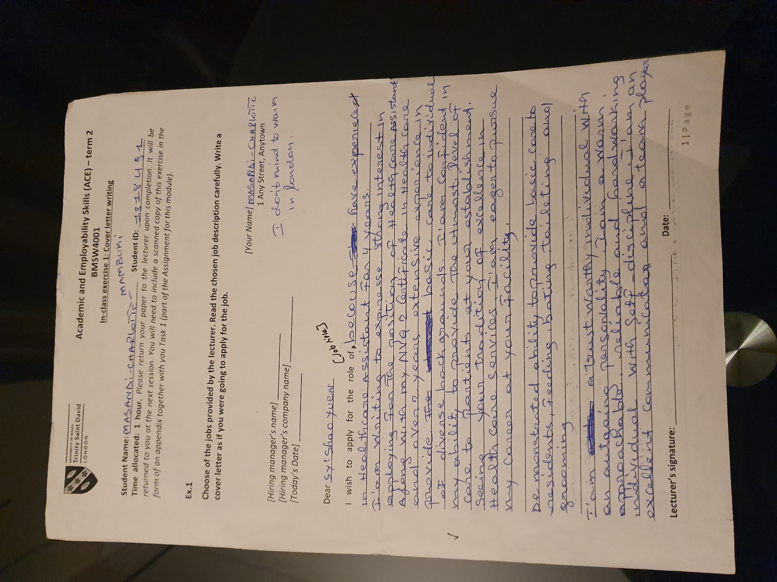

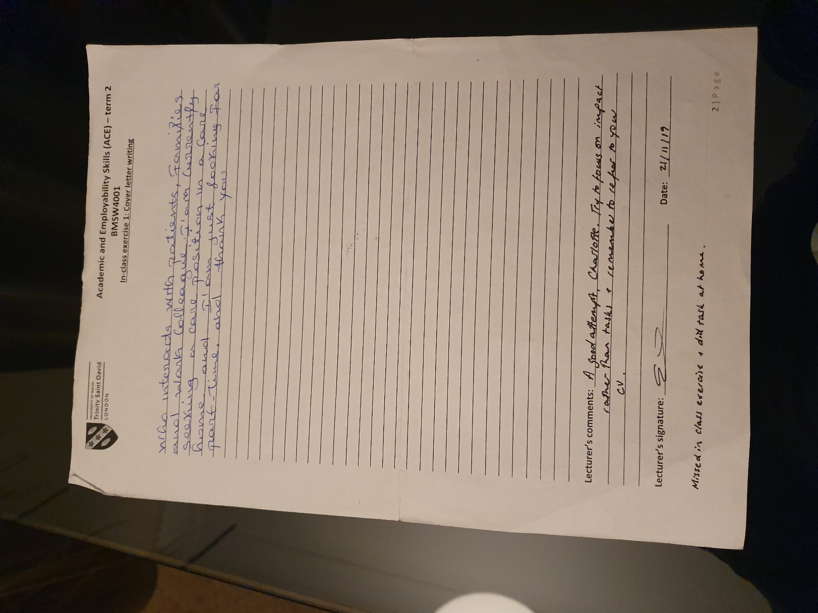

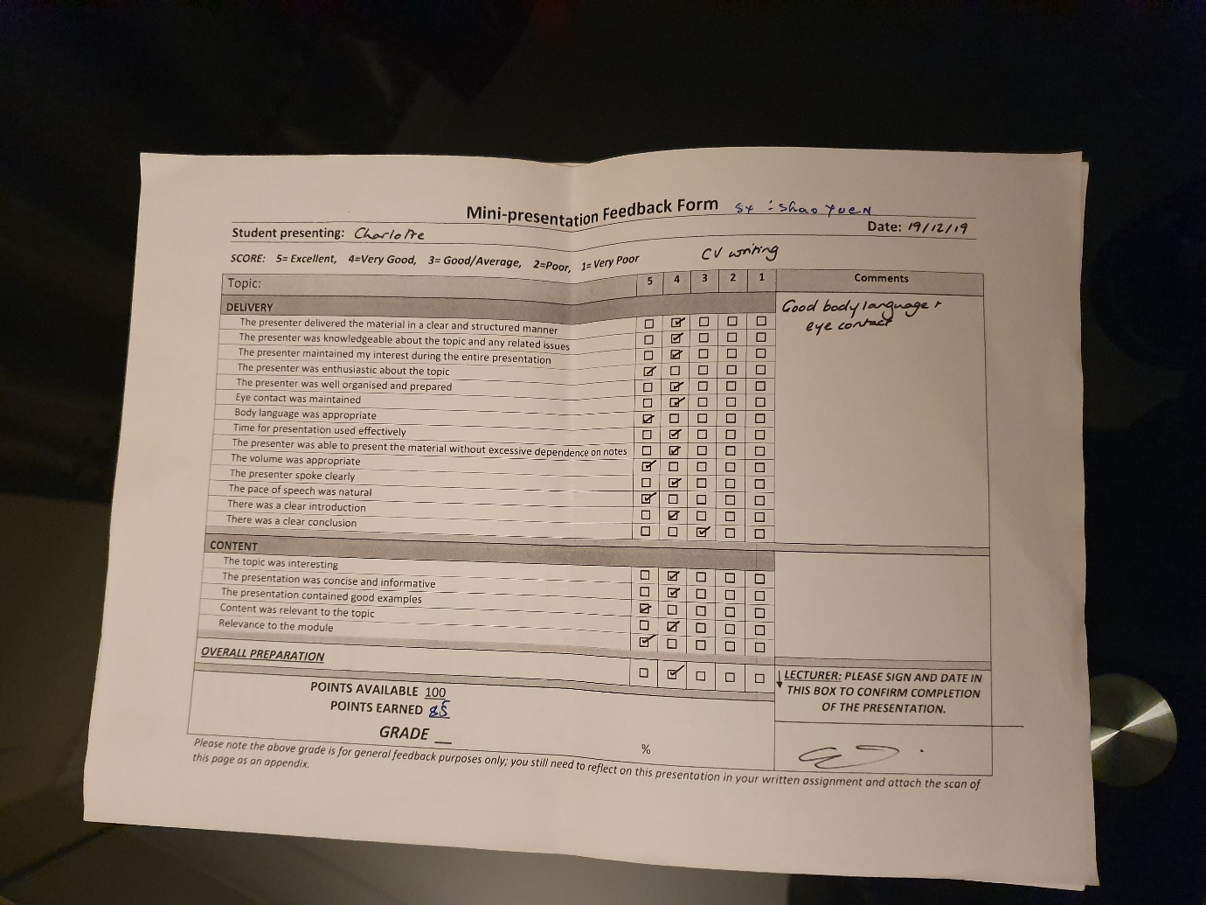

10 Essential Employability Skills

- Problem-solving
- Oral communication
- Adaptability
- Collaboration
- Resource management
- Organizational skills
- Written communication
- Technology use
- Information use
- Certain personality traits

04/01/2020;https://zety.com/blog/employability-skills

“Employability is having a set of skills, knowledge, understanding and personal attributes that make a person more likely to choose and secure occupations in which they can be satisfied and successful. Dacres Pool & Sewell 2007”

Your employability depends on:
- Your Knowledge (what you know)
- Your Skills (what you do with what you know)
- Your Attitudes (how you approach things)
04/01/2020;http://www.mycit.ie/contentfiles/careers/what%20is%20employability.pdf

N ational dialogue has escalated around the concepts of college and career readiness. Influential national and state policymakers have called for high schools to prepare students to be ready for both college and a career. But what do these terms really mean? All too often, the terms "career ready" and "college ready" are used interchangeably, and discussions around career readiness are limited to traditional academic skills that allow students to successfully enroll in postsecondary education. While there is no debate that a rigorous level of academic proficiency, especially in math and literacy, is essential for any post-high school endeavor, the reality is that it takes much more to be truly considered ready for a career.
Career readiness involves three major skill areas: core academic skills and the ability to apply those skills to concrete situations in order to function in the workplace and in routine daily activities; employability skills (such as critical thinking and responsibility) that are essential in any career area; and technical, job-specific skills related to a specific career pathway. These skills have been emphasized across numerous pieces of research and allow students to enter true career pathways that offer family-sustaining wages and opportunities for advancement.
ACADEMIC SKILLS As has been documented by such organizations as ACT and Achieve, career-ready core academics and college-ready core academics are essentially the same, thus creating overlap in the preparation students need to be ready for postsecondary education and careers.1 All students need foundational academic knowledge, especially in math and English language arts, and, in today's eco
nomic environment, all high school students need the academic skills necessary to pursue postsecondary education without remediationthe measure many consider "college readiness."
However, to truly be career-ready, students also need to be able to apply academics in context, and some academic skills need more attention and development. For example, employers often cite deficiencies in English and written communications, such as memos, letters and complex technical reports. This supports the idea that most of the written material students will encounter in their careers is informational in nature, such as technical manuals and research articles, and they must be equipped academically to analyze and use these materials. Too often, these skills are not emphasized in traditional academic classrooms. Workplace deficiencies in math are also commonly noted, with more attention needed on areas such as data analysis and statistics, reasoning, and solving mathematical problems.2
Students must also be able to apply academic knowledge to authentic situations they may face in their careers, a skill that takes practice and intentional instruction that may need to be tailored to a student's specific career goals. For example, students preparing to be nurses need to be able to calculate and apply ratios, proportions, rates and percentages to determine drug dosages,3 while construction students need to be able to apply geometrical principles to design and implement building plans.
EMPLOYABILITY SKILLS Employability skills have often been cited by employers as the skills most critical to workplace success in the 21st-century economy. These skills include (but are not limited to) critical thinking, adaptable
04/01/2020;http://leg.wa.gov/JointCommittees/Archive/CEOTF/Documents/Background/CareerReadyBrief_ACTE.pdf

Types of Employability Skills

Communication
All employers look for job candidates with strong communication skills. These refer to one’s ability to convey information clearly to others. Employers want employees with strong written, verbal, and nonverbal communication skills. Part of being a strong communicator also includes being a good listener; employees need to be able to understand the questions and concerns of their clients and listen to their employer’s directions.
04/01/2020;https://www.thebalancecareers.com/employability-skills-list-and-examples-4143571

The Importance of Good Communication Skills
Developing your communication skills can help all aspects of your life, from your professional life to social gatherings and everything in between.
The ability to communicate information accurately, clearly and as intended, is a vital life skill and something that should not be overlooked. It’s never too late to work on your communication skills and by doing so, you may well find that you improve your quality of life.
Communication skills are needed in almost all aspects of life:
- Professionally, if you are applying for jobs or looking for a promotion with your current employer, you will almost certainly need to demonstrate good communication skills.
Communication skills are needed to speak appropriately with a wide variety of people whilst maintaining good eye contact, demonstrate a varied vocabulary and tailor your language to your audience, listen effectively, present your ideas appropriately, write clearly and concisely, and work well in a group. Many of these are essential skills that most employers seek.
04/01/2020: https://www.skillsyouneed.com/ips/communication-skills.html

Examples of employability skills
Skills sought by graduate employers include teamwork, communication, planning and organising, problem solving, and so forth. Some skills overlap with one another. Leadership, for example, encompasses a number of other skills including decision making, verbal communication, planning, organising, and collaboration.
employing organisation.
Personal attributes that contribute to overall employability include commitment, adaptability, honesty and integrity, reliability, ability to deal with pressure, motivation, and cultural fit with the employing organisation.

04/01/2020 .https://sydney.edu.au/careers/students/career-advice-and-development/employability-skills.html

https://www.exeter.ac.uk/ambassadors/HESTEM/resources/General/STEMNET%20Employability%20skills%20guide.pdf

