Evidence of Learning E-Portfolio
BMPS4010
Chloe Clark (2207404)

Blog 1

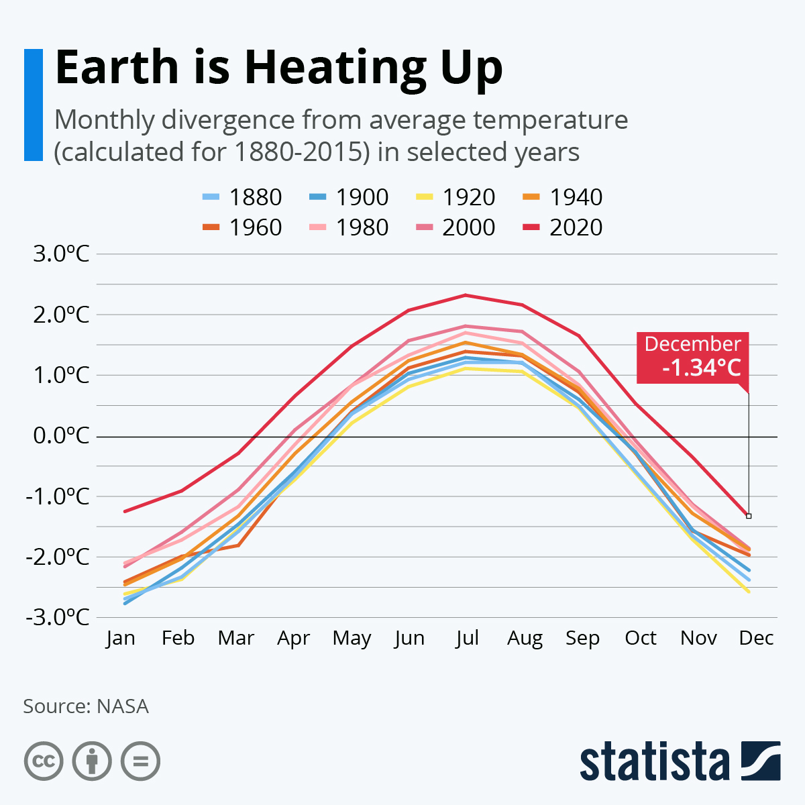

Global warming is having a drastic effect on not just our planet and the environment but also us as people. Written in (WorldWildlife.org), as our climate worsens and changes, the weather is becoming even more severe these events are becoming more frequent and more dangerous. From the sea levels rising dramatically and the ocean itself warming considerably, it is starting to become a threat to the wildlife living in an around them.
As stated by (Nasa), climate change is not a problem for our future selves it’s a serious issue this is our problem now, the changes in the earth’s climate are propelled by our use of greenhouse gasses, and it already in 2023 is having a huge impact on the environment.

The (National Park Service), states that the rising temperature of the earth poses a risk to wildlife and the earths ecosystem, it destabilizes the balance. While plants can adapt to their everchanging environments, animals not so much, this meaning that animals are forced to change environments and face newer ones. Some species will start to struggle to find food which is nutritious enough to fit their existing diet, which is right for them, they will also start to find that were they have their habitats now is no longer suitable due to plants etc growing differently. Some animals will be able to adapt to these newer warmer environments and they will strive, this means they will also start to expand their habitats and territory. Not all wildlife will flourish in the environment that they adapt to as it causes some to lose their natural instincts and makes then more vulnerable.
According to the (CDC) global warming will start to have a huge affect on human health, it will start to result in members of the population to die prematurely due to weather events becoming so severe, the disruption in the geographical distribution of water-born and even food-born illnesses will start to become more frequent and we will start to become of susceptible to more infectious diseases and it will start to have a much greater affect on our mental wellbeing.
There are many ways you can help to reduce your carbon footprint according to (Colburn, 2022), some of these ways are as simple as this, to try and steer away from using fossil fuels in your home, some examples of fossil fuels are, coal products, or even gases. So, to try and reduce this you would switch from a coal fire to an electric fire. You could also try to reduce the amount you drive, and you could either walk or ride a bike or you could even use public transportation, this means there is one less car on the road. You can also help the environment more by even just recycling more and avoiding products you buy that have a lot of access packaging, for example when you order online these companies tend to use a lot of extra packaging which usually includes plastic. Which isn’t great.

Blog 1- Reference list

WWF (2021). Effects of Climate Change | Threats | WWF. [online] World Wildlife Fund. Available at: https://www.worldwildlife.org/threats/effects-of-climate-change#:~:text=More%20frequent%20and%20intense%20drought.
Date accessed 9th March 2023.

NASA (2022). The Effects of Climate Change. [online] Global Climate Change: Vital Signs of the Planet. Available at: https://climate.nasa.gov/effects/.
Date accessed 9th March 2023.

National Park Service (2021). Wildlife and Climate Change (U.S. National Park Service). [online] www.nps.gov. Available at: https://www.nps.gov/articles/000/wildlife-climateimpact.htm.
Date accessed 9th March 2023.

CDC (2020). Climate Change and Public Health - Climate Effects on Health | CDC. [online] www.cdc.gov. Available at: https://www.cdc.gov/climateandhealth/effects/default.htm#:~:text=The%20health%20effects%20of%20these.
Date accessed 9th March 2023

Colburn, N. (2022). 50 Ways to Reduce Climate Change: A Different Kind of List. [online] Nadia Colburn. Available at: https://nadiacolburn.com/50-ways-to-reduce-climate-change/
Date accessed 9th March 2023.
‌Image Reference
Statista Infographics. (n.d.). Infographic: Earth is Heating Up. [online] Available at: https://www.statista.com/chart/19048/global-warming-monthly-divergence/.
Date accessed 9th March 2023.
‌Blog 2

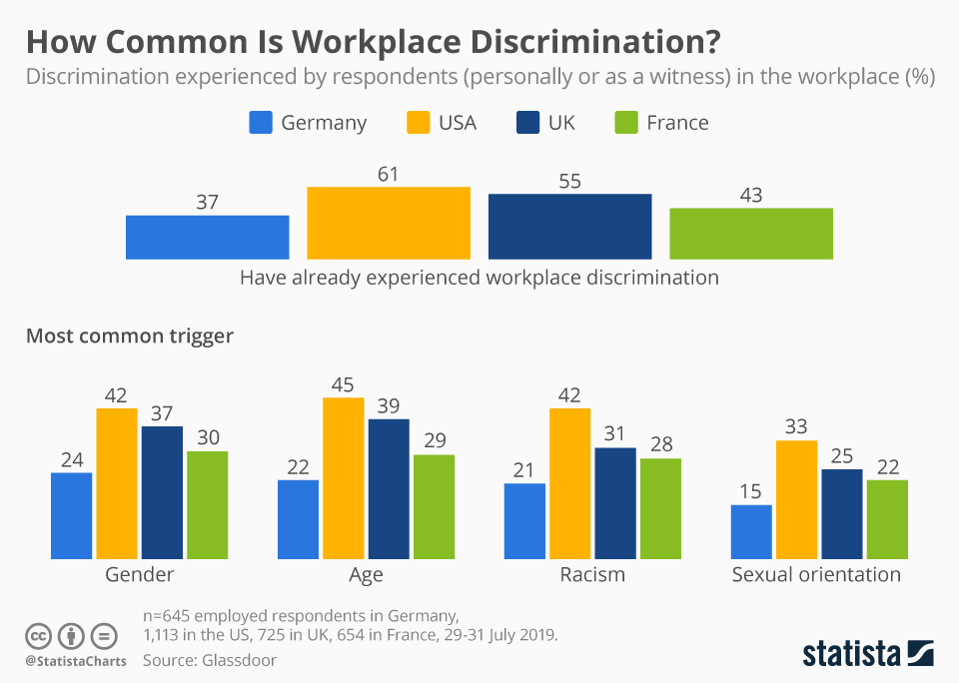
Surprisingly age bias in one’s workplace can come up quite a lot, it is more common than you think. Written in the (university of Rhode Island), it states that people who are much younger that others in the workplace, some feel that they get treated unfairly and like a child by co-workers that are older than them. This can lead to conflict of ideas and opinions when in the workplace. Everybody should be treated in the same manor but, this isn’t always the case. To overcome age bias in the workplace (Everfi), writes that people in the workplace should be given full training in these areas such as discrimination and diversity, and try to ensure that polices and procedures are enforced in and around your workplace.
There are many types of conflict you may come across in the workplace, this can range from creative ideas conflict and not liking someone’s approach to something, or it can even be based off the status the person holds at work. This can cause conflict in many ways as this person may feel like their opinion is more important than others. According to (Atlas Staffing), you should try to ensure that a mutual degree of respect of people’s differences throughout the workplace, higher up staff such as shift leaders or managers should try to remain aware of their own leadership styles. When in a workplace you should try to consider that everybody is different.
The way in which you negotiate in the workplace or even in daily life can be crucial to the success of what you want to achieve, written by (Shon, 2022), they state that negotiating is a lot of back and forth when you are trying to communicate with someone. Negotiations are designed so that you can reach a decision as you go through your negotiations. When negotiating you must try to ensure you follow simple steps, just aim to make sure that you are clear and concise, and you know exactly what you want to achieve.
When making a decision it is important that you try to take your time, you must ensure that you take a minute to sit back and think about the decision you want to make. According to (Umassd), you should try and take different steps when it comes to your decision making, try to ensure that you are gathering information that is relevant to the decision, try to find alternatives for if you need then and keep these as options to choose from. Try to ensure that you weigh up any pros and cons in the decision you are making so you are making sure it is right for you. By using a step-by-step system, it may be easier for you to reach your decision, it helps you to ensure that you have all the relevant information and that you achieve the outcome you were hoping for.
Blog 2- Reference list

web.uri.edu. (n.d.). Age or Generational Issues? | Work-Life Resources at URI. [online] Available at: https://web.uri.edu/worklife/homepages/workplaceproblemspages/age_generation/..
Date accessed 9th March 2023

Everfi (2015). How to Avoid Age Discrimination in the Workplace. [online] EVERFI. Available at: https://everfi.com/blog/workplace-training/how-to-avoid-age-discrimination-in-the-workplace/.
Date accessed 9th March 2023

Atlas Staffing (2018). 6 Workplace Conflicts and How to Deal with Them. [online] Atlas Staffing. Available at: https://atlasstaffing.com/blog/6-common-workplace-conflicts-and-how-to-deal-with-them/.
Date accessed 9th March 2023

‌Shonk, K. (2019). Top 10 Negotiation Skills. [online] PON - Program on Negotiation at Harvard Law School. Available at: https://www.pon.harvard.edu/daily/negotiation-skills-daily/top-10-negotiation-skills/.
Date accessed 9th March 2023
University of Massachusetts Dartmouth (2021). Decision-making process. [online] Umassd.edu. Available at: https://www.umassd.edu/fycm/decision-making/process/.
Date accessed 9th March 2023
Photo Reference

McCarthy, N. (2019). Infographic: How Common Is Workplace Discrimination? [online] Statista Infographics. Available at: https://www.statista.com/chart/19761/discrimination-experienced-by-respondents-in-the-workplace/.
Date accessed 9th March 2023

Blog 3
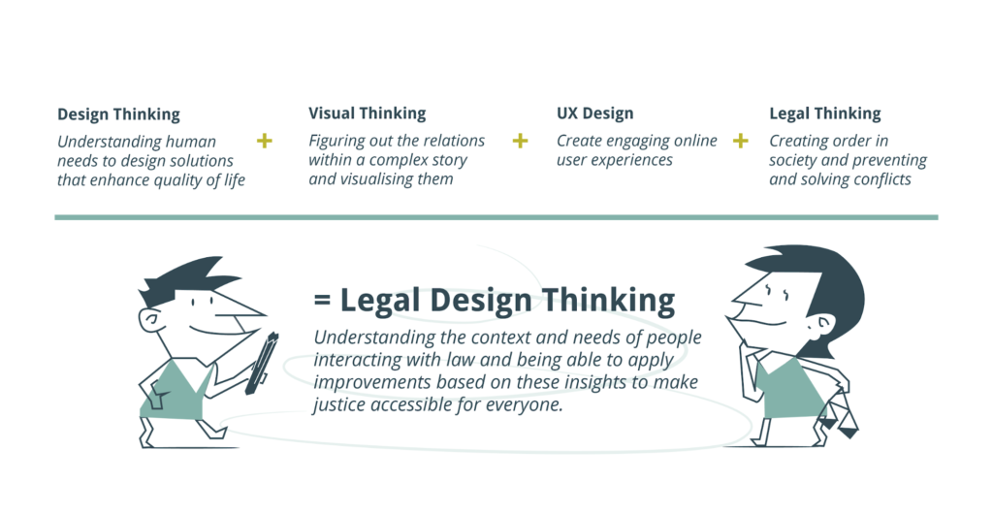
‌According to (Kaplan, 2022), creative thinking is the capability to come up with ideas that are original and unique to you, this can also be known as problem solving. Creative thinking is a very beneficial and is a great skill to have. It will help to guide you through many different career paths in which you choose, creative thinking is about being able to brainstorm your ideas and experimenting with them in such ways you are able to come up with solutions into how they fit into daily problems. Creative thinkers aren’t scared to take the necessary risks that enables them to try new things and ideas. Creative thinking can make you a great asset.
Design thinking in itself as written in (Interaction Design Foundation, n, d.), is not something that is consistent, it’s a repetitive process that teams use to help understand their users. Design thinking is important because its crucial in life that you develop and refine your skills as you grow to understand rapid changes.
According to (Leoyan, 2022), there are a few stages to design thinking. One being, the empathize stage, this is the process you use empathy to look into the problem in which you are trying to solve. Empathy is vital in the design thinking process. Next is the define stage, this is when you encounter an issue that does not technically a have a specific problem that is needing to be solved. These problems are to guide you so that you work on possible solutions for these issues that may arise. You also have a prototype stage, this is important so that designs can be tested by others outside your team in order to weed out any issues you may face, ensuring you have enough time to find a solution to these issues. The final stage is the testing stage, after testing out the different prototypes and improving on the issues you have faced during the project. Design thinking framework is unpredictable and ever changing.
Design thinking is a great asset when practicing law because as stated in (High, 2021), is helps to identify different strategies and even solutions that may not be instantly clear, it helps focus on creating a deeper understanding for the solution that is being developed and the people that it is for. It is important that you are able to find the right approach as this could be new not only to you but, new to the clients who you deal with on a daily basis, it helps easy people in and make them feel more comfortable.

Blog 3- Reference List

Kaplan, Z. (2022). What Is Creative Thinking? Definition and Examples. [online] Forage. Available at: https://www.theforage.com/blog/skills/creative-thinking#:~:text=Creative%20thinking%20includes%20the%20process.
Date accessed 9th March 2023.

Interaction Design Foundation (n.d.). What is Design Thinking? [online] The Interaction Design Foundation. Available at: https://www.interaction-design.org/literature/topics/design-thinking#:~:text=Design%20thinking%20is%20a%20non.
Date accessed 9th March 2023.

Asana (n.d.). Get out of a creative rut with the design thinking process. [online] Asana. Available at: https://asana.com/resources/design-thinking-process.
Date accessed 9th March 2023.

‌High, J. (2021). Improve your legal innovation with design thinking | Legal Blog. [online] Thomson Reuters Law Blog. Available at: https://legal.thomsonreuters.com/blog/better-legal-innovation-with-design-thinking/
Date accessed 9th March 2023.

Photo reference
Beelen, L. (2019). A human-centered approach to the legal system. [online] TestingTime. Available at: https://www.testingtime.com/en/blog/human-centered-approach-legal-system/
Date accessed 9th March 2023.
‌

‌

‌

‌

‌

