

Name: Javaid iqbal
Student ID: 2534172
Module Code: LCHS4001
Module: Academic and Employability skills
Lecturer: Markus Klingelfuss (Module Lead- Birmingham)
Submitted on: Friday, 24th July 2026, 10 am

Table of Contents
1.1 Introduction ............................................................................................................................................................ 3
2 SEND Support Worker in the Health, Social Care and Education Sector ........................................................... 3
2.1 Description of SEND Support Worker in the Health, Social Care and Education Sector ............................... 3
2.2 Explanation of the Most Significant Skills Needed for a SEND Support Worker in the Health, Social Care and Education Sector .................................................................................................................................................. 4
3 Strategies for Skill Improvement for a SEND Support Worker in the Health, Social Care and Education Sector ........................................................................................................................................................................... 5
3.1 Three Strategies to Improve the Skills for a SEND Support Worker in the Health, Social Care and Education Sector ......................................................................................................................................................... 5
Conclusion ................................................................................................................................................................... 7
Reference List .............................................................................................................................................................. 8

1.1 Introduction
Children and young people with Special Educational Needs and Disabilities (SEND) require personalised support to access education, develop independence and achieve positive outcomes. Within the UK, SEND Support Workers play an important role in promoting inclusive practice by working collaboratively with teachers, families and other professionals to meet each pupil's individual needs (Department for Education, 2023). This report examines the role of a SEND Support Worker in the Health, Social Care and Education Sector. It describes the responsibilities of the role, explains three essential skills required for effective practice, evaluates strategies for developing these skills and highlights their importance in delivering safe, inclusive and person-centred support.

(Istock, 2026)

2.1 Description of SEND Support Worker in the Health, Social Care and Education Sector
A SEND Support Worker in the Health, Social Care and Education Sector plays an important role in helping children and young people with Special Educational Needs and Disabilities (SEND) overcome barriers to learning and participate fully in education. Pupils with autism spectrum disorder (ASD), attention deficit hyperactivity disorder (ADHD), speech and language difficulties, learning disabilities or physical disabilities often require personalised support to achieve their educational and developmental goals. Working alongside teachers and other professionals, SEND Support Workers promote inclusion, independence and emotional wellbeing by ensuring support is tailored to each pupil’s individual needs (Department for Education, 2023; Education Endowment Foundation, 2021).
The responsibilities of a SEND Support Worker include adapting classroom activities, supporting Education, Health and Care Plans (EHCPs), monitoring progress and encouraging communication, social interaction and independence. They also work closely with teachers, Special Educational Needs Coordinators (SENCOs), therapists and parents to provide consistent support while maintaining safeguarding responsibilities (Department for Education, 2023; Webster et al., 2021). For example, when a pupil with autism becomes anxious after an unexpected timetable change, the SEND Support Worker may use a visual timetable, explain the new routine clearly and provide reassurance until the pupil feels settled. This practical approach reduces anxiety, supports inclusion and enables the child to continue learning confidently.

2.2 Explanation of the Most Significant Skills Needed for a SEND Support Worker in the Health, Social Care and Education Sector

2.2.1 Communication Skills
Communication is a vital skill for a SEND Support Worker in the Health, Social Care and Education Sector because children with SEND communicate in different ways and often require information to be adapted to their needs. Effective communication helps build trusting relationships and enables accurate information to be shared with teachers, parents and therapists. For example, when supporting a pupil with speech and language difficulties, the worker may use visual symbols, simple language and active listening to help the child express their needs and participate in classroom activities. Effective communication improves inclusion, pupil engagement and partnership working (Education Endowment Foundation, 2021; Douglas et al., 2022).

2.2.2 Empathy
Empathy enables a SEND Support Worker to understand children's emotions and respond with patience and respect. Many pupils with SEND experience anxiety or frustration during learning, so an empathetic approach helps them feel safe and supported. For example, if a pupil with autism becomes overwhelmed by classroom noise, the worker can provide reassurance and move the child to a quieter area before gradually helping them return to learning. This approach builds trust, supports emotional wellbeing and encourages positive participation in school activities (Malmqvist, Nilholm and Lindqvist, 2023; Department for Education, 2023).

2.2.3 Adaptability
Adaptability is essential because every child with SEND has different learning needs and abilities. A SEND Support Worker must adjust teaching approaches, communication methods and classroom resources to suit each pupil. For example, when a literacy task is too challenging, the worker may simplify instructions and use visual resources to improve understanding. Adapting support enables pupils to remain engaged, develop confidence and make progress towards their educational goals (Florian and Beaton, 2022; Education Endowment Foundation, 2021).

2.2.4 Impact of Poor Communication, Empathy and Adaptability
Without communication, empathy and adaptability, the quality of support for pupils with SEND is reduced. Poor communication may lead to misunderstanding and limited participation, while a lack of empathy can prevent children from feeling valued and confident enough to express their concerns. Poor adaptability may result in learning activities that do not meet individual needs, reducing engagement and progress. These weaknesses can increase anxiety, weaken collaboration with teachers and parents, and limit educational achievement and inclusion. Therefore, these three skills are fundamental to providing effective, child-centred support that promotes positive learning and wellbeing (Department for Education, 2023; Malmqvist, Nilholm and Lindqvist, 2023).

3.1 Three Strategies to Improve the Skills for a SEND Support Worker in the Health, Social Care and Education Sector

3.1.1 Strategy to Improve Communication Skills: Makaton and Augmentative and Alternative Communication (AAC) Training
Makaton and Augmentative and Alternative Communication (AAC) training is an effective strategy for developing communication skills because many children with SEND experience difficulties expressing themselves through spoken language. This strategy is supported by research showing that visual communication methods improve interaction, understanding and classroom participation for pupils with additional needs (Marshall and Goldbart, 2023; Grove and Walker, 2022). It was chosen because it provides practical techniques that SEND Support Workers can apply immediately in educational settings. Through training, workers learn to use signs, symbols and visual resources to support communication. For example, a pupil with speech and language difficulties may use Makaton signs or communication boards to express needs during lessons, reducing frustration and improving participation.
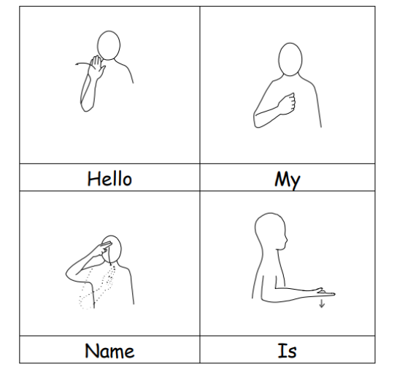

(Neurodiverse, 2026)

3.1.2 Strategy to Improve Empathy: Reflective Practice and Professional Supervision
Reflective practice supported by professional supervision is an effective strategy for developing empathy because it encourages SEND Support Workers to evaluate their interactions with pupils and consider how their responses affect children's wellbeing. This strategy was selected because research shows that reflection improves emotional awareness, person-centred practice and professional decision-making (Malmqvist, Nilholm and Lindqvist, 2023; Department for Education, 2023). During supervision, workers receive constructive feedback and identify ways to respond more sensitively to children's emotional needs. For example, reflecting on how an anxious pupil responded to classroom changes can help the worker develop more supportive approaches that strengthen trust and improve future interactions.

3.1.3 Strategy to Improve Adaptability: Continuous Professional Development (CPD) in Inclusive Education
Continuous Professional Development (CPD) in inclusive education is an effective strategy for improving adaptability because it helps SEND Support Workers develop current knowledge and practical skills for supporting pupils with diverse needs. It was chosen because research indicates that ongoing professional learning improves confidence in adapting teaching approaches and implementing evidence-based inclusive practices (Education Endowment Foundation, 2021; Florian and Beaton, 2022). CPD introduces strategies for supporting pupils with autism, ADHD and learning disabilities through differentiated teaching and flexible classroom support. For example, after completing CPD, a SEND Support Worker may adapt lesson resources using visual aids and simplified activities, enabling a pupil with autism to participate more independently and confidently in learning.
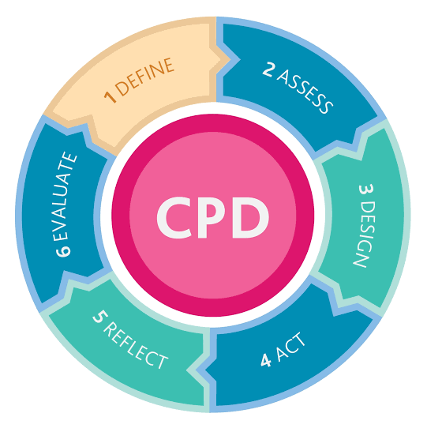
(Struthers, 2020)

Conclusion
SEND Support Workers play an essential role in promoting inclusive education and supporting children with Special Educational Needs and Disabilities to achieve positive educational, social and emotional outcomes. This report has demonstrated that effective communication, empathy and adaptability are fundamental skills for providing safe, child-centred and personalised support. It has also shown that strategies such as Makaton and Augmentative and Alternative Communication (AAC) training, reflective practice with professional supervision and Continuous Professional Development (CPD) strengthen these skills and improve professional practice. Overall, well-trained SEND Support Workers contribute to inclusive learning environments where every child has the opportunity to participate, develop and reach their full potential.

REFERENCES
Department for Education (2023) Special educational needs and disability code of practice: 0 to 25 years. London: Department for Education.
Douglas, G., McLinden, M., Robertson, C. and Smith, E. (2022) ‘Inclusive communication practices for learners with special educational needs’, Support for Learning, 37(4), pp. 503–519.
Education Endowment Foundation (2021) Special Educational Needs in Mainstream Schools: Guidance Report. London: Education Endowment Foundation.
Florian, L. and Beaton, M. (2022) ‘Inclusive pedagogy in practice: supporting diverse learners in mainstream classrooms’, International Journal of Inclusive Education, 26(10), pp. 1001–1016.
Grove, N. and Walker, M. (2022) ‘Using augmentative and alternative communication to support inclusive learning’, Support for Learning, 37(3), pp. 312–327.
Malmqvist, J., Nilholm, C. and Lindqvist, G. (2023) ‘Supporting participation and inclusion for pupils with special educational needs: the importance of relationships and professional practice’, European Journal of Special Needs Education, 38(3), pp. 347–361.
Marshall, J. and Goldbart, J. (2023) ‘Communication support strategies for children with special educational needs in educational settings’, Journal of Research in Special Educational Needs, 23(2), pp. 145–156.
Webster, R., Blatchford, P. and Russell, A. (2021) Maximising the impact of teaching assistants. Abingdon: Routledge.

