The Royal Liver Building – Concrete Framed Building Analysis


Figure 1- The Royal Liver Building

By Ceri James (2526474)

Table of Contents
- Concreted Framed Building Research 3
  - Introduction and Overview 3
- Analysation of the framing Materials 3
  - Strength, Durability and Climatic resistance 3/4
  - Time, Labour, Programme and Cost compared to steel 4/5
  - Assembly and Adaptation 5
  - Integration of Building Services 5
  - Demolition and End-of-Life Challenges 6
- Environmental Impact of Concrete Production 6
  - Negative Impacts on the community 6/7
  - Negative Impacts on the environment 7
- Conclusion 7/8
- Sieve Analysis 8/9
- References 9/10

- Concrete Framed Building Research
1.1 Introduction and Building Overview
In this report I will be discussing the use and importance of concrete in the modern era. Particularly the analysis of concrete framed buildings, the building I will be focusing on is The Royal Liver Building.
Th Royal Liver Building was built in 1911 by architect Walter Aubrey Thomas. This building was one of the first buildings in the world to be constructed using a reinforced concrete frame, and was the tallest building up until the 1960`s (Royal Liver Building, 2024)
At the time of construction, the building was seen a symbol of pioneering in the construction world for its use of reinforced concrete. This was a significant development in building technology and allowed the building to become one of the first skyscrapers in the United Kingdom.
This report will discuss the building’s design and construction methods, analyses the properties of the concrete framing system, evaluates its performance compared to steel framing, and explores issues such as service integration and demolition challenges. The environmental impacts of concrete production are also discussed in relation to the wider construction industry.

- Analysation of the framing material
2.1 Strength, Durability and Climatic Resistance
Reinforced concrete provides significant structural advantages due to its high compressive strength. The reason why concrete is used for columns, foundations and load bearing structural elements is because it performs extremely well under compressive loads. The structure also gains tensile strength by embedding steel reinforcement which allows the building to resist bending and structural stress (Chudley and Greeno, 2016).
The durability of reinforced concrete is highted by the Royal Liver Building. This building shows the longevity of reinforced concrete as the building has been able to stay structurally safe through its history, proving that if the structure is constructed correctly then the building can withstand large periods of time.
This structure also showcases positive durability by being located by the sea. Being a constructed to the height of approximately 98 metres tall and consists of 13 floors, this exposes the building to sea air and wind and opens the building to damage from salt particles. This was thought whilst being constructed and the engineers used 14” thick granite cladding on the frame (The Victorian Web, July 2016), this helps protect the building from exposure of direct weather.
As a result of using reinforced concrete, this built eliminates the risk of damage. For example, the effects of a fire outbreak are minimised because of the use of reinforced concrete.
2.2 Time, Labour, Programme & Cost comparison to steel
From the viewpoint of time comparison between reinforced concrete and steel, steel is seen as the fast construction method due to the components being prefabricated and can easily be assembled on site. Reinforced concrete takes longer to construct as the concrete requires curing time to set in place. This can delay projects and lead to missing project deadlines, but reinforced concrete does have more advantages to steel as the concrete has a great flexibility range during construction and design, whereas steel must be straight forward construction and design to have the ability to withstand the required load (Prasad, 2023).
Labour is another important factor in the construction of reinforced concrete, as already mentioned steel requires prefabrication which requires more manpower to be able to complete deadlines especially for high scale projects such as The Royal Liver Building.
The comparison between the use in reinforced concrete and steel is highlighted when it comes to cost. Concrete is generally less expensive than steel in terms of raw material costs. This is because the primary components cement, sand and aggregates are widely available whereas steel includes higher material costs but benefit from faster assembly and reduced construction time.
Overall, while reinforced concrete construction may take longer due to curing times, it offers far greater advantages in terms of cost durability and fire safety which out weight the time disadvantage.
2.3 Assembly and Adaptability
The use of reinforced concrete in the construction of The Royal Liver Building provided the engineers with structural flexibility during construction. The concrete could be poured into moulds of various shapes and sizers, leading to complex structural forms.
The design of The Royal Liver Building was a collum and beam system which were ideal for office environments. This system allowed for the building to be used for various purposes; with the use of partition walls the building could be adapted to the needs of the occupants.
Although reinforced concrete has many advantages, one disadvantage that stands out in the difficult of modifying the buildings structure after the complete of it construction. This is because the structure is a solid material around steel reinforcement meaning the cutting and removing of structural elements can lead to weakening the building.
Despite these challenges, The Royal Liver Building has undergone several refurbishments allowing the building to be modernised while still preserving the historical aspects intact (N/A, 2025)
2.4 Integration of building services
The integration of building services can present a challenge in reinforced concrete structures. All services such as electrical wiring, plumbing systems, heating and air conditioning systems must be installed without compromising the structures integrity.
These challenges were faced with The Royal Liver building when the most recent refurbishment by CBRE after the purchase in February 2017 with plans to integrate new offices, restaurants and even a gym (Commercial News Media, 2018).
There are many ways in which this can be achieved without effecting the building`s integrity. The introduction of raised flooring systems, suspended ceilings and cable ducts are among the few methods that can be used. These allow for the services to be concealed while maintaining the building structure and allow for upgrades and refurbishments to take place while not effecting the original design.
2.5 Demolition and End-of-life Challenges
The demolition of reinforced structure can be difficult and can come with challenges; it requires specialised equipment to be dismantled. The methods used can be manual such as using sledgehammers, bolt cutters or even hydraulic breakers, these methods are often used for small or more precise structures. For large scale structures a ball and crane can be used for faster and more efficient demolition of concrete structures.
Another main challenge that is faced during the demolition is separating the steel reinforcement from the concrete; this needs to be done for recycling to take place. This can often lead to an increase in labour costs to sort the concrete and make sure the two components are separated.
A positive for the demolition of reinforced concrete and the separation between the steel and the concrete is that once the concrete is broken down into smaller pieces it can then be recycled and reused in a new construction project as recycled aggregate. This shows that the process is completely sustainable and can be used repeatedly.
In comparison to this building, The Royal Liver Building is highly unlikely to be demolished due to its historic and architectural significance, the building protected from demolition as it is a grade I Listed building and is part of Liverpool`s Three graces that celebrates the landmarks along the city`s waterfront. (Historic England, 2019)
- Environment Impact of Concrete Production
Although reinforced concrete can be seen as a product with large amounts of positives in the sense on reusability and having cheaper raw materials, concrete can also have negative effects, these effects can impact us in different aspects.
3.1 Negative Impacts on the Community
One negative can be the impacts on the community; there are many aspects of the community the production can affect ranging from everyday noise pollution to major health risks.
For concrete to be made it needs serval raw materials, some of these materials need to be extracted from the ground in facilities such as quarries and cement plants. These facilities use heavy machinery to make the process possible, producing loud noise from blasting, crushing and drilling which can create disturbances to residents, schools and several other workplaces which can upset the community.
Another negative to the community Is an increase in air pollution, cement production releases fine dust particles that can be spread throughout the community leading to poor air quality and can affect a person’s health such as breathing difficulties. This is from crushing rocks and the transportation of the raw materials.
The production of concrete can also affect the community by damaging local lands, the raw materials need to be dug up and extracted from the ground. This takes up space from the community and effects roads due to constant traffic in and out of quarries and plants.
3.2 Negative Impacts on the Environment
Effects on the environment is a major negative impact from the production of concrete; one the main negative effects are high CO2 emissions.
The production of cement, which is a main product required in the production of concrete as it is a binding agent, produces very high levels of CO2. This is from heating materials like limestone in kilns which creates a chemical reaction releasing CO2. This method is responsible for around 7% of the global CO2 emissions, this then contributes to climate change and global warming putting a massive strain on the environment (World Cement Association, N/A).
Since methods such as this are needed in today’s world to produce projects and buildings such as The Royal Liver Building there are still demands that need to be met. Organisation such as the World Cement Association (WCA) aim to reduce the negative output such as CO2 emissions by using alternative materials and technologies (World Cement Association, N/A).
- Conclusion
To conclude The Royal Liver Building is a significant building in the construction history, and a milestone in the development of reinforced concrete construction. The building was completed in 1911 over a 3-year period and showcased the potential of reinforced concrete as a structural framing material that could support large and complex buildings.
This building is a perfect example of how reinforced concrete provides excellent strength, durability standing 115 years from completion and being fire resistant.
Although the building showcases many problems, it also has some challenges. These are due to the construction time needed to cure the concrete and allow it to set before the next phase could begin. The environmental impact of concrete production is a growing concern as more advance studies have shown the negative sides to its production leading to an increase to CO2 emissions and public health.
Overall, The Royal Liver Building stands today as an outstanding structure, showcasing the longevity of correct construction methods in reinforced concrete and how durable and versatile it can be in the construction industry.
- Sieve Analysis
In the table below I have analysed a sample on aggregate to measure the particle size distribution and suitability for direct use as an aggregate. After calculating the table I have identified that the percentages of the aggregate used in 44% Coarse and 56% fine aggregate. This means that the distribution is balanced but slightly finer dominated so it is likely to enhance workability but may increase water demand.
Total Sample Size | 1250g
Sieve Size (mm) | Mass (g) | % on Sieve | % Passing
125 | 0 | 0 | 100
75 | 0 | 0 | 100
63 | 0 | 0 | 100
37.5 | 120 | 9.6 | 90.4
20 | 137 | 10.96 | 76.44
10 | 143 | 11.44 | 68
6.3 | 105 | 8.4 | 59.6
3.35 | 45 | 3.6 | 56
2 | 130 | 10.4 | 45.6
1.18 | 63 | 5.04 | 40.56
0.6 | 105 | 8.4 | 32.16
0.3 | 102 | 8.16 | 24
0.212 | 109 | 8.72 | 15.28
0.15 | 98 | 7.84 | 7.44
0.063 | 55 | 4.4 | 3.04

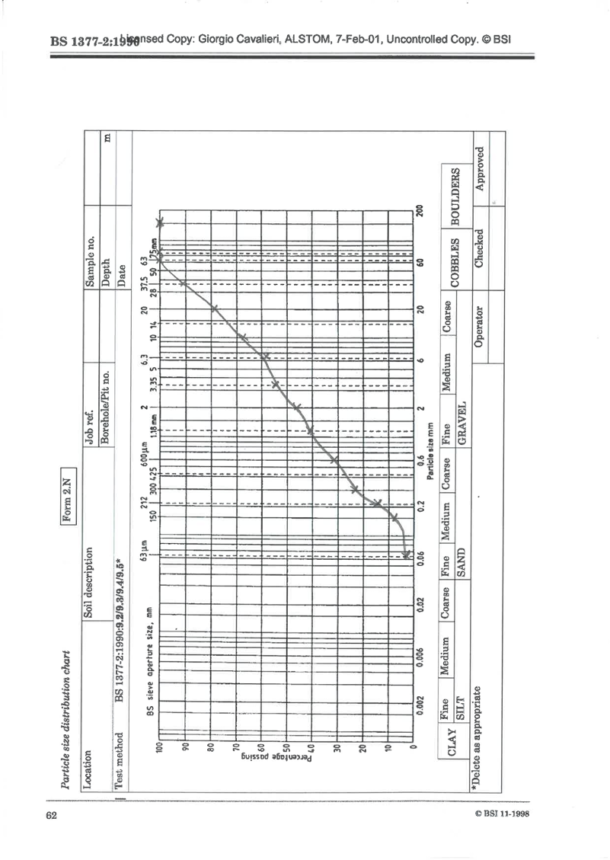
From the table above I have used the data calculated to plot on the graph attached below.

- References
  - Royal Liver Building (2024) History of the Royal Liver Building. Available at: https://www.royalliverbuilding.com (Accessed 8th March 2026).
  - Roy Chudley and Roger Green (2016) Building Construction Handbook. 11th edition. London: Routledge.
  - N/A (2016) Victorianweb.org. Available at: https://victorianweb.org/art/architecture/liverpool/33.html (Accessed 9th March 2026).
  - Prasad (2023) Structural Guide. Available at: https://www.structuralguide.com/steel-structures-vs-reinforced-concrete-structures/ (Accessed 11th March 2026).
  - N/A (2025) Royalliverbuilding.co.uk. Available at: https://royalliverbuilding.co.uk/fourth/ (Accessed 20th March 2026)
  - Commercial News Media (2018) Commercialnewsmedia.com. Available at: https://www.commercialnewsmedia.com/archives/77587 (Accessed 14th March 2026)
  - Historic England (2019) Historicengland.org.uk. Available at: https://historicengland.org.uk/listing/the-list/list-entry/1356370?section=overview (Accessed 21st March 2026)
  - World Cement Association (N/D) worldcementassociation.org. Available at https://www.worldcementassociation.org/about-us/sustainability (Accessed 14th March 2026)

